Assessing the Effectiveness of AI-Personalised Recommendation Systems and Their Impact on Customer Engagement and Satisfaction: A Case Study of Jumia in Lagos, Nigeria

Name and Programme of Study: MBA Research Project
Supervisor: Ruth Bavin
Date of Submission: 16/12/2024

Abstract
This research critically examines the effectiveness of AI-driven personalised recommendation systems and their impact on consumer engagement and satisfaction within the context of Jumia, a leading e-commerce platform in Lagos, Nigeria. The study explores how cultural dynamics, and economic variables shape consumer perceptions of AI-driven personalisation by focusing on the interaction between consumers’ socio-economic status, digital literacy, and the use of AI technology. Economic factors such as purchasing power and the varying levels of accessibility to technology among different segments of Lagos' population are also examined to understand the differential impact of AI recommendations across consumer groups. Additionally, the research delves into the challenges posed by cultural resistance to AI systems and the technological and legal limitations in the Nigerian context, including concerns over data security and privacy regulations. The study aims to provide insights into how AI personalisation can enhance or hinder customer engagement, satisfaction, and loyalty, offering strategic recommendations for e-commerce platforms targeting emerging markets. The study is expected to contribute to the literature on AI in emerging markets, shedding light on how businesses can optimise AI-driven marketing strategies to align with local consumer expectations and overcome contextual barriers.

Acknowledgements
I want to extend my heartfelt gratitude to my wife, Felicia A. Taiwo, and our newborn child, Amaris T. Taiwo, for their unwavering support and love throughout this journey. Your patience, encouragement, and understanding have consistently served as a source of strength for me. I am also profoundly grateful to my mother, Omotolani Taiwo, for her continual encouragement, wise counsel, and belief in my potential. Your support has been invaluable, motivating me to navigate challenges and stay focused on my goals. I would also like to sincerely thank my supervisor, Ruth Bavin, for her exceptional guidance and support throughout this research process. Her insightful feedback, constructive criticism, and patience have been instrumental in shaping the direction and quality of this dissertation. Additionally, I appreciate all the participants who generously shared their time and experiences, significantly enhancing the depth and relevance of this study. Finally, I am thankful to the University of Central Lancashire for providing the necessary resources and a supportive environment that facilitated the completion of this research.

Table of Contents
Abstract
Acknowledgements ii
Table of Contents iii
List of Figures v
List of Tables vi
1.0. Chapter 1: Introduction 1
1.1. Background of the Study 1
1.2. Aims and Objectives 3
1.1. Scope and Limitations 4
1.2. Research Questions 4
1.3. Significance of the Study 5
1.4. Justification for the Research Question 5
2.0. Chapter 2: Literature Review 5
2.1. Introduction 5
2.2. AI Personalised Recommendation Systems in E-commerce 6
2.2.1. Overview of AI-Personalised Recommendations 6
2.2.2. Types of AI-Personalisation Techniques 7
2.2.3. AI-Personalised Recommendations as a Marketing Tool 9
2.3. Theoretical Framework 10
2.4. AI Personalisation in Emerging Markets 11
2.5. AI Impact on Customer Engagement and Satisfaction 13
2.6. Challenges in Implementing AI-Personalisation in Emerging Markets 15
2.6.1 Infrastructure Limitations 16
2.6.2 Cultural Challenges 17
2.6.3 Privacy Concerns 17
2.6.4 Algorithmic Bias and Fairness 17
2.6.5 Economic Challenges 17
2.7. Identification of Literature Gaps 18
2.8. Conclusion 18
3.0. Chapter 3: Methodology 19
3.1. Research Philosophy and Approach 19
3.1.1. Pragmatism 19
3.1.2. Inductive and Deductive Approach 19
3.2. Research Strategy 20
3.2.1 The Case Study Method 20
3.2.2 Data Sources 20
3.3. Research Design 20
3.4. Data Collection Methods 21
3.4.1 Quantitative Data Collection 21
3.4.2 Qualitative Data Collection 21
3.5. Sampling Strategy 22
3.6. Data Analysis Methods 22
3.6.1. Quantitative Data Analysis 22
3.6.2. Qualitative Data Analysis 23
3.7. Ethical Considerations 23
3.8. Limitations of the Study 24
4.0 Chapter 4: Data Analysis and Findings 24
4.1 Overview 24
4.2 Data Preparation 24
4.3. Exploratory Data Analysis 25
4.3.1. Statistical Summary 25
4.3.2. Univariate analysis 27
4.3.3. Bivariate Analysis 33
4.3.4. Multivariate analysis 37
4.4. Hypothesis Testing 38
4.4.1. Hypotheses and Corresponding Tests 38
4.4.2. Results of Hypothesis Testing 39
4.4. Thematic Analysis of Qualitative Data 41
4.4.1. Key Themes and Subthemes 41
5. Discussion 45
5.1. Overview of AI Personalisation Benefits and Drawbacks 45
5.2. Economic Disparities in AI Personalisation 45
5.3. Digital Literacy and Accessibility Barriers 46
5.4. Cultural Sensitivity and AI Alignment 47
5.5. Privacy Concerns and Trust 47
5.6. Repetitive Recommendations and User Fatigue 48
6. Conclusion and Recommendations 48
6.1. Summary 48
6.2. Recommendations 49
6.3. Future Research Directions 50
References 51
Appendix 1: Tables and Figures 61
Appendix 2: Analysis Tools and Framework 62
Appendix 3: Data Analysis Process 63
Appendix 4: Questionnaire 64

List of Figures
Figure 1: Mobile Internet User Penetration in Nigeria from 2020 to 2029 (Statista, 2024) 3
Figure 2: Basic flowchart of recommendation systems (Yıldız et al., 2023). 6
Figure 3: System architecture of Hybrid recommendation system (Khanal et al., 2019) 8
Figure 4: The Application of Artificial Intelligence in Marketing (Haleem et al., 2022) 9
Figure 5: Global Artificial Intelligence Market (Market.us, 2023). 12
Figure 6: An artificial intelligence conceptual model (Trawnih et al., 2022) 13
Figure 7: The application of AI personalised Chatbot on customer experience (Jenneboer et al., 2022) 14
Figure 8: Global Challenges and Downsides Associated with AI (Qadir et al., 2022) 16
Figure 9: The Demographic Composition of Jumia Respondents 27
Figure 10: Consumers' Perceptions Regarding the Significance and Influence of Personalised Recommendations 28
Figure 11: Respondents' Levels of Satisfaction Regarding AI Recommendations 29
Figure 12: Participants Perception Pertaining to Loyalty, Preference, Cultural and Economics 30
Figure 13: Analysis of Respondents' Privacy Concerns, Trust in Data Transparency, Purchasing Power, and Challenges Associated with AI Recommendations 31
Figure 14: Analysis of User Interaction, Shopping Habits and Repeat Purchases 32
Figure 15: The Interplay of Privacy Concerns, Transparency, Trust, And Satisfaction with AI Recommendations 33
Figure 16: The Influence of Income, Trust, And Cultural Relevance on Satisfaction with AI Recommendations 35
Figure 17: Correlation Matrix for Key Variables 37
Figure 18:Wordcloud of Suggested improvement, Privacy concerns, and Additional comments 42
Figure 19: Wordcloud of Suggested improvement, Privacy concerns, and Additional comments for Respondents earning below #50,000 43

List of Tables
Table 1: Statistical Summary of the Key Variables 26
Table 2: Hypothesis Testing Summary 39
Table 3: Hypothesis Results 40
Table 4: Key Themes and Subthemes 44
Table 5:Recommendations 49

Chapter 1: Introduction

Background of the Study
The e-commerce sector has been revolutionised by the rapid growth of AI and its ability to tailor marketing experiences (Gao et al., 2023). As a result of this development, AI-personalised recommendation systems have emerged as a marketing tool that leverages consumer behaviour to provide product recommendations (George et al., 2024). Ifekanandu et al. (2023) propose that AI-personalised recommendations optimise the allocation of the right products to consumers, hence improving customer engagement and satisfaction. Pardeshi et al. (2023) additionally investigate the integration of AI-driven recommendation systems as a marketing tool employed by e-commerce platforms such as Amazon and Alibaba to enhance customer satisfaction and loyalty.
Jumia, an e-commerce platform in Nigeria, deploys AI technologies to enhance customer interaction and satisfaction by providing personalised marketing and product recommendations (Griffin, 2022). While the efficacy of AI-driven customised experiences is well-established in advanced nations, its impact in emerging regions such as Nigeria remains uncertain (Nkwo et al., 2018; Nwachukwu, 2023). Based on a Statista report in 2024, most Nigerians are young, with more than 60% of the population being under 30. Nigeria's economic centre, Lagos, has a diverse population, with most people in the city between the ages of 0 and 35, which supports the country's vibrant youth-driven economy (Statista, 2024; Wright et al., 2024). Moreover, Bananda & Nwagwu (2021) argue that Jumia's target market is young individuals; about 87% of Jumia's online customers in Nigeria are under 45, with the majority being between 25 and 35 years. This demographic trend is consistent with Nigeria's young population, as younger people are more inclined to use digital platforms and adopt digital technology (Bananda & Nwagwu, 2021).
Lagos is a dynamic metropolis renowned for its significant economic and cultural disparities, encompassing a diverse population with a wide range of backgrounds, from those with little incomes to those with great riches (Ezennia & Marimuthu, 2020; Olagunju et al., 2020). Disparities in the state of the economy have become major obstacles for e-commerce platforms (Olagunju et al., 2020; Nkwo et al., 2018). According to Bananda & Nwagwu (2021), different people have different levels of purchasing power due to differences in their economic status; some segments will find that tailored product recommendations are less effective. Trust is essential in economies where individuals depend upon internet platforms (Gao et al., 2023; Oke et al., 2024). The widespread utilisation of AI personalisation tools is attributable to their substantial simplicity and relevance (Nkwo et al., 2018). However, consumers in Lagos may need to be more open about sharing personal information due to concerns over privacy and security (Khan & Uwemi, 2018; Gold et al., 2024). Gold et al. (2024), the lack of adequate legislation regarding data protection on e-commerce platforms deters users, which makes it extremely crucial to establish trust in these systems as powerful marketing tools. Furthermore, Nkwo et al. (2018) demonstrate that the cultural milieu in Lagos positively influences consumers' perception of AI personalised services. The cultural diversity in Nigeria, characterised by over 250 ethnic groups, plays a significant role in shaping consumer behaviour and perceptions (Oluwadele et al., 2023).
According to Sasu (2024) on Statista in Figure 1 below, Nigeria's growing penetration of mobile phones and the internet renders it an ideal location for e-commerce enterprises such as Jumia (Khan & Uwemi, 2018).
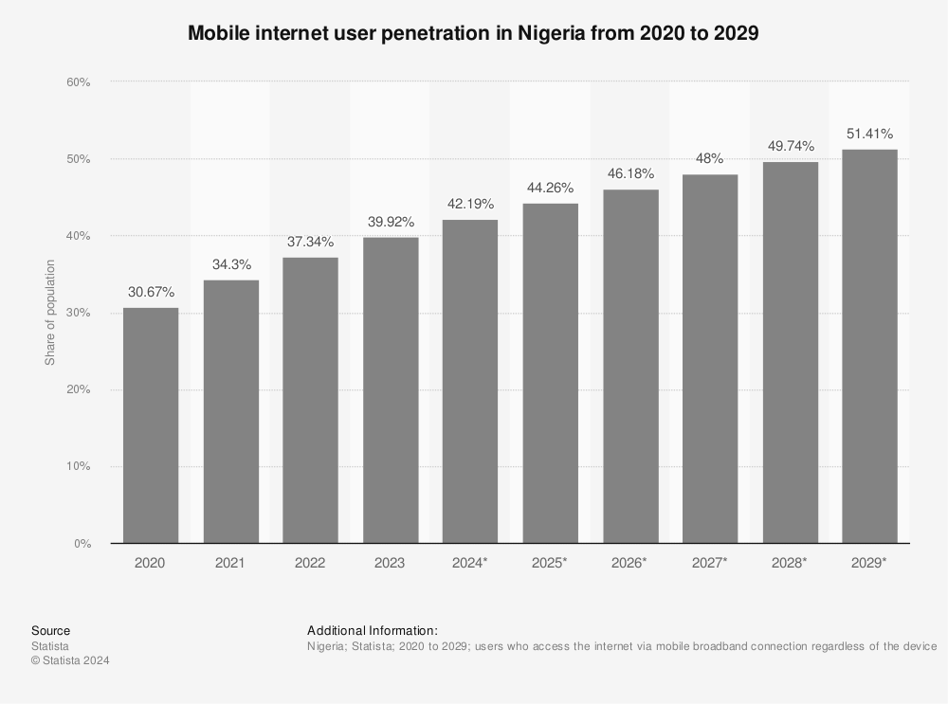
Figure 1: Mobile Internet User Penetration in Nigeria from 2020 to 2029 (Statista, 2024)
Nevertheless, the deployment of AI-tailored recommendation systems in Lagos, Nigeria, is susceptible to challenges because of its intricate economic, social, and technological environment (Oluwadele et al., 2023). This study aims to address these concerns by examining the effectiveness of AI-personalised recommendations on Jumia in Lagos, Nigeria, specifically focusing on how well these systems cater to consumer needs within the local context.

Aims and Objectives
This study aims to evaluate how AI personalised recommendations as a marketing tool affect consumer engagement and satisfaction among Jumia customers in Lagos, Nigeria. The objectives include.
- To examine consumers' perceptions of the effectiveness of AI-driven personalised recommendations on Jumia, with a particular focus on how cultural and economic factors influence these perceptions.
- To examine the challenges encountered by Lagos consumers when interacting with AI-driven personalised recommendations and how these challenges impact customer engagement.
- To assess how AI-personalised recommendations influence customer engagement and satisfaction, particularly by enhancing customer trust, improving personalised experiences, and increasing interaction with the platform.

Scope and Limitations
This research will focus on Jumia customers in Lagos, Nigeria, and investigate the way consumers perceive AI-driven personalised recommendations and its influence on their engagement and satisfaction. The study’s result will be limited to Lagos and may not be applicable to other geographical areas or e-commerce platforms. Furthermore, the process of gathering data would depend on customer surveys, which have the potential to impose biases or constraints in accurately capturing the whole spectrum of consumer experiences. The scope of the study may also be constrained by the respondents' digital literacy levels and their familiarity with AI-driven recommendations.

Research Questions
- How do consumers perceive the effectiveness of AI-driven personalised recommendations on Jumia, considering the influence of cultural and economic factors?
- What challenges do Jumia consumers living in Lagos face when interacting with AI-driven personalised recommendations, and how do these challenges impact customer engagement?
- To what extent do AI-personalised recommendations influence customer engagement and satisfaction by enhancing customer trust, improving personalised experiences, and increasing interaction with the platform?

Significance of the Study
The present study aims to provide significant contributions to the understanding of the role of AI personalised recommendation as a marketing tool and its effectiveness in driving customer engagement and satisfaction in Lagos, Nigeria. By examining Jumia, this research will provide insights into how enhanced AI technologies streamline their operations to better meet local consumer expectations and tackle any AI implementation challenge. Moreover, the study can guide business enterprises operating in emerging markets in formulating strategies to improve consumer satisfaction and loyalty through the effective use of AI-personalised recommendations.

Justification for the Research Question
The research question of this study is justified by the critical and expanding role of AI in shaping consumer experiences and business performance (Nkwo et al., 2018). AI-driven personalisation has been argued in a global context to improve customer engagement and satisfaction by tailoring recommendations to individual preferences, thereby enhancing the precision of marketing efforts and optimising conversion rates (Grewal et al., 2024; Gold et al., 2024). However, the unique cultural and economic context of Lagos, Nigeria, requires an exploration of how these factors influence consumer perceptions and interactions with AI systems (Koetz, 2019; Nkwo et al., 2018).

Chapter 2: Literature Review

Introduction
According to Wawack et al. (2022) and Singh and Daisy (2023), AI-powered personalised recommendation systems are becoming a significant component of the e-commerce sector due to their ability to provide tailored product recommendations, make predictions about consumer behaviour, and segment customers. These AI algorithms use consumer data, including browsing history as well as previous interactions, to recommend products that match the consumer's needs, hence improving both customer engagement and satisfaction (Bawack et al., 2022). These methodologies enable e-commerce platforms to cultivate customer loyalty and stimulate recurring transactions, which are essential elements of an e-commerce marketing strategy (Olson & Levy, 2017; Desai & Sankalpa, 2016). According to Ezennia and Marimuthus (2020), the assessment of AI-personalised recommendations in emerging markets offers a distinct chance to evaluate the difficulties associated with implementing global AI methods within emerging African countries. Factors such as consumer trust, privacy concerns, cultural and economic factors, and the level of digital literacy among consumers may greatly impact the effectiveness of AI-personalised recommendations in this region (Oladoyinbo et al., 2024; Khan & Uwemi, 2018). The objective of this literature review is to evaluate the current research on AI personalised recommendation systems as a marketing tool and their impact on customer engagement and satisfaction.

AI Personalised Recommendation Systems in E-commerce

2.2.1. Overview of AI-Personalised Recommendations
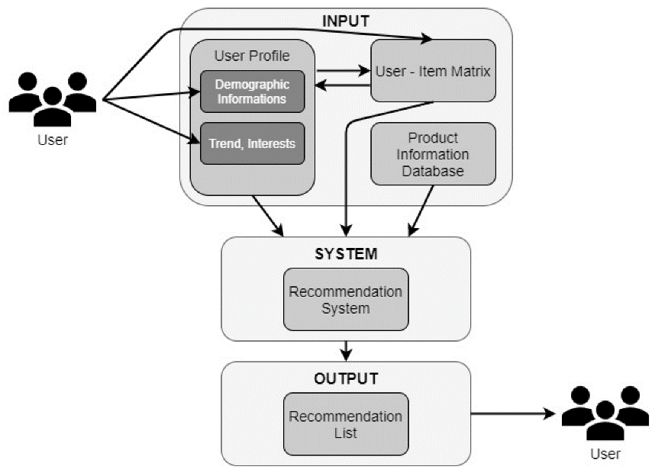
According to Messaoudi and Loukili (2024), personalised product recommendations are developed by AI models gathering demographic data and monitor behavioural patterns to provide a personalised experience for different consumers, with the objective of improving user interaction satisfaction and fostering engagement (Auwal, 2024). AI systems developed these recommendations by implementing machine learning algorithms that align user preferences with the products that are currently accessible, therefore providing a tailored shopping experience (Pardeshi et al., 2023). Raji et al. (2024) contend that implementing this approach allows e-commerce platforms to have the potential to enhance customer satisfaction and stimulate repeat purchases, setting AI personalisation as a highly useful marketing tool. In Figure 2 below, Yıldız et al. (2023) explicates the functioning of an AI-personalised recommendation system by leveraging consumer data, including browsing history purchasing behaviours, as well as user profiles and demographic information.
Figure 2: Basic flowchart of recommendation systems (Yıldız et al., 2023).

2.2.2. Types of AI-Personalisation Techniques
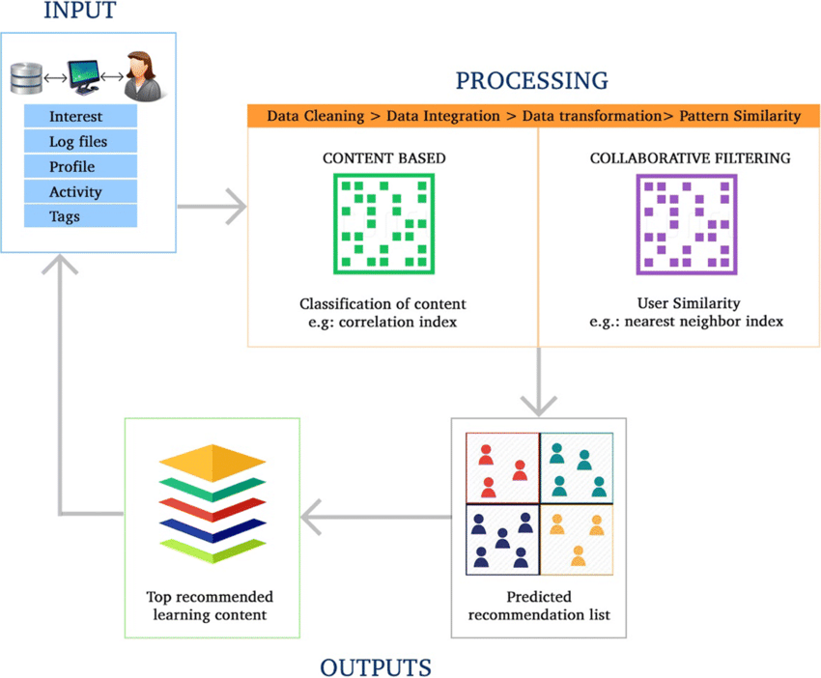
Messaoudi and Loukili (2024) assert that several personalised strategies are frequently employed in the domains of e-commerce, content streaming, and social media communities. Messaoudi and Loukili (2024) identified collaborative filtering, content-based filtering, and hybrid approaches as the three primary recommendation systems used in e-commerce operations. The collaborative filtering technique, as proposed by Necula and Păvăloaia (2023), examines the actions of similar users to provide recommendations. The AI model recommends a product that one user has acquired to another user if both users have previously shown interest in a similar product. This approach is recognised for its effectiveness in increasing consumer engagement through the utilisation of social proof and user likeness (Necula & Păvăloaia, 2023). The personalised AI technique known as content-based filtering leverages individual user data to provide product recommendations (Bashynska, 2023). It offers tailored suggestions for products that align with the user's interests and preferences. Nevertheless, content-based filtering might occasionally generate an “echo chamber phenomenon” by continuously presenting customers with the same specific product, therefore restricting their exposure to a diverse range of products (Bashynska, 2023; Ge et al., 2020). Prakash (2023) suggests that hybrid approaches, which combine collaborative and content-based filtering, offer more precise recommendations by considering both user commonalities and individual preferences together.
Figure 3: System architecture of Hybrid recommendation system (Khanal et al., 2019)
Figure 3 above depicts a hybrid recommendation system process developed by Khanal et al. (2019) that utilises content-based filtering and collaborative filtering techniques to analyse user data such as interest, profiles, log files, activities, and tags. Nevertheless, the implementation of these techniques necessitates significant technological resources and can present difficulties in areas with inadequate infrastructure (Nkwo et al., 2018)

2.2.3. AI-Personalised Recommendations as a Marketing Tool
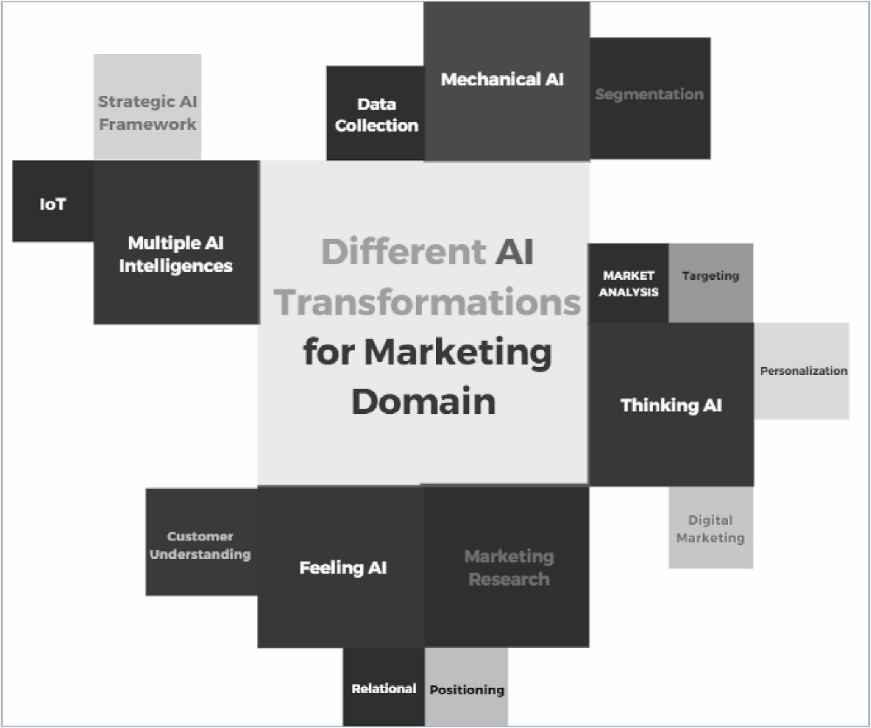
The implementation of data gathering, segmentation, market research, personalisation, customer experience, and strategic AI frameworks has led to significant alterations in the marketing field, as shown in Figure 4 below, based on the studies done by Haleem et al. (2022).
Figure 4: The Application of Artificial Intelligence in Marketing (Haleem et al., 2022)

Haleem et al. (2022) further define AI-personalised recommendation systems as strategic marketing tools in e-commerce that allow firms to move beyond general marketing approaches. To enhance conversion rates and keep customers, e-commerce platforms such as Jumia can utilise real-time behavioural data to provide highly focused product recommendations (Gold et al., 2024; Dung et al., 2022). In contrast to traditional marketing, which often targets a broad demographic, AI personalised marketing strategies for individual consumers, therefore minimising decision fatigue and delivering a smooth shopping experience (Olson & Levy, 2017). According to Olson and Levy (2017), the increase in precision in targeting leads to improved consumer engagement and overall satisfaction. However, Algorithmic biases that arise in AI-personalised systems could affect recommendations, therefore restricting the range of products offered to specific user groups (Nwachukwu, 2023; Nkwo et al., 2018). Furthermore, excessively personalised marketing can occasionally be perceived as intrusive, which may lead customers to view such systems as a violation of their privacy rather than an improvement in service quality(Messaoudi & Loukili, 2024; Patel et al., 2023). According to Nkwo et al. (2018), the integration of AI-powered personalisation recommendations in developing markets should be done with careful attention to ethical concerns and cultural sensitivity (Nyong et al., 2023).

Theoretical Framework
According to Gao et al. (2023) and Na et al. (2022), the integration of consumer behaviour theories into AI-driven personalisation is needed to understand how customers interact with recommendation systems. In Nigeria, where Jumia also operates, the Theory of Planned Behaviour (TPB) and the Technology Acceptance Model (TAM) provide valuable frameworks for understanding the factors influencing consumer engagement and satisfaction with AI-personalised recommendation systems (Oke et al., 2024; Na et al., 2022). According to Nwachukwu and Affen (2023), TPB highlights how attitudes, societal norms, and perceived behaviour control significantly influence consumer decisions, especially in a region where cultural and social dynamics play an essential role in customer acceptance of AI-driven personalisation. However, how these cultural dynamics have been explicitly addressed within the context of AI systems in Lagos, Nigeria needs to be clarified.
The Theory of Planned Behaviour (TPB) has been criticised for oversimplifying consumer interactions—especially in regions such as Africa, where factors such as trust, digital literacy, and economic disparities can heavily influence technology acceptance (Na et al., 2022; Nwachukwu & Affen, 2023; Bashynska, 2023). In contrast, in developed regions with advanced technological infrastructure and high digital literacy, such as the US and Western Europe, consumers typically exhibit higher levels of confidence in AI systems. In some West African countries such as Nigeria and Ghana, Jumia faces the challenge of navigating a framework where consumer trust, data privacy, and economic inequalities are significant obstacles to deploying AI successfully (Khan & Uwemi, 2018; Messaoudia & Loukilic, 2024). Similarly, the Technology Acceptance Model (TAM) provides another important lens for analysing the adoption of AI-personalised recommendations. Bawack et al. (2022) and Oke et al. (2024) argue that TAM offers a useful statistical framework for predicting technology adoption. However, it faces significant constraints in geographical regions in Africa, where technological infrastructure and digital literacy are limited, preventing consumers from interacting with AI-driven systems as effectively as they might in developed regions (Nkwo et al., 2018; Oke et al., 2024). The constraints are driven by insufficient infrastructure, such as unreliable internet connections, which impede the seamless function of AI-personalised recommendations.
Additionally, Nwachukwu (2023) and Raji et al. (2024) suggest that complexity theory provides a valuable perspective, proposing that AI systems operate as adaptive systems whereby various interconnected factors influence their outcomes. In some regions in Africa, such as Nigeria, there are some factors, such as economic inequalities, cultural norms, and technological limitations, that interact in complex ways and have a greater effect on the adoption and effectiveness of AI systems. Therefore, it is imperative to understand local circumstances, which often need to be addressed in the existing theoretical frameworks (Nkwo et al., 2018; Khan & Uwemi, 2018). By focusing specifically on the Lagos context, the research will contribute to the body of knowledge by exploring these complexities in greater depth, highlighting how various local factors shape consumer engagement with AI-personalised recommendations.

AI Personalisation in Emerging Markets
Ifekanandu et al. (2023) emphasise the differences in AI personalisation between industrialised and emerging economies. Figure 5 indicates the projected growth of the global AI market to $2,745B by 2032, indicating an uneven distribution of advantages. Developed nations are expected to benefit more from enhanced infrastructure, while developing countries may have challenges with adopting AI technology (Market.us, 2023).

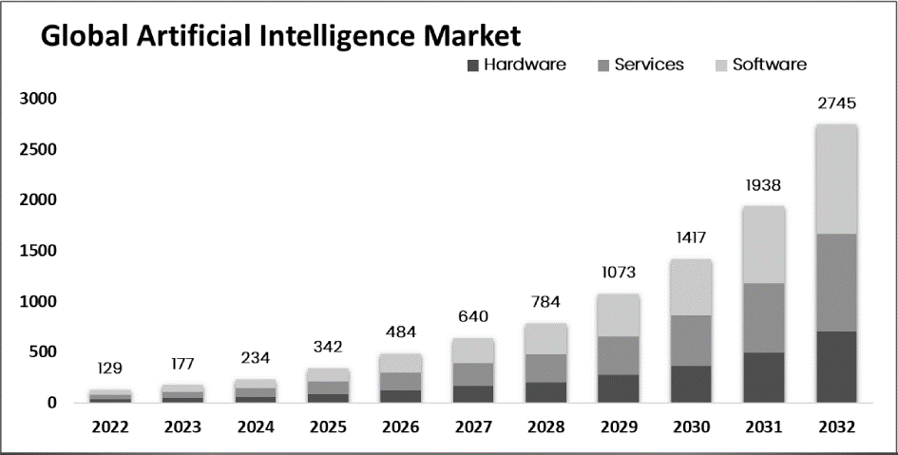
Figure 5: Global Artificial Intelligence Market (Market.us, 2023).
Advanced economies such as the United States and Western Europe incorporate extensive digital engagement, and companies have access to vast datasets, which indicates that the integration of AI personalisation systems can significantly enhance customer satisfaction and increase sales (Gold et al., 2024; Singh & Daisy, 2023). These developed markets encompass well-developed infrastructure and a substantial level of consumer trust in technology (Rajis et al., 2024). This trust enables the integration of AI capabilities into the service provided to intended users (Messaoudi & Loukili, 2024; Raji et al., 2024).
Conversely, Auwal (2024) and Ezennia and Marimuthu (2020) state that emerging places such as Sub-Saharan Africa and South Asia offer a more complicated environment for tailored AI applications. These environments are characterised by various infrastructural and socio-economic challenges that hinder effective AI implementation. Notwithstanding the difficulties, there is an increasing possibility for AI personalisation in these areas. In Nigeria, the effectiveness of AI systems is often hindered by challenges such as poor internet connectivity, limited smartphone usage, and insufficient consumer data (Prakash, 2023; Nguyen & Hsu, 2022). However, while these challenges have been previously identified, the literature has not explored their direct implications on user engagement and satisfaction, specifically on Jumia's platform.
Additionally, Nigeria is made up of people with income inequality, indicating personalised recommendations could unknowingly promote unaffordable products to the people, leading to social disapproval rather than engagement (Amosu et al., 2024; George et al., 2024). This indicates that AI systems must be adaptable to social and economic conditions and user needs based on their socio-status and provide tailored recommendations that cater to individual preferences and financial capacities (Amosu et al., 2024). This indicates an absence of mechanisms to consider the power of purchasing despite utilising purchase history, which may result in inappropriate recommendations and diminished engagement (Amosu et al., 2024). This study will assess how income disparities affect AI recommendation relevance on Jumia in Lagos and evaluate data integration effectiveness in mitigating negative experiences.

AI Impact on Customer Engagement and Satisfaction
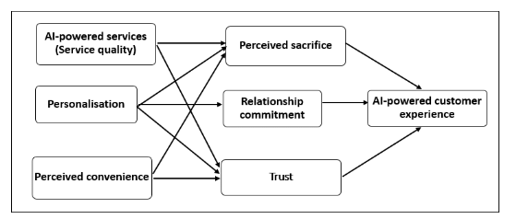
Raji et al. (2024) and Singh & Daisy (2023) state that AI improves the consumer purchasing experience by analysing user behaviour, resulting in effective customer engagement and boosting overall satisfaction. AI personalised recommendation is known to be common in e-commerce companies such as Amazon, eBay, and Jumia, which implemented AI personalised recommendations and AI chatbot models to boost their customer retention and loyalty (Nkwo et al., 2018). Kibandi and Reuben (2019) define customer engagement as the depth and frequency of user interactions with an e-commerce platform. AI-driven personalisation enhances these interactions by recommending products that align with the user’s interests, behaviours, and demographics. However, how these positive effects manifest in the unique socio-economic and cultural context of Lagos provides additional insights into region-specific challenges and opportunities.
Figure 6: An artificial intelligence conceptual model (Trawnih et al., 2022)
Trawnih et al. (2022) developed an AI conceptual model, as depicted in Figure 6 above. The author identified AI-driven services, personalisation, and perceived convenience as the critical elements enhancing customer relationship commitment, trust, and overall experience. Additionally, one of the factors, perceived sacrifice, has a positive influence on service quality, which has resulted in a multifaceted interaction between AI capabilities and customer engagement. For instance, Jumia utilised AI to adjust the content customers view based on their preferences and purchase history (Nkwo et al., 2018). This dynamic personalisation of products and marketing enhances customer engagement by removing obstacles in the buying process, thereby enhancing the user's convenience in finding their desired products (Bashynska, 2023; Nkwo et al., 2018). However, there is a gap in examining whether AI personalisation methods are equally effective across all demographic groups in Lagos, thereby contributing to understanding AI's impact in diverse settings.
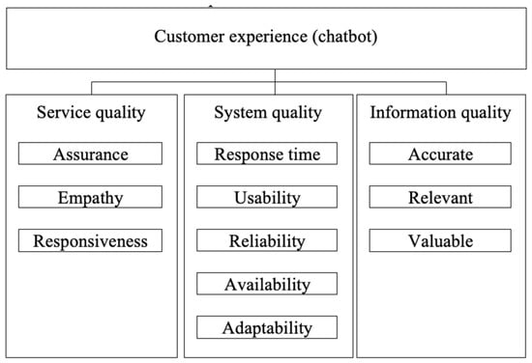
Moreover, AI personalisation improves customer satisfaction by providing products that match individual preferences and interests, thus minimising search time and enhancing the overall shopping experience (Krishnan et al., 2022; Desai & Sankalpa, 2016). According to Bag et al. (2021), when recommendations match customers' preferences and buying behaviour, it boosts the customer's perception of e-commerce and fosters their loyalty. Although the above existing studies consistently highlight these positive impacts, this research aims to critically evaluate the extent of Jumia customer trust in AI recommendations in Lagos.
Figure 7: The application of AI personalised Chatbot on customer experience (Jenneboer et al., 2022)
Based on Jenneboer et al. (2022) research, as depicted in the figure 7 above, the AI-personalised bot has a great effect on customer satisfaction and loyalty through enhanced service quality, system reliability, and information quality. AI personalisation recommendation further enhances the customer experience by offering relevant, personalised recommendations, leading to fast response times. This resulted in long-term customer loyalty by fostering trust and engagement (Jenneboer et al., 2022). Furthermore, Ifekanandu et al. (2023), Trawnih et al. (2022), and Krishnan et al. (2022) argue that AI-driven chatbots have a positive impact on customer satisfaction. However, the primary focus of this study will be to examine how customers in Lagos perceive these benefits uniformly.

Challenges in Implementing AI-Personalisation in Emerging Markets
This section explores the key challenges of AI personalisation in emerging markets based on the theoretical perspective of previous researchers. However, the researcher aims to explore these challenges in practice and contribute an applied perspective to the effectiveness of AI-personalised systems in Lagos.

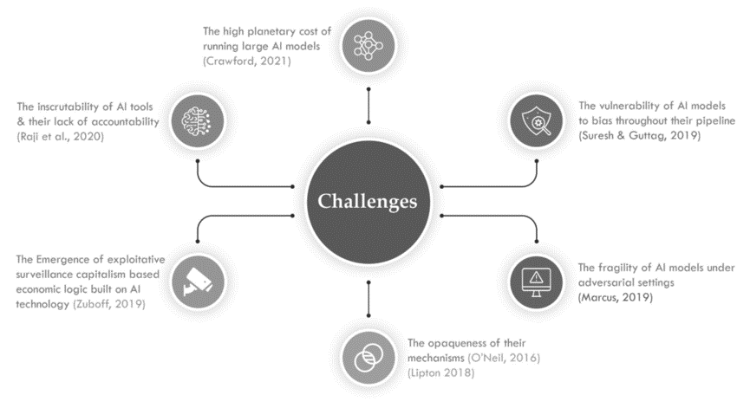
2.6.1 Infrastructure Limitations
Figure 8: Global Challenges and Downsides Associated with AI (Qadir et al., 2022)

Figure 8, developed by Qadir et al. (2022), shows the global challenges that various authors have identified, which include AI model bias, a lack of accountability, high planetary costs, and vulnerability in adversarial settings. However, Roy and Jain (2022) depict that technology infrastructure limitations, unreliable networks, and seamless algorithmic integration will hinder the deployment of AI personalisation systems. Moreover, the technological infrastructure limitation in emerging markets includes poor internet connectivity and network speed, which can prevent the effective functioning and interaction of AI recommendation systems (Gold et al., 2024; Nwachukwu & Affen, 2023; Nkwu et al., 2018). It is imperative to consider infrastructure development through the improvement of network dependability and data storage capabilities to optimise the efficiency of personalised AI recommendations (Messaoudie & Loukilie, 2024).

2.6.2 Cultural Challenges
Ifekanandu et al. (2023) and Adekoya et al. (2024) argue that different cultural practices in developing countries pose a challenge in personalising AI services to meet the specific needs and preferences of individuals. In communal settings, societal norms hold more significance than individual decisions, as AI models depend on large data and may not effectively resonate with consumers that prefer ideas from their society rather than personalised recommendations produced by AI models (Adekoya et al., 2024). Neglecting these preferences may result in AI personalisation systems becoming less relevant to a big segment of the population and facing difficulties in building trust in technology, which is a major challenge that needs to be overcome (Necula & Păvăloaia, 2023).

2.6.3 Privacy Concerns
AI-personalised recommendations have indicated effectiveness in emerging markets, where considerable scepticism towards technology may lead customers to regard these recommendations with fear, particularly if they perceive their privacy to be violated (Nwachukwu, 2023; Nkwo et al., 2018). Singh Daisy (2023) argues that e-commerce platforms should adopt AI technologies that adhere to privacy regulations and provide users with comprehensive descriptions of how their data is utilised. The lack of data protection legislation in emerging economies exacerbates the issue by causing concerns among consumers about privacy and the protection of their data integrity (Raji et al., 2024; George et al., 2024).

2.6.4 Algorithmic Bias and Fairness
Concerns about privacy and ethics, especially data acquisition and utilisation for AI personalised recommendation systems, highlight the potential bias and unfairness in AI algorithms. These biases and unfairness can affect the optimisation of AI recommendations across different segments of emerging markets (Massoud & Loukill, 2024; Varsha, 2023).

2.6.5 Economic Challenges
Economic circumstances directly influence the effectiveness of AI-powered personalised solutions. Individuals in developing economies exhibit a high degree of price sensitivity, which may lead them to disregard product recommendations provided by AI if they are inconsistent with their individual needs (Nwachukwu & Affen, 2023; Prakash, 2023). Given the dynamic nature of markets and economic conditions, AI technology must promptly adapt to align with consumer preferences (Nwachukwu, 2023).

Identification of Literature Gaps
The existing literature on AI personalised recommendation systems primarily focuses on developed markets, while the unique socio-economic and cultural dynamics of Lagos, still need to be explored. Although there is increasing research on AI recommendations in emerging markets, much of it remains regionally general and needs a more specific analysis of Lagos' local context. This gap underscores the need for further research to understand the effectiveness of AI systems in environments characterised by less developed infrastructure, lower digital literacy, and unique consumer expectations (Khan & Uwemi, 2018; Bawack et al., 2022; Singh & Daisy, 2023).
Furthermore, the literature shows a notable scarcity of studies testing established consumer behaviour theories, such as the Theory of Planned Behaviour (TPB) and Technology Acceptance Model (TAM), specifically within Lagos' e-commerce environment. While these theories have been valuable in understanding technology adoption, they have not yet been empirically tested in contexts where infrastructure and cultural dynamics present unique challenges (Na et al., 2022; Oke et al., 2024). Therefore, this study aims to bridge this gap by empirically assessing the applicability of these frameworks in Lagos, Nigeria, providing new insights into how cultural, economic, and infrastructural factors affect AI adoption.
Moreover, while existing studies such as Messaoudi and Loukili (2024) and Raji et al. (2024) suggest positive outcomes for AI-driven personalisation, they often assume that these benefits are uniformly experienced. This research will investigate whether such benefits are perceived consistently by different consumer segments in Lagos, considering factors like socio-economic disparities and digital literacy. Thus, the study will contribute to a nuanced understanding of AI effectiveness in a diverse and challenging context, adding empirical data to support the adaptation of existing theoretical models.

Conclusion
Undertaking field research will yield practical insights for implementing AI-personalised recommendation systems in the African e-commerce industry (Nwachukwu, 2023). This study examines the influence of socio-economic and cultural factors on the effectiveness of AI recommendations in Lagos, Nigeria. This research seeks to enhance comprehension of AI system adaptation for Jumia and similar platforms by assessing consumer perceptions, challenges, and effects on consumer trust, engagement, and personalised experiences. This literature study will contribute to the methodology presented in the next chapter, ensuring a systematic approach to investigating these mechanisms.

Chapter 3: Methodology
This methodology section outlines the systematic approach employed in this research to ensure the validity and reliability of findings (Creswell & Plano, 2018). Utilised a mixed-methods design, data collection involved structured surveys and in-depth interviews, with ethical considerations ensuring informed consent and confidentiality.

3.1. Research Philosophy and Approach

3.1.1. Pragmatism
The research was grounded in pragmatism, indicating the practical application of research findings and the necessity of addressing real-world problems. This pragmatism aligned with the mixed-method approach by enabling flexibility in selecting the right methods to address the research questions (Nowell et al., 2017; Fadeyi, 2024). By integrating both approaches, this study aimed to derive findings that are not only theoretically valuable but also directly applicable to improving AI-personalisation strategies of Jumia and other e-commerce platforms as well as sectors like digital marketing and online retail, where customer engagement and customised experiences are vital for business performance.

3.1.2. Inductive and Deductive Approach
The research utilised both inductive and deductive approaches to offer an in-depth understanding of consumer engagement and satisfaction with AI personalisation. The inductive approach was particularly applied in the qualitative analysis to derive themes and patterns from the data collected. This approach is suitable for exploring new areas of inquiry where existing theories may need to fully capture the nuances of consumer engagement and satisfaction in the context of AI personalisation (Fadeyi, 2024). These qualitative findings informed the hypotheses tested through the deductive approach in the quantitative phase, enabling the validation of identified patterns and relationships with statistical evidence (Fadeyi, 2024). This combined approach is particularly appropriate for addressing the research aims because it allows a broader understanding of how AI-driven personalisation can influence consumer satisfaction and engagement, not only within Jumia but also in similar contexts, thereby ensuring the research provides both specific and generalisable insights (Johnson & Onwuegbuzie, 2004; Nguyen et al., 2023).

3.2. Research Strategy

3.2.1 The Case Study Method
The case study was employed to foster an in-depth examination of the research within the specific context of Jumia and Lagos in Nigeria. These allowed an extensive exploration of the complexities and nuances of consumer interactions with AI-driven recommendations, capturing quality quantitative and qualitative data that other methods may overlook.

3.2.2 Data Sources
This study employed a primary source of data collection. Primary data will be gathered through structured questionnaires and open-ended questions directed at Jumia customers, enabling the capture of firsthand experiences and perceptions regarding AI personalisation (Bawack et al., 2022).

3.3. Research Design
This study adopted a mixed-method research design by incorporating both quantitative and qualitative approaches to provide a comprehensive understanding of the research problem. The quantitative component involved the collection of numerical data through structured questionnaires, which allowed the researcher to measure variables such as customer satisfaction, engagement, and perception of AI personalisation (Tashakkori & Teddlie, 2010). The qualitative aspect included open-ended questions to gather in-depth insights from participants, which allowed the participants to express their personal experiences, challenges, and perceptions in detail. This method provided the opportunities to uncover insights that may not be fully captured by quantitative data alone, such as emotional responses and unique personal interactions with AI technologies (Tashakkori & Teddlie, 2010; Creswell & Plano Clark, 2018). Moreover, this design allowed for triangulation of data, which enhanced the validity and reliability of the findings. The adoption of both methods was particularly beneficial in exploring complex phenomena such as consumer behaviour and satisfaction, where statistical trends and personal narratives were essential for a comprehensive understanding (Ayomipo, 2024). The research questions were evaluated by researchers using a mixed-method approach, which allowed for a detailed investigation of quantitative elements such as engagement levels and provided qualitative insights into customer experiences. This allowed for a more nuanced understanding of how customer satisfaction was impacted by AI-personalised recommendations across various consumer segments in Lagos, Nigeria (Mazhar et al., 2021).

3.4. Data Collection Methods

3.4.1 Quantitative Data Collection
The researcher developed a structured questionnaire to collect quantitative data from Jumia customers in Lagos. Quantitative data was gathered using structured questionnaires, which will assess key metrics such as customer engagement, satisfaction, and overall perceptions of AI-driven personalised recommendations. The Likert scale was employed to quantify the participant response, which enables the statistical analysis of the data. The participants were Jumia customers in Lagos, selected through a stratified random sampling method to ensure comprehensive representation across key demographic groups (e.g., age, gender, and income levels). The distribution of participants across demographic categories closely mirrored the actual demographic breakdown of Jumia's consumer base in Lagos. This approach enhanced the generalisability of the findings across various segments of Jumia’s customer base. Before the data collection, the questionnaire was pilot-tested with 10 Jumia consumers to ensure clarity, relevance, and effectiveness before full deployment. Their participation led to some rephrasing of some questions to make them more straightforward and some adjustments of response alternatives to better reflect local consumer experiences(Mazhar et al., 2021).

3.4.2 Qualitative Data Collection
The questionnaire (see Appendix 5) included open-ended questions in addition to closed-ended questions to capture qualitative insights from participants. The questions developed allowed the respondent to share their opinion based on their experience with AI personalised recommendations, including perceived benefits, challenges, and suggestions for improvement. Qualitative data was collected through open-ended questions embedded within the same questionnaire. These questions provided participants with the opportunity to express their opinions and share personal experiences in their own words (Nowell et al., 2017). This method allowed a deeper understanding of the challenges, perceptions, and potential benefits of AI personalisation systems, offering richer insights that may not be fully captured through quantitative measures alone (Nguyen et al., 2023). This qualitative component is essential for gaining insights into the emotional and cognitive responses of consumers to AI personalisation (Nowell et al., 2017).

3.5. Sampling Strategy
A stratified random sampling method has been employed to ensure the collection of samples from various demographic groups of Jumia customers within Lagos. The strata were determined by criteria including age, gender, income level, and digital literacy, facilitating a more precise representation of these groupings. This strategy was selected to enhance the generalisability of the findings to the broader population (Dillman et al., 2020). A sample size of 195 respondents was selected to match practical problems with statistical validity. A minimum of 195 respondents is typically adequate for exploratory studies in urban populations such as Lagos because it allows preliminary insights while ensuring a feasible scope (Braun & Clarke, 2013). Moreover, targeting up to 195 respondents guarantees a more accurate margin of error and improves the reliability of the findings (Nguyen et al., 2021). According to Etikan et al. (2016), the implementation of the stratified random sample technique guarantees sufficient representation of critical demographic categories, which is vital for deriving generalisable results (Braun & Clarke, 2013). The selected sample size of 195 respondents was determined based on statistical procedures to ensure a 95% confidence level with a 5% margin of error for reliable results. This sample size is considered adequate for diverse populations like Lagos to generate generalisable insights (Fadeyi, 2024).

3.6. Data Analysis Methods

3.6.1. Quantitative Data Analysis
Quantitative data were analysed using Microsoft Excel for data organisation and descriptive statistics. At the same time, Python programming and Jupyter Notebook (utilising libraries such as Pandas, NumPy, Matplotlib, Seaborn, SciPy, and Statsmodels) were employed for advanced statistical analysis and data visualisation (see Appendix 3). The exploratory data analysis approaches, including univariate, bivariate, and multivariate analyses, were employed to provide descriptive statistics. These analyses effectively summarised the demographic characteristics of respondents and their responses to the closed-ended questions, offering a comprehensive overview of the dataset's foundational trends and patterns. Inferential statistics, such as correlation, regression analyses, Anova and Manova, were employed using scipy.stats to examine the relationships between AI-personalised recommendations, customer engagement, and satisfaction. This statistical analysis will allow for the identification of significant predictors of customer satisfaction and engagement, providing insights into the effectiveness of AI personalisation strategies (Patel, 2023).

3.6.2. Qualitative Data Analysis
The qualitative data were analysed using a thematic analysis with the six-step process, which includes familiarisation with the data collected, generating initial codes, searching for themes, reviewing themes, defining and naming themes, and producing the final report (Mogaji et al., 2020). This analysis utilised Python tools and libraries such as pandas, re, nltk, CountVectorizer, WordCloud and so on (See Appendix 3 and 4). This method allowed the identification of key themes and patterns in participants' responses, providing valuable insights into their experiences with AI-personalised recommendations. The thematic analysis enabled the researcher to explore the complexities of consumer perceptions and behaviours, offering a nuanced understanding of the impact of AI personalisation (Nowell et al. (2017; Creswell & Plano Clark, 2018)

3.7. Ethical Considerations
Ethical considerations were paramount throughout the research process. Informed consent was embedded at the beginning of the questionnaire (see Appendix 5), where participants were required to agree or disagree to participate before proceeding with the survey. Confidentiality and anonymity were maintained by assigning unique identifiers to each respondent, and all data were securely stored on a password-protected computer system, ensuring participant privacy. Ethical approval was sought and granted by the Lancashire School of Business and Enterprise (SOBUS), under the supervision of Ruth Bavin, before the commencement of data collection (see Appendix 2). The study adhered to the ethical guidelines set by the British Psychological Society (BPS, 2021) to ensure that participants' rights and well-being were prioritised. This involves protecting participants from harm, permitting them to enquire, and offering the ultimate option to withdraw at any point during the research process (Papić, 2023).

3.8. Limitations of the Study
The research conducted heavily depended on participants' self-reported data, which has the possibility of containing biases or recollections that are only partially accurate. Furthermore, the results' application to other areas or e-commerce platforms is limited by the researcher's attention to Jumia customers in Lagos. Another limitation that is considered paramount is the rapid growth of AI technology, which may further impact the applicability of the study. Moreover, the conclusions' depth and generalisability could be influenced by the sample size being limited by time and resource limitations. Finally, evaluating the long-term impacts of AI-personalised recommendations on customer behaviour is difficult due to the need for longitudinal data.

4.0 Chapter 4: Data Analysis and Findings

4.1 Overview
This chapter highlights the data analysis and findings from the evaluation of the effects of AI-driven personalisation on consumer engagement and satisfaction on the Jumia platform in Lagos, Nigeria. The survey yielded 195 participants, and it was structured to provide a comprehensive evaluation of both the qualitative and quantitative data gathered, including demographic insights and hypothesis testing.

4.2 Data Preparation
Based on established best practices, the data preparation method started with a preliminary analysis and organisation in Excel to comprehend the information and detect missing values (Davenport et al., 2019; Dillman et al., 2014). Missing values in non-essential variables were filled in using mean replacement, whilst significant errors were removed to preserve statistical validity. The initial data cleaning and transformation were performed in Python using Jupyter Notebook to ensure appropriate data manipulation. Moreover, some vital features, including categorical variables, were converted into numerical scales for statistical analysis, while ordinal variables were carefully standardised to ensure consistency and accuracy. According to Mazhar et al. (2012), the methodological approach facilitated thorough data analysis to achieve a comprehensive investigation of Jumia's customer perception of AI personalisation.

4.3. Exploratory Data Analysis
Mohan et al. (2024) asserts that exploratory Data Analysis (EDA), such as Univariate, Bivariate and Multivariate Analysis, is a statistical methodology employed to summarise and visualise data to reveal patterns, trends, and anomalies. Table 1 provides a summary of the key statistical insights from the survey data collected.

4.3.1. Statistical Summary
Table 1 below represents the statistical summary of the data collected from the respondents.

Table 1: Statistical Summary of the Key Variables

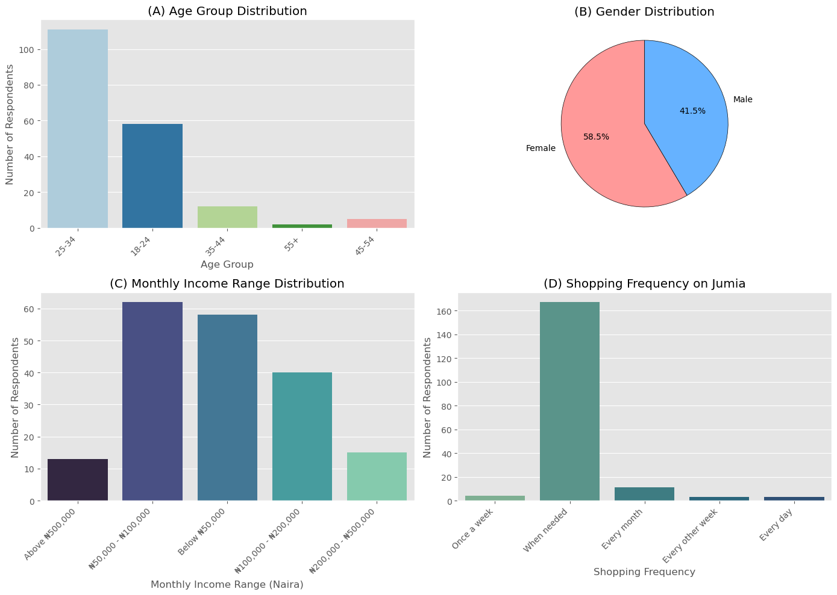
4.3.2. Univariate analysis

Figure 9: The Demographic Composition of Jumia Respondents
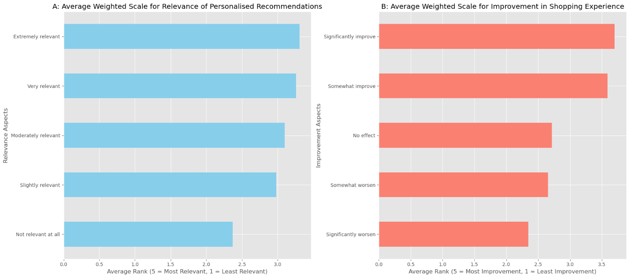
Figure 9a illustrates that the predominant demographic consists of younger users (ages 25–34), validating Bananda and Nwagwu's (2021) findings that tech-savvy individuals are the majority in Nigeria's e-commerce sector. Figure 9b shows a 58.6% female majority, aligning with research indicating an increasing engagement of women in online buying. Figure 9c illustrates a predominance of middle-income individuals (₦50,000–₦100,000), supporting Adekoya et al. (2024), which underscores the significance of affordability in engagement. Figure 9d illustrates "when needed" shopping, aligning with George et al. (2024), which argues that loyalty programs stimulate recurring purchases.
Figure 10: Consumers' Perceptions Regarding the Significance and Influence of Personalised Recommendations
Figure 10a indicates that 75% of respondents categorised recommendations as "extremely relevant" or "very relevant," which is consistent with the findings of Ifekanandu et al. (2023), highlighting the significance of relevance in engagement. Figure 10b indicates that 68% of respondents assumed recommendations improved purchasing behaviour, whereas 12% reported "no effect," underscoring varied expectations and the necessity for enhancement.

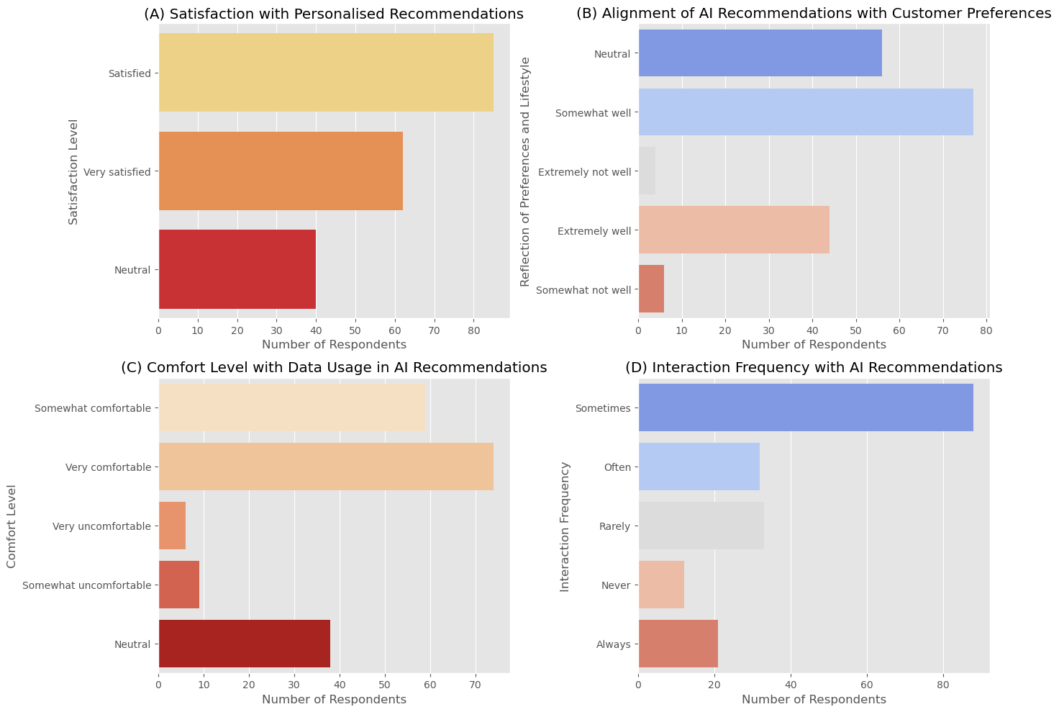
Figure 11: Respondents' Levels of Satisfaction Regarding AI Recommendations
Figure 11a indicates that 78% of respondents reported being "satisfied" or "very satisfied," which is consistent with the findings of Ifekanandu et al. (2023), which emphasise the importance of relevance in determining satisfaction levels. Figure 11b indicates that 62% of respondents perceived the recommendations aligned "extremely well" or "somewhat well" with their preferences, demonstrating the effectiveness of AI. Figure 11c indicates a 30% level of discomfort regarding data usage, aligning with the findings of Gold et al. (2024), which link privacy concerns with barriers to AI adoption. Figure 11d indicates that only 20% of users "always" or "often" interact with recommendations, indicating that Jumia has the potential to enhance relevance to increase engagement.
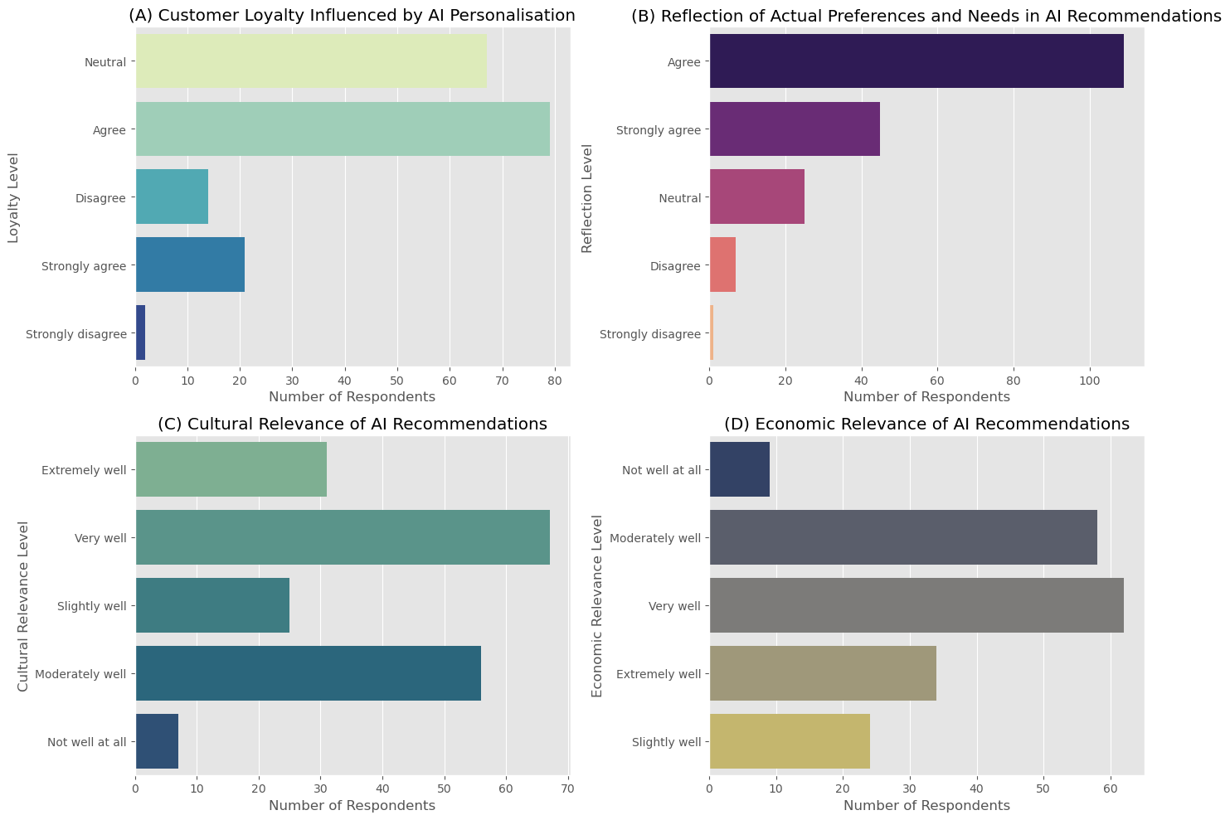
Figure 12: Participants Perception Pertaining to Loyalty, Preference, Cultural and Economics
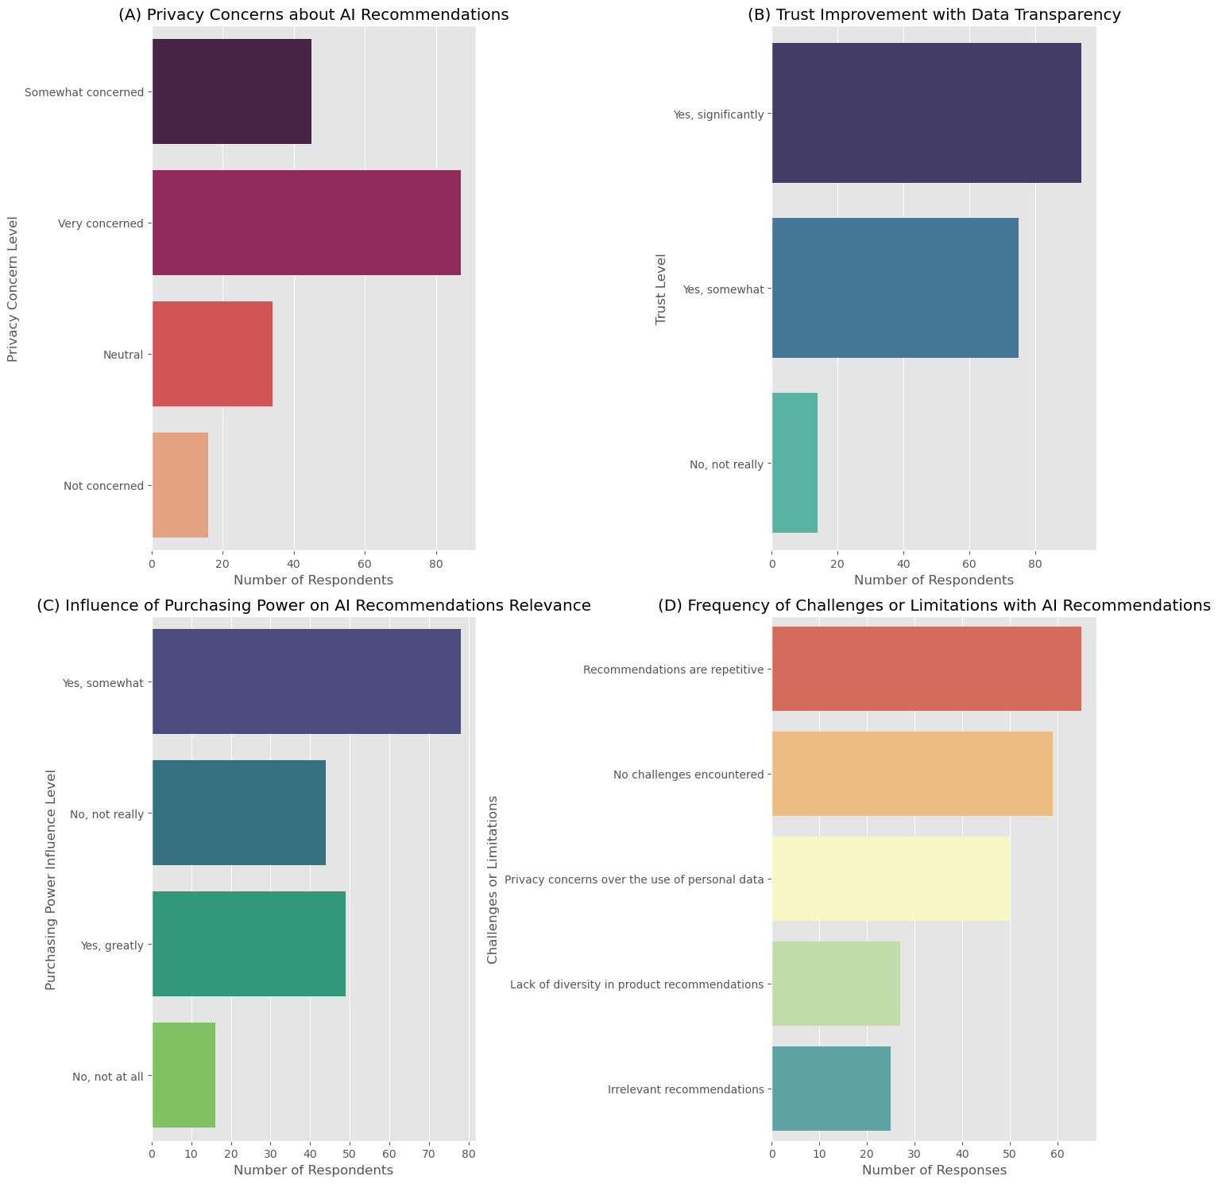
Figure 12a shows that 68% of respondents agreed or strongly agreed that AI personalisation enhances loyalty, aligning with the findings of Grewal et al. (2020), which indicate that personalised marketing reinforces brand loyalty. Figure 12b indicates that 75% of respondents perceive the recommendations as consistent with their preferences. Based on Figure 12c and Figure 12d, only 60% of respondents considered AI culturally or economically significant. This finding aligns with Brobbey et al. (2021), which underlines the need for culturally sensitive changes to effectively serve Nigeria's diverse population.
Figure 13: Analysis of Respondents' Privacy Concerns, Trust in Data Transparency, Purchasing Power, and Challenges Associated with AI Recommendations
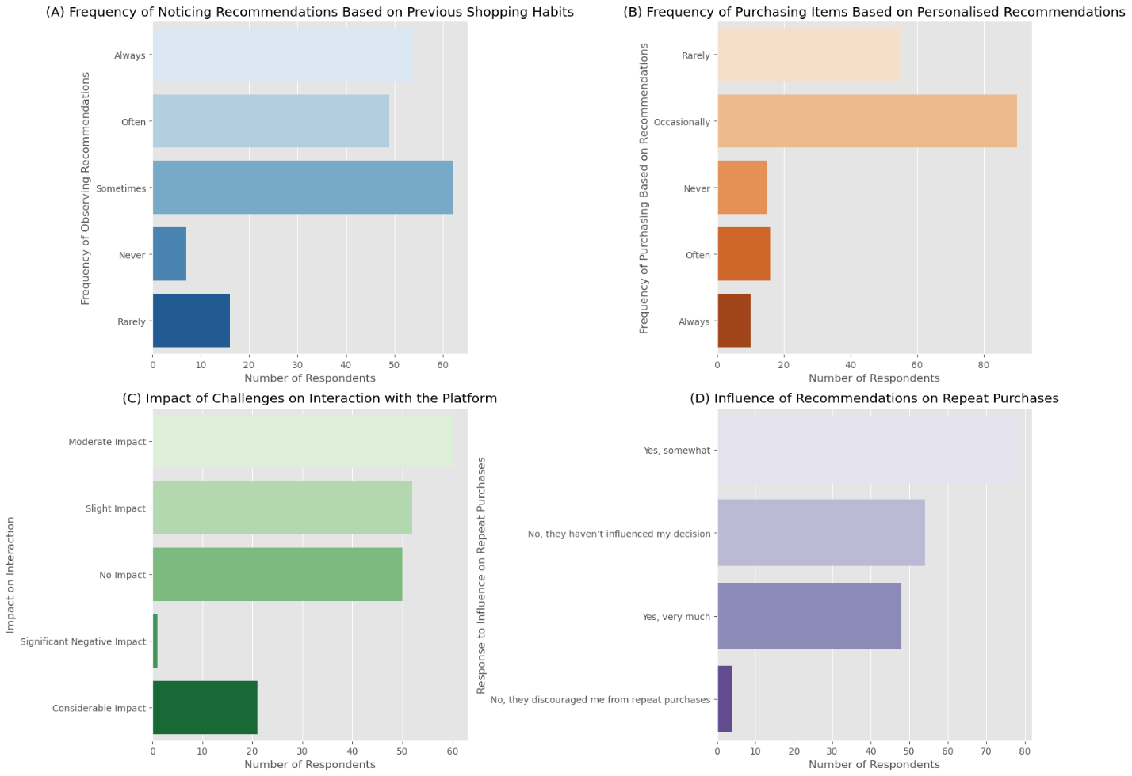
Figure 13a shows that 65% expressed significant privacy concerns. According to Gold et al. (2024), data sensitivity is considered extremely important in AI. Figure 13b reveals that 72% reported increased trust with transparency, which is crucial for Jumia’s AI. Figure 13c indicates that 60% found purchasing power influenced relevance, aligning with Brobbey et al. (2021), advocating adjustments for economic inequities. Figure 13d shows 45% noted repetitive recommendations, supporting Ifekanandu et al. (2023) on the need for diversity to reduce fatigue.

Figure 14: Analysis of User Interaction, Shopping Habits and Repeat Purchases
Figure 14a indicates that 65% of respondents often observe personalised recommendations derived from their previous shopping behaviours. Figure 14b indicates that 55% of individuals occasionally make purchases based on these recommendations. Figure 14c shows that 40% of respondents indicate a moderate impact of challenges on their interaction with the platform. In Figure 14d, 60% of respondents agree that recommendations have a significant impact on repeat purchases.

4.3.3. Bivariate Analysis
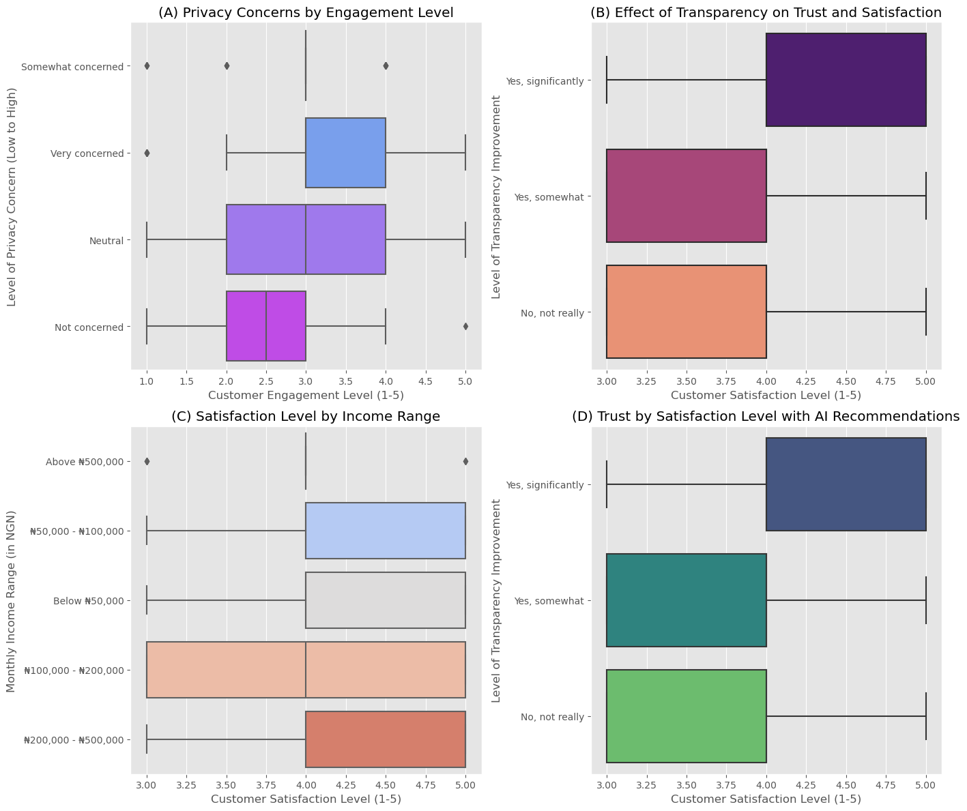
Figure 15: The Interplay of Privacy Concerns, Transparency, Trust, And Satisfaction with AI Recommendations
Figure 15a shows that 60% of respondents are "somewhat concerned" or "very concerned" about privacy, aligning with Gold et al. (2024), which highlighted the significant impact of privacy concerns on user interaction with AI in emerging markets like Nigeria. Figure 15b indicates that 75% of respondents indicate enhanced trust due to transparency, supporting the argument made by Gao et al. (2023) that transparent AI processes cultivate increased consumer trust. Figure 15c demonstrates uniform satisfaction levels across income brackets, with 70% expressing satisfaction. Brobbey et al. (2021) emphasise the necessity of considering economic diversity in AI. Figure 15d illustrates that transparency enhances trust. According to Raji et al.(2024), perceived control and transparency bolster user engagement.
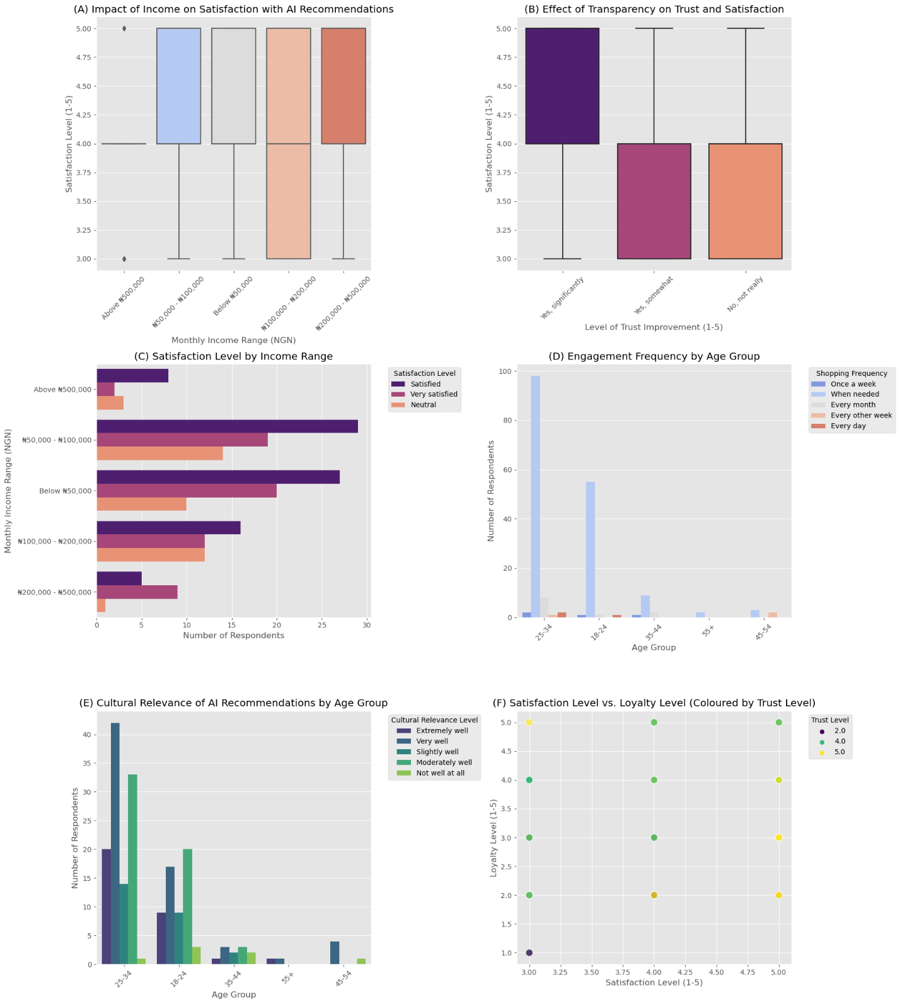
Figure 16: The Influence of Income, Trust, And Cultural Relevance on Satisfaction with AI Recommendations

Figure 16a shows that higher-income groups report slightly higher satisfaction, suggesting that economic capacity enhances the perceived value of AI. According to Ifekanandu et al. (2023), there is a connection between higher income and increased engagement with personalised AI. Figure 16b validates that transparency improves satisfaction, which aligns with Gao et al. (2023), which highlighted the importance of transparency in fostering trust. Figure 16e shows that individuals aged 25-34 exhibit significant cultural alignment with AI recommendations, as noted by Oluwadele et al. (2023). Figure 16f demonstrates a positive correlation between satisfaction, loyalty, and trust, thereby reinforcing the connection between satisfaction and user loyalty.

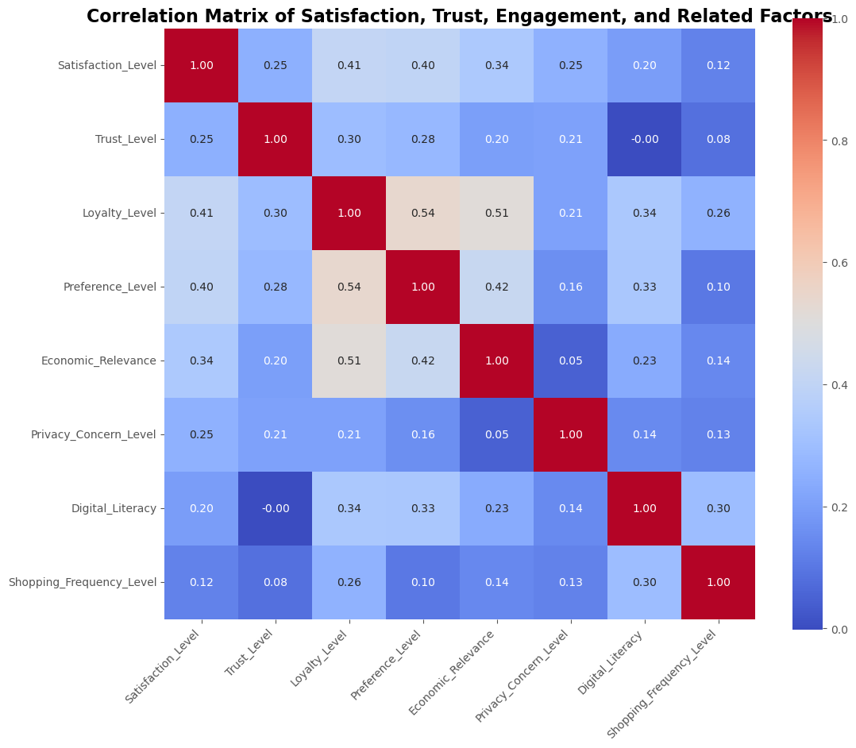
4.3.4. Multivariate analysis

Figure 17: Correlation Matrix for Key Variables
In Figure 17, Users whose preferences align with AI recommendations are more likely to be loyal, according to a positive correlation of 0.54 between loyalty and preference levels. A moderate connection is indicated by the 0.41 correlation between loyalty and satisfaction. This supports the theory that satisfaction enhances loyalty, according to Adekoya et al. (2024), which assert that customer satisfaction significantly impacts loyalty in AI systems. The correlation of 0.3 between trust and loyalty underscores the importance of trust in promoting loyalty.

4.4. Hypothesis Testing

4.4.1. Hypotheses and Corresponding Tests
Table 2 summarises the hypotheses, theoretical frameworks, test statistics, p-values, methodologies, and acceptance/rejection status. Table 2 identifies which hypotheses were supported by the data and which were not, highlighting significant relationships and areas for further exploration in the context of AI-driven personalisation.
Table 2: Hypothesis Testing Summary

4.4.2. Results of Hypothesis Testing
Table 3 analyses the hypothesis, highlighting the complex relationships between various factors influencing the effectiveness of AI personalisation on Jumia.
Table 3: Hypothesis Results
In Summary, Trust and privacy concerns significantly influence user engagement. Gold et al. (2024) emphasise that privacy issues hinder interaction, underscoring the necessity for transparency. Economic factors influence user satisfaction, with higher-income individuals reporting greater satisfaction, thereby reinforcing the argument made by Brobbey et al. (2021) regarding the need to address economic diversity. Transparency enhances trust and satisfaction, as emphasised by Gao et al. (2023), highlighting its significance in AI systems. These insights indicate that Jumia should prioritise privacy, economic inclusivity, and transparency to improve personalisation.

4.4. Thematic Analysis of Qualitative Data
According to Braun and Clarke (2006), thematic analysis serves to identify and interpret patterns within qualitative data. In the context of this research, it facilitates a comprehensive understanding of customer feedback regarding AI recommendations on the Jumia platform.

4.4.1. Key Themes and Subthemes
Table 4 and Figure 18 below illustrate the key themes, subthemes, and word clouds derived from qualitative feedback on AI recommendations regarding consumer concerns, suggested improvements, and additional comments, along with a critical analysis of each theme using findings and Figure 18.

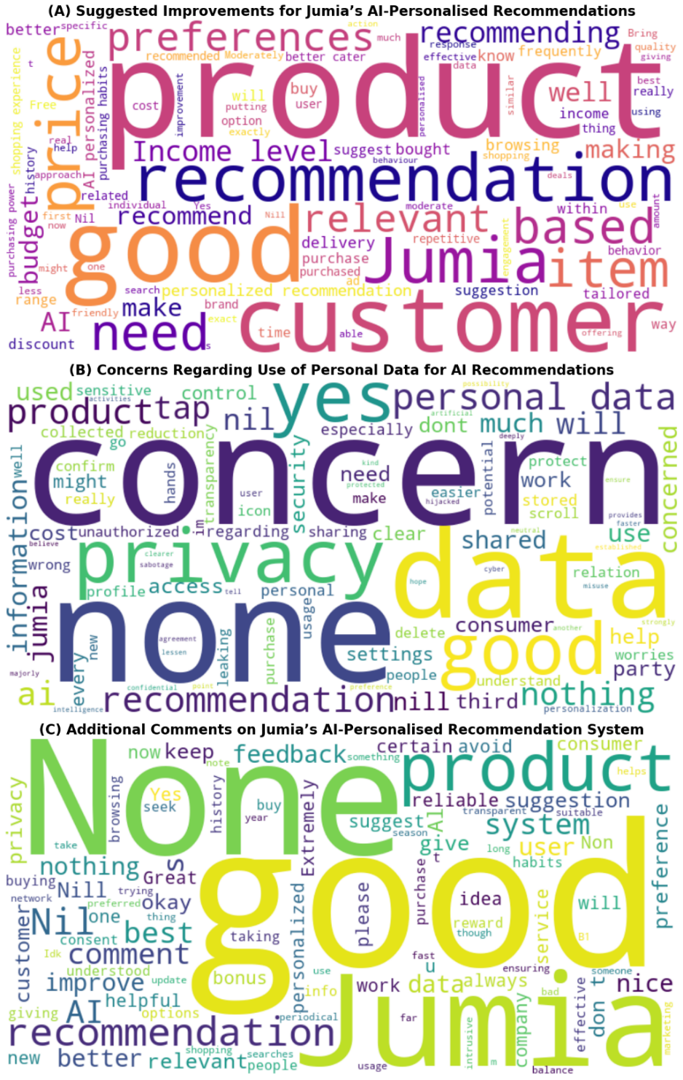
Figure 18:Wordcloud of Suggested improvement, Privacy concerns, and Additional comments

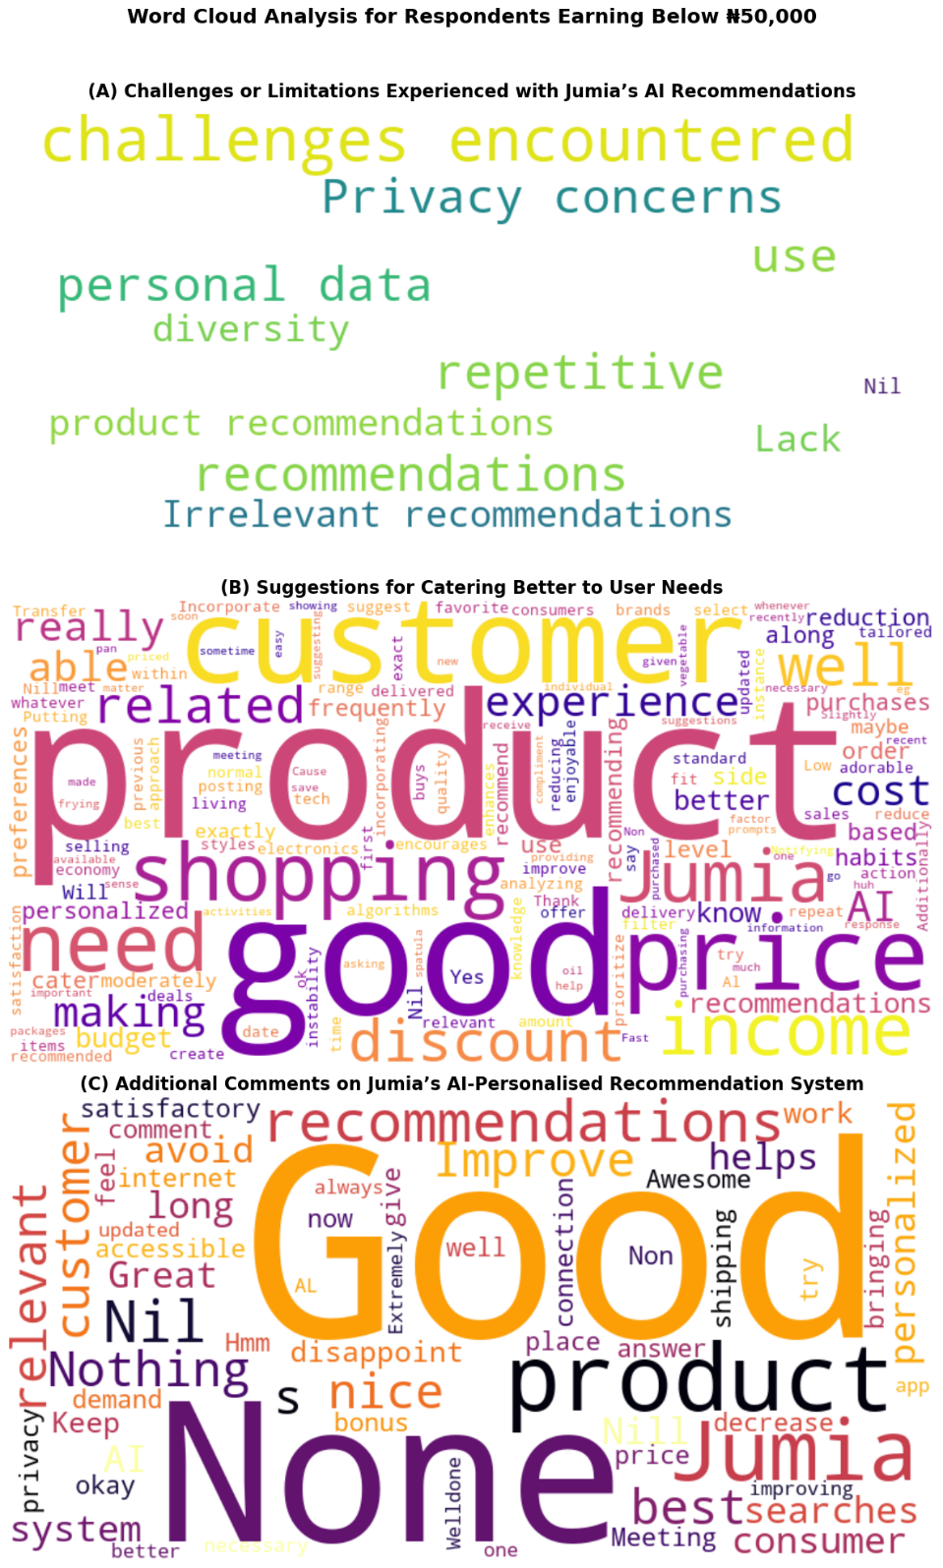
Figure 19: Wordcloud of Suggested improvement, Privacy concerns, and Additional comments for Respondents earning below #50,000

Table 4: Key Themes and Subthemes

5. Discussion

5.1. Overview of AI Personalisation Benefits and Drawbacks
The findings (Figure 9a) show that Jumia's AI-driven recommendations positively influence engagement and satisfaction among younger, tech-savvy users, thus supporting hypotheses H1 and H2. However, they are less effective for older or less digitally proficient demographics. Figure 11a confirmed that younger respondents (aged 25–34) were significantly more satisfied with recommendations, with 68% categorising them as "very satisfied" or "satisfied." Conversely, merely 42% of older respondents (35+) indicated comparable satisfaction levels, highlighting the limited reach of Jumia's AI systems across different demographics (see Figure 16e).
This corresponds with the perceived significance of recommendations, indicating a greater affirmative reaction among younger populations (see Figure 10a). Gao et al. (2023) contend that younger users exhibit a greater tendency to engage with AI, attributable to their experience with digital tools. Bananda and Nwagwu (2021) assert that elevated digital literacy in younger demographics enhances the implementation of customised systems inside Nigeria's e-commerce sector. Certain respondents’ opinions (see Table 4) expressed irritation over the non-intuitive nature of Jumia's interface, validating Auwal (2024), which emphasised that platforms aimed at emerging markets must prioritise accessibility for all age demographics. Moreover, repeat purchases (Figure 14a) were identified as a significant factor influencing satisfaction among younger users, with more than 45 respondents, which shows that tailored recommendations helped their decision-making process. According to Ifekanandu et al. (2023), AI-driven repeat purchase patterns improve customer satisfaction when effectively included in recommendation systems. The correlation matrix (Figure 17) reinforces this by indicating a robust positive association (r = 0.54) between satisfaction and loyalty.

5.2. Economic Disparities in AI Personalisation
The findings showed that consumers with higher incomes were more satisfied with Jumia's AI recommendations than those with lower incomes, emphasising economic inequities as a significant factor, thus supporting Hypothesis H4 (Figure 16c). This indicates that 60% of respondents earning more than ₦100,000 per month consider recommendations as "satisfied" or "highly satisfied," while only 30% of respondents earning less than ₦50,000 reported similar levels of satisfaction. This suggests that Jumia's algorithms do not adequately take economic diversity into account, which reduces their applicability to price-conscious consumers. The relationship between the perceived cultural significance of AI recommendations and income levels (Figures 12c, 12d) also shows that respondents with higher incomes are more satisfied with personalised products than those with lower incomes. Brobbey et al. (2021) emphasise that economic inclusivity is essential for the significance of AI systems in emerging markets, particularly in environments marked by considerable income inequality. Adekoya et al. (2024) emphasise the importance of socio-economic factors in shaping consumer interaction with AI technologies. The qualitative data (see Figure 19) reinforces these findings, with respondents from lower-income groups often describing the recommendations as "not really relevant," underscoring a gap between product pricing and consumer purchasing power. The lack of price-filtering mechanisms in Jumia's AI system intensifies this disparity. Respondents often indicated that AI ought to emphasise cost-effective options, promotional discounts, or bundles aligned with their income levels. Papić (2023) emphasises the necessity of integrating economic factors into personalised systems in developing regions to promote inclusivity.

5.3. Digital Literacy and Accessibility Barriers
Figure 11d indicates that respondents engage more regularly with AI recommendations, especially those classified as "Sometimes" or "Often," are likely to possess greater digital literacy. These users exhibit a greater tendency to engage with AI, indicating a stronger acceptance of AI technology. This supports Hypothesis H6, indicating that people with elevated digital literacy demonstrate increased acceptance and trust in AI-generated recommendations. However, Figure 18 underscored this issue, with participant responses often referencing themes such as 'confusing' interfaces, 'unnecessary' features, and 'irrelevant recommendations,' which users recognised as substantial barriers to enhancing the overall user experience and AI effectiveness. Gold et al. (2024) contend that inadequate digital literacy obstructs the adoption of AI systems and exacerbates user mistrust, especially in emerging markets. Bananda and Nwagwu (2021) discovered that intricate e-commerce platforms were often difficult for Nigerian users with low technological proficiency to navigate, which resulted in disengagement. Ifekanandu et al. (2023) emphasise the need for user-friendly designs that improve engagement to overcome these challenges.

5.4. Cultural Sensitivity and AI Alignment
Hypothesis H3 (see Table 3) was rejected even though 70% of respondents expressed satisfaction with Jumia's AI cultural alignment (see Figure 12C). H3 failed to achieve statistical significance, indicating an absence of a considerable impact of cultural factors on consumer engagement. This result diverges from Figure 18, in which users indicated a preference for more localised recommendations, particularly for "preferences," "suitable," "consumer behaviour," and "relevant" (see Figure 18). Papić (2023) emphasises that culturally insensitive AI systems may alienate consumers in diverse markets. Participants in this study reported that recommendations frequently appeared to be "generic" and without relevance to local contexts (Figure 18). The significance of cultural alignment is illustrated in Figure 17, which shows a moderate positive correlation (0.33) between satisfaction and cultural relevance. According to Oladoyinbo et al. (2024), the relevance and effectiveness of AI recommendations are enhanced by the inclusion of cultural indicators, such as local festivals, language preferences, and region-specific products. Gao et al. (2023) and Adekoya et al. (2024) underline how cultural sensitivity builds trust and promotes ongoing customer interactions.

5.5. Privacy Concerns and Trust
Privacy concerns were identified as a crucial factor influencing confidence in Jumia's AI system. Figure 13a shows that 58% of respondents expressed worries about data privacy; however, 75% of those that viewed Jumia's data policies as transparent reported greater confidence and engagement (see Figure 13b). The findings substantiate the acceptance of hypothesis H11 while rejecting hypothesis H10, indicating that privacy concerns and the perceived control individuals have over their data play a substantial role in shaping user engagement. In contrast, the data reveals that trust does not exert a significant influence on user engagement within Jumia’s AI system, as illustrated in Table 2.
Moreover, Figure 18b highlights concerns regarding the use of personal data for AI recommendations, revealing key themes such as "concern," "privacy," "data," and "security," indicating significant unease regarding the handling of personal information. Additionally, terms like "unauthorised access," "leaking," and "confidentiality" suggest that users worry about the potential misuse of their data. According to Gao et al. (2023), transparency is essential for fostering confidence in AI systems. Adekoya et al. (2024) contend that ethical data practices cultivate trust and engagement. Several respondents suggested that Jumia provide more comprehensive explanations about the use of their data for producing recommendations (Figure 18c). This aligns with Brobbey et al. (2021), which supports the establishment of data utilisation reports to improve transparency.

5.6. Repetitive Recommendations and User Fatigue
Another critical factor of the Jumia AI system is the need for more variety in product recommendations for consumers. There is an indication that more than 30% of respondents perceived the AI recommendation as redundant, leading to user fatigue. Figure 18 confirmed that novelty significantly influences engagement, with qualitative feedback highlighting the need for more dynamic and varied offers (see Figure 13d). Ifekanandu et al. (2023) contend that the effectiveness of AI systems is compromised due to decreased user interest caused by repetitive recommendations. Many respondents often characterised the recommendations as "predictable" or "insignificant," indicating that changes integrating collaborative filtering techniques, new product launches, or seasonal trends are needed (see Figure 18). Dynamic enhancements are crucial for sustaining competition in e-commerce with the incorporation of features like "trending now" or "recently added" products (Papić, 2023; Bag et al., 2021).

6. Conclusion and Recommendations

6.1. Summary
The study's findings demonstrate that Jumia's AI-driven personalisation has positively impacted customer engagement and satisfaction, particularly among younger, technologically adept consumers in Nigeria. The influence is not consistently seen across all demographics. Economic considerations affect perceptions of recommendation relevance, with higher-income people deeming them more satisfactory. Cultural relevance and privacy issues emerged as critical factors that needed Jumia's attention. Although the AI system has largely excelled in providing personalised experiences, challenges such as limited diversity recommendations and a lack of transparency regarding data utilisation have been recognised as opportunities for enhancement.

6.2. Recommendations
Table 5:Recommendations

6.3. Future Research Directions
This research provides valuable insights into AI personalisation in e-commerce, specifically within the context of Jumia’s Lagos-based consumers. However, future research could expand these findings by addressing broader demographic diversity, particularly targeting older consumers (35+) and those in rural regions that may have distinct needs and limited technological access compared to urban, digitally proficient millennials (Bananda & Nwagwu, 2021). Cross-cultural studies in other African markets like Kenya or Ghana could reveal regional preferences. Additionally, research into platform-specific factors, comparing sites like Konga or Amazon, could provide insights into platform-dependent consumer behaviour. Future research should explore how transparency in AI models and user control over personal data influences trust, particularly in areas with high privacy concerns. Moreover, delving into psychological and behavioural segmentation could help understand how trust, loyalty, and shopping patterns influence user engagement with AI recommendations (Amosu et al., 2024). These future directions would enhance AI personalisation techniques to meet the diverse needs of consumers across different markets.

References
Adekoya, O.D., Mordi, C. and Ajonbadi, H.A. (2024) ‘A dystopian or utopian tale? The challenges and opportunities of AI-powered workplace in the Nigerian gig economy’, HRM, Artificial Intelligence and the Future of Work, pp. 305–328. Available at: http://doi.org/10.1007/978-3-031-62369-1_16.
Amosu, O.R. et al. (2024) ‘Data-driven personalized marketing: Deep learning in retail and e-commerce’, World Journal of Advanced Research and Reviews, 23(2), pp. 788–796. Available at: http://doi.org/10.30574/wjarr.2024.23.2.2395.
Auwal, W. (2024) ‘Leveraging artificial intelligence and machine learning for enhanced marketing strategies’, International Journal of Information, Technology & Innovation in Africa, 12(7), pp. 55–64. Available at: http://doi.org/6732-0-183-066-35-1276.
Ayomipo Fadeyi, H. (2024) ‘Pragmatic critical realism and Mixed methods in Inter-disciplinary Research-Management and Information systems’, International Journal of Scientific Research and Management, 12(3), pp. 5953–5962. Available at: http://doi.org/10.18535/ijsrm/v12i03.em01.
Bag, S. et al. (2021) ‘Journey of customers in this digital era: Understanding the role of artificial intelligence technologies in user engagement and conversion’, Benchmarking: An International Journal, 29(7), pp. 2074–2098. Available at: http://doi.org/10.1108/bij-07-2021-0415.
Bananda, R.A. and Nwagwu, D.O. (2021) ‘The changing face of e-commerce in Nigeria: Prospects and challenges’, International Journal of Trend in Scientific Research and Development, 5(3), pp. 1228–1234. Available at: https://www.ijtsrd.com/papers/ijtsrd38018.pdf
Bashynska, I. (2023) ‘AI-driven personalization in advertising: Transforming consumer engagement through sustainability and circular economy’, Scientific Journal of Bielsko-Biala School of Finance and Law, 27(4), p. 7. Available at: http://doi.org/10.19192/wsfip.sj4.2023.15.
Bawack, R.E. et al. (2022) ‘Artificial intelligence in e-commerce: A bibliometric study and literature review’, Electronic Markets, 32(1), pp. 297–338. Available at: http://doi.org/10.1007/s12525-022-00537-z.
Braun, V. and Clarke, V. (2006) ‘Using thematic analysis in psychology’, Qualitative Research in Psychology, 3(2), pp. 77–101. Available at: https://doi.org/10.1191/1478088706qp063oa
Braun, V. and Clarke, V. (2013) Successful Qualitative Research: A Practical Guide for Beginners. London: SAGE Publications.
British Psychological Society (2021) Code of Human Research Ethics. Available at: https://www.bps.org.uk/news-and-policy/bps-code-human-research-ethics (Accessed: 9 October 2024).
Brobbey, E.E. et al. (2021) ‘The role of artificial intelligence in integrated marketing communications: A case study of Jumia online Ghana’, Inkanyiso, 13(1), p. 17. Available at: http://doi.org/10.4102/ink.v13i1.21.
Bryman, A. (2016) Social Research Methods (5th ed.). Oxford: Oxford University Press.
Carman, M. and Rosman, B. (2023) ‘Applying a principle of explicability to AI research in Africa: Should we do it?’, Conversations on African Philosophy of Mind, Consciousness and Artificial Intelligence, 23(2), pp. 183–201. Available at: http://doi.org/10.1007/978-3-031-36163-0_13.
Creswell, J.W. and Plano Clark, V.L. (2018) Designing and Conducting Mixed Methods Research. 3rd edn. Thousand Oaks, CA: Sage Publications.
Davenport, T., Guha, A., Grewal, D. and Breßgott, T. (2019) ‘How artificial intelligence will change the future of marketing’, Journal of the Academy of Marketing Science, 48(1), pp. 24–42. Available at: https://doi.org/10.1007/s11747-019-00696-0.
Desai, Darshana and Sankalpa (2016) ‘A study of personalization effect on users’ satisfaction with e-commerce websites’, Journal of Management & Research, 6(2), pp. 51–62. Available at: https://www.proquest.com/scholarly-journals/study-personalization-effect-on-users/docview/1849632009/se-2?accountid=17233

Desaid, D. (2018) ‘An empirical study of website personalization effect on users' intention to revisit e-commerce website through cognitive and hedonic experience’, Advances in Intelligent Systems and Computing, pp. 3–19. Available at: http://doi.org/10.1007/978-981-13-1274-8_1.
Dillman, D.A., Smyth, J.D. and Christian, L.M. (2014) Internet, Phone, Mail, and Mixed-Mode Surveys: The Tailored Design Method. Hoboken, NJ: Wiley.
Dung, L. et al. (2022) ‘A framework of artificial intelligence (AI) applications in marketing’, Artificial Intelligence for Marketing Management, pp. 41–51. Available at: http://doi.org/10.4324/9781003280392-5.
Dzulfikar, M.F. et al. (2018) ‘Personalization features on business-to-consumer e-commerce: Review and future directions’, 2018 4th International Conference on Information Management (ICIM). Available at: http://doi.org/10.1109/infoman.2018.8392839.
Earley, S. (2017) ‘The problem of personalization: AI-driven analytics at scale’, IT Professional, 19(6), pp. 74–80. Available at: http://doi.org/10.1109/mitp.2017.4241471.
Etikan, I., Musa, S.A. and Alkassim, R.S. (2016) ‘Comparison of Convenience Sampling and Purposive Sampling’, American Journal of Theoretical and Applied Statistics, 5(1), pp. 1-4.
Ezennia, C.S. and Marimuthu, M. (2020) ‘Factors that positively influence e-commerce adoption among professionals in Surulere, Lagos, Nigeria’, African Journal of Science, Technology, Innovation and Development, 14(2), pp. 405–417. Available at: http://doi.org/10.1080/20421338.2020.1840051.
Field, A. (2018) Discovering Statistics Using IBM SPSS Statistics. London: Sage Publications.
Gao, B. et al. (2023) ‘Artificial intelligence in advertising: Advancements, challenges, and ethical considerations in targeting, personalization, content creation, and ad optimization’, SAGE Open, 13(4). Available at: http://doi.org/10.1177/21582440231210759.
George, S.M. et al. (2024) ‘Role of artificial intelligence in marketing strategies and performance’, Migration Letters, 21(S4), pp. 1589–1599. Available at:
https://migrationletters.com/index.php/ml/article/view/7579
Gold, N.O. et al. (2024) ‘Leveraging big data for personalized marketing campaigns: A review’, International Journal of Management & Entrepreneurship Research, 6(1), pp. 216–242. Available at: http://doi.org/10.51594/ijmer.v6i1.778.
Gomes, M.A. and Meisen, T. (2023) ‘A review on customer segmentation methods for personalized customer targeting in e-commerce use cases’, Information Systems and e-Business Management, 21(3), pp. 527–570. Available at: http://doi.org/10.1007/s10257-023-00640-4.
Grewal, D., Ahlbom, C., Beitelspacher, L., Noble, S., and Nordfält, J. (2018) ‘In-store mobile phone use and customer shopping behavior: Evidence from the field’, Journal of Marketing, 82(4), pp. 102-126. Available at: https://doi.org/10.1509/jm.17.0277.
Griffin, C. (2022) ‘Fashion analytics in Africa and Middle East: Strategies, tools, and insights for fashion brands’, in Brooksworth, F., Mogaji, E., and Bosah, G. (eds) Fashion Marketing in Emerging Economies Volume II: South American, Asian and African Perspectives. Cham: Springer International Publishing, pp. 241–268. Available at: http://doi.org/10.1007/978-3-031-07078-5_9.
Gupta, A. (2021) ‘Exploratory analysis of factors influencing AI-enabled customer experience for e-commerce industry’, Bioscience Biotechnology Research Communications, 14(5), pp. 104–112. Available at: http://doi.org/10.21786/bbrc/14.5/21.
Haleem, A. et al. (2022) ‘Artificial intelligence (AI) applications for marketing: A literature-based study’, International Journal of Intelligent Networks, 3, pp. 119–132. Available at: http://doi.org/10.1016/j.ijin.2022.08.005.
Ifekanandu, C.C. et al. (2023) ‘Influence of artificial intelligence (AI) on customer experience and loyalty: Mediating role of personalization’, Journal of Data Acquisition and Processing, 38(3). Available at: http://doi.org/10.5281/zenodo.98549423.
Jenneboer, L., Herrando, C. and Constantinides, E. (2022) ‘The impact of chatbots on customer loyalty: A systematic literature review’, Journal of Theoretical and Applied Electronic Commerce Research, 17(1), pp. 212–229. Available at: http://doi.org/10.3390/jtaer17010011.
Johnson, R.B. and Onwuegbuzie, A.J. (2004) ‘Mixed Methods Research: A Research Paradigm Whose Time Has Come’, Educational Researcher, 33(7), pp. 14-26. Available at: https://doi.org/10.3102/0013189X033007014
Kanade, T.M., Batule, R.B. and Joseph, J. (2024) ‘Leveraging predictive analytics for success in developing economies’, in Advances in Marketing, Customer Relationship Management, and E-Services, Chapter 22, pp. 451–476. Available at: http://doi.org/10.4018/979-8-3693-7122-0.ch022.
Khan, H.U. and Uwemi, S. (2018) ‘Possible impact of e-commerce strategies on the utilisation of e-commerce in Nigeria’, International Journal of Business Innovation and Research, 15(2), p. 231. Available at: http://doi.org/10.1504/ijbir.2018.089145.
Khanal, S.S. et al. (2019) ‘A systematic review: Machine learning-based recommendation systems for e-learning’, Education and Information Technologies, 25(4), pp. 2635–2664. Available at: http://doi.org/10.1007/s10639-019-10063-9.
Kibandi, E.N. and Reuben, J. (2019) ‘Impact of online shopping on consumer buying behaviour: A case study of Jumia Kenya, Nairobi’, Global Scientific Journal, 7(11), pp. 116–165. Available at: https://www.researchgate.net/publication/348658275_IMPACT_OF_ONLINE_SHOPPING_ON_CONSUMER_BUYING_BEHAVIOUR_A_CASE_STUDY_OF_JUMIA_KENYA_NAIROBI
Koetz, C. (2019) ‘Managing the customer experience: A beauty retailer deploys all tactics’, Journal of Business Strategy, 40(1), pp. 10-17. Available at: http://dx.doi.org/10.1108/JBS-09-2017-0139
Krishnan, C. et al. (2022) ‘Impact of artificial intelligence-based chatbots on customer engagement and business growth’, in Studies in Big Data, pp. 195–210. Available at: http://doi.org/10.1007/978-3-031-10869-3_11.
Lund, B. et al. (2020) ‘Perceptions toward artificial intelligence among academic library employees and alignment with the diffusion of innovations’ adopter categories’, College & Research Libraries, p. 865. Available at: http://doi.org/10.5860/crl.81.5.865.
Lund, D., Hansen, J., Robicheaux, R. and Oreja, C. (2021) ‘The direct and interactive effects of retail community engagement’, European Journal of Marketing, 55(12), pp. 3250-3276. Available at: https://doi.org/10.1108/ejm-01-2020-0071.
Mazhar, S.A., Anjum, R., Anwar, A.I. and Khan, A.A. (2021) ‘Methods of Data Collection: A Fundamental Tool of Research’, Journal of Integrated Community Health, 10(1), pp. 6–10. Available at: https://medicaljournalshouse.com/index.php/ADR-CommunityHealth/article/view/631 (Accessed: 24 October 2024).
McLean, G., Osei-Frimpong, K. and Barhorst, J. (2021) ‘Alexa, do voice assistants influence consumer brand engagement? – Examining the role of AI-powered voice assistants in influencing consumer brand engagement’, Journal of Business Research, 124, pp. 312-328. Available at: https://doi.org/10.1016/j.jbusres.2020.11.045.
Messaoudi, F. and Loukili, M. (2024) ‘E-commerce personalized recommendations: A deep neural collaborative filtering approach’, Operations Research Forum, 5(1), pp. 1-25. Available at: http://doi.org/10.1007/s43069-023-00286-5.
Mogaji, E., Akinwunmi, B. and Ojo, A. (2020) ‘Thematic analysis of customer engagement in the digital age: A case study of Nigerian banks’, Journal of Retailing and Consumer Services, 54, pp. 102-110. Available at: https://doi.org/10.1016/j.jretconser.2019.102110.
Na, S. et al. (2022) ‘Acceptance model of artificial intelligence (AI)-based technologies in construction firms: Applying the technology acceptance model (TAM) in combination with the technology–organisation–environment (TOE) framework’, Buildings, 12(2), p. 90. Available at: http://doi.org/10.3390/buildings12020090.
Necula, S.-C. and Păvăloaia, V.-D. (2023) ‘AI-driven recommendations: A systematic review of the state of the art in e-commerce’, Applied Sciences, 13(9), p. 5531. Available at: http://doi.org/10.3390/app13095531.
Nguyen, T.D., Shih, M-H., Srivastava, D. and Tirthapura, S. (2021) ‘Stratified random sampling from streaming and stored data’, Distributed and Parallel Databases, 39(4), pp. 1–46. Available at: http://doi.org/10.1007/s10619-020-07315-w.
Nguyen, T.K. and Hsu, P.-F. (2022) ‘More personalized, more useful? Reinvestigating recommendation mechanisms in e-commerce’, International Journal of Electronic Commerce, 26(1), pp. 90–122. Available at: http://doi.org/10.1080/10864415.2021.2010006.
Nkwo, M., Omoju, O. and Eyaba, O. (2018) ‘E-commerce personalization in Africa: A comparative analysis of Jumia and Konga’, 3rd International Workshop on Personalization, Persuasive Technology (PPT '18). CEUR Workshop Proceedings, pp. 68–76. Available at: https://ceur-ws.org/Vol-2089/7_Nkwo.pdf. (Accessed: 17 October 2024).
Nowell, L.S., Norris, J.M., White, D.E. and Moules, N.J. (2017) ‘Thematic analysis: Striving to meet the trustworthiness criteria’, International Journal of Qualitative Methods, 16(1), pp. 1-13. Available at: https://doi.org/10.1177/1609406917733847.
Nwachukwu, D. (2023) ‘Evaluating the influence of artificial intelligence marketing on customer satisfaction with products and services of telecommunication companies in Port Harcourt, Rivers State, Nigeria’, International Journal of Management and Marketing Systems, 13(9), pp. 01–31. Available at: http://doi.org/10.272614566711391.
Nwachukwu, D. and Affen, M. (2023) ‘Artificial intelligence marketing practices: The way forward to better customer experience management in Africa (systematic literature review)’, International Academy Journal of Management, Marketing and Entrepreneurial Studies, 9(2), pp. 44–62. Available at: http://doi.org/27214256637924.
Nyong, A.C., Samson, A.C. and Akarika, D. (2023) ‘Role of artificial intelligence in enhancing digital marketing in Nigeria’, AKSU Journal of Communication Research (AJCR), 9(1). Available at: https://www.researchgate.net/publication/372966882_ROLE_OF_ARTIFICIAL_INTELLIGENCE_IN_ENHANCING_DIGITAL_MARKETING_IN_NIGERIA.
Oke, T.T. et al. (2024) ‘Factors influencing the adoption and intensity of use of AI chatbots for online purchasing in Nigeria’, International Journal of Scientific Research Updates, 7(2), pp. 037–046. Available at: http://doi.org/10.53430/ijsru.2024.7.2.0031.
Olagunju, T., Oyebode, O. and Orji, R. (2020) ‘Exploring key issues affecting African mobile e-commerce applications using sentiment and thematic analysis’, IEEE Access, 8, pp. 114475–114486. Available at: http://doi.org/10.1109/access.2020.3000093.
Oladoyinbo, T.O., Adebayo, M. and Kola, O. (2024) ‘Exploring the challenges of AI in data integrity and its social impact in Nigeria’, Asian Journal of Advanced Research and Reports, 18(2), pp. 1–23. Available at: https://ssrn.com/abstract=4693987 (Accessed: 17 October 2024).
Olson, C. and Levy, J. (2017) ‘Transforming marketing with artificial intelligence’, Applied Marketing Analytics: The Peer-Reviewed Journal, 3(4), p. 291. Available at: http://doi.org/10.69554/ydwt3570.
Papić, M. (2023) ‘Ethical considerations in AI-powered e-commerce systems: Insights from consumer data’, Journal of Business Ethics, 172(3), pp. 599-613. Available at: https://doi.org/10.1007/s10551-023-05389-2.
Pappas, I.O. et al. (2017) ‘The interplay of online shopping motivations and experiential factors on personalized e-commerce: A complexity theory approach’, Telematics and Informatics, 34(5), pp. 730–742. Available at: http://doi.org/10.1016/j.tele.2016.08.021.
Pardeshi, K., Pathak, P. and Alsadoon, Z. (2023) ‘Applications of artificial intelligence and machine learning in e-commerce’, AIP Conference Proceedings. Available at: http://doi.org/10.1063/5.0170750.
Patel, A. (2023) Statistical Analysis in Research: A Comprehensive Guide. London: Academic Press.
Patel, A.K. et al. (2023) ‘A study on AI: Customer feedback and personalized marketing comparison between India and Nigeria’, Journal of International Conference Proceedings, 6(4), pp. 110–122. Available at: http://doi.org/10.32535/jicp.v6i4.2610.
Prakash, A. (2023) ‘AI-driven personalization in CRM: Tailoring customer experiences’, Express Computer. Available at: https://www.researchgate.net/publication/382302902_AI-Driven_Personalization_in_CRM_Marketing_Revolutionizing_Customer_Engagement_at_Scale.
Qadir, J., Islam, M.Q. and Al-Fuqaha, A. (2022) ‘Toward accountable human-centered AI: Rationale and promising directions’, Journal of Information, Communication and Ethics in Society, 20(2), pp. 329–342. Available at: http://doi.org/10.1108/jices-06-2021-0059.
Rabiu, A.M. et al. (2019) ‘Adoption of e-commerce in Nigeria: Challenges and future prospects’, 2019 2nd International Conference of the IEEE Nigeria Computer Chapter (NigeriaComputConf). Available at: http://doi.org/10.1109/nigeriacomputconf45974.2019.8949641.
Raji, M.A. et al. (2024) ‘E-commerce and consumer behavior: A review of AI-powered personalization and market trends’, GSC Advanced Research and Reviews, 18(3), pp. 066–077. Available at: http://doi.org/10.30574/gscarr.2024.18.3.0090.
Rane, N. et al. (2024) ‘Artificial intelligence in sales and marketing: Enhancing customer satisfaction, experience and loyalty’, SSRN Electronic Journal. Available at: http://doi.org/10.2139/ssrn.4831903.
Roy, G. and Jain, V. (2022) ‘Role of artificial intelligence in gamification for the emerging markets’, Advanced Series in Management, pp. 9–25. Available at: http://doi.org/10.1108/s1877-636120220000029002.
Singh, N. and Daisy, A. (2023) ‘AI-driven personalization in e-commerce advertising’, International Journal for Research in Applied Science and Engineering Technology, 11(12), pp. 1692–1698. Available at: http://doi.org/10.22214/ijraset.2023.57695.
Statista (2024) 'Age distribution of population in Nigeria 2020, by gender', Statista. Available at: https://www.statista.com/statistics/1121317/age-distribution-of-population-in-nigeria-by-gender/ (Accessed: 24 October 2024).
Statista (2024) 'Internet user penetration in Nigeria from 2017 to 2023, with estimates until 2027', Statista. Available at: https://www.statista.com/statistics/972900/internet-user-reach-nigeria/ (Accessed: 24 October 2024).
Tashakkori, A. and Teddlie, C. (2010) SAGE handbook of mixed methods in social & behavioral research. SAGE Publications, Inc. Available at: https://doi.org/10.4135/9781506335193.
Trawnih, A. et al. (2022) ‘Understanding artificial intelligence experience: A customer perspective’, International Journal of Data and Network Science, 6(4), pp. 1471–1484. Available at: http://doi.org/10.5267/j.ijdns.2022.5.004.
Varsha, P.S. (2023) ‘How can we manage biases in artificial intelligence systems: A systematic literature review’, International Journal of Information Management Data Insights, 3(1), p. 100-165. Available at: http://doi.org/10.1016/j.jjimei.2023.100165.
Wright, K.O., et al. (2024) 'A population-based estimation of maternal mortality in Lagos State, Nigeria using the indirect sisterhood method', BMC Pregnancy and Childbirth, 24(314). Available at: https://doi.org/10.1186/s12884-024-06516-w
Yıldız, E., Güngör Şen, C. and Işık, E.E. (2023) ‘A hyper-personalized product recommendation system focused on customer segmentation: An application in the fashion retail industry’, Journal of Theoretical and Applied Electronic Commerce Research, 18(1), pp. 571–596. Available at: http://doi.org/10.3390/jtaer18010029.

Appendix 1: Tables and Figures
Table 1: Statistical Summary of the Key Variables 26
Table 2: Hypothesis Testing Summary 39
Table 3: Hypothesis Results 40
Table 4: Key Themes and Subthemes 44
Table 5:Recommendations 49

Figure 1: Mobile Internet User Penetration in Nigeria from 2020 to 2029 (Statista, 2024) 3
Figure 2: Basic flowchart of recommendation systems (Yıldız et al., 2023). 6
Figure 3: System architecture of Hybrid recommendation system (Khanal et al., 2019) 8
Figure 4: The Application of Artificial Intelligence in Marketing (Haleem et al., 2022) 9
Figure 5: Global Artificial Intelligence Market (Market.us, 2023). 12
Figure 6: An artificial intelligence conceptual model (Trawnih et al., 2022) 13
Figure 7: The application of AI personalised Chatbot on customer experience (Jenneboer et al., 2022) 14
Figure 8: Global Challenges and Downsides Associated with AI (Qadir et al., 2022) 16
Figure 9: The Demographic Composition of Jumia Respondents 27
Figure 10: Consumers' Perceptions Regarding the Significance and Influence of Personalised Recommendations 28
Figure 11: Respondents' Levels of Satisfaction Regarding AI Recommendations 29
Figure 12: Participants Perception Pertaining to Loyalty, Preference, Cultural and Economics 30
Figure 13: Analysis of Respondents' Privacy Concerns, Trust in Data Transparency, Purchasing Power, and Challenges Associated with AI Recommendations 31
Figure 14: Analysis of User Interaction, Shopping Habits and Repeat Purchases 32
Figure 15: The Interplay of Privacy Concerns, Transparency, Trust, And Satisfaction with AI Recommendations 33
Figure 16: The Influence of Income, Trust, And Cultural Relevance on Satisfaction with AI Recommendations 35
Figure 17: Correlation Matrix for Key Variables 37
Figure 18:Wordcloud of Suggested improvement, Privacy concerns, and Additional comments 42
Figure 19: Wordcloud of Suggested improvement, Privacy concerns, and Additional comments for Respondents earning below #50,000 43

Appendix 2: Analysis Tools and Framework

Appendix 3: Data Analysis Process
  - Jupyter Notebook
https://github.com/OlaoluwajohnsonT/Impact-of-AI-Personalised-Recommendations/blob/main/JPY%20Effectiveness%20Of%20AI%20personalisation%20Data%20Analysis.ipynb
  - Python
https://github.com/OlaoluwajohnsonT/Impact-of-AI-Personalised-Recommendations/blob/main/Effectiveness%20Of%20AI%20personalisation%20Data%20Analysis.py

Appendix 4: Questionnaire
Questionnaire summary link: https://forms.microsoft.com/Pages/AnalysisPage.aspx?AnalyzerToken=fDbZo2azbJbUMFg67KJsmfRIEj4mopqH&id=gpn262sDxEyyAnrrGUxQZe-uR-G6efhKiUf03D8UU99UOTdEVVI5UjJNSUIwQjRHU0FLNVJBWjEySS4u

