AN INVESTIGATION INTO THE PRESENCE AND OPINION OF THE IRISH POPULATION IN GREATER MANCHESTER

JACK. D. ARMSTONG
B.A. GEOGRAPHY
3RD YEAR

“I declare that the main text of this dissertation is no more than then 10,000 words (+/- 10%), and is all my own work”

Date: _______________ Signed: __________________

Abstract:
Ireland reached a peak population of 8.2 million in 1841, and then came under hardship from “The Great Famine” of 1845, causing a significant drop in its population down to around 5.8 million in 1861. This decline was primarily down death brought on by the famine but it was also largely down to large percentages of the Irish population immigrating to other countries, England was one of those main countries. Infact Manchester alone saw an increase in their Irish born population increase by 22,700 between the years of 1841 and 1851. Tis influx of Irish caused a small community to appear by the name of “Little Ireland”, this was a physical community. There were tensions between the host population (British people) and the new immigrants; this was mainly thanks to the process of mirroring, where the host nation projected their negatives onto the new community. This along with alcohol tarred Irish heritage.
The study being undertaken in this dissertation will try to establish if there is still an Irish community within Greater Manchester, and it will then try to calculate what the modern “Mancunion” opinion of the Irish actual is. The way that this will be done is through the use of surveys.
The outcome of this dissertation was as follows, it was establish that there is an imagined Irish community within Greater Manchester; however the data was not enough to see if there was a physical one. It was also discovered that the opinion of the Irish has changed dramatically since the 19th century.

Acknowledgements
I would like to thank Mr Daniel Boff for his accompaniment when carrying out my surveys.
I would also like to thank Dr Mark Toogood for convincing me to change my dissertation topic and Dr Hannah Neate for the encouragement provided during my dissertation interview.

Contents
Table of Figures……………………………………………………………………………..……5
Table of Tables……………………………………………………………………………..……..5
1. Introduction……………………………………………………………………………………...6
1.1 Aims & Objectives……………………………………………………………………...…….6
2. Literature Review………………………………………………………………….……..…….7
2.1Intro to Literature Review................................................................................................7
2.2 Ireland between 1800 – 1845…………………………………………………………….…7
2.3 The Great Famine……………………………………………………………………….……8
2.4 From Ireland to Britain…………………………………………………………………….…10
2.5 Little Ireland……………………………………………………………………………..……12
2.6 Irish, friend or foe?.......................................................................................................15
2.7 Irish community?..........................................................................................................17
2.8 Common traits, traditions and what it meant to be Irish……..……………………….…19
2.9 How will the study contribute to the literature?............................................................22
3. Methodology……………………………………………………………………………………23
3.1 Classification of study ……………………………………………………………………....23
3.2 Targeted social group …………………………………………………………………...….23
3.3 Approach of study …………………………………………………………………………..23
3.4 The survey questions…………………………………………………………………….…25
3.5 Data analysis………………………………………………………………………….……...28
4. Results& analysis………………………………………………………………………….… 30
4.1 Age& Gender………………………………………………………………………………...30
4.2 The number of people in the GM area……………………………………………….…...32
4.3 The demographic of people who live in the GM area ……………………………….…33
4.4 The demographic of people who live in the GM area sorted by location………….….34
4.5 Activities that could be considered Irish………………………………………….…..…...39
4.6 support of Irish establishments…………………………………………………….……...41
4.7 Analysis of the community questions …………………………………………………..…42
4.8 Analysis of the opinion towards the Irish ………………………………………………...45
4.9 Study limitations…………………………………………………………………………….49
4.10 Future work……………………………………………………………….………………..49
4.11 Conclusion………………………………………………………………………….…..… 50
References…………………………………………………………………………………..…..51
Appendix…………………………………………………………………………………….…….54

Table of Figures
Figure 1: A scene from an Irish cabin. 11
Figure 2: An Irish Emigrant Landing at Liverpool 11
Figure 3: A map showing the location of "Little Ireland" 12
Figure 4: A commemorative plaque on the site of "Little Ireland" 13
Figure 5: A depiction of the weighing of an Irish man v a black man ……...……………...15
Figure 6: An edited satellite image taken from Google maps, 2013 25
Figure 7: A percentage demographic of age 31
Figure 8: Gender Percentage of survey 32
Figure 9: Percentage of people who live in the GM area 33
Figure 10: Demographic of the people within GM 34
Figure 11: The Demographic of the survey sorted by location 37
Figure 12: Percentage demographic of the three most common locations 39
Figure 13: Percentage of People who live in GM and partake in "Irish Activities" 40
Figure 14: The number and variety of Irish activites 40
Figure 15: Percentage of people who support Irish establishments 42
Figure 16: The establishments that people support 42
Figure 17: Percentage of people who said there was an Irish community 43
Figure 18: Different focal points of the community 44
Figure 19: What word come to mind ... totals 46
Figure 20: Comparison between Irish and British for “what comes to mind...” 47

Table of Tables
Table 1: Age & Sex 31
Table 2: Male & Female 32
Table 3: GM Area 33
Table 4: Ethnicity & GM Area 34
Table 5: Ethnicity of the three most common locations 38

“GM” will be used instead of “Greater Manchester”

1.Introduction

The subject of the study, Irish people was chosen due to interest and personal heritage. The location was chosen for two reasons; Greater Manchester (GM) is of huge significance in terms of recent Irish history, due to emigration caused by (among other things) “The Great Famine” of 1845. The second reason that being the researcher’s home town it was of great ease of access and there was already a strong knowledge of the area and a large amount of its history. To sum up the reasoning for carrying out this study, it was selected due to ease of access, personal interest and the location was of relevance to the purposed subject.
1.1 Aims & Objectives
- The first objective of this study is to read and critically evaluate all of the necessary literature surrounding the topic, both historical and current.
- The second objective is to produce an appropriate set of questionnaires that can be used to collect the opinion of the public, at St Albert’s Square during the Irish festival.
- The Third objective is to then translate the raw data into a spread sheet programme.
- One of the main aims of the study is to establish whether there is still an Irish community within GM.
- The next aim is to analysis the data collected and formulate what the current opinion is of the Irish, within GM.
- The final aim is to establish a conclusion on the overall state of the Irish community within GM, taking into account the host nationality, history and traditions.
2.Literature Review

2.1 Intro to Literature Review

Ireland is the homeland of the Irish. It is thought and widely accepted that Ireland was first populated by hunters of a Mesolithic nature between 8000 B.C and 6000 B.C. That had migrated from England or Scotland to what is now modern Ireland and Northern Ireland. (Freeman, 1969). This investigation, however, will not be looking into the ancient past of Ireland, neither into present day Ireland. Instead the focus will be on the people of Ireland and their presence or "community" within contemporary England, more specifically the city of Manchester. Before reaching the stage of analysing the Irish in Greater Manchester, this literature review will set down a specific view of Ireland’s immediate history and its influence on immigration. The ways in which Irish immigrants settled in Britain and the conditions in which they lived, following this there will be an overview on how Irish immigrants were viewed by the British population, this historical perception will then later be compared to data collected for this research concerning the modern perception of the Irish in Greater Manchester. Next within the Literature review there will be a look at what a community actually is and the different forms that exist. Moving from what a community is there will be a look into what actually made up the Irish community and how the Irish saw themselves and were seen during the 19th century.

2.2 Ireland between 1800 - 1845
Firstly it must be established why there is an Irish population within England. To answer this there must be a small step back in time to the beginning of the 19th century more specifically between 1800 and 1845. Between these years Ireland’s Population was increasing at quite a rapid rate, rising from around 5 million in 1800 to a peak of 8.2 million in 1841, (Freeman, 1969). The reason for this increase has been associated with Ireland’s exports at the time, which consisted of meats, butter, cattle and grain and their high demand from industrializing countries such as England. Ireland was not undergoing the same industrialization as its neighbour England however this did not limit Ireland’s growth. (Freeman,1969). It is a topic of debate whether Ireland's population of 8.2 million was economically stable with their resources in 1845, it is put forward in, Connell (1962) that the population was far too large for a country of agriculture to sustain and that combined with the "Potato Famine/ The Great Famine" of 1845 is what led to the dramatic decline in population. Whereas Ó Gráda (1988) suggested that the population was completely sustainable and it was due to legislation and the famine that the population declined, it had nothing to do with the population size and Ireland’s ability to support it. The only common theme that these two theories for the decline of Ireland’s population share is that of The Potato Famine.

2.3 The Great Famine
The Famine of 1845 was considered a natural catastrophe; the initial start of the disaster was when the distribution and trade of produce grown from Irish soil stopped meeting the needs of the native population. This was then impounded by the fact that there was a widespread failure or Ireland’s potato crop. The actual famine was quite short in length, however its effects where felt for years to come. (Edwards, 1994). The next recorded population figure shadowing the start of the famine was of 6.5 million in 1851, this was a percentage decrease in population size of 19.5 per cent from Ireland’s Peak population of 8.2 million in 1841. (Freeman, 1969). The next reliable population figure was from the 1861 census and put Ireland's population at 5.8 million this was a further decrease of 11.5 per cent from 10 years previous. Ireland had a declining population up until 1946 where it was recorded that there was a population increase of two per cent bringing Ireland’s population back to a level of 4.3 million. These figures are seen and accepted as accurate representations of 19th century Ireland; although Ireland's earlier population figures are highly contested as shown by Connell (1950).
It is estimated that the Famine killed a minimum of 1 million Irish people and caused a further 2 million to emigrate. (Guinnane,1994). Swift, (1990), states that between 1820 and 1910 nearly 5 million migrants left their homeland of Ireland. The migrating populace took mainly one of three routes; they either went east to Great Britain, south to Australia or west to America and Canada.
This Dissertation will have its focus on the city of Manchester alone, but to first arrive at Manchester's Irish population the whole of England and the reasons why Irish people moved there must first be looked into. In 1841 there were already 400,000 Irish born migrants within the borders of Great Britain, these were mostly situated within cities such as London, Glasgow, Liverpool and Manchester. (Edwards, 1994). The reason for these cities being the host to Irish migrants was down to their ever increasing industrial growth and need for labour. This need for labour represents one of the early “pulling” reasons why Irish people wanted to live in Britain. Therefore if the availability of jobs is a “pull” factor for emigration to England, then the famine would be depicted as a “Push” factor for leaving Ireland. The famine was the largest “push” factor for migration, however there were other Reasons that pushed a percentage of people from their Native land. One of which was the inability to modernise agricultural practices, within Ireland, which in turn led to; lower wages, a poorer work force and an increasingly debilitated economy. (This was a “push” factor before the Great Famine). (Swift, 1990). It could have been said that the Famine was merely an accelerator for people to leave, for previously mentioned reasons. However having the Famine as a catalyst still did not got give everyone the means and power to leave, this was normally due to being of a poorer class, people simply did not have the money to depart from their homes (if they had one). Hence the reason why so many people suffered and at least 1 million people died. (Swift, 1990).

2.4 From Ireland to Britain
In 1861 the Irish born Population of Britain was recorded at 806,000 this is a 101 per cent increase on the previously recorded total from 1841. (Davis, 1991). In fact 31 British cities had an Irish born population of over 1,000 in 1861. When selecting a new city to inhabit, Irish migrants looked for several criteria these included, the religious demographic of the Irish people already living in the city, the availability and types of jobs and the political agendas of the local government. Liverpool was one of the first cities an Irish migrant would see upon entering Britain; this is simply because of its location as English port on the Irish Sea. Below is a depiction of an Irish emigrant (Jim Blake) arriving into Liverpool after a journey across the Irish Sea (Figure 2). It is quite appropriately named “An Irish Emigrant Landing at Liverpool” and was painted by Erskine Nicol in 1871. (Nicol, 1871). Nicol painted a plethora of oil on canvas images of Irish people, in Ireland, Scotland and England, all of his Images are designed to show how the Irish both, in native and foreign lands lived, worked and most of all suffered following the Great Famine. Another painting that Nicol completed shows how Irish people within Ireland were living during this period , this painting shows a family in what was considered an average rural family's residence during the famine and is called “Scene Of An Irish Cabin” and was painted in 1851. (Nicol, 1851). It is shown below (Figure 1). As is apparent from the image, the lower class within Ireland were not living in suitable conditions, especially for raising a family, therefore this image can be used as a representation of why Irish people sought to emigrate to other continents seeking a better and more secure way of life. Figure 2 symbolises what would be awaiting the emigrating masses from Ireland.
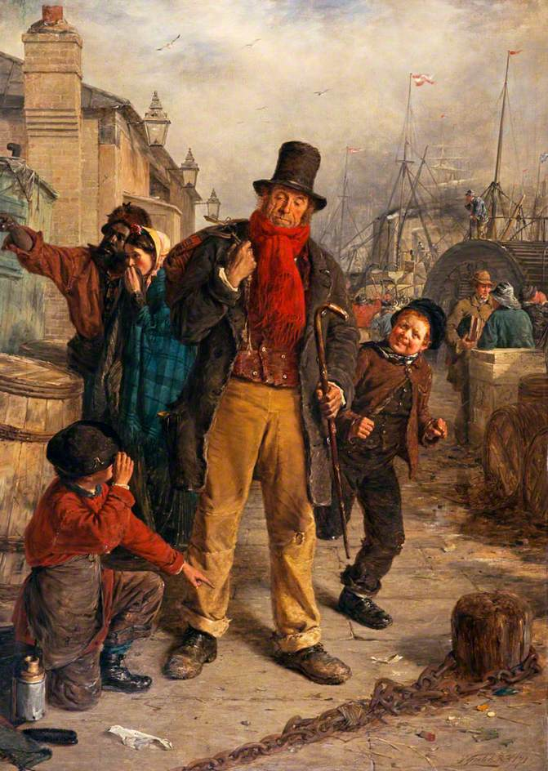
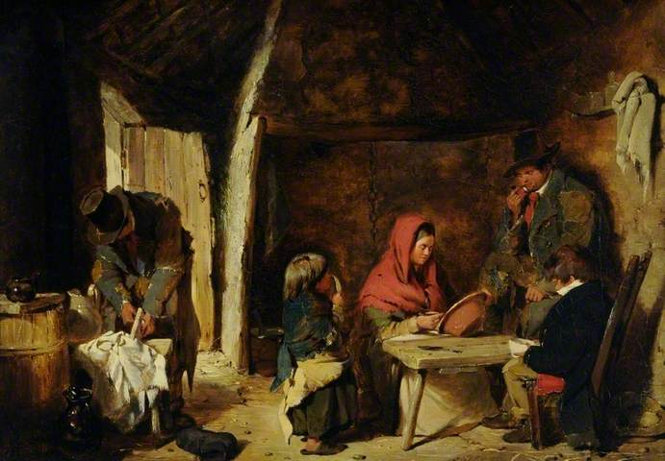
Figure 1: A scene from an Irish cabin.
Figure 2: An Irish Emigrant Landing at Liverpool

2.5 Little Ireland
Between 1841 and 1851, 38.2 per cent of Liverpool's total population increase can be accounted for by Irish settlers, this is considered a large percentage. Manchester saw a total increase in its population of 68,000 during the years between 1841 and 1851, of the total increase of 68,000, 22,700 people were Irish born immigrants (this is around one third of the total increase). (Davis,1991). These large influxes of Immigrants had a tendency to settle in the same location within their chosen cities, in the case of Manchester this area became known as “little Ireland”, (Davis,1991). Little Ireland was located, behind Oxford road station and was encapsulated within a meander of the River Medlock. This location meant that even though it was situated within the heart of Manchester city centre it was still isolated from its surroundings. This can be seen in figure 3. Little Ireland (2002).
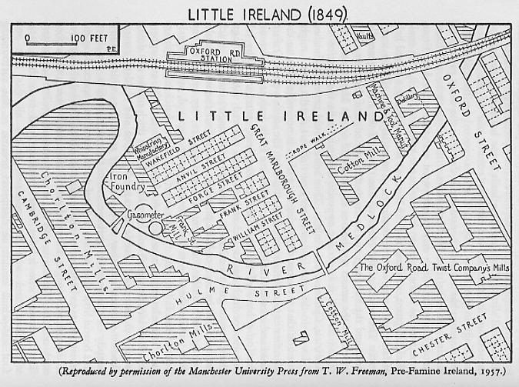
Figure 3: A map showing the location of "Little Ireland"

Little Ireland was built in 1827 and was exclusively populated by Irish Immigrants until their forced eviction in 1847. These dates were obtained from a plaque found on the site, where Little Ireland used to be. This Plaque is shown next (Figure 4).
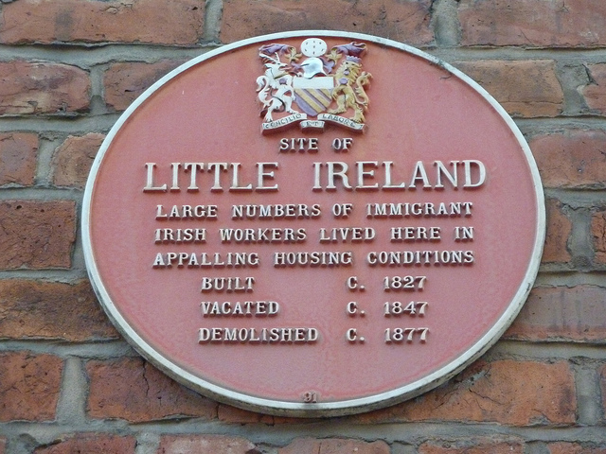
Figure 4: A commemorative plaque on the site of "Little Ireland"

The Irish immigrant population became notorious for living in some of the most appalling conditions during the 19th century, with Little Ireland being the prime example of these conditions. Little Ireland has been described by several academics from the 19th century. Friedrich Engels 's Description is as follows.
“In a rather deep hole, in a curve of the Medlock and surrounded on all four sides by tall factories and high embankments, covered with buildings, stand two groups of about two hundred cottages, built chiefly back to back, in which live about four thousand human beings, most of them Irish. The cottages are old, dirty, and of the smallest sort, the streets uneven, fallen into ruts and in part without drains or pavement; masses of refuse, offal and sickening filth lie among standing pools in all directions; the atmosphere is poisoned by the effluvia from these, and laden and darkened by the smoke of a dozen tall factory chimneys. A horde of ragged women and children swarm about here, as filthy as the swine that thrive upon the garbage heaps and in the puddles.... The race that lives in those ruinous cottages... or in dark, wet cellars. In measureless filth and stench... must really have reached the lowest stage of humanity.” (Engles, 2009).
This description of Little Ireland was released in 1844, The description depicts Little Ireland as a physical community made up of around four thousand people mainly of Irish blood, it also shows how foul and dirty the conditions where. The statement also compares the Irish women to “swine” and states that the community “must really have reached the lowest stage of humanity”. This description not only shows the impoverished conditions that the poorer Irish were living in; it also allows an insight into how the Irish immigrants were viewed by the host nation during the 19th century. The opinion presented in this case is a negative one with connotations of Irish people being of a lower standard than other ethnicities. However Davis puts forward a slightly different description in his book, with a description from Werly.
“The Physical ghetto consisted both of external and internal features. Black smoke polluted rivers, unpaved streets, the smell of pig sties, privies and open sewers. Coupled with the filthy cramped dwellings with their barren, damp interiors, all created a miserable existence for the Irish of Little Ireland.” (Davis, 1991).
This account for the way that the people of Little Ireland used to live comes with no snobbery only a description of the foul surroundings and a small notice of sympathy put forward by the final sentence “Created a miserable existence for the Irish of Little Ireland” (Davis ,1991). This shows how the opinion of others towards the Irish, was not and agreed upon subject and people held different beliefs about the Irish Immigrants. Both of the previous descriptions did agree on the fact that the living conditions for Immigrants where of an awful state. They were not an improvement from the way that they were living, in their motherland, of Ireland.

2.6 Irish, friend or foe?
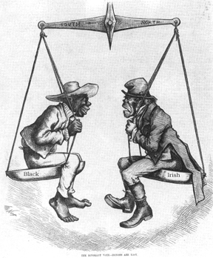
Figure 5: A depiction of the weighing of an Irish man v a black man (Haug, 2012)

It has been stated that these representations of the Irish communities within England set a tone and a stereo- typical view of the Irish to the English natives. O'Sullivan (1992) suggested that the likes of Engles and other people involved in the sanitary reform act, conveyed a negative racist view of the Irish population through their reports for economic and political gain. O'Sullivan (1992) then went on to suggest that due to the close link between the Irish and deprivation, there came an opinion that the Irish caused deprivation. It also became apparent that the Irish were being depicted and received to be sub human. This was concreted by imagery that was released in papers and other forms of media during the 19th century, an example of which is shown above, (figure 5). (Haug,2012). Figure 5 shows how the Irish were giving the same negative weighting as Black people, were given for the things that were going wrong economically and socially with both Britain and the United States. Also shown in Figure 5 is how Irish people were drawn when being portrayed within a cartoon, normally Irish men and women were drawn as apes or monkeys to show how they were of a lower intelligence and of a low level of hygiene.
Some other negative views of the Irish came about with the link between Irish immigrants and the loss of jobs for native men, mainly in manual labour positions. This opinion was so wide spread throughout Britain that it became the point of contention for demonstrations and riots, the first anti Irish riots took place in Manchester in 1807 and were in reaction to the influx of Irish immigrants. More violent demonstrations took place in the years following; 1830, 1834 and 1835, these riots were to do with both job availability and how it was supposedly due to the Irish and also due contrasting religious views between British Protestants and Irish Catholics. (O'Sullivan, 1992). In fact you would have been hard pressed to find a working or middle class male during the 19th century who would have spoken highly of any Irish man.
Drawing from religion being one of the reasons for rioting in Manchester during the 19th century, it would make sense to understand why Catholicism was seen as such a negative trait of Irish people. Firstly the fast majority of British people at the time were of Protestant belief, this was largely due to the Evangelical revival following 1790 and Irish people were largely of Catholic belief. (Swift, 1990). It got to the stage where the words Irish and Catholic were one in the same in the eyes of the British people. One event that heightened the tensions between the two races/ religions was the restoration of the Roman Catholic hierarchy in 1850, this meant that Catholic people were represented properly within the Britain and Catholic organisations were allowed on British soil. (Swift, 1990). This was seen as weakness and was unwelcome according to the vast majority of British Protestants, in-fact there was another well-known riot in 1861 in Oldham (Greater Manchester), and these riots were referred to as the orange and green riots. The “Orange and Green” riots consisted of Protestant people attacking Catholic churches, it’s said that an Englishmen was handled roughly by an Irishmen and that market street was impassable due to Irish people drinking and skirmishing of a Saturday and Sunday evening. And for these reasons the young protestant community of Oldham sought revenge on the Irish population by attacking and trashing local Irish and catholic establishments and places of worship. (The Oldham Standard, 1861). These reasons were not seen as evident enough for a riot or for vandalism and were seen as the actions of the younger, more “hobbledeboyism” section of the English community, the kind of youngsters who were “ over ripe for any kind of mischief”, (The Oldham Standard, 1861). Although these riots were put down to over mischievous youths it still solidifies the hatred that was felt by the Irish from the host people.
This research paper will later aim to determine whether this level and general feeling of hatred towards the Irish of Manchester still exists and if not what the feeling towards Irish people is now. However it must first be established what a community is and if there still is an Irish community within Greater Manchester.

2.7 Irish community?
A community is a group of people living within the same place or having a specific characteristic in common. (Oxford Dictionary, 2013). This definition states that a community is a group of people living in the same space, this would of meant that the people of little Ireland would have been classified as a community. The people of little Ireland would also of been classified as a community via the second section of the definition since they all shared the characteristic of being Irish. Although this definition correctly determines that Little Ireland was a community, it is still a very simplistic explanation of what a community is and does not fully cover what a community can be. To expand the definition other academic sources had to be explored, starting with Benedict Anderson and his 2006 book “Imagined Communities”. This book is seen as the corner stone of the study of nationalism. It sets out that everyone is part of some form of community, whether it is physical or imagined. Anderson (2006), actually states that every one of the same nationality is part of the same imagined community and all share a link even if they will never meet or know of each other. The reason that these communities are imagined is because the members of the community do not need to be within a physical setting with each other, in fact space plays virtually no role when it comes to imaged communities. It is then brought to the foreground that all nations and therefore communities have boundaries that encompass what makes them a community, these boundaries are considered elastic and will change, expand and contract overtime to include and excluded certain people and beliefs. It is the belief of Anderson (2006), that even though all human beings share the fundamental connection of being human there will never be a whole joined together world community, this is due to communities being just as much about how people differ than they are the same. (Anderson, 2006). The research section of this paper will look into whether; these elastic boundaries of community have expanded to include Irish and British within one community.
This new information surrounding communities brings to light the premise that the Irish immigrants in Greater Manchester were a community for four reasons: Reason one, they were a community due to the fact that they were all of Irish blood. Reason two, because they all occupied the Greater Manchester area. Reason three, they were a community since they were not British, this raises a question though whether the other immigrant factions within Greater Manchester were also part of this community? The fourth reason is that they were all perceived to be part of that community and were labelled to be part of their own community by the British people.
The fourth reason directly links to the process of mirroring, the process of mirroring is where a culture, nationality or community is defined by how they are perceived by outside sources and so take on these perceptions. (Crang,1998). In the case of the Irish in Manchester the local British people used a method known as projective identification; this is where a section of people project their bad qualities and problems onto another group of people. This led to the defining of the Irish community as that of an impoverished, undereducated, dirty community and the English community as the clean, intelligent and affluent community. Britain did the same with the continent of Africa depicting them as a dark and evil community hence making Britain a light and righteous community. (Crang,1998). This links heavily back to the “Irish Friend or Foe?” section and explains another reason why the Irish were despised by British people during the 19th century.
The research of this dissertation will look into, if there is any form of Irish community still in GM, and whether it is physical, like the settlement of Little Ireland between 1827 and 1847 or it has changed to just an imagined community, where there are Irish people but they no longer live within their own boundaries, but have filtered into the general populace of Greater Manchester. Also what the public perception of the community is (if there is a community) and how this modern opinion differs from the historical one of 19th century Manchester and if it does differ why that is?

2.8 Common traits, traditions and what it meant to be Irish
Even though a community within a foreign land, is mainly defined by how the host population sees them “mirroring”, (Crang,1998). This should not detract from what actually makes the community what it is and how the community perceives itself. The Irish community in Manchester during the late 19th century and early 20th century all shared a common, recent history; this history is that of the Great Famine. Even though the great Famine was considered a horrific and catastrophic event for the Irish people, it also gave the generation affected by it a shared event in which they could all find hardship, courage and bereavement. (Crang, 1998). This shared event and the feelings attached to it allow a sense of togetherness between the Irish immigrants that came to populate the slums of Manchester, a sense of belonging that no other nationality could partake in since they had not shared the same experiences.
This common history, or shared event however did not have to be experienced first-hand to be part of someone, its events such as the Great Famine that are passed down through generations, entitling the younger generations to identify with it, which in turn connects them with the Irish population. An example of which is held by the author of this dissertation. My family tree extends back through my mother’s side to that of the Moore’s of More Hall. Moore Hall was an estate constructed by my great ancestor George Moore between the years of 1792 and 1796. However it’s not the construction of Moore Hall which entitles me to be a part of Ireland’s history, it was with another relation that the connection came. George Henry Moore was born in 1810 and died in 1870; George Henry was a student of Law and was also a keen horse racer. It was with his Horse “Coranna” that he won the Chester Cup on the 6th of May 1846. He then used his winnings of £17,000 to ship 4,000 tonnes of maize to his estate (Moore Hall), to provide for his starving tenants. (Moorehall, 2010). It was because of his selfless actions and compassion that all of the tenants on the estate survived the Great Famine, it was also due to these actions why he later became an M.P for the County of Mayo. Upon his death in 1870 hundreds of poor and deprived people from across the County Mayo and Ireland travelled to attend his funeral to show respect for his help during the Famine. (Moorehall, 2010). Although these actions were not taken by me, my mother or her father, they still entitled me to be a part of a shared history of Ireland during the Great Famine, simply because of my heritage.
Not all shared experiences were of a disaster or happened on a widespread scale, in fact some personal trails or ceremonies that had become tradition throughout the Irish community now became a shared experience for a large number of Irish people. The best example for this is that of Holy Communion, with the main religion of Ireland being Catholicism the vast majority of Irish people would have gone through Holy Communion as a young adult. This again is an event that most Irish people would of experienced, shared in and so could draw from, again it was events such as Holy Communion that were deciding factors on whether people were part of a community or not.
The concept of a “Hidden Music” is brought up in Crang, (1998). This concept suggests that certain traditions are like a music that can only be heard by people of a certain nationality or people who are part of specific community. This does not actually mean that people of a different nationality do not know of these traditions but more likely that they do not partake in the traditions and that they hold no meaning to the population outside of said community. Irish dancing could very well be considered a form or “secret music”, since it is almost exclusively undertaken by people of Irish decent. In the same sense the playing and listening to of Irish music ironically could be considered a form of “secret music”.
The Irish throughout history have been labelled as, drunks, violent yobs, thieves (tinkers), disease ridden and poverty stricken, (Davis, 1991). Most of which have been placed upon them though the process of mirroring, apart from the title of drunks. It has been suggested that this label was earned following the Great famine in the slums and streets of GM, since encounters with the law were quite common for working class Irish men, normally due to resisting arrest for being drunk and violent. (Davis, 1991). The research later will look into whether these labels are still connected to the Irish communities of 2013.

2.9 How will the study contribute to the literature?
Most of the literature reviewed so far has been of an historical nature, this is because there are no recent studies into the Irish community in Manchester and none on the social opinion surrounding the population. This is where this study will contribute to the existing literature by testing to see if there still is a substantial Irish community within GM and what the opinions are surrounding that community. It is worthy to note that there have been papers and resources produced on the Irish in GM following the early 20th century, however these papers will not be reviewed since the most abundant and relevant data is from the mid-19th century to the early-20th century. Also the British opinion of Irish emigrants was at its strongest during this time period, this opinion will later be compared to modern opinion to test whether there is still some remnants of 19th century opinion in present day.

3. Methodology
3.1 Classification of study
This geographical study can come under one of two sub-headings “Human Geography” or “Physical Geography”. Human Geography has been labelled as “the study of society in relation to space and place” (Kitchin,2000). Whereas physical geography is “the study of the natural world and its processes” (Kitchin, 2000). This study focusses on population, community and social opinions and would therefore come under the classification of human geography. The data used within this study will be primary data.

3.2 Targeted social group
This research's main focus was on two different groups of people. The first of which was Irish people or those with Irish heritage and the second was that of the main nationality of Greater Manchester, British people. The reason these two groups were the main focus was simply due to the fact that the study was of the Irish population within a British city. Who better to question than the people you are studying and the primary demographic of the city the study is taking place in.

3.3 Approach of study
The main method used for data collection, was that of a survey. This survey was to be carried out in one location within the Greater Manchester; this location was Albert Square on Peter Street. The reasoning for this location was that, there was a 10 day long Irish festival being held in Manchester between the 8th and 18th of March 2013. (Eastland Colour, 2013). Albert Square was the epicentre of this festival; this is where all the tents, stages, stalls, displays and various forms of entertainment were being held. This festival allowed a much better demographical split of people who were of Irish descent and people who were not. This location enabled answers to be collected from both nationalities so the analysis of it could be critical and comparative. The use of Albert Square during a festival also meant that there was no form of competition between the researcher and other clipboard wielding people, fighting for the attention of passing strangers. This was due to the festival being fenced off, with security on all of the entrances and exits. To gain access to the site four emails were sent to the people in charge of running the festival, along with several phone calls. Access to carry out research on the site was granted on the 5th of March.

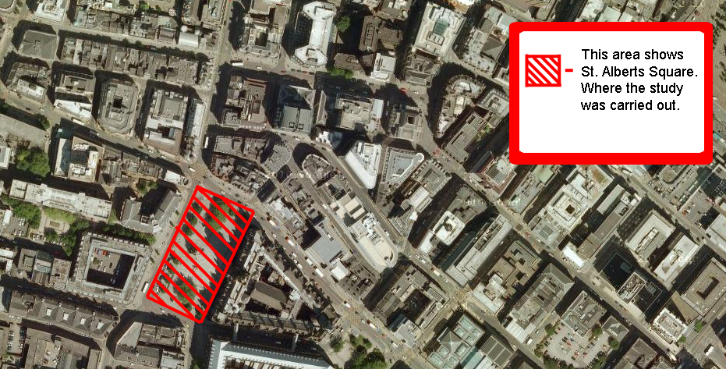
Figure 6: An edited satellite image taken from Google maps, 2013

The survey was carried out on three separate days between the hours of 10am and 3pm. The dates were as follows; Friday the 8th of March, Saturday the 16th of March and Sunday the 17th of March. These dates were chosen because, the 8th was the first day of the festival so hopefully there was a larger crowd due to the novelty of the festival, the 16th and 17th were chosen for similar reasons although the 17th was also St Patrick’s day which meant that there were thousands more people in the square than on any other day. Another reason for the dates chosen was that they were all on different days, giving a wider spread in terms of the kind of person who would be encountered and possibly questioned. The aim was to obtain 50 complete surveys on each of the days, this was achieved.

This survey was conducted in a humanistic manner, and focused mainly on a qualitative method of questioning, whilst maintaining a quantitative framework allowing the classification of the individuals that took part in the study. The reason this specific method was adopted over other methods was because, to gain a person’s true perspective they must be allowed to have completely free choice when answering a question and not be restricted to yes and no answers. The quantitative classification made it much easier when comparing the qualitative results obtained.

3.4 The Survey Questions
The Survey consisted of sixteen questions, 11 of which were multiple choice (quantitative) and 5 of which were open ended (qualitative). A blank questionnaire can be found in the appendix of this dissertation (Appendix). The opening questions to the survey are of a closed nature and are the normal questions you would find on most questionnaires; age, with 5 possible categories and sex with two options male and female. The 5 age categories at first seem irregular however they were chosen for several reasons, they are as follows:
“0-17 / 18-29 / 30-49 / 50-69 / 70+”
0-17 and 18-29 were divided as such since with the age of 18 also comes a lot of new experiences such as drinking, it is also a common age when people leave the education system and enter into work. This was important since it allowed the formulation of more reasons why peoples’ answers may have differed. 30-49 and 50-69 were divided as such since it seemed appropriate to have ranges of equal length, also they more than likely divided applicants into two different generations who hopefully had opposing views due to their age and upbringing.70+ was selected since by the age of 70 most people are of retirement age and may have different views because of this.

The third question was given the wording “What would you consider yourself?” rather than “what is your nationality?” By doing this it was hoped that the researcher could find out whether those questioned consider themselves to be part of the Irish or British culture and also whether they believe they are part of the Irish community or see themselves as part of the host community.
The next question was designed to establish whether any of the participant’s parents were Irish, British or other. This question was important to allow a comparison to be made with the previous question to see whether people with one or two Irish parents consider themselves Irish or British.
The following question asks for a person’s place of birth, since this study is only interested in Ireland and Britain there are only 3 categories “Ireland, Britain and Other”, This question could have been open ended however there would have been a distinction made between Scotland, Wales and England and this would of drawn away from the focus of the study by dividing the host population into different sections.
“Do you have an Irish or British passport?” this question was designed to find out what a person’s actual national identity was so that the result could be compared to what people consider their nationality to be.
As this study is of Greater Manchester specifically the next question is simple and needed, “do you live in the Greater Manchester Area?” This question allows the filtering out of people who do not apply to the main aspect of the study, although their opinions can still be used to present overall opinions for the entirety of Britain. The second part of this question is open ended and asks where in the Greater Manchester area do you live? The premise behind this question was to calculate if there was any difference in opinion or belief between the different areas of Greater Manchester, and also to see if there was an abundance of people who consider themselves Irish within certain areas.
The next question was open ended, and wanted to gather what people thought of when they thought of the Irish. The actual question was; “What words come to mind when you think of the word Irish?” This question was inspired by the works of Peter R. Grant and John G. Holmes (Grant, 1981) who conducted a study into the stereotypical views of Chinese and Irish people. Their study showed that when given two ethnicities and two words that can both be applied stereotypically to these ethnicities nearly one hundred per cent of people will match the stereotypical word to the right ethnicity, (Grant, 1981). Instead of giving the participants of the survey words and asking them to say whether they were Irish or not, it was better to ask what they thought of when presented with the word Irish. This approach allowed the participant to put forth their own opinion and did not limit them to only having a stereotypical answer. This question also served as an ice breaker for the next section of the survey which demands more from the person undertaking it.
It’s common that people who are part of a community will take part in activities that support that community; also some activities come under the earlier mentioned category of “secret music”. This question asks “Do you or any of your immediate family take part in any activities that could be considered Irish?” This question purposely does not specify what activities are Irish, leaving it to the interpretation of the individual questioned to decide what is considered Irish. This will hopefully show the amount of people with a connection to Irish activities whilst also bringing forward some questionable activities.

Greater Manchester has a wide range of establishments and centres that are either run by Irish people or are considered Irish, some examples are O’Shea’s pub, the Irish World Heritage centre, Chorlton Irish club and Dancing Celtic (an Irish dance shop). This question simply asks whether people are supporting these establishments. This will in turn show whether people are making a conscious effort to support the Irish community (if there is one).
The final two questions on the survey were trying to find out if the public of Greater Manchester think there’s an Irish community present and also what they think the community is made up of and what are its focal points. The first of the final two questions was a simple yes or no answer, the question was; “Would you say there is an Irish community in Manchester”. The final question was the main one, “If yes please explain what the community consists of in a few sentences”. This question was the most qualitative throughout the survey and it was also the primary reason for the questionnaire. The aim of this question was to see what people thought the Irish community was built on and around. The foreseeable problem with this question was its demanding nature, people were likely to give a short answer or not answer at all.

3.5 Data analysis
The data collected from the surveys will then be analysed, for this to happen the data must first be taken from paper format and translated into a form of digital spread sheet. The program used for this was “open office spread sheet” the reason for this program being used over Microsoft Excel was simply down to not having access to Excel. The majority of the data collected can be entered into spread sheet format with ease however the final question asked for a few sentences as an answer, to solve this problem the answers collected will be categorized into different single word answers that summarise the general opinion conveyed within the answers given. For example; “I think the Irish community has its main focus around pubs, because everyone knows that Irish people love a good drink”. This answer would be shortened to the word “Pubs”.

Once the data has been sorted and entered, it will then be analysed through the use of graphical analysis. Graphs will be created showing the following:
- The number of male and female participants
- The number of people that live in the Greater Manchester area
- The number of people who live in the Greater Manchester area divided into their respected nationalities and location within Manchester.
- The number of people whose immediate family take part in activities that could be considered Irish
- The different activities people said and the number of times each was said.
- The number of people who support Irish establishments
- The different establishments and the number of people who support each one
- The number of people who think there is an Irish community in Greater Manchester
- The different explanations for the community and the number of people who said which ones.
- The total number of different words that come to mind when thinking of the word Irish
- What came to mind when people who consider themselves Irish or Both thought of the word Irish compared to what people who consider themselves British thought when thinking of the word Irish?

4. Results & Analysis
This chapter will be presenting the results gathered from the surveys that were carried out on the 8th, 16th & 17th of March 2013. Due to the nature of the results, the analysis will occur directly following the graphical representation produced. The analysis will look for correlations between supposedly connected results, whether these correlations agree with theories put forward, whether the results show similarities to historical opinions and facts surrounding the Irish and also hopefully show if there is an Irish community either physical or imagined within the Greater Manchester area. Finally it will discuss the modern opinion surrounding the Irish.
4.1 Age & Gender
Table 1: Age & Gender
Figure 7: A percentage demographic of age

Table 2: Male & Female
Figure 8: Gender Percentage of survey

Table 1 and Figure 7 both show the number of people who fall into each age category that participated in the questionnaire. Table 1 shows the number of people out of 150 whereas Figure 7 shows what percentage of the participants came under which age category. As Figure 7 shows 0-17 and 70+ both had the smallest sample size, a couple of reasons for this were that people who fall into the 0-17 age category where normally accompanied by an adult and when the mixture of adults and Children where approached the adult had a tendency to answer the questionnaire and not the younger person who would of come under the 0-17 category. On the other end of the age groups the 70+ category has a much smaller representation in general so the chances of asking an individual that falls into this section is reduced, also there is always the chance people did not want to admit their age was above that of 70.

Table 2 and Figure 8 show the number and percentage of people who were male or female that took part in the questionnaire. The percentage and number of people who were female was larger than that of the males because upon carrying out the questionnaires female recipients were much more willing to answer than males. Hence, why this is represented with, males taking up 41% of the demographic and females taking 59%.
Table 3: GM Area

4.2 The Number of People Who Live In the GM Area
Figure 9: Percentage of people who live in the GM area

The main focus of this research was to try and establish whether there was an Irish community still within GM, and to investigate whether the social opinion of the host community has changed since the 19th Century. Since the location of the study is Greater Manchester, the only results that can be used to formulate an answer can be taken from people who live within the GM area. Table 3 shows that 111 of the 150 people questioned lived within GM and therefore can have their opinion effect the result of the research. Figure 9 shows the results as a percentage.

Table 4: Ethnicity & GM Area
4.3 The demographic of people who live within the GM Area
Figure 10: Demographic of the people within GM

Figure 10 shows the percentage of nationalities that live within the GM area took part in the survey. The largest percentage was of people who consider themselves British, who actually made up 60% of the Demographic. The second being of people who consider themselves to be both with 22% and the Third largest being people who consider themselves to be Irish with 16%. As Table 3 shows this chart only accounts for 111 of the participants of the survey, Table 4 shows the number of people that make up each percentage.
This Data clearly shows the presence of Irish people within GM, out of the 111 people who live within the GM area 42 people claimed to be of some Irish identity ( this number was the sum of the people who said “Both” and “Irish”). This meant 38% of the GM residents questioned, had enough Irish heritage or “blood” for it to be a defining factor about themselves. As stated previously, in 1851 the number of people in GM who were of Irish nationality, was equal to 15% of the total GM population, Kidd (1996). When compared to the percentage gained from this research there would at first apear to be an increase of that percentage of 23%, however this is obviously not the case and this conclusion cannot possible be drawn, just as it cannot be stipulated that 38% of GM's total population is of Irish decent. The reasons for this are; one that the data collected is of a sample size that makes up less than 0.004% of GM's 2.6 million current residents, (OFNS, 2012). Reason two being, that the area in which the survey was carried out had an unfair ratio of Irish people, due to the nature of the festival. Meaning that there was clearly more Irish people in St Albert’s Square on the days of the Survey than there would be on any other day. Due to these reasons no real conclusion can be drawn from these specific results regarding a percentage for the Irish in GM; however these results do show that this research is made up of an “okay” split between the two nationalities, giving a more comparable piece of research.

4.4 The demographic of people who live in the GM area sorted by location
This section will look at different areas that people live in within the confines of the GM area, also the different number of nationalities that occur with each area. The graph is split between two pages and form just one figure, (figure: 11)

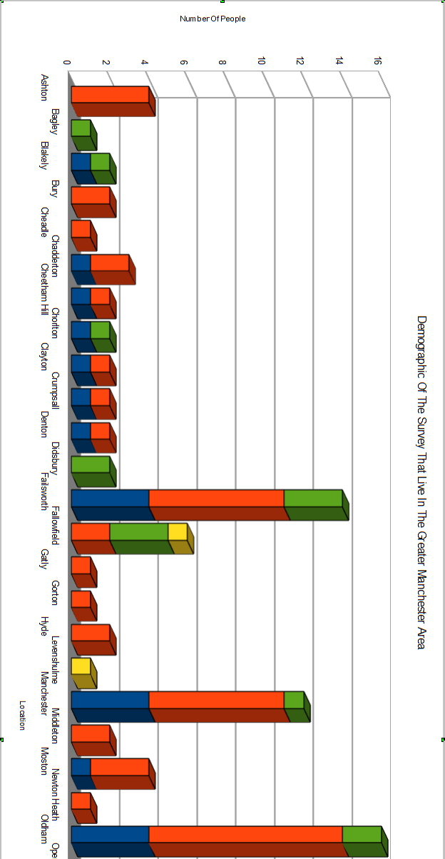
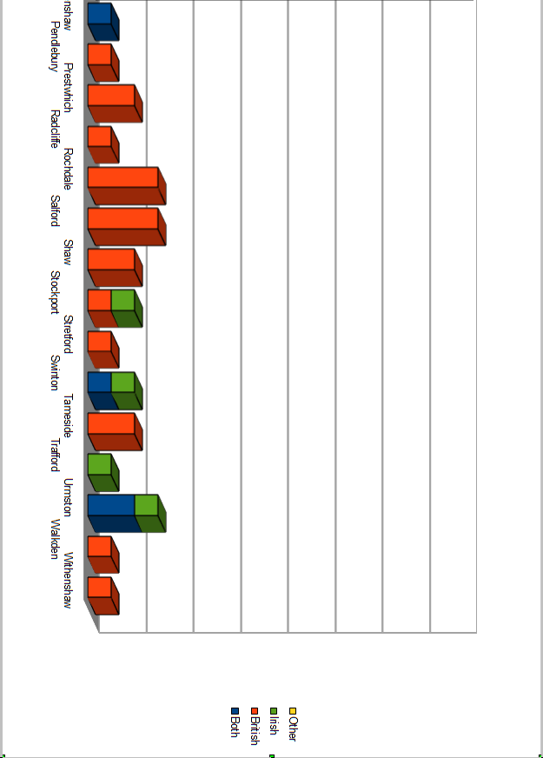
Figure 11: The Demographic of the survey sorted by location

Figure 11 shows several different results, Firstly it shows the 38 different locations that people stipulated they live in that come under the GM area, quite a few of these areas could have been consolidated into 1 area rather than being kept the way they have been, yet this would have gone against the point of the study. The reason being that the question “If yes, where abouts in the GM area” was open ended so that people could give the name of the location as they know it. This was due to the research carried out on Little Ireland, even though Little Ireland came under the Central Manchester district it was still known and studied as its own individual location, (MacRaild, 2000). It only seemed appropriate to allow the same for all other areas.

Figure 11 also shows the demographic of each of these areas (the number of people that come under the categories of “Both, Irish, British or Other”). Figure 11 clearly shows that some areas have too few participants to draw any conclusion from, only 3 locations have 10 or above representatives, these are Failsworth (14 representatives), Central Manchester (12 representatives) and Oldham (16 representatives). This is shown in Table 5.

Table 5: Ethnicity of the three most common locations

Figure 12: Percentage demographic of the three most common locations

Failsworth had a 50/50 split of British people and those of some Irish decent, Central Manchester Had a 58% British 42% Irish split and Oldham Had a 63% British to 38% Irish demographic. Both Central Manchester and Oldham have already been discussed previously in this dissertation, since they were both known to have large percentages of Irish born people during the 19th century. Central Manchester had Little Ireland, (O'Sullivan, 1992). Oldham had a large enough population to be the focus of riots, (The Oldham Standard, 1861). so therefore it could be stated that there is still a significant Irish population within these two districts, both because of the percentages of Irish present and the fact that the surveys were collected in such an Irish intensive location and managed to produce a medium to large sample. Meaning that the festival attracted a large number of Irish people of which a substantial percentage came from Oldham, Failsworth and Central Manchester. On the other hand, again no actual conclusion upon Irish population can be drawn from these demographics, the results when divided into their respected locations, form too many small sample sizes not giving reliable data to conclude from.

4.5 Activities that could be considered Irish?

Figure 13: Percentage of People who live in GM and partake in "Irish Activities"
Figure 14: The number and variety of Irish activates

Figure 13 shows the amount of people who live in the GM area and take part in activities that could be considered Irish or have immediate family who do, according to the results 48 people do take part in activities and 63 people do not. These translate to 43% of people do and 57%of people do not. These figure where unexpectedly balanced, the expectation was that maybe 50% of the Irish population of GM took part (or had immediate family that did) in Irish activities, this expected result would have meant that only 21 people would of taken part in activities of an Irish nature. This would not have been much use in trying to prove there was an Irish community in GM. Instead these results show how the “secret music” (Crang, 1998), is still listened to by today’s generation of Irish and part Irish people. The actual activities that are being undertaken are mostly applicable to the theory of “secret music”, for example; music, Irish dancing, hurling, speaking Gaelic and Holy Communion. Were all practised or undertaken by the Irish in the 19th century. (MacRaild, 2000). and all occur within the results presented in Figure 14. Some of the answers given are not necessarily indicators of community e.g. digging; however they do show that people see certain activities to have relevance to Irishness.
These results point towards there being an Irish community within GM, although the limitations of the results must also be taken into consideration.

4.6 Do you support any local Irish establishments, if yes which ones?

Figure 15: Percentage of people who support Irish establishments

Figure 16: The establishments that people support

The results of whether people support local Irish establishments in the local area, were unexpectedly insignificant especially when it has been established that 43% of the people asked “do you or any of your immediate family take part in anything that could be considered Irish” said they did. Whereas only 28% of people said they supported local Irish establishments, this percentage is of too low a value to contribute towards the evidence that there is an Irish community within GM. The reason this percentage is low in comparison to the previous could be due to a whole host of reasons, one of which was that people may have misinterpreted the word establishment, rendering the question ineffective due to a lack of understanding. Although the data is not sufficient enough to say there is a large Irish community of the same size and consistency of the 19th century Manchester, Figure 16 does point out some establishments which could quite possibly be focal points for a community, the prime example being “The Irish World Heritage Centre” in Cheetham Hill. Which is supported by 25 of the people, who claimed that they support a local establishment?

4.7 Analysis of the community questions
Figure 17: Percentage of people who said there was an Irish community

Figure 18: Different focal points of the community
The Final two questions that were asked in the survey were the most important ones. The first was “do you think there is an Irish Community in Manchester?” With a closed answer system of yes or no. The second part or second question was, “If yes please explain what the community consists of in a few sentences?” This question was open ended. Again there is a blank Questionnaire in the appendix (Appendix 1).
The results for the first question were extremely positive with a total of 127 of the 150 participants, 85% of the entire sample, replying with yes there is an Irish community within GM. (see figure :17).This percentage along with the Percentage from figure 15 could make a very strong quantitative case for their being an Irish community within GM.
Figure 18 shows what people in GM of Irish and British nationality, think the Irish community consists of, It is hugely apparent that the most common answer to this question is that of centres, with a count of 41. Which in turn means that most people believe that the main focal points of the Irish community in Manchester are that of the IWHC, St kent's centre and Chorlton Irish centre. Figure 18 also shows that churches and pubs are also seen to be a large section of the community with counts of 17 and 10. Figure 16 supports the theory of pubs since it shows O'shea's pub as the second most supported establishment. Moreover figure 14 also shows that drinking could possibly be part of the Irish community, further cementing the possibility that pubs are a modern focal point within the Irish community. The Irish of the 19th century were well known for being drunks, as mentioned in chapter 2. (Davis, 1991).
In short these results show there still is an Irish community within GM, but it can only be said there is an imagined community, (Anderson, 2006) these results cannot stipulate that there is a physical community that has replaced “Little Ireland”.

4.8 Analysis of the opinion towards the Irish

Figure 19: What word come to mind ... totals

Figure 20: GM only difference in answers between Irish and British for “what comes to mind...” question

Figure 19 shows the total results gathered from the question “what words come to mind when you think of the word Irish?” These results show that the most common word that came to mind was the word “green” with 21 mentions, followed closely by family with 18 and Guinness with 15. However Guinness and drink are both technically the same thing so when combined under the name drink, they have a total of 24 mentions making it the leading answer for the total collected results. Upon first analysis Figure 19 shows how the opinions formed in 19th century Manchester through the process of “mirroring” (Anderson, 2006) surrounding the Irish are still present in 2013. As mentioned in the Literature review “the Irish were well known for being drunks” (Davis, 1991) this data could be interpreted to show that they still are. On the other hand within Figure 19 are some examples of very modern examples, for example “Louis Walsh” and “Westlife”, although the number of times the two are mention is only 3 when combined, it must be remembered that a small percentage of younger people were questioned, and all 3 of the times that the “famous people” were mentioned was within the age category of 0-17. This could be cause for some further research.
Even though some conclusions can be drawn from figure 19 concerning the general opinion or “thoughts” of the Irish, it cannot be used to formulate conclusions on the GM area alone or what the people of Irish heritage thought in comparison to what the British people thought, to do this Figure 20 must be examined. Figure 20 shows all the people who live in the GM area, their ethnicity and the number of times they stated a category of word. The words have been sorted into categories, so that the data can be presented more simply and therefore be analysed to a higher standard. The make-up of the different categories is specified below:
- Drink – Drink & Guinness
- Family & Friends – Mum, Dad, Granddad, Friend, friendly & People
- Negative – Tinkers, Thieves and foreigners
- Iconic Images – Shamrock, Clover & Leprechaun
- Place – Mayo, Galway & Dublin
- Famous people – Westlife, Louis Walsh
- Music & Dance – Music & Dance
What conclusions can be drawn concerning GM and the View of the Irish community within it by using Figure 20, Firstly it becomes immediately apparent that the People of Irish decent hold a much more sentimental view of themselves, this is shown by the highest number of mentions by those of Irish heritage being that of “Family and Friends” with 21 and “Home” with 9. In comparison to the top British Result which is Iconic Images with a result of 16. This shows that British people see Irish people by how they are portrayed and not by how they are on a human level. It could also be said that St Patricks day and other Irish festivals put forward that much Imagery of Ireland that it has saturated the opinions of the host nation clouding what it truly means to be Irish. Figure 19 and 20 both have a reoccurring theme and that is with the category of “drink”, However in figure 20 drink is shown to have a near equal split between both Irish opinion and British opinion, this raises the question has the mirrored image of Irish people being drunks rubbed off onto the Irish themselves (Anderson, 2006) or is it that the Irish community of GM genuinely do love to drink?
In the 19th century there was a huge number of anti-Irish media campaigns (Haug, 2012), Anti-Irish riots (The Oldham Standard, 1861) and Anti-Irish Government research and policies (Engles, 2009). Figure 20 shows that there may be some left over negative views, possibly passed down through generations of British (and quite possibly Irish), this is shown by the category “negative”, additional to this point it should be made that only 4 times was a negative word but forward by any British person taking part in this study. It would be fair to say that, if this survey was carried out in mid-19th century GM, that figure could have easily and most probably would have been the highest.
4.9 Study Limitations
This study encountered a wide array of problems; firstly was the issue that a larger sample size could not be obtained for the 0-17 age range, this limited the detail to which age could be used as a defining factor when concluding some of the data. Secondly is that the question “do you support any local Irish establishments?” may have been misinterpreted and therefore loss a large amount of value when it came to carrying out the analysis. Next was with the final open ended question “If yes please explain what you think the community consists of in a few sentences.” People do not like to be asked to right a few sentences when filling out a survey, this led to the majority of people giving one word answers and a smaller but equally significant selection either not answering it or answering with not sure. Finally for the limitations it must be stated that not real conclusions could be drawn from figure 11 due to how thinly the results were spread.
4.10 Future work
If there was to is any further work carried out on this topic the sample size would have to be increased tenfold for the quantitative data collection, and have the qualitative data be collected through its own study. If this study was to narrow down its approach to the younger age group of 0-17 it may see a completely different outcome to this study, due to the social changes that are currently undergoing, with the widespread use of the internet and the raising popularity of so many famous Irish people. If there was to be a future study it would more than likely be into “the opinion of British youngsters (up to the age of 17) of the Irish”.
4.11 Conclusion
The final overall conclusion to this study is that there is an imagined Irish community in Greater Manchester, and its main focal points are of that of the centres, with the Irish World Heritage Centre being the main one and they have a large percentage of their community that take part in activities such as Irish dance and Irish Music. The opinion of the host nation has changed dramatically from the negative hate fuelled 19th century opinion and will continue to change with time, the current overlying opinion of the Irish in GM is that they like the colour green are very fond of shamrock, clovers and a pint of Guinness or two.

References

Alan Kidd (1996). Manchester. 2nd. ed. Cornwall: Hartnolls LTD

Benedict Anderson (2006). Imagined Communities. 1st. ed. London: Verso
Christine Haug (2012). victoriana [online]. Available from: <http://www.victoriana.com/Irish/IrishPoliticalCartoons.htm>. [Accessed 02/02/2013]

Cormac Ó Gráda (1988). Ireland before and after the Famine. 1st Edition. ed. Manchester, M13 9PL: Manchester University Press.

Donald M. MacRaild (ed). (2000). The Great Famine and Beyond. Dublin: Irish Academic Press

Eastland Colour, 2013. Manchester Irish Festival 2013. [PDF] Manchester. 2013. Available at:http://www.manchesteririshfestival.co.uk/ [Accessed 01/03/2013].

Erskine Nicol (1851). Scene in an Irish Cabin. Oil on canvas. At: Sheffield: Sheffield Museum, Sheffield Museum. VIS.1399.

Erskine Nicol (1871). An Irish Emigrant Landing at Liverpool. Oil Painting. At: Scotland: National galleries of Scotland, Scottish National Gallery. NG 925.

F. Engles (2009). The Conditions Of The Working Class In England (1844). 1st. ed. London: Echo Library

Google Maps [online]. (2013). Available from: <https://maps.google.co.uk/>. [Accessed 20/03/2013]

Graham Davis (1991). The Irish In Britain 1815 - 1914. 1st . ed. Dublin: Gill and Macmillan LTD

K. H. Connell (1950). The Economic History Review. Land and Population in Ireland, 1780-1845. Vol. 2, pp.278-289

K. H. Connell (1962). Peasant Marriage in Ireland. Its Structure and Development Since the Famine. Vol:14, pp.502-523

Little Ireland [online]. (2002). Available from: <http://home.arcor.de/friedrichengels/ireland2.htm>. [Accessed 22/02/2013].

Mike Crang (1998). Cultural Geography. 1st. ed. London: Routledge

moorehall [online]. (2010). Available from: <http://www.moorehall.com/historyhall.htm>. [Accessed 7/02/2013].

Office for National Statistics [online]. (2012). Available from: <http://www.ons.gov.uk/ons/publications/re-reference-tables.html?edition=tcm:77-274670>. [Accessed 27/03/2013]

Oxford Dictionary [online]. (2013). Available from: <http://oxforddictionaries.com/definition/english/community>. [Accessed 04/02/1013]

Patrick O'Sullivan (1992). The Irish In The New Communities. 2nd. ed. London: Leicester University press.

Peter R. Grant, Jonh G. Holmes (1981). The Integration of Implicit Personality Theory Schemas and Stereotype Images. Social Psychology Quarterly [online]. 44, p.107-115. Available from: <http://www.jstor.org/stable/3033706>. [Accessed 17/02/2013]

R. W. Dudley Edwards, Thomas Desmond Williams, Cormac Ó Gráda (1994). The Great Famine: Studies in Irish History 1845-52. illustrated. ed. Dublin: The Lillput Press.

Rob Kitchin, Nicholas J Tate (2000). Conducting Reshearch into Human Geography. 1st. ed. Harlow, Essex: Pearson Education Limited.

Roger Swift (1990). The Irish In Britain 1815 - 1914. 1st . ed. London: The Historical Association

T.W.Freeman (1969). Ireland. 4th . ed. London: Butler and Tanner LTD
The Oldham Standard (1861). Disturbances Between The English And Irish In Oldham. Attack On The Roman Catholic Chapel. THE OLDHAM STANDARD, June 1861, p.1-6

Timothy W. Guinnane (1994). American Economic Association. The Great Irish Famine and Population: The Long View. Vol:84, pp.303-308

APPENDIX

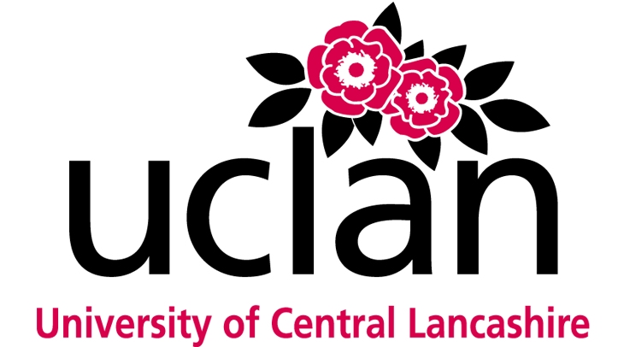
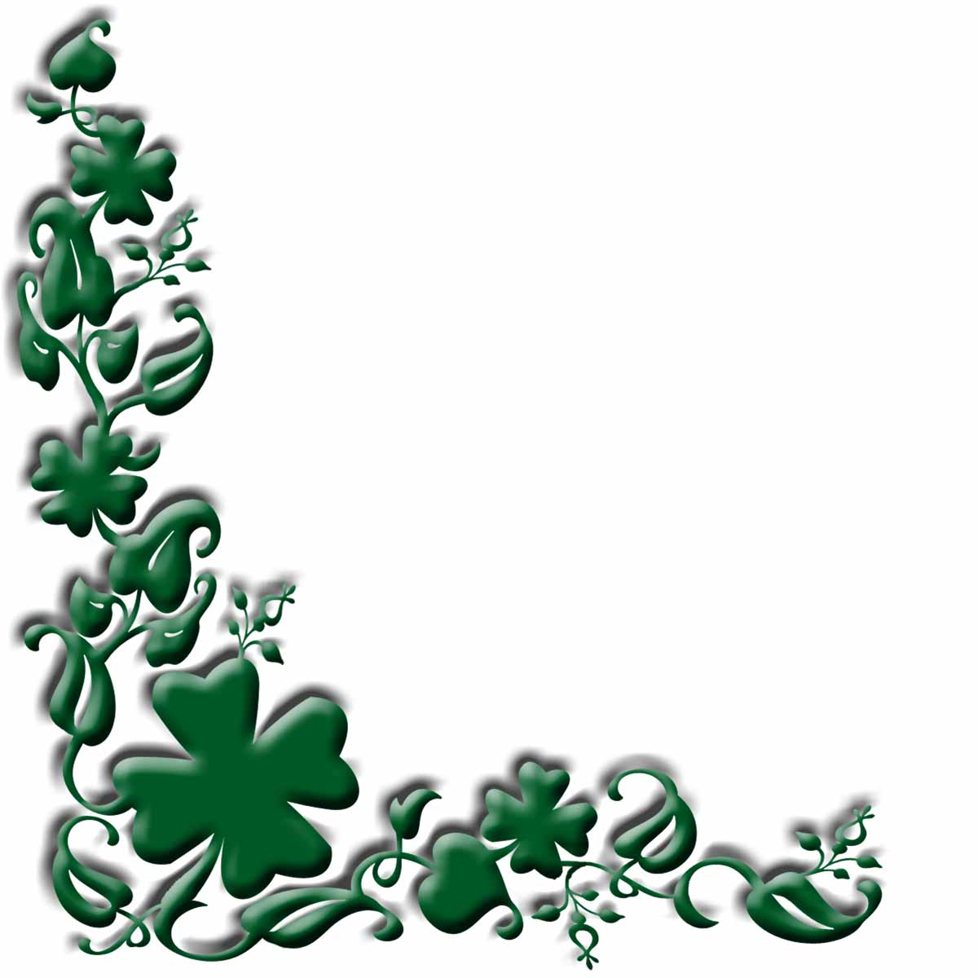
QUESTIONNAIRE
Is there an Irish community in Greater Manchester?
All of the data will remain anonymous and
be disposed of after the investigation

Age: 0-17 / 18-29 / 30-49 / 50-69 / 70+ Sex: M / F

What would you consider yourself?

Irish / British / Both / Other

Please circle which one your parents are;

Mother : British / Irish / Other
Father : British / Irish / Other

Place of birth?

Ireland / Britain / Other

Do you have an Irish or British passport?

Irish / British / Other

Do you live in the Greater Manchester area?

Yes /No
If Yes Where about in the Greater Manchester Are? _____________________________________

What words come to mind when you think of the word Irish?
_______________________________________________________________________________

Do you or any of your immediate family take part in any activities that could be considered Irish?

Yes/No
What are they? ___________________________________________________________________

Do you support any of the local Irish establishments or the Irish centres?

Yes/No
If yes, how and which ones? ________________________________________________________

Would you say there is an Irish community in Manchester?

Yes / No

If Yes, please explain what the community consists of in a few sentences.
________________________________________________________________________________________________________________________________________________________________________________________________________________________________________________________________________________________________________________________________

