The Importance of Public Houses and the Implications of their Closure in Village Communities

Thomas Bainbridge
Geography (BA)
3rd year

I declare that the main text of this dissertation is no more than 10,000 words (+/- 10%), and is all my own work.

Signed: _ _ _ _ _ _ _ _ _ _ _ _ _ _ _ Date: _ _ _ _ _ _ _ _ _ _ _ _ _

Abstract:
The following paper is an undergraduate dissertation that investigates the implications of pub closures and the roles that public houses play in village communities. Initially existing literature surrounding public houses was reviewed in order to give a background to the study and to place the study within the context of current knowledge on the subject. The methods used in order to carry out the study’s aims were based on interviews with 40 residents from 2 villages containing pubs and 40 residents from 2 villages that had lost their pubs. The 4 sites were located in County Durham. The responses of the residents from the two categories of village were compared in order to assess how severely the presence of pubs affects village communities and combined with the opinions of residents regarding pub closures; a picture of how pub closure affects communities was constructed. The conclusions drawn from the paper indicated that the presence of pubs in village has a positive effect on the strength of village communities and that pub closures can have various negative implications for village communities.
Acknowledgements:
Richard Jonathan Cook - Soon to be graduate of the University of Sunderland who, with the help of his trusty Citroen Saxo, assisted with much of the data collection.
Mark Swailes - statistics expert, who gave advice on statistical analysis.Mark Toogood – Dissertation Supervisor.

Contents Page
Chapter 1: Introduction 5
- 1.1: Aims and Objectives 5

Chapter 2: Existing Literature 7
- 2.1: History of the public house 7
- 2.2: Pubs in national and local culture 8
- 2.3: Pub closures 9
- 2.4:Maintaining and creating social networks 10
- 2.5: Marginalization 11
- 2.6: Socio-economics 12
- 2.7: Charity 13
- 2.8 Community cohesion 13
- 2.9:Community pubs 15
- 2.10: Most relevant literature 15
- 2.11: Where this paper fits 16

Chapter 3: Methodology 17
- 3.1: Choosing the sites 17
- 3.2: Interviews 18
- 3.3: Sampling 19

Chapter 4: Results and Discussion 21
- 4.1: Study limitations 32
- 4.2: Conclusions 33

Table of Figures
Figure 1 Map showing the four chosen sites 6
Figure 2, Histogram showing frquency of pub visits of the residents of the four villages. 21
Figure 3, Histogram showing how often residents of the four villages socialise within the village. 23
Figure 4, Histogram showing how often residents of the four villages take part in local activities. 25
Figure 5, Histogram showing the main reasons residents of the four villages visited pubs. 27
Figure 6, histogram showing what sense of community residents felt in the four villages …………….28

Table of Tables
Table 1 21
Table 2 23
Table 3 25
Table 4 27
Table 5 28

Chapter 1: Introduction
Human geography is a broad spanning subject that can envelop many issues. As all forms of geography it is concerned with space but is more concerned with how features of the social world change throughout space and how the differences that exist in space can affect the way human life develops (Jones, 2012). The space that is being studied in this paper is the villages of rural England, village communities of Durham to be exact, and the topic that is to be studied in this paper is the public house which is an integral part of many village communities. Throughout this paper it will be studied how significant pubs are in affecting how human life develops in these places. Recent reports have found that in the UK 18 pubs close down every week (Camra, 2012) so it is with this issue in mind that this paper investigates how important pubs are and the effects that pub closures are having.
1.1: Aims and Objectives
The paper aims to study the various roles that public houses play in village communities and the implications that pub closures can have on said communities. The paper focusses on the social role that public houses play in the community but also aims to study all implications that arise due to pub closures on village communities.
The first objective was to assess the various roles that pubs play in village communities through studying existing literature.
The second objective was to investigate the social strength and activity of communities in villages with and without pubs through interviews with residents.
The third objective was to assess the implications of pub closures on village communities through comparing data on the different villages and through the opinions and experiences of residents and pub staff.
Sacriston was chosen as a case study because it has suffered 3 pub closures in the last 2 decades which were The Shoes, The Robin Hood and the Village Inn (also known as the Colliery Inn) leaving the village without any pubs. Shotton Colliery was chosen because it too has had pub closures (See appendix 3) and is now left without any pubs. Witton Gilbert was chosen because it has 3 pubs which are the Glendenning arms, the Traveller’s Rest and the White Tun. Lanchester was chosen because it has 2 pubs the Kings head and the Black Bull. Both Sacriston and Shotton Colliery are former pit villages.
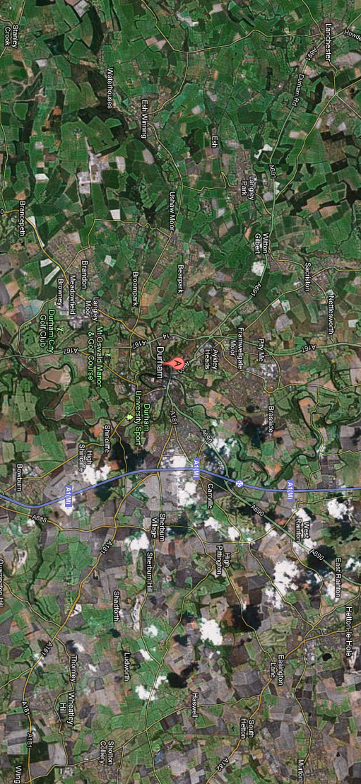
Figure 1 Map showing the four chosen sites
(Google, 2013)

Chapter 2: Existing literature
2.1 History of the public house
Much of the literature about pubs is primarily about, or delves into, the history of this social institution. Information surrounding the origin of pubs and the changes that have occurred throughout history to shape the pub we know today is frequently documented and easily accessible. Studying the history of pubs is important and relevant to the study because it gives background information about pubs showing the roles that they have played in the past and both how and why they have grown to be part of village communities over the years. The English have long been associated with the consumption of beer or similar malt beverages; in 361 AD the Roman Emperor Julian described the northern European races as ‘sons of malt’ (Haydon, 1994). The origins of the English pub date back to the Roman colonization of Britain, which brought two innovations that, were significant to the origins of the English pub, roads and wine. Along the roads, buildings and stalls were built for the sale and consumption of wine.
Historically different forms of public drinking establishment have developed over time to serve different purposes that stem from different categories of social use as discussed by Michael Smith (1983). For example the inn developed from the coaching tradition providing shelter and refreshment for travellers. Over time these establishments would grow to offer entertainment and recreation for travellers, traders and people selling their wares and crafts, inns were dominantly used by relatively wealthy people and catered for catholic drinking tastes selling beer, wine and spirits. Taverns, it is claimed, originally developed from the increasing availability of wine due to the cultivation of vines in medieval monasteries. These taverns were mainly concerned with the consumption of wine but by the late 18th century were difficult to distinguish from inns and both catered for a varied range of users meeting the needs of the casual drinker. The alehouse was the traditional drinking place of the village. The alehouse sold only beer, which was often brewed on the premises and did not offer accommodation or forms of formal entertainment as did the inns. It was essentially the local community drinking and meeting place of a village and was a fundamental part of village life. Locality was an integral theme of the alehouse with customs and traditions of rural culture tied in.
Other literature regarding the history of the pub looks into its early association with the church. Studies find that inns derived from a religious background, in medieval times feasting and drinking on the church ground was common and the abuse of which led to the construction of churchwardens’ quarters from which many inns originate. Inns near ancient abbeys were likely to stem from guesthouses established by monks who would brew their own beer. The religious association with pubs can be seen on the signs of present day pubs with names such as the Angel, the Salutation and the Cross Keys (Catholic Herald, 1938).
2.2 Pubs in national and local culture
Other scholars make note of the English pub as a unique institution that is not only a key part of English culture but is one of the building blocks that has shaped our culture to become the way it is today. Jackson, in his book The English Pub (1976), claims that the English pub is one of the many things that defines England but one of the very few things that separates England from other nations. “Other countries have royal families, parliaments and double-decker busses but only England has Pubs” the pub belongs to an island race which has crossed over the borders into Wales and Scotland but despite efforts to transplant this unique phenomenon into other countries the pub remains exclusive to the shores of Britain because it is an organic part of the growth of English community life. Jackson goes on to give an insight into the customs, rituals and drinking habits that occur in English pubs such as the simplest example that of buying rounds which have shaped our culture as a nation but also at a local level in village communities. The pub and the people, (Mass observation, 1943), was a ground breaking piece of pub literature in which a team of anthropologists moved into Bolton or ‘worktown’ to study what working class life was like in Bolton through the method of observation. The book records the culture of people living in 1930s Bolton through observing the goings on in public houses. The book looks into various aspects of the three hundred pubs in work town such as the exterior and interior appearances of the pubs and the different drinks that were popular. The book’s findings document the different people who frequent pubs, their opinions and habits and also the various activities that took place in pubs as the time such as gambling, entertainment and of course drinking. The study highlights the importance of the public house as a working class establishment in which. The book, although many decades old and focussing on more urban pubs, is still relevant because through observing pubs the team compiling the book gave reasons as to why people visited pubs and why they were important to the people of Bolton many of which are timeless and unique to the pub and still important in communities today.
2.3 Pub Closures
When talking about pub closures it is important to look at reasons for why pub closures have become an increasing occurrence in recent years, and there is varied literature that illustrates reasons for pub decline. There have been many factors that have influenced pub closures, an important one being the changes in the type of pub ownership in the last few decades. Pubs operate in one of three different forms that shape the way the pub is run and what the pub sells. These are freehold pubs that are owned independently; brewery owned pubs, which typically can only sell the beer that is supplied by the brewery, and pubs owned by companies that do not brew their own beer but own many pubs throughout the country. The 1989 beer orders was an act that drastically changed the composition of pub ownership, its aim was to break down the monopoly of pub ownership because at the end of the 1980s breweries owned over 50 per cent of Britain’s pubs. This was not what happened in practise because as a result of the beer orders pub companies or ‘Pubcos’ gradually bought up a massive amount of pubs to the extent that three of the major PubCos owned around 20,000 pubs by 2007. Pubcos generally focus on making profit so many pubs that were not making profit; this included many pubs in rural locations (Jennings, 2007). An example of a PubCo is Wetherspoons who appear to invest more thought into profit and the appearance of their pubs as what they offer to the community Haydon (1994) argued along with saying they were in danger of becoming to formula. There were also many reasons that lead to falling trade for pubs. The 90s were a decade in which UK consumer spending was quite low and along with competition from other attractions the traditional pub began to lose trade and began to lose its status as the major leisure amenity. Other factors included changing demographics as the population of the UK began to lose people from the 18-25 age category and the 75+ age category grew and the older consumers were less likely to use the facilities that the traditional pub offered (Pratten and Lovatt, 2002). Other factors that lead to pub closures included legislation changes such as the smoking ban and rising beer duty along with competition from supermarkets (Markham, 2011).

2.4 Maintaining and creating social networks
There is much evidence in literature, especially considering issues surrounding pub closure in recent years, pointing to pubs as an important social institution. The public house plays an important part in developing social networks between different people in the local area. There are two major ways in which local pubs support social networks; one is that they provide a meeting place to get together with friends and family, which strengthens current social networks and the other is a location to meet and interact with new people in order to extend their social network (Muir, 2012). The pub has long been a place in which locals feel a strong sense of belonging and it provides a communal social location in which existing social networks of friends can get together. These could be a group of ‘pub only friends’ who are together for the sole purpose of the interactions that occur within a pub. Otherwise they could be a group of friends from different social contexts who also meet in different settings outside of pub (SIRC, 2008).
It is a place of neutral ground and is a comfortable setting that has certain advantages over one’s own home. Jackson (1976) notes this as he argues that the Englishman is jealous of his home and the pub is a place where he can invite acquaintances for a drink without the risk that the style of his home life will be judged or without the emergence of any quibbles over class attitudes. Another advantage of the pub that Jackson offers is that in the pub setting compared to the home there will not be any problems regarding getting rid of tiresome guests since the person who invites an acquaintance for a drink can excuse himself when he pleases, assuming it is not his round.
The pub is a location that is important for assisting the expansion of social networks and new friendships. An important and quite unique characteristic of the pub is how easy it is to make a new acquaintance due to the pub’s social environment. Pub etiquette allows two strangers to comfortably strike up a conversation in the knowledge that they do no not have to continue the conversation for any longer than they want. Conversations can start whilst ordering a drink at the bar or even whilst in the toilets and both parties can choose to continue interacting socially or just leave it at that. In pubs it is socially acceptable to drift in and out of conversations with a range of people and both sides are able to say as little or as much as they want which one would not be able to do in other situations. This is a rare occurrence in today’s society and as one scholar argues ‘the bar counter in a pub is possibly the only site in the British Isles in which friendly conversation with strangers is considered entirely appropriate and normal behaviour’ (Fox 1996: 5). Vary rarely are people willing and feel comfortable to talk to complete strangers in this way in such situations as on public transport or at the supermarket, which is why the pub should be commended as a unique social institution. The pub would therefore be extremely useful for new residents of an area because it is one of the few places, especially in rural areas, that one can get to know other locals and feel comfortable interacting with other people they have never met and vice versa gives the current local residents a chance to meet any people who move into the village. Another unique aspect of pub tradition is the range of activities that take place within a pub. Local participation in activities is also a traditional aspect of pub tradition. Another unique role the pub plays in village communities is a hub for a range of local activities that would rarely occur if such a site did not exist. The pub is not only a place where people go to drink, eat and chat, it is a place where people take part in a whole host of activities for example playing pub games such as darts, dominos and pool which people within the village can get together to take part in. These activities also connect surrounding villages through competitive leagues. Pub activities such as pub quizzes can be an initial reason for visiting a pub, as these are appealing factors that draw people into a pub, but these can provide means of developing different kinds of social networks and later the stronger attraction of the pub becomes more about socializing. “I first went to this pub because of the pub quizzes ... it's a real mixture with a lot of older, 'real' village people … a big age range." (SIRC, 2008). Therefore activities found in pubs, that one would rarely take part in outside of the pub environment, can lead to developing of particular kinds of social networks. And it is the combination of the comfort and sense of belonging in current social networks and the excitement of new and unexpected social interactions that makes the pub the unique social hub of a community.
2.5 Marginalization
One piece of literature looks into the role that pubs play in the marginalized sections of society. A conceptual paper by Sandiford and Divers (2010) takes note of the social role that pubs play in communities and explores the relationship between the pub and groups of people and individuals who are on the margins of society and find themselves outside of the social mainstream. The paper discusses the idea of the pub as a valuable place where marginalized groups and individuals can meet and interact with their peers and members of the mainstream society so that they do not become alienated. It is also noted that when a pub closes or changes its function by becoming a restaurant or by trying to cater for more of a niche market it loses its function as a broad, welcoming establishment and can no longer fulfil its role as a place where anybody including marginalized groups and individuals can meet and interact.

2.6 Socio-economics
Pubs can also be a vital part of the local economy and can act as hubs for socio-economic activity within a village. There have been studies into the role that pubs play at a socio-economic level such as that from Cabras and Reggiani (2010) in an econometric study of the village pubs of rural Cumbria. Pubs, as discussed earlier, are places where locals meet and come together and can act as ‘fertile terrain’ for a network of different relationships to exist. Through this network socio-economic benefits can arise from initiatives that often have origins in village pubs. Examples of these initiatives could include the organisation of public events, voluntary services as well as other initiatives that can develop from social networks and meeting together in the pub environment. These initiatives can result in the accumulation of social capital that can lead to increased socio-economic activity. Cabras and Reggiani’s econometric study of village pubs in rural Cumbria assessed the hypothesis that pubs can promote socio-economic activity through the role they play in rural communities. In order to evaluate the hypothesis an index of socio-economic activity was constructed for each village studied which was incorporated into an econometric model. The study found that the socio-economic activity in an area is positively influenced by the presence of one or more pubs. It was found that pubs play a significant role in encouraging individuals to accumulate social capital and feeding socio-economic activity. Social networks are a pre-requisite for a prosperous socio-economic activity and since pubs are important in developing social networks there is correlation between the two (Cabras and Reggiani, 2007).
2.7 Charity
When discussing the importance of pubs charity is a noteworthy topic because there is some literature that recognises the connection between public houses and charity. The Brewers and Licenced Retailers Association (1994) discuss the topic of charity arguing that although it is not known how much is raised per year in pubs for charitable causes it is estimated that around 90% of pubs are involved in charitable fundraising in one way or another and it was estimated in 1994 that pubs were responsible for raising around £60 million a year for charity.
2.8 Community Cohesion
Another point that should be discussed when considering the importance of pubs in village communities is a term that is becoming increasingly used in public policy called ‘community cohesion’ which is the relationship within a community between the different people from different backgrounds that make up that community. It seems the idea of a pub as a place where people from different levels of society mix has been prominent since the late Middle Ages as Beat Kumin writes in his study of social elites in the early modern public house (reference) “From the evidence surveyed here, it looks as if different groups did indeed mix in drinking establishments in which social barriers could be overcome”. Today the pub still has a role in providing a site where a range of people can come together in order for social barriers to be overcome. A poll was taken by CAMRA in 2009 to assess the most common location of interaction between people of different backgrounds on a local level. People were asked where they had mixed socially with people from different backgrounds to their own. In this poll the pub scored highest with 36%, beating the home. coming in at 26%, work and college at 26% and local shops at 22% (CAMRA Tracking Omnibus Survey, January 2009). From these results it is not unreasonable to argue that pubs are directly linked with community cohesion and as a result are more responsible than other institutions at a local level in bringing people from different walks of life together. Considering the on-going pub closures across the country social cohesion could become vulnerable because areas with few or no pubs have fewer locations to interact with people of different backgrounds and therefore differing groups of people may be more likely to only associate with other locals of a similar age and social background to themselves. On the other hand, it has been discussed by some scholars that village pubs, especially in more rural areas, can act as places in which social distinctions between different types of people in the local community are formed and maintained. It could be argued that gender is one social distinction that is traditionally biased in pubs. It is common for, especially rural, pubs to be dominated by men, which is partly due to the majority of the people who go to pubs being men. But also the informal convention of pubs may restrict the presence of women as customers to certain nights of the week because at other times the conversation and practices that go on in pubs are generally of a masculine nature (Woods, 2011). Social distinctions within a community can be created and maintained due to the traditional themes of British village pubs. Pubs may be places in which social boundaries between men and women are sustained due to the biased traditional view of the pub as a place frequented dominantly by men. An example of this is from a study of two village pubs in South Island, New Zealand, which found that drinking in public houses involved highly competitive social interaction between the men who drank there including joking about drinking capacity and sexual prowess. There were also references to local knowledge and practices with certain occupations outside of an acceptable range deemed feminine (Campbell, 2000). The author goes on to suggest that these male practices persist because rural pubs can act as sites of male power and are places where certain dominant forms of masculinity occur. Scholars also argue that pubs can act as sites of class distinction along with differentiation between local residents and incomers, which is contrary to earlier arguments made about pubs as sites that promote social cohesion. For example an ethnographic study of a country pub in southern England showed the social distinction in different ways. Age was a distinction with one corner of the pub being reserved for village elders. Another distinction was wealth as certain richer newcomers showed their wealth by buying larger, expensive rounds of drinks. Also in communities where there are two or more pubs, social differentiation can mean that the different pubs can become sites that highlight the different group identities of differing customers. An example of this was a study by Bell (1994) about a village in southern England in which two pubs saw a divide in the different pub goers as one pub, The Fox, was favoured by middle-class residents whereas the second pub, The Horse and Hounds, was frequented more by the working-class villagers - thus creating a divide rather than social cohesion?. Also the drinking habits and forms of socialising differed in the two pubs. The customers in the first pub would socialise as more of a group huddled round the bar whereas in the second pub people would sit in separate groups sat opposite one another. Bell notes that even though the villagers in second pub seemed less open they appeared to look like the group more at ease in its identity. Acts of community took different forms such as the act of buying rounds was more likely in the second pub whilst the first pub’s social activity included a football team.
2.9 Community pubs
There is also information out there on Co-operative pubs are becoming an increasingly common phenomenon, about co-operative pubs that is which are pubs that are owned and run by members of the local community. Since the pub has been recognised as a vital social and economic hub of the community, members of communities across the country have saved their pub from closure and have begun trading as community run pubs. No community run pub to date has faced closure had to close, and there are several social and economic benefits that arise. For example with many members of the community investing and helping run the pub it can strengthen the community and ensures that money stays in the community and profits are shared among the investing members (Plunkett Foundation, 2013).
2.10 Most relevant literature
It is apparent that the subject of pubs and their importance in society is becoming a hot topic amongst scholars, especially in social sciences, since a lot of the relevant literature has been published in very recent years. One piece of literature that has similar goals to this is a study by Claire Markham (2011) which shares the same themes of the current study. The paper by Markham is relevant as it looks at the social role that pubs play in rural communities and how pub decline affects rural communities socially through interviews with residents of 20 villages in rural Lincolnshire. The paper is brief and only has preliminary conclusions as it is part of an on-going PHD but the findings will be helpful to compare alongside that of the current paper. The study found that although there has been a decline in the number of rural public houses there has not been much of a decline in the social importance of pubs. When pubs close there can be a drop in the quality of life due a loss of a gathering place. There can be increased chances of social exclusion and a lapse of communication among members and a general breakdown of communities (Markham, 2011).

Where this paper fits
As discussed above the topic of pubs and their role in communities is a very current one. (Also due to current political field - recession, changes to welfare state, loss of feeling of society due to other factors) Although a preliminary study (Markham, 2011) has similar aims, there has not been a study that looks into the direct effects of pub closures through the use of the comparison between case study villages both containing pubs and lacking pubs. This study will add to the subject area by acquiring conclusions regarding the variances between village communities that have been able to keep their pubs and those who have lost them, along with resident’s opinions on the topic of pub closures. This will contribute to the understanding of how communities are directly affected by pub closures.

Chapter 3: Methodology
To complete the study on the importance of pubs and effects of pub closures in village communities both primary and secondary research was used. Both current literatures relevant to the subject along with primary research collected for the study was needed. The primary research consisted of interviews with residents and pub landlords and staff from villages that contain pubs along with interviews with residents from villages that have suffered from pub closures and no longer have any pubs. The secondary research consisted of looking at the findings of other scholars that have conducted relevant studies about pubs. The findings of other studies as well as the primary research collected could be analysed, compared and discussed later in this paper.
The primary research for this study took place in county Durham in early December 2012 and early January 2013.

3.1 Choosing the sites
Consideration of the types of site needed for this study along with being conscious of the limiting factors that could be constraining when collecting the original data were important in choosing the amount and location of sites for this study. The sites were all villages, which are by definition rural, therefore could not be part of any urban area, town or fringe. As a way of measuring the importance of pubs and effects of pub closure in these villages two differing categories of villages needed to be selected, villages that contain pubs and villages that have suffered from pub closures and no longer have any. These villages acted as case studies for this investigation. All the villages had to be within a certain range so that they could be reached by a short car journey or preferably on foot. The decision of the amount of villages from which to collect data was reached after considering how many villages could be studied to the extent needed to collect appropriate data whilst also considering the time and travel constraints that would affect the amount of research that could be suitably carried out within the time frame. The decision was made to collect data from 4 villages, two that contained 2 or more pubs and 2 that have suffered pub closures. Collecting data from only 2 villages was deemed insufficient and would be less valid method because only one case study for each category of village would be studied therefore the data collected could not be compared to that of similar villages. 6 villages would have been preferable because this would have given more reliable results due a greater range of data. However due to factors surrounding the data collection process, 6 sites was not feasible. The time available for data collection meant that studying 6 sites may not have been achievable because less time could be spent collecting data from each site. Also 6 sites would have meant that 2 more suitable villages would have needed to be found and would have been further afield and more difficult to travel to. The 4 villages chosen to collect data from were Sacriston, Shotton Colliery, Witton Gilbert, and Lanchester.
3.2: Interviews
The method of data collection included interviews with residents, pub goers, Landlords and pub workers from the different villages. The interviews took place on the street, in pubs and in other locations in the villages such as shops, libraries, community centres and in or outside resident’s houses.
The interviews with residents from the 4 case study areas were structured to the point that certain parts of the interviews were identical for all residents interviewed. This meant that the interview had some quantitative questions that allowed for empirical data to be collected such as asking the question ‘how often do you visit a pub?’ These kinds of questions are important in this study because it means that data can be calculated to give a statistic about a certain village, which can then be compared to the data found in another village where the same question was asked. Therefore once all the data had been collected the analysis of such data allowed one to find any correlation between certain factors in the two categories of village. The interviews also had qualitative questions in which there were no options given in the questions and the data was drawn from the resident’s experiences and opinions about the certain topic asking about. These types of questions such as ‘What affects have pub closures had on the village?’ are important because they are not limited to certain choices and can let the residents give personal answers which are often interesting and are a key part of social geography. The qualitative parts of the interviews were different in the villages with and without pubs (See appendix 1 and 2). The semi-structured nature of the interviews and the more open-ended questions also allowed for the residents to give answers that may not be relevant to the specific questions asked by the interviewer but may still interesting and relevant to the study as a whole. For example residents are allowed to go off topic from the original question and are allowed to talk about what they have observed and how the general subject of the study has affected them. Follow up questions may also be asked if and when it seems appropriate which means the subject can be explored more widely.
A set of questions were drawn up and used for provisional, trial interviews that took place in Sacriston and Witton Gilbert. The purpose of these interviews was not only to test whether the questions being asked in the interviews were suitable to satisfy the aims of the study but also to test whether the sampling technique would be appropriate and feasible. The trial interviews gave an insight into how the final interviews would transpire and lead to changes being made to the method of research. Firstly the trial interviews showed a lack of willing from the village residents to take part in an interview and encouraging residents to agree to be interviewed became an issue. Originally it was decided that there would be either 25 or 30 residents interviewed from each village however due to the nature of the trial interviews it was decided that the number of interviewees initially stated was too optimistic and the figure was lowered to 20 from each village. Secondly the sampling technique being used was altered after completing the trial interviews. Finally the questions being used for the interviews were modified and perfected after the trial interviews.
3.3: Sampling
The most preferable technique of sampling for this study would have been stratified sampling. This would be preferable because it would take into account the different subpopulations (age and gender) of each site that samples are taken from. This technique is fair because a proportionate amount of samples from the different subpopulations are taken. This type of sampling would give results that were more representational of the population as a whole because it considers the differences within the population that could affect the results. However after completing the trial interviews it became apparent that the stratified sampling technique could not be achieved to the extent that was desired. The main reason for this was the willingness of people to agree to take an interview. In order to fulfil the sampling technique a certain amount of women and men of different age groups would be required to agree to take an interview however it would have been difficult and time consuming to find the exact number of willing interviewees from the different age and gender groups. Because of this unfortunate situation the boundaries for the samples became more relaxed. The sampling technique used in the final interviews focussed on taking samples from the approximate proportions of required men and women of different age groups. For each site an effort was made to take a range of samples by interviewing both male and female residents at every site as well as interviewing younger residents, considered to be between the ages of 18 and 25, and older residents, considered to be over 65 years, at every site. Other than this the sampling technique used was random.

Chapter 4: Results and discussion
A main objective of this study was to assess the social role that pubs play in village communities and how village communities can be affected socially by the closure of their pubs. To investigate this role a number of questions were asked to the residents of both villages during the interviews. The first question asked was “How often do you go to the pub?”

Figure 2, Histogram showing frquency of pub visits of the residents of the four villages.

Figure 2 shows the responses from the residents interviewed from the 4 separate villages when given the four options shown in the legend in order to investigate the correlation between the presence of pubs in a village and the frequency of pub visits of the village residents. The results for Witton Gilbert and Lanchester were amalgamated, as were the results for Sacriston and Shotton, in order to give 2 sets of data, villages with pubs and villages without pubs. This data is shown in the following table.

 | Monthly or Less | Fortnightly | Weekly | More than Weekly | Average Number of Visits per Resident per Month
Villages with pubs | 8 | 10 | 7 | 15 | 4.4
Villages without pubs | 18 | 7 | 11 | 4 | 2.7
Table 1
At a glance it can be seen straight away that there is a significant difference between the figures. For villages without pubs 18 of the 40 residents only visited the pub on a monthly basis or less, with only 4 visiting more than once a week. In comparison with the data for the villages with pubs the more than weekly column is the most popular category, with a total of 15.
In order to investigate whether there was any correlation, the data categories were initially coded accordingly: Monthly: 1, Fortnightly: 2, Weekly: 4, More than Weekly: 8. The chosen values relate to the total number of expected visits to the pub per resident within a monthly period for each different category. In the table a column can be seen showing an average number of visits per resident per month, which was calculated using the following formula:
(# Monthly Visits x 1)+(# Fortnightly x 2) +(# Weekly x 4) + (# More than Weekly x 8)
Total # People
From the table you can also see that there is a significant difference between the average number of visits made per resident between villages with pubs and without pubs. The figure of 4.4 for villages containing pubs is 1.7 higher than that of villages lacking pubs, which as a percentage is 63.0% more. This is expected because residents of the villages with pubs that have closed down would have to travel to visit a pub, so frequenting pubs is not as convenient. Another observation that can be made is that more than twice as many residents from villages that have suffered pub closures visit pubs monthly or less which could be a problem regarding the social health of the community because as has been discussed by Muir (2012) and Markham (2011), the pub is an important social establishment and is still valuable for sustaining communities especially in rural areas. If residents visit pubs less often because of the closure of their local pubs then this could impair the sustainability of the communities that they are part of.
Another question that was asked to all the residents of the four villages was ‘How often do you socialise with other residents in the village?’

Figure 3, Histogram showing how often residents of the four villages socialise within the village.

Figure 3 shows the responses from the residents interviewed from the 4 separate villages when given the four options shown in the legend in order to investigate the correlation between the presence of pubs in a village and how frequently a resident socialises with other local residents. As before, the results from the 4 villages were amalgamated into the two categories of village and an average amount of times each resident socialises per month was calculated using the same procedure as for pub visits. The data is shown in the following table.

 | Monthly or Less | Fortnightly | Weekly | More than Weekly | Average Amount per Resident per Month
Villages with pubs | 4 | 5 | 8 | 23 | 5.75
Villages without pubs | 9 | 5 | 9 | 17 | 4.775
Table 2
From the table it can be seen that the figure of 5.75 for villages containing pubs is 0.975 higher than that of villages lacking pubs, which as a percentage is 20.4% more. The figures stating that people in the villages containing pubs seem to socialise with fellow residents more often could be explained by and could be evidence to show the function of the pub as a social facility. Since a relationship between residing in a village containing pubs and average frequency of pub visits was established after analysing the data in figure 4.1 it could be argued that living in a village with pubs allows residents to frequent pubs more often and this could help explain any correlation between living in a village with pubs and the amount a village resident socialises. This is because of the social function of the pub as a place where social networks are maintained and also where the creation of new relationships can broaden social networks. The presence of these social institutions could affect the strength of social networks within the village and could help explain the amount villagers socialise together. However it must be said that since the figure for the average amount of times a residents socialises per month is only 20.4% higher for villages containing pubs the difference between the average figures is not great enough to prove any significant correlation, especially for samples of this size. Any future investigations into presence of pubs and amount of social activity of village residents should consider a larger sample size than the one used in this paper.
Another question that was asked to all the residents of the four villages was ‘How often do you take part in local activities within the village?’

Figure 4, Histogram showing how often residents of the four villages take part in local activities.
Figure 4 shows the responses from the residents interviewed from the 4 separate villages when given the four options shown in the legend in order to investigate the correlation between presence of pubs in a village and how frequently a resident takes part in local activities. As before, the results from the 4 villages were amalgamated into the two categories of village and an average amount of times each resident takes part in local activities per month was calculated by the same procedure as for pub visits, however a new formula was used because the options given to the residents had changed slightly from the two previous questions. This was because during the trial interviews very few people responded by saying they took part in local activities more than once a week or even once a week so this question was adapted for the real interviews. In order to investigate whether there was any correlation, the data categories were initially coded accordingly: Less often: 0 monthly: 1, fortnightly: 2, weekly: 4. The chosen values relate to the total number of expected participations in local activities per resident within a monthly period for each different category. This time the formula used to calculate the average was:
(# Monthly Visits x 1)+(# Fortnightly x 2) +(# Weekly x 4)
Total # People – (# Visits less often)
The data is shown in the following table.
 | Less often | Monthly | Fortnightly | Weekly | Average Amount per Resident per Month
Villages with pubs | 10 | 7 | 11 | 12 | 3.133333333
Villages without pubs | 24 | 6 | 4 | 6 | 2
Table 3
At a glance it can be seen straight away that there is a significant difference between the figures because more than half of the residents in villages without pubs responded by saying they take part in local activities less than once a month compared to only a quarter of residents in villages with pubs. From the table it can be seen that the figure of 3.13 for villages containing pubs is 1.33 higher than that of villages without pubs, which is 56.7% more. This correlation could be explained by the notion of the pub functioning as a ‘hub’ for village communities. It has been discussed that the pub can function as the social centre of the village so can act as a platform for organising local events and activities. Since earlier results showed residents in villages with pubs are more likely to frequent pubs it is more likely that information about local activities can be spread throughout the social networks of the village more easily due to people visiting the pubs and hearing through word of mouth or from information that is displayed in pubs. In the 4 of the 5 pubs visited there were notice boards to display any local events that were happening in the near future and in the King’s Head there was an electronic monitor that showed alternating messages including notices about events and clubs in the village. The pubs visited not only helped to promote local activities and initiatives but were themselves venues for local activity. The travellers rest hosts a pub quiz every Tuesday as well as acting as a meeting place for a number of clubs; two car clubs, the BMW and Triumph clubs as well as the shooters (a shooting club) and less frequently the women’s institute meet there. The black bull is part of a pool league. The assistant manager of the king’s head stated that the pub hosted charity events such as Macmillan as well as quiz nights, parties for kids such as a Halloween party that had recently been hosted and other theme nights. The Glendenning arms often takes part in darts and domino leagues.
It has been discussed, in this paper, the connection between pubs and socio-economic activity in an area. Cabras and Regianni argued that pubs, due to their nature are places where social networks are strengthened and local initiatives and activities are encouraged, have a positive socio-economic effect on an area. This paper does not study in depth the socio-economic role of pubs but the results showing how presence of pubs positively affects the participation of local residents supports the argument. There were clues showing that the pubs visited were hubs for social and economic activity in the. The pubs are places where local businesses and initiatives could be advertised for example a local beautician was advertised on an electronic notice board in the king’s head. The travellers rest had set up somewhat of a business relationship with a local farm in which the pub as a place to eat and drink was recommended by the farmer to the people using the farm to take part in activities such as quad biking and in return the staff of the pub would recommend the farm to their customers as a place for entertainment. Another example is the eggs of a local chicken breeder that are sold behind the bar as a favour to him as a regular of the pub.
Another question asked to all residents interviewed was ‘What is the main reason you would visit a pub?’

Figure 5, Histogram showing the main reasons residents of the four villages visited pubs.

Figure 5 shows the responses from the residents interviewed from the 4 separate villages when given the four options shown in the legend in order to investigate whether presence of pubs in a village has an effect on the main reason that its residents visit pubs. The results were amalgamated into the two categories of village and the data was shown in the following table.

 | Social | Food | Entertainment | Drink
Villages with pubs | 21 | 13 | 3 | 3
Villages without pubs | 8 | 20 | 9 | 3
Table 4
Since the data in this table is categorical as opposed to numerical no further statistical analysis could be performed on the data. But from the table it can be seen that 52.5% of residents from villages containing pubs said socialising was the main reason compared to only 20% of residents from villages without pubs. 50% of residents from villages without pubs said food was the main reason compared to 32.5% from villages without pubs and 3 times as many residents from villages without pubs said entertainment was the main reason. The results show that residents in villages with pubs are more likely to visit pubs to socialise whereas in villages without pubs the most likely reason for visiting pubs is for food and entertainment. This is probably explainable by the fact that residents in villages without pubs will have to travel further to visit a pub and visit pubs less often. Therefore if they were to visit a pub it would be for more of a formally organised reason and are perhaps less likely, and have less opportunity, than residents in villages containing pubs to visit pubs spontaneously for a quick catch up with other locals.

Another question asked to residents from all villages was ‘What sense of community do you feel in the village?’

Figure 6, Histogram showing what sense of community residents felt in the four villages

Figure 6 shows the responses of residents from the 4 separate villages in order to investigate whether the presence of pubs in a village has an effect on the resident’s opinions of what sense of community the villages have and whether there is much community spirit. The results were amalgamated as before into the two categories of village and the results displayed in the following table.

 | Strong | Some | Very little or none.
Villages with Pubs | 23 | 13 | 4
Villages without pubs | 6 | 22 | 12
Table 5
From the table it can be seen that 57.5% of residents in villages containing pubs responded by stating that they considered their village to have a strong sense of community compared to only 15% in villages without pubs, the difference of 42.5% is quite significant here. Meanwhile the 30% of residents in villages without pubs that said they considered their village to have very little or no sense of community was three times as many compared to only 10% of residents in villages with pubs. From the results it can be seen that the presence of pubs in a village has an effect on the residents’ opinions of how strong a sense of community there is in the village. In the villages with pubs there was clearly a stronger sense of community. This backs up the notion of pub as an important social hub of the community discussed by Muir and Markham.
A question that was asked to the 40 residents from the two villages that had suffered pub closures (Sacriston and Shotton) was ‘What have been the effects of pub closures on the village?’
In Shotton many of the residents, especially older residents, said that one effect of pub closures was that they felt there was less opportunity to socialise and get together with other locals in the village than there used to be with many of them saying they miss the pub at the top of the village. Some residents said they still socialised with people they know from the village, sometimes at the local club, but not as much as they used to. Two of the residents said however that the club committee were strict in letting any local activities take place there and getting things organised there was a chore. Some residents said that as a result of pub closures they tended to drink more at home, however it was noted by one resident that cheap alcohol in the supermarkets was also a reason for this. Many residents also said there is less chance of taking part in local activities than there used to be for themselves but also for the younger residents. A recurring theme amongst residents was feelings of distress and sympathy towards the younger people of the village. One older female resident said that she had sometimes felt unsafe in the village and tended to stay out of the way from younger residents. As a result of pub closures many older and middle aged residents noted that as an effect of pub closures younger people have less to do, more young people drink on the street or have house parties and younger people can get involved with vandalism and disorder such as graffiti and fighting amongst themselves. One resident mentioned an increase in litter in the village due to alcohol containers which made the village look untidy. One young male said that an effect of pub closures was that he spent most of his time and had more friends in surrounding villages than in Shotton. The local butcher in the village said that he and his friends used to go to the pubs in the village to ‘pull women’ and said that he met his wife in a pub in the village that has since closed down. He went on to say that young people these days go on websites such as face book find partners instead of going to the local pub. There was also a recurring theme amongst older residents saying that the pub closures had a negative effect on the village because certain characteristics of the village were not as good as they had been in the past. 4 residents mentioned a decrease of community spirit in the village over the years since the pubs closed. Many of the older residents said that their social life had been affected by pub closures saying they get out of the house less and socialise less with people they used to. Two older male residents said they used to get together to play billiards and other games in the old pubs but that they rarely get to do that sort of thing anymore.
In Sacriston there were similar themes with some people saying that they drink more at home as a result of pub closures along with people noting a loss of community spirit. On the whole it seems that in Sacriston the people affected most socially by the closure of the village pubs are the older people. Many of the older people, especially men, interviewed said that they missed the pubs because they were a place they could meet with others and socialise whereas they don’t get as much opportunity to do so. One older woman mentioned that years ago she used to go away on coach trips that departed from outside the pub that was last called the Shoes but that stopped a long time ago. Two retired men that stopped to be interviewed said that there was very little to do now on a midweek afternoon. Some other residents empathised with the older people in the village and agreed that OAPs are especially affected, one lady who was on her rounds as a care worker said that OAPs with no families in the village are affected as they now have fewer options in terms of getting out and having conversations with other people. Considering the paper from Sandiford and Divers (2010), the negative social effects of pub closures on older people can be a problem as marginalization could start to occur and residents could become isolated. When asked about the main effects of pub closures in the village some of the residents mentioned the negative effects of the buildings left abandoned after the pubs have closed down the most prominent was the fact that when boarded up and left to go into disrepair they make the village look untidy. Two of the residents mentioned people breaking into the abandoned ex-pubs, especially the Village Inn which has been left abandoned for around a decade. One resident went on to describe the antisocial activities associated with the abandoned buildings saying that squatters were an issue as homeless people in the past have broken into the pubs to sleep there. One resident mentioned that the car parks of abandoned pubs have been used to dump rubbish which leaves the area looking untidy and run down. One resident said another problem with these abandoned buildings is that people have broken into one of the abandoned buildings in order to take drugs; stating that the Village Inn has been used as a “drugs haven”. Another resident said that people have broken into the pubs to steal metals to sell them on. Another effect of pub closures noted by Sacriston residents was the fact that residents were now more likely to drink in town and in the surrounding villages. One lady expressed her worry that the loss of the pubs in the village could be leading to more drink driving. She said that her nephew had been caught drink driving after coming back from a pub in Durham city and made an interesting point that drink driving could be less likely if there were more pubs to drink in the village because people would be less likely to drive to a pub. Some of the residents interviewed made an important point in saying that the closing of pubs in the Sacriston brings less money into the village. Less money is being spent in the village as people are either buying alcohol in the supermarket and going for meals and drinks in the city or other places instead of going the pub in Sacriston and doing the same thing there. Also the loss of local jobs was mentioned.
A question asked to the 40 residents from the two villages that contain pubs (Witton Gilbert and Lanchester) was ‘What are the main benefits of having pubs in the village?’
In Witton Gilbert the recurring points made by residents were that the pubs were beneficial for socialising and for community gatherings. Some residents mentioned that the pubs were beneficial as venues for occasions such as birthday parties and celebrations of weddings and baptisms. Other benefits included bringing jobs to the village, especially the Travellers rest that employs many young residents. During the interviews it also became apparent that there were also disadvantages of pubs in the village for example there had been issues of disorder at the White Tun due to people fighting but that had occurred less often since the a managerial change.
In Lanchester there were similar responses as residents said the main benefits of pubs in the village were that they were able to get out more and socialise with the advantage of not having to leave the village, therefore not having to drive.

4.1 Study limitations
One significant limitation of the study was the number of samples that were taken. Because only 20 samples could be taken from the 4 sites there were some limitations of the results that came out of the study. Because only 20 samples from each site were taken the quantitative analysis of the results suffered. It was advised that statistical analysis of the results through the use of software would not be worthwhile because there were not enough samples from each site. The study used both quantitative and qualitative methods to investigate the aim which drew from the same samples taken. In hindsight it would have been preferable to take the quantitative samples separately and on a larger scale as more quantitative samples were clearly needed to assess correlation. If more samples were taken then the results would also have been more reliable and accurate. The results could also have been improved if more sites were used which would have made
Another limitation was that the data was recorded by the author by hand instead of on a voice recorder. It would have been advisable to use a voice recorder to collect data because recording the data by hand meant that it was more difficult to record every piece of information and quote. The use of a voice recorder however may have meant that the residents agreeing to an interview was less likely.
4.3 Conclusions
From studying the literature on pubs, their roles and their closure, an idea of the roles that pubs play became apparent. It was discussed their beneficial socio-economic role in communities and the role they play in breaking down or maintaining social boundaries. The most relevant literature came from reports from Muir and the SIRC along with the paper from Markham that documented the social role that pubs play in that is greatly beneficial to rural communities. It was noted that pubs are important for aggregating social networks due to their unique social characteristics along with their role as a gathering place and focal point of communities. This paper has developed a number of conclusions that add to the knowledge that can be obtained from relevant literature on pubs. A key conclusion from this study was that residents in villages with pubs felt their villages had a stronger sense of community than those in villages without pubs. This result addresses the aims of the study as it shows that pubs are important in village communities as their presence strengthens communities. Other deductions that were made helped to support and explain this. Residents in villages with pubs are more likely to frequently visit pubs and are more likely to visit pubs in order to socialise. Therefore the social importance of pubs is supported, if more residents are visiting and socialising in this socially fertile location then one would expect a stronger community. The results also showed that residents of the villages with pubs were more likely to take part in local activities which is a positive sign of community strength. The deductions made also address the objection regarding the implications of pub closures because the deduction that the presence of pubs strengthens village communities has negative connotations for the villages without pubs. Other implications of pub closure were discovered through the opinions and experiences of residents of the villages that had lost their pubs. It was found that in these villages there were incidents where pub closure meant more people, especially young people, drinking at home or on the street which, along with problems due to abandoned buildings left by pub closure, can lead to antisocial behaviour in the area, although antisocial behaviour associated with pubs in Witton Gilbert was mentioned by some residents. It was also found that pub closure can have a significant detrimental effect to older residents mainly as there is less opportunity to socialise.

Appendices:
Appendix 1 – Questions asked to residents of Witton Gilbert and Lanchseter:
- How often do you go to the pub?
- Main reason for going to the pub? (Food/Socialising/drink/Entertainment/Other)
- What sense of community do you feel in the village? (Strong/some/weak/none)
- Where do you socialise most often?
- How often do you socialise with other locals in the village?
- Do you or have you recently taken part in local activities in the village? If so what?
- Have you noticed any crime or disorder in the area? If so what?
- What do you think are the main benefits of having 3 pubs in the village?
- What affect do you think pub closures would have on the village?

Appendix 2 – Questions asked to residents of Sacriston and Shotton Colliery:
1. How often do you go to the pub?
2. Main reason for going to the pub? (Food/Socialising/drink/Entertainment/Other)
3. What sense of community do you feel in the village? (Strong/some/weak/none)
4. Where do you socialise most often?
5. How often do you socialise with other locals in the village?
6. Do you or have you recently taken part in local activities in the village? If so what?
7. Have you noticed any crime or disorder in the area? If so what?
8. What have been the effects of pub closures on the village?
9. Would you participate towards a community run pub?

List of former pubs in Shotton Colliery :
• The Central (AKA The Buffs, Prince Bishops and the Goldmine)
• The Red Brick (bottom of Front Street, towards Peterlee. Now demolished)
• The Station Hotel (opposite the War Memorial, now demolished)
• The Fleming Hotel (Now demolished)
• The Throstles Nest (Now demolished)
• The Gordon House (AKA The Melrose)
• The Albert Hotel (Now a home)
• The Commercial (Stood empty for 30 years plus)
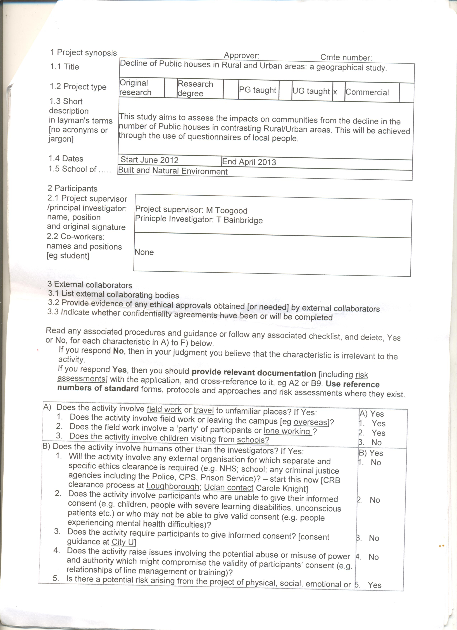
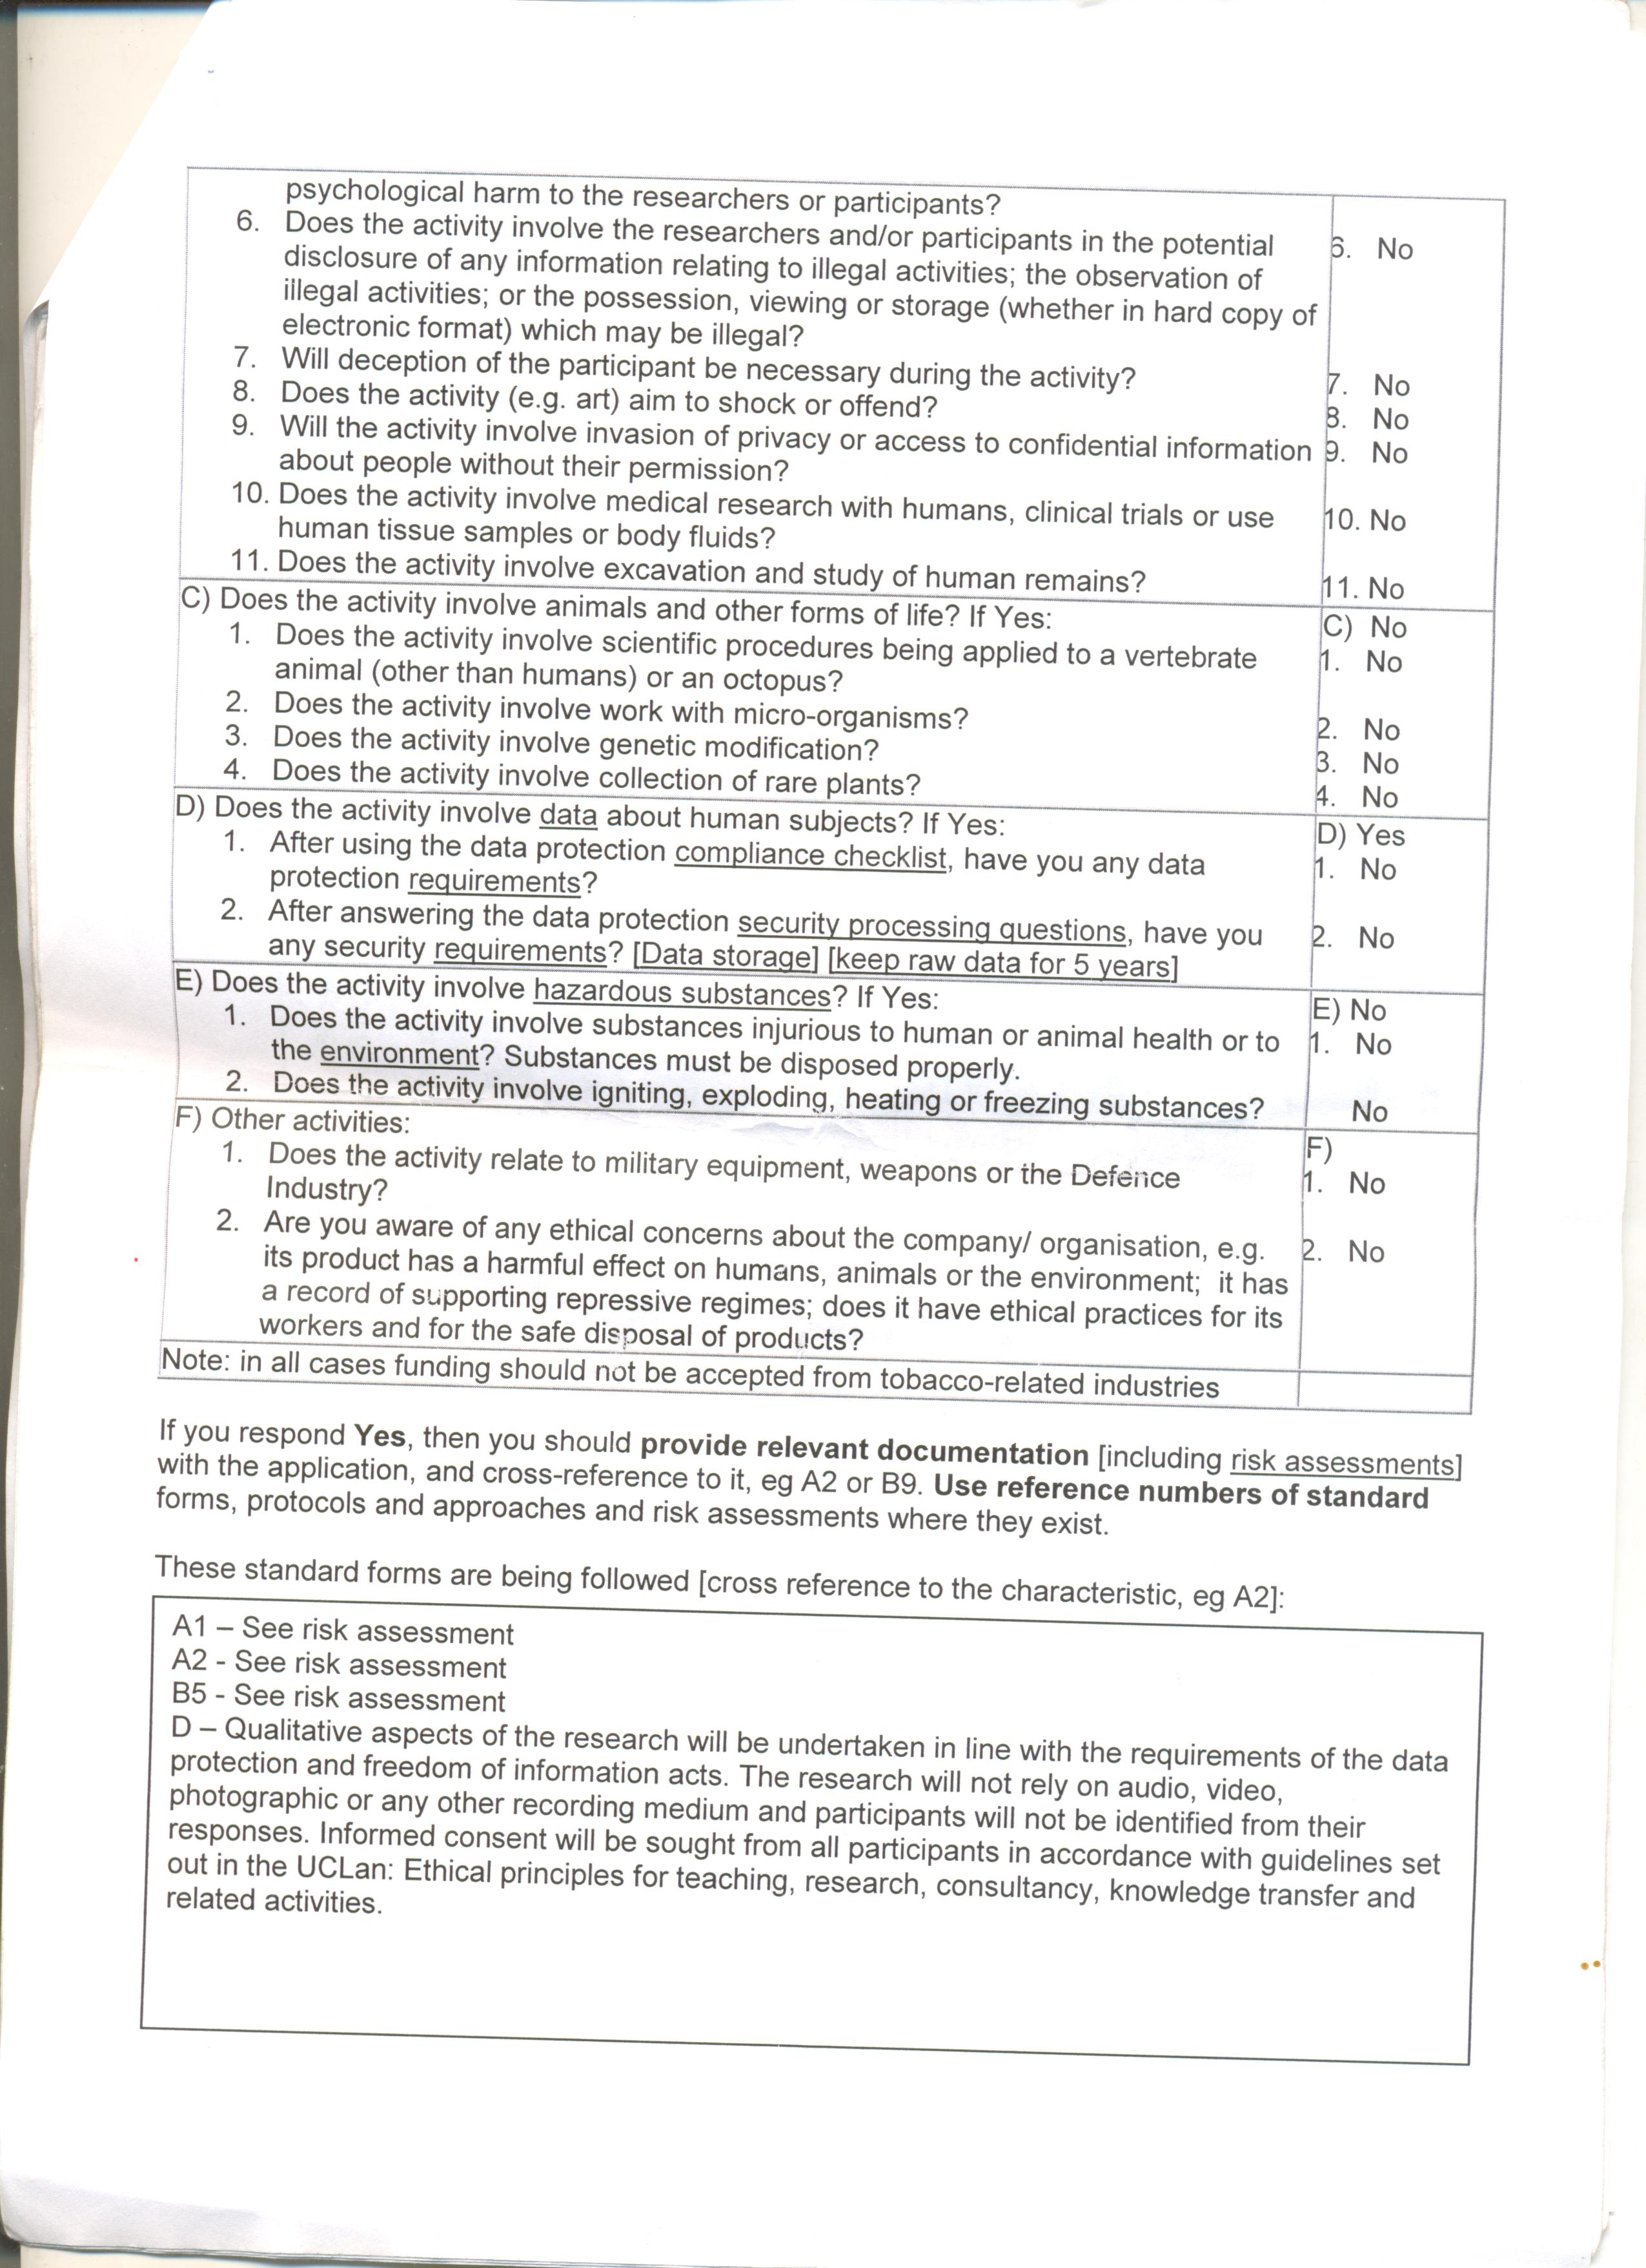

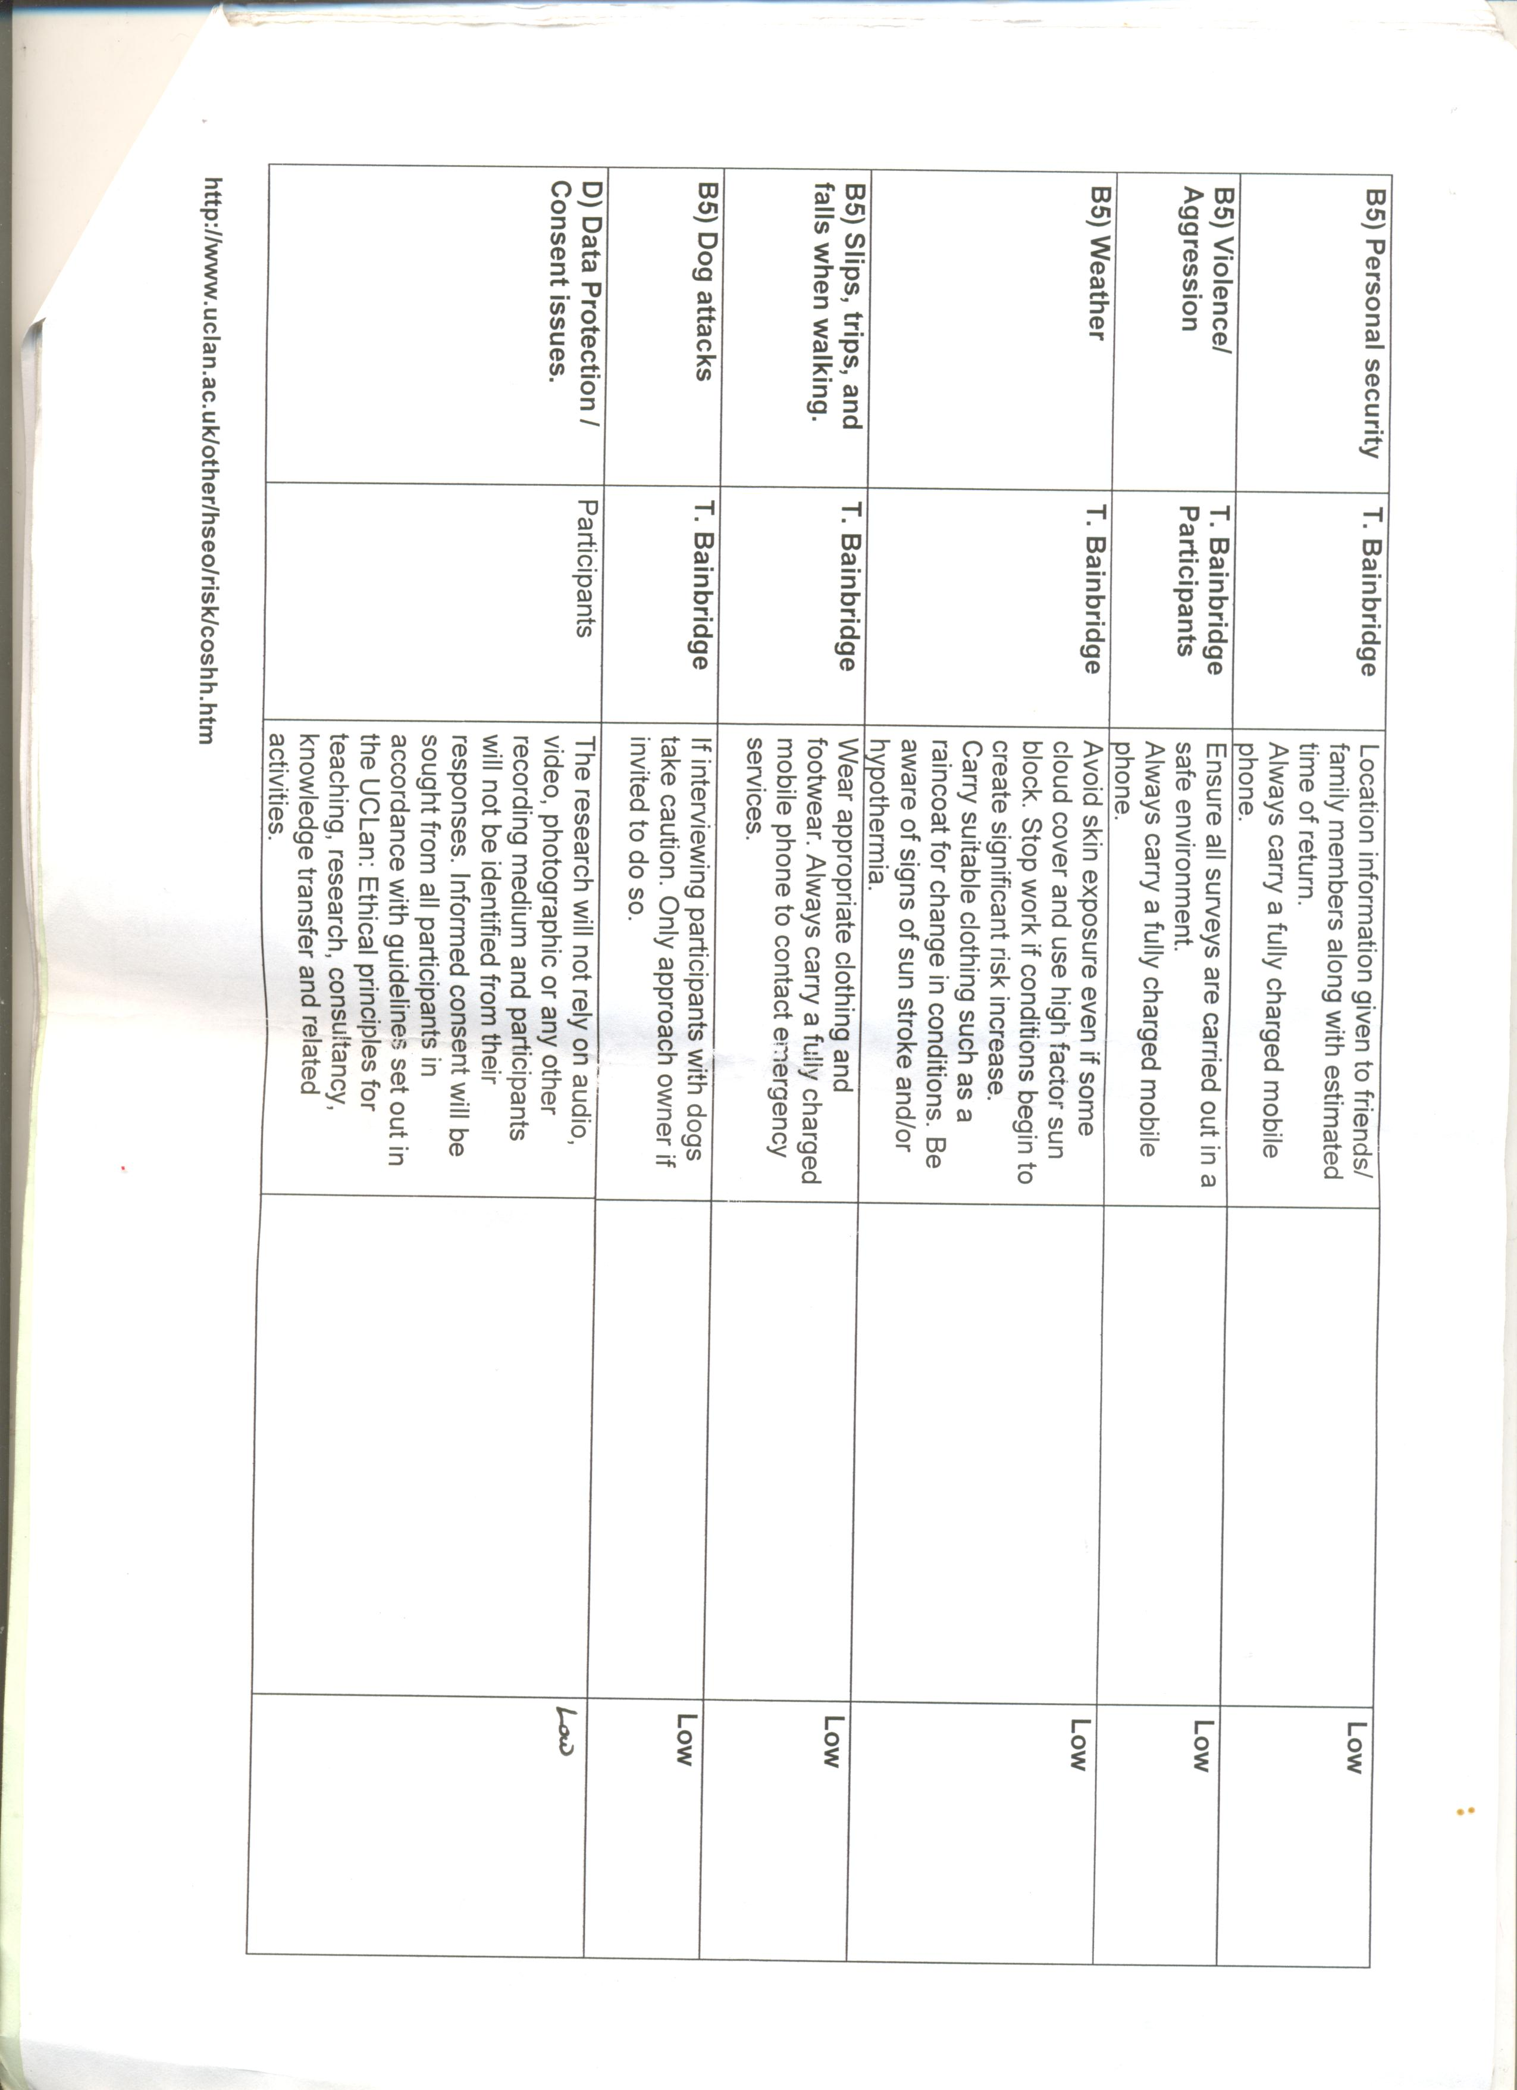
References
Beat Kumin, 2003, ‘Run by the poor for the poor’? Social Elites in the Early Modern Public House, University of Warwick, Link to published version: http://www2.warwick.ac.uk/fac/arts/ren/projects/publications/journal/seven/
Bell, 1994, Childerley: Nature and Morality in a country village, Chicago: University of Chicago press.
Brewers and Licenced Retailers Association, 1994, Beer and pubs: still best.
Cabras and Reggiani, 2010, Village pubs as a social propellant in rural areas: an econometric study, Journal of Environmental Planning and Management, 53:7,947-962.
Campbell, 2000, The glass phallus: pub(lic) masculinity and drinking in rural New Zealand, Rural Sociology, 65: 562-81
CAMRA Tracking Omnibus Survey, January 2009, cited in: Muir, 2012, Pubs and Places, The Social Value of Community Pubs, Second edition, Report for the Institute for Public Policy Research.
Camra, 2012, Camra concerned about pub closure figures, http://www.bbc.co.uk/news/uk-wales-20164532
Catholic Herald, 1938, WHEN MONKS BREWED ALE AND RAN THE PUBS Old English Inns with Catholic Origins, Catholic Herald archive, http://archive.catholicherald.co.uk/article/25th-february-1938/11/when-monks-brewed-ale-and-ran-the-pubs-old-english
Fox, 1996, Passport to the Pub: The Tourist’s Guide to Pub Etiquette, Brewers and Liscenced Retailers Association, London.
Google, 2013, map produced from google maps.
Haydon, 1994, The English Pub: A History, First Edition, Robert Hale.
Jackson, 1987. The English Pub, 1st Edition, Harpercollins.
Jennings, P (2007) The Local - A History of the English Pub, Tempus Publishing Limited, Gloucestershire.
John Pratten, Chris Lovatt, (2002) Can the rural pub survive? a challenge for management or a lost cause, Management Research News, Vol. 25 Iss: 1 pp. 60 – 72
Jones, 2012, Human Geography – the basics, Routledge, Oxon.
Markham, 2011, The Role of the Public House in Sustaining Rural Communities,
Michael Woods, 2011, Rural (Key Ideas in Geography), 1st Edition, Routledge, Oxon.
Muir, 2012, Pubs and Places, The Social Value of Community Pubs, Second edition, Report for the Institute for Public Policy Research.
Plunkett Foundation, 2013, Co-operative Pubs, http://www.plunkett.co.uk/whatwedo/Co-operativepubs.cfm
Sandiford and Divers, 2011, The public house and its role in society's margin, International Journal of Hospitality Management, Volume 30, Issue 4, December 2011, Pages 765–773.
SIRC (2008) The Enduring Appeal of the Local, The Social Issues Research Centre, Oxford.
Smith, 1983, Social Usages of the Public Drinking House: Changing Aspects of Class and Leisure, The British Journal of Sociology, Vol. 34, No. 3, Sep., 1983.

