University of Central Lancashire
The Effect of Tourism on Island Conservation;
A Case Study of Hilbre Island, Wirral.
Jennifer Carubia
Geography BSc 2012-13

Supervisor: Dr Kevin Butt

Declaration
I declare that the main body of text in this dissertation is all my own work.

Jennie Carubia.

Abstract
Hilbre Island is a Special Area of Conservation (SAC) site located within the Dee Estuary, off the North-West coast of England. The archipelago of three islands, of which Hilbre Island is the largest, is owned by Wirral Borough Council and maintained by volunteers from the Wirral Borough Council Coastal Rangers and the Friends of Hilbre Island Trust. A large number of visitors are received on the island throughout the year, inevitably increasing pressure on the landscape. This research sought to investigate, through qualitative and quantitative methods, the impact that visitors have on three selected footpaths on Hilbre Island, and how this erosion is linked with, and can be influenced by, a lack of information available at the site. Monthly visitor surveys indicated that visitors were generally unaware of the conservational status of the site and did not feel enough information was available to them; on the other hand, interviews with management bodies and people associated with the site demonstrated a general feeling of enough information being available, and opposition to new interpretation boards being erected. This study aimed to indicate the necessity of interpretation on the island and suggest methods of seeking a balance between the natural beauty of the site and provision of protection through visitor awareness in erecting one new interpretation board, and updating the current interpretation board on the island.

Acknowledgements
Firstly I would like to thank my supervisor Dr Kevin Butt for all his help through planning and carrying out my research and for his advice and guidance during throughout the project. My partner Joshua Hill, and friend Chris Holmes, for accompanying me on my monthly data collections. The Wirral Borough Council Voluntary Rangers and Friends of Hilbre Trust for their participation, with special thanks to June Atkinson, Josef Hanik and John Ball, and Merseyside Industrial Heritage Society for all their help and support.

Word Count: 10,784
Total Pages: 55

Contents
List of Figures 3
List of Tables 4
1. INTRODUCTION 5
1.1. Introduction to dissertation 5
1.2. Aims 6
1.3. Objectives 6
1.4. Research hypotheses 6
1.5. Structure 6
2. LITERATURE REVIEW 7
2.1. Conservation and geological significance 7
2.2. Impact of tourism 9
2.3. Permission and legislation 10
2.4. Impact of foot traffic on erosion of footpaths 10
2.5. Visitor counting and surveying 11
3. METHODOLOGY 12
3.1. Visitor questionnaire surveys 12
3.2. Interviews 13
3.3. Footpath measurement 13
3.4. Data supplements 14
4. RESULTS 15
4.1. Visitor questionnaire surveys 15
4.1.2. Visitor group age 16
4.1.3. Reason for visiting the island 17
4.1.4. Demography and familiarity 18
4.1.5. Visitor perception of information available and knowledge of site ownership and management 19
4.2. Interviews 21
4.2.1. Amount of information available 21
4.2.2. Visitor numbers and associated issues 22
4.2.3. Natural and human mediated processes occurring 23
4.2.4. How changes occurring can be managed 23
4.3. Footpath measurement 24
4.3.1. Site 1 24
4.3.2. Site 2 24
4.3.3. Site 3 25
4.4. Degree of accuracy 25
5. DISCUSSION 26
5.1. Visitor questionnaire surveys 26
5.2. Interviews 28
5.3. Footpath measurements 29
5.4. Limitations 29
5.5. Suggestions for further work 29
6. CONCLUSION 30
7. REFERENCES 31
8. APPENDICES 34
8.1. Appendix 1: Risk assessment form 34
8.2. Appendix 2: Ethical approval form 35
8.3. Appendix 3: Pilot survey 37
8.4. Appendix 4: Final survey 38
8.5. Appendix 5: Interview questions 39
8.6. Appendix 6: Raw data (monthly) 40
8.7. Appendix 7: Raw data (seasonal) 42
8.8. Appendix 8: Raw data (footpath width) 43
8.9. Appendix 9: Photographic timeline (site 1) 44
8.10. Appendix 10: Photographic timeline (site 2) 46
8.11. Appendix 11: Photographic timeline (site 3) 48
8.12. Appendix 12: Monthly notes 50

List of Figures
Figure 1 OS Map showing Hilbre Island, source: Ordnance Survey, 2013 5
Figure 2 View of Hilbre Island during low tide from Middle Eye, 10.3.12 7
Figure 3 Armeria maritima at Hilbre Island, 21.5.12 7
Figure 4 Red bunter sandstone cliff face on Hilbre Island eroded by tide, 21.4.12 8
Figure 5 Fire damage to vegetation on Hilbre Island, 23.2.13 9
Figure 6 Steps on footpath on Hilbre Island showing evidence of erosion, 10.3.12 11
Figure 7 Location where visitor questionnaire surveys were conducted, 10.3.12 12
Figure 8 Location from which photographic evidence for Site 1 was taken, location marked 1, 10.3.12 13
Figure 9 Location from which photographic evidence for Site 2 was taken, location marked 2 (Source: Geolocation, Image by Turner) 14
Figure 10 Location from which photographic evidence for Site 3 was taken, location marked 3, 10.3.12 14
Figure 11 Total number of visitors to Hilbre Island, data collected by handheld tally (by month) 15
Figure 12 Total number of visitors to Hilbre Island, data collected by handheld tally (by season) 15
Figure 13 Age of visitor groups surveyed on Hilbre Island (by season) 16
Figure 14 Reason for visiting on the day given by visitor groups surveyed on Hilbre Island (by season) 17
Figure 15 Visitor group response when asked whether they would consider themselves to live locally to Hilbre Island (by season) 18
Figure 16 Visitor group response when asked whether it was the first time visiting Hilbre Island (by season) 19
Figure 17 Visitors who were considered to live locally and who were first time visitors to Hilbre Island (by season) 19
Figure 18 Visitor group perspective on whether the amount of information available is adequate (by season) 20
Figure 19 Visitor awareness of, and participation in, ownership, maintenance and voluntary bodies by season 20
Figure 20 Footpath width data per month (Site 1) 24
Figure 21 Footpath width data per month (Site 2) 24
Figure 22 Footpath width data per month (Site 3) 25
Figure 23 Evidence of the impact of vehicle usage on Hilbre Island, 23.2.13 26
Figure 24 Oil visible on the western coast of Hilbre Island, 23.2.13 26
Figure 25 Current interpretation board on slipway entrance to Hilbre Island, 10.3.12 27
Figure 26 Dips in footpath at Hilbre Island (grid ref: SJ 1844 8800), 23.2.13 29

List of Tables
Table 1 Interview respondents by name, occupation and association with Hilbre Island, relating to questions 1 and 2 of interview questions 21
Table 2 Issues associated with visitors to Hilbre Island as indicated in interview responses and name of interviewees to have noted the issue 22

- INTRODUCTION
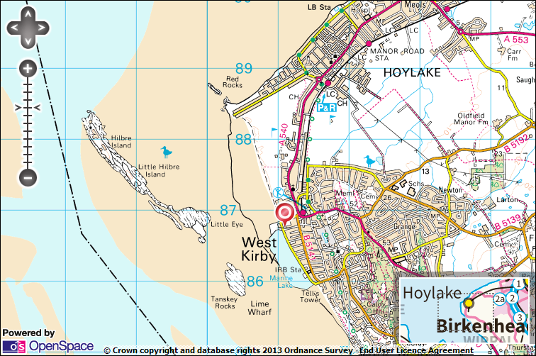
Hilbre Island is a popular tourist site located approximately two miles off the coast of the Wirral Peninsula on the North West coast of England, see figure 1. The site is owned by Wirral Borough Council who purchased the site in 1974 (Wirral Borough Council, 2012) from previous owners Hoylake Urban District Council. In recent history, Hilbre Island is largely associated with the Trustees of Liverpool Docks who owned and used the island for trade from 1828-1945 (Craggs, 1974). The site is managed by volunteers from the Friends of Hilbre Island Trust and from the Wirral Borough Council Voluntary Coastal Rangers Sector. Hilbre Island is liable to erosion by both natural and human mediated processes. This erosion occurs through the tidal pressure on the cliff side and the foot traffic received from visitors.

  - Introduction to dissertation
Figure 1 OS Map showing Hilbre Island, source: Ordnance Survey, 2013
This dissertation takes a two pronged approach to investigate the impact of tourism on the landscape, and explore the reasons for the damage that visitors to the island create. Qualitative data collection is in the form of monthly visitor group questionnaire surveys, and interviews with management and maintenance bodies, to gain understanding of what type of visitors visit the site, when the site receives the most visitors, and how much visitors know about the conservation, management and maintenance. Quantitative data collection in the form of monthly footpath width measurements were also collected as a supplement to the qualitative data, to support and emphasise the theory for visitor led erosion. It is hypothesised that the leading factor in tourism related erosion and visual disturbances is a lack of knowledge and awareness relating to the delicate nature of this site.
It is vital at sites like Hilbre Island to seek a balance between adequate information regarding points of interest such as heritage and history, and important conservational measures toward the flora, fauna, and erosion occurring, and keeping the natural beauty of island free from obvious tourism features. This research aims to provide argument for one free standing board to be erected with adequate information on both historical interest and island regulations near to the old telegraph house and Friends of Hilbre centre (grid reference: SJ 1842 8804), and for the current interpretation board (grid reference: SJ 1857 8778) located on the slipway to be updated, to limit the damage that visitors cause.
  - Aims
    - To determine whether visitors are aware of the conservation in place and of the ownership/management of Hilbre Island, and to investigate the reasons that people visit the island (activities).
    - To investigate whether bodies associated with the ownership, management and/or maintenance of Hilbre Island feel that the information provided on site is sufficient, and whether a link has been distinguished by themselves between tourism and erosion.
    - To monitor footpath erosion and determine whether there is a link between visitor traffic and the erosion occurring.
    - To indentify and distinguish a trend between the number of visitors to the island monthly and seasonally, and the erosion caused to certain footpaths, to provide evidence and argument for the implementation of interpretation board(s).

  - Objectives
- To count, and survey, visitors to the site on a set monthly schedule, to analyse the results by season.
- To interview bodies associated with the ownership, management and/or maintenance of Hilbre Island to determine their level of association and views on tourism and erosion at the site.
- To measure footpaths at set points monthly to gather evidence of footpath erosion caused by visitor traffic over the 11 month study period to supplement results obtained through objectives 1 and 2.
- To gather evidence to support research hypotheses 1-9 as outlined in section 1.4

  - Research hypotheses
    - Hilbre Island receives more visitors during the summer and autumn months
    - Hilbre Island receives more visitors in older age groups (35-49, 50+) during the spring months
    - Hilbre Island receives more visitors during the spring months for the purpose of walking, bird watching and nature viewing
    - Hilbre Island receives more visitors of a mixed age group (mixed group) for the purpose of a family day during the summer and autumn months
    - Visitors to Hilbre Island do not feel there is enough information available on site
    - The majority of visitors to Hilbre Island (50%+) do not know who owns and/or maintains the site
    - The width of all three monitored footpaths will have increased overall at the end of the 11 month study period
    - The width of all three monitored footpaths will increase more rapidly during the summer months than during the spring, autumn or winter months
    - Members of the Friends of Hilbre Island Trust and Wirral Borough Council Voluntary Coastal Rangers would like more information to made available on the island

  - Structure
The structure of this dissertation contains an introduction to the research, a review of appropriate literature, methodological detail for the three main data collection types, followed by the results of the three data collection types, discussion of the results and a conclusion. All raw data, photographic evidence and questionnaire and interview examples can be found in the appendices.

- LITERATURE REVIEW
  - Conservation and geological significance
Hilbre Island was designated a Special Area of Conservation in 2001 (Archer et al, 2010) and forms only a small part of the Local Nature Reserve (LNR), Ramsar site, Special Protection Area (SPA), Sensitive Marine Area (SMA), and Site of Special Scientific Interest (SSSI), which is the Dee Estuary (Bimson, n.d.). The main island is the largest part of the Hilbre archipelago with an area of approximately 4.5 hectares, located two miles south west off the coast of West Kirby and is only accessible during low tide, see figure 2.
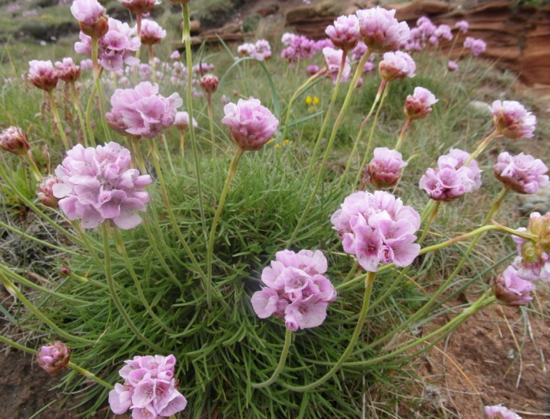
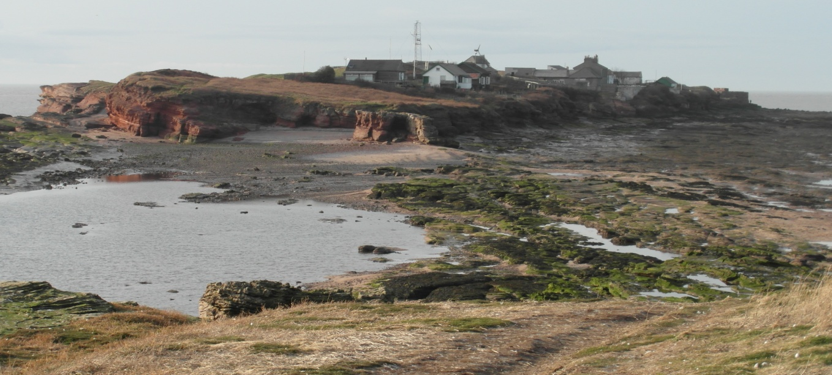
Hilbre Island is a constant habitat for many species of flora and fauna, including the endemic flora Rock Sea Lavender (Limonium britannicum celticum) (English Nature, 2006), of which Hilbre Island is one of only five places in the world where this species can be found (Wirral Council, 2013), Sea Thrift (Armeria maritime) see figure 3, and native woodlouse Sea Slater woodlouse, Ligia Oceanica (Craggs, 1982). There is interest for bird watchers in each month of the year, covered by four categories; Estuary birds, sea birds, migrating land birds, and breeding birds (Smith, n.d.). Migrating birds and sea birds are commonly seen throughout Spring and Autumn on the island, including Leach’s Storm Petrel Oceanodroma leucorhoa, for which Hilbre is famed (Smith, n.d.), and occasional sightings of visiting British bird species such as the Grey Partridge, Perdix perdix (Hilbre Bird Obs, 2012). Visitors to the island often allow dogs to roam the grasses and children to run near to the pond; both areas are of great concern not only for the protection of species that reside on the island but also for human safety. There is currently neither a safety sign nor an educational sign relating to the conservation or the species on the island.
Figure 2 View of Hilbre Island during low tide from Middle Eye, 10.3.12
The archipelago is rich in archaeological history, having been inhabited by a monastery in early years. The findings of a monastic grave site and chapel remains in 1862 (Wirral Borough Council, 2012) indicate a pre-eleventh century inhabitation. The island was subject to short-term commercial exploitation for both the salt and oyster trading industries in the late 17th century by members of the Liverpool Docks, indicating the growth of the River Mersey port and the decline of the Chester and Hoylake ports. Several features are still visible on the island dating back to this time such as the narrow brick and cinder pipelines near to the old lifeboat station (grid reference: SJ 1838 8821) (Craggs, 1982) which are of particular interest to heritage groups such as Merseyside Industrial Heritage Society who provide historical tours of the island, and visitors with an interest in local history.
Figure 3 Armeria maritima at Hilbre Island, 21.5.12
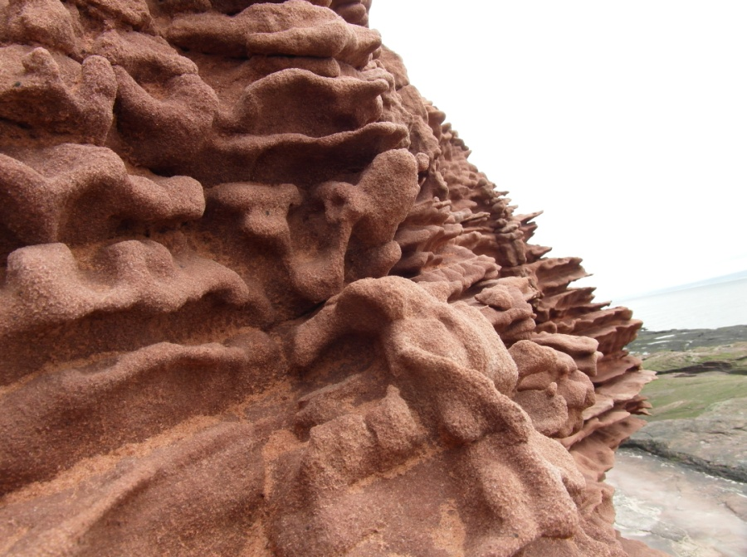
The three islands also have great geological significance as the red bunter sandstone from which the islands are formed, can also be found on the mainland between Thurstaston and West Kirby, indicating that the islands were once connected to the mainland prior to the last ice age (Wirral Borough Council, 2012). This theory is supported by findings of flint arrowheads and a flint axe-head in the 1950s dating to the neolithic period (Liverpool University, 2003). It is for these reasons that planning permission to erect interpretation boards is unlikely to be passed, though the rate of erosion, both natural and human mediated, occurring on the islands gives valid argument for an application.
Crawford and Black (2010) suggest that sites of geological importance have a different appeal to those who conserve a site, and those who visit as tourists. In a study of Giant’s Causeway in Northern Ireland, Crawford and Black suggest that the site is “globally significant to geologists” due to the lava formations, whereas it is appealing to mass tourism due to the columnar formation and mythology. The study sought to investigate visitor understanding of the geological importance of the site and the influence that interpretation available on site has on management and erosion. A similar theory can be applied to this research; though the studied site is much smaller and has much less global significance, there is a clear contrast between visitor and management appeal. For conservation bodies, Hilbre Island is a rare site forming the only natural hard rock coast in the Dee Estuary (English Nature, 1998), a principle roosting platform for migrating bird species, habitat to rare flora, and the incredibly valuable Sabellaria alveolata (Honeycomb Worm) reefs visible on the south shore of Hilbre Island, among other features (English Nature, 2006). In contrast, visitor appeal is often associated with the isolation of the island from the mainland, the achievement and satisfaction of getting to the site, and the views. Many visitors travel to the Wirral to visit the site for the mystery of the island, or to watch the seals or migrating birds, but many also visit the island purely out of curiosity and spare time whilst walking on nearby West Kirby beach. As proposed by Crawford and Black (2010), visitors who are less educated on the importance of the site can potentially cause more damage to the landscape and its features due a lack of awareness associated with a lack of interpretation. The theory behind the research, and the empirical evidence documented, provides keen similarity between the issues at hand at Giant’s Causeway and those at Hilbre Island.
Figure 4 Red bunter sandstone cliff face on Hilbre Island eroded by tide, 21.4.12
Goudie (2002) argues that “aesthetics and relevance are essential for making geomorphology a discipline that appeals to the general public and to potential students”. Like the works of Crawford and Black (2010), Goudie argues that without interpretation at such important sites, the priority appeal of geological history and importance can be lost, in turn allowing for careless and inconsiderate foot traffic, this is moderately accurate when applied to Hilbre Island.

  - Impact of tourism
Hilbre Island has been studied periodically by scientists and biologists with the focus of rock formation, bird species and marine organisms that are present at the site (Liverpool University, 2003). Hilbre Island has not been the focus of any research for the purpose of visitor understanding of conservation or tourism related erosion. Tourism and erosion are both subjects of mass research and literature; however literature regarding the field of tourism related erosion has been relatively immature (Green et al, 1990).
Green et al (1990) argue that the environment is an important tourist attraction, thus the management and conservation of such sites is important for the future of tourism. While this may be regarded an accurate vision from the perspective of tourism, it increasingly emphasises the theory that sites of great environmental value receive a high number of visitors, which will inevitably increase foot traffic and tourism related erosion.
The landscape and history of Hilbre Island, as well as the appearance of visiting grey seals, have attracted tourists to the site for decades, but in 1991 (King and Thomson, 2000) a new attraction was identified in the form of fossilised footprints within the sandstone. It is very lucky that this site has not been subject to the fracturing of rocks in search of fossils since this discovery, unlike the Scottish Isle of Skye where visitors searching for fossils have used hammers and chisels to carve out fragments for themselves (Clark, 2010). This discovery was the first Lower Triassic period fossil occurrence in the British Isles and remains a focal point for tourists visiting the site.
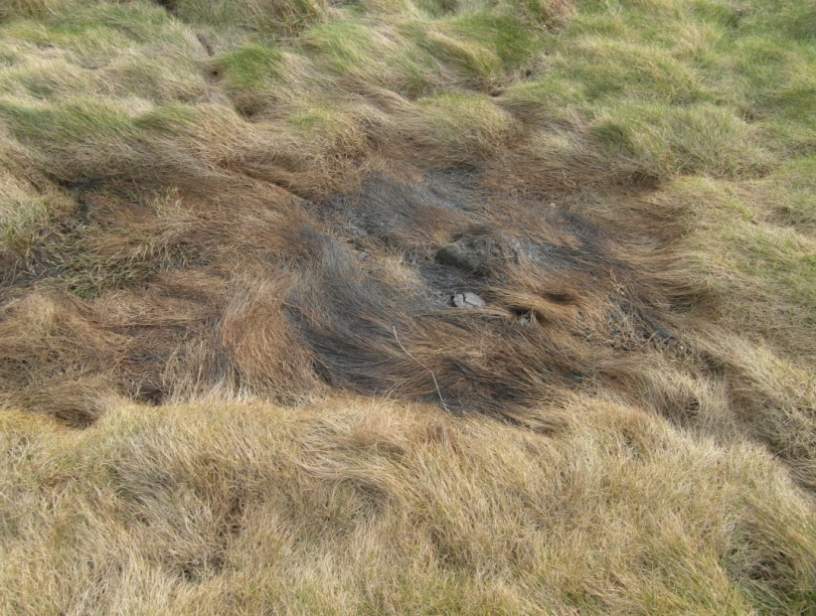
It has been suggested by Coppock (1982) that the negative effects of tourism on natural landscapes can be divided into five categories; loss of habitat, pressure of human feet and/or vehicles on soil quality and vegetation, disturbance of fauna especially small mammals and birds, damage to flora and fauna by fire and damage to flora and fauna by pollution. Hilbre Island is not subject to damage by fire, except for occasional fires started by inconsiderate visitors (see figure 5), but is indeed vulnerable to the other four factors indicated with differing measures of severity. Loss of habitat is tied into human pressure of soil and vegetation in this case study as many species on the island live amongst the vegetation that during the summer months receive a larger quantity of trampling. Human foot traffic is one of the two most significant threats on the conserved island of Hilbre as several human made paths and tracks are visible through the soil and vegetation, separate from the paths intended for use, including the three sites monitored for this study. Although Hilbre Island is not accessible by vehicle (for anybody other than council rangers), pollution in the form of visitors dropping litter can be devastating with many of the residing species being small mammals such as mice and voles, and a vast diversity of bird species; litter poses a threat by poisoning or trapping for the species. Disturbance of fauna is another issue that is critical to the nature of the island as it provides habitat to such a diversity of species including wading birds, small mammals, insects, marine life and grey seals, though this is very hard to detect and analyse except through careful monitoring over an extended period of time, which is not suitable for this study. Disturbance by humans is now a widely recognised cause of stress for fauna (Fowler, 1999, in Martin and Reale, 2008) through studies undertaken previously, and so without using this as a base line for this study it can be acknowledged when analysing the impact of tourism.
Figure 5 Fire damage to vegetation on Hilbre Island, 23.2.13
  - Permission and legislation
Until recently the Hilbre Permit Scheme was in place to ensure that all visitors to the island were accounted for, and were informed of tidal times and safety as well as general rules of conduct at the site. This scheme proved difficult to maintain due to a vast lack of participants as hundreds of people visit the site without a permit, this led to the proposal of a sign to be erected in the window of the Day Room advising of tide times and emergency regulations (Hanik, 2011). Although this sign would be an improvement on the interpretation already in place, its proposed location is not considered to be readily accessed with not all visitors walking near to the Day Room. This sign has not yet been erected, furthering the necessity of more information becoming available, and in a location which is clearly visible.
The overuse of a site by visitors is not only an internal pressure (Curry-Lindahl, 1974, in Shafer, 1990) on the landscape and its’ features, but also creates a need for adapted management and legislation. The legislation surrounding conservation of National Nature Reserves (NNRs) and Local Nature Reserves (LNRs), and the conservation of Sites of Special Scientific Interest (SSSIs) are written and overseen by Natural England. Natural England was formed in 2006 incorporating parts of the Rural Development Service, the Countryside Agency and English Nature. English Nature was formerly the government advisory agency for environmental affairs and was established in 1991 (HMSO, 1995), assuming the role of the Nature Conservancy Council in its duties and responsibilities toward conservation in England. Though Natural England hold high responsibility over the designation and management of conserved areas such as NNRs, LNRs and the SSSIs within them, local authorities have the right to power over such areas as stated in Section 28 of the National Parks and Access to the Countryside Act 1949 (English Nature, 1995), with Natural England overseeing their commitments and duties, and acting as point of power for any alterations that local authorities wish to project. It is for this reason that Natural England were interviewed for this research as the impact of tourism on both landscape and fauna plays a pivotal role in their allocation of management techniques.
  - Impact of foot traffic on erosion of footpaths
In association with the negative effects demonstrated that tourism can have on a site, Edwards (1987) argues that “the number of visitors that a site receives is reflected to a degree in the ecological deterioration present” (Edwards, 1987), though it would be very difficult to accurately measure this due to the influence of outside variations, such as seasonal factors and weather, which can influence the degree of degradation that a habitat is susceptible to. While Edwards (1987) provides a detailed analysis of ecological deterioration, the limited time scale of this research project would not allow for the intricate methodology required for that type of research, though this literature can be acknowledged and utilised when examining the impact of foot traffic on erosion at the site. This theory is not dissimilar to that of Agate (1983), in which the ecological carrying capacity and physical carrying capacity of footpaths is determined. Agate argues that “all grasses are in some degree resistant to trampling, because growth occurs from a point protected by the sheath, and is not on the tip of the shoot” but that resistance is dependent on carrying capacity. Ecological carrying capacity is described as the level of flora and fauna, and soil type, to deter or resist damage, and physical carrying capacity is expressed as being set by physical limits such as width, height and gradient. Agate’s theory can be applied to Hilbre Island as some areas such as the grassland surrounding the lake are not suitable nor appealing to walk on due to the dense vegetation and varying gradient due to the wet soil surrounding the lake, whereas some footpaths which are steady, flat and bare are more appealing and so receive a higher amount of foot traffic. One main issue with assessing coastal sites for footpath erosion is the drainage patterns of the ground during heavy rainfall or in the case of Hilbre Island, during exceptionally high tides. Drainage patterns can become altered by unrestricted public access leading to trampling of vegetation and exposing soil to rainfall and high tides, increasing erosion, as is occurring at the steps shown in figure 6 (grid reference: SJ 1840 8810). For this part of the study, methods similar to that of Coleman (1977) will be used. Coleman suggests that “in path management, erosion that is too limited to be measured... is too limited to be a problem”, however the research carried out by Coleman forms part of a study of North-west England mountain and coastal footpaths which are subject to a different force of foot traffic related erosion, and is relative to the study focus. Limited erosion of footpaths on such a small, yet biologically and geologically important site as Hilbre Island is not too limited to be a problem as over time this limited impact may influence a vast and rapid deterioration, and so this research aims to target the cause of this erosion.
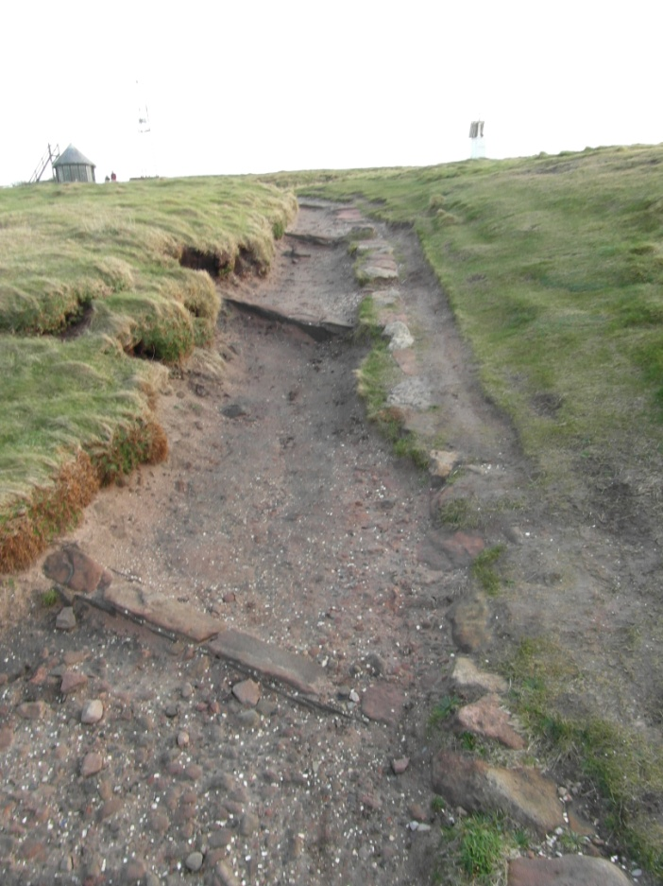
In a past study into tourism in a Local Nature Reserve (Spurn Nature Reserve in Yorkshire), Usher et al (1974) discovered through visitor questionnaire surveying that the foot traffic count was increased during the summer months, this was the same at Woolong Panda Sanctuary in China (He et al, 2008) and the island of Dominica in the Caribbean (Weaver, 1991) amongst others, and so it is hypothesised that this increase will occur at Hilbre Island, and will impact upon the erosion of the footpaths.
Figure 6 Steps on footpath on Hilbre Island showing evidence of erosion, 10.3.12
  - Visitor counting and surveying
Visitor monitoring is a common practice incurred at tourism sites globally through manual or computerised counting methods and surveying. Data collected through visitor monitoring can then be used to determine whether enhancements are necessary to management strategies, or whether strategies are adequate, in accordance with visitor numbers. Similarly, visitor surveying collects data that can be vital in making strategic decisions based on visitor opinions and preferences (Leones, 1998). For many sites, the availability of qualitative data can determine the likelihood of funding also (Cope et al, 2000); this does not apply at Hilbre Island however as the site is primarily an area of conservation and is not marketed for tourism. Cope et al (2000) argue that qualitative data and visitor monitoring is “vital in environmental assessment”, this ensures that all issues highlighted by visitors, whether first time or repeat visitors, are acknowledged and dealt with accordingly. It is important also to distinguish between first time and repeat visitors to a site as there can be a large shift in perspective, and observed issues that may be highlighted. Lau and McKercher (2004) demonstrated significant differences between first-time “explorer” visitors and repeat “acquisition” visitors in Hong Kong through a series of surveys, the theory proposed in their study can be applied to Hilbre Island. It was discovered that first time visitors participated in a variety of activities and explored much of the area that they were visiting, whereas visitors who had been before went only to certain areas to take part in certain activities. At Hilbre Island, repeat visitors often take part in bird watching, seal watching or walking, and will visit certain parts of the island, whereas first time visitors will explore the whole island and may be less sensitive to the landscape in climbing the cliff faces. It is for this reason that self-administered surveys were considered most appropriate for this research as it allowed for conversation between the conductor and the visitor, and enabled the conductor to enhance the visitor knowledge of the site.

- METHODOLOGY
The data collection for this study undertook a two pronged approach of both qualitative and quantitative methods to gather information on public and managerial perception, and supplementary evidence of erosion. Visitor questionnaires and footpath measurements were carried out on a monthly basis for a period of 11 months (April 2012 – February 2013); the data was then divided into seasons to gain both monthly and seasonal perspective. Data collections took place on the third Saturday of each month, with the exceptions of November, December and February when the data was collected on the fourth Saturday of the month due to inaccessibility to the island because of shorter day-light hours and restrictive tide times. Data was not collected for the month of January due to the aforementioned reason on the third Saturday, and severe weather conditions leading to the closure of roads, and inaccessibility to the island on the fourth Saturday.
Tide times were collected from the National Tidal and Sea Level Facility website each month in advance of data collections to ensure safety and determine the best timing for public surveying. Interviews were conducted throughout the study period by email to allow flexibility for correspondents. All photographs were taken by the author unless expressed otherwise. A risk assessment form and ethical approval form were completed before any data collection was undertaken, see appendices 1 and 2.
  - Visitor questionnaire surveys
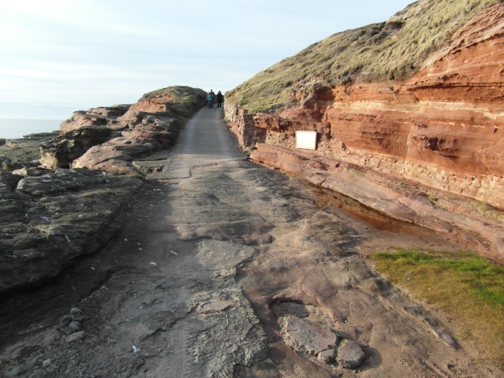
Visitor surveys were conducted on the main footpath leading to Hilbre Island, see figure 7. The survey was constructed using closed-ended (or dichotomous) questions and multiple choice questions, see Appendix 4. The questions were created to ascertain specific non-personal data on a large scale, and so unobtrusive closed-ended questions were most appropriate. The questions asked sought to determine the age range of visitors, their reasons for visiting and their knowledge on the ownership and management of the island. Visitors were also asked if they were members of the Friends of Hilbre Trust and whether they felt sufficient information was available to them on the island. By asking whether visitors were aware of the ownership and management bodies, and their perception on the availability of information, the answers received could provide evidence to support hypotheses 5 and 6, that people are unaware due to a lack of information, and by gauging the number of visitors it could be determined whether this unawareness has an influence on erosion through tourism pressure. Visitors were asked whether they were members of the Friends of Hilbre Trust to put into perspective the amount of visitors to the island that have a direct link to the management or conservation. A pilot survey was carried out in March (10.3.12); see Appendix 3, and the questions were adjusted according to public feedback. Only one member of each group of visitors was required to complete a survey, as a representative of the group.
Figure 7 Location where visitor questionnaire surveys were conducted, 10.3.12
Other methodologies were considered for this research, however were considered to be not appropriate. Postal or door-to-door data collection by questionnaire was not suitable as not all local residents have visited the island. Online surveying was not suitable as the audience was too broad to collect accurate and locally specific data.
Visitor numbers were ascertained using a handheld tally counter, in addition to visitor questionnaire results, to monitor the flow of visitors to the site on a monthly and seasonal basis, and to determine which months received the most visitors in correlation with the months indicating higher footpath erosion.
  - Interviews
Interviews were conducted by email to accommodate the interviewee’s personal schedules, see Appendix 4. Like the visitor questionnaires, the questions asked were designed to be unbiased and neutral to avoid influencing the correspondent’s answers and voiding the research. Interviews were conducted with members of the Wirral Council Voluntary Rangers, Friends of Hilbre Trust, Merseyside Industrial Heritage Society, the Royal Society for the Protection of Birds, and Natural England. Interviews were conducted with these organisations due to their association with either the management of the island or their controlled visits and tours of the island. Each interviewee was asked to confirm their name, job title and their association with Hilbre Island before answering questions on their opinion of management and erosion on the island. Though the questions asked were worded to be neutral, the interview process retains a “top-down dimension” (Carey and Sutton, 2004) as the researcher is in the position of asking selected questions and interpreting data for relevance. To counter this, all data collected was broadly analysed for consistencies and for extreme outliers to allow for a fair analysis to be obtained.
  - Footpath measurement
The widths of footpaths at three designated sites on the island were measured using a 30 metre tape measure and the use of a solid point to measure from, and with previous photographic evidence for comparison. The three footpaths chosen are of a very different standard emphasising the interest for monitoring and comparison. This data was collected as evidence to support the argument for the erection of interpretation board(s) at the site, and is intended to be indicative only. Only one measurement was taken per month for the purpose of indication.
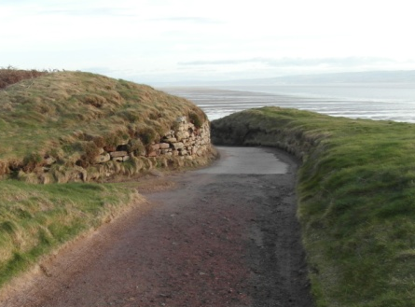
Site 1 (SJ 1855 8782) is located 15m from the end of a concrete slipway entrance to the island and is a logical, designated public footpath. The 15m distance was measured from the centre of the path where the concrete slipway ends and the soil path begins, see figure 8.
1
Figure 8 Location from which photographic evidence for Site 1 was taken, location marked 1, 10.3.12

Site 2 (SJ 1842 8801) is a narrow, trampled path through grassland off the main footpath. The measurement for this path was taken on an estimated 45º angle from the right hand corner of the step of the telegraph station, when facing toward the main pathway and wall, see figure 9.

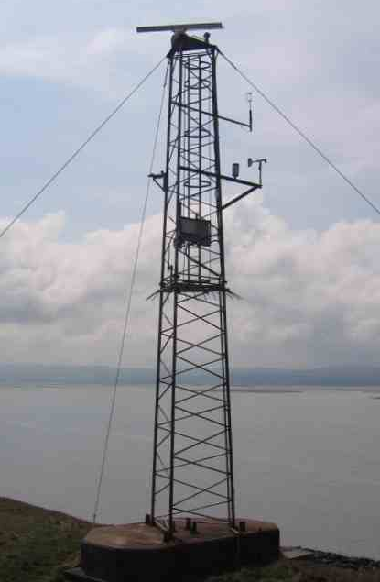
2
Figure 9 Location from which photographic evidence for Site 2 was taken, location marked 2 (Source: Geolocation, Image by Turner)

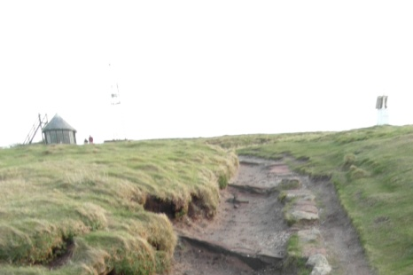
Site 3 (SJ 1841 8807) is located toward the far side of the island and is a continuation of the designated footpath where erosion from heavy use over a long period is visible. The measurement for this path was collected 10m from the top step, see figure 10, toward the telegraph house.
3
Figure 10 Location from which photographic evidence for Site 3 was taken, location marked 3, 10.3.12
The measurement for all three sites was estimated for the month of January as no data was collected, using a mid-point between measurements from December and February.
  - Data supplements
Photographs were taken of each of the three footpaths from a set point each month to demonstrate visually the changes that were occurring. All photographic evidence was collected at the solid point used to measure from, as outlined for each footpath in section 3.3.
Notes were made, and photographs taken, each month to document any local media surrounding Hilbre Island such as newspaper articles or museum exhibitions, and litter and any other visual disturbances, see appendix 12.

- RESULTS
  - Visitor questionnaire surveys
Visitors were asked to complete one questionnaire per group, as a representative of the group. All visitor groups invited to complete the questionnaire, except for one, did so. The group that refused to complete the questionnaire was a drug rehabilitation group in data collection month April, who did not feel it appropriate to take part.
    - Visitor count (using handheld tally)
Hilbre Island received the most visitors during the summer season of 2012, as hypothesised, with a total of 424 visitors (see figure 12), though the month with the highest visitors was September, at the beginning of the autumn season with 214 visitors (see figure 11). The months with the lowest visitor count was December, where no visitors were recorded, and November when 23 visitors were recorded. The season with the lowest number of visitors was winter, in which all 87 visitors were recorded during February, the end of the winter season. There were no visitors recorded in December, and there was no data collection in January. Spring received only 173 visitors with the highest number recorded in May at 97.
Figure 11 Total number of visitors to Hilbre Island, data collected by handheld tally (by month)
Figure 12 Total number of visitors to Hilbre Island, data collected by handheld tally (by season)
*
* No data collected
    - Visitor group age
During spring there were no visitors aged 0-17, and 9.09% were 18-24, see figure 13. The largest proportion of visitors was aged 50+ with over 36% and the second highest proportion was mixed groups with over 22.7%. 18% of visitors were aged 25-34 and the remaining 13.6% were aged 35-49.
The summer months saw an increase in younger visitors with 3% of visitors aged 0-17 and 16% aged 18-24. The largest age group in the summer was mixed groups with 35.8%, followed by 25-34 year olds with 26.9%. Only 10% of visitors were aged 50+ during these months, a significant decrease from the spring months, and visitors aged 35-49 decreased also with 9%.
Autumn has a more evenly distributed range of age groups with the largest percentage at 30% mixed groups, and the lowest at 5.7% aged 0-17. The age group 0-17 has seen another increase at nearly twice the amount of summer visitors in this age range. The remaining four categories are very close in their results for this season with age 50+ having a slightly higher percentage at 17.14% and all 18-24, 25-34 and 35-49, having 15.71%.
In the winter season, the age group 0-17 continued to increase to over 6%, and both age groups 18-45 and 25-34 saw an increase of 3.04% to a total of 18.75%. Both 35-49 and 50+ decreased during these months to 9.38% and the mixed group category increased to 37.5%.
The age group 0-17 was lowest during spring and peaked during winter, 18-24 similarly was lowest during spring and highest during winter. The age group 25-34 was highest during the summer months and lowest during autumn, whereas 35-49 was highest during autumn and lowest during the summer months. The over 50 age range was lowest during the winter months and was largely dominant during spring. The mixed group category retained a large percentage throughout the year, being the largest age group in all seasons except for spring, and was highest in percentage in winter and lowest during spring.
Figure 13 Age of visitor groups surveyed on Hilbre Island (by season)
    - Reason for visiting the island
Visitors were asked for what reason they were visiting the island on the day, with a multiple choice selection. Visitors could select more than one option.
During the spring months, the majority of visitors (63.64%) recorded declared “walking” as their reason for visiting, see figure 14. This reason for visiting remained prominent throughout the study. The second highest percentage was recorded in “nature viewing” with 32%, followed by “family day” with 22.73%. There were no visitors that recorded “other” as their reason for visiting the island, and 9.09% recorded “dog walking”. “Bird watching” and “sight-seeing” gained 18.18% and 13.64% respectively and were not dominant reasons for visiting Hilbre Island during the spring months.
The summer months received the majority of visitors for the reason of “walking” and “family day” with 50.75% and 47.76% respectively. This combination of reasons remained prominent for the duration of the study. Like the spring period, “bird watching” was not recorded by a large proportion of visitors, gaining 11.94% , and “dog walking” saw an increase from the spring months with 10.45%. “Sight-seeing” and “nature viewing” were both recorded as a reason for visiting by 25.37% each, and 1.49% recorded “other” as their reason for visiting.
The majority of visitors during autumn recorded “family day” as their reason for visiting (48.57%) followed by “walking” with 37.14% and “sight-seeing” with 32.86%. “Nature viewing” as a reason for visiting declined from the spring and summer months with 18.57% recorded in autumn, similarly “dog walking” and “bird watching” declined with 5.71% and 4.29% respectively. No visitors recorded “other” as their reason for visiting.
Figure 14 Reason for visiting on the day given by visitor groups surveyed on Hilbre Island (by season)
During the winter months a vast majority of visitors recorded both “walking” and “family day” as their reason for visiting with 90.63% and 81.25% respectively. There was no recording of “other” as a reason for visiting, and the smallest percentages with 6.25% each were “sight-seeing” and “bird watching”. “Nature viewing” declined further this season with only 9.38% of visitors recording it as a reason, and “dog walking” increased by 9.92% to 15.63%.
Both “family day” and “walking” remained prominent throughout the study period as a reason for visiting. “Family day” peaked at 81.25% during the winter period, as did “walking” with 90.63%. “Bird watching” was recorded as a reason for visiting most during the spring months by 18.18% of visitors; similarly “nature viewing” was highest during this period with 32%. “Dog walking” peaked during the winter period along with “family day” and “walking” and was lowest in the autumn. “Sight-seeing” was recorded highest during the autumn period and lowest during the winter period.
    - Demography and familiarity
Visitors were asked whether they considered themselves to live locally to Hilbre Island (see figure 15) and whether it was their first visit to the site, see figure 16. A slight majority recorded it being their first visit in the summer, autumn and winter months with 58.21%, 51.43% and 59.38% respectively. During the spring months the result for “no” was higher than “yes” with 54.55%, this was the only season where the majority of visitors had been to the island before. The percentage of visitors that recorded living local to Hilbre Island increased throughout the study period with 45.45% recording “yes” in spring, resulting in a slight minority, and 75% in winter as three quarters of the total. The spring and summer months received narrowly under half local visitors with 45.45% and 46.27% respectively recording “no”, whereas the autumn and winter periods were dominated by local visitors with 61.43% and 75% respectively.
Figure 15 Visitor group response when asked whether they would consider themselves to live locally to Hilbre Island (by season)

Figure 16 Visitor group response when asked whether it was the first time visiting Hilbre Island (by season)

Figure 17 Visitors who were considered to live locally and who were first time visitors to Hilbre Island (by season)

There were more first time local visiting groups in the spring months and less in the summer months than any other season, see figure 17. The highest percentage of total visitor groups that declared considering themselves to live locally to Hilbre Island, and that it was their first time visiting the site, was 27.27%, while the lowest was 16.42%. The autumn and winter months saw an incline in these figures with 20% and 21.88% respectively. As a percentage of visiting groups who considered themselves to live locally, 60% were first time visitors in spring, this is the only season in which over half of local visitor groups surveyed were visiting for the first time. There is a steady decline in the following seasons in the percentage of local visiting groups who stated it was their first visit from 35.48% in summer to 29.17% in winter.
    - Visitor perception of information available and knowledge of site ownership and management
The majority of visitors recorded “no” across all four seasons when asked whether they felt enough information was available on the island, see figure 18. The highest percentage of visitors recording “yes” was the spring period with 40.91% which rapidly decreases to 19.40% in the summer months and 12.86% and 15.63% in autumn and winter respectively.

Figure 18 Visitor group perspective on whether the amount of information available is adequate (by season)

There is a clear decline from spring through to winter in visitors recording “yes” to being aware of the conservational status of Hilbre Island, see figure 19. The highest percentage is 50% in spring and the lowest is 37.50% in winter. The highest recorded percentage for visitors knowing who owned Hilbre Island was 27.27% in spring, the second highest being 0.13% less at 27.14% in autumn. Winter showed a slight decrease at 25% and summer recorded a much smaller percentage at 14.93%. The autumn months received the highest percentage of visitors recording “yes” to knowing who maintains the site with 20%, 1.92% higher than spring and 13.75% higher than the lowest percentage of 6.25% in winter. Summer was below half the percentage of autumn with 8.96%. Visitors who were members of the Friends of Hilbre Island Trust visited the site during spring, summer and autumn with 4.55%, 1.49% and 2.86% recorded respectively. No members of Friends of Hilbre Island Trust were recorded during the winter period.
Figure 19 Visitor awareness of, and participation in, ownership, maintenance and voluntary bodies by season
  - Interviews
Nine responses were received following interview questions (see Appendix 5) being emailed to correspondents throughout the study period. Of these 9 responses, 3 were from members of the Hilbre Island Trust, 3 were of an archaeological perspective, 2 were from the current senior coastal ranger and current voluntary coastal ranger, and 1 from Natural England, see Table 1. The local representative for the Royal Society for the Protection of Birds failed to respond.

Name | Occupation | Association with Hilbre Island
Christine Longworth | In Retirement, Freelance Museum archaeological consultant (Previously Curator of British and European Antiquities, National Museums Liverpool) | Archaeological surveying, created research group to study archaeology and history of archipelago
Hannah Birtles | Lead Advisor of Land Management, Cheshire to South Lancashire Team – Natural England | Responsible Officer for the Dee Estuary SSSI, SPA, SAC and Ramsar site
John Ball | Voluntary Coastal Warden | Warden for archipelago for three seasons over last 2 years
Josef Hanik | Senior Ranger for Wirral’s Coast | Manager of reserve for 10 years
June Atkinson | Retired Teacher | Member of Friends of Hilbre for 9 years, Volunteer co-ordinator on seal watching open days for 6 years
Ken Stackhouse | Retired Engineer | Mid-week task co-ordinator for Friends of Hilbre for 7 years
Dr Rob Philpott | Acting Director, Museum of Liverpool/Head of Archaeology | Minor excavations ahead of developments or changes to the island
Roy Forshaw | Building Surveyor | Surveying Hilbre for landscape interpretation and recording Archaeological finds
Sue Craggs | Retired Biology Teacher | Member of Friends of Hilbre, visits to the island since 1948
Table 1 Interview respondents by name, occupation and association with Hilbre Island, relating to questions 1 and 2 of interview questions

    - Amount of information available
The majority of responses (7 out of 9) indicated a general sense of sufficient information being available at the site. Ken Stackhouse, mid-week task co-ordinator for the Friends of Hilbre Island Trust, declared that there was not enough information available at the site and that there ought to be more information at West Kirby, and on” the approach to the island” (Stackhouse, pers. comm. 2012); this response is considered to be an outlier as it was the only response to directly state “no” as an answer. Another outlier was identified in the response of Hannah Birtles who stated that she was “not familiar with the site” but was aware of information available nearby at West Kirby, Thurstaston Visitor Centre and on the internet (Birtles, pers. comm., 2013). Other respondents advocated the current interpretation board should be updated, and more information ought to be available at West Kirby, but that no new boards should be erected on the island itself.
    - Visitor numbers and associated issues
Three respondents answered “yes” when asked whether they considered visitor numbers to have increased, these responses were from John Ball, Josef Hanik and Ken Stackhouse, all of whom have regular contact with the island and with visitors on the island. Three respondents answered that they were unsure as they did not visit the island enough to comment. Three respondents answered that there had not been an increase of late, and referred to historical busy periods such as the “late 1800s-1900s” (Forshaw, pers. comm., 2012) or the “mid-20th century” (Longworth, pers. comm., 2012) and the “sunny ‘Hilbre Days’ of the 1950’s” (Craggs, pers. comm., 2012).
When asked to comment on issues associated with the visitors at Hilbre Island, a variety of responses were received, see table 2. The most frequently occurring response referred to a lack of information surrounding tide times leading to visitors becoming stranded, this responses was noted by four interviewees. Dogs off leads, litter, and footpath erosion appeared frequently also with each answer having been indicated more than once. All other responses were only indicated once.

Issue Identified | Identifying Respondent
Lack of tidal knowledge | Sue Craggs  Roy Forshaw  Josef Hanik  John Ball
Dogs not on leads | June Atkinson  Christine Longworth  Sue Craggs
Litter | Dr Rob Philpott  John Ball  Christine Longworth
Footpath erosion | Dr Rob Philpott  June Atkinson
Vandalism | June Atkinson
Soil erosion | Josef Hanik
Plant erosion | Sue Craggs
Fire | Sue Craggs
Damage to archaeological remains | Dr Rob Philpott
Lack of disabled access | Christine Longworth
Burial of human ashes and introduction of alien species (flowers) | Sue Craggs
Anti-social behaviour | Josef Hanik
Table 2 Issues associated with visitors to Hilbre Island as indicated in interview responses and nameof interviewees to have noted the issue

Only one interviewee provided no issues in their response; Hannah Birtles from Natural England, stated that she was “not aware of any problems associated with visitors” and that visitors were “managed by the council” (Birtles, pers. comm., 2013). Similarly, Roy Forshaw indicated that “most visitors appreciate the island and there is little vandalism” (Forshaw, pers. comm., 2012). In contrast, the answers provided by a number of other respondents indicate that these problems are frequent and are often deliberate. Both Christine Longworth and Susan Craggs state that the signs telling visitors to keep dogs on a lead and to take litter home are often ignored. Ken Stackhouse believes that the main issue associated with visitors to Hilbre Island is a “lack of knowledge, especially the correct way to treat a nature reserve” (Stackhouse, pers. comm., 2012). Similarly, Josef Hanik, Senior Coastal Ranger for Wirral Borough Council, noted that some visitors query the lack of signage on the island, and there have been “incidents of anti-social behaviour and for police assistance” though this type of visitor associated issue is not common (Hanik, pers. comm., 2013).
    - Natural and human mediated processes occurring
All respondents identified issues of natural erosion and human mediated erosion. Seven out of nine responses indicated erosion to the rock faces due to the force of the weather and the sea, and three of these responses also indicated people climbing on the cliff faces as a cause of rock erosion. Three respondents noted changes to the slipway and old lifeboat station due to storm damage, indicating that natural erosion was an important issue. June Atkinson stated the “effects of the sea and weather conditions have caused more damage than the people” (Atkinson, pers. comm., 2012), though over half of the interviewed respondents (five out of nine) noted “footpath erosion” as a process occurring on the island. Hannah Birtles made reference to changes on the island caused by human interference such as the creation of buildings and the erection of fences having an influence on the natural processes occurring, but did not indicate the processes to which she was referring.
    - How changes occurring can be managed
All responses indicated “management” but not all directly commented on Wirral Borough Council, the Friends of Hilbre Island Trust, or any other management bodies. Ken Stackhouse commented on the work of the coastal rangers and indicated that a continuation of the work by the rangers would be adequate management of the changes occurring. Both Roy Forshaw and Dr Rob Philpott noted the work of Wirral Borough Council and the Friends of Hilbre Island Trust as a means of management, and John Ball, current voluntary coastal warden for Wirral Borough Council responded “working with the Friends of Hilbre Island Trust” (Ball, pers. comm., 2012). Sue Craggs indicated that the work currently being carried out by both the council and the volunteers from the Friends of Hilbre Island Trust was adequate in managing the changes, but that “more visitor control” is needed (Craggs, pers. comm., 2012). Both Christine Longworth and June Atkinson made reference to necessary work on the old lifeboat house, June Atkinson furthered this comment to state that the “funds necessary were not forthcoming” and that she “feared that the Friends were having little impact” (Atkinson, pers. comm., 2012).
Josef Hanik, current senior coastal ranger for Wirral Borough Council, explained that by “working with the Friends of Hilbre Island Trust and re-establishing the Hilbre Island Advisory Group we hope to be able to highlight particular changes and focus attention on certain issues” (Hanik, pers. comm., 2013), he continued to explain that recent issues highlighted include the use of ranger vehicles on site and mowing footpaths to reduce erosion.
Hannah Birtles of Natural England responded that she was “unaware of any changes occurring on the island” (Birtles, pers. comm. 2013).
The responses received for this question contained a variety of opinions, the general consensus was that continued work by the Wirral Borough Council and the Friends of Hilbre Island Trust was the best way to manage the site and the changes occurring, but one response indicated that volunteers are not always enough and funding is not always available to continue the necessary work.

  - Footpath measurement
    - Site 1
There is a clear upward trend in the width of this path, see figure 20. There is an increase from 2.25m in April to 2.49m in February. There was a steady increase between April and July before a steady decline 2.32m in September. From September onwards there was an incline, increasing rapidly between October and November and becoming a steady increase from November to February; the width of this footpath increased by 0.24m throughout the study period and was the biggest growth recorded out of the three measured sites.

Figure 20 Footpath width data per month (Site 1)
    - Site 2
The width of this footpath increased overall throughout the study period by 0.11m, see figure 21. The width of the path was stable between April and May but increased in June to 0.39m before a steady decline to 0.32m in August. The width increased gradually from 0.32m in September through to February where it reached its peak at 0.48m. There is a steady upward linear trend between the start of the study period and the end.

Figure 21 Footpath width data per month (Site 2)
    - Site 3
The data collected for the width of this footpath is erratic in comparison to the results of sites 1 and 2. There is a rapid incline between April and May, in which the width increased by 0.1 m from 2.49m to 2.59m, continuing to increase to 0.6m in June, see figure 22. A gradually increasing decline followed between July and September when the width decreased by 0.05m to 2.55m, reducing the overall growth so far by half. This decline was followed by a steady increase in October and a more rapid increase in November before a plateau between November and December at 2.59m. The final months showed an increase of 0.04m to 2.63m. The width of this footpath increased by 0.14cm throughout the study period, from 0.49m in April to 0.63m in February.

Figure 22 Footpath width data per month (Site 3)

  - Degree of accuracy
All responses from the visitor questionnaire survey and interviews are considered in good faith. Visitor questionnaire surveys were completed by only one member of each group and so may not be an accurate representation of all members of the group visiting on the day, though visitors were advised to complete the questionnaire as a representative of the group.
Footpath measurements were only taken at one point for each path, and only one time, so no average was obtained. The point at which measurements were taken was estimated each month through the use of a measured distance from a solid point, previous photographs and personal memory. Measurements may vary each month due to the angle of the tape measure; no measures were in place to ensure that the point of measurement was exact. This data is not considered to be wholly accurate but is intended as a supplement to support, and provide evidence for, the theory that visitors cause erosion due to a lack of awareness of the conservation, and that the use of interpretation boards may limit this erosion.

- DISCUSSION
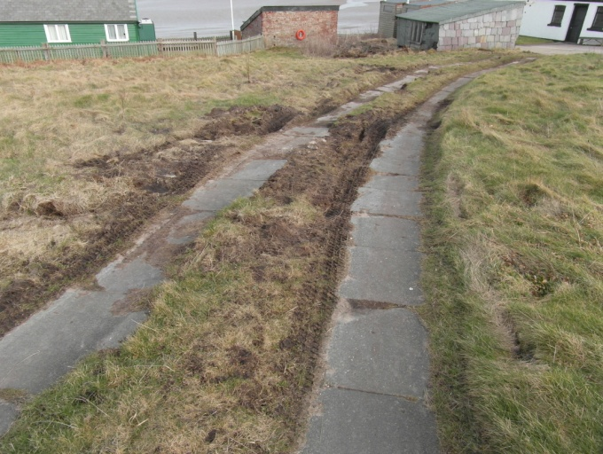
Hilbre Island receives thousands of visitors per year. Though this research only demonstrates 10 days throughout an 11 month period, if these visitors are representative of the mass body of visitors throughout the year, there is a great issue of a lack of visitor awareness. There are other factors too that must be noted as erosion on the island is not solely due to visitor awareness and its associated problems. Natural forces such as the weather and the tidal power of the estuary inevitably have a damaging impact on the islands, and though there are measures that can be implemented to protect the island, it would not be possible to prevent this form of erosion altogether, whereas altering the actions of visitors may have a more influential impact. As well as foot traffic from visitors, the actions of the management and maintenance bodies on the island have a detrimental impact. Though the coastal rangers and conservationists from Wirral Borough Council and the volunteers of the Friends of Hilbre Island Trust are keen and active in protecting and preserving the island, some of their actions may be considered contradictive. The use of vehicles to travel to the island, and to carry tools and materials, causes visible erosion to the soil, vegetation, and pathways (see figure 23), and this must be addressed as a matter of urgency.
Figure 23 Evidence of the impact of vehicle usage on Hilbre Island, 23.2.13
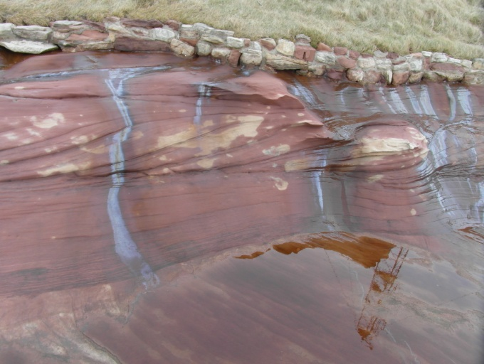
Many issues were observed throughout the study period, as noted in appendix 12, relating to a range of erosional forces. During December the toilet block on the island became flooded, the hinges on the doors were broken and the doors became warped; this was likely due to a combination of heavy rain and/or snow, and high tides and storm surges. This issue was not rectified by the end of the study period in February, though the doors had been tied to the adjacent railing to prevent further damage, indicating that the rangers on the island were aware of the issue. There was little litter or other obvious visitor issues identified throughout the study period, though in February there was litter and fire damage identified on the island. Similarly, tracks made by the management vehicles were more obvious in February due to the wet ground. Oil was identified in February also on the western side of the island which appeared to have been washed onto the island with the tide, see figure 24. This is an issue that management should be aware of though there is little that can be done to prevent this occurrence. No suggestions have been made regarding prevention of or protection from oil spillages on the island.
Figure 24 Oil visible on the western coast of Hilbre Island, 23.2.13
  - Visitor questionnaire surveys
As hypothesised, visitor numbers did increase during the summer and autumn months, this was primarily due to the longer daylight hours, good weather and school holidays attracting family groups and younger visitors to the island. Similarly, the majority of visitors during the spring months were of older ages and the majority came for the purpose of bird watching and walking, as anticipated, due to the season bringing migrating birds to the site and the cool weather. The results observed during this research was similar to those noted in Ann and Tim Cleves’ report “A year on Hilbre”. Though this report focused largely on living conditions on the island and the variable weather conditions, the Cleves’ wrote that bird watchers were present from March until April and that a vast number of visitors began to appear starting from the bank holiday in April through to the end of the summer; the end of the summer was when most visitors, notably school groups, were present (Ann and Tim Cleves in Craggs, 1982). The weather throughout the study period was variable, similarly to the Cleves’ report; this variability and the tidal times impacted the number and type of visitors throughout the study. Family groups were more common during sunny weather whereas the majority of visitors attending during wet weather were walkers or bird watchers (see Appendix 6).
There was more litter identified during the summer months when the visitor numbers increased, however many visitors questioned the lack of bins around the site when in discussion following the survey. At present there are no signs that say that litter must be taken away from the island, and the danger that litter causes for many species that reside on the island, similarly there is no information to relay the reason behind the lack of bins. Understandably, due to the high tides and strong winds that occur frequently at the island, litter is swept into the estuary and so there is little use in having bins on site, however to visitors this may seem as though there is little care from the management with regard to litter as no bins have been provided for them and unfortunately not everybody sees fit to take litter home with them, a point raised during interviews with members of the Friends of Hilbre Island Trust, see section 4.2.2.
Visitors were generally unaware of the ownership or management of island and often asked for more information following the survey. Similarly, the vast majority of visitors did not feel enough information was available to them at the site and many were not aware of the conservational status of the island or of the charity group the Friends of Hilbre Island Trust. As many visitors throughout the study period indicated that they lived locally to Hilbre Island, it became apparent that the answer of “Wirral Borough Council” to knowing who owned and/or maintained the island was a combination of knowing and guessing. Similarly, several visitors commented on their answer of “Friends of Hilbre Island Trust” being solely in relation to seeing the group name written in the last question of the survey, although they did not know what the group did. There was a large amount of interest displayed by visitors following the survey. Many visitors asked for more information about the Trust and how to join, indicating that more advertising of the Trust is necessary.
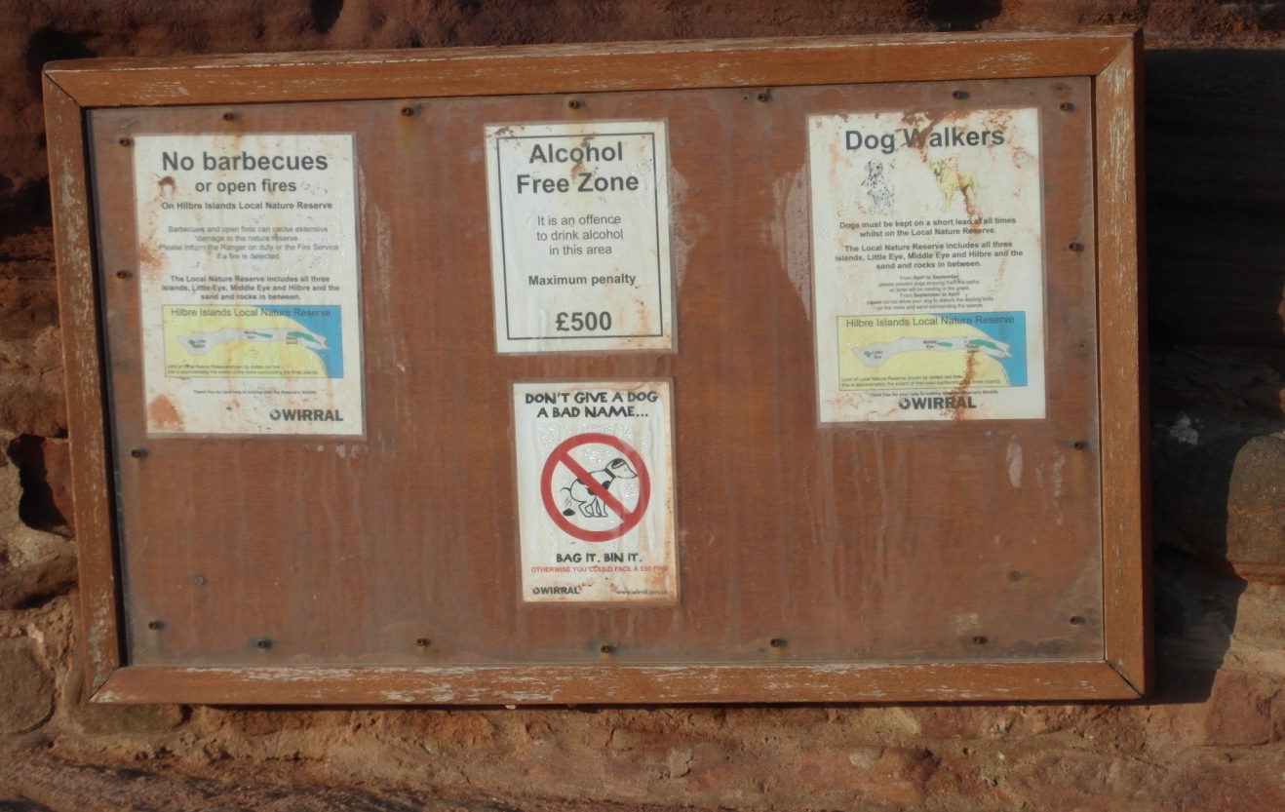
Throughout the study period only eleven visitor groups surveyed declared “dog walking” as a reason for visiting and although the current interpretation board houses a small sign indicating that dogs should be kept on a lead, see figure 25, many did not adhere to this. Through discussion with several dog walking visitors, once they were informed of the reasons for keeping dogs on a lead they were more willing to comply. This emphasises the need for more information to be provided as without specific and localised reasoning, commonly witnessed signs such as “keep your dog on a lead” may be dismissed. Although the sign does have in small print that dogs should not be allowed to roam between certain months of the year due to the nesting and wading birds at the reserve, many visitors said they did not read the small print due to the apparent lack of care of the interpretation board and the message it portrays. Similarly, many of the 97 visitor groups that declared “family day” as a reason for visiting allowed their small children to run in the vegetation and trample flora. As sites like Hilbre Island are not constantly monitored, there is a need to inform the public through clearly visible signage of not only the damage that trampling can cause but also the dangers of running near to the cliff edges and ponds. The current interpretation board does not display any information relating to safety measures on the island or the reason why adhering to the messages displayed is so important in relation to the conservation, other than to disturbing visiting bird species. At present, the current interpretation board displays a sign indicating that dogs must be kept on a lead, a sign declaring that the site is an alcohol free zone, and a sign that declares no barbeques or fires must be lit on the island as they may cause damage. While these signs do display the primitive message of some of the regulations they do not reinforce the message with adequate reasoning, and are in many cases casually dismissed due to a lack of present enforcement bodies such as a permanent ranger. It is accepted that a permanent ranger is not a feasible option due to the lack of electricity and running water on the island, and so it is suggested that the board be updated with more appealing signage, and that care is taken to maintain it. It is also suggested that a further interpretation board be erected near to the old telegraph house and Friends of Hilbre Island Trust centre (grid reference: SJ 1842 8804), as many visitors pass this area to use the toilet facilities and the viewpoint atop the telegraph house, and to sit and eat.
Figure 25 Current interpretation board on slipway entrance to Hilbre Island, 10.3.12
  - Interviews
All interviewees identified an issue relating to visitors to Hilbre Island whether they provided detail on specific problems or solely noted conflict between tourism and conservation. Many of those interviewed however did not suggest any means of improvement on the current situation. This indicates that there is a clear and acknowledged problem with the amount of information available and visitor understanding at present, but that there is very little or no improvements planned or in discussion. It was hypothesised that the majority of interviewed parties would be in favour of further interpretation on the island however there was no evidence to support this. Suggestions of leaflets and more interpretation on the West Kirby slipway were made, however these gestures will not fully address the issue at hand. One interviewee indicated that further interpretation on the island would not be appropriate due to the nature of the site; though this opinion was not supported by other interview responses, it was not contested either.
Two respondents made reference to the management and maintenance currently in action at Hilbre Island, and the positive effect that the teams have had. Restoration projects that have taken place at the site, and volunteer led open days, indicate awareness among the Wirral Borough Council rangers and Friends of Hilbre Island Trust of the pressure that visitors create on the landscape, and demonstrate the efforts being made to maintain the site. It is for this reason that some interviewees said there was not a problem with visitor management as it was felt that volunteers did the work adequately. Although the work of the volunteers is very useful, the time which they are available on site is less than sufficient as shown in the visitor survey questionnaire results. It is important to note that less than 20% of visitors per season were aware of who maintained the island (see fig 19, p22), and many visitors asked for more information regarding the Friends of Hilbre Island Trust, indicating the presence of the Friends of Hilbre Island Trust volunteers may not be sufficient. This argument can be countered however by the results of “first time visitors” being up to 60% per season, and no link between the results from the two questions being established.
The interview responses provided by the representative from Natural England indicate that contact between the management of the island and Natural England is very limited as the representative was not aware of any visitor related issues or figures, or of any processes occurring on the island.
  - Footpath measurements
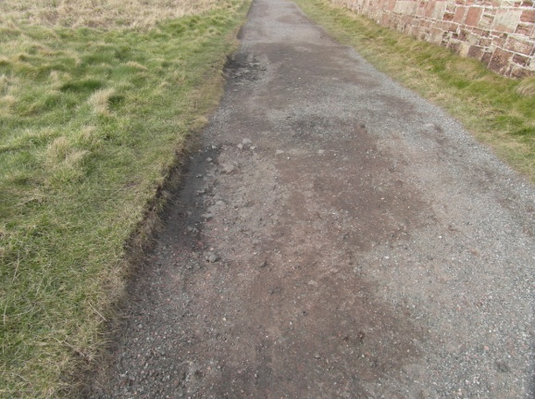
It was during the summer months when the biggest increase in footpath width was hypothesised to occur, however heavy rain caused a dramatic decline in width due to the rain encouraging marshy re-growth. All three measured footpaths increased by up to 14cm throughout the eleven month study period which indicates, and supports the hypotheses that erosion is occurring due to foot traffic. There was no direct link established between the number of visitors and the width of the measured footpaths, this is considered to be due to the weather creating an unexpected decrease in width. The largest increase witnessed was site 3 (SJ 1841 8807) which was anticipated throughout the study as there are many dips along this section of path which visitors avoid during wet weather. Similarly, the dirt path leading from the concrete slipway toward the old telegraph house show many dips which collect precipitation leading to visitors navigating the paths around the dips, in turn causing an increase in foot traffic on other parts of the path and creating new dips. This is also presumed to be the reason why very little or no grass is visible on this stretch of path. Some of these dips are shown in figure 26. Although this data shows only a small increase in the width of each footpath, if this amount of erosion continues each year it may cause a serious problem, and with the island reducing in size each year due to tidal erosion there is a possibility that much of the grassland may be lost over an extended period of time. The erosion of footpaths can also be influenced by the weather and by tidal surges. This form of erosion would be difficult and expensive to mitigate through coastal protection structures, whereas the impact of visitor foot traffic can be more easily managed through an increase in interpretation, and by mowing pathways to reduce erosion in other areas, as is currently in practice, see section 4.2.3.
Figure 26 Dips in footpath at Hilbre Island (grid ref: SJ 1844 8800), 23.2.13
Though this data is intended only as a supplement to the qualitative data collected through visitor questionnaire surveys and interviews, it is indicative evidence of an issue that has been raised repeatedly by interviewees, and can be taken into account when considering management strategies.

  - Limitations
Only 11 months of data could be collected due to the limited time scale available for the project therefore the spring period is shorter than all other seasons. Data was only collected once a month which while being sufficient for quantitative data cannot be considered a wholly accurate indication for the qualitative data collected as there are many variables including tide times, weather and local activities that influence the number and type of visitors on the island.
Due to a major fault with the camera during data collection 9 (December), a different camera had to be used. This only affected the visual data collection however and the measurements are still accurate. Data collection 10 (January) was not possible due to severe weather conditions. Interviews were not completed by all invited to, or had agreed to, and responses received were limited.
  - Suggestions for further work
If this study was to be reproduced a longer study period with more field visits per month would be recommended. Conducting interviews in person rather than by email would be beneficial as more thorough and person specific questions can be asked. Other areas of the island could be studied in the same way, for example the cliffs on the eastern side of the island, similarly a study including Middle Eye and Little Eye would be a more accurate representation of the issue at hand.
- CONCLUSION
Sites that are known for conservation will always attract visitors and Hilbre Island is no exception. Conflict between tourism and conservation is inevitable as demonstrated by Dr Rob Philpott during an interview (Philpott, pers. comm., 2012), by a member of Wirral Borough Council’s Tourism sector during a monthly visit (see Appendix 12), and at many other conservation sites globally. Seeking a balance between the two sectors is crucial, as is retaining a balance between natural beauty and obvious tourism features. Whilst the coastal ranger and wardens are aware of the damage they cause through the use of vehicles, there has been no absolute solution to the problem, and the erection of new signage has not been completed months after the proposal. There is enthusiasm on behalf of the management of the island to meet the needs of the visitors, and the site, though improvements in this field are slow. The management of Hilbre Island is very good at present, and the restoration work of the walls and stone features undertaken by the volunteers has been of a high standard, however visitors still remain largely unaware of the general regulations of the island, and of the history and status of the island also. This has been demonstrated through the 11 month visitor survey questionnaire period.
Trampled footpaths appear across the island; whilst only three were measured monthly it is clear that these footpaths are widening over time, which may eventually create a vast problem of vegetation loss and soil erosion. By educating visitors on the conservational status of the island, and providing reasons to keep to the mown paths, this footpath erosion may be limited. Similarly, by updating the current board, and maintaining the board more effectively, and providing reason to keep dogs on leads, not have fires, etc., other visitor associated issues may be avoidable. It is proposed that the best position to erect a new interpretation board is near to the old telegraph house as this is where a vast proportion of visitors are likely to see it. Though a new interpretation board would be costly and timely in planning permission, and archaeological planning permission documents and fees, the ecological and environmental benefits would greatly outweigh the financial cost, and may lead to a more aware and more considerate visitor base, which could have a significant impact on the future of the island.

- REFERENCES
Agate, E., 1983, Footpaths; A Practical Handbook, British Trust for Conservation Volunteers, Oxfordshire
Archer, M., Grantham, M., Howlett, P., Stansfield, S., 2010, Bird Observatories of Britain and Ireland, T & AD Poyser, London
Atkinson, J. (Bill.june@virgin.net), 1 November 2012, Re: Interview Questions, Email to J. Carubia (JCarubia@uclan.ac.uk)
Ball, J. (Johnball93@live.co.uk), 17 July 2012, Re: Interview Questions, Email to J. Carubia (JCarubia@uclan.ac.uk)
Bimson, L., n.d., RSPB: Hoylake, Red Rocks and Hilbre Island, Available at: http://www.rspbliverpool.org.uk/Hoylake.htm, Accessed 7.3.13
Birtles, H. (Hannah.birtles@naturalengland.org.uk), 2 February 2013, Re: Interview Questions, Email to J. Carubia (JCarubia@uclan.ac.uk)
Carey, P., and Sutton, S., 2004, Community Development Journal; Community development through participatory arts: Lessons learned from a community arts and regeneration project in South Liverpool, Vol 39, No 2, pp123-134, Oxford University Press
Clark, N.D.L., 2010, University of Glasgow Research Deposits; Dinosaurs in Scotland, Vol 12, p36-39
Coleman, R., 1977, Environmental Conservation; Simple Techniques for Monitoring Footpath Erosion in Mountain Areas of North-West England, Vol 2, No 7, pp145-148
Cope, A., Doxford, D., Probert, C., 2000, Land Use Policy; Monitoring Visitors to UK Countryside Resources: The Approaches of Land and Recreation Resource Management Organisations to Visitor Monitoring, Vol 17, No 1, pp59-66
Coppock, J., 1982, Tourism Management; Tourism and Conservation, Vol 3, No 4, pp270-276
Crawford, K., Black, R., 2011, Geoheritage; Visitor Understanding of the Geodiversity and the Geoconservation Value of the Giant’s Causeway World Heritage Site, Northern Ireland, Vol 5, pp115-126
Craggs, J.D., 1982, Hilbre the Cheshire Island; Its History and Natural History, Liverpool University Press
Craggs, S. (Susancraggs9@hotmail.com), 4 November 2012, Re: Interview Questions, Email to J. Carubia (JCarubia@uclan.ac.uk)
Edwards, J., 1987, Annals of Tourism Research; The UK Heritage Coasts: an Assessment of the Ecological Impacts of Tourism, Vol 14, No 1, p71-87
English Nature, 1995, Local Nature Reserves in England, 2nd Edition, Cityprint Ltd, Peterborough
English Nature, 1998, SSSI Citation Sheet; Site Name: Dee Estuary, Available at: http://www.sssi.naturalengland.org.uk/citation/citation_photo/1000595.pdf, Accessed: 22.2.13
English Nature, 2006, Views About Management/Management Plan, Available at: http://www.sssi.naturalengland.org.uk/Special/sssi/vam/VAM%201000595.pdf, Accessed: 22.2.13
Forshaw, R. (Royhilbre@hotmail.co.uk), 30 August 2012, Re: Interview Questions, Email to J. Carubia (JCarubia@uclan.ac.uk)
Goudie, A.S., 2002, Geomorphology; Aesthetics and Relevance in Geomorphological Outreach, Vol 47, pp245-249
Green, H., Hunter, C., Moore, B., 1990, Tourism Management; Assessing the Environmental Impact of Tourism Development: Use of the Delphi Technique, pp111-120
Hanik, J., 2011, The Friends of Hilbre Newsletter; Rangers News, Vol 1, No 34, Online Edition: March 2011, Available at: http://www.deeestuary.co.uk/hilbre/newsfoh34.htm, Accessed: 7.7.12
He, G., Chen, X., Liu, W., Bearer, B., Zhou, S., Cheng, L., Zhang, H., Ouyang, Z., Liu, J., 2008, Environmental Management: Distribution of Economic Benefits from Ecotourism; A Case Study of Woolong Nature Reserve for Giant Pandas in China, Vol 42, No 6
Hilbre Bird Obs, 2012, Hilbre Bird Observatory Blog: Latest News from the Island, Tuesday 1st May 2012, Available at: http://hilbrebirdobs.blogspot.co.uk/2012/05/1st-may-2012.html, Accessed 3.5.12
HMSO, 1995, House of Commons: Committee of Public Accounts; Protecting and Managing Sites of Special Scientific Interest in England, Eleventh Report, Her Majesties Stationary Office, London
King, M., Thompson, D., 2000, Proceedings of the Geologists’ Association; Triassic Vertebrate Footprints from the Sherwood Sandstone Group, Hilbre, Wirral, Northwest England, Vol 111, Issue 2, p111-132
Lau, A.L.S., McKercher, B., 2004, Journal of Travel Research; Exploration vs Acquisition: A Comparison of First-time and Repeat Visitors, Vol 42, No 3, pp279-285
Leones, J., 1998, A Guide to Designing and Conducting Visitor Surveys, Available at: http://ag.arizona.edu/pubs/marketing/az1056/az1056.html, Accessed: 2.1.13
Liverpool University, 2003, Hilbre Islands Local Nature Reserve Draft Management Plan, Available at: http://www.liv.ac.uk/~cmi/dee/hilbre2003appendices_10175.pdf, Accessed 8.12.12
Longworth, C. (Christinelongworth47@gmail.com), 13 July 2012, Re: Interview Questions, Email to J. Carubia (JCarubia@uclan.ac.uk)
Martin, J., Reale, D., 2008, Behavioural Process: Animal Temperament and Human Disturbance; Implications for the Response of Wildlife to Tourism, Vol 7, No 1, pp66-72
Ordnance Survey, 2013, OS Map of West Kirby Beach [online], Available at: http://www.britishbeaches.info/west-kirby-wirral/osmap, Accessed 12.2.13
Philpott, R. (Rob.philpott@liverpoolmuseums.org.uk), 12 July 2012, Re: Interview Questions, Email to J. Carubia (JCarubia@uclan.ac.uk)
Shafer, C.L., 1990, Nature Reserves; Island Theory and Conservation Practice, Smithsonian Institution Press, Washington and London
Smith, R., n.d., Friends of Hilbre Island; Wildlife of Hilbre: The Birds of Hilbre Island, Available at: http://www.deeestuary.co.uk/hilbre/hilbirds.htm, Accessed: 15.3.12
Stackhouse, K. (Pamstackhouse@hotmail.com), 6 November 2012, Re: Interview Questions, Email to J. Carubia (JCarubia@uclan.ac.uk)
Turner, J.S., 2008, Mast on Hilbre Island, photograph, viewed 20.3.13, http://www.geolocation.ws/v/W/File%3AMast%20on%20Hilbre%20Island%20-%20geograph.org.uk%20-%201399460.jpg/-/en
Usher, M., Pitt, M., de Boer, G., 1974, Environmental Conservation: Recreational Pressures in the Summer Months on a Nature Reserve on the Yorkshire Coast, England., Vol 1, No 1, p43-49
Weaver, D., 1991, Annals of Tourism Research: Alternative to Mass Tourism in Dominica, Vol 18, Issue 3, p414-432
Wirral Borough Council, 2012, Local Nature Reserves: Hilbre Island, Available at: http://www.wirral.gov.uk/my-services/leisure-and-culture/parks-beaches-and-countryside/parks-greenspaces-and-countryside/local-nature-reserves/hilbre-isl, Accessed 10.3.12
- APPENDICES
  - Appendix 1: Risk assessment form
  - Appendix 2: Ethical approval form
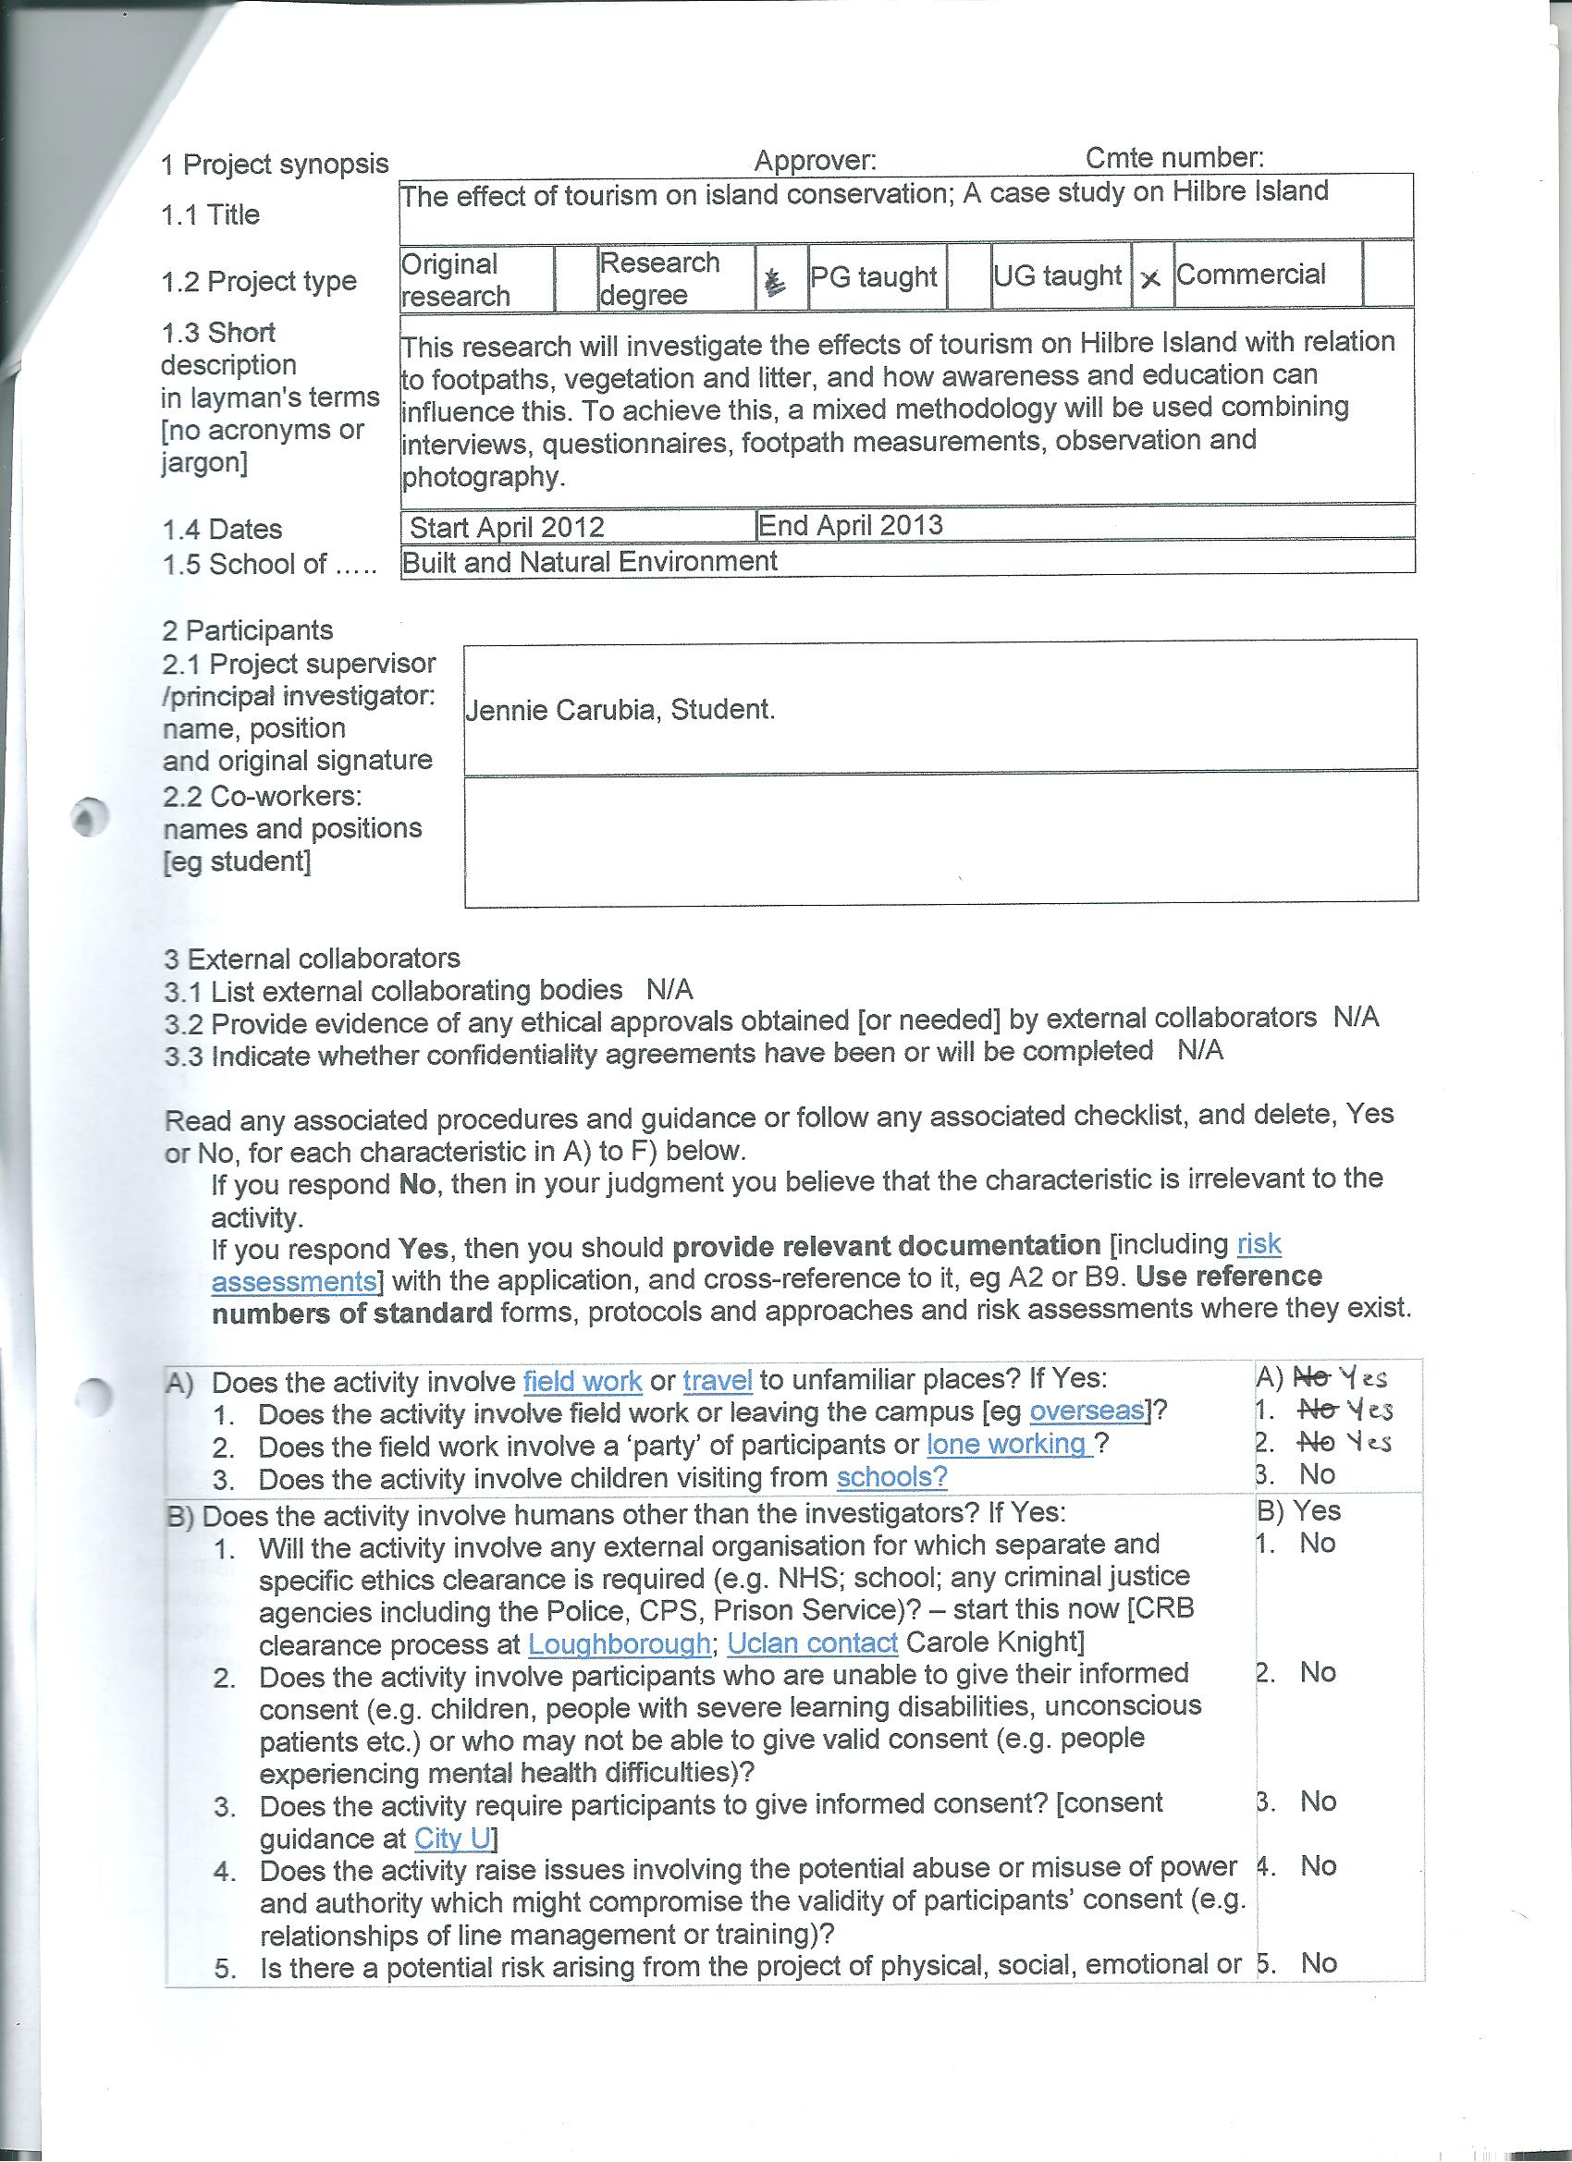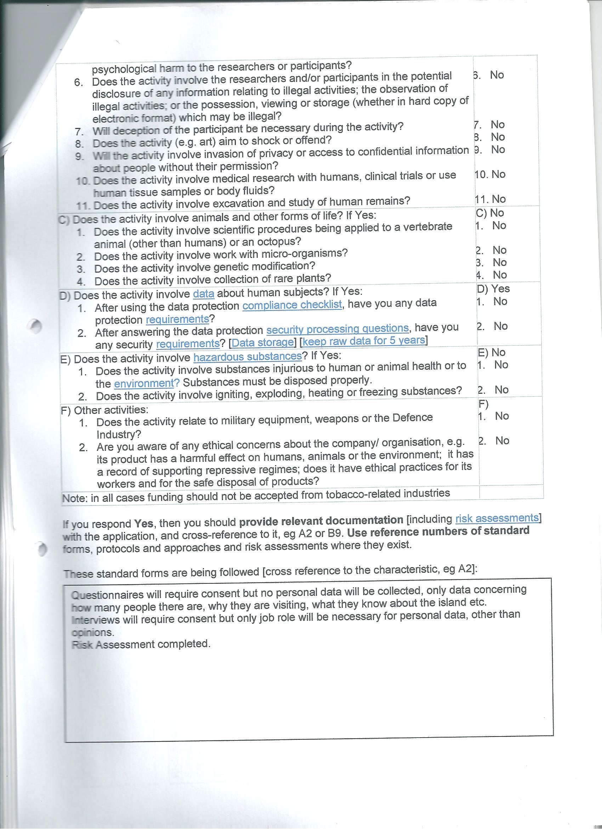
  - Appendix 3: Pilot survey
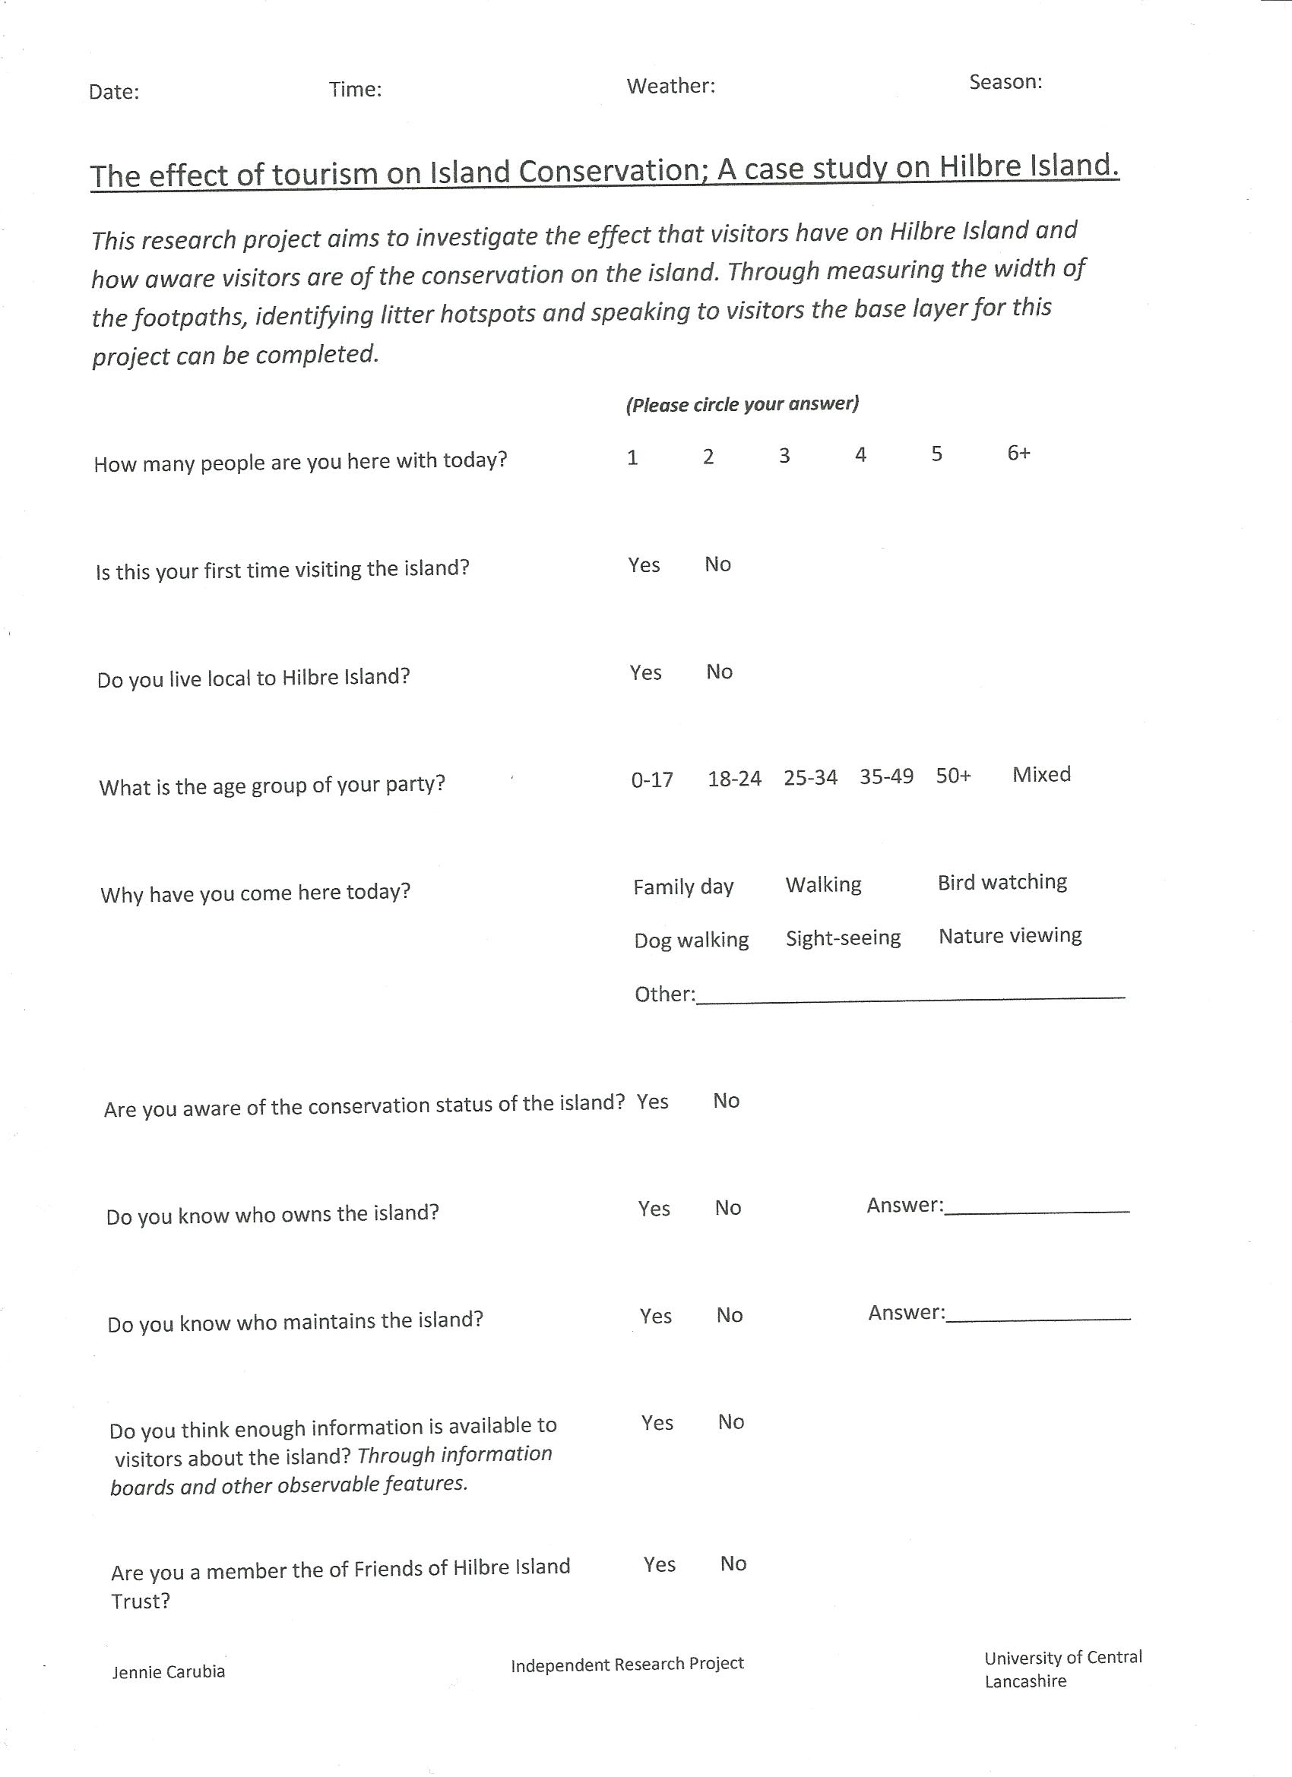
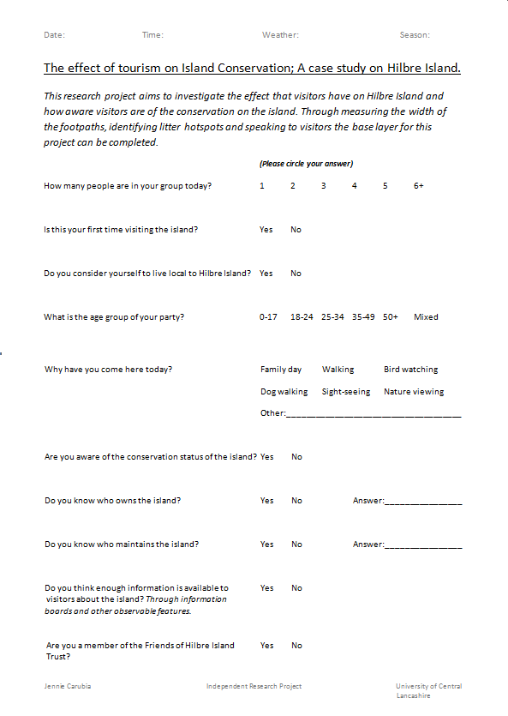
  - Appendix 4: Final survey

  - Appendix 5: Interview questions

- Can you please confirm your name and job title?

- What is your connection with Hilbre Island and the timescale of your involvement?

- Do you consider there to be sufficient information (for example, interpretation boards) available to the visitors of Hilbre Island?

- If not, what do you consider to be the way forward in this matter?

- In your opinion, are there any problems associated with visitors to Hilbre Island?

- Would you consider the number of visitors to the island has increased of late?

- Is there any hard evidence to show whether visitor numbers have increased/decreased? Please comment further.

- To your knowledge, are there any natural, or human mediated processes occurring on the island?

- If you believe that changes are occurring on the Island, how in your opinion, can these be managed?

- Are there any other points regarding Hilbre Island that you wish to note?

  - Appendix 6: Raw data (monthly)
Date |  | 21.4.12 | 19.5.12 | 16.6.12 | 21.7.12 | 18.8.12 | 22.9.12 | 20.10.12 | 24.11.12 | 22.12.12 | 19.1.13 | 23.2.13
Season |  | Spring | Spring | Summer | Summer | Summer | Autumn | Autumn | Autumn | Winter | Winter | Winter
Time |  | 14.40-16.10 | 13.40-15.45 | 13.10-15.10 | 15.00-17.20 | 14.40-17.00 | 10.30-14.10 | 11.20-13.40 | 12.40-14.20 | 11.35-14.40 | x | 12.10-15.20
Tide (H-H) |  | 10.52-23.10 | 9.51-22.13 | 8.42-21.09 | 00.52-13.16 | 23.53-12.16 | 03.42-16.12 | 02.39-15.03 | 07.52-20.08 | 06.05-18.29 | 03.50-16.10 | 09.30-21.55
Weather |  | Cloudy, sunny intervals, windy | Cloudy, dry | Overcast, windy, light rain | Sunny, dry, warm | Sunny, dry, hot | Dry, sunny, hot | Dry, breezy, sunny intervals | Still, inter-mittent rain, cold | Inter-mittent rain, occasion-al hail, windy, cold | x | Light rain, light snow, cold
Total Visitors |  | 76 | 97 | 83 | 137 | 204 | 214 | 167 | 23 | 0 | x | 87
Total Surveys |  | 11 | 11 | 8 | 22 | 37 | 36 | 31 | 3 | 0 | x | 32
Group Size | 1 | 1 | 1 | 0 | 2 | 2 | 3 | 2 | 0 | 0 | x | 0
Group Size | 2 | 6 | 5 | 1 | 5 | 7 | 5 | 6 | 0 | 0 | x | 6
Group Size | 3 | 0 | 1 | 2 | 3 | 4 | 4 | 3 | 2 | 0 | x | 3
Group Size | 4 | 1 | 1 | 1 | 5 | 6 | 9 | 7 | 2 | 0 | x | 12
Group Size | 5 | 0 | 0 | 1 | 2 | 2 | 1 | 1 | 0 | 0 | x | 0
Group Size | 6+ | 3 | 3 | 3 | 5 | 16 | 14 | 12 | 1 | 0 | x | 11
First Visit | Yes | 4 | 6 | 4 | 13 | 22 | 22 | 13 | 1 | 0 | x | 19
First Visit | No | 7 | 5 | 4 | 9 | 15 | 14 | 18 | 2 | 0 | x | 13
Live Locally | Yes | 5 | 5 | 7 | 7 | 17 | 26 | 14 | 3 | 0 | x | 24
Live Locally | No | 6 | 6 | 1 | 15 | 20 | 10 | 17 | 0 | 0 | x | 8
Live Locally and First Visit |  | 3 | 3 | 2 | 6 | 3 | 10 | 3 | 1 | 0 | x | 7
Group Age | 0-17 | 0 | 0 | 0 | 2 | 0 | 2 | 2 | 0 | 0 | x | 2
Group Age | 18-24 | 1 | 1 | 0 | 3 | 7 | 6 | 5 | 0 | 0 | x | 6
Group Age | 25-34 | 2 | 2 | 1 | 5 | 12 | 7 | 4 | 0 | 0 | x | 6
Group Age | 35-49 | 2 | 1 | 1 | 1 | 4 | 7 | 4 | 0 | 0 | x | 3
Group Age | 50+ | 4 | 4 | 1 | 4 | 2 | 5 | 5 | 2 | 0 | x | 3
Group Age | Mixed | 2 | 3 | 5 | 7 | 12 | 9 | 11 | 1 | 0 | x | 12
Visit Reason | Family Day | 3 | 2 | 4 | 6 | 22 | 19 | 14 | 1 | 0 | x | 26
Visit Reason | Walking | 4 | 10 | 4 | 15 | 15 | 17 | 6 | 3 | 0 | x | 29
Visit Reason | Bird Watching | 0 | 4 | 2 | 4 | 2 | 3 | 0 | 0 | 0 | x | 2
Visit Reason | Dog Walking | 1 | 1 | 2 | 3 | 2 | 1 | 1 | 2 | 0 | x | 5
Visit Reason | Sight-seeing | 2 | 1 | 4 | 7 | 6 | 9 | 13 | 1 | 0 | x | 2
Visit Reason | Nature Viewing | 5 | 2 | 1 | 7 | 9 | 9 | 3 | 1 | 0 | x | 3
Visit Reason | Other | 0 | 0 | 0 | 0 | 1 | 0 | 0 | 0 | 0 | x | 0
Aware of Status | Yes | 6 | 5 | 4 | 7 | 17 | 12 | 12 | 3 | 0 | x | 12
Aware of Status | No | 5 | 6 | 4 | 15 | 20 | 24 | 19 | 0 | 0 | x | 20
Know who owns | Yes | 3 | 3 | 2 | 3 | 5 | 8 | 10 | 1 | 0 | x | 8
Know who owns | No | 8 | 8 | 6 | 19 | 32 | 28 | 21 | 2 | 0 | x | 24

Know who maintains | Yes | 2 | 2 | 0 | 2 | 4 | 6 | 7 | 1 | 0 | x | 2
Know who maintains | No | 9 | 9 | 8 | 18 | 33 | 30 | 24 | 2 | 0 | x | 30
Enough info available | Yes | 4 | 5 | 1 | 6 | 6 | 5 | 4 | 0 | 0 | x | 5
Enough info available | No | 7 | 6 | 7 | 16 | 31 | 31 | 27 | 3 | 0 | x | 27
Member of FOH | Yes | 0 | 1 | 0 | 1 | 0 | 2 | 0 | 0 | 0 | x | 0
Member of FOH | No | 11 | 10 | 8 | 21 | 37 | 34 | 31 | 3 | 0 | x | 32

  - Appendix 7: Raw data (seasonal)
Season |  | Spring |  | Summer |  | Autumn |  | Winter
Total Visitors |  | 173 |  | 424 |  | 404 |  | 87
Total Surveys |  | 22 |  | 67 |  | 70 |  | 32
Group Size | 1 | 2 | 9.09% | 4 | 5.97% | 5 | 7.14% | 0 | 0.00%
Group Size | 2 | 11 | 50.00% | 13 | 19.40% | 11 | 15.71% | 6 | 18.75%
Group Size | 3 | 1 | 4.55% | 10 | 14.93% | 9 | 12.86% | 3 | 9.38%
Group Size | 4 | 2 | 9.09% | 12 | 17.91% | 18 | 25.71% | 12 | 37.50%
Group Size | 5 | 0 | 0.00% | 5 | 7.46% | 2 | 2.86% | 0 | 0.00%
Group Size | 6+ | 6 | 27.27% | 24 | 35.82% | 27 | 38.57% | 11 | 34.38%
First Visit | Yes | 10 | 45.45% | 39 | 58.21% | 36 | 51.43% | 19 | 59.38%
First Visit | No | 12 | 54.55% | 28 | 41.79% | 34 | 48.57% | 13 | 40.63%
Live Local | Yes | 10 | 45.45% | 31 | 46.27% | 43 | 61.43% | 24 | 75.00%
Live Local | No | 12 | 54.55% | 36 | 53.73% | 27 | 38.57% | 8 | 25.00%
Live Locally and First Visit |  | 6 | 27.27% | 11 | 16.42% | 14 | 20.00% | 7 | 21.88%
Group Age | 0-17 | 0 | 0.00% | 2 | 2.99% | 4 | 5.71% | 2 | 6.25%
Group Age | 18-24 | 2 | 9.09% | 11 | 16.42% | 11 | 15.71% | 6 | 18.75%
Group Age | 25-34 | 4 | 18.18% | 18 | 26.87% | 11 | 15.71% | 6 | 18.75%
Group Age | 35-49 | 3 | 13.64% | 6 | 8.96% | 11 | 15.71% | 3 | 9.38%
Group Age | 50+ | 8 | 36.36% | 7 | 10.45% | 12 | 17.14% | 3 | 9.38%
Group Age | Mixed | 5 | 22.73% | 24 | 35.82% | 21 | 30.00% | 12 | 37.50%
Visit Reason | Family Day | 5 | 22.73% | 32 | 47.76% | 34 | 48.57% | 26 | 81.25%
Visit Reason | Walking | 14 | 63.64% | 34 | 50.75% | 26 | 37.14% | 29 | 90.63%
Visit Reason | Bird Watching | 4 | 18.18% | 8 | 11.94% | 3 | 4.29% | 2 | 6.25%
Visit Reason | Dog Walking | 2 | 9.09% | 7 | 10.45% | 4 | 5.71% | 5 | 15.63%
Visit Reason | Sight-seeing | 3 | 13.64% | 17 | 25.37% | 23 | 32.86% | 2 | 6.25%
Visit Reason | Nature Viewing | 7 | 32.00% | 17 | 25.37% | 13 | 18.57% | 3 | 9.38%
Visit Reason | Other | 0 | 0.00% | 1 | 1.49% | 0 | 0.00% | 0 | 0.00%
Aware of Status | Yes | 11 | 50.00% | 28 | 41.79% | 27 | 38.57% | 12 | 37.50%
Aware of Status | No | 11 | 50.00% | 39 | 58.21% | 43 | 61.43% | 20 | 62.50%
Know who owns | Yes | 6 | 27.27% | 10 | 14.93% | 19 | 27.14% | 8 | 25.00%
Know who owns | No | 16 | 72.73% | 57 | 85.07% | 41 | 58.57% | 24 | 75.00%
Know who maintains | Yes | 4 | 18.18% | 6 | 8.96% | 14 | 20.00% | 2 | 6.25%
Know who maintains | No | 18 | 81.82% | 61 | 91.04% | 56 | 80.00% | 30 | 93.75%
Enough info available | Yes | 9 | 40.91% | 13 | 19.40% | 9 | 12.86% | 5 | 15.63%
Enough info available | No | 13 | 59.09% | 54 | 80.60% | 61 | 87.14% | 27 | 84.38%
Member of FOH | Yes | 1 | 4.55% | 1 | 1.49% | 2 | 2.86% | 0 | 0.00%
Member of FOH | No | 21 | 95.45% | 66 | 98.51% | 68 | 97.14% | 32 | 100.00%

  - Appendix 8: Raw data (footpath width)
 | Apr | May | June | July | Aug | Sept | Oct | Nov | Dec | Jan (estimated) | Feb
Site 1 | 2.25 | 2.29 | 2.34 | 2.37 | 2.34 | 2.32 | 2.33 | 2.43 | 2.45 | 2.47 | 2.49
Site 2 | 0.37 | 0.37 | 0.39 | 0.36 | 0.32 | 0.32 | 0.33 | 0.36 | 0.4 | 0.44 | 0.48
Site 3 | 2.49 | 2.59 | 2.6 | 2.59 | 2.56 | 2.55 | 2.56 | 2.59 | 2.59 | 2.61 | 2.63

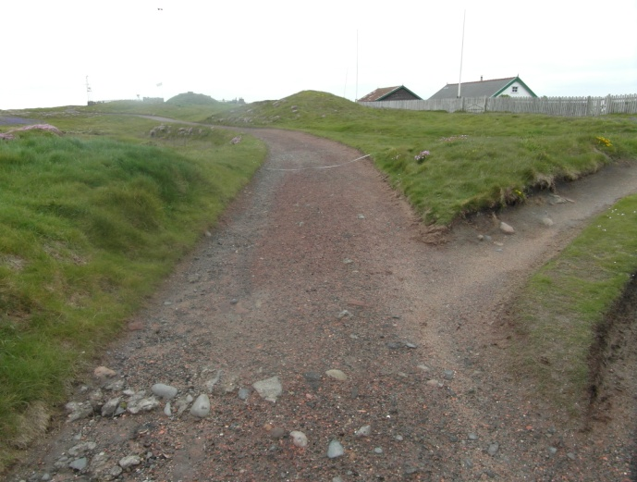
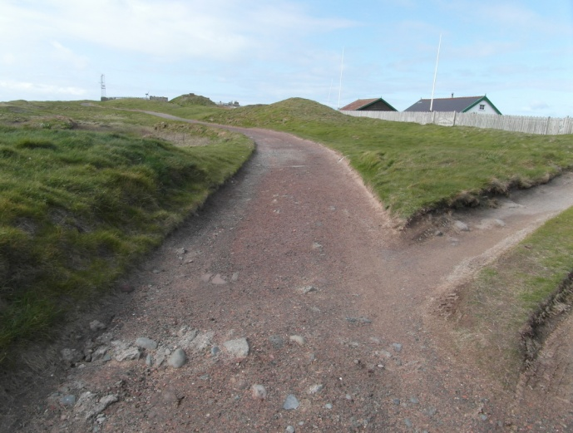
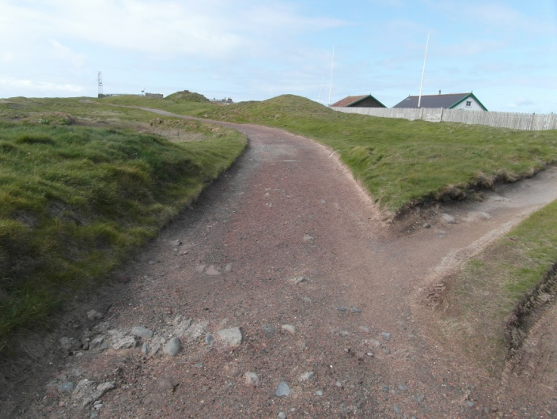
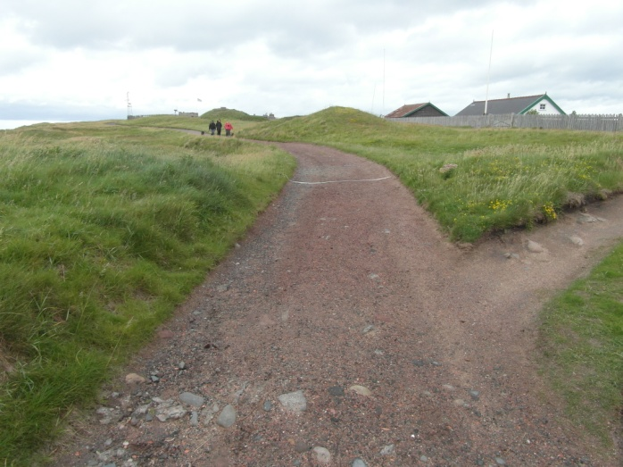
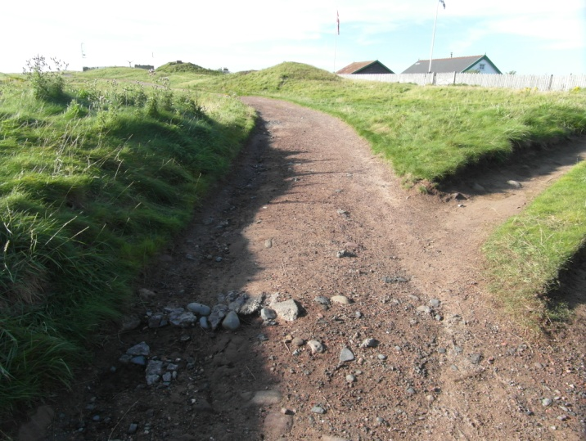
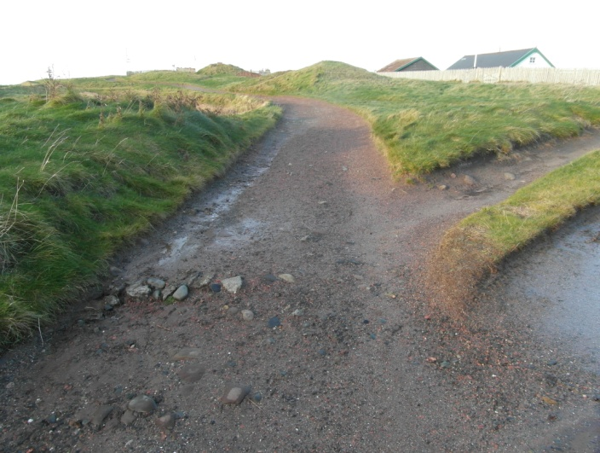
  - Appendix 9: Photographic timeline (site 1)
May: 19.5.12 15:50
April: 21.4.12 16:15
July: 21.7.12 17:25
June: 16.6.12 15:16
September: 22.9.12 14:15
August: 18.8.12 17:06
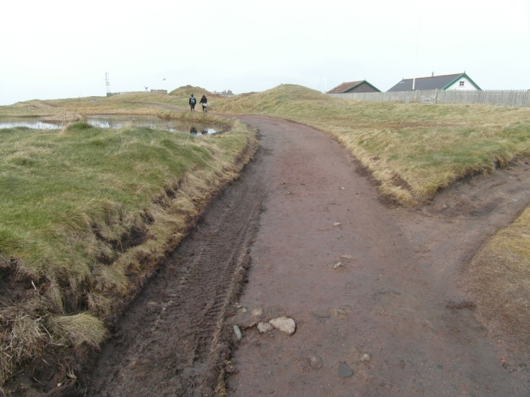
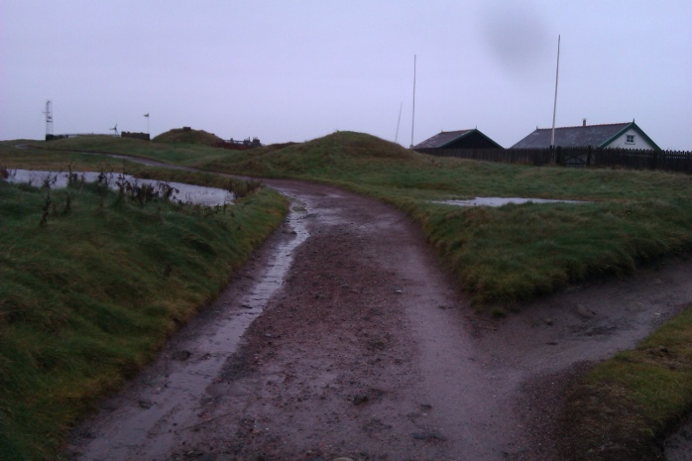
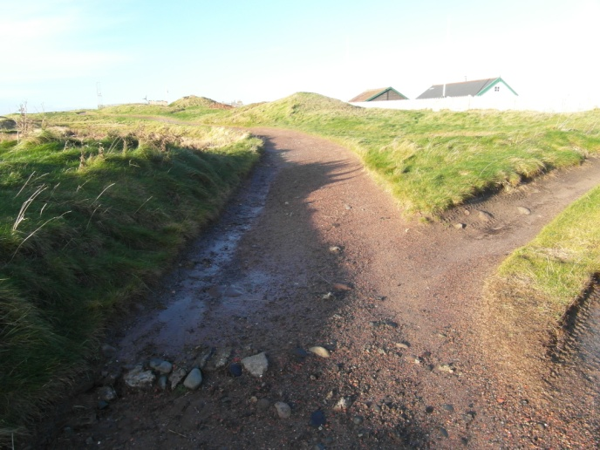
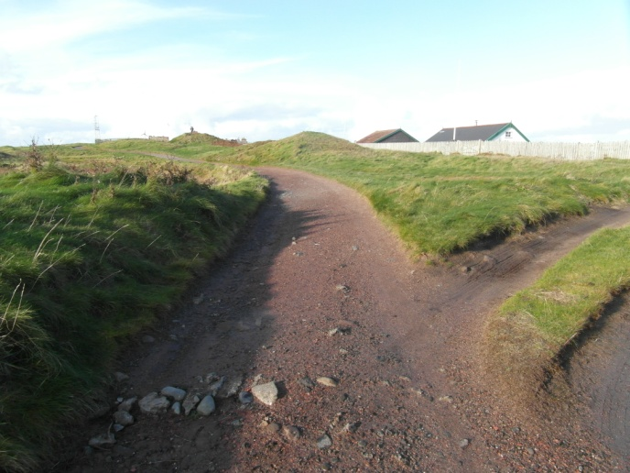
February: 23.2.13 15:25
December: 22.12.12 14:46
November: 24.11.12 14:25
October: 20.10.12 13:45
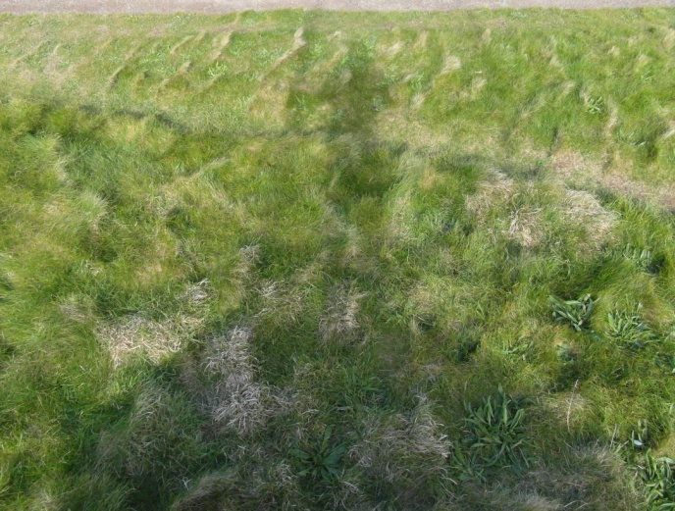
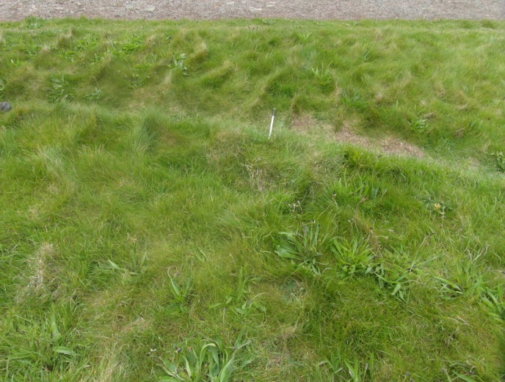
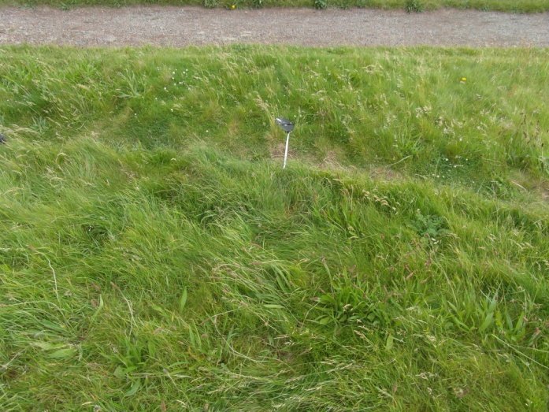
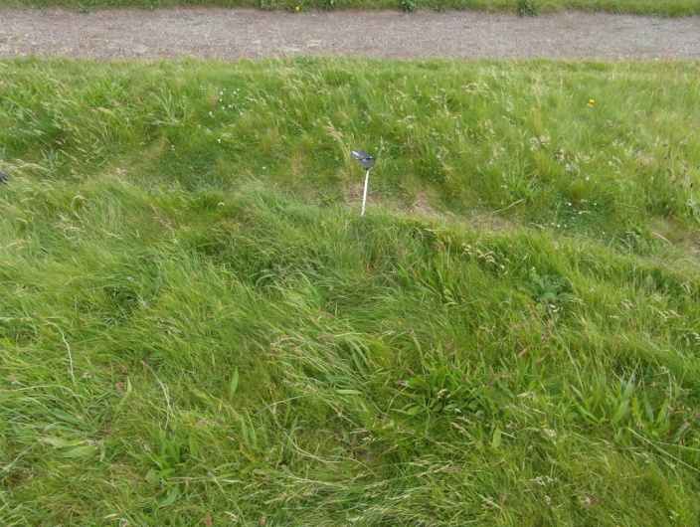
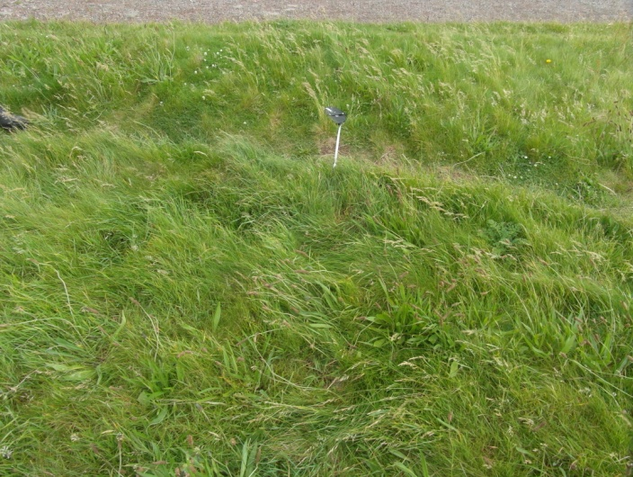
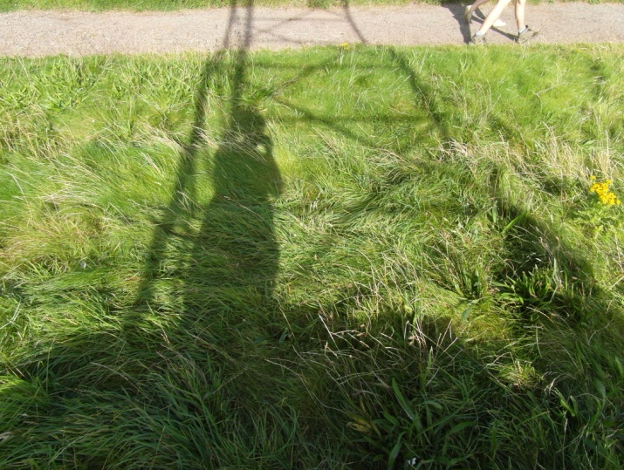
  - Appendix 10: Photographic timeline (site 2)
April: 21.4.12 16:23
May: 19.5.12 15:59
June: 16.6.12 17:41
July: 21.7.12 17:32
August: 18.8.12 17:12
September: 22.9.12 14:27
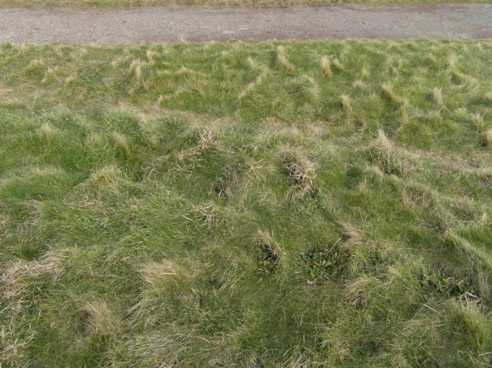
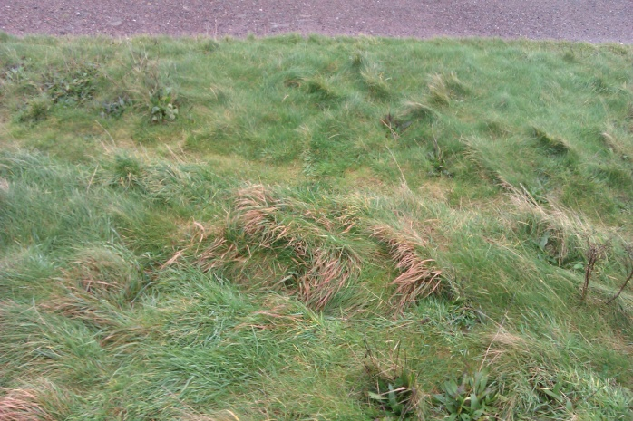
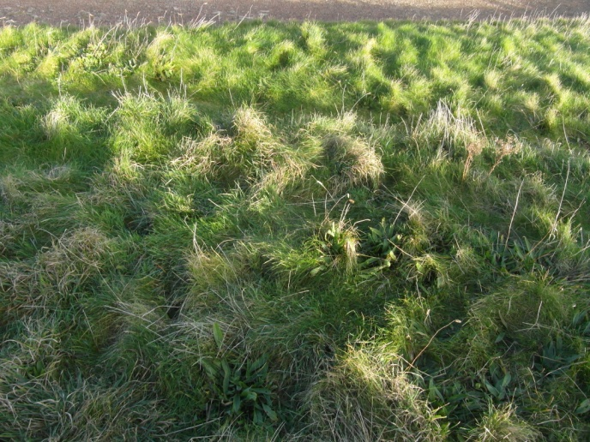
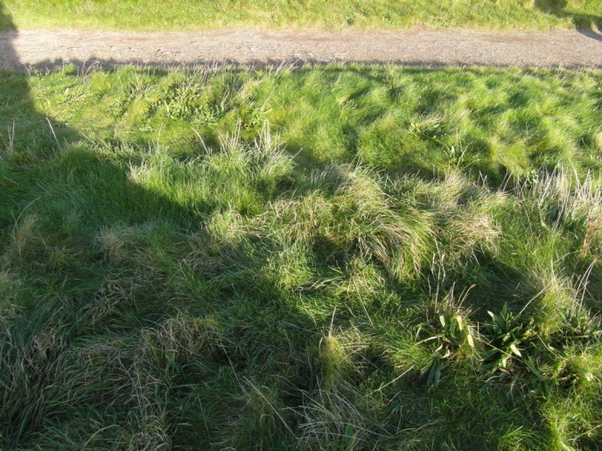
February: 23.2.13 15:34
December: 22.12.12 14:52
November: 24.11.12 14:32
October: 20.10.12 13:54
  - Appendix 11: Photographic timeline (site 3)
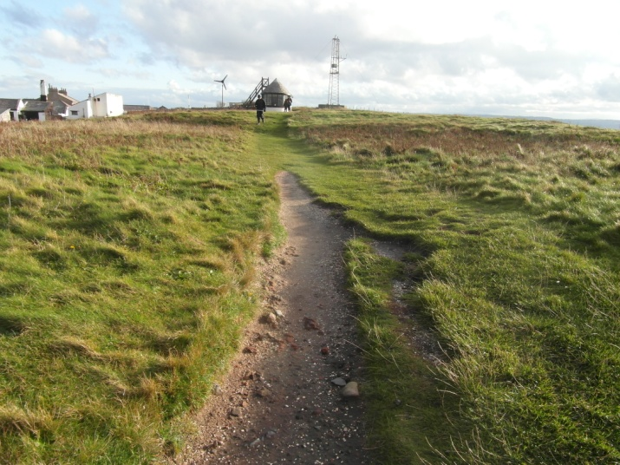
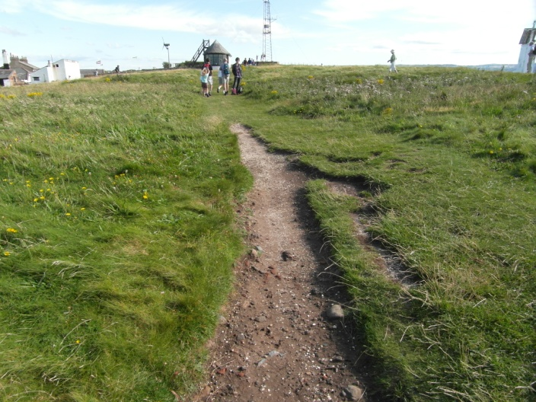
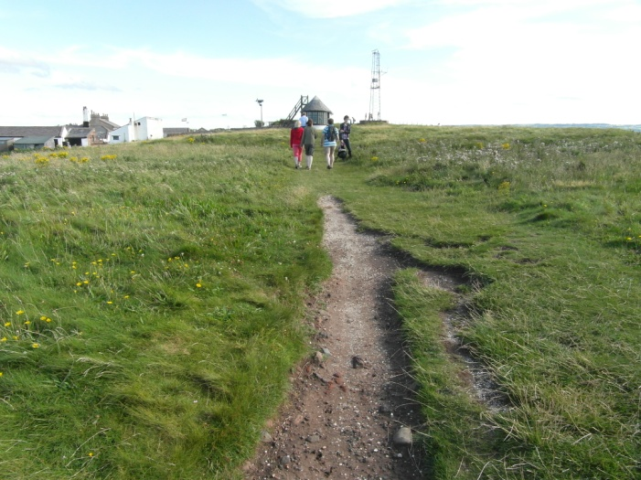
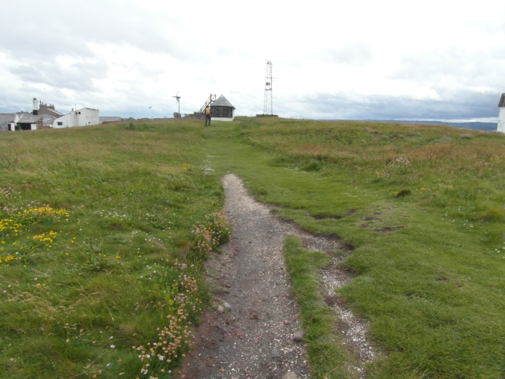
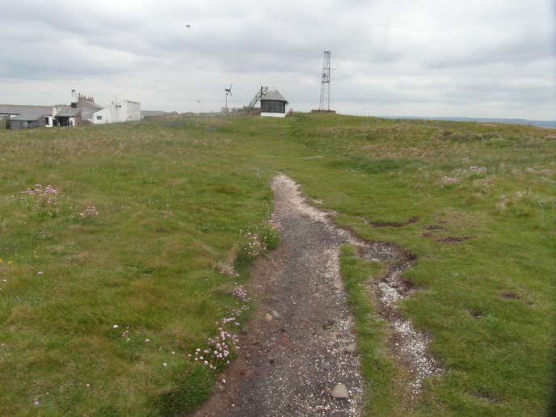
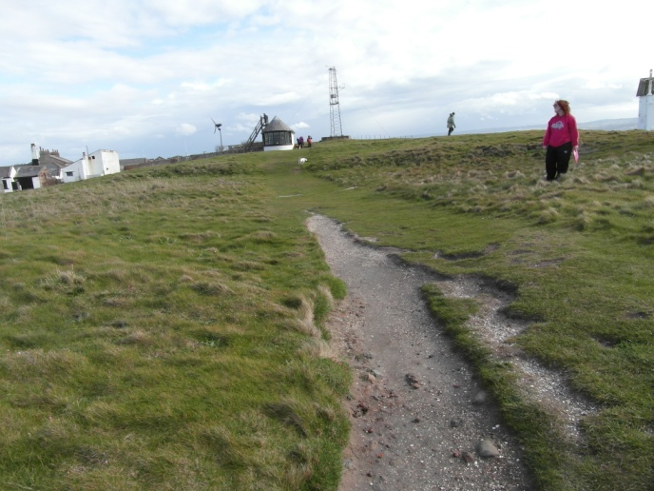
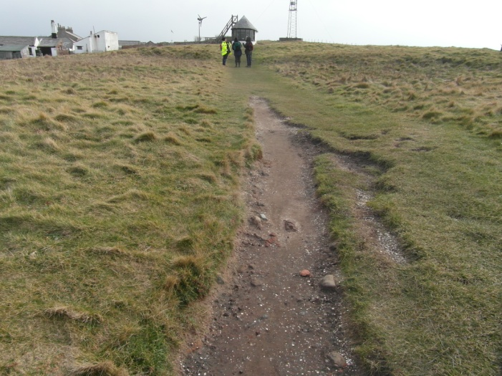
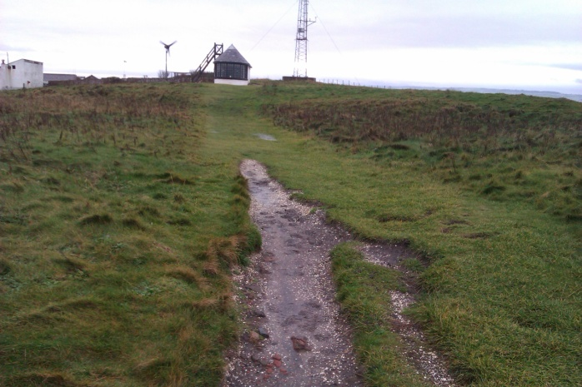
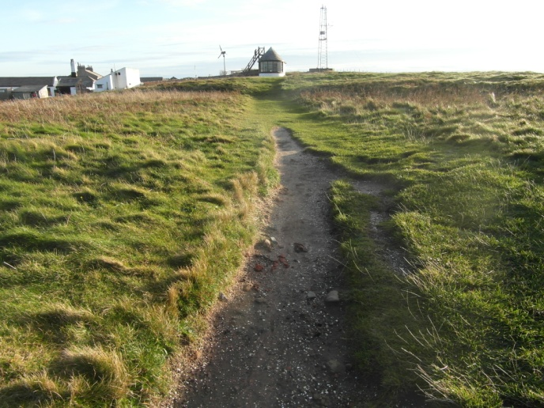
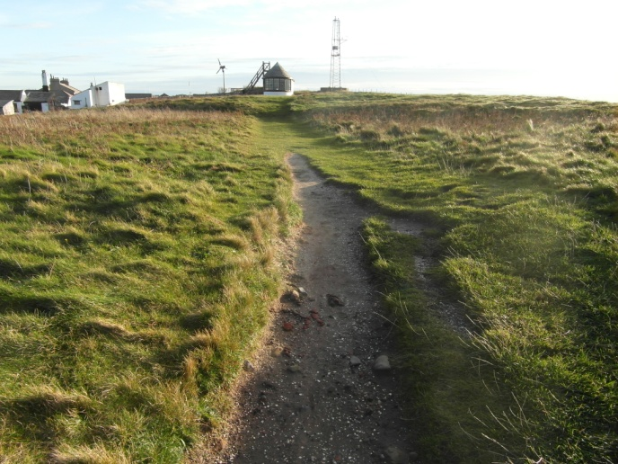
September: 22.9.12 14:40
August: 18.8.12 17:35
July: 21.7.12 17:49
June: 16.6.12 15:42
May: 19.5.12 16:10
April: 21.4.12 16:32
February: 23.2.12 15:53
December: 22.12.12 15:10
November: 24.11.12 14:55
October: 20.10.12 14:08
  - Appendix 12: Monthly notes
April: Visitor told of The Times article on Top 10 walks of England which rated “Hilbre Islands, Merseyside”.
May: Radiographers present though reason unknown.
Grey Partridge spotted for second time in the month:
http://hilbrebirdobs.blogspot.co.uk/2012/05/1st-may-2012.html
1st May 2012 - The easterly influence to the wind continued and produced another great spring day on the island. A diverse array of species were recorded today including Goosander, a moderate fall of warblers, including the first Grasshopper Warbler of the year (singing near the SK during the afternoon) but the undoubted star of the show was a Grey Partridge (the first for many years) found initially on Middle Eye by voluntary Coastal wardens John and Liam, before being seen by Obs members it then moved briefly to the South End of the main island. More details on other sightings will follow.
Spokesperson from Wirral Borough Council Tourism Sector:
“There has been a lot of conflict in recent times between the tourism sector and the conservation section, namely the rangers and the trust, as our priority is to get visitors onto the island whereas it appears to be theirs to keep the island visitor-free for environmental reasons. I cannot comment further. A spokesperson for the Wirral Borough Council Tourism Department".
June: Visitor told of current ‘local history’ exhibition at Liverpool Museum with information about Hilbre Island. N.B. no evidence of this was found.
July: Conversation with Voluntary Ranger John Ball:
“We go out every Monday morning to refill the toilet rolls after the weekend and to do a general check of the island, we don’t tend to find litter to be much of a problem as it just blows away. Obviously it is a problem that it blows into the river but for the species on the island itself they do not appear to suffer from litter, and we don’t find much of it at all”.
Aug: Extreme period of wet weather has let to marshy re-growth of the grass which has made the footpaths appear narrower, this could disprove hypothesis – really outlined timescale limitation as weather during this 11 month period has not been fairly representative, 3 years or more would be necessary for accuracy.
Sept: Footpaths continuing to narrow, grass is bushier than last visit.
Most visitors so far today, hot weather has encouraged visitors.
Oct: Mostly big groups of families and friends, people flying kites in the breeze.
Nov: Considerable change in footpath width after re-growth, grass appears to be dying due to the cold weather.
Dec: Not a single visitor today – most likely due to it being 22nd December, and only a few days until Christmas.
CAMERA FAULT – different camera had to be used for timeline.
Geese swimming by.
Toilet doors are both broken and warped due to stormy weather – flooded including toilet and toilet roll.
Lake is considerably fuller.
Jan: No visit to Hilbre this month due to extreme snow and ice conditions.
Feb: Last weekend of half term so lots of children/families around.
Evidence of fire in two places on the island, also oil visible on Western side of island.

