
Does the possible effect of varying sea states affect shell fragmentation at Sandscale Haws, Cumbria

Victoria Ellen Cooney
BSc (Hons) Environmental Management 2013

Declaration

I declare that the main text in this document submitted is no more than 10,000 words. In addition, it is all my own word. Information extracted from another source has been fully or partly identified and acknowledged in the references and throughout the course of the content.

Name of Student: Victoria Ellen Cooney

Signature of Student:

Acknowledgements
For the duration of this dissertation it has been demanding in both physical and academic aspects. The support from my dissertation supervisor, Alison Robinson, was vastly important to achieve what I have today. I thank my family and friends for aiding me, as their help during the field investigations was invaluable.

Contents
List of Figures vi
Abstract vii

Chapter 1. Introduction 1
Aims and Objectives 8
Rationale 9
Methodology of Dissertation 9
Chapter 2. Literature Review 10
Introduction 10
Sandscale Haws 10
Shell Fragmentation 10
Geomorphology and Coastal Erosion 11
Sea Level Rise 12
Climate change 13
Shell fragmentation and Sea State 14
Summary of the Literature Review 16
Chapter 3. Methodology 18
Initial Plan 18
Site Description 19
Test Transect 19
Actual Transect 20
Methods of Statistical Analysis 22
Chapter 4. Results 24
Numerical Data 24
Transect one 24
Transect two 25
Transect three 25
Whole Shells 26
Larger than 5mm Shells 27
Less than 5mm Shells 27
Kruskal-Wallis Results 28
Summary of Key Results 28
Chapter 5. Discussion 30
Analysis of Transects 30
Chapter 6. Conclusion 38
Limitations of the Investigation 38
Future Research 40
References 41
Appendices
Appendix 1 – Health, Safety and Ethics forms 45
Appendix 2 – Risk Assessment forms 48
Appendix 3 – Photographic Observations 50
Appendix 4 – Table of Raw Data 92
Appendix 5 – Minitab statistics Kruskal-Wallis 97

List of Figures
3.0 Map showing Sandscale Haws (Google Maps, 2013) 19
3.1 Diagram showing how the transect was done over the beach (Image Authors Own, 2012) 21
3.2 Image showing how the distance was measured between each quadrat and each quadrat (Image Authors Own, 2012) 21
3.3 Image showing how the fragments were measured to analysis which group the fragment would be placed in (Image Authors Own, 2012). 22
4.0 Graph showing the overall shell fragments in transect one (Image Authors Own, 2013) 24
4.1 Graph showing the overall shell fragments in transect two (Image Authors Own, 2013) 25
4.2 Graph showing the overall shell fragments in transect three (Image Authors Own, 2013) 26
4.3 Graph to show the amount of whole shells found over each transect (Image Authors Own, 2013)
26
4.4 Graph to show the amount of larger than 5mm shells found over each transect (Image Authors Own, 2013) 27
4.5 Graph to show the amount of less than 5mm shells found over each transect (Image Authors Own, 2013) 28
5.0 Image showing the geology of Sandscale Haws (BGS, n.d) 31
5.1 Image showing the prevailing wind direction (Met Office, n.d.) 32
5.2 Image showing the river Duddon (Edina Digimaps, n.d.) 33
5.3 Image showing the sand banks across the Duddon Estuary (Edina Digimaps, n.d.) 34
5.4 Image showing Sandscale Haws in 1850 and now (Edina Digimaps, n.d.) 35
5.5 Image showing Askam Pier in relation to Sandscale Haws 1850 and now(Edina Digimaps, n.d.)
36

Abstract
This study is a quantitative investigation researching the effect of sea states that influences shell fragmentation along Sandscale Haws beach in Cumbria. The main aim of this investigation is to analyse whether the varying sea states significantly affect the shell fragmentation, looking into detail different types of shell fragments as a comparison. Measurements of the differing types of shell fragments were obtained in order to establish a suitable comparison between the different transects. By recording results over a few transects at the same section of the beach, patterns may emerge between each type of shell fragment and each transect. These patterns will then be subjected to statistical analysis to examine the interrelationships between the parameters tested.
From the results obtained, it is apparent that there is a varying fragmentation between the shell types. From statistical analysis, the significance of transect comparisons shows there is a significant difference between transects, this could be an influence from varying sea states. This investigation has arrived at the conclusion that is inconclusive but the significant statistics showed that with further investigation sea states and possibly sea level rise due to climate change could be partly understood from shell fragmentation.

1.0 Introduction
This investigation is a study on the extent to which both varying sea states affect the fragmentation of shells. It will be based on quantitative data obtained from Sandscale Haws beach situated in Cumbria. The data will concentrate on the three topic of shell fragmentation, geomorphology of beaches and sea states. The use of these three topics throughout the investigation will bring the focus area of if shell fragmentation can be influenced by sea states. However, sea states will not just affect shell fragmentation therefore geomorphology will be researched and the possibility of future factors affecting such as climate change.
Shell fragmentation is a constant feature on most sandy beaches and although there can be many factors that influence the process it has not been an area that has been researched into in detail. The detail of the individual shells themselves is an area that information has been researched but the actual factors affecting shell fragmentation is an area which is has inefficient detail. In order to gain an understanding of the factors affecting shells fragmentation, an empirical study is required which would eventually provide a degree of comprehension of climate change having a significant effect.
There are different ways of measuring and sampling shell fragmentation depending on the study area. This investigation will focus on measuring the different degrees of fragmentation, by comparing transects over different time periods on the same section of beach, the variation of shell fragmentation and the interrelation between sea state and other factors will be researched.
1.1 Aims and Objectives
This investigation aims to discuss the area of shell fragmentation in regards to sea state. Ultimately this will aim to seek and answer the initial question; does sea state effect on the rate of shell fragmentation?
The objectives of the investigation were as follows:
Using a Transect to identify the varying fragmentation along the beach
This objective will be completed by working out the best transect to use to get a varying sample along the beach. Then test transects will take place to make sure the best sample will be taken in order to get results that can be comparable.
Learn the factors affecting sea state on coastlines
This objective will be completed by research into sea state and how it can affect coastlines which can affect shell fragmentation.
Compare sea state and its effect on shell fragmentation
This objective will be completed by using the information collected through both the investigation and research on the subject area.
1.2 Rationale
This investigation into shell fragmentation and state began due to the on-going and constant threat of coastal erosion. The area of shells has always been an interest so therefore decided to bring the two areas together. As shell fragmentation is an area that is surprisingly under researched this part of the investigation became an area of interest. Then researching into a connection between the two areas became the subject.
1.3 Methodology of Dissertation
This dissertation will discuss in chapter 1 the introduction and then in chapter 2 a detailed literature review will discuss the areas of shell fragmentation, sea state, geomorphology, sea level rise and climate change. Then in chapter three the methodology will go into detail of the process of the investigation, of how the end research area was finally discussed. The next chapter is the fourth which looks into the results from the investigation bringing in statistics and graphs to explain. Following the results chapter five goes into a detailed discussion which will discuss the results further and bring in the key areas of the investigation, also explaining any limitations. Then the final chapter six is the conclusion which will bring in all the areas of research and give an idea of what they show.

2.0 Literature Review
2.1 Introduction
The following chapter will provide an overview of the literature from which this study has been derived. Brief outlines of shell fragmentation, geomorphology, sea level rise, climate change and sea state are discussed, in order to create a basis for the analysis of data taken at Sandscale Haws in Cumbria. The focus around Sandscale Haws is to create a basis for the analysis of data throughout this investigation. This literature review aims to provide a theoretical framework for this research, before giving reasons as to the variation in shell fragmentation over sea state variants.
2.2 Sandscale Haws
There is little information on Sandscale Haws other than that when available for the general public (National Trust, 2010). This information focuses on trips, facilities and what can be found around the area. The research specifically aimed at Sandscale again is limited and is connected with other areas. These include Burton (2001) who discussed the grazing management of the site and who discussed certain basic details such as that the site is of special scientific interest (SSSI) and that it contains many species including the Natterjack Toad (Epidalea calamita). In terms of looking further afield there is information on the Duddon Estuary as a whole but it is again very general, being either for public of council use, such as the Cumbria County Council leaflet on landscapes. This goes into general detail of the area and some basic information about the ecology of the area which again is lacking in detail as it is available via their website for public use (Cumbria County Council, 2011). Although there is little detail surround Sandscale Haw the Duddon Estuary has a lot more information that can be found. The basic information can be found in terms of the length of the River Duddon being 13 Miles (Corrie-Close, 2010).
2.3 Shell Fragmentation
The research for this dissertation showed that little study has been done of shell fragmentation. Zuschin at al (2003) indicated that a greater knowledge of shell fragmentation is rarely utilized as knowledge of various areas of study is needed. The idea of insufficient research appeared in a limited number of journals which focussed specifically on shell fragmentation. This was stated in Wittel et al (2004) who observed that, “hardly any studies have been devoted to fragmentation of shells”. It has been stated however that the completeness of molluscan shells and the fragmentation to show information on the formation process. The literature was lacking yet it was found that for sites with thousands of shells, researching into fragmentation is more efficient than information that can be found on individual shells (Claassen, 1998). Although there is little on the fragmentation of shells what the studies do show is the affect that predators have on shells and how it can affect fragmentation. As discussed in Oji et al (2003) focusing on predators that can crush hard shells of prey organisms. This area of research seems to be quite well studied compared to modern day shell fragmentation. The variation in related literature varied from all different time periods as it is known from the beginning of the Phanerozoic about predation of shells as discussed in Zaton and Salmon (2008). Overall, however, many beaches and dunes are rich in calcium carbonate from broken shells and coral fragments (Viles and Spencer, 1995). Further research showed, as discussed in Kauffman (1972), that previous work on marine vertebrate predation connected with shell fragmentation had not been previously documented in detail. The limited amount of research done into the area of shell fragmentation from many differing angles proves how this is an area that could reveal gaps in knowledge of coastal erosion.
The connection with shells and sea level rise is an area which has limited research, however in 2012 through the University of Reading a study was published connecting mussel shells and sea level rise. The study which was done over several years indicated that there could be a connection and it could be an indicator for climate change. The focus area of research looked into the meltwater at Greenland and measured the oxygen isotopes in order to find out the past meltwater which could be used to work out the rate of sea level rise (Versteegh et al, 2012). This indicates that shells could be used as a possible research area for the future possibly connected with shell fragmentation.
2.4 Geomorphology and Coastal Erosion
In studies of coasts it is commonly thought that coasts are one of the most important natural boundaries on earth. The shore is described as the ‘area of direct, reciprocal interaction of land and sea’. The eustatic sea level rise known as the Flandrian Trangression has been a major influence of present-day coastal forms (Ahnert, 1996).
Beaches and dunes are found globally around the world and sediments vary from fine sand (<1mm) to cobbles of 150mm which depends on wave energy (Viles and Spencer, 1995). The geomorphology of a beach can indicate the variation of coastal effects in differing areas such as tidal, erosion and coastal sediment (Harvey, 2012). The area of geomorphology is quite researched in most aspects to give a general idea of the type of beach and the processes that affect it; however as stated before there is information lacking on Sandscale Haws itself. Due to the coasts being mostly young around the globe as there is constant change, it is important to understand the effects of coastal erosion which, as discussed in Harvey (2012), there are three areas which drive coastal erosion: current, waves and tides. The beach at Sandscale Haws has a gentle offshore profile which increases the wavelength for the breaking wave which is constructive (Harvey, 2012). In general the information on British coasts indicates that the vertical range for erosion of the coasts is wider. The shoreline is depositional as the sediment is shingle, sand, clays and silt which in high sheltered low energy coastal environments is deposited e.g. an estuary such as the Duddon Estuary (Harvey, 2012). It is generally confirmed that estuaries are funnel-shaped river mouths in tidal areas which are widened by erosion, and wide estuaries have several deep channels which are separated by mud or sand banks (Ahnert, 1998). Dunes are common on low-lying coasts such as Sandscale, where they have a gentle seaward slope in the intertidal zone which has a high tidal range. The large areas of sand which are exposed at low tide are the source of sand which form the dunes (Harvey, 2012). As beaches and dunes are key sites for recreation and tourism which due to erosion and deposition changes the sediment stores, this erosion and pollution causes stress to the coastline.
In terms of beaches variation in the area of breakage, this could show an added affect to coastal erosion. This would be a knock on affect with climate change and sea level rise. As discussed in Zhang et al (2004) one of the most certain consequence of climate change is an increase of the global sea level also known as the eustatic change. This will affect low lying areas and exacerbate sandy beach erosion which an added effect will be exacerbation of sandy beach erosion. Beaches being lost will cause the impact from storm waves to be even more affective which should further affect shell fragmentation. The varying range in climate can cause a dramatic difference in weather events due to climate change. As discussed in Mclachlan and Brown (2006) the increase in storms is likely to cause major impacts on beaches. The increase storms connected with differing rainfall patterns will effect erosion of the beach itself. If there were an increase in hurricane intensity and frequency then there would be geomorphological consequences which would increase river flooding and coastal surges triggering such examples as landslides and land erosion (Goudie, 2006). It is stated in Walkden and Dickson (2008) that ‘understanding and quantifying profile response to accelerated sea level rise is one of the most important issue facing coastal geomorphology’. In the 21st Century it has been found that erosion and flooding of ocean shores have been enhanced when a comparision was done with the past (Komar, 2011). There is a model which predicts that the erosion of beaches will be between 50-200 times faster than the possible rate of sea level rise which is a lot greater than the effect of simple inundation. There was a study done which analysed US coastlines over the different years and it found a comparison between erosion and sea level rise that showed that the rate of erosion was 150 times larger when looking at sandy beaches (Douglas, 2001). The effect of beach erosion is likely to cause the loss of sediment on a beach which will cause the amount of shell fragmentation to increase and the amount of shells to decrease.
Overall the erosion of ocean beaches and shorefronts are due to multiple processes and environements acting together which is why the future is quite unpredictable for British coastlines. The effect of coastal erosion is affected by human modification such as construction of jetties and breakwaters which can decrease the amount of sand and gravel on a beach by preventing long shore drift, therefore increasing erosion (Komar, 2011).
2.5 Sea Level Rise
As a result of current predictions about climate change, sea level rise is becoming a concern for the future. In the late quaternary between 18,000 and 6,000 years ago a marine transgression took place which caused the world’s coastlines to retreat rapidly. This happened due to the climate warming which caused the glaciers to melt, therefore submerging continental shelves and increasing the volume of the oceans, even though the marine transgression stopped the sea level rise has continued (Bird, 1996). One of the main reasons to study sea level rise is to predict severity and frequency and improve the ability to access coastal flooding in the future possibility of sea level rise in the future (Jandin and Mandia, 2012)
There are varying ideas for the possible rise in sea level possibly by as much as several metres in the next few centuries, however, the predicted levels for 2100 are now thought to be higher than originally thought which would cause detrimental effects to British coastlines (Jandin and Mandia, 2012). Sea level rise was an area which became a topic of discussion from years before with the predictions being that from the 1990’s over the next fifty years the rise was predicted to be between 15-25 cm (Milliman and Haq, 1996). Coastlines have been rapidly retreating since the quaternary, and rising sea levels in the future would only increase the effect of coastal erosion (Bird, 1996). The predictions for the British coastlines is that where is has been stated that there is a high rise, low probability with a maximum sea level rise of 1.9 metres possible for 2100 (Jandin and Mandia, 2012).
The modern sea levels have established from 6000 years ago and modern coasts have young features as they are from the Holocene period (Harvey, 2012). It has been found that the sea level of the Holocene period can be understood from the sediments that are found across the continental shelf as a trace of its progress (Kearney, 2001). The coasts of todays are unlikely to have got to an equilibrium which means there will be continuing change (Harvey, 2012). There are varying predictions about climate change and no one really knows what is going to happen over the next century exactly. There are some predictions which are stating that increased rates of sea-level rise presently could be 0.5-1m due to continued greenhouse gases (Komar, 2011). It is also stated that sea level rise in the 20th century had been between 3-5mm a year which would indicate that erosion on beaches would be about 5m every decade (Douglas, 2001) However in a publication dated fairly recently in Harvey (2012) it is stated that the rise could be up to 2 metres instead of one. The idea of sea level rise was discussed as early as the late nineteenth century and during the twentieth century is it thought to have risen between 0.15-0.20m (Komar, 2011). This could be due to actual changes but it can also be due to that predictions and modelling are difficult on such a subject (Goudie, 2006). It is thought that the primary cause of increased storm intensities is the effects of global warming and increased ocean water temperature. There have also been studies which showed that the wave heights have increased as measured by ocean buoys over the recent decades (Komar, 2011). The idea of storm intensities increasing over the years due to climate changes has been thought about for many years and even back in the 1990’s it was an area that could cause specific effect to low-lying areas which are affected by coastal flooding (Jandin and Mandia, 2012).
The effect of coastal erosion and the possible indication of sea level rise has been brought up in publications and in Bird (1996) it was stated that it may not be a reliable indication however the it was also stated that evidence is there to show that areas with sea level rise there is a more rapid and extensive coastal erosion.
The actual effect of sea level rise is an area that is causing major concern as its not just erosion of beaches, there is increased flooding and storm damage, low-lying areas being inundated and the height of water tables increasing which can cause an impact on surface waters and aquifers in terms of salt intrusion. It has been proposed for a long time that the reasoning behind sandy beaches having long term erosion is due to the on-going effect of sea level rise (Douglas, 2001).
2.6 Climate Change
Climate change is thought to affect many areas including the increase in air and temperature rises, and the melting of snow and ice which brings problems for coasts in the form of rising sea levels (Jandin and Mandia, 2012). Even back in 1996 there was lots of information on this key subject and it was one of the most debated subject areas both scientifically and publically due to the potential global effect, therefore all governments were wanting to solve the issue and protect the future (Milliman and Haq, 1996) The area of coastal zones are very dynamic physically however they are unstable environments with erosion problems which is one of the most clear signs of instability along the shore. Beaches have various aspects of erosion and urbanisation, recreation and climate change are stated to be a large part of this (Bessa et al, 2013).
The connection between climate change and shell fragmentation is an area that has not been researched into, however the connection with coastal erosion and the effects from sea level rise there is a good deal of research done in journals and in the news. The idea of climate change has been thought about for past few decades becoming a serious subject with governments and the media trying to support a ‘greener’ lifestyle. The examples include as stated in The Independent (2013) how climate change will bring greater extremes of weather, warns government’s chief scientific adviser. The pressure from the changes caused by climate change to humans which includes sea level rise and increased storminess, bring the demand for solutions an ever increasing problem which is intensifying worldwide (Bessa et al, 2013). The identified most important threat to shells is destroying the habitat (Wye, 1991).
In Australia’s temperate regions the water have had ocean warming a fair amount more than the global average (Wernburg, 2011). The idea of global warming is an area which is affecting the ice sheet melting at an extremely fast rate and in 2012 the ice that thawed jumped from 45% to 97% in the month of july alone. It is predicted that in the 21st century the sea level rise globally could be up to 10cm, but if the ice sheet was to melt over centuries then the sea level is predicted to rise up to a possible seven metres which would cause major problems all around the world (Anon, 2012).
As discussed in Goudie, A.S (2006) global warming will have impacts on fluvial geomorphology and how it will affect the intensity of rainfalls, the sea levels and the activity of tropical cyclones. Although tropical cyclones also known as hurricanes are mostly in other countries with changing climates due to global warming these are possibilities to affect the British coastline in terms of sandy beaches. This in term will affect the shell fragmentation of a beach in a lot of ways cause the shells to be everywhere and most likely have a small fragments maybe even moulding into the sand as micro-fossils. These would then be basically undetectable from the naked eye and would have to be studied under a microscope. There was a study done in Japan which looked into the connection between bivalves and coastal climate change. Although the study itself focused on shell growth after samples were taken at various sites it was found that there is a strong correlation between shells and coastal climate change. The study did also state that there is hardly any information been done on shells which is as is stated before an area that in lacking in research (Anon, 2011).
In terms of beach morphology there has been seasonal change with the variations in wave energy level, the calmer summer conditions causing wider beaches and the narrow beaches in winter. It has been noted in literature that there can be large seasonal variations which would effect the shell fragmentation along the beach (Masselink and Pattiaratchi, 2001).
Overall climate change is very detailed and has lots of research all over globe and the methods being put in place to slow down and stop climate change although there is controversy in terms of if it is real, it is very much proven that changes are happening which will affect coastlines specifically by sea level rise.
2.7 Shell Fragmentation and Sea State
In the events of a storm surge there may be coastal flooding as the tidal zone may rise. In terms of weather events, an example of a tsunami was studied and the varying shell taphonomy was significant. As discussed in Donato et al (2007), a large earthquake that caused a tsunami that struck the coast of Oman, the shell assemblages that occurred across this area were large and 59% were articulated bivalves and as 20% lagoon species, indicating large-scale erosion and transport. An example such as this one showed that impacts that could be caused due to global warming and the varying weather conditions. When major events happen like these the shell bed record is disrupted, and scattered broken shells are one, of the methods of confirming how it was originally. In terms of fragmentation, this is a key part of a shells life and shows a lot from life assemblages. As discussed in Wittel et al (2004) the fragmentation is caused by many areas including ecological, biostratinomic or diagenetic processes which also depends on the shell strength. The strength of a shell reflects the multifunctionality although there are no clear shell parameters. However thickness, microstructure types and degree of organic matrix seem to have the strongest influence on pre- and post-mortality strength. These effects will all affect the strength of the shell which will vary the shell fragmentation dramatically especially in a beach situation where the sea coasts strength will need to be great. Although another area that will affect the fragmentation of a shell includes shell shape, sculpture features and specific aperture types which provide various defence strategies rather than increasing strength as discussed in Wittel et al (2004). In terms of specific aperture types the gastropods are helped by this as their shapes can hold the structure more and hence are likely to be found in a more complete form along a beach (Opalinska, 2011). There are variations of shells strength over species, for example Anomalocardia are shells which are thick and prevent fragmentation better when compared with shells such as mussels, who break easily are very thin and fragile (ProQuest, 2008). The varying fragmentation of shells is, as stated before, an area that has not been researched to its full potential. The data is often not available due to constrained time and field resources as discussed in Opalinska (2011).
The research into shell fragmentation over varying weather conditions shows the effect that climate change is having on our coasts and could act as an early indication of the rate of coastal erosion in the future. In terms of long-term climate change the changes in rainfall, including the increase and intensity of storms, will cause significant effects on beach dynamics as discussed in Mclachlan and Brown (2006). Due to sand being transported to sea during storms, which will include shell fragments, the amount of fragments will therefore change along the beach.

2.8 Summary of the Literature Review
The literature review indicates that although there are limitations to the research done into shell fragmentation, the varying areas of sea state and climate change connected with beaches there is a wide range of information available. The literature review shows that climate change is a growing concern globally and how it could affect beaches including the effects with erosion which are very much found in detail. The overall effect of coastal erosion is causing concern and with problems such as sea level rise including the geomorphology of a beach which will have an effect, which could affect the future. If the predictions were to be true about climate change then the effect on coasts would be great which could increase the fragmentation of shells, causing the overall future of coastlines be a concern.

3.0 Methodology
In an attempt to achieve the aims for this investigation, a number of methods were used. The following will provide a detailed account of the method used in the field. Furthermore, any alterations made to the proposed methodology will be stated and justified. This investigation used fieldwork conditions to explore the relationship between varying sea states and shell fragmentation.
3.1 Initial Plan
Before the investigation began an ethics and risk assessment for the fieldwork were completed. Due to there being minimal risk involved apart from tides and the possibility of lone working the forms were passed and the investigation began the ethics and risk assessment forms can be seen in appendix 1. For this investigation to be successful the selection of a fieldwork site was important so that there was a comparable aspect in the research. As the main factor that was being investigated was shell fragmentation a suitable beach with a wide range of fragmentation available was important. In order to achieve a sample that would statistically viable and would make sampling easier a line transect was chosen as the method to do the investigation. The initial proposal for the transects was to assess two to three beaches in the vicinity of Barrow-In-Furness looking over the fragmentation of the shells and doing a comparison. However exploration of these beaches in the initial research into the ideal coastlines it was found that mostly rocky beaches were in the immediate area. On Walney Island the beach was very rocky with minimal shells and the other area on the coast road it again was mostly a rocky shore with minimal shells.
Therefore Sandscale Haws(figure 3.0) was chosen as the research area and the research subject changed so that a comparison over varying sea states became the subject area to be studied due to the one beach to be studied. To compare the varying sea states over a single beach a comparison over different periods of time and the transect was decided to be repeated three times so results could be compared and a mean could be produced.
The method to collect data was chosen to be a transect as it would give a manageable sample to give the best results to be analysed. The method of a transect has been used over varying samples in different research and a line transect is commonly known as a method to estimate population abundance (Eidous, 2012). The use of a transects specifically a line transect was to collect a sample size that was big enough for the right amount of data but was easy enough to analyse, as it can allow a productive sample when there is a larger area (Sutherland, 2006). The transect would consist of quadrat size squares at varying points along the beach which would be photographed and the shells would be counted within each quadrat which would then be grouped into differing sections to be tallied for later use for the results.
3.2 Site Description
The site known as Sandscale Haws forms part of a sandy Estuary known as the Duddon Estuary which has a strong constant tide (National Trust, 2010). The site itself is mostly covered by marine alluvium or undulating boulder clay which is covered by recent windblown sand and soil. At sandscale it is predominantly covered with dunes with different slacks and the dunes are highly influenced by weather events, tidal movements and the coast. The land mostly has raised beaches, hummocky sand dunes and wet hollows which are between the sea and farmland. (Cumbria County Council, 2011).
3.3 Test Transect
In this stage of planning the method for the study it was decided that the transect was then initially to be done over the whole beach at every 3 metres down the beach and every 5 metres across. At each quadrat over the transect a picture was taken and the shell fragments were counted and placed into groups on a tally:
- Full (Intact) Shell
- Half Shell
- Fragment (50% of Shell Present)
- Fragments <5mm
However during this initial study it was found that the beach was too large taking nearly four hours to go along 60 metres of the beach. It was also found that there were too many shell groups to tally into which would cause a problem when doing the results. Therefore it was decided that a larger distance between quadrats and a smaller scale for the fragments would be used in order to get varying results over the distance of the section of the beach.
Figure 3.0 showing a map of Sandscale Haws (Google Maps, 2013)
3.4 Actual Transect
In order to consider health and safety tide times were worked out for each transect before they took place, also each transect was done with two people. The first transect then took place on 24th November 2012 along Sandscale Haws coast line about 144 metres across over 57 quadrat points which would remain a constant variable. The first quadrat was done at the top of the beach and at the end so to have a constant starting point for the other transects thereafter. The distance between each quadrat was measure by a measuring tape so that the distance remained a constant variable, this was done by two people in order to achieve an accurate measurement. There were quadrat size squares drawn at every 12 metres down and 9 metres across which was decided during the testing process (figure 3.1). This was done from the top of the beach to the sea line an estimated 5 quadrats were placed at every 12 metres from top of the beach to the sea line and then 9 metres were measured across before going up the beach every 12 metres again with quadrat size squares. The quadrat size squares were equally measured with a measuring tape so that every quadrat stayed the same size so to keep a constant variable. This process continued until 57 quadrats had been measured which estimated to be about 144 metres along the beach. The distance between each quadrat was measured using a measuring take to get an exact measurement throughout (figure 3.2). 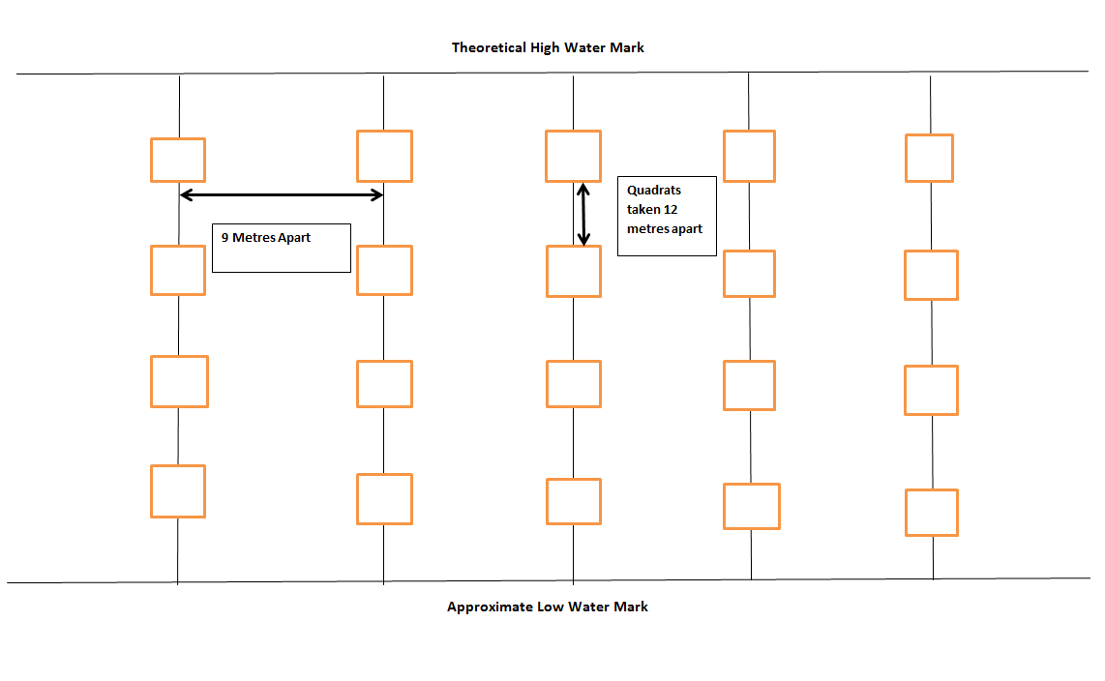Figure 3.1 showing how the transect was done over the beach (Image Authors Own, 2012)

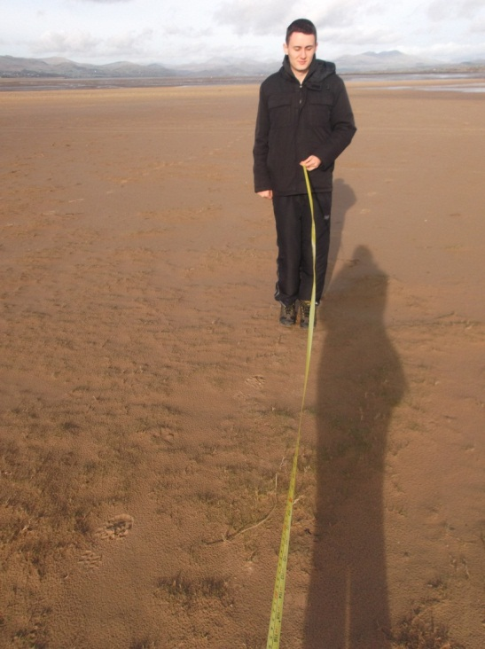
Figure 3.2 showing how the distance was measured between each quadrat (Image authors own, 2012)
At each quadrat a picture was taken and the shells were put into percentages into the newly sectioned groups:
- Whole shell
- Fragment larger than 5mm
- Fragment less than 5mm.
There is a variation of research done where terminology for recording shell fragmentation has shown that an idea for researching shell using the scale: Intact shell, Broken and fragment which gave an idea for the end product in this investigation (Claassen, 1998).The percentages were used due to the amount of fragments less than 5mm in certain quadrats so that the use of numbers was even throughout in order for better results. The percentages were worked In order to work out which section the shell fragments would come under unless obvious an mm measurement was used to give an accurate result (figure 3.3). This method was repeated for transect two on the 3rd January 2013 and the 4th January 2013.
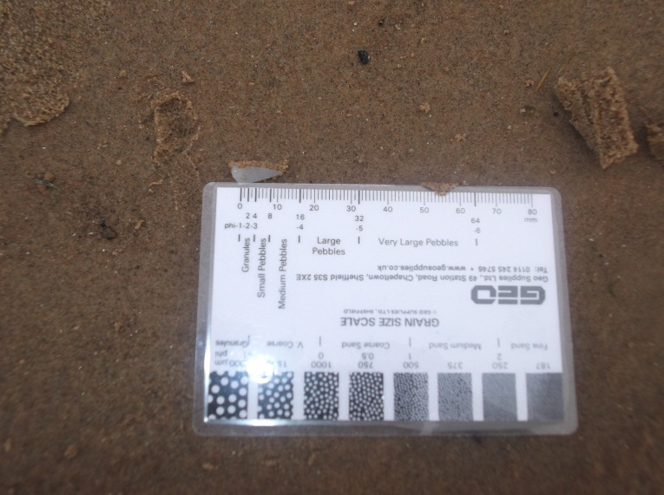
Figure 3.3 showing how fragments were measured to analysis which group the fragment would be placed in (Image Authors Own, 2012)
3.5 Methods of Statistical Analysis
The following chapter will provide an analysis using line transects, based on the table of results found in appendix 4, to observe trends that have occurred along Sandscale Haws beach. However, in order to achieve accurate results throughout this investigation, the relationship between each transect and the varying areas of shell fragmentation will be subject to statistical analysis. Firstly the different groups of shell fragmentation with be tested using a Mann-Whitney test to see if there is any significant difference between the groups. Secondly, the different transects will be tested again using a Mann-Whitney test to see if there is any significant difference between transects.

4.0 Results
The subsequent chapter will combine the raw data gathered in the field to illustrate the trends and patterns observed between the each type of shell fragmentation and each transect. The initial section in this chapter will provide a statistical analysis for the relationship between the three different types of shell fragmentation studied and the different transects which will ideally support material presented in chapter 1 and 2.
4.1 Numerical Data
As the majority of the data obtained at each transect was more numerical rather than descriptive, the data will be described statistically in the form of graphs and statistical tests. At each transects every quadrat had a photo taken and then placed in a document so that all the quadrats with fragments for each transect can be seen clearly as can been seen in appendix 3 . The different shell types at each transect were placed individually into percentages as explained in the methodology this was the easiest way to keep a constant variable instead of numbers and percentages. This has also been stated in research when looking into shells as stated by Classeen (1998) ‘Relative or percentage frequencies probably most common encountered statistic for shells in sites with more than one molluscan species and one which bears most of interpretative weight in those reports’. In order to compare the different shells variations graphs were made of the overall percentages of shells found at each transect.
4.2 Transect 1
The first transect of Sandscale Haws taken along the first 144 metres of beach for the different fragments of shell had results as shown in the table found in appendix 4.

Figure 4.0 Graph showing the overall shell fragments on transect one (Image Authors Own, 2013)
The graph shows that in transect one there was more less than 5mm shells found over the whole transect with very little whole shells being found. The photos taken of the quadrats where fragmentation was counted can be seen in appendix 3.
4.3 Transect two
The second transect at Sandscale Haws was taken again over 144 metres to keep this a constant variable which again the table of results can be found in appendix 4 and are shown below in the form of a graph.

Figure 4.1 Graph showing the overall shell fragments on transect two (Image Authors Own, 2013)

The graph shows that overall there is larger than 5mm fragments found in transect two, yet again the amount of whole shells was minimal. The photos taken at the transects where fragmentation was counted can be seen in appendix 3.
4.4 Transect three
The third transect at Sandscale Haws was taken again over 144 metres to keep this a constant variable which again the table of results can be found in appendix 4 and the results are shown below in the form of a graph.

Figure 4.2 Graph showing the overall shell fragments on transect three (Image Authors Own, 2013)
The graph shows that there is less than 5mm shell fragments amount increased found overall on transect three, yet again there is also minimal amount of whole shells found. The photos taken at the transects where fragmentation was counted can be seen in appendix 3.
4.5 Whole Shells
In order to give a full comparison the individual shells themselves were compared with each other to see if there is any relation with tide height and different periods of time. There was 57 quadrats done on each transect to keep this a constant variable for comparability.

Figure 4.3 Graph to show the amount of whole shells over each transect (Image Authors Own, 2013)
The graph shows that there is more whole shells in transect three but only with less than 10% difference between the three transects.
4.6 Larger than 5mm Shells
The larger than 5mm fragments of shells were easily detectable and therefore the count would be more accurate.

Figure 4.4 Graph to show the amount of larger than 5mm shell fragments over each transect (Image Authors Own, 2013)
The graph shows that there is significantly more larger than 5mm shell fragments found in the latter two transects.
4.7 Less than 5mm shells
The less than 5mm fragments were not easily detectable and a certain amount of estimating was require due to the sheer amount of fragments found in a quadrat.

Figure 4.5 Graph to show the amount of less than 5mm shells fragments over the each transect (Image Authors Own, 2013)
The graph shows that there is more less than 5mm shells in transect three.
4.8 Kruskal-Wallis
In order to get a more statistically valid result the data was put through a statistically test on the software minitab known as Kruskal Wallis which would show if there is any significant difference between the three types of shells and over the three different transects.
The results from the statistical test from the types of shell can be found in appendix 5. The tests show that in all cases p values are greater than 0.05 show that in order accept the null hypothesis that there was no significant difference in the % coverage (for each shell type) found at each transect. This is opposed to the alternative hypothesis that there is a significant difference.
The results from the statistical test from the different transects can be found in appendix 5. The tests show that in all case the p values are less than 0.05 so you would this suggested that the null hypothesis showed that there was significant difference in the amount of fragmentation over the different transects. This is opposed to the alternative hypothesis that there is a significant difference.

4.9 Summary of Key Results

From the data gathered it appears that there are trends and patterns which can relate shell fragmentation with varying sea state. It appears that although there is not a significant different between the different shell types there is a significant difference between the different transects.

5.0 Discussion
The following chapter will give a detailed account of the results gained throughout this study, shown in appendix 4. In addition, the results of statistical data used to test the relationship between both shell fragment type and transects will provide evidence in order to investigate the original title of this investigation. Furthermore, using the previous research and knowledge outlined in chapter 2, existing relationships observed in the field can be explained in depth and associated with trends parameters investigated particularly from this investigation.
The aim of this investigation was to find a relationship between shell fragmentation and variations in sea state by doing multiple transects along a section of beach at Sandscale Haws. By conducting research of multiple transects, a comparison can be made to observe the difference over time and tide height. As discussed in chapter 3, the main method used in carrying out this research was that of marking out quadrats along a transect to analyse shell fragmentation along that section of the beach. From the results in chapter 4, it is apparent significant differences have been found between each transects, although not between each varying shell fragmentation type. Statistical analysis of the data in chapter 4 shows that there is a significant relation between each transect over time. The following will provide an account of a possible connection between shell fragmentation and sea level rise. Other results collected from the data will also be analysed.
5.1 Analysis of Transects
The first transect done at Sandscale Haws showed varying comparison with the sea state. The sea state can vary a lot (Wu, 1979) and takes into consideration a lot of varying areas of study such as the wind and waves (Spencer, 2006). The first transect one was done on a low tide day; although no comparisons could be drawn at that time with other transects, relationships between shell types could be made. The initial analysis indicated that overall there were more fragmented shells less than 5mm than whole shells found along that section of beach as seen in chapter 4. The geology along Sandscale Haws is mainly formed by wind blown elements. The bedrock at Sandscale is calcarenite which formed in the carboniferous period, which is fairly recent and the superficial geology is made mostly of wind blown sands and wind blown deposits as seen in figure 5.0 (BGS, n.d.)
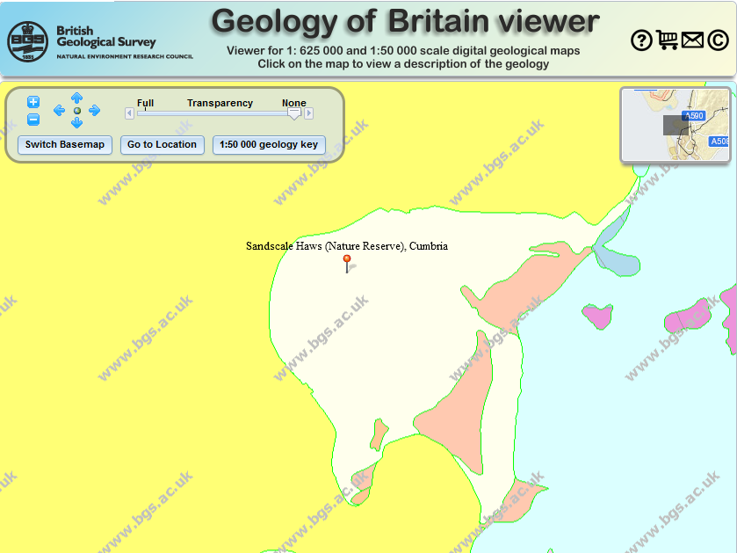
Bedrock: Dalton Formation- Calcarenite
Superficial Geology: Blown Sand
Figure 5.0 Image showing the geology of Sandscale Haws (BGS, n.d)
The geology would indicate that the tides are very gentle as the superficial geology is blown sand. This would mean that the beach is flatter due to the wind blown geology the assumptions include the wind is uniform and steady; the surface is usually unobstructed and horizontal with uniform size sediments (Sherman, 1995). The gentle wave action on the beach could cause the fragmentation to be less due to the affect of weather being less severe. The results for transect one statistically, as shown in chapter 4, were shown to be less than 0.05 p value between the different shell variants indicating that there was significant difference between them. This shows that the different shell variants had a large enough variation such as the difference between the amount of <5mm fragmented shells an whole shells being 73%.
The prevailing wind direction as shown in figure 5.1 shows that due to its position the beach is a sheltered area. The prevailing wind focuses on a south west direction as shown by the met office in figure 5.1.
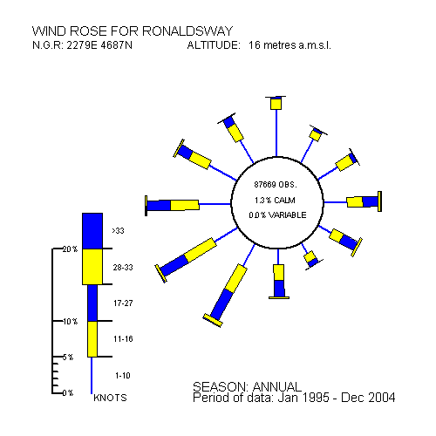
Figure 5.1 Image showing the prevailing wind direction (Met Office, n.d.)
The direction of the prevailing wind supports that the beach is in a sheltered beach and the tide will be gentle. The shells along the beach will therefore be less affected than a beach facing the sea that is subject to a lot of erosion. This is different due to the prominently exposed North West section of the coast which would be affected by some of the strongest winds to affect the UK. In Cumbria there have been winds up to 88mph specifically at St Bees Head in 2005 (Met Office, n.d.). This supports the case that when the research was being done initially into the study area for the investigation Sandscale Haws became the best beach as it was all sandy whereas the others were mostly rocky beaches. The likely explanation for this is that fact that the other areas such as Walney Island were more open to the Irish Sea which would explain the type of erosion taking place.
The second transect took place around a month after the first transect when the tide height was higher overall at 8.4m this showed a changed in the results where there was less whole shells over the whole transect as seen in appendix 3. The difference in shell breakage between the two transects was 20% which showed a variation that could be affected by the different variations in weather. The tide height could be the result of a variation from the Duddon River as seen in figure 5.2 which has an approximate discharge of 33.5 km surrounding the Duddon Estuary.
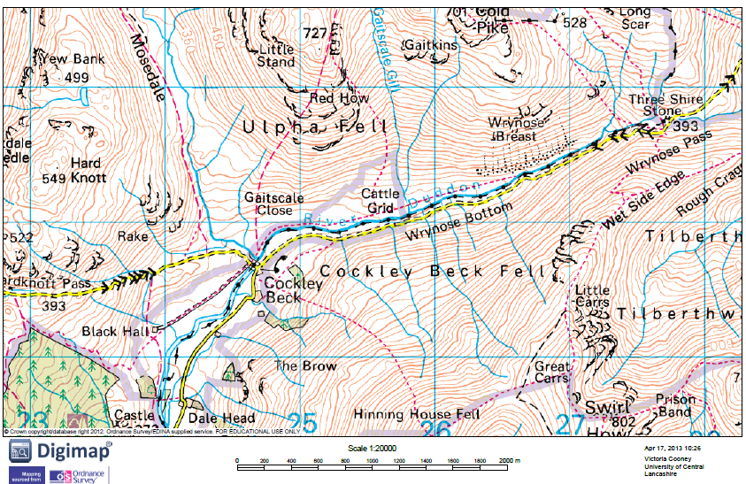
RIVER DUDDON
Figure 5.2 Image showing the River Duddon (Edina Digimaps, n.d.)
The River Duddon is 13 Miles long with various tributarys along its journey to the Duddon Estuary (Corrie-Close, 2010). The discharge of rivers has become a growing concern due to its possible connection with climate change and the impact of human perturbations to the marine environment (Milliman and Farnsworth, 2011). The effect of the very large river on the beach at Sandscale Haws, especially with increased dangers of flooding, will be an area of concern for the future. The possible coastal erosion will have an effect on the beach sediment which in turn will affect the shell fragmentation along the beach.
The third transect took place shortly after the second due to the time and availability of the investigation which may have affected the results due to the short period in which the access changes to the beach. However the results showed that although there were more whole shells than found were in the previous transects, the number of fragmented shells less than 5mm increased dramatically. The amount of less than 5mm fragments almost doubled from the first transect, which shows the effect of varying tides could have on the shell fragmentation. There was no significant difference between the varying types of shell unfortunately as originally thought. But as the amount of research done on shell fragmentation is minimal as stated in chapter 2 it would seem that it would need a large weather even to cause a significant increase in shell breakage. An example of this was documented in 2007 where a tsunami showed there was significant variation of shell taphonomy (Donato et al, 2007).
There was found to be a significant statistical difference between the three transects in that for each shell type showed a P-value of over 0.05. This indicates that the tides and other influences have caused the fragmentation to differentiate and increase dramatically in some areas, although certain aspects, such as public use of the beach have an unknown influence on the fragmentation. The influence of the weather on shell breakage may vary greatly, although witter et al (2004) syggested that sea coasts need to be subjected to significant variations in wind and waves in order to affect shell fragmentation significantly. Therefore this indicates that the transects had be affected by variation in tides and weather which is enough to cause a difference in fragmentation, although it is unknown the effect of other aspects from the beach.
As stated in Hindle (1998) the Duddon Estuary has sand banks known as Duddon Sands, as shown in figure 5.3. The shallow banks form a low energy environment which makes the tides more gentle than other areas which are on a more open coastline (Schwartz, 2006).
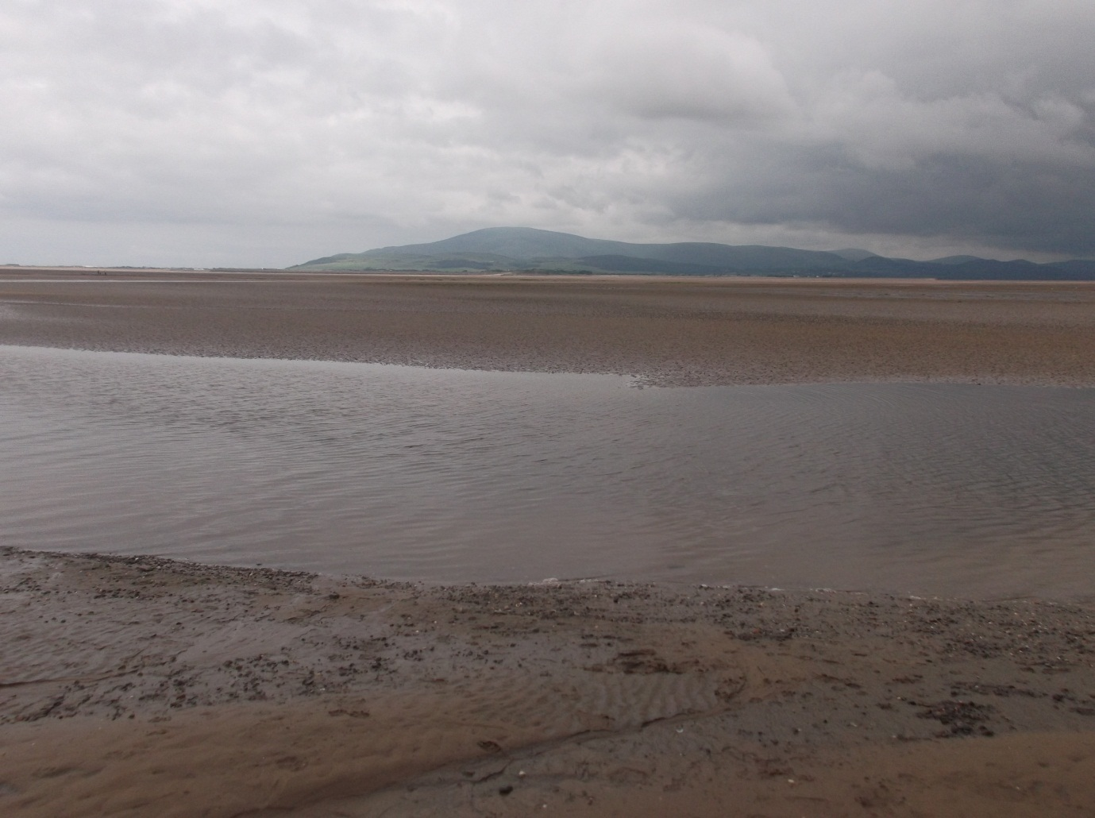
Figure 5.3 Image showing the sandbanks across the Duddon Estuary (Image Authors Own, 2012).
The sand banks will cause the area to have varying tides which in turn will affect the beach and shell fragmentation. Figure 5.4, show the large area covered by sandbanks and how the sandbanks vary along the whole of the estuary which would cause the current to be of a lower energy. Along the Duddon Estuary there is no dredging that takes places to affect the tides as that possibility would cause loss of habitat in the estuary and affect the natural amount of sediment which is found there, which could cause various affects to the surrounding area.
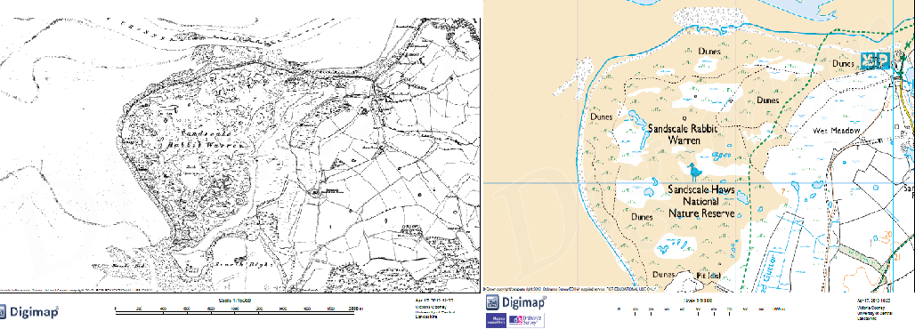
Figure 5.4 Image showing Sandscale Haws in 1850 and now (Edina Digimap, n.d.)
The coastline of Sandscale Haws has eroded over the past century. The erosion could increase dramatically over the next few decades, affecting the beach and the sediment. The idea of coastal erosion is a growing concern all around the world and this would affect the shell fragmentation along the beach. The maps show that the round point of Sandscale Haws has changed shape over the years, however that side of the beach is not sheltered and is affected by the sea.
The beach is possibly affected by longshore drift as seen in figure 5.5 as the pier which is at Askam looks to show the direction.
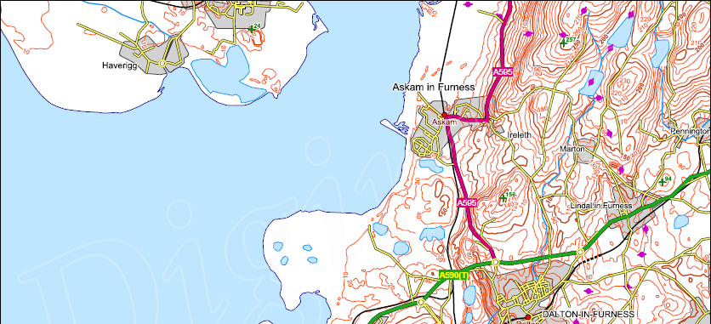
Askam Pier
Sandscale Haws Haws
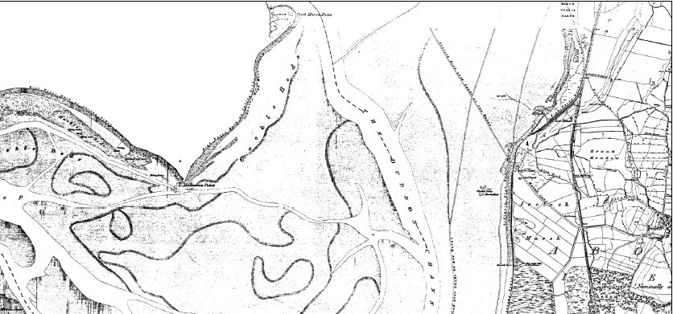
Askam pier
Figure 5.5 Image showing Askam pier in relation to Sandscale Haws 1850 and now(Edina Digimap, n.d.)
The way the pier has formed shows that the possibility of longshore drift could be a reason behind the way the coastline has formed. The pier will support the argument of a low energy environment and indicates the movement along the beach which may have influenced the results due to the fact that longshore drift has the ability to move large-quantities of material down the beach which could possible be out of the investigation area.
The overall results for the transects are inconclusive due to the fact that the transects would need to be done over a longer period of time in order to gather more results and provide a greater comparison to see if there is any significant change. The results, although inconclusive, could provide a basis for future research which examines shell fragmentation as an indicator of further coastal erosion of the Duddon Estuary. The possibility of sea level rise in the future due to climate change is an area of concern around the world which is something which could affect Sandscale Haws and the fragmentation of shells. The sea level change could be the result of charge to the natural area which is affected by the sea level change of around 1.5mm to 2mm per year and the change in land level locally (Natural England, 1997).

6.0 Conclusion
This investigation concludes that the relationship between the varying sea state and shell fragmentation is inconclusive. Although there were significant differences found around the three different transects in terms of the varying fragmentation the difference was reserved over a small area over a short period. The beach can be influenced by different factors such as the prevailing wind direction which can indicate how much the beach will be affected. In the case of Sandscale Haws it has been seen that due to the nature of the beach and the positioning the beach it is rather sheltered. This would mean that the sea is gentle more than in surrounding areas which are usually affected by a lot of erosion in the North West. The geology begins to explain this by the fact that the bedrock is fairly recent, only forming in the carboniferous period. The superficial geology is mostly wind blown sand which indicates that the area is more sheltered and is not likely to be affected as severely as some of the other areas. The Duddon Estuary is formed from the Duddon River which affects the whole of the surrounding area, the river itself being 13 miles long with various tributaries which all affect it. The base of the Duddon Estuary has sand banks which create a low energy environment which would cause the tides to be a lot gentle on the beach itself. The general variation in weather could cause some fragmentation of the shells, but due to the Duddon Estuary being a lower energy environment the variation may be minimal. The beach itself however looks to be affected by longshore drift, suggested by Askam pier which has enlarged over the years. However, although the beach itself looks to be affected by a lower energy environment, transects showed that there was a variation in shell breakage: specifically the difference between the amount of fragments less than 5mm. When the comparison was carried out between transect one and transect two there was over double the number, which even if the anomalies were taken out of the equation such as public use the difference was still significant.
Therefore, although at this moment in time the investigation is inconclusive it still indicates that it is an area for future research. Based on the increased shell fragmentation as an early indication of coastal erosion, If sea-level rise as predicted this could help to serve as an early warning system to alert future generations to what is happening to British coastlines. The connection with sea state could eventually bring an overall larger study regarding the future of coastlines in relation to the possible sea level rise and climate change.
6.1 Limitations of the investigation
During the course of this study a number of limitations arose which consequently affected the overall accuracy and reliability of the data. These obstacles apparent in the field and throughout the initial states of the research have restricted the investigations aim of answering ‘does varying sea state affect the fragmentation of shells at Sandscale Haws’ set out in chapter 1.
The main weakness of this study was the limited data collected in situ. This means that when originally choosing the amount of transects done to compare there should have been time made to do a larger amount, this reduced the ability to evaluate the fragmentation of the shells. Due to the restricted range of data obtained, this investigation encompasses an empirical approach to collecting data and uses comparisons with existing research in some areas to further increase the analyses, (Naish, 2002). Further research into this topic of interest would include increasing the amount of data collected over a longer period of time specifically over a few decades as this would be beneficial in making this study more reliable and accurate in its conclusions.
Furthermore, not only was the lack of diversity in data collected proven to limit the investigation, but also the amount of transects showed restraints on quantity of data able to be obtained. During the preliminary research of suitable sites along each beach factors taken into account included recording the type of sediment and amount of shell found in general along the beach to have a beach that had enough shell diversity to bring a large enough comparability. However, it was evident that the transects that took place showed limitations in the form of the amount of quadrats found without any fragments in at all. Therefore, an ideal set of data was not attained.
Further limitations were found due to temporal factors. The initial time frame research was intended to be undertaken within was over a number of certain weeks. However the ability to get to the study site and the amount of time needed to be between transects for the comparability to be able the investigation had problems. As the results show, the first and second transects were around a month apart but the second and third transect are one after another which would have influenced the results but a comparison was able to be made between the first transect and the second and first and third.
A further limitation was the affect from the public use of the beach of which over time would cause the fragmentation from simply walking along the beach itself. This was an area which could not be control nor could it be measured to work out an estimate was to how much. The beach itself is used for dog walking and is fairly quiet especially the time of year that this investigation took place but if this limitation would have been able to be taken away the results could have changed dramatically. However this is an area which cannot be controlled now can it be fully monitored as it would mean having a way to constantly measure the amount of public use of the beach, unless the area of study was protected during the whole investigation which is not practical.
The final limitation of this investigation was the influence of human errors and management of the results and the methods of obtaining results. Initially, the locations of the quadrats would be found by planning a transect along the beach and choosing quadrats of equidistance. In addition, inconsistencies were discovered when using the quadrat to collect the sample from the beach. The ability to use an actual quadrat caused problems as this changed the method to measuring each quadrat with a measuring tape as shown in figure (3.2) which was also used to measure the difference between the quadrats. Therefore, an inaccurate measurement of the shell fragments may have been recorded. Further research into this subject, without time constraints, would evaluate the influence of varying sea states have on shell fragmentation.
6.2 Further Research
This investigation shows that there is a variation of fragmentation along the beach although this investigation was inconclusive the number of factors affecting fragmentation could be incorporated into future research in this topic. From the data obtained during the course of this study there was no final deductions taken that can assume varying sea state is the major factor controlling shell fragmentation. Nevertheless, factors observed in the field in terms of the increase in less than 5mm shell fragments and the low amount of whole shells can be integrated into further investigations. By solely focussing on the shell fragmentation to understand the influence sea state has does not begin to analyse the overall extent varying sea states plays in shell fragmentation.
As explained in chapter 5, a wider range of data is required in order to gain a better understanding of the influence varying sea states has on shell fragmentation. Further research into this investigation would include doing a transect over a larger area and over a longer period of time specifically over a few decades to get a full results over time. The use of a quadrat and the possibility of using GPS to get the exact positions for every quadrat to get a more reliable result could be used for future use. If these aspects were taken into account the investigation could eventually be used to study the possibility of sea level rise and climate change.

7.0 References
Ahnert, F (1998). Introduction to Geomorphology. Arnold Publishers. London
Andree, M, Beer, J, Oeschger, H, Mix, A, Broecker, W, Ragano, N, O’Hara, P, Bonani, G, Hofmann, H, J, Morenzoni, E, Nessi, M, Suter, M, Wolfli (1985). Accelerator Radiocarbon Ages Foraminipera and Atmospheric CO₂: Natural Variations Archean to Present. American Geophysical Union. Washington.
Anon (2011). Advances in Climate Change and Global Warming Research and Application. Scholarly Editions. Atlanta. Georgia.
Anon (2012). Mussel power – ocean shells can help predict rise in sea levels. Available at: http://www.reading.ac.uk/news-and-events/releases/PR479588.aspx. Accessed 20/01/13.
Bessa, F., Cunha, D., Goncalves, S, C., Marques, J, C.,(2013). Sandy beach macrofaunal assemblages as indicators of anthropogenic impacts on coastal dunes. Ecological Indicators. 30. 196-204.
Bird, E, C, F,.(1996). Coastal Erosion and Rising Sea-Level. In: Milliman, J, D and Haq, B, U,.(1996). Coastal Systems and Continental Margins Sea Level Rise and Coastal Subsidence Causes, Consequences, and Strategies. Kluwer Academic Publishers. The Netherlands.
British Geological Survey (2012?). Geology of Britain Viewer. Available at: http://mapapps.bgs.ac.uk/geologyofbritain/home.html. Accessed 16/02/13.
Burton, P (2001). Grazing as a Management Tool and the Constraints of the Agricultural System: A Case Study of Grazing on Sandscale Haws Nature Reserve, Cumbria, NorthWest England. In: Houston, J, A, Edmonson, S, E, and Rooney, P, J. ed. (2001). Coastal Dune Management Shared Experience of European Conservation Practice. Liverpool: Liverpool University Press, pp. 80-85.
Claassen, C,.(1998). Cambridge Manuals In Archaeology Shells. Cambridge University Press. Cambridge.
Corrie-Close, B, (2010). Duddon River Association. Available at: http://www.scrt.co.uk/duddon-river-association/duddon-river-association. Accessed 15/02/13.
Cumbria County Council (2011). Cumbria Landscape Character Guidance and Toolkit Part One Landscape Character Guidance. Available at: http://www.cumbria.gov.uk/eLibrary/Content/Internet/538/755/2789/406869467.pdf. Accessed 20/08/12.
Digimap Roam (n.d.). Ordance Survey of River Duddon. Available at: http://digimap.edina.ac.uk/roam/mapper. Accessed 02/02/13.
Digimap Roam (n.d.). Ordance survey of Sandscale Haws. Available at: http://digimap.edina.ac.uk/roam/mapper. Accessed 04/03/13.
Digimap Roam (n.d.). 1850 map of Sandscale Haws. Available at: http://digimap.edina.ac.uk/ancientroam/mapper. Accessed 06/03/13.
Douglas, B,C,.(2001). The Importance of Sea Level Rise. In: Douglas,B,C, Kearney, M,S, and Leatherman, S, P,.(2001). Sea Level Rise History and Consequence. Academic Press. San Diego. California, pp. 1-10.
Donato, S.V. Reinhardt, E.G. Boyce, J.I. Rothaus, R. Vosmer, T (2007). Identifying tsunami deposits using bivalve shell taphonomy. Geology. 33. 3. 199-202.
Eidous, O, M,.(2012). A New Kernel Estimator for Abundance using Line Transect Sampling Without Shoulder Condition. Journal of the Korean Statistical Society. 41. 2. 267-275.
Google Maps (2013). Satellite Image of Sandscale Haws. DigitalGlobe.
Goudie, A.S (2006). Global Warming and Fluvial geomorphology. Geomorphology. 79. 3-4. 384-394.
Harvey, A (2012). Introducing Geomorphology A Guide to Landforms and Processes. Dunedin Academic Press Ltd. Edinburgh.
Jandin, H and Mandia, S, A,. (2012). Rising Sea Levels: An Introduction to Cause and Impact. United States.
Kauffman, E. G. (1972). Ptychodus predation upon a Cretaceous Inoceramus. Journal of Paleontology 15(3):439-444.
Kearney, M,S,.(2001). Late Holocene Sea Level Variation. In: Douglas,B,C, Kearney, M,S, and Leatherman, S, P,.(2001). Sea Level Rise History and Consequence. Academic Press. San Diego. California, pp. 13-18.

Komar, P, D (2011). 3.11 – Coastal Erosion Processes and Impacts: The Consequence of Earth’s Changing Climate and Human Modifications of the Environment. Treatise on Estuarine and Coastal Science. 3. 285-308.
Masselink, G and Pattiaratchi, C, B. (2001). Seasonal Changes in Beach Morphology Along the Sheltered Coastline of Perth, Western Australia. Marine Geology. 172. 3-4. 243-263.
Mclachlan, A. Brown, A (2006). The Ecology of Sandy Shores. Academic Press. London
Met Office (n.d.). North West England & Isle of Man: climate. Available at: http://www.metoffice.gov.uk/climate/uk/nw/. Accessed 06/01/13.
Milliman, J, D and Farnsworth, K, L (2011). River Discharge to the Coastal Ocean A Global Synthesis. Cambridge University Press. New York.
Milliman, J, D and Haq, B, C.(1996). Sea Level Rise and Coastal Subsidence: Towards Meaningful Strategies. In: Milliman, J, D and Haq, B, U,.(1996). Coastal Systems and Continental Margins Sea Level Rise and Coastal Subsidence Causes, Consequences, and Strategies. Kluwer Academic Publishers. The Netherlands.
Naish, M, (2002). Action Research for a New Professionalism in Geography Education. In: Smith, M and Smith, M. ed. (2002). Teaching Geography in Secondary School: a reader. RoutledgeFalmer. London.
National Trust (2010). Sandscale Haws Visitor Information. Available at: http://www.nationaltrust.org.uk/sandscale-haws/visitor-information/. Accessed 20/09/12.
Natural England (1997). Cumbrian Coast Natural Area Profile. Available at: http://www.sssi.naturalengland.org.uk/science/natural/profiles%5CnaProfile119.pdf. Accessed 15/03/13.
Oji,T. Ogaya, C. Sato, T. (2003). Increase of shell-crushing predation recorded in fossil shell fragmentation. http://paleobiol.geoscienceworld.org/content/29/4/520.short. Visited 10/02/12
Opalinska, B. (2011). Shell Fragmentation as an Indicator of Occupation Intensity at Shell-Bearing Sites: Narrows Inlet, British Columbia. Premier, Archaeology. 1.
ProQuest Information and Learning Company. (2008). UMI Microform 3303757. United States.
Schwartz, M (2006). Encyclopedia of Coastal Science. Springer. Netherlands.
Sherman, D, J, Jackson, D, W, T, Namikas, S, L and Wang, J (1998). Wind-Blown Sand on Beaches: an Evaluation of Models. Geomorphology. 22. 2. 113-133.
Spencer, L (2006). Determining Scale and Sea State from Water Video. Image Processing, IEEE Transactions on. 15. 6. 1525-1535.
Sutherland, W,J, (2006). Ecological Census Techniques Second Edition A Handbook. University of East Anglia, Norwich.
The Independent (2013). Climate Change Will Bring Extremes in Weather, warns Governement’s Chief Scientific adviser. Available at: http://www.independent.co.uk/environment/climate-change/climate-change-will-bring-greater-extremes-in-weather-warns-governments-chief-scientific-adviser-8547893.html. Accessed 25/03/13.
Versteegh, E, A, A, Blicher, M,E, Mortensen, J, Rysgaard, S, Als, T, D, Wanamaker Jr, A, D (2012). Oxygen isotope ratios in the shell of Mytilus edulis: archives of glacier meltwater in Greenland?. Biogeosciences. 9. 5231-5241.
Walkden, M and Dickson, M (2008). Equilibrium erosion of soft rock shores with a shallow or absent beach under increased sea level rise. Marine Geology. 251. 1-2. 75-84.
Wernberg, T, Russell, B,D, Moore, P, J, Ling, S,D, Smale, D,A, Campbell, A, Coleman, M, A, Steinberg, P,D, Kendrick, G, A and Connell, S, D (2011). Impacts of Climate Change in a Global Hotspot for Temperate Marine Biodiversity and Ocean Warming. Journal of Experimental Biology and Ecology. 400. 1-2. 7-16.
Wittle,F.K. Kun, F. Kroplin, B.H. Herrmann, H.J (2004). Fragmentation of shells. Accepted publication by phys.
Wu, J (1979). Ocean Whitecaps and Sea State. Journal of Physical Oceanography. 9. 1064-1068.
Wye, K, R,.(1991). The Encyclopedia of Shells. Chartwell Books. New Jersey.
Zaton, M. Salmon, M.A (2008). Durophagous Predation On Middle Jurassic Molluscs, As Evidence From Shell Fragmentation. Paleontology. 53. 1. 63-70.
Zhang, K. Douglas, B. C. Leatherman, S. P (2004). Global Warming and Coastal Erosion. Climatic Change. 64. 1-2. 41-58.
Zuschin, M. Stachowitsch, M. Stanton Jr, R, J (2003). Patterns and Processes of Shell Fragmentation in Modern and Ancient Marine Environments. Earth-Science Review. 63. 1-2. 33-82.

Appendix 1

Appendix 2

Appendix 3
TRANSECT ONE 24/11/12
Weather: 2⁰c, Cold
Time: 9am until 1pm
Tide: (Out while doing transect)
Low Tide 02:22 (2.00m)
High Tide 08:13 (7.10m)
Low Tide 14:48 (2.20m)
High Tide 20:27 (7.40m)
Down 12m Across 9m
Tally
Whole: 14
Fragment>5mm: 45
Fragment<5mm: 38

Quadrats (57 total)
Quadrat 1: 1<5 fragment
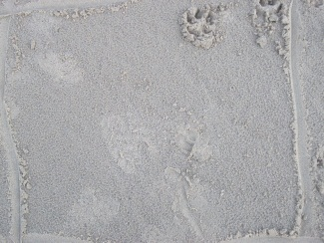
Appendix 3.1 – Quadrat 1
Quadrat 5: 1<5 fragment
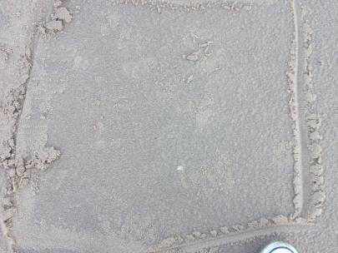
Appendix 3.2 – Quadrat 5

Quadrat 6: 2 whole, 1>5 fragment and 3<5 fragment
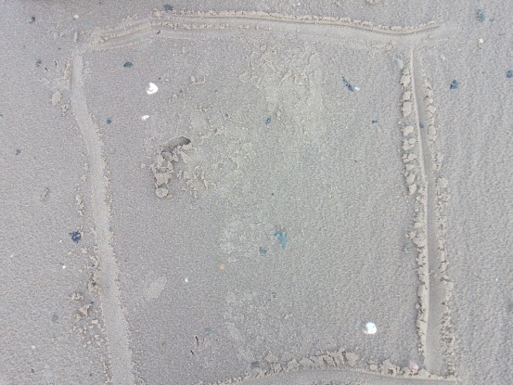
Appendix 3.3 – Quadrat 6
Quadrat 7: 1>5 fragment
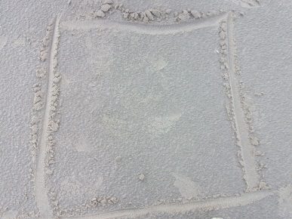
Appendix 3.4 – Quadrat 7

Quadrat 9: 1>5 fragment
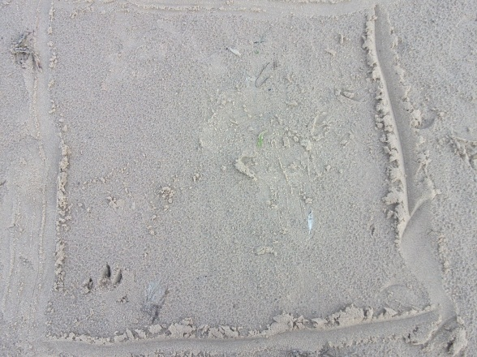
Appendix 3.5 – Quadrat 9
Quadrat 10: 1 whole, 1>5 fragment and 1<5 fragment
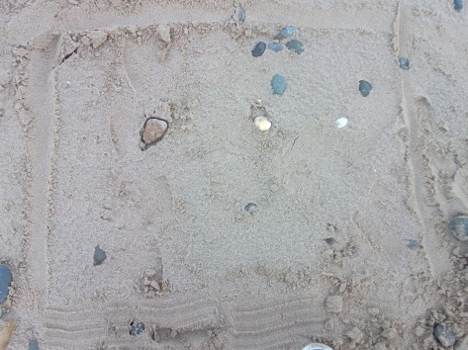
Appendix 3.6 – Quadrat 10
Quadrat 14: 2>5 fragment
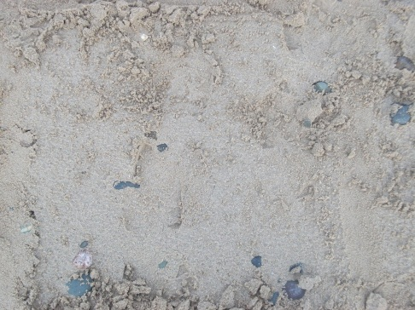
Appendix 3.7 – Quadrat 14
Quadrat 15: 1>5 fragment and 4<5 fragment
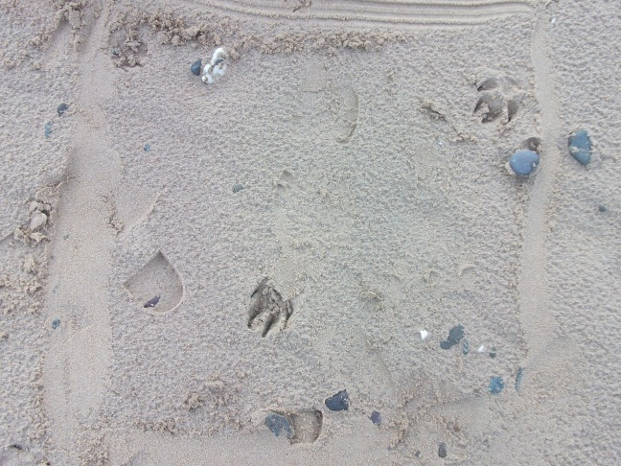
Appendix 3.8 – Quadrat 15

Quadrat 16: 2>5 fragment and 8<5 fragment
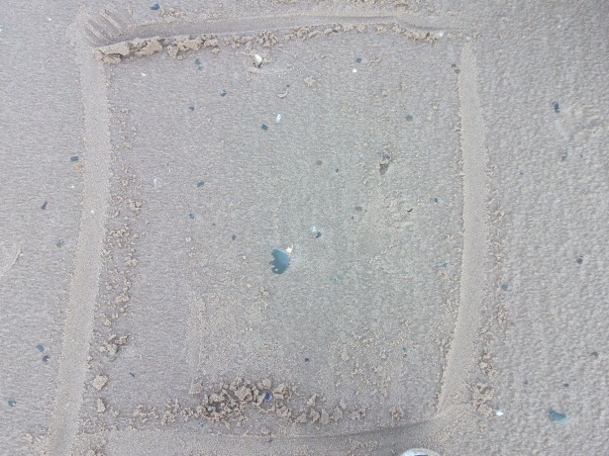
Appendix 3.9 – Quadrat 16
Quadrat 20: 2>5 fragment and 3<5 fragment
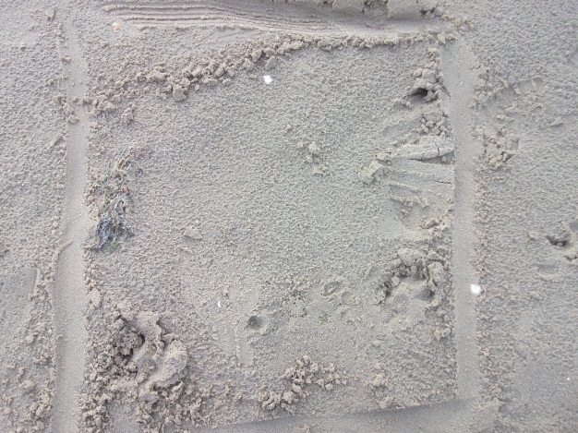
Appendix 3.10 – Quadrat 20

Quadrat 21: 4<5 fragment
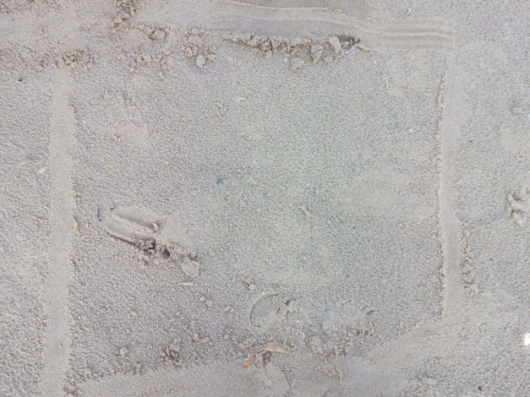
Appendix 3.11 – Quadrat 21
Quadrat 22: 1>5 fragment
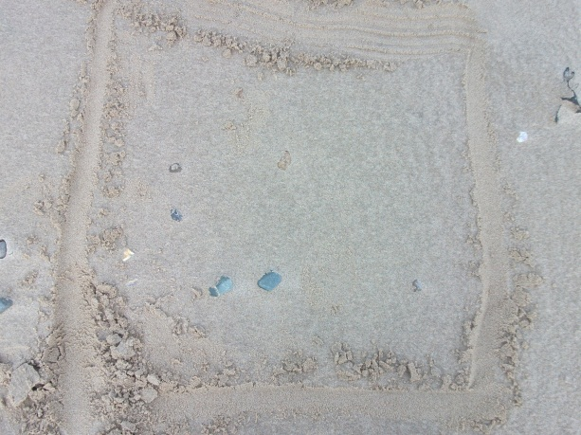
Appendix 3.12 – Quadrat 22

Quadrat 24:2>5 fragment
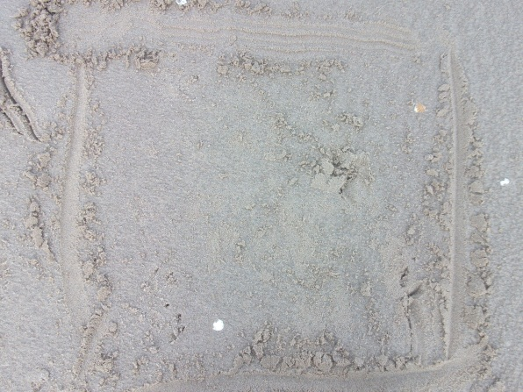
Appendix 3.13 – Quadrat 24
Quadrat 25: 1>5 fragment
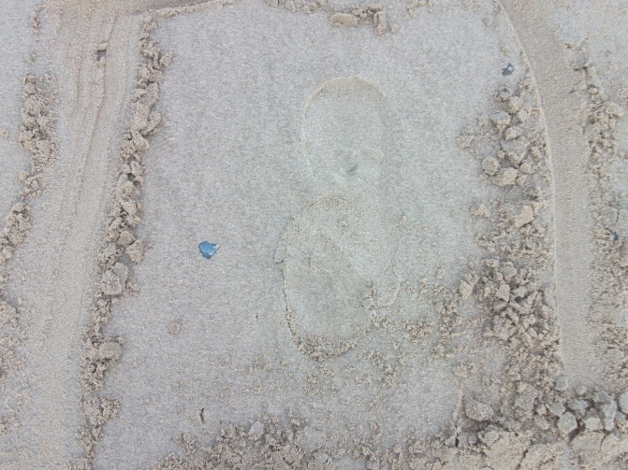
Appendix 3.14 – Quadrat 25

Quadrat 29: 2>5 fragment
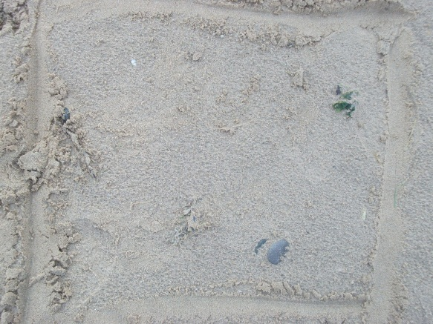
Appendix 3.15 - Quadrat 29
Quadrat 30:1>5 fragment
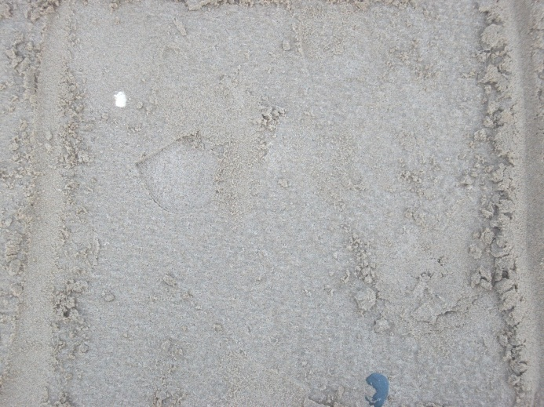
Appendix 3.16 – Quadrat 30

Quadrat 40: 2<5 fragment
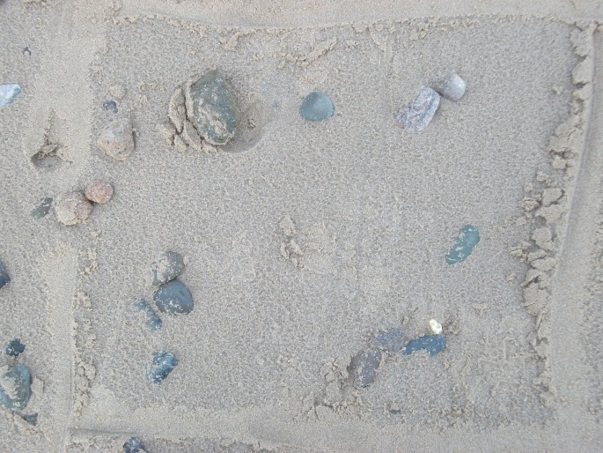
Appendix 3.17 – Quadrat 40
Quadrat 44: 1 whole
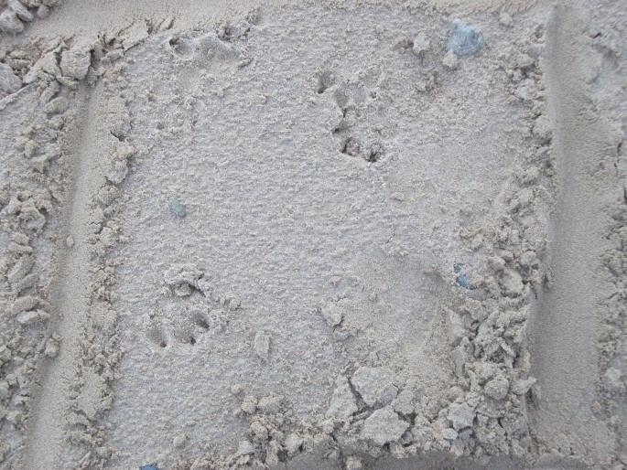
Appendix 3.18 – Quadrat 44
Quadrat 45: 1>5 fragment
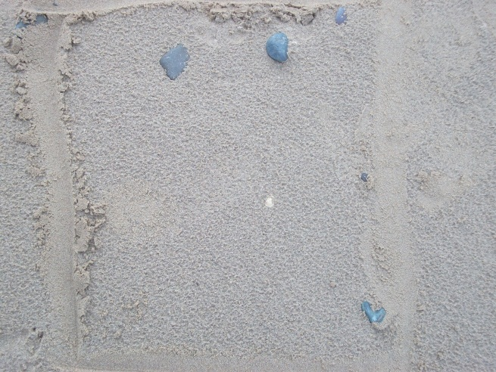
Appendix 3.19 – Quadrat 45
Quadrat 46: 1<5 fragment
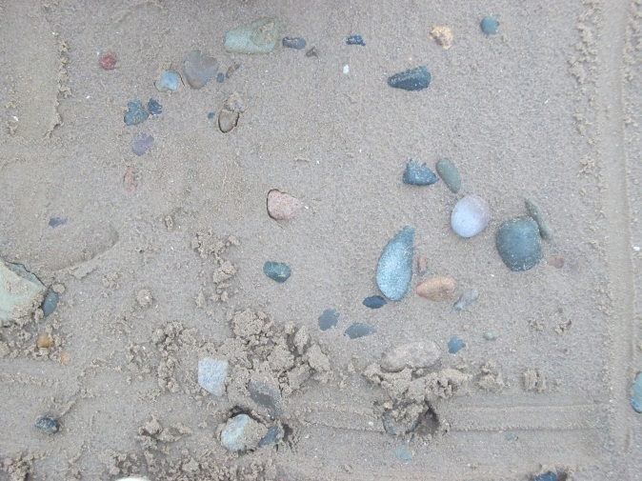
Appendix 3.20 – Quadrat 46

Quadrat 47: 1<5 fragment
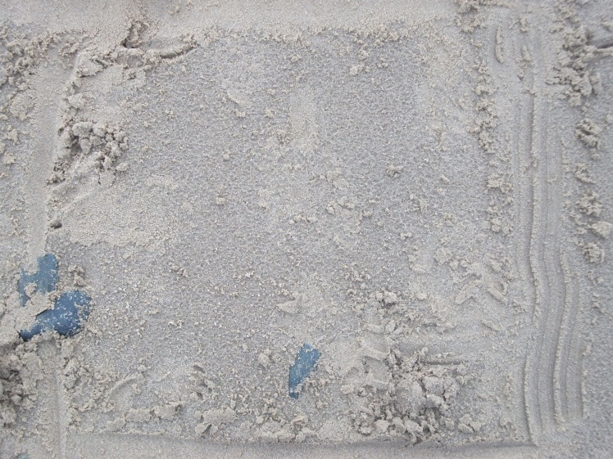
Appendix 3.21 – Quadrat 47
Quadrat 50: 4 whole, 10>5 fragment and 40%<5 fragments
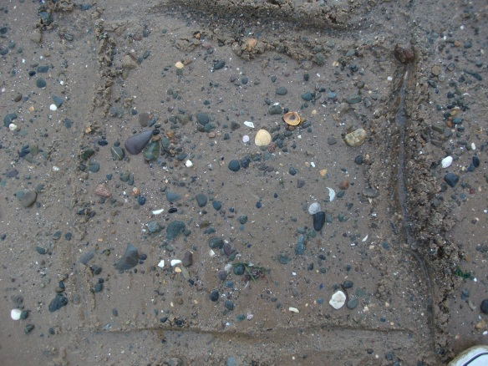
Appendix 3.22 – Quadrat 50

Quadrat 51: 4 whole, 2>5 fragment and 6<5 fragment
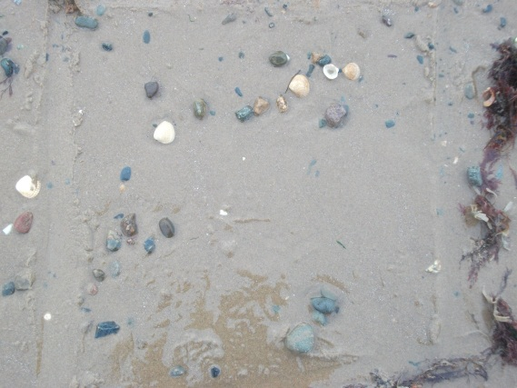
Appendix 3.23 – Quadrat 51
Quadrat 52:9>5 fragment and 20%<5 fragments
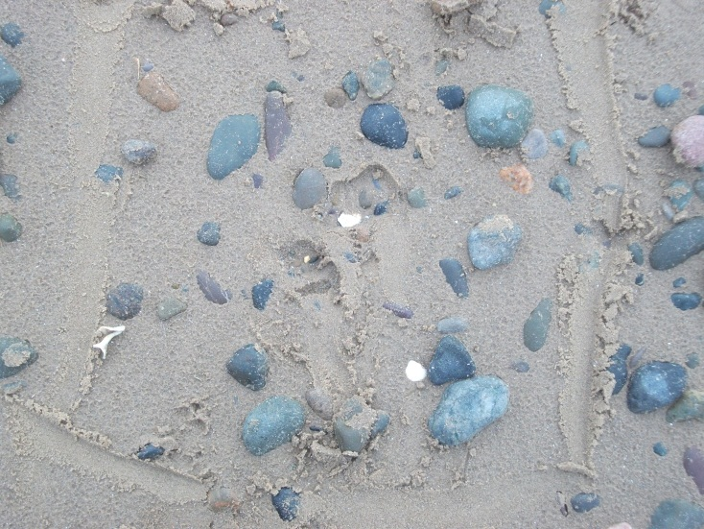
Appendix 3.24 – Quadrat 52

Quadrat 56:6>5 fragment and 20%<5 fragment
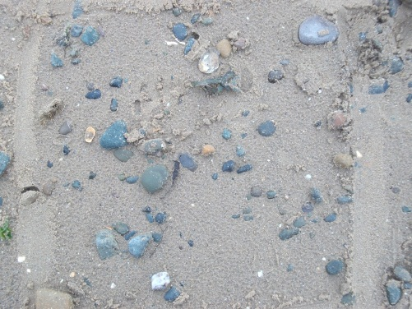
Appendix 3.25 – Quadrat 56

Quadrat 57: 2 whole, 8>5 fragment and 3<5 fragment
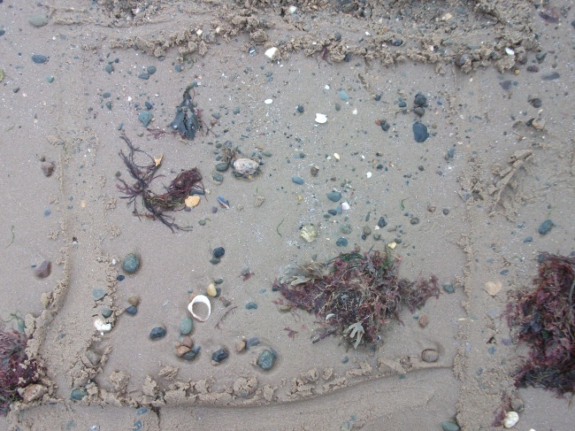
Appendix 3.26 – Quadrat 57
Transect 03/01/12
Weather: Sunny, Cloudy and Cold
Time: 9.30 till 12
Tide: Out
High 0239 8.4
Low 0907 2.2
High 1456 8.6
Low 2144 2.1
Down 12 Across 9
Tally: 57
Whole: 13
Fragment>5mm: 64
Fragment<5mm: 22
Quadrats (57 Total):
Quadrat 1: 2<5fragments
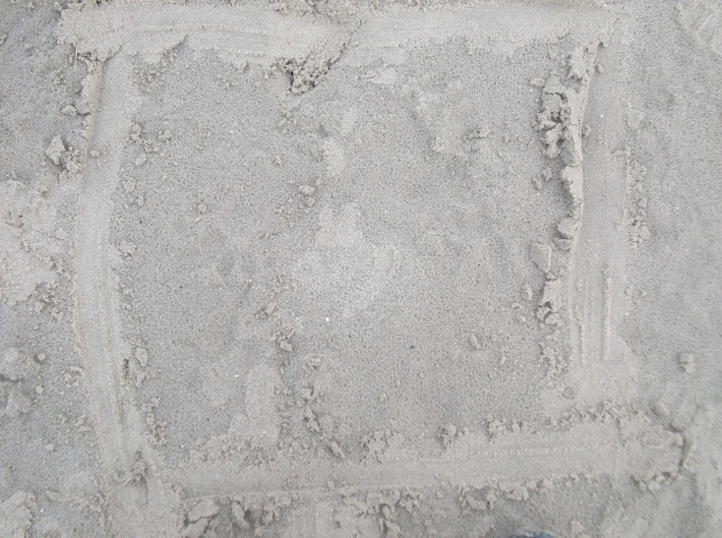
Appendix 3.27 – Quadrat 1
Quadrat 3: 1>5 fragments
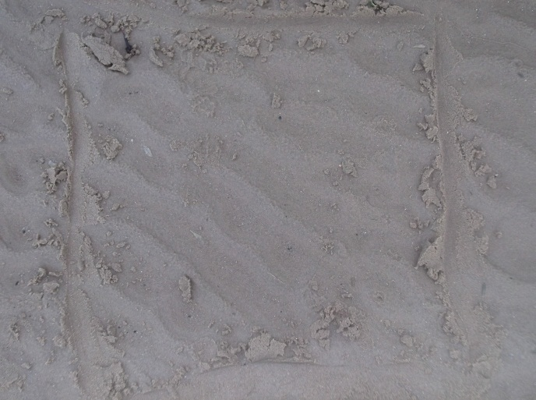
Appendix 3.28 – Quadrat 3
Quadrat 6: 3 Whole, 2>5 fragments, 2<5 fragments
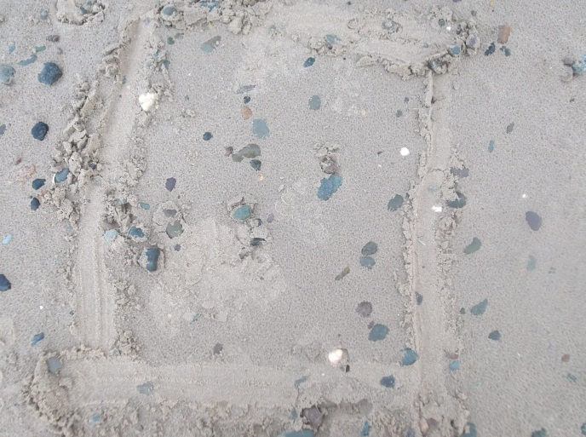
Appendix 3.29 – Quadrat 6

Quadrat 7: 7>5 fragments, 13<5 fragments
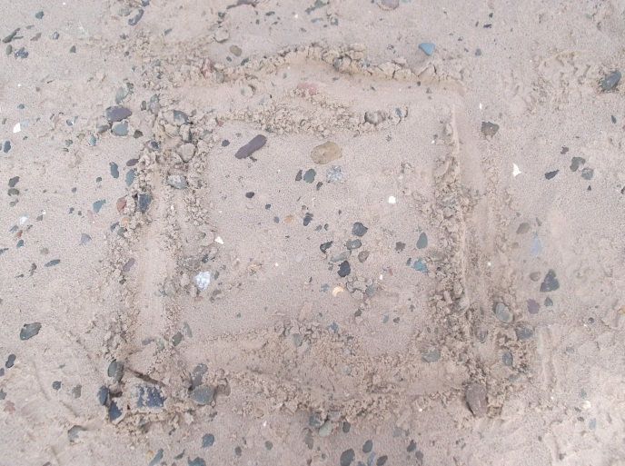
Appendix 3.30 – Quadrat 7
Quadrat 10: 1>5 fragment
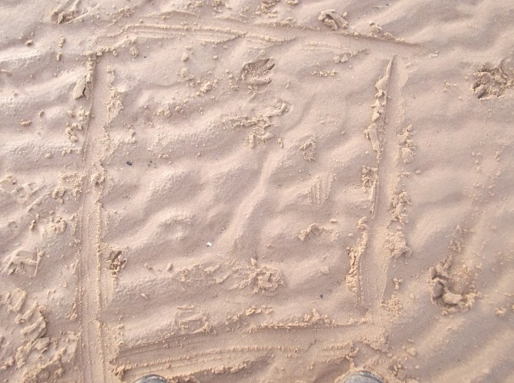
Appendix 3.31 – Quadrat 10

Quadrat 11: 1 Whole
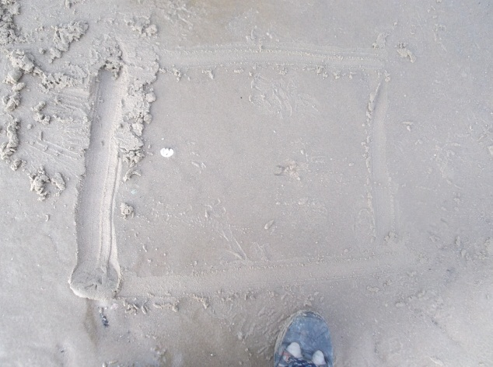
Appendix 3.32 – Quadrat 11
Quadrat 14: 2>5 fragments
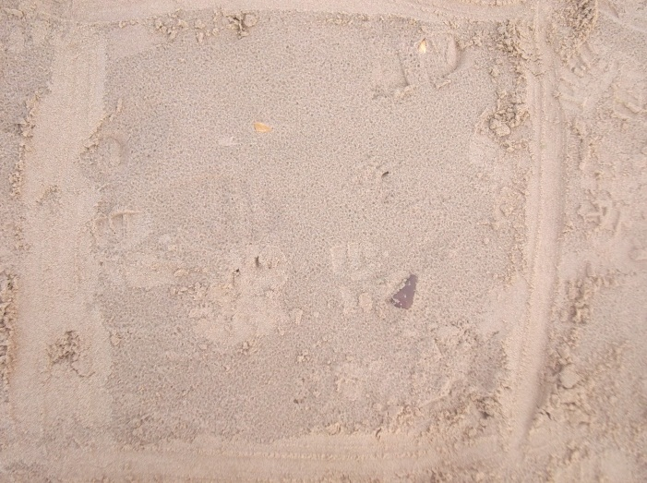
Appendix 3.33 – Quadrat 14
Quadrat 16: 14>5 fragments, 5<5 fragments
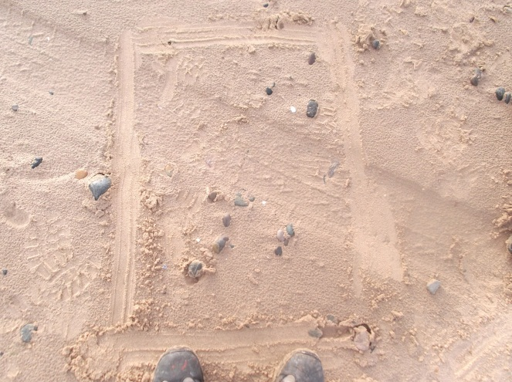
Appendix 3.34 – Quadrat 16
Quadrat 20: 1>5 fragment
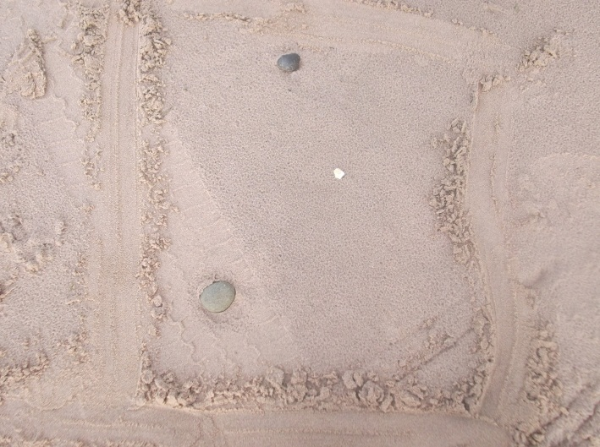
Appendix 3.35 – Quadrat 17
Quadrat 21: 1>5 fragment
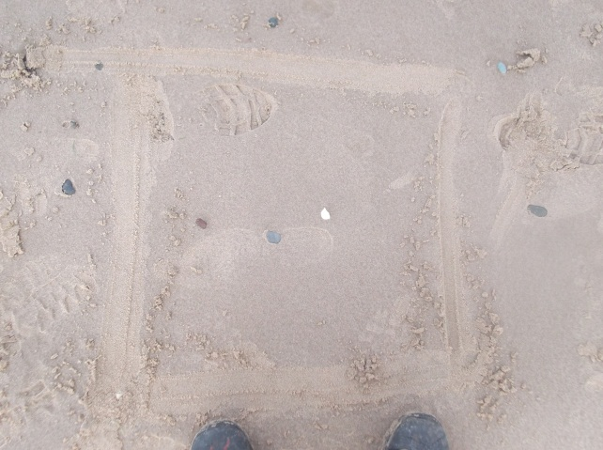
Appendix 3.36 – Quadrat 21
Quadrat 22: 3 Whole, 2>5 fragments
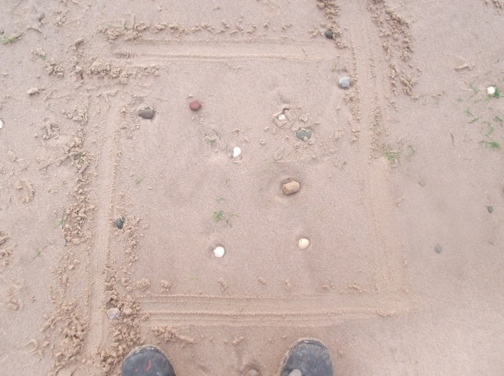
Appendix 3.37 – Quadrat 22
Quadrat 29: 1>5 fragment
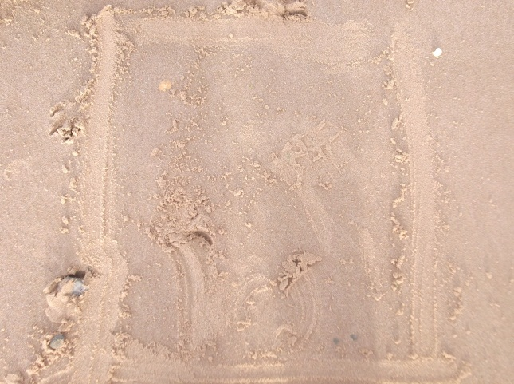
Appendix 3.38 – Quadrat 29
Quadrat 35: 1>5 fragment
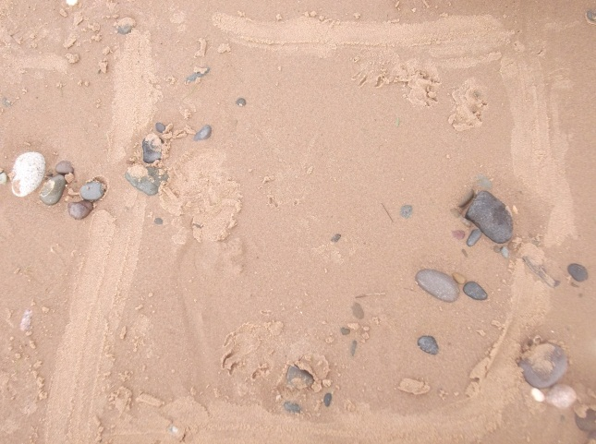
Appendix 3.39 – Quadrat 35

Quadrat 37: 2 Whole, 3>5 fragments
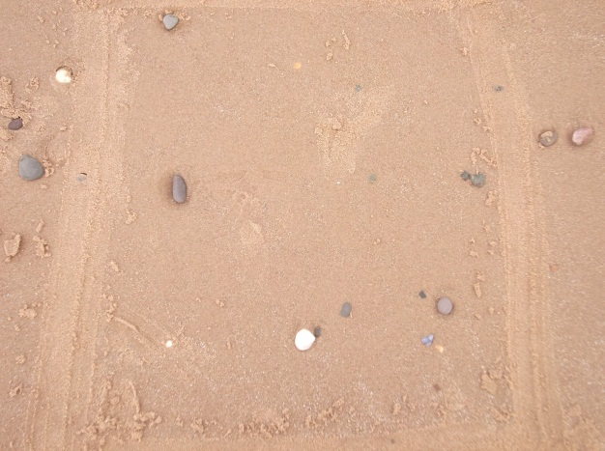
Appendix 3.40 – Quadrat 37
Quadrat 38: 1>5 fragment
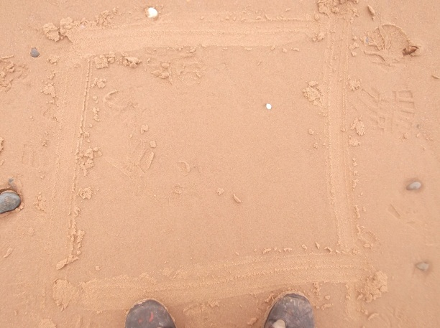
Appendix 3.41 – Quadrat 38

Quadrat 39:1>5 fragment
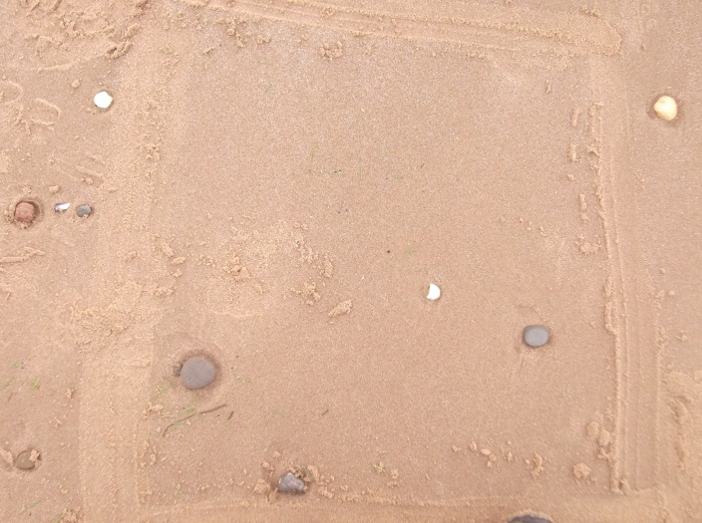
Appendix 3.42 – Quadrat 39
Quadrat 41: 1>5 fragment
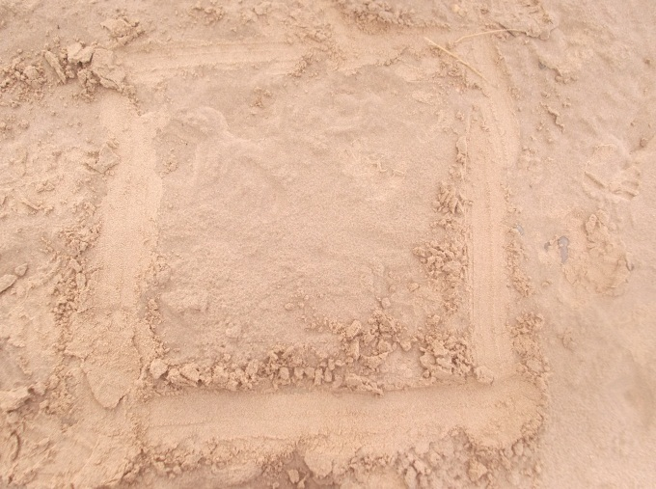
Appendix 3.43 – Quadrat 41

Quadrat 45:1 Whole, 3>5 fragments
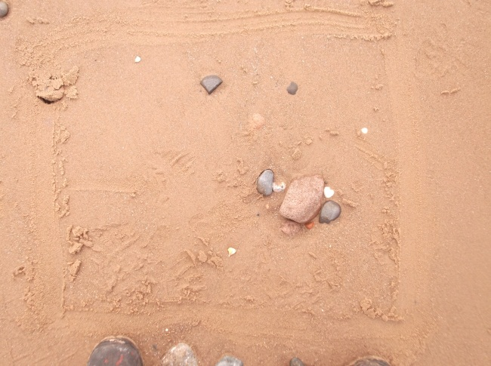
Appendix 3.44 – Quadrat 45
Quadrat 49:1>5 fragment
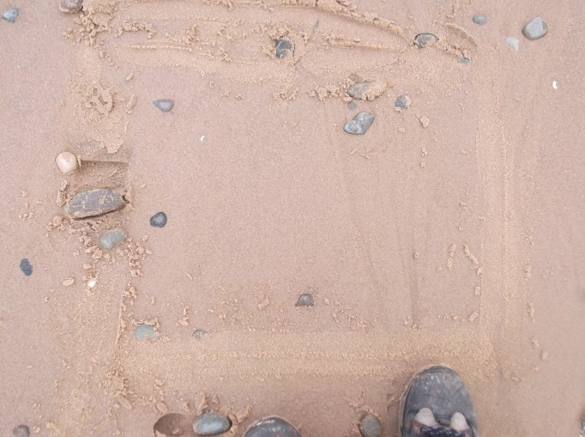
Appendix 3.45 – Quadrat 49

Quadrat 50: 17>5 fragments, 10%<5 fragments
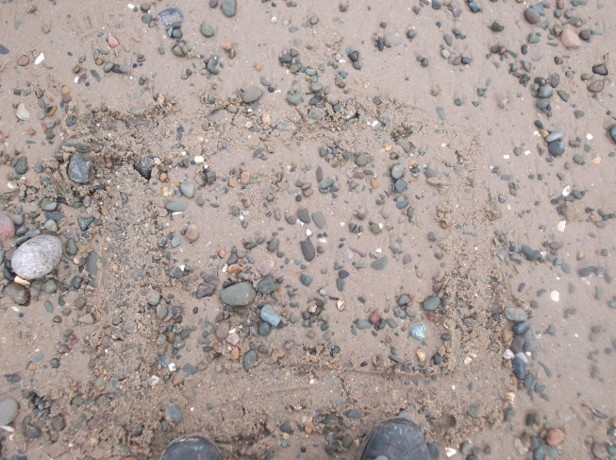
Appendix 3.46 – Quadrat 50
Quadrat 51: 6>5 fragments, 5%<5 fragments
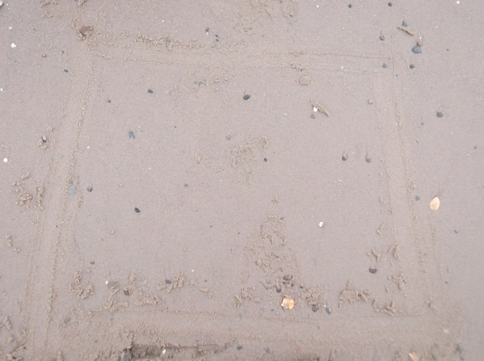
Appendix 3.47 – Quadrat 51
Quadrat 52: 1 Whole, 5%>5 fragments, 10%<5 fragments
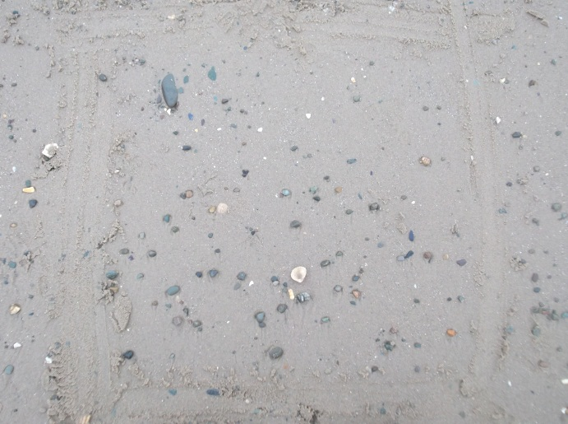
Appendix 3.48 – Quadrat 52
Quadrat 53: 20%>5 fragments, 15%<5 fragments
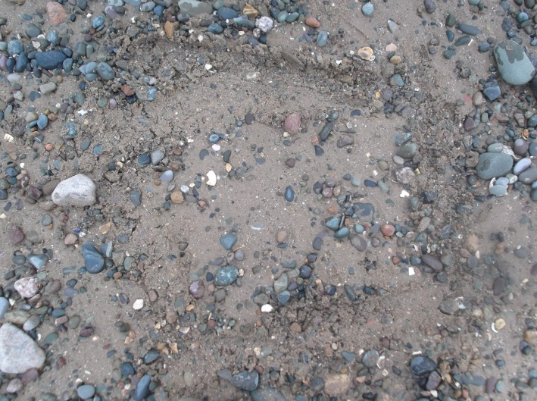
Appendix 3.49 – Quadrat 53

Quadrat 54: 1 Whole, 1>5 fragment
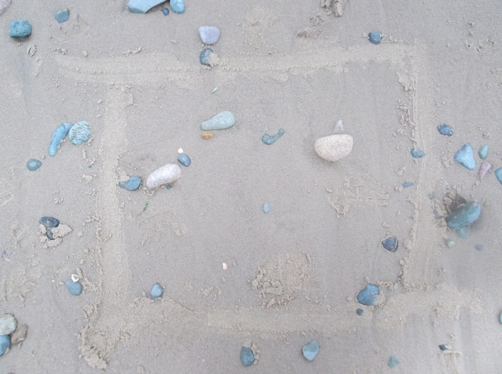
Appendix 3.50 – Quadrat 54
Quadrat 55: 3>5 fragments
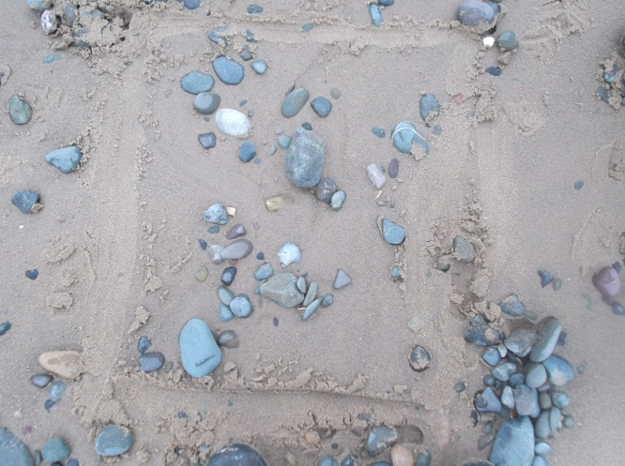
Appendix 3.51 – Quadrat 55
Quadrat 56: 1 Whole, 10%>5 fragments, 15%<5 fragments
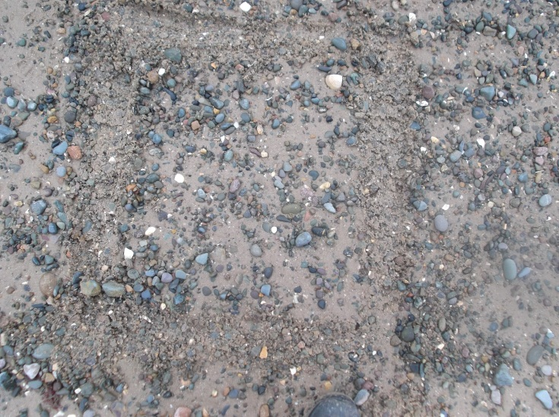
Appendix 3.52 – Quadrat 56
Quadrat 57: 4>5 fragments, 5%<5 fragments
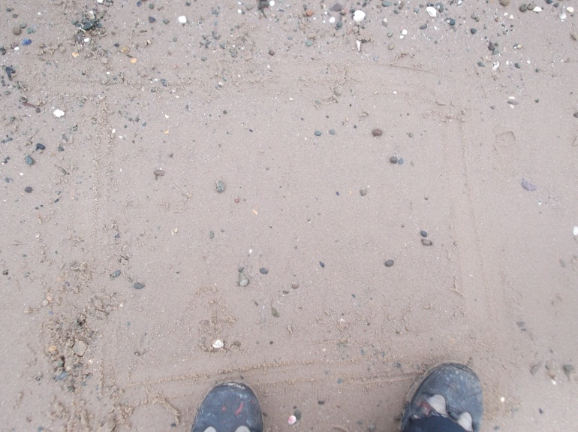
Appendix 3.53 – Quadrat 57
Transect 04/01/12
Weather: Dull, Rainy, Cloudy
Time: 9.30 till 11.30
Tide: Out
High: 3:25 AM GMT / 8.09 m
Low:9:57 AM GMT / 2.36 m
High:3:47 PM GMT / 8.26 m
Low:10:29 PM GMT / 2.22 m
Down 12 Across 9
Tally: 57
Whole: 18
Fragment>5mm: 68
Fragment<5mm: 53
Quadrats (57 total):
Quadrat 3: 1>5mm fragment
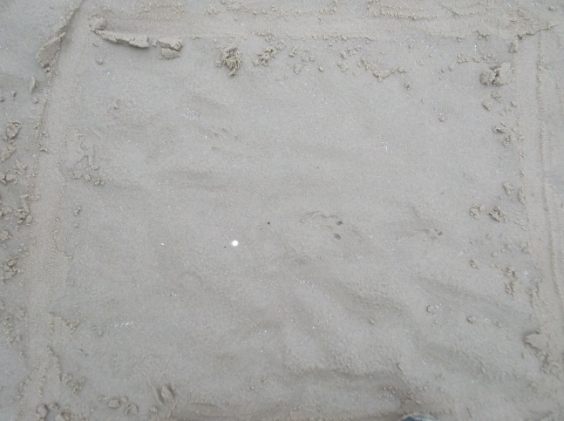
Appendix 3.54 – Quadrat 3
Quadrat 4: 3Whole fragments, 8>5mm fragments, 12<5mm fragments
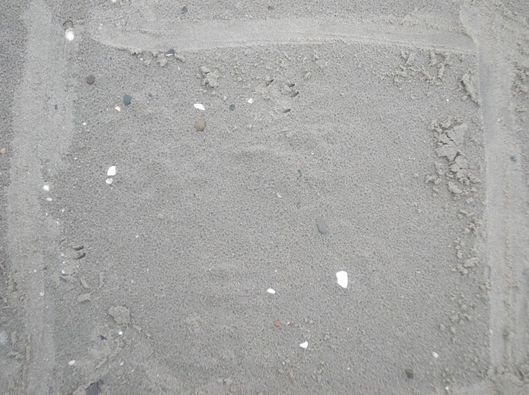
Appendix 3.55 – Quadrat 4
Quadrat 5: 5<5mm fragments
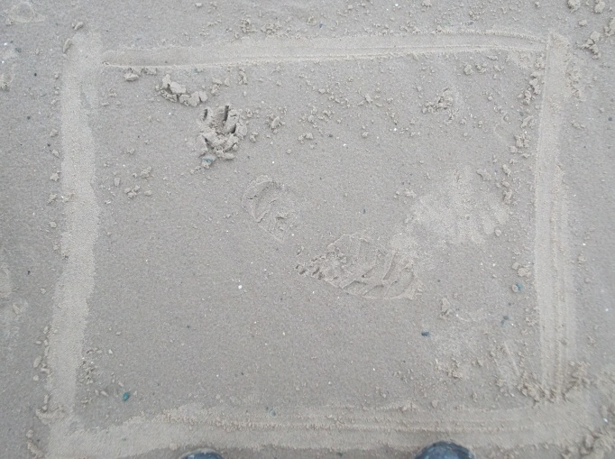
Appendix 3.56 – Quadrat 5

Quadrat 7: 3>5mm fragments
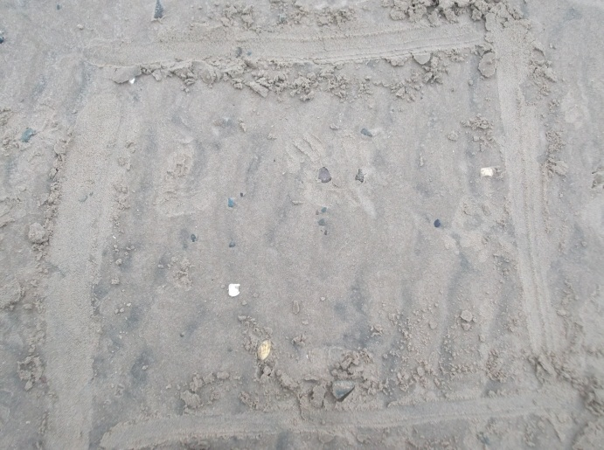
Appendix 3.57 – Quadrat 7
Quadrat 8: 1 Whole fragment, 1>5mm fragment
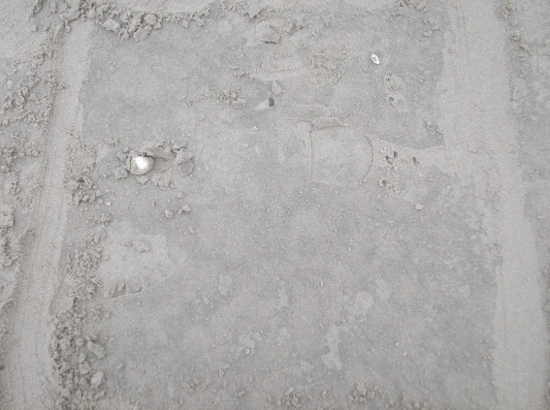
Appendix 3.58 – Quadrat 8
Quadrat 10: 12<5mm fragments
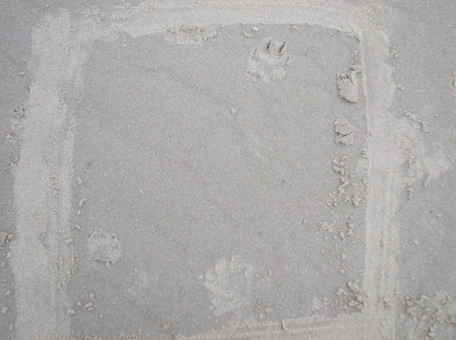
Appendix 3.59 – Quadrat 10
Quadrat 12: 12<5mm fragments
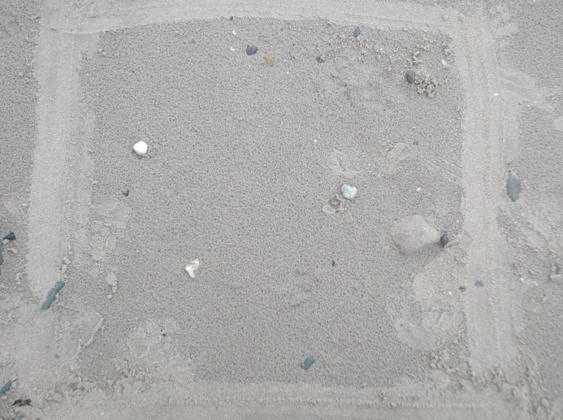
Appendix 3.60 – Quadrat 12

Quadrat 17: 1 Whole fragment, 1>5mm fragment, 4<5mm fragments
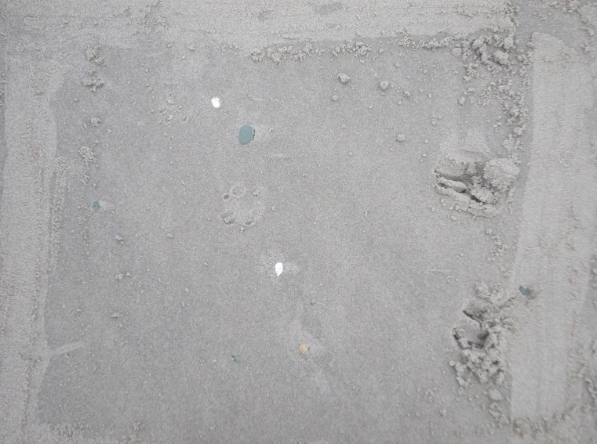
Appendix 3.61 – Quadrat 17
Quadrat 18: 3>5mm fragments
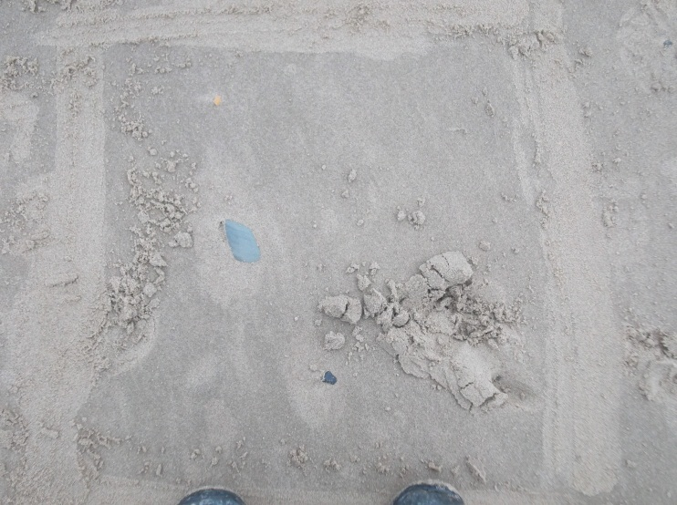
Appendix 3.62 – Quadrat 18

Quadrat 21: 1>5mm fragment
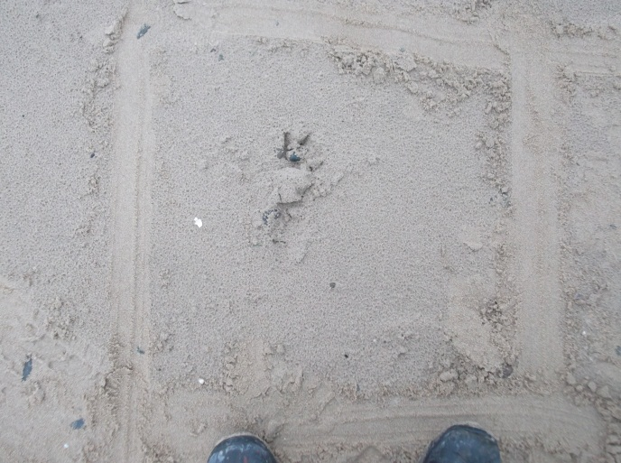
Appendix 3.63 – Quadrat 21
Quadrat 25: 4 Whole fragments, 1>5mm fragments
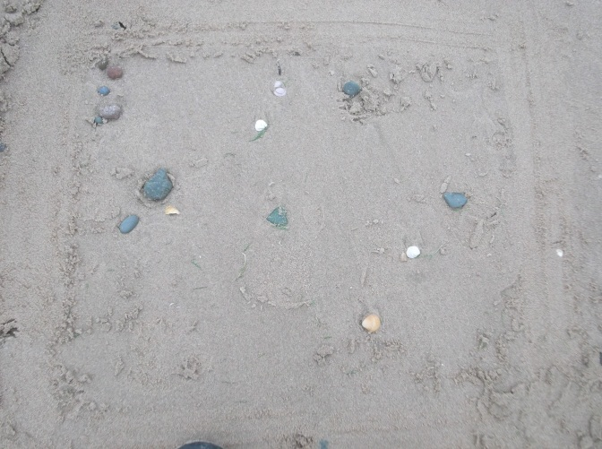
Appendix 3.64 – Quadrat 25

Quadrat 26: 1>5mm fragment
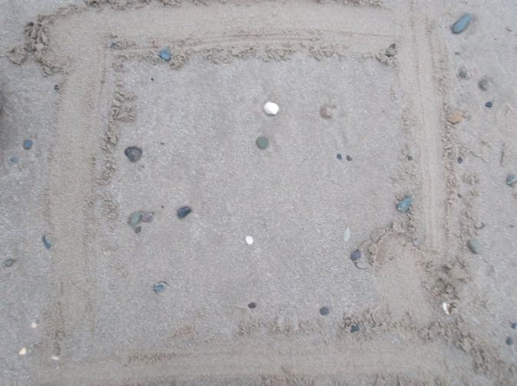
Appendix 3.65 – Quadrat 26
Quadrat 28: 2>5mm fragments
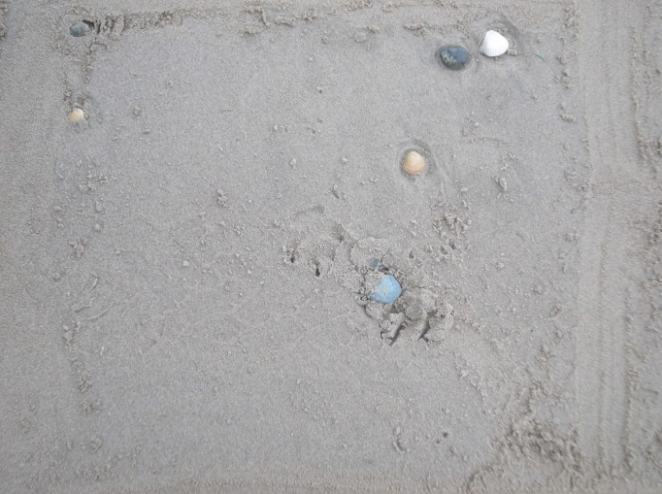
Appendix 3.66 – Quadrat 28

Quadrat 29: 1 Whole fragment
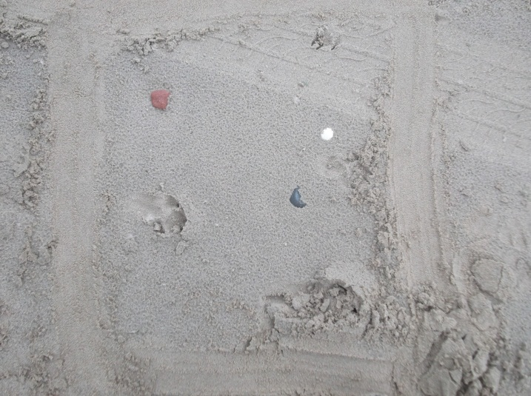
Appendix 3.67 – Quadrat 29

Quadrat 34: 2 Whole fragments, 1>5mm fragment, 8<5mm fragment
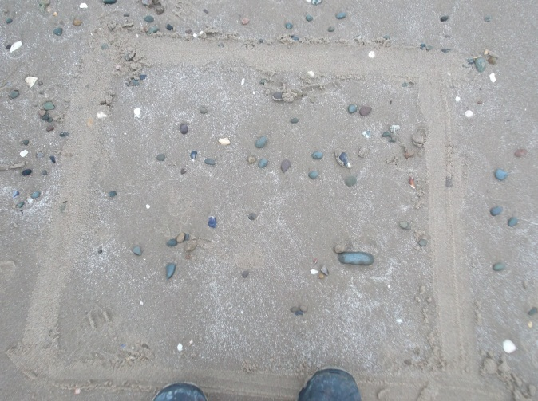
Appendix 3.68 – Quadrat 30
Quadrat 35: 8>5mm fragments, 9<5mm fragments
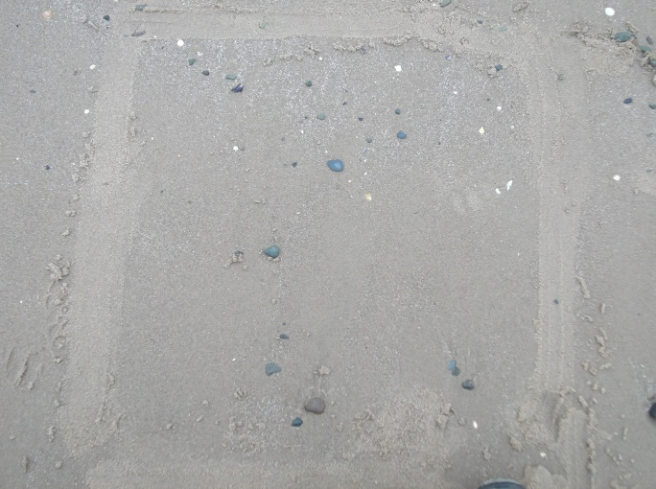
Appendix 3.69 – Quadrat 35
Quadrat 38: 1 Whole fragment
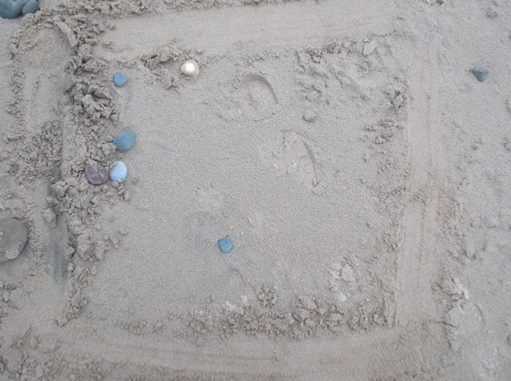
Appendix 3.70 – Quadrat 38

Quadrat 41: 2>5mm fragments
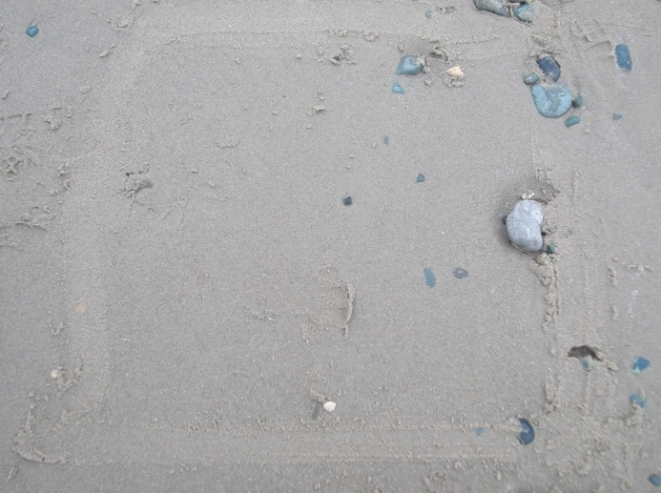
Appendix 3.71 – Quadrat 41
Quadrat 42: 4 Whole fragments, 7>5mm fragments, 20%<5mm fragments
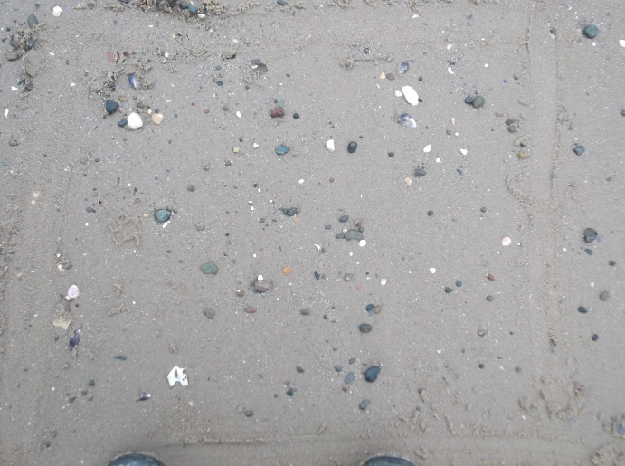
Appendix 3.72 – Quadrat 42
Quadrat 43: 10>5mm fragments, 30%<5mm fragments
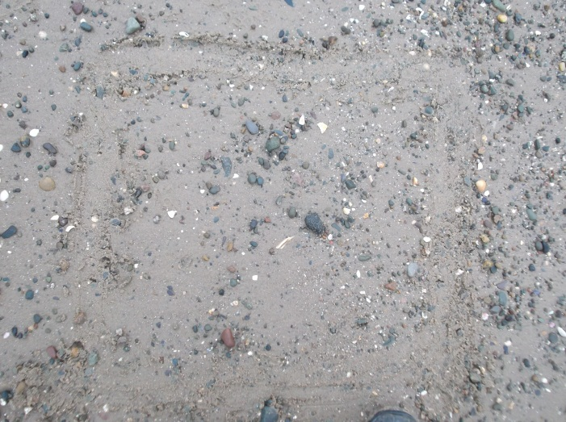
Appendix 3.73 – Quadrat 43
Quadrat 44: 6>5mm fragments, 3<5mm fragments
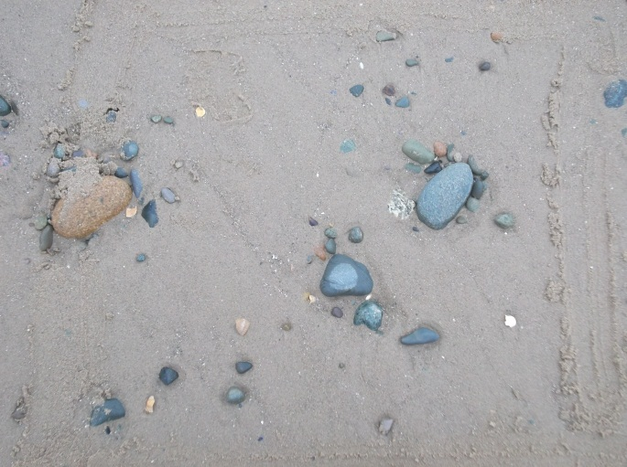
Appendix 3.74 – Quadrat 44
Quadrat 49: 20%>5mm fragments, 20%<5mm fragments
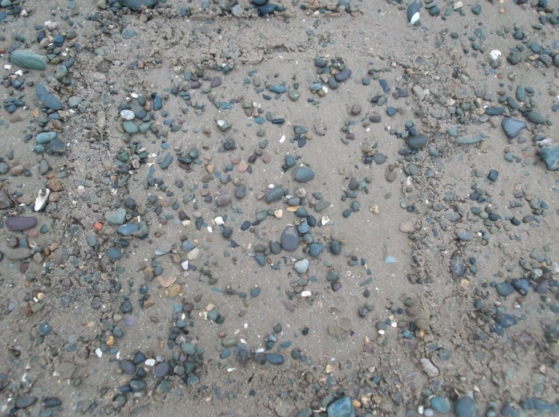
Appendix 3.75 – Quadrat 49
Quadrat 50: 10>5mm fragments, 40%<fragments
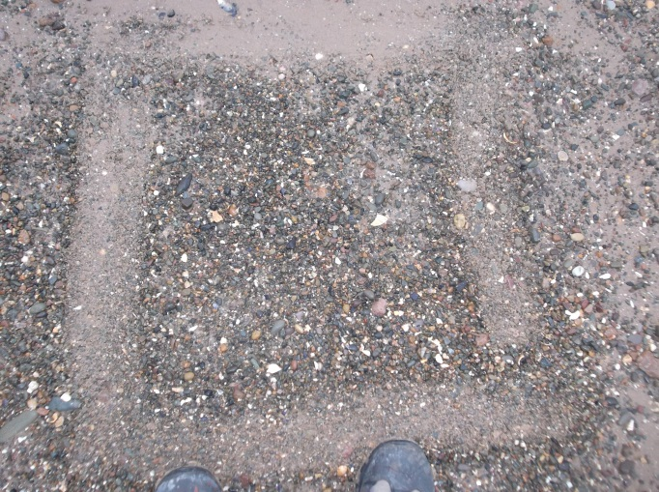
Appendix 3.76 – Quadrat 50

Quadrat 51: 5%>5mm fragments, 30%<5mm fragments
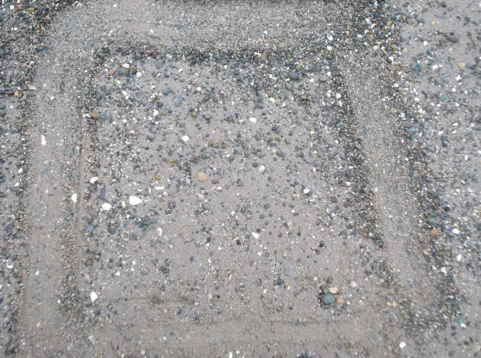
Appendix 3.77 – Quadrat 51
Quadrat 52: 1 Whole fragment, 20%>5mm fragments, 40%<5mm fragments
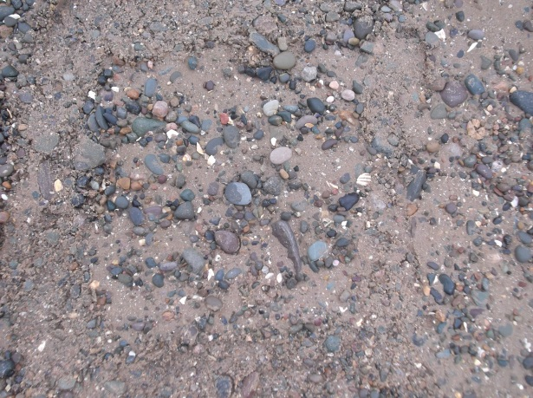
Appendix 3.78 – Quadrat 52

Quadrat 55: 1>5mm fragment
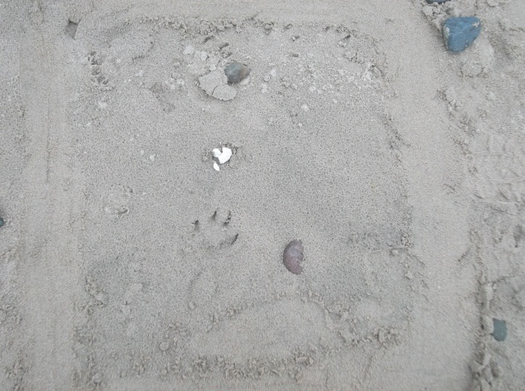
Appendix 3.79 – Quadrat 55

Appendix 4
Transect one raw data table
Transect one
Whole Shells (%) | >5 Shells (%) | <5 Shells (%)
0 | 0 | 0.5
0 | 0 | 0
0 | 0 | 0
0 | 0 | 0
0 | 0 | 0.5
3 | 1 | 1.5
0 | 1 | 0
0 | 0 | 0
0 | 1 | 0
1.5 | 1 | 0.5
0 | 0 | 0
0 | 0 | 0
0 | 0 | 0
0 | 2 | 0
0 | 1 | 2
0 | 2 | 4
0 | 0 | 0
0 | 0 | 0
0 | 0 | 0
0 | 2 | 1.5
0 | 0 | 2
0 | 1 | 0
0 | 0 | 0
0 | 2 | 0
0 | 1 | 0
0 | 0 | 0
0 | 0 | 0
0 | 0 | 0
0 | 2 | 0
0 | 1 | 0
0 | 0 | 0
0 | 0 | 0
0 | 0 | 0
0 | 0 | 0
0 | 0 | 0
0 | 0 | 0
0 | 0 | 0
0 | 0 | 0
0 | 0 | 0
0 | 0 | 1
0 | 0 | 0
0 | 0 | 0
0 | 0 | 0
1.5 | 0 | 0
0 | 1 | 0
0 | 0 | 0.5
0 | 0 | 0.5
0 | 0 | 0
0 | 0 | 0
6 | 10 | 40
6 | 2 | 3
0 | 9 | 20
0 | 0 | 0
0 | 0 | 0
0 | 0 | 0
0 | 6 | 20
3 | 8 | 1.5
Transect two raw data table
Transect two
Whole Shells (%) | >5 Shells (%) | <5 Shells (%)
0 | 0 | 1
0 | 0 | 0
0 | 1 | 0
0 | 0 | 0
0 | 0 | 0
4.5 | 2 | 1
0 | 7 | 6.5
0 | 0 | 0
0 | 0 | 0
0 | 1 | 0
1.5 | 0 | 0
0 | 0 | 0
0 | 0 | 0
0 | 2 | 0
0 | 0 | 0
0 | 14 | 2.5
0 | 0 | 0
0 | 0 | 0
0 | 0 | 0
0 | 1 | 0
0 | 1 | 0
4.5 | 2 | 0
0 | 0 | 0
0 | 0 | 0
0 | 0 | 0
0 | 0 | 0
0 | 0 | 0
0 | 0 | 0
0 | 1 | 0
0 | 0 | 0
0 | 0 | 0
0 | 0 | 0
0 | 0 | 0
0 | 0 | 0
0 | 1 | 0
0 | 0 | 0
3 | 3 | 0
0 | 1 | 0
0 | 1 | 0
0 | 0 | 0
0 | 1 | 0
0 | 0 | 0
0 | 0 | 0
0 | 0 | 0
1.5 | 3 | 0
0 | 0 | 0
0 | 0 | 0
0 | 0 | 0
0 | 1 | 0
0 | 17 | 10
0 | 6 | 5
1.5 | 5 | 10
0 | 20 | 15
1.5 | 1 | 0
0 | 3 | 0
1.5 | 10 | 15
0 | 4 | 5
Transect three raw data table
Transect three
Whole Shells (%) | >5 Shells (%) | <5 Shells (%)
0 | 0 | 0
0 | 0 | 0
0 | 1 | 0
4.5 | 8 | 6
0 | 0 | 2.5
0 | 0 | 0
0 | 3 | 0
1.5 | 1 | 0
0 | 0 | 0
0 | 0 | 6
0 | 0 | 0
0 | 0 | 6
0 | 0 | 0
0 | 0 | 0
0 | 0 | 0
0 | 0 | 0
1.5 | 1 | 2
0 | 3 | 0
0 | 0 | 0
0 | 0 | 0
0 | 1 | 0
0 | 0 | 0
0 | 0 | 0
0 | 0 | 0
6 | 1 | 0
0 | 1 | 0
0 | 0 | 0
0 | 2 | 0
1.5 | 0 | 0
0 | 0 | 0
0 | 0 | 0
0 | 0 | 0
0 | 0 | 0
3 | 1 | 4
0 | 8 | 4.5
0 | 0 | 0
0 | 0 | 0
1.5 | 1.5 | 0
0 | 0 | 0
0 | 0 | 0
0 | 2 | 0
6 | 7 | 20
0 | 10 | 30
0 | 6 | 1.5
0 | 0 | 0
0 | 0 | 0
0 | 0 | 0
0 | 0 | 0
0 | 20 | 20
0 | 10 | 40
0 | 5 | 30
1.5 | 20 | 40
0 | 0 | 0
0 | 0 | 0
0 | 1 | 0
0 | 0 | 0
0 | 0 | 0

Appendix 5
Minitab Kruskal-Wallis Statistics
Kruskal-Wallis Test: Whole shells versus Transect

Kruskal-Wallis Test on Whole shells

Transect N Median Ave Rank Z
Transect 1 57 0.000000000 84.7 -0.25
Transect 2 57 0.000000000 85.8 -0.04
Transect 3 57 0.000000000 87.5 0.29
Overall 171 86.0

H = 0.10 DF = 2 P = 0.953
H = 0.27 DF = 2 P = 0.875 (adjusted for ties)

Kruskal-Wallis Test: >5 Shells versus Transect

Kruskal-Wallis Test on >5 Shells

Transect N Median Ave Rank Z
Transect 1 57 0.000000000 80.7 -0.99
Transect 2 57 0.000000000 91.0 0.93
Transect 3 57 0.000000000 86.3 0.06
Overall 171 86.0

H = 1.24 DF = 2 P = 0.538
H = 1.64 DF = 2 P = 0.441 (adjusted for ties)

Kruskal-Wallis Test: <5 Shells versus Transects

Kruskal-Wallis Test on <5 Shells

Transects N Median Ave Rank Z
Transect 1 57 0.000000000 88.2 0.41
Transect 2 57 0.000000000 81.3 -0.88
Transect 3 57 0.000000000 88.5 0.47
Overall 171 86.0

H = 0.78 DF = 2 P = 0.677
H = 1.42 DF = 2 P = 0.492 (adjusted for ties)

Kruskal-Wallis Test: Transect 1 versus Different shell variants

Kruskal-Wallis Test on Transect 1

Different
shell variants N Median Ave Rank Z
<5 Shells 57 0.000000000 89.1 0.57
>5 Shells 57 0.000000000 93.8 1.45
Whole Shells 57 0.000000000 75.2 -2.02
Overall 171 86.0

H = 4.35 DF = 2 P = 0.113
H = 7.77 DF = 2 P = 0.021 (adjusted for ties)

Kruskal-Wallis Test: Transect 2 versus Different Shell Variants

Kruskal-Wallis Test on Transect 2

Different
Shell Variants N Median Ave Rank Z
<5 Shells 57 0.000000000 80.7 -0.99
>5 Shells 57 0.000000000 101.1 2.82
Whole Shells 57 0.000000000 76.2 -1.82
Overall 171 86.0

H = 8.16 DF = 2 P = 0.017
H = 14.07 DF = 2 P = 0.001 (adjusted for ties)

Kruskal-Wallis Test: Transect 3 versus Different Shell Variants

Kruskal-Wallis Test on Transect 3

Different
Shell Variants N Median Ave Rank Z
<5 Shells 57 0.000000000 86.5 0.10
>5 Shells 57 0.000000000 95.2 1.72
Whole Shells 57 0.000000000 76.3 -1.82
Overall 171 86.0

H = 4.20 DF = 2 P = 0.123
H = 7.00 DF = 2 P = 0.030 (adjusted for ties)

