Reintroduction of the Scottish wildcat (Felis silvestris grampia): A feasibility study of the Argyll area

By Rachel Daniels

BSc (Hons.) Geography and Environmental Management

Supervisor: Kevin Butt

Declaration

I declare that this dissertation is no longer than 10,000 words and is all my own work.

Signed: _____________________________________________________________________

Rachel Daniels

Acknowledgements
I would like to take this opportunity to thank my parents, for all the hard work, travelling and crying they had to deal with. I would also like to thank my supervisor, Kevin Butt, for dealing with stupid questions at silly hours in the morning and keeping me focussed throughout the work. Finally, I would like to thank my friends and family who have nagged me enough to get this dissertation handed in on time.

Abstract
The Scottish wildcat is a feline native to the UK. As numbers have dramatically declined over recent centuries the idea of captive breeding for reintroduction is increasingly appealing. This study investigates the concept of Argyll, Scotland being a feasible place for reintroduction of the Scottish wildcat. For this to take place numerous factors need to be considered beforehand. The investigation looks into a variety of factors that need to be considered in relation to reintroduction including the habitat and food sources along with the proximity to humans. Field data was collected from the Glasdrum Wood National Nature Reserve and used alongside maps of Argyll to establish the overall suitability of the area for wildcat reintroduction. As no research is currently being undertaken into wildcat reintroduction it was not known what the results of the research would show.
Overall the study indicates that the Argyll area of Scotland is not suitable for wildcat reintroduction. The research indicates that while the habitat, vegetation and proximity to humans were all suitable for wildcat habitation, prey populations were too low to be sustainable. The prey populations would suffer from wildcat reintroduction which would in turn affect both the wildcat and other carnivorous species found in the area.

List of Figures

Figure 1: Image of F. silvestris grampia | 1
Figure 2: Image showing the difference between wildcat and domestic tabby cats | 2
Figure 3: Map of Glasdrum Wood NNR | 3
Figure 4: Image of F. silvestris grampia | 6
Figure 5: Showing relative abundance of food sources for wildcats, hybrids and domestic cats | 8
Figure 6: Image of white-tailed sea eagle | 9
Figure 7: Image of dam built by C. fiber | 10
Figure 8: Image of common shrew | 13
Figure 9: Image of bank vole | 13
Figure 10: Image of wood mouse | 13
Figure 11: Map showing the location of Glasdrum Wood NNR | 15
Figure 12: Image showing Habitat Survey Locations | 17
Figure 13: Image showing the correct placement of Longworth traps | 17
Figure 14: Image of set Longworth live traps | 18
Figure 15: Image showing where Longworth trapping was undertaken | 19
Figure 16: Graph showing the numbers a species of trapped mammals | 22
Figure 17: Image of wood mouse trapped on 26/9/2012 | 23
Figure 18: Pie chart showing gender of trapped individuals | 23
Figure 19: Pie chart showing maturity of trapped individuals | 23
Figure 20: Graph showing number of trappings per date | 24
Figure 21: Graph showing timings of trapped individuals | 24
Figure 22: Map of Argyll and Bute Council Area | 26
Figure 23: Image of mole hills found in Glasdrum Wood NNR | 27
Figure 24: Image showing mushroom which has been partially eaten, found in Glasdrum Wood NNR | 27

List of Tables
Table 1: Site specific results | 25

Contents | Page Number
List of Figures | v
List of Tables | vi
- Introduction  - The Scottish wildcat  - Glasdrum Wood National Nature Reserve, Argyll  - Aims and objectives | 1  1  3  4
- Literature Review  - Scottish wildcat ecology  - Threats  - Case studies  - Reintroduction of white-tailed sea eagle  - Reintroduction of European beaver  - Removal of golden eagle  - Fieldwork preparation | 5  5  6  8  8  10  11  12
- Methodology  - Research site location  - Habitat research  - Longworth live traps  - Mapping  - Analysis | 15  15  16  17  20  20
- Results  - Longworth trapping results  - Site specific results  - Mapping results  - Additional information | 22  22  25  26  27
- Discussion  - Longworth trapping discussion  - Habitat discussion  - Mapping discussion  - Additional information  - Limitations  - Conclusions  - Future work | 29  29  31  32  32  33  34  34
- References | 35
- Appendix  - Appendix A  - Appendix B  - Appendix C | 41  41  49  52

1.0 Introduction
1.1 The Scottish wildcat
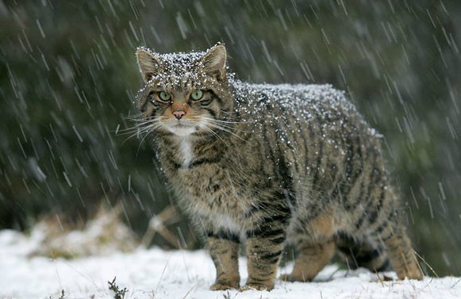
The Scottish wildcat (Felis silvestris grampia) is a notoriously elusive creature found in only a few locations across Scotland. Once widespread throughout the UK, Scottish wildcat (Figure 1) numbers have suffered from numerous factors, resulting in the population now being estimated as low as 400 individuals in the wild, making it the second rarest cat species in the world (CNP Wildcat Conference, 2008). Human persecution, habitat loss, fragmentation and hybridisation have all negatively impacted the population, resulting in an unsure future for the species (SWA, n.d). Due to suffering so much as a result of human activity including decline in abundance and range over the past century, F. silvestris grampia are eligible for the Scottish Natural Heritage Species Action Plan which is just one of many projects hoping to improve the numbers of the species (SNH, 2007).

Figure 1

Image of F. silvestris grampia

Source: Highland Tiger (n.d)

With the Scottish wildcat being one of the few remaining large predators found in the UK, there are many conservation projects already in place and more being set up to protect the species (SWA, n.d). The aim of most of the current projects is to improve the current populations using wild animals, however should numbers get too low for the population to increase without inbreeding, reintroduction is a viable option. For this to become possible there must be a feasible area for populations to survive with emphasis on habitat, prey population and proximity to human settlement (SWA, n.d). Along with this, feral, domestic and hybrid cats need to be removed from the area prior to reintroduction. To establish the purity of an individual field, trapping and testing must be carried out. This has taken some time but genetic testing is now at a high enough standard that these tests can be carried out in the field and are highly accurate at establishing whether an individual is a hybrid or pure wildcat (RZSS, n.d). It is important for genetic testing to be at a high standard as it can be very difficult to distinguish between pure and hybrid markings (Figure 2).
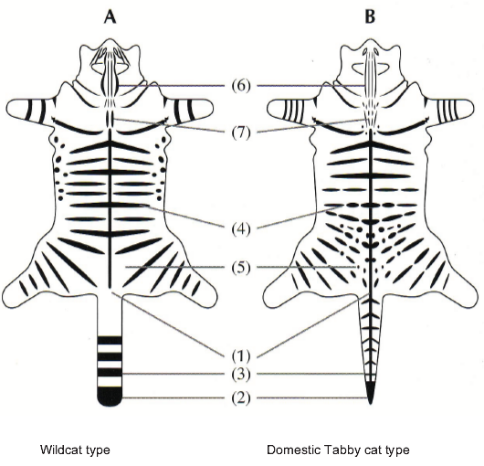
Figure 2

Image showing the difference between wildcat and domestic tabby cats

Taken from: Davis and Gray (2010)
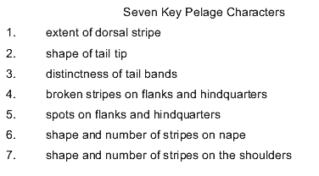
If reintroduction of the species is to be successful then suitable habitat must be found. Due to the elusive nature of F. silvestris grampia, suitable habitat would be expansive, with few human settlements or transport links (SNH, 2007). Like most feline species F. silvestris grampia are solitary animals, coming together only to breed. By marking the boundary of their territories it prevents them from overlapping (SWA, n.d). For this reason a density of one cat per 3km² is used in highly suitable habitat while one cat in 10km² is used in unfavourable habitat, with mountainous, forested areas being the preferred habitat for the species (Mammal Society, n.d). Prey must also be sufficient, as F. silvestris grampia’s diet largely consists largely of small mammals, such as shrews, voles and mice, large birds, larger mammals, like hares and rabbits (Wildcat Association, n.d). As a result of this it is important to look at the habitat type, size and food sources when considering areas suitable for reintroduction. Once this has been done, projects similar to the ‘Wildcat Haven’ can take place to remove feral, domestic and hybrid cats from the region, making it suitable for reintroducing F. silvestris grampia (Wildcat Association, n.d). For this reason it is necessary to research the area of interest before deciding whether to remove hybrid and feral cats.
1.2 Glasdrum Wood National Nature Reserve, Argyll
Argyll is a region of Scotland that stretches from the west to the south of Glasgow and down to the Mull of Kintyre (Argyll, n.d). Glasdrum Wood National Nature Reserve is located on the slopes of Beinn Churalain, around 27km north of Oban (Figure 3). With changes in both altitude and soil types found within the reserve there are numerous types of habitat to be found (SNH, 2005). Oak and ash woodlands interspersed with bracken and grassland provide a rich diversity of both plants and animals (Welcome to Scotland, n.d). With otter known to visit the reserve via Loch Creran and a rich variety or insects and butterflies (SNH, 2005) there is good reason to believe this will lead to large numbers of small mammals, implying that this area of Argyll may be suitable for wildcat reintroduction.
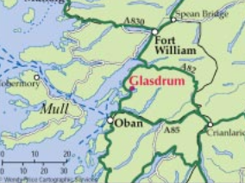

Figure 3

Map of Glasdrum Wood NNR

Source: SNH (2005)

Glasdrum Wood NNR was chosen for this work due to the location and the implication that it would be suitable before research. Work on potential wildcat reintroduction has not been undertaken in the Argyll area before and could be of use in the future. This reserve was specifically chosen due to its relative isolation from human settlement and habitat type.
1.3 Aims and Objectives
Aims
This project aims to discover whether the Argyll area of Scotland is a suitable place for Scottish wildcats to repopulate. The majority of the field based work will take place in and around the Glasdrum Wood Nature Reserve.
The proposed approach will largely use quantitative research.

Objectives
- To estimate small mammal population indices through live trapping.
- Calculate suitability of habitat using field based work.
- Establish areas of undisturbed habitat throughout Argyll using map based work.
- Deduce the overall suitability of Argyll as a potential reintroduction site for Scottish wildcats.

2.0 Literature review
This chapter will discuss the literature associated with the Scottish wildcat and use examples of reintroduction of other species.

2.1 The Scottish wildcat ecology
The Scottish eildcat (Felis silvestris grampia) is thought to be the last of Britain’s large predators having outlived the British lynx by over 1000 years and the British wolf by over 500. This is an impressive feat considering wildcats were believed to be man killers until as late as the 1950s and were historically feared by many of the highland clans (SWA, n.d). The species was once found throughout much of Britain, present from as early as the Early Holocene period (Beaumont et al, 2001). Numbers were however drastically reduced as a result of deforestation in the Middle Ages throughout England and Wales (Hubbard et al, 1991) and the species is now confined to Scotland. While the wildcat has done well to survive this far, their numbers have continued to decline and while exact numbers cannot be accurately established it is estimated that less than 400 remain in the wild. This number is so low and populations so fragmented that it is feared they may become extinct in the wild within the next 5 years (SWA, n.d). A recent call for cloning to be considered as a viable means of preserving the species helps capture how poor the outlook for wildcat currently stands (Courier, 2013).
A highly specialised predator, the Scottish wildcat is a shy and elusive species. Once perceived as vicious, F. silvestris grampia are now seen to be creatures that prefer to draw as little attention to themselves as possible. Having evolved alongside other, larger predators, even wildcat kittens will play in silence to avoid being found. Eating only meat, the species has an important role to play in the controlling of small to medium sized prey with rabbits being the preferred food source. With night vision almost seven times better than the average human’s, the Scottish wildcat is active largely at night. Hunting at night is especially effective as many small mammals are more active during the dark. This has resulted in F. silvestris grampia evolving to have an increased sense of hearing, especially in relation to pitch (SWA, n.d).
Although the wildcat is generally thought of as elusive, the species is sometimes found on hunting estates and it is thought that abundance of prey is a more important factor to the cats than proximity to human settlements. The study that discovered this also found that F. silvestris grampia prefers a mixture of both woodland and grassland areas, which is supported by research of the wildcat across Europe. This is largely due to the increased likelihood of there being a mix of both small rodents and larger prey such as rabbits and hares found in a variety of habitats (Planet earth, 2013). While the individuals themselves may not choose to avoid humans, there is a good case for finding areas of habitat suitable for reintroduction away from humans, as the chances of mating with domestic cats will be severely reduced (SWA, n.d).

2.2 Threats
There are numerous factors negatively impacting the Scottish wildcat that have resulted in F. silvestris grampia having a critically endangered status. The main reasons for this status are habitat loss and fragmentation, persecution from humans and interbreeding with feral and domestic cats (Highland Tiger, n.d). Scottish wildcat (Figure 4) look similar to domestic tabby cats with some noticeable differences. F. silvestris grampia are around a third larger than domestic cats and have much stronger striped markings on the face and down the back, concluding with a blunt black end on the tail (SWA, n.d). This makes it incredibly difficult to identify wildcats on sight and a cost-effective means of identifying species without capture and testing is yet to be found (Highland Tiger, n.d).

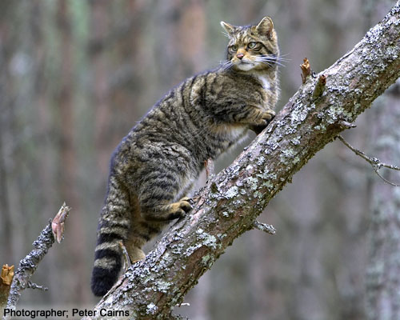
Figure 4

Image of F. silvestris grampia

Source: SWA (n.d)

Due to the population being so small, it is possible that problems may occur relating to inbreeding and contamination of genetics. Ensuring wildcats are purebred in breeding programmes is an important factor in conserving F. silvestris grampia. By understanding the genetics of each individual, it is possible to avoid genetic bottlenecks and inbreeding which will, in turn, widen the gene pool. In doing this there will be fewer issues with disease and problems inherited from parents, as genetic diversity often makes a species more resistant (biology-online, n.d). This helps explain why there is such a large number of wildcat in captivity at the present. It is hoped that a diverse set of populations can be bred so that upon rerelease there a lesser chance of the population being wiped out should disease strike (SWA, n.d). Understanding genetics is especially important in the case of the Scottish wildcat, as breeding with feral and domestic cats combined with the difficulty in establishing purity on sight mean the gene pool of wildcat has been diluted significantly. This is thought to be one of the leading factors in the decline of the species and the reason there are so many hybrids found (Hubbard et al, 1991).
Wildcat species in general have been suffering from similar problems to the Scottish wildcat such as the European wildcat (Felis silvestris) being affected by hybridisation and introgression (Beaumont et al, 2001). For this reason, every new birth is important for the species and purebred kittens are considered to be the last hope for the species (ThisIsLondon, 2007). A breeding-for-release programme has been set up which aims to build a sustainable population with the hope of releasing captive bred animals into the wild in specially chosen areas. These areas have been chosen due to landscape suitability and having little interference from humans. The area is then cleansed of all wild, feral and domestic cats to reduce the likelihood of contamination (SWA, n.d). The problem of hybridisation of the European wildcat (which the Scottish wildcat is a subspecies of) seems to vary by location. While in Belgium hybrids have been found to count for only 2% of the total population, in Scotland hybridisation is at high levels (Eckert et al, 2009).
Not only do domestic and hybrid cats pose problems with genetics of F. silvestris they cause problems due to competition for food sources. A study in France showed that hybrid and domestic cats appeared to receive less than 50% of their diet from human sources (Figure 5). While wildcats obviously do still live in the area this added competition needs to be considered (Germain et al, 2009), especially in Scotland as there is also competition from other protected species such as pine marten (Martes martes) increasing the importance of schemes such as the wildcat haven, where wild and hybridised cats are removed before reintroduction (SWA, n.d).

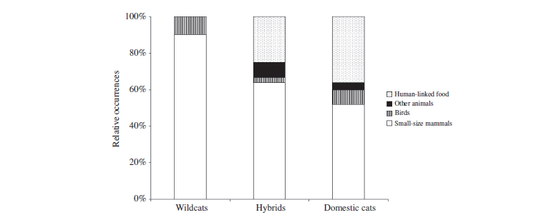
Figure 5

Showing relative abundance of food sources for wildcats, hybrids and domestic cats

Source: Germain et al (2009)

Over recent years further problems have begun to face the Scottish wildcat with shortages in some of its main food sources. The increase of the myxomatosis disease means colonies of rabbits and rodents have suffered drastically. With the research offering explanations as to recent Scottish wildcat population decline, it makes it easier to understand how to solve these issues and scientists are now of the opinion that conservation zones must be set up to ensure survival of the species (Deadline, 2013).

2.3 Case Studies
2.3.1 Reintroduction of white-tailed sea eagles
The problems that have faced F. silvestris grampia have also caused problems for other animals. One of the animals that has faced persecution and habitat loss is the white-tailed sea eagle (Haliaeetus albicilla) which resulted in it becoming extinct from the British Isles. Once a common sight on the UK’s coast, the last H. albicilla pair nested in Britain in 1916. Persecution, especially from farmers, resulted in this extinction as poisoning and shooting because increasingly common. As the birds became increasingly rare there was an added pressure on the species as there was a raise in collectors being interested in both eggs and skins (Love and Ball, 1979).
With H. albicilla (Figure 6) being such an iconic species there have been numerous attempts to reintroduce the bird to Britain, with some more successful than others (Arts et al, 2012). As with all reintroduction stories there are certain aspects that are important to look at prior to undertaking the process. In the case of most raptor species, as with F. silvestris grampia, habitat and prey abundance are important (Ontiveros and Pleguezuelos, 1999). The first two attempts happened in 1959 and 1968, however these involved 3 and 4 birds respectively being reintroduced, which is thought to have played an important factor in these schemes failing. A more considered plan was determined to reintroduce the species more effectively. This included numerous phases. The first phase, spanning ten years, began in 1975 with 85 juvenile H. albicilla being reintroduced to the Isle of Rum. The second phase started in 1993 and ran to 1998 constituted of 58 juveniles being reintroduced to Wester Ross. In 2007 the third phase began, aiming to reintroduce a further 20 animals per year for 5 years into the Eastern mountainous areas of Scotland. The success of this scheme was evident as by 2008 over 250 chicks had fledged off the coasts of Scotland. Both failed and successful stories of reintroduction have their merits and lessons to learn. In the case of H. albicilla the lessons learned are associated with numbers and staggering of reintroduction (Arts et al, 2012).
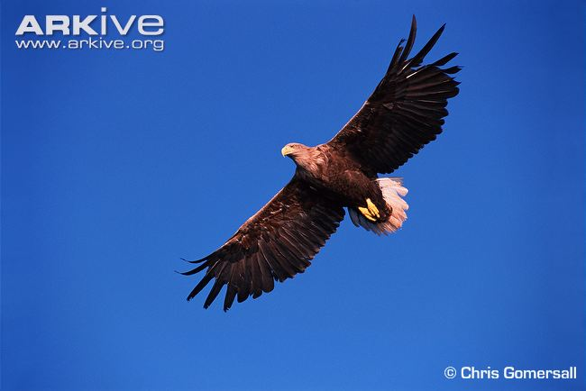
Figure 6

Image of white-tailed sea eagle

Source: Arkive (n.d.)

The likelihood of a species being successfully reintroduced appears to be increased if it has only gone extinct as a result of human persecution. This was the case for H. albicilla, where it is known that human activity had major implications in the species extinction in the UK, negative publicity surrounding the animal needs to be faced. As a result of this, it was important to work alongside the public, especially farmers, to change public perception and reduce the chances of murder of the species. In the case of farmers, an incentive plan was put into place which reimbursed the farmers for lost stock and paid them for protecting the species. In the case Eurasian lynx (Lynx lynx), there is interest in reintroducing the species to Britain as a result of its extinction only occurring due to human activity. This is opposed by some who see L. lynx as dangerous, however as with F. silvestris grampia the Eurasian lynx elusive nature works in its favour (Arts et al, 2012).
2.3.2 Reintroduction of European beaver
As with the story of H. albicilla, other species have become extinct in the British Isles as a result of human activity. This factor is important when considering suitable species for reintroduction. One such animal going through a trial period at the moment is the European beaver (Castor fiber) which is believed to have first become extinct in the UK in the 16th Century (South et al, 2000). Though extinction occurred in the UK, over-hunting was a problem globally and was only prohibited in the ‘nick of time’. A series of reintroductions was sparked around Eurasia in response to C. fiber being brought back to Sweden in the 1920s (Nolet and Rosell, 1996). While initially reintroduced for highly sought after fur, this was later undertaken so the species could act as ecosystem engineers. Due to the way they store food and the lodges they build for shelter (Figure 7) throughout the winter beavers often cut down trees and build dams, causing changes in the environment (Rosell et al, 2005). Contemplating environmental changes is important when discussing reintroduction, both for the impacts on the environment and for the likelihood of success. Should the changes be significant, there is a chance the species may die out anyway, which happened for some attempted reintroductions. While this scheme failed due to the major impact the individuals had on the environment there is also the argument that too few individuals were reintroduced. Combining this with the H. albicilla example in Section 2.3.1 the importance of large numbers being reintroduced at a site (Nolet and Rosell, 1996).
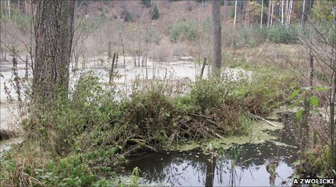
Figure 7

Image of dam built by C. fiber

Source: BBC (2011)

In Scotland, plans were initially drawn up to contemplate C. fiber reintroduction in the late 1980s, however strong opposition to the ‘Friends of the Beaver’ scheme resulted in the plans being shelved. In 1999 plans were drafted and in 2001 a licence for trial reintroduction was put in by Scottish Natural Heritage, however this was later rejected by the Scottish Executive. In 2007 the beaver once again became the main focus of reintroduction as SNH drew up the Species Action Plan and in 2008 a trial plan was put in by Scottish Wildlife Trust and Royal Zoological Society of Scotland. This was accepted. The trial involved families being moved from Norway into Argyll’s Knapdale Forest in 2009, the effects of which will be assessed in 2014. The likelihood of this success rests largely on how quickly the niche is filled by C. fiber (Arts et al, 2012). With kits being born to the family on the Dubh Loch, it appears so far that reintroduction has been a success (BBC, 2012).

2.3.3 Removal of golden eagle
When reintroducing animals into the wild there must not be any negative effects on the populations the individuals are being taken from. In the case of transporting the golden eagle (Aquila chrysaetos) into Ireland, three important factors had to be faced before individuals could be removed to limit the impact on the original population. These were; getting land owner’s permission, not retrieving individuals from dangerous places and only nests with twins could have an individual taken from it. Before moving the chicks had to be able to eat and thermoregulation had to be achieved with no help from parents. While this works in the case of a relatively widespread species (O’Toole et al, 2001) in some cases species are reintroduced from captive bred populations. It is thought that using captively breeding individuals for wild release may mean there is less of a chance of success due to changes in behaviour along with susceptibility to diseases found in the wild. While some studies have shown that wild born individuals have a much significantly higher survival rate in some cases translocation is not an option. In these cases other factors such as time of year the animals have been released play a factor and are an important consideration (Jule et al, 2008). Although F. silvestris grampia are low in numbers in the wild a captive breeding programme is ensuring the genetic diversity of the mammal is maintained. The aim of the centres involved is to breed pure wildcats in the hope that they may be released in the future (SWA, n.d).

2.4 Fieldwork Preparation
Using lessons learned from the reintroduction of other species it is clear that there are several important factors to consider when preparing an area for the process. In the case of F. silvestris grampia it is important to find a food source large enough to sustain populations. Once areas considered potentially suitable are identified further testing for abundance of prey is carried out. The number of individuals that can be reintroduced at a site can vary as territories can be between 3km² and 10km², depending on the amount of prey and suitability of the habitat in question (Mammal Society, n.d). Small mammal populations are used as they are good environmental indicator species and support a large number of larger carnivores (Buesching et al, 2007).
Population assessments need to be carried out to establish amount of prey found in the area, not only enough for the introduced species to eat but for the prey to survive in viable numbers (Flowerdew et al, 2004). Longworth Live Traps are often used for establishing populations of small mammals as they make it possible to trap and rerelease the mammals. While they are good for trapping both mice and voles (Doperski and Brodie, 1991), shrews can often become trapped in them and as they have such a high metabolism a special licence is needed from Scottish Natural Heritage. This raises the awareness with people using the traps that they are dangerous to shrew spieces and can result in deaths of individuals trapped (SNH, n.d). There is no training involved in gaining a licence from SNH, however a comprehensive understanding of using the traps in the correct manner is needed. This includes having a suitable reason for trapping to take place initially. Some of the most important factors when trapping shrews are to ensure they have a plentiful food supply and to be checked very regularly (SNH, n.d).
Identifying small mammals that are found in the traps is imperative. For this, an understanding of small mammals is important and before going into the field a basic knowledge of small mammals has to be gained. Figures 8-10 show a selection of small mammals often found through Longworth trapping in the UK. The Mammal Society (n.d.a) also has factsheets referring to small mammals throughout Britain which help with identification.
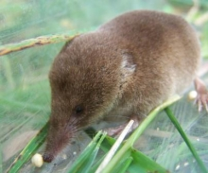
Figure 8

Image of common shrew

Source: Mammal Society (n.d.b)
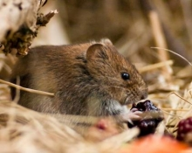
Figure 9

Image of bank vole

Source: Mammal Society (n.d.c)
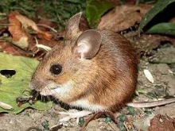
Figure 10

Image of wood mouse

Source: Mammal Society (n.d.d)

There is strong evidence to suggest that reintroduction of a species can be successful whether this be from a captive, bred or wild population. The most important factors have been ensuring that programmes are well thought out and thorough research is done into the species and area being considered for reintroduction. In the case of F. silvestris grampia, area size and food sources are the most important factors to research for initial plans. Using past research on attempts to reintroduce different species, especially carnivorous mammals, means future trials may become easier. This is the reason for this research. While this may take some time to set up it gives hope for breeding more pure wildcats in captivity that may be one day trained to make survival in the wild a possibility.
In addition to this, the habitat has to be suitable for reintroduction. Classifying the habitat type through surveys enables a greater understanding of what to expect in the area. There are a number of different survey types, the most common of which are NVC, Phase 1 Habitat and UK Biodiversity Action Plan assessments. By establishing the habitat type through any of these surveys it is possible to give a rapid understanding of the habitat, meaning further research would only be continued in detail if it was suitable at this stage (Defra, n.d). Phase 1 Habitat Surveys are used most commonly throughout the UK as they are easy to understand because they use codes found in the JNCC (Joint Nature Conservation Committee) handbook. The codes are sectioned into different vegetation cover types and whether they are managed or not. By using the codes in the JNCC handbook, other people can understand the habitat type without having to visit the site (JNCC, 2010).

3.0 Methodology
This chapter will review and critically discuss the methods used within the research. Details about the location and procedures will be included in this. A risk assessment and ethics form were completed and can be found in Appendix A. A shrew trapping licence was also filled in and approved (Appendix B).

3.1 Research Site Location
The location used for research in this study was the Glasdrum Wood National Nature Reserve in Argyll and Bute, Scotland (Figure 11). Located on the slopes of Beinn Churalain about 27km north of Oban, changes in both soils and altitude result in a variety of habitats within and around the reserve (SNH, n.d). Oak and ash woodland are interspersed with bracken and grassland areas which results in a rich diversity of both plants and animals found within the reserve (Welcome to Scotland, n.d). Glasdrum Wood is located close to Appin and Invercreran, both of which are small settlements. Larger settlements in close proximity are located on the opposite side of the loch.
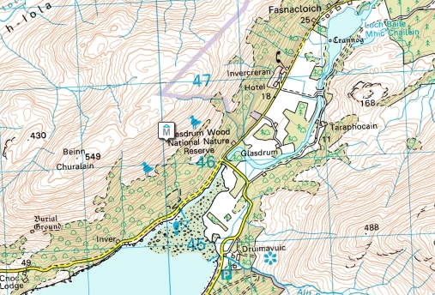

Figure 11

Map showing the location of Glasdrum Wood NNR

Source: VisitScotland (n.d)

Glasdrum Wood was chosen for research due to the habitat types and location. With so few large settlements and roads in the area there is a high amount of privacy which suits F. silvestris grampia. The area has been further quietened with the re-routing of the truck road over the Creagan Bridge in 2000 (SNH, n.d). Pine marten (Martes martes) and buzzards (Buteo buteo) being found in the area is a strong indication that the populations of small mammals must be sufficient for predators. This information combined with the knowledge that the habitat had sufficient open and covered areas means the area can be considered suitable for further research.

3.2 Habitat Research
Upon reaching the research, site a closer analysis of the plant species in the reserve was undertaken. Looking at the plant species and habitat as a whole gives more of an idea as to the animals that could be found in the area. Due to the mild climate in the area (SNH, n.d) many species of mosses and lichens are found in the reserve, which gives way to an impressive diversity of species. With small streams and a loch located within and close to the reserve, fresh water is relatively easy to access and mammals such as otters and pine marten are known to visit the area (SNH, n.d).
While trapping was taking place these surveys were taken from different sections around the reserve. This area was then looked at in more detail using the tape measure to mark out a 3m by 3m square (Figure 12). The added knowledge of the types of plant species and evidence of any animals will help with understanding the suitability of the habitat both for small mammals and for possible reintroduction of F. silvestris grampia. Having looked through the reserve when searching for places for trapping, sites were chosen for variety in both habitat and placement within the reserve. While some of these research areas have been planted they are rich in variety and are surrounded by natural woodland.
The research largely looked at the dominant and secondary species of trees and grasses. This information was then used to formulate a Phase 1 Habitat survey which is the standard habitat survey type used throughout the UK. Using Phase 1 Habitat surveys means the habitat can be identified rapidly and can cover a large area with ease (Defra, 2010).
Phase 1 Habitat surveys consider the main components that make up the vegetation. This is then used to establish a code which can be found in a handbook produced by the JNCC (Joint Nature Conservation Committee). To do this they are separated into different sections of major vegetation types and are narrowed down by how they are managed. The information collected in the field was compiled into one table and this was used to establish the code from the JNCC handbook (JNCC, 2010).

Balance with Bite
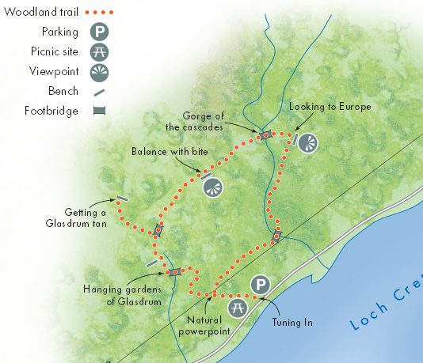
Bridge one

Figure 12

Image showing habitat survey locations

Source: SNH (2005)
Glasdrum Tan

Trapping Area

3.3 Longworth Live Traps
For capture of live small mammals Longworth live traps (Figure 13) were used. While there are numerous types of traps that can be used to trap small mammals Longworth traps are the most commonly and effectively used in the UK. This high usage compared to other traps is largely due to them being comparatively light and having a high sensitivity (Flowerdew et al, 2004). Using Longworth live traps ensures simultaneous monitoring of all small mammals in the area, with enough room within the trap to ensure suitable food and bedding for all small mammals that may be trapped (Macdonald et al, 1998).
Figure 13

Image showing the correct placement of Longworth traps

Source: Doberski and Brodie (1991)

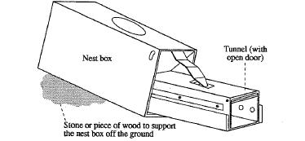

When using the traps the nest boxes were filled with bedding and food to ensure the trapped mammal’s safety. This is especially important when there is a chance shrews might be caught because they have such a high metabolism. For this reason, a shrew trapping licence was acquired from Scottish Natural Heritage before research was undertaken (SNH, n.d.a). The traps were also placed with the tunnel flat and the nest box slightly elevated to ensure no rainwater enters the trap and keeps the nesting material dry (Figure 13). When trying to establish population numbers, using more than one trap at each site is most effective. Consequently four traps were placed at each site, an example of which can be seen in Figure 14. Once placed the traps should then be covered in vegetation, both to act as camouflage but to also ensure it remains at a comfortable temperature (Doberski and Brodie, 1991).
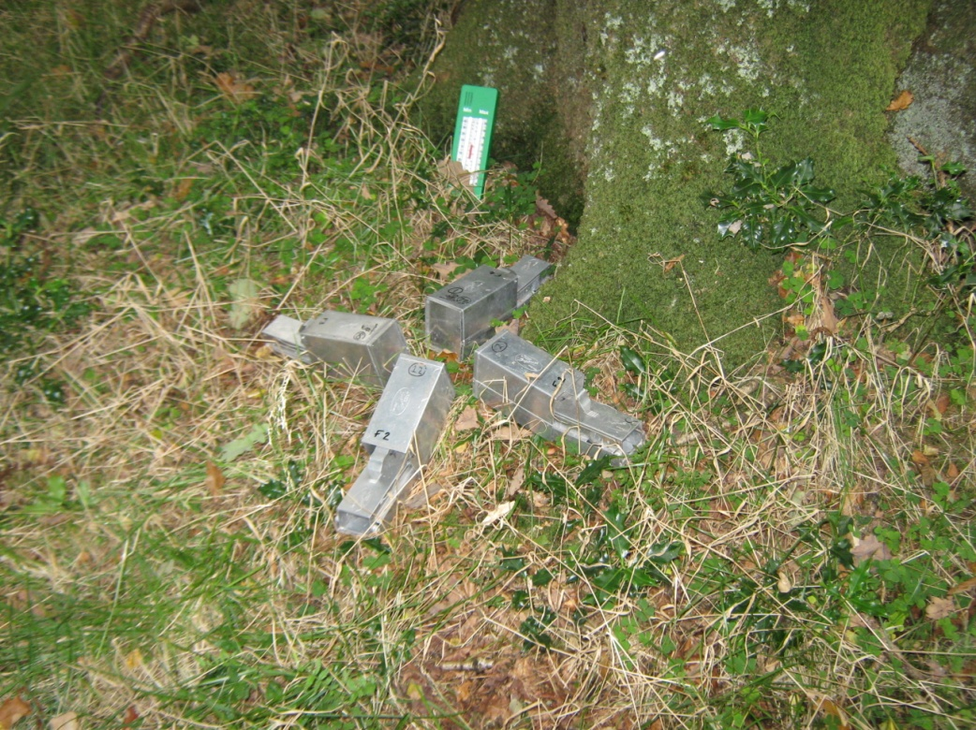
Figure 14

Image of set Longworth live traps

Source: Author (2012)

When a mammal enters the trap the door springs shut after the release is triggered at the end of the tunnel section. The simplest way of handling the animal is to empty the trap into a large, transparent plastic bag. Once in the bag the animal can be controlled with one hand while other hand can be used to safely pick up the individual by pinching the piece of skin between the head and body. Using this technique reduces the amount of stress caused to the animal and there is less danger of being bitten. It also means identifying and sexing the mammal is much easier. Once this has been done, the animal can be placed into a smaller plastic bag which can be used to weigh the individual (Doberski and Brodie, 1991). While the traps are refilled using fresh food and nest material, studies have shown that some species are more likely to enter a trap that has not been cleaned. For this reason it was ensured that all residues of previous trapped mammals was removed but thorough cleansing was not used as it would leave an unnatural smell (Boonstra and Krebs, 1976).
The first thing to do upon visiting the site was to establish the most suitable area for trapping. This involved a walk around the reserve looking for evidence of small mammals and which habitats would be most suited to the animals known to be found in the area. The section of Glasdrum Wood that was chosen for research was close to the entrance of the reserve (Figure 15). The reasons for deciding upon this stretch of habitat were the ease of access during night time monitoring and that it spanned two habitats. Being located both in woodland and a grassy area gave a lesser probability of excluding small mammals based upon habitat preferences.

Figure 15

Image showing where Longworth trapping was undertaken

Source: SNH (2005)

Having filled the nest boxes with sufficient bedding and food, the traps were set out in groups of four at points around the area chosen, with each trap facing outwards. For the first 24 hours the traps were locked open to let animals become accustomed to them. With mammals becoming less wary of being trapped they are less likely to avoid them, however animals have known to become ‘trap happy’ and will visit this sure source of food often (Flowerdew et al, 2004). Position of the traps is important, as placing them on natural runs or next to roots and rocks improves the chances of trapping small mammals.
Having set the traps and left them for 24 hours the traps were then set to close, ensuring they would shut behind an animal that entered it. These were then placed where they had been and checked regularly to ensure the welfare of any trapped mammals.
When mammals were found trapped they were identified, aged, sexed and weighed. After using the mammal handbook to identify the species found they were then aged using the size and weight of the mammals. Understanding ages and sexes of mammals help to establish whether the population is healthy. Both males and females of different species tend to imply healthy populations that are suitable for predation.

3.4 Mapping
Using maps of the Oban and Fort William area it is possible to establish the areas of Argyll that might be suitable for reintroduction due to urban conurbations. By plotting major towns, cities and roads it is easier to compare this to areas of land which F. silvestris grampia is already found. Using the information found on these maps it is possible to ascertain range and suitability in Argyll. A map of Argyll and surrounding areas was taken from Google Maps and modified within Microsoft Word to give a visual indicator of how inhabited the Argyll and Bute area was. This is important because there is evidence that while F. silverstris grampia will live in proximity to humans, healthy populations tend to occur further away from disturbances.
The approximate area of open land was then estimated and this figure was used when deciding how suitable Argyll is for a population of F. silvestris grampia to be reintroduced. The area will also be compared in terms of human activity to the Cairngorms area, as this is a region known to contain Scottish wildcat (BBC, 2013).

3.5 Analysis
Having the research split into more than one section means that suitability for each section was established before being combined for a final conclusion. Food sources were ascertained using live trapping and evidence in the field. Maps were used for estimating land area that would be suitable and the numbers of F. silvestris that could possibly be reintroduced.
Trapping results are used to give an idea of population density. There are numerous equations that can be used to establish this, however the majority of these are for long term studies with subject mammals being marked and recaptured more than once. Area covered and numbers of mammals trapped have a part to play in population density and will be shown in a tabular form before being shown in graphs. This information was used alongside additional information gathered during fieldwork such as evidence of other small mammals and predatory species.
The habitat surveys from around Glasdrum Wood NNR were also used to establish whether the habitat type would be suitable both for F. silverstis grampia and prey food sources. This information was also combined with the trapping results to establish the overall suitability of the reserve in respect to Scottish wildcat. This was then used to decide upon the size of territory that would be needed to sustain an individual, as wildcat are known to alter the territory size depending on their needs. Higher density populations are found in areas with high suitability, whereas fewer individuals are found in areas with lower prey animal populations (Mammal Society, n.d).
Using information from maps of the areas it is possible to estimate the area of land that is suitable for Scottish wildcats due to proximity to humans and large settlements. Based on the territory size estimated from Longworth trapping it is possible to approximate the number of individuals that would be able to live in the area. This information along with other data gathered during research is then used to establish the overall suitability for the Argyll area of Scotland for reintroduction of F. silvestris grampia.

4.0 Results
This section shows the results from Longworth live trapping and vegetation data for the research undertaken in Glasdrum Wood NNR. It also shows the work done using maps to indicate roads and large settlements. All raw data can be found in Appendix C.

4.1 Longworth Trapping Data
Figure 16 shows the numbers and species of mammals found during the Longworth trapping. While not many individuals were captured the graph shows that more wood mice were found in the area than field voles. All the individuals were healthy, an example of which can be seen in Figure 17. The wood mouse in the picture was active and alert, indicating no harm came to it during trapping. Using the information from Figure 16 and the fact that 40 traps were placed, it is possible to deduce that a trapping rate of only 1/40 each time the traps were set. This gives a trap night rate of 1/160.

Figure 16

Graph showing the numbers a species of trapped mammals

Source: Author (2013)

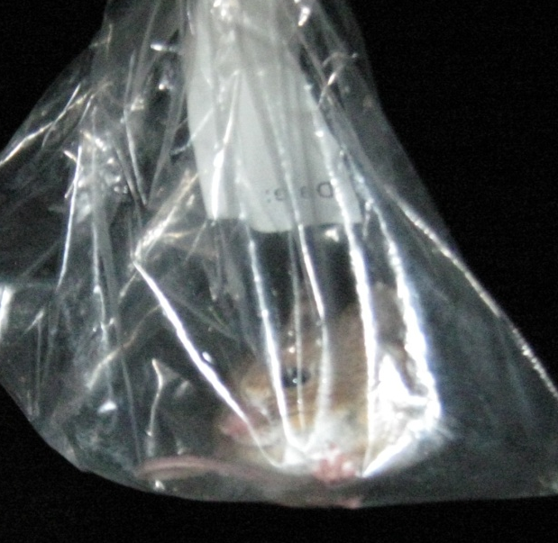
Figure 17

Image of wood mouse trapped on 26/9/2012

Source: Author (2012)

Figures 18 and 19 represent the age and gender of all the mammals trapped during the survey. Figure indicates there is equilibrium of ages, with equal numbers of adult and juvenile animals being found during the study. Figure suggests the balance between genders is also equal, with the same numbers of males and females being trapped.

Figure 18

Pie chart showing gender of trapped individuals

Source: Author (2013)

Figure 19

Pie chart showing maturity of trapped individuals

Source: Author (2013)

Figure 20 shows the relationship between the number of trappings and the dates that they occurred on. The Longworth traps were set at 7am on the 23rd and the last check occurred at 1pm on the 26th. The 25th was the most successful day, accounting for half of the overall captures throughout the study.
Figure 20

Graph showing number of trappings per date

Source: Author (2013)
Figure 21 shows the timing of individuals found in traps using all the data collected during the study. The graph shows that all individuals were trapped overnight with the highest number being trapped between 01:00 and 07:00. During the day, no mammals were found within the traps.
Figure 21

Graph showing timings of trapped individuals

Source: Author (2013)

4.2 Site Specific Research
Table 1, below, shows the results from the site specific research. The full results which can be found in Appendix C have been used to establish a Phase 1 Habitat Survey result for each area. Additional information important for F. silvestris grampia has also been included in this table.
Table 1 – Site specific results
 | Balance With Bite | Trapping Area | Bridge One | Glasdrum Tan
Dominant Vegetation
Oak |  | ✔
Holly
Hazel
Birch |  |  | ✔
Mountain Ash
Alder | ✔
Rowan | ✔
Bracken |  |  |  | ✔
Fern | ✔
Mixed Grasses |  | ✔ |  | ✔
Fungi
Secondary Vegetation
Oak |  | ✔ | ✔
Holly | ✔ | ✔
Hazel |  | ✔ | ✔ | ✔
Birch | ✔ | ✔
Mountain Ash | ✔ | ✔
Alder
Rowan |  |  |  | ✔
Bracken | ✔
Fern
Mixed Grasses | ✔ | ✔
Mosses/Lichen |  | ✔ | ✔
Fungi | ✔ |  | ✔
Animals
Spiders | ✔ | ✔ |  | ✔
Beetles |  | ✔
Flying Insects |  | ✔ |  | ✔
Phase One Habitat Survey Classification
 | A.1.1.1.  Broadleaved Woodland - Semi Natural | A.1.1.1.  Broadleaved Woodland - Semi Natural | A.1.1.2.  Broadleaved Woodland - Plantation | B.2.2.  Neutral Grassland – Semi Improved
Additional Information
 | - Abundance of berries on the ground | - Abundance of nuts on the ground  - Large Oaks mean area is still open | - Located close to stream  - Uniform vegetation | - Deer droppings  - Semi-managed habitat

Table 1 shows the dominant and secondary vegetation and animal species found in numerous areas throughout the reserve. The table shows there are a number of different types of habitat found within the reserve, with a variety of plant species found at all sites. Trees are the dominant species at most of the sites however Glasdrum Tan has no tree species found in the test site. This is the biggest factor when showing that the reserve has both wooded and grassed areas, indicating a wide mix of habitats. These have then been used to show Phase One Habitat Survey Classifications.
Table 1 also shows which sites insects and spiders are found at. Beetles have a specific notation as they were more abundant in the Trapping Area than any other animals. A variety of animals were found at all sites, however Bridge One, where no creatures were found, was also the only area to be located in close proximity to water.

4.3 Mapping
Figure 22 shows the Argyll and Bute council area with major conurbations highlighted. These areas are the largest found in mainland Argyll with only Oban being the biggest of these, with a population of only around 8,500 people (Oban, n.d). The map also shows the major roads found within the region, which largely joining the major towns. Part of the Loch Lomond and the Trossachs National Park is also located within Argyll and is identified by the green shading. The map clearly shows large areas of land where there is little disturbance from humans, especially between Oban and Inveraray.
Using Figure 22 it has been estimated that around 130km² of land would be suitable for wildcat reintroduction in conjunction with the towns and main roads in Argyll. Large parts of this are found in two major areas. The first stretches from Oban to Inveraray and across to the Argyll border. The second area is located around Benderloch, as far as the road to the East. This area is the smaller of the two, however it stretches beyond the border into Inverness-shire. There are other, less significant areas in the Southern half of Argyll that would contribute to population statistics, however these are much smaller and more fragmented than the two larger areas. The map also shows that fragmentation occurs not only as a result of roads and towns but lochs, which are numerous in the county.

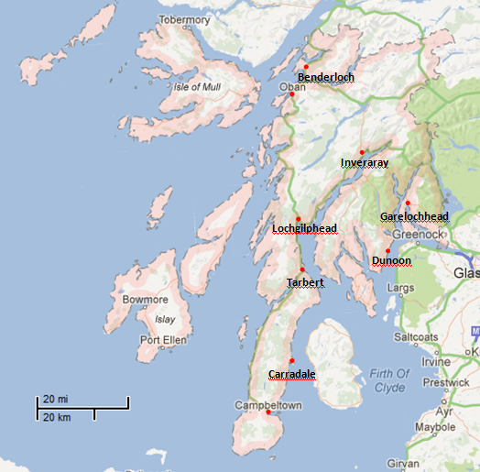

Figure 22

Map of Argyll and Bute council area

Source: Google Maps (2013)
Edited by: Author (2013)

4.4 Additional Information
In addition to the results from the Longworth trapping, general observations were also made. These often came about when site specific research was being undertaken.
On the way to and from the reserve, Buzzards (Buteo buteo) were seen daily. This was more than likely one individual with a territory which included the reserve, as it was seen at the same time every day. Other birds were also seen within the reserve, including groups of blue tits (Cyanistes caeruleus), coal tits (Periparus ater) and robins (Erithacus rubecula) and a pair of tawny owls (Strix aluco) were heard.
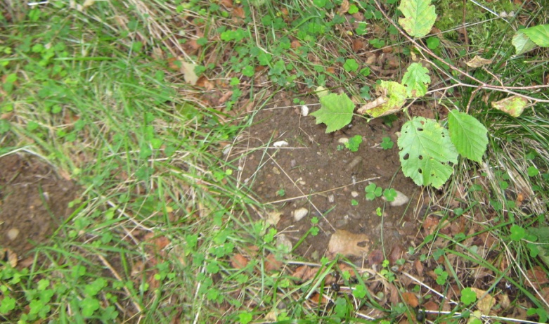
Along with the birds, evidence of other small mammals not found in the Longworth live traps were found. Both pygmy shrew (Sorex minutes) and European mole (Talpa europaea) were noted in the reserve. Mole hills (Figure 23) were seen next to the path around the reserve, while a dead pygmy shrew was seen being dragged along by a large beetle. There was also evidence in the form of nuts that had teeth marks on them and fungus with bites taken out of it (Figure 24).
Figure 23

Image of mole hills found in Glasdrum Wood NNR

Source: Author (2013)

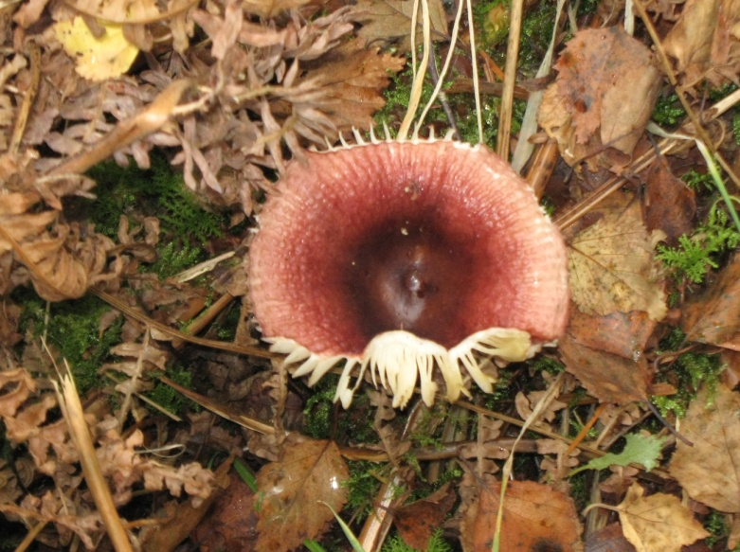
Figure 24

Image showing mushroom which has been partially eaten, found in Glasdrum Wood NNR

Source: Author (2012)

5.0 Discussion

5.0 Discussion
5.1 Longworth trapping discussion
Using Figure 16 it is clear there were few mammals captured during the research. While this in itself is might imply there is not a large small mammal population in the area there was a significant diversity within the trapped mammals and evidence of other species. Wijesinghe (2010) found during a study in tropical rainforests that species with higher population densities were often caught at an early stage of the study. In the study Wijesinghe also found that using a trap density of 140 traps per ha was intense enough that over 90% of species found in an area will be trapped within the first four days. After this the rate of species capture lowers drastically. While this implies the Longworth trapping showed an accurate account of the small mammals found within Glasdrum Wood NNR, other evidence was found to suggest that other small mammals were found in the area. Section 4.3 has evidence which include other small mammals that were not found in the traps. Using these findings it is possible to deduce the populations and species of small mammals found in Glasdrum Wood may well be larger. Wijisinghe indicates that more common species will be trapped earlier into the trapping period than those that are less commonly found. This implies that field voles are less common than wood Mmice in the reserve and had trapping continued it is possible that more species might have been found in the traps.
While F. silvestris grampia do not have a preference between wood mice or field voles it is important to understand the numbers within the small mammal populations. A smaller number of species would indicate healthy populations and as such it can be deduced that the wood mouse population found in Glasdrum Wood NNR is healthier than that of field vole.
Figure 20 shows that trapping occurred throughout the study, however it is important to remember that the 23rd and 26th were half days. The fact that the 23rd was a half day and no captures were made on this day can be explained using Figure 21. Given the traps were only set to trap at 1pm on the 23rd it is unsurprising that no mammals were trapped on that day as all trappings occurred between 7pm and 7am for the rest of the study. This has been backed up in other small mammal studies in the UK. During a study over 600 trap nights by Keene (2009), a total of 62 mammals were captured. From these 62 captures only 2 occurred during daytime hours. This is largely as a result of certain species, including wood mice and field voles, being active during the night. The Scottish wildcat is also active largely during the night and has specialised hearing which enables the species to detect the squeaks of small mammal species (SWA, n.d). This overlap in timing of activity indicates the wildcat would not be hampered by a lack of available prey during the day.
While the timing of the captures can be explained by the small mammals found in Glasdrum Wood being largely nocturnal species this does not explain the overall low capture rate of individuals. There have been numerous studies into the capture rate of small mammals and what can affect this. It is indicated that the weather can be an important factor. Shrews (Doucet and Bider, 1974) and other rodents (Goldingay and Denny, 1986) have been found to be more active after periods of rainfall, especially after especially dry periods. This supports the evidence from the study as Northern Argyll is known to be a particularly mild area of Scotland and during the research period there was little to no rain.
Another influencing factor on small mammal populations which runs alongside the impact of weather is the phases of the moon and clarity of sky at night. Numerous studies have indicated that moon visibility can have effects upon mammals when hunting and foraging. Lockard and Owings (1974) found that kangaroo mice in Portal, Arizona were three times more likely to forage during nights without a moon than those with. Of the nights with a moon that foraging did take place, the activity spanned smaller areas than observed without a moon indicating there is a reason the mice do not search for food during periods that are brighter. This may have something to do with staying undercover and being less easy to find. This works alongside the fieldwork which occurred in Glasdrum Wood NNR, as during the fieldwork period the sky was clear. An area such as Glasdrum Wood is extremely remote and this means the brightness of both the moon and stars is more noticeable than in urban areas. While the weather may not have had any effect on the capture rate, further research would have to be undertaken in the area to fully understand the effect of the conditions observed.
Not only were each of the animals trapped a different individual, there were also differences in age, sex and species. A healthy population of most species needs both males and females to sustain growth and as both were captured in Glasdrum Wood NNR there is an implication that a healthy population may be found in the area. A juvenile wood mouse was also trapped, which enhances this theory as it implies there are breeding individuals in the area. Having trapped both wood mice and a field vole and having evidence of both moles (Figure 23) and pygmy shrews within the reserve, there is a large chance that the individuals captured are not truly representative of small mammal populations in the reserve.
The most important factor for determining population numbers is to consider the number of individuals per trap night. In other studies numbers trapped per 100 trap nights are most commonly considered which in this case is a rate of only 0.625. Compared with other studies of small mammal populations this is extremely low. Jenkins et al (2005) had a trap night rate of 16.5 per 100 nights, significantly higher than in this study. This indicates the populations of small mammals in Glasdrum Wood are not particularly healthy. This is supported by Keene’s (2009) study of two corridors in North East Somerset, which had a trap night rate of 10.33 per 100. While the study Jenkins et al did had a higher capture rate per 100 trap nights the research was extensive and the habitat greatly different to Glasdrum Wood. There is more resemblance between Jenkins et al’s (2005) research and Keene’s study as they ran for similar lengths of time in similar habitats. This is therefore very important when establishing how healthy the populations of small mammals in Glasdrum Wood NNR are. In a direct comparison, it is clear that Keene’s study was significantly more successful, indicating there are not large mammal populations living within the reserve.

5.2 Habitat Discussion
As indicated in Table 1, Glasdrum Wood NNR has different habitat and vegetation types included within it. The reserve is semi-managed and as a result varies greatly close to the path, with more natural areas spreading out from there. The forestry commission also owns the land surrounding the reserve which has recently been left to grow as natural grassland. Having the correct habitat is very important for reintroduction of species into an area.
A study by Moorhouse et al (2008) indicated the importance of habitats the reintroduction of water voles. While reintroductions are usually considered either a success or a failure there are numerous levels of success, which can be attributed to habitat suitability. This is also supported by research from Hebblewhite et al (2011) about far Eastern leopards. This is such an important factor as the far Eastern leopard and Scottish wildcat are both predators and have a similar impacts on the environment. This information makes it even more important to take into account the habitat preferences of Scottish wildcat in the Cairngorms, where they are already found.
In comparison to the habitat Scottish wildcat are known to live in (SWA, n.d), the Glasdrum Wood NNR seems to be a good area for reintroduction. With the knowledge that wildcat like a mixture of both wooded and grassland habitats, both of which are found in Glasdrum Wood (see Table 1), the implications are positive. All this information implies that Argyll would be a suitable place for reintroduction of wildcat, taking only habitat into consideration. As habitat is so important to success rates for reintroduced animals, this implies that wildcat would repopulate Argyll efficiently, building a healthy population.

5.3 Mapping Discussion
Using Figure 23 it is possible to estimate the overall area of suitable habitat for F. silvestris grampia reintroduction. As stated in Section 4.3, the overall area in Argyll suitable for wildcat reintroduction has been estimated at 130km² overall. This number is, however split into two large fragments, with numerous smaller areas combining to complete the overall size. This is the number that will be used in relation to the other results and information to establish the number of wildcat that could live in the area, however future work would need to estimate the area more accurately and take into account the separate regions.

5.4 Additional Information
Along with the diversity found within the individuals caught, there is other evidence that small mammal populations are large enough to sustain predatory species. The area has many bird species that live and visit, including birds of prey. During the study, a pair of tawny owls (Strix aluco) and common buzzard (Buteo buteo) were seen both in and around Glasdrum Wood NNR. Both of these species are known to have a similar diet to F. slvestris grampia and live and hunt in similar terrain. S. aluco are largely nocturnal animals which hunt upon small mammals, small birds, fish, insects and worms (RSPB, n.d), while B. buteo diet largely consists of small mammals, carrion and birds (RSPB, n.d.a). F. silvestris grampia are well known to feed largely on small mammals, however they will also eat small birds if the opportunity arises. This information implies there is enough prey found in the area to support numerous predatory animal populations. F. silvestris grampia will also increase their territory if prey is not in large enough abundance, with areas reaching as much as 10km² (SWA, n.d). This means that although the use of Longworth traps did not firmly indicate a healthy population of small mammals, it is possible that there may be enough prey to support healthy individuals. It is not, however, possible from this information to indicate how large a population the prey might be able to support.

5.5 Limitations
The biggest and most influential limitation recognised in this study was the length in which it was undertaken. As with all types of research the longer and more extensive the data collection, the more accurate the results are likely to be. This stands for Longworth trapping, especially as small mammals can be initially wary of the traps. Due to only a five-day week being spent in the field, there was only data for three night’s worth of trapping, with an additional night of the traps being locked open. Although locking the traps open for that initial night gives the species time to adjust, they can still be wary for some time. Had the study period been longer there would have been more time for the animals to adjust to the traps, meaning they would use them as normal. There would also have been more time to carry out trapping, increasing the chances of capturing more individuals in the area.
Had the trapping been undertaken over a longer period it might have been possible to use Program CAPTURE. This is software that estimates overall population from the numbers caught, but needs a minimum of five individuals being trapped during the study to do the calculation. Doing this would have made it easier to establish the suitability of Argyll for F. silvestris grampia reintroduction.
While a longer study period would have increased the chances of capture it would have been more effective and accurate if there had been numerous in field study periods. As in Keene’s study (2009), three sessions in November 2006 and February and March 2007 were used to capture small mammals. In doing this it is possible to reduce the impacts of uncontrollable variables such as the weather. Had there been more opportunity and time then four study periods lasting around two weeks apiece would have been more effective, especially if they were undertaken in different seasons. By doing this it removes the impacts of temperature and weather and incorporates the seasonal variations in animal activity such as breeding. Limiting the study periods to two weeks, including nights with the traps locked open, reduces the likelihood of animals becoming ‘trap happy’, where an individual will revisit traps with the knowledge that food will be found there.
Another limitation to the study was the location. While Glasdrum Wood NNR was a suitable place for research to take place, the study would have been more accurate if numerous places had been chosen for research to be undertaken. While the small mammal populations might not be suitable within Glasdrum Wood there is a good chance that they would be different in the south of Argyll. Without this knowledge it is not possible to make an accurate decision as to whether wildcat could be reintroduced into Argyll, as the suitability of different areas no doubt changes throughout the district. This will also have affected the accuracy in habitat and vegetation cover as these are so variable. With the vegetation changing significantly within the reserve, only a very extensive piece of research would have been able to cover all of Argyll. Due to the word limit it would not have been realistic to research numerous sites in such detail.

5.6 Conclusions
The research undertaken in this dissertation would indicate that Argyll is not suitable for reintroduction of F. silvestris grampia. While the habitat and proximity to humans are similar to those required by the Scottish wildcat the lack of prey found in Glasdrum Wood NNR would suggest there is not enough food to sustain both healthy wildcat and small mammal populations. As the prey is highly unsuitable the territories for the introduced individuals would be at the higher end of the size estimates. With a density of only one individual per 10km² a population of around 130 would be the highest limit for the Argyll area.
The results of this research indicate that the number of individuals that would be able to be reintroduced into the area would be so low that populations would not remain healthy and would be at risk of fragmentation. However, as discussed in section 5.5 there is opportunity to research prey in more detail throughout Argyll. Should this be done there would be a more detailed account of Argyll and this would mean a more accurate estimation of numbers of wildcat that could survive in the area.

5.7 Future Work
Although the conclusion of this research is not promising for wildcat reintroduction in Argyll, there are still many opportunities for further work. As discussed in Section 5.6, there were numerous limitations to this research. However, this means there is also scope for further research. Should the Argyll area be looked at in the future in relation to reintroduction of F. silvestris grampia a more extensive and in depth study would need to be undertaken. In order for future research to be extensive enough it would have to take place over a space of years and look at a wider variety of places.
Future work into Scottish wildcat reintroduction in Argyll would also have to incorporate the threat of hybridisation from both domestic and feral cats. By using camera traps it would be possible to establish the population of feral, domestic and hybrid cats. If the results from this were positive reintroduction attempts of F. silvestris grampia it would be possible to use these results to estimate the overall cost of the process and the likelihood of success. By doing such in depth studies it means there is a lesser chance of failure. All of this presents option for future research.

References

Argyll (n.d) About Argyll (online) Available at: http://www.argyll.org/about/index.php (Accessed on 15/1/2013)

Arkive (n.d) White-Tailed Eagle (online) Available at: http://www.arkive.org/white-tailed-eagle/haliaeetus-albicilla/image-G13157.html (Accessed on 16/2/2013)

Arts, K. Fischer, A. and Van Der Wal, R. (2012) Common stories of reintroduction: A discourse analysis of documents supporting animal reintroductions to Scotland Land Use Policy, 29, 911-920

BBC (2011) European beavers construct ideal habitat for bats (online) Available at: http://news.bbc.co.uk/earth/hi/earth_news/newsid_9353000/9353551.stm (Accessed on 13/2/2013)

BBC (2012) Baby beaver trio filmed in Argyll forest (online) Available at: http://www.bbc.co.uk/news/uk-scotland-glasgow-west-19110708 (Accessed on 14/2/2013)

BBC (2013) Cairngorms National Park celebrates 10th anniversary (online) Available at: http://www.bbc.co.uk/news/uk-scotland-highlands-islands-21902130 (Accessed on 2/4/2013)

Beaumont, M. Barratt, E. Gottelli, D. Kitchener, A. Daniels, M. Prtichards, J. and Bruford M. (2001) Genetic Diversity and Introgression in the Scottish Wildcat, Molecular Ecology, 10, 319-336

Biology-Online (n.d) Genetic Diversity (online) Available at: http://www.biology-online.org/dictionary/Genetic_diversity (Accessed on 12/2/2013)

Boonstra, R. and Krebs, C. J. (1976) The effect of odour on trap response in Microtus townsendii, Journal of Zoology, 180, 467-476

Buesching, C. Newman, C. Twell, R. and Macdonald, D. (2007) Reasons for arboreality in wood mice (Apodemus sylvaticus) and Bank Voles (Myodes glaveolus) Mammalian Biology, 73, 318-324

CNP Wildcat Conference (2008) Practical Wildcat conservation in the Cairngorms National Park (online) Available at: http://highlandtiger.co.uk/pdf/CNPWildcatConference.pdf (Accessed on 21/1/2013)

Courier (2013) Call for cloning to help save Scottish Wildcat (online) Available at: http://www.thecourier.co.uk/news/local/perth-kinross/call-for-cloning-to-help-save-scottish-wildcat-1.67024 (Accessed on 14/2/2013)

Davis, A. R. and Gray, D. (2010) The distribution of Scottish Wildcats (Felis silvestris) in Scotland (2006-2008) Scottish Natural Heritage Commissioned Report No. 360

Deadline (2013) Scottish Wildcats hit by rabbit shortage as numbers decline (online) Available at: http://www.deadlinenews.co.uk/2013/03/17/scottish-wildcats-hit-by-rabbit-shortage-as-numbers-decline/ (Accessed on 2/4/2013)

Defra (n.d) UK Habitat Classifications (online) Available at: http://jncc.defra.gov.uk/page-1425 (Accessed on 5/4/2013)

Defra (2010) Handbook for Phase 1 habitat survey – a technique for environmental audit (online) Available at: http://jncc.defra.gov.uk/page-2468 (Accessed on 18/3/2013)

Doberski, J. and Brodie, I. (1991) Techniques in ecology: Terrestrial organisms and habitats Daniels Publishing, Cambridge

Doucet, G. and Bider, J. (1974) The effects of weather on the activity of the masked shrew Journal of Mammalogy 70, 643-652

Eckert, I. Suchentrunk, F. Markov, G. and Hartl, G. (2009) Genetic diversity and integrity of German wildcat (Felis silvestris) populations as revealed by microsatellites, allozymes and mitochondrial DNA sequences Mammalian Biology 75, 160-174

Flowerdew, J. Shore, R. Poulton, S. and Sparks, T. (2004) Live Trapping to Monitor Small Mammals in Britain Mammal Review, 34, 31-50

Germain, E. Ruette, S. and Poulle, M. (2009) Likeness between the food habits of European wildcats, domestic cats and their hybrids in France Mammalian Biology, 74, 412-417

Goldingay, R. and Denny, M. (1986) Capture-related aspects of the ecology of Antechinus flavipes (Marsupialia: Dasyuridae) Australian Mammalogy, 11, 67-70

Google Maps (2013) Google Maps (online) Available at: http://maps.google.co.uk/ (Accessed on 31/3/2013)

Hebblewhite, M. Miquelle, D. Murzin, A. Aramilev, V. and Pikunov, D. (2011) Predicting potential habitat and population size for reintroduction of Far Eastern leopards in the Russian Far East. Biological Conservation, 144, 2403-2413

Highland Tiger (n.d) The Highland Tiger (online) Available at: http://www.highlandtiger.com/about_highland_tiger.asp (Accessed on 12/2/2013)

Hubbard, A. McOrist, S. Jones, T. Boid, R. Scott, R. and Easterbee, N. (1991) Is survival of European wildcats Felis silvestris in Britain threatened by interbreeding with domestic cats? Biological Conservation, 61, 203-208

Jenkins, K. Roberts, S. L. and Seaman, E. (2005) Monitoring Small Mammal Populations in Coniferous Forest Ecosystems of Olympic National Park: Preliminary Assessment (online) Available at: http://fresc.usgs.gov/products/papers/1459_Jenkins.pdf (Accessed on 5/4/2013)

JNCC (2010) Handbook for phase 1 habitat survey (online) Available at: http://jncc.defra.gov.uk/PDF/pub10_handbookforphase1habitatsurvey.pdf (Accessed on 4/4/2013)

Jule, K. Leaver, L. and Lea, S. (2008) The effects of captive experience on reintroduction survival in carnivores: A review and analysis Biological Conservation, 141, 355-363

Keene, A. (2009) Study of small mammal populations within two Barn owl corridors at Folly Farm Bioscience Horizons, 2, 155-163

Lockard, R. and Owings, D. (1974) Moon-related surface activity of Bannertail (Dipodomys spectablis) and Fresno (D. nitratoides) Kangaroo Rats Animal Behaviour, 22, 262-273

Love, J. and Ball, M. (1979) White-Tailed Sea Eagle Haliaeetus Albicilla Reintroduction to the Isle of Rhum, Scotland 1975-1977 Biological Conservation, 16, 23-30

Macdonald, D. Mace, G. and Rushton, S. (1998) Proposals for the future monitoring of british mammals DETR and JNCC, Peterborough

Mammal Society (n.d) Species factsheet: Scottish Wildcat (online) Available at: http://www.mammal.org.uk/sites/default/files/factsheets/wildcat_complete_on_web.pdf (Accessed on 22/1/2013)

Mammal Society (n.d.a) The Mammal Society (online) Available at: http://www.mammal.org.uk/ Accessed on 15/1/2013

Mammal Society (n.d.b) Common Shrew (online) Available at: http://www.mammal.org.uk/species-factsheets/Common%20shrew (Accessed on 30/3/2013)

Mammal Society (n.d.c) Bank Vole (online) Available at: http://www.mammal.org.uk/species-factsheets/Bank%20vole (Accessed on 30/3/2013)

Mammal Society (n.d.d) Wood Mouse (online) Available at: http://www.mammal.org.uk/species-factsheets/Wood%20mouse (Accessed on 30/3/2013)

Moorhouse, T. Gelling, M. and Macdonald, D. (2008) Effects of habitat quality upon reintroduction success of water voles: Evidence from a replicated experiment Biological Conservation, 142, 53-60

Nolet, B. and Rosell F. (1996) Comeback of the Beaver (Castor fiber): An overview of old and new conservation problems Biological Conservation, 8, 165-173

Oban (n.d) About Oban (online) Available at: http://www.oban.org.uk/Oban-tourism-information-and-accommodation,-Argyll (Accessed on 31/3/2013)

Ontiveros, D. and Pleguezuelos, Z. (1999) Influence of prey densities in the distribution and breeding success of Bonelli’s Eagle (Hieraaetus fasciatus): Management implications Biological Conservation, 93, 19-25

O’Toole, L. Fielding, A. and Haworth, P. (2001) Re-introduction of the golden eagle into the Republic of Ireland Biological Conservation, 103, 303-312

Planet Earth (2013) Scientists identify essential wildcat habitat (online) Available at: http://planetearth.nerc.ac.uk/news/story.aspx?id=1345 (Accessed on 14/2/2013)

Rosell, F. Bozser, O. Collen, P. and Parker, H. (2005) Ecological impact of beavers Castor fiber and Castor Canadensis and their ability to modify ecosystems Mammal Review, 35, 248-276

RSPB (n.d) Tawny Owl (online) Available at: http://www.rspb.org.uk/wildlife/birdguide/name/t/tawnyowl/index.aspx (Accessed on 5/3/2013)

RSPB (n.d.a) Buzzard (online) Available at: http://www.rspb.org.uk/wildlife/birdguide/name/b/buzzard/index.aspx (Accessed on 5/3/2013)

Rzss (n.d) Scottish Wildcat Genetics Group (online) Available at: http://www.rzss.org.uk/research/applied-genetics-projects (Accessed on 21/1/2013)

SNH (2005) The Story of Glasdrum Wood National Nature Reserve (online) Available at: http://www.snh.org.uk/pdfs/publications/nnr/glasdrumwoodnnrstory.pdf (Accessed on 25/1/2013)

SNH (2007) A five year species action framework: Making a difference for Scotland’s species (online) Available at: http://www.snh.org.uk/pdfs/species/species%20action%20framework.pdf Accessed on 22/1/2013)

SNH (n.d) Trapping Shrews (online) Available at: http://www.snh.gov.uk/docs/C210762.pdf (Accessed on 3/2/2013)

SWA (n.d) Scottish Wildcat Association (online) Available at: http://www.scottishwildcats.co.uk/wildcat.html (Accessed on 10/1/2013)

ThisisLondon (2007) The Scottish Wildcat kitten saving its species from extinction (online) Available at: http://www.thisislondon.co.uk/news/the-scottish-wildcat-kitten-saving-its-species-from-extinction-6585414.html (Accessed on 12/2/2013)

VisitScotland (n.d) Glasdrum Wood (online) Available at: http://www.visitscotland.com/info/see-do/glasdrum-wood-p333911 (Accessed on 1/2/2013)

Welcome to Scotland (n.d) Glasdrum Wood (online) Available at: http://www.welcometoscotland.com/things-to-do/attractions/nature-reserves/argyll-bute/glasdrum-wood (Accessed on 25/1/2013)

Wijesinghe, M. (2010) Efficiency of Live Trapping protocols to assess small mammal diversity in tropical rainforests of Sri Lanka Belg. J. Zoo. 140, 212-215

Appendix A

Application for safety and ethical approval for all projects

School of Built and Natural Environment
All undergraduate, postgraduate, commercial and research projects need ethical approval. No field work, experimentation or work with participants can start until approval is granted. The questions below should be completed by the Principal Investigator or supervisor of the proposed project. Where projects involve students, the Principal Investigator is always the supervisor and never the student.
For undergraduate and postgraduate taught projects: use the questions to identify whether the project should be referred to the relevant Ethics Committee.
- If you answer “No” to questions, then do not apply for approval.
- If you answer “Yes” to any of the questions, please discuss them with your supervisor. If your supervisor is confident that you can follow standard forms, protocols or approaches, then your supervisor can approve your application. If your supervisor is not, then the application should be sent for approval.
For research, commercial and other projects: use the questions to help compile suitable evidence to support your application.
- If you answer “No” to questions, then your application is likely to be approved quickly.
- If you answer “Yes” to any of the questions, please provide evidence relating to the management of the activity. If your approach seems appropriate, then your application is likely to be approved quickly.
Submit the application form and any supporting evidence to an appropriate Ethics Committee. Different committees might have different approval processes.
Principal Investigators, or project supervisors, are responsible for ensuring that all activities fall within the principles set down in the University Code of Conduct for Research and the University Ethical Principles for Teaching, Research, Knowledge Transfer, Consultancy and Related Activities. They are also responsible for exercising appropriate professional judgment in undertaking this review and evaluating the activity according to the criteria laid down in this application. If you are uncertain about any sections of this document, or need further information and guidance, please consult a member of the relevant School Ethics Committee.
TheSchool Ethics and Safety Committees are to ensure that you comply with the University’s ethical principles in the conduct of the activity. Committees can ask for clarification or set conditions for you to meet before approval is granted.
Expiry and review: The principal investigator is responsible for ensuring activities are reviewed. Normally:
- each year: review risk assessments: check for changes to hazards and training refreshers
- after 5 years: review ethics: check for new laws, practices
- closure: dispose of materials and sensitive data properly
Refer to the relevant documents from the following links:
- Ethical Principles for Research, Consultancy, Practical Work and Related Activities
- Research Governance (Multiple documents)
- Health, Safety & Environment (Multiple documents)

1 Project synopsis |  |  |  | Approver: |  |  |  | Cmte number:
1.1 Title | Reintroduction of the Scottish Wildcat (Felis silvestris grampia): A feasibility study of the Argyll area.
1.2 Project type | Original research |  | Research degree |  | PG taught |  | UG taught |  | X | Commercial
1.3 Short description  in layman's terms [no acronyms or jargon] | The project aims to investigate the feasibility of reintroducing the Scottish Wildcat into an area of Argyll, Scotland and will consist of primarily quantitative based research. A profile survey of small mammal frequency, along with visual evidence of larger mammals and using maps of the area will be combined for the outcome.
1.4 Dates | Start: May 2012 |  |  | End: April 2013
1.5 School of …..

2 Participants
2.1 Project supervisor /principal investigator:  name, position  and original signature | Project Supervisor: Kevin Butt  Principle Investigator: Rachel Daniels, student
2.2 Co-workers:  names and positions  [eg student] | N/A

3 External collaborators
3.1 List external collaborating bodies

Scottish Wildcat Association,
Glasdrum Wood Reserve.
3.2 Provide evidence of any ethical approvals obtained [or needed] by external collaborators

N/A
3.3 Indicate whether confidentiality agreements have been or will be completed

N/A

Read any associated procedures and guidance or follow any associated checklist, and delete, Yes or No, for each characteristic in A) to F) below.
If you respond No, then in your judgment you believe that the characteristic is irrelevant to the activity.
If you respond Yes, then you should provide relevant documentation [including risk assessments] with the application, and cross-reference to it, eg A2 or B9. Use reference numbers of standard forms, protocols and approaches and risk assessments where they exist.

- Does the activity involve field work or travel to unfamiliar places? If Yes:  - Does the activity involve field work or leaving the campus [eg overseas]?  - Does the field work involve a ‘party’ of participants or lone working ?  - Does the activity involve children visiting from schools? | A) Yes  - Yes  - Yes  - No
B) Does the activity involve humans other than the investigators? If Yes:  - Will the activity involve any external organisation for which separate and specific ethics clearance is required (e.g. NHS; school; any criminal justice agencies including the Police, CPS, Prison Service)? – start this now [CRB clearance process at Loughborough; Uclan contact Carole Knight]  - Does the activity involve participants who are unable to give their informed consent (e.g. children, people with severe learning disabilities, unconscious patients etc.) or who may not be able to give valid consent (e.g. people experiencing mental health difficulties)?  - Does the activity require participants to give informed consent? [consent guidance at City U]  - Does the activity raise issues involving the potential abuse or misuse of power and authority which might compromise the validity of participants’ consent (e.g. relationships of line management or training)?  - Is there a potential risk arising from the project of physical, social, emotional or psychological harm to the researchers or participants?  - Does the activity involve the researchers and/or participants in the potential disclosure of any information relating to illegal activities; the observation of illegal activities; or the possession, viewing or storage (whether in hard copy of electronic format) which may be illegal?  - Will deception of the participant be necessary during the activity?  - Does the activity (e.g. art) aim to shock or offend?  - Will the activity involve invasion of privacy or access to confidential information about people without their permission?  - Does the activity involve medical research with humans, clinical trials or use human tissue samples or body fluids?  - Does the activity involve excavation and study of human remains? | B) No  - No  - No  - No  - No  - Yes  - No  - No  - No  - No  - No  - No
C) Does the activity involve animals and other forms of life? If Yes:  - Does the activity involve scientific procedures being applied to a vertebrate animal (other than humans) or an octopus?  - Does the activity involve work with micro-organisms?  - Does the activity involve genetic modification?  - Does the activity involve collection of rare plants? | C) Yes  - No  - No  - No  - No
D) Does the activity involve data about human subjects? If Yes:  - After using the data protection compliance checklist, have you any data protection requirements?  - After answering the data protection security processing questions, have you any security requirements? [Data storage] [keep raw data for 5 years] | D) No  - No  - No
E) Does the activity involve hazardous substances? If Yes:  - Does the activity involve substances injurious to human or animal health or to the environment? Substances must be disposed properly.  - Does the activity involve igniting, exploding, heating or freezing substances? | E) No  - No  - No
F) Other activities:  - Does the activity relate to military equipment, weapons or the Defence Industry?  - Are you aware of any ethical concerns about the company/ organisation, e.g. its product has a harmful effect on humans, animals or the environment; it has a record of supporting repressive regimes; does it have ethical practices for its workers and for the safe disposal of products? | F)  - No  - No
Note: in all cases funding should not be accepted from tobacco-related industries

If you respond Yes, then you should provide relevant documentation [including risk assessments] with the application, and cross-reference to it, eg A2 or B9. Use reference numbers of standard forms, protocols and approaches and risk assessments where they exist.

These standard forms are being followed [cross reference to the characteristic, eg A2]:
A1 – See Risk Assessment
A2 – See Risk Assessment
B5 – See Risk Assessment
C – See Risk Assessment

Health, Safety and Environment Section  RISK ASSESSMENT FORM | 

Risk Assessment For |  | Assessment Undertaken By |  | Assessment Reviewed
Service / Faculty / Dept:  SBNE |  | Name: Rachel Daniels |  | Name:
Location of Activity: Glasdrum Wood Reserve, Argyll |  | Date: |  | Date:
Activity: Profile trapping of small mammals and evidence of larger mammals |  | Signed by Head of Dept / equivalent
REF: Trap/Argyll |  | Date

List significant hazards here: | List groups of people who are at risk: | List existing controls, or refer to safety procedures etc. | For risks, which are not adequately controlled, list the action needed. | Remaining level of risk: high, med or low
A1) Transportation: Car | Rachel Daniels | Contact details for insurance and breakdown/recovery services. Mobile phones (ensure charged). |  | Low
A2) Lone working | Rachel Daniels | Avoid lone working where possible especially if it is in an unfamiliar area.  Take a third party to assist in the survey.  Always carry fully charged mobile phone  Location information given to friend / family member along with estimated time of return. |  | Low
B5)Slips , trips and falls when walking | Rachel Daniels | Use of appropriate clothing and footwear. Mobile phones to contact emergency services. Take into account environment and the kind of clothing and footwear required. Carry first aid kit. |  | Low
B5) Cuts and Grazes | Rachel Daniels | Carry first Aid kit  Make sure tetanus injections are up to date. |  | Low
B5) Personal Security | Rachel Daniels | Mobile phone number and information given to friend / family member as to the location of the survey and estimated time of return. |  | Low
B5) Weather | Rachel Daniels | Avoid skin exposure even if some cloud cover and use high factor sun block. Stop work if conditions begin to create significant increases in risk. Carry suitable clothing for change in conditions. Be aware of signs of hypothermia and / or sun stroke. |  | Low
C) Handling Small Mammals | Rachel Daniels | Avoid handling animals where possible. Correctly hold all animals when it is needed. Wear thick gloves to avoid being bitten.  Make sure tetanus injections are up to date.  Wash hands after handling animals. |  | Low

Appendix B
Scottish Natural Heritage
Species Licensing
Great Glen House
Leachkin Road
Inverness
IV3 8NW
01463725000
e-mail: licensing@snh.gov.uk

Animal Licence
Licence Number: 13983 Valid from :13-AUG-12 Valid to :26-AUG-12
Licence Holder : Miss Rachel Daniels
Address:
35 Jubilee Gardens
New Mills
High Peak
SK22 4PL
Additional Persons
Name Role Additional Conditions
Jeanne
Daniels
Assistant
Name Role Additional Conditions
Michael
Daniels
Assistant
This Licence is Granted under the following Legislation:
Wildlife and Countryside Act 1981 (as amended): Section 16 (3) (a)
Project Details
To take shrews using longworth live traps in order to identify, weigh and measure at Glasdrum wood to understand the prey volume in the area as part of a dissertation on the the re-introduction of wildcats
and food sources.
Activities, species and locations covered by this licence are listed in Annex 1
Conditions
1 All works must be carried out in accordance with the methods described in the current licence application but subject to any changes in the methodology as required by other conditions contained in this licence.
2 All equipment used for the purposes of this licence shall be so constructed and maintained as to avoid cruelty and distress to wild animals.
3 Any wild animal taken under this licence shall be liberated at the site of capture immediately after examination and/or marking, (if permitted).
4 The licensee shall follow the attached 'Guidelines issued by Scottish Natural Heritage for setting live capture small mammal traps'.
5 While engaged in work authorised by this licence, the licensee(s) and accredited agents if appointed, shall each carry a copy of the licence and produce it to any police officer,
authorised person, or official of SNH on demand.
6 No work authorised by this licence may be undertaken on a National Nature Reserve without the prior written permission of the SNH Area Officer for the area concerned.
7 No later than one month after the date on which this licence expires or otherwise comes to an end, the Licensee shall provide Scottish Natural Heritage with a report of the action taken under this licence.
Notes
Licence holders or any other persons covered by this licence should note the following;
1 The licence holder should follow the guidance given in the "Accompanying Notes for Survey and Monitoring" issued by the SNH Licensing Officer and "Guidance Note for field surveys and monitoring where field workers are supported by SNH or have licences from SNH".
2 This licence is granted subject to compliance with the conditions as specified. Anything done otherwise than in accordance with the terms of the licence may constitute an offence
3 This Licence may be modified or revoked at any time by Scottish Natural Heritage.
4 If appointed assistants must work under the personal supervision of the licence holder.
5 If appointed, accredited agents may work independently of the licence holder. It is the responsibility of the licence holder to ensure that accredited agents have the appropriate training and experience.
6 Nothing in this licence shall confer any right of entry on to land or property
7 This licence only exempts any legal provision contained in the Wildlife and Countryside Act 1981. Licences should be obtained from the Home Office to fulfill the requirements of the Animal (Scientific Procedures) Act.
This licence is granted subject to compliance with the terms and conditions specified
Licence no:13983
Authorised on behalf of Scottish Natural Heritage by: Katherine Christie Date: 20-JUL-2012

Licence no:13983
Annex 1: Permitted activites

Action Purpose Species Location Grid
Reference
Method
Take
Science,
Research
and
Education
Common Shrew Lesser
White-toothed Shrew Pygmy
Shrew Water Shrew
At Glasdrum Wood
Reserve in Argyll &
Bute Council area
-Longworth
Live Trap

This licence is granted subject to compliance with the terms and conditions specified
Licence no:13983
Authorised on behalf of Scottish Natural Heritage by: Katherine Christie Date: 20-JUL-2012

Appendix C
Longworth Trapping Results
Day/Time | Species | Age | Sex | Weight (g)
24/9  07:00 | Field Vole | Juvenile | Female | 18
25/9  07:00 | Wood Mouse | Adult | Male | 26
25/9  07:00 | Wood Mouse | Adult | Female | 27
26/9  01:00 | Wood Mouse | Juvenile | Male | 18

Habitat Results
Site Specific Surveys
Bridge 1
-Newly Planted
-Uniform vegetation
-Silver Birch dominated
- Oaks and Hazelnut saplings
-Birch closely planted
-Moss covering ground
-No grasses
- Few spiders/bugs
-Very quiet
-No bird song
-Lots of fungus

Balance With Bite
-Rowan/Alder/Mountain Ash dominant species
-Oak saplings
-Bramble
-Tall grasses
-Ferns mainly at base of trees
-Abundance of spiders
-Moss on trees
-Fruit/berries common on ground

Trapping Area
-Mixed deciduous woodland
-Large Oak dominates area
-Holly/Hazel/Birch/Rowan saplings
-Grass/clover covering ground
-Mosses growing on trees
-Fungi growing in rock/root crevices
-Abundance of nuts
-Spiders/flying bugs v. common
-Lots of birdsong
-Deer prints
-Dead wood scattered

Glasdrum Tan
-Semi-managed
-Thick vegetation
-Bracken/Fern/Bramble dominant
-Meadow/Woodland plants
-Abundance of spiders
-Small insects in undergrowth
-Deer droppings

Species on walk
-Oak
-Silver birch
-Hazel
-Alder
-Holly
-Mountain Ash
-Foxglove
-Honeysuckle
-Bramble
-Fern
-Tormentil
-Bluebell
-Violet
-Heather
-Bell Heather
-Bilberry
-Bracken
-Buttercup
-Scabius
-Tree Ears
-Ivy
-Coltsfoot

