“The success rate of C. europaeus nests upon Cannock Chase in Staffordshire”

By

Amy Keeling

Geography and Environmental Management
2013

Supervisor: Kevin Butt

Declaration
I Amy Keeling, confirm that this work submitted for assessment is my own and is expressed in my own words. Any uses made within it of the works of other authors are correctly acknowledged at the point of use. A full list of the references used has been provided.

Signed:

Date:

Abstract
Ground nesting birds face many challenges as nests being upon the ground are vulnerable to predation, human activity and the changing landscape. Nightjars are just one of a number of ground nesting birds that arrive to the United Kingdom to breed during the spring, whereby this dissertation has examined the success of Nightjar nests found upon one location within the UK with this being Cannock Chase.
Over a period of three months a number of Nightjar nests were located and monitored where the majority of these were predated upon by predators such as foxes, however, despite a vast amount of nests failing there were successful nests despite concerns raised over particularly high rainfall throughout spring and summer. The young chicks upon nests that were successful were ringed by members of the Forestry Commission so that the information could be passed to the British Trust for Ornithology.

Acknowledgements
Throughout the process of this dissertation there have been a number of people involved who without their support it would have been very difficult to complete.
I would like to express my thank you to my mother who has supported me throughout university life as well as offering a helping hand throughout the research during the summer. Despite wading through the numerous trees I think we had fun!
I would also like to thank my grandparents who share a real interest in birds so were very keen to hear about my research.
To my supervisor Kevin Butt I would like to express how grateful I was for the advice on how to put a dissertation together. I found it to be one of the most challenging aspects of university yet with his help it somehow all came together.
During the research carried out there were a number of people who took part throughout the ground surveys and evening ringing meetings. I would like to say how truly grateful I am to those, with a special mention to Tim Jobling, Katie Bridge and Ben Dolan.
I would like to thank the Forestry Commission at Birches Valley for giving me an insight into the type of environment in which the staff work every day. It was incredibly interesting and I thoroughly enjoyed it.
Lastly I would like to express my appreciation to Jim Stewart of the Forestry Commission who without his support and knowledge this dissertation would have been incredibly difficult to complete. I cannot thank him enough for what he did for me throughout the summer and indeed up until the deadline. It was a pleasure to work with him as I learnt so much not just about Nightjars but also about Cannock Chase which is a place that means quite a lot to me.

Contents
List of Figures.....................................................................................................................i
List of Tables....................................................................................................................iii
1: Introduction
1.1 Overview.....................................................................................................................1
1.2 Aims and Objectives....................................................................................................1
1.3: Structure.....................................................................................................................1
Chapter 2: Literature Review
2.1 Bird Species within the UK.........................................................................................2
2.2 Nightjar Ecology..........................................................................................................2
2.2.1 Taxonomy............................................................................................................2
2.2.2 Biology................................................................................................................3
2.2.3 Behaviour.............................................................................................................5
2.2.4 Diet......................................................................................................................6
2.2.5 Natural Predators.................................................................................................7
2.3 Nightjars in the UK.....................................................................................................8
2.3.1 Current Legislation..............................................................................................8
2.3.2 UK Distribution...................................................................................................9
2.3.3 Decline in the UK..............................................................................................10
2.3.4 Habitat Loss.......................................................................................................11
2.3.5 Human Influence...............................................................................................13
2.4 Climate Change and Extreme Weather Events..........................................................14
2.4.1 Climate Change Impacts on Wildlife...............................................................14
2.4.2 Climate Change Impacts on Ground Nesting Birds.........................................14
2.4.3 Rainfall.............................................................................................................15
2.5 Cannock Chase..........................................................................................................16
2.5.1 Nightjars on Cannock Chase............................................................................19
2.6 Bird Surveying Techniques.......................................................................................19
2.6.1 Territory Mapping Methods.............................................................................19
2.6.2 Point Counts.....................................................................................................20
2.6.3 Catching and Marking......................................................................................20
2.6.4 Counting Individual Species.............................................................................20
2.6.5 The Nest Record Scheme.................................................................................21
2.6.6 Ringing.............................................................................................................21
2.6.7 Netting..............................................................................................................22
2.7 Nightjar Surveying Techniques.................................................................................22
2.7.1 Digital Cameras................................................................................................23
2.7.2 Radio Tracking.................................................................................................23
Chapter 3: Methodology
3.1 Physical Ground Survey Method...............................................................................24
3.2 Nightjar Nest Monitoring..........................................................................................27
3.3 Netting.......................................................................................................................28
Chapter 4: Results
4.1 Physical Ground Survey Results...............................................................................30
4.2 Nightjar Nest Monitoring Results..............................................................................32
4.2.1 Secondary data on C. europaeus monitoring carried out on Cannock Chase...39
4.3 Netting Results..........................................................................................................41
Chapter 5: Discussion
5.1 Physical Ground Survey Analysis.............................................................................42
5.2 Nightjar Nest Monitoring Analysis...........................................................................43
5.2.1 Weather..............................................................................................................43
5.2.2 Predation............................................................................................................44
5.2.3 Secondary Data Analysis...................................................................................45
5.2.4 Human impacts..................................................................................................45
5.3 Nightjar Netting Analysis..........................................................................................45
5.4 Limitations.................................................................................................................46
5.4.1 Time...................................................................................................................46
5.4.2 Transport............................................................................................................46
5.4.3 Weather..............................................................................................................47
5.5 Recommendations.....................................................................................................47
5.6.1 Recommendations for the study........................................................................47
5.6.2 Recommendations for Cannock Chase..............................................................48
5.6.3 Recommendations for C. europaeus Populations Globally...............................48
Chapter 6: Conclusion
6.1 Summary....................................................................................................................49

References
Appendix A – Nest Record Scheme Code of Conduct
Appendix B – Site Locations
Appendix C – Ethics and Risk Assessment

List of Figures
Figure 1: Physical Appearance of C. europaeus
Figure 2: Adult male C. europaeus with distinguishing white markings
Figure 3: Global distribution of C. europaeus
Figure 4: Individual C. europaeus tracked movement
Figure 5: C. europaeus nest predation by Crow.
Figure 6: UK distribution of C. europaeus
Figure 7: The relative abundance and distribution of C. europaeus in the UK in 2004
Figure 8: Nightjar nest disturbance by dog
Figure 9: England and Wales precipitation
Figure 10: The location of Cannock Chase AONB in respect to AONBs across England, Wales and Northern Ireland.
Figure 11: Cannock Chase AONB Boundary
Figure 12: Tree rows visible on Cannock Chase
Figure 13: C. europaeus physical ground survey through thick pine woodland at site 12
Figure 14: Low vegetation cover at site 9
Figure 15: Net in place for catching C. europaeus
Figure 16: Tree Pipit having been ringed after being taken out of the net
Figure 17: Location of Site 1 where two nests were found in 2012
Figure 18: Monitoring results from C.europaeus research carried out on Cannock Chase in 2012
Figure 19: Nest 1 of C. europaeus at site 1
Figure 20: The predated C. europaeus eggs of nest 1 at Site 1
Figure 21: An image of Site 2 where the area is next to a public footpath
Figure 22: Site 2 where nest 3 had been abandoned
Figure 23: The Skeleton of a chick from the nest at Site 2
Figure 24: Nest 7 had hatched at site 5 with the young chicks on the nest
Figure 25: Young chick at site 5
Figure 26: An adult female C. europaeus upon the nest 4 at Site 6
Figure 27: Chicks upon nest 9 at Site 9
Figure 28: Chicks from Site 9
Figure 29: The percentage of C. europaeus nest failure and success on Cannock Chase in 2012
Figure 30: Number of C. europaeus found on Cannock Chase during 2010-2012
Figure 31: An adult male C. europaeus ready for release

All pictures are that of the Author’s unless stated otherwise.
List of Tables
Table 1: Migrant birds to the UK 2012
Table 2: Sites visited and dates of Nightjar nests found in 2012
Table 3: Observations at each nest found in 2012

1: Introduction
1.1 Overview
This dissertation will explore the breeding success of C. europaeus within Cannock Chase, an Area of Outstanding Natural Beauty (AONB) in the county of Staffordshire. During this research C. europaeus nests will be located and recorded across a number of locations across the area, they will then be returned to in order to record further developments.
1.2 Aims and Objectives
1.2.1 To investigate the current numbers of breeding C. europaeus on Cannock Chase.
- Survey areas by physically searching for nests
- To record the number of C. europaeus nests found on Cannock Chase between June and August 2012.
- Return to any nests found in order to record further developments.
1.2.2 To consider what may be negatively impacting upon breeding C. europaeus on Cannock Chase.
- Find nests and record observations.
- Record if any members of the public are in areas close to where nests are found.

1.3: Structure

This dissertation will follow a set structure of a literature review, followed by a methodology section of which a results section will proceed. A discussion of the results section will be carried out whereby a summary of the study will be put forward within the conclusion.

Chapter 2: Literature Review
2.1 Bird Species within the UK
Birds within the United Kingdom are under a number of different threats. As discussed by the Royal Society for the Protection of Birds (RSPB, 2007), wildlife predation, loss of habitat, habitat fragmentation, climate change and human persecution and disruption, have all contributed to pressure being placed upon a number of bird species across the country.
Bird population numbers rise and fall, with this determined by a balance between births and deaths, along with the numbers of individuals moving between local populations (RSPB, 2007). Most deaths amongst species of birds occur through predation by other wildlife, disease and injury, lack of food and extreme weather conditions (RSPB, 2007).
As examined by Newton (1998), predation on eggs and young chicks is the main reason for loss at early stages; it is also the primary cause of adult mortality. Predation is therefore a major factor in the survival of bird species within the UK, with suggestions that ground nesting birds are at a higher risk of predation than other species (RSPB, 2007). Species such as waders (e.g. lapwing and golden plover) along with game birds (e.g. capercaillie and grey partridges) are vulnerable as their nests and young are easily accessible for predators (RSPB, 2007).
The ground nesting bird of particular interest within this dissertation is the Eurasian Nightjar, Caprimulgus europaeus. C. europaeus within the UK are species of conservational concern due to a decline in breeding range; due to this they are Red list species on the Birds of Conservational Concern (BoCC) list, whereby across the UK they are now a priority species (RSPB, 2009).
2.2 Nightjar Ecology
2.2.1 Taxonomy
As discussed by the International Union for Conservation of Nature and Natural Resources (IUCN, 2012), C. europaeus belong to the order Caprimulgiformes, whereby it is a member of the Caprimulgidae family. It is estimated that there are approximately 80 species that fall into the Caprimulgidae family, which is further split into two sub-families: Nightjars (Caprimulgidae) and New World Nighthawks (Chordeilinae) (Mares, 1999).
2.2.2 Biology
As examined by the British Trust for Ornithology (BTO, 2013), both male and female C. europaeus average 27cm in length, with an average wingspan of 60cm and an average weight of 83g. The weight of the birds varies depending at different times of year.
C. europaeus are nocturnal species, which means they require camouflage when nesting upon the ground in order to protect them from daytime predators. C. europaeus are covered in brown and grey mottled streaked plumage, which provides the camouflage they need whilst resting or nesting with young; this is indicated in Figure 1.
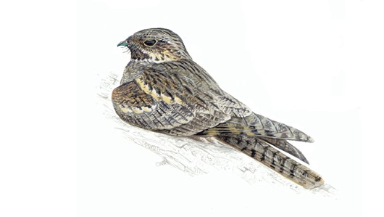
Figure 1: Physical Appearance of C.europaeus

Source: RSPB (2012b)
The male C. europaeus has distinctive white markings upon the base of its feathers along the wings and tail, these are distinguishing feature that help to differentiate between the male and female, this is indicated in Figure 2. As the Forestry Commission (2012) discuss, the female has only brown markings whereby the male is much more visible, particularly at night time when they can be seen perching on trees performing a prolonged churring call which can last several minutes.
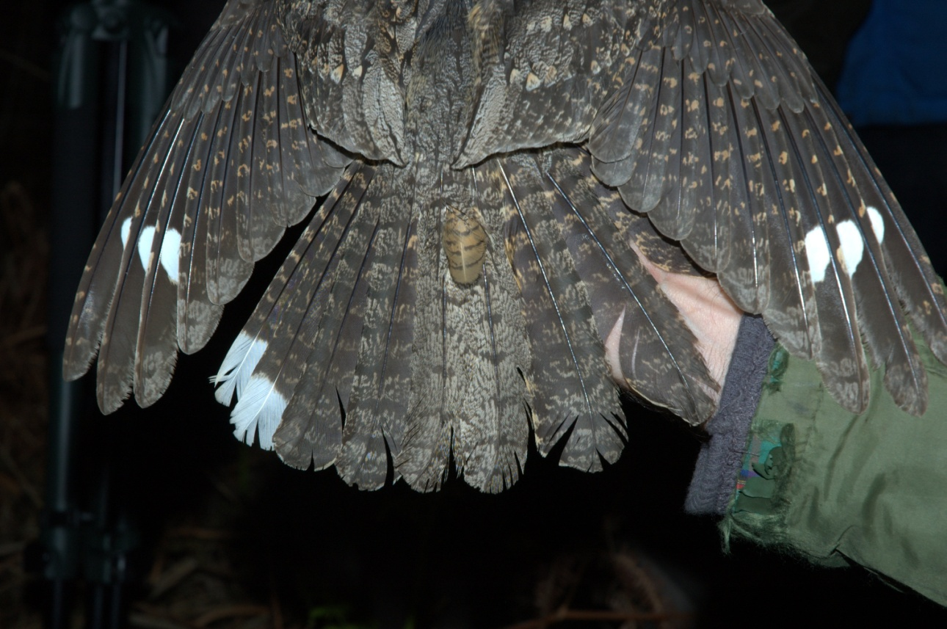
Figure 2: Adult male C. europaeus with distinguishing white markings.

Source: Dolan (2012)
C. europaeus usually start breeding once they reach one year of age, they produce two eggs within a clutch and then proceed to start a second brood once the first nest has successfully hatched (BTO, 2013). They are also territorial therefore a second nest upon one site will always be that of the original pair (Stewart, 2012a). The incubation period is around eighteen days, where from each nest between one and two birds will survive to reach fledgling stage. Young C. europaeus take roughly eighteen days to reach fledgling stage from hatching, where they will live to be around four years old (BTO, 2013).
C. europaeus nests, also known as ‘scrapes’ are not typical of a nest built by birds as they do not physically collect material to construct one. C. europaeus nests consist of flat areas of ground which may be surrounded by small fragments of leaf litter; the female will incubate her eggs and raise the chicks upon this (Dolman, 2010).

2.2.3 Behaviour
C. europaeus have an extremely large breeding range across Europe and indeed further afield into areas across Asia. C. europaeus are in fact native to areas in the west, south and east of the African continent where they spend the majority of the year living (Bird Life International, 2013). The global distribution of C. europaeus is indicated in Figure 3 where the dark blue represents native breeding distribution and the light blue represents the native non breeding distribution of the species.
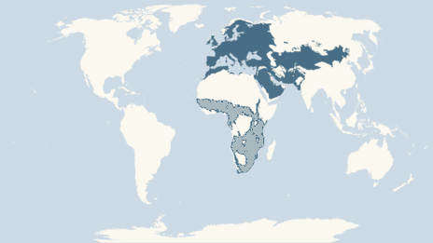
Figure 3: Global distribution of C. europaeus
Source: BBC (2013)
As show in Figure 4, an individual C. europaeus was tracked where a large distance throughout the year was covered, with orange ellipses indicating autumn migration locations. The blue ellipses indicate winter locations and yellow indicates spring locations. The solid lines present show actual routes of movement whereby the broken lines indicate likely routes of movement of the individual. The birds therefore travel a long distance in order to return to the UK to breed.

Figure 4: Individual C. europaeus tracked movement
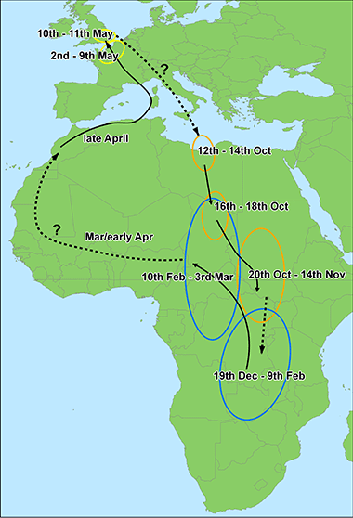

Source: BTO (2012a)
2.2.4 Diet
The diet of C. europaeus consists mainly of moths, whereby during their arrival to the UK the moth population is normally very high (Forestry Commission, 2012). As examined by the BTO (2012b) the year of 2012 was very poor for the moth population due to the heavy rainfall experienced; this had an influence upon birds which fed upon them resulting in species such as the Blue Tit and Great Tit having poor results in terms of chicks reaching fledgling stage.

2.2.5 Natural Predators
Across the UK the number of predators of birds has increased over the last few decades, with factors such as recovery from widespread pesticide pollution and a reduction in human persecution being factors involved in the increase (RSPB, 2007). However, with an increase in predators there has thought to be an increase in predation on birds in the UK (RSPB, 2007).
Breeding Lapwings in the UK have declined in numbers over the last few decades (Baillie et al, 2005). This is thought to be down to factors such as changing farming methods such as land drainage (Chamberlain et al, 2000). Therefore, due to this decline and habitat contraction Lapwings are believed to be more vulnerable to predation.
Predation is an issue which is addressed by wildlife managers, where the removal or exclusion of predators can be carried out. Predator removal in the past has led to an increase in breeding numbers of ground nesting birds (RSPB, 2007).
As examined by Thompson et al (1994), across a four year study in the north of England both adults and young Lapwings were more likely to return to areas to breed where there were higher numbers of gamekeepers; areas such as Teesdale was an example of this. In comparison, Eden Valley in Cumbria had less gamekeepers present therefore the Lapwings were much less likely to return. As Thompson et al (1994) further states, the Teesdale population of Lapwings remained stable across the four year study period, whereas the population halved in Eden Valley as predators were more abundant.
As the Forestry Commission (2012) discuss, there are threats to C. europaeus, with some generally thought to be more prominent than others. The impacts of predation on the species by stoats, foxes, adders and magpies do not appear to be very damaging to successful breeding populations; however predation on small local populations can be devastating as just one event that leads to predation is enough to ensure that nesting attempt fails (Langston et al, 2007a).
As Langston et al (2007a) examines, video recordings taken from C. europaeus nests on the Dorset Heathlands during 2003 recorded incidents of nest flushing by humans and dogs on several occasions. In one of these incidents once the adult C. europaeus had been flushed from the nest a Carrion Crow predated the nest within 20 seconds of the incubating parent leaving; this is indicated in Figure 5. It is was also noted that C. europaeus nests on the Dorset Heathlands were more likely to be predated if they were located in areas of short vegetation (Langston et al, 2007a).
Figure 5: C. europaeus nest predation by Crow.
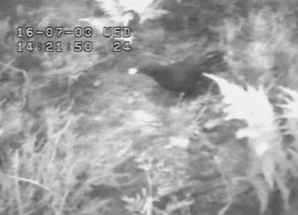

Source: Langston et al (2007a)
2.3 Nightjars in the UK
2.3.1 Current UK Legislation
C. europaeus are currently protected across the UK under the Wildlife and Countryside Act 1981 where as discussed by the RSPB (2012a) The Wildlife and Countryside Act is a key piece of government legislation which protects animals, plants and habitats within the UK.
The Act provides basic protection whereby law protects all birds, eggs and their nests; therefore it is an offence to:
- Intentionally take, damage or destroy the nest of any bird whilst it is currently being built or whilst it is in use.
- Intentionally take or destroy the eggs of any wild bird.
- Use traps or similar items to kill, injure or take wild birds.
- Intentionally or recklessly disturb wild birds whilst they are nest building, nesting, or when young dependant chicks are present.
As well as this, C. europaeus are a Red List species under the BoCC review of 2009, and also a priority species under the UK Biodiversity Action Plan (Wildlife Trust, n.d).
2.3.2 UK Distribution
C. europaeus arrive in the UK between late April to early June and as indicated in Figure 6 the species has a widespread distribution across England, Wales and parts of south west Scotland. Larger populations are found in the south of England where C. europaeus have a variety of habitats in which they can be found, these consist of open woodland, moorland, heathland and more recently, felled conifer plantations (RSPB, 2012b).
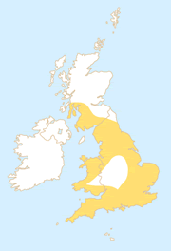
Figure 6: UK distribution of C. europaeus

Source: RSPB (2012b)
2.3.3 Decline in the UK
Historically C. europaeus have declined in numbers across the UK, with population numbers being monitored over time through the use of surveys. As the BTO (2012a) discuss, in just over thirty years there has been a 36% increase seen in the UK population of the species. During the National Nightjar Survey (NNS) of 1981 the UK population of C. europaeus was estimated at just 2,010 churring males (Langston et al, 2007b).
The NNS of 1992 recorded an increase in number of C. europaeus males which was more than double that of the 1981 NNS, of which an estimated 3,400 churring males were recorded. The most recent NNS of 2004 recorded an estimated 4,606 churring males, showing a further increase in the UK population size (Langston et al, 2007b). As shown in Figure 7, C. europaeus are more abundant in the south of England compared to the rest of the UK.
Figure 7: The relative abundance and distribution of C. europaeus in the UK in 2004

Source: Conway et al (2007)
As discussed by the BTO (2008), trends in C. europaeus breeding productivity have over the last forty years decreased with nest failures increasing both at the egg and chick stage. This could be down to changes in the use of suitable habitat in the UK as recreational activities by humans may be influencing nest success rates (Cross et al, 2007).
2.3.4 Habitat Loss
As the number of people across the world increases the demand placed upon the world’s natural resources also increases. Land is widely used for agriculture and housing, therefore replacing the natural vegetation that was once present; this reduces the amount of habitat that was once in place for a wide variety of species (Chapman and Reiss, 2009). As discussed by Hannah et al (1994), it is difficult to fully comprehend the impacts that human disturbance has had upon wildlife across the globe. It is now hard to find any examples across the world where humans have not had an influence upon species or the delicate balances of ecosystems by which new introductions of new species, pollution and disturbance have had a negative impact (Hannah, et al 1994).
As Chapman and Reiss (2009) state, the cultivation of natural ecosystems, increased industry and aggressive farming now pose a substantial threat to local and global biodiversity. A reduction in habitat not only reduces the amount of space available for species, it also reduces the species richness of the habitat.
As discussed by Farrell (1993), across the UK there have been substantial losses of semi natural habitats such as heathland and deciduous woodland due to an increase in urban development. Heathland loss as discussed by Moore (1962) has been mostly documented on the Dorset Heathlands where by 1960 the area had lost 28% of its heathland to agricultural purposes and 23% to urban development.
C. europaeus forage over a wide distance from their nesting areas of which this can cover a wide range of habitat depending on the availability of food (Ravenscroft, 1989). Therefore, as Langston et al (2007b) examines, a change in habitat or indeed habitat loss is likely to be detrimental to C. europaeus.
The loss of habitat is of concern for C. europaeus however, due to better management of public forests the population numbers appear to be improving. The Forestry Commission locate and identify the species so that felling can be carried out in order to plant new trees. This process provides a source of food and a suitable habitat for the birds, of which they seem to favour as 50% of the UK population of C. europaeus nests are in felled woodland (Forestry Commission, 2012). As Gibbons et al (1993) states, newly felled plantations and those of which are up to five years old after replanting hold the highest density of C. europaeus populations, with these numbers declining each year up to seventeen years later. In 2004, 57% of the UK’s population of C. europaeus were associated with conifer plantations (Conway et al, 2007).
In 1978, management of lowland heathland and woodland began at Minsmere RSPB reserve in Suffolk, where intentions were to increase the number of breeding C. europaeus. Management methods included the provision of potential nesting sites by clearing small areas of heather at the base of trees, as well as creating glades in woodland and lengthening woodlands edge habitat (Burgess et al, 1989). The results of these methods led to an increase in C. europaeus from 8 churring males to 23, suggesting that habitat improvement through conservation methods helped to improve the status of the species.
Restoration of heathland is important for C. europaeus as it is the natural habitat in which the species is found. As discussed by Bright et al (2007), there has been extensive management on heathland sites in recent years across the UK, particularly across areas of Dorset. The removal of dense scrub and pine cover has allowed areas of heathland to be opened up and restored, whereby as Lake (2004) examines, the sites that have been restored have seen an increase in the numbers of C. europaeus between 1994 and 2004.
The original habitat of C. europaeus appears to be gradually changing; questions have to be asked as to why this is happening. The loss of habitat may be one, as heathlands have a great deal of pressure upon them from urban development and large human populations (Liley and Clark, 2003). Both the factors of development and human populations close to heathland areas may be forcing C. europaeus to adapt to different habitats such as felled forest areas.
2.3.5 Human Influence
The human race as discussed by Hunter (2007) has had a negative impact upon biodiversity. From the destruction of habitats due to wide scale agricultural processes, to pollution caused through industrial activity biodiversity has been damaged (Hunter, 2007).
The increase in humans has inevitably led to a loss in habitat for a number of species across the world, not just C. europaeus. However, human activities do not just include industry and agricultural as there are also recreational activities which have an impact upon many wildlife species (Cross et al, 2007).
Upon a recreational site there will be a variation in visitor numbers on a day to day basis. The amount of dogs, walkers and other recreational visitors at a location will depend on how popular the location is, as well the time of day, day of the week and indeed season also being a factor in visitor numbers (Cross et al, 2007).
Disturbance of ground nesting birds by dogs can be an issue, where as shown in Figure 8, a Springer Spaniel dog disturbs a C. europaeus on its nest, which results in the bird being flushed. The same dogs on two separate occasion’s returns to the nest when eggs are present and once the chicks have hatched. It is noted that the nest was successful however, the issue with this type of disturbance is that whilst the parent bird is away from the nest it leaves the nest unprotected and vulnerable to predation during the daytime (Langston et al, 2007a).
From the RSPB study carried out on the Dorset heathland it is suggested that C. europaeus nests which were located in areas with higher levels of recreational activity such as dog walking were subjected to greater levels of disturbance, with the disturbance primarily being caused by dogs (Langston et al, 2007b).
Human disturbance of nest sites can be detrimental to the success of a particular nest as repeated disturbance as discussed by Leseberg et al (2000) can result in reduced productivity or even total abandonment of the nest. However, even though it has been suggested that human disturbance can cause temporary changes in behaviour of the birds Nisbet (2000) argues that disturbance by humans such as walking to a nest and then returning is not deemed to have an adverse affect on the breeding success of ground nesting birds.
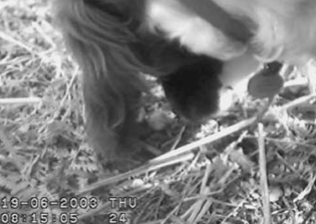
Figure 8: Nightjar nest disturbance by dog

Source: Langston et al (2007a)
2.4 Climate Change and Extreme Weather Events
Climate change and extreme weather events are linked, with both having impacts upon wildlife.
2.4.1 Climate Change Impacts on Wildlife
Climate change is thought to be having an impact on species and ecosystems across the world (Root et al, 2003). These impacts range from changes in species distribution, reductions in population size, direct loss of habitat through changes in sea level and increases in forest fires. Furthermore climate change is leading to the increased spread of invasive and non native species such as plants, animals and pathogens (Mawdsley et al, 2009). These changes can have impacts upon species native to a country along with changing the behaviour of migratory species.
2.4.2 Climate Change Impacts on Ground Nesting Birds
The factor of climate change having an impact upon ground nesting birds such as C. europaeus needs to be considered. As discussed by Crick (2004), weather can influence the foraging conditions for birds as well as the ability to carry out courtship behaviour. Climate change is an ever increasing issue within today’s society; with there already being evidence to suggest that climate change is having an impact on bird species. These impacts range from population distribution to breeding performance that can impact upon egg size and overall nesting success such as the Dartford Warbler (Walther et al, 2000, Parmesan and Yohe, 2003).
2.4.3 Rainfall
The spring and summer of 2012 experienced high amounts of rainfall compared to previous years. As discussed by the BTO (2012b), the Met Office records show that rainfall for across England and Wales was at an all time high with the month of April having four times the average rainfall and the month of June experiencing twice the amount; this is indicated in Figure 9.
Figure 9: England and Wales precipitation

Source: BTO (2012b) England and Wales monthly precipitation indicated as a solid line for 2012 and mean monthly precipitation for 2007-2011; indicated as a dashed line.
As indicated in Figure 9, between February and March 2012 conditions were drier than average, which allowed early resident breeding birds such as the Tawny Owl to nest earlier. However, for migratory species returning to the UK they had to experience severe weather systems across Europe, and once they arrived to the UK they were faced with wet and cold weather (BTO, 2012b). As a result of this the laying rates of the migrant species shown in Table 1 were all delayed, with this being compared to a five year average.
Many of the species shown in Table 1 feed on small insects such as moths and caterpillars which may have been difficult to find during periods of heavy rainfall (BTO, 2012b).
Table 1: Migrant birds for 2012
Species | Laying | Clutch | Brood | Egg stage | Chick stage | Fledglings
Species | date days | size % | size % | survival % | survival % | produced %
Migrants
Swallow | 6.6 | -1.3 | -0.9 | -1.8 | 1.2 | -1.6
Redstart | 4.5 | -0.6 | -4.5 | -2.7 | -1.1 | -8.4
Reed Warbler | 10.7 | -5.6 | -10.2 | -14.3 | -13.1 | -35.8
Blackcap | 4.1 | 0 | -7.3 | -16.8 | -5.7 | -31.8
Whitethroat | 15.4 | -3.4 | -8.7 | -0.1 | -23.4 | -35.8
Chiffchaff | 2.4 | -4.8 | -2 | -16.2 | -4.6 | -25.8
Willow Warbler | 4.3 | -0.5 | -1.3 | -0.3 | 1.6 | 0.5
Pied Flycatcher | 5.1 | -3 | 0.5 | -1.8 | -1 | -2.5
Source: BTO (2012b)
Table 1 shows the productivity for 25 species relative for the previous five years. The laying dates are provided as a number of days earlier or later than the five year average with any negative changes highlighted in red.
2.5 Cannock Chase
Situated in the West Midlands, Cannock Chase (CC) was designated an AONB in 1958, with the areas scenery, wildlife and history being deciding factors. The AONB has vast areas of woodland and forest, as well as providing the largest area in the midlands of lowland heathland habitat. Wild deer such as Red Deer, Fallow Deer and Muntjac Deer are present in the area, in which the Red Deer are thought to descend from the original heard hunted during royal medieval hunting expeditions (Cannock Chase AONB, n.d).
The AONBs wetlands, woodlands and heathland habitats are classified as Sites of Specific Scientific Interest (SSSIs), as they provide valuable habitats for invertebrates, along with increasingly rare vertebrate species such as the Nightjar and Adder (Natural England, n.d). Across England there are over 4,000 SSSIs, covering an estimated 8% of the country (Defra, 2011). SSSIs aim to conserve and protect wildlife, geology and cultural heritage for the public and future generations. With an area having SSSI status this puts in place legal protection for wildlife under the Wildlife and Countryside Act 1981 (Defra, 2011).
Throughout England, Wales and Northern Ireland there are 46 AONBs, with CC indicated in Figure 10 being the smallest spanning 26 miles across the county of Staffordshire (Landscapes for Life, 2013).
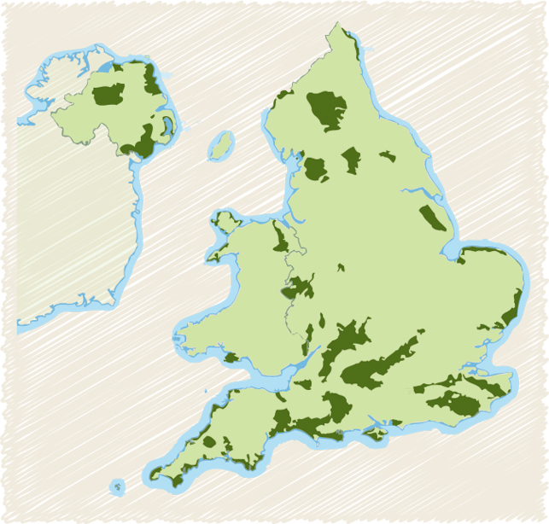
Figure 10: The location of Cannock Chase AONB in respect to AONBs across England, Wales and Northern Ireland.

Cannock Chase AONB

Source: Landscapes for Life (2013)
The boundary of CC AONB is indicated in Figure 11, whereby the area is surrounded by urban development, this includes major road networks.
Figure 11: Cannock Chase AONB Boundary
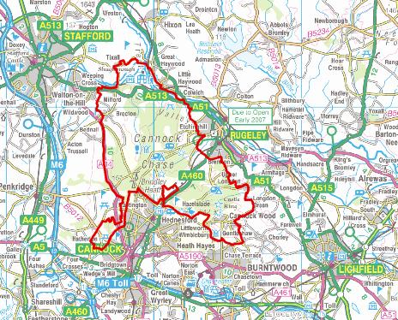
Source: Cannock Chase AONB (2007)
Upon CC recent habitat management has reduced the issue of widespread bracken, which has led to the restoration of heather heathland (Red Kite Environment, 2010). There are a number of habitats available on CC providing nesting and feeding sites for many species of birds, particularly rare species such as the Nightjar, Woodlark and the Dartford Warbler.
The breeding bird census carried out in 2007 reported that a total number of 45 species of birds were actively breeding on CC with declines, increases and newly recorded breeding activity being compared to the breeding survey carried out in 2009 (Red Kite Environment, 2010).
Population increases were found within the Buzzard, Raven, Woodlark and the Grey Wagtail whereas declining populations were found amongst species such as the Nightjar, Tree Pipit, Lapwing and the Lesser Spotted Woodpecker (Red Kite Environment, 2010). As well as this new breeding recordings of the Dartford Warbler, Barn Owl, Yellow Wagtail, Stock Dove and the Blackcap were recorded (Red Kite Environment, 2010).
Generally the population of bird numbers on CC do fluctuate, with species such as the Woodlark responding to the management practices that have been carried out in the past. Nightjars however are thought to be on the decline due to an increase in recreational activities, however, climate change may be forcing the species further north (Red Kite Environment, 2010).
2.5.1 Nightjars on Cannock Chase
In terms of C. europaeus being present upon CC, there is research to suggest that their numbers may be quite high, with the NNS of 2004 recording an increase in C. europaeus in Staffordshire. A total of 29 males were recorded in the NNS of 1992, with this figure rising to 66 in 2004 (BTO, 2009).
2.6 Bird Surveying Techniques.
In order to record bird numbers and the success of nests there are a number of methods that can be used.
2.6.1 Territory Mapping Methods
Many species of birds are territorial, particularly during the breeding season, with territories often marked by song, display and disputes with neighbouring birds (Bibby et al, 1993). However, areas of habitat are not always suitable therefore there are often areas where no territories are present. As Bibby et al (1993) discusses, in these instances mapped registrations of birds should fall into clusters approximately coinciding with territories. Where the territories are close to one another the mapping of singing birds presumed to be in their own range is important. Therefore the mapping approach depends on locating all of the signs of birds across a number of visits and then using the information gained to estimate locations and numbers of territories present (Bibby et al, 1993)

2.6.2 Point Counts
As examined by the United States geological Survey (USGS, 2013), point counts are another method used in order to study bird population densities in local areas, as well as population trends in individual species over time; habitat preference of a particular species can also be calculated from this method.
A point count also known as a circular plot survey involves a series of points at which bird species and numbers are counted during a set period of time, usually no longer than 20 minutes. The point stations are set with a sufficient distance between them in order to reduce the possibility of the same individual bird being counted (USGS, 2013).
2.6.3 Catching and Marking
A method widely used in order to measure populations of species is that of mark, release and recapture. Species that are small such as insects and mammals are often difficult to count therefore population numbers of such species are hard to establish. Due to the difficulty in this population estimates are made through what is known as the Lincoln Index (Chapman and Reiss, 2009).
The method is carried out through capturing a number of individuals which are then marked so that they can be recognised again if they are recaptured after the initial release. The original marked individuals may be recaptured whereby the proportion of marked to unmarked individuals can then be calculated to estimate the population size through the following equation (Chapman and Reiss, 2009).
N= CM
R
Whereby N refers to the whole population, C is the number of individuals captured, M is the number of individuals marked and R is the number of individuals released.
2.6.4 Counting Individual Species
There are generally three different methods for counting individual species, with these being direct and indirect counting, along with look-see counting (Bibby et al, 1993). Direct counting involves the counting of all visible birds from a suitable vantage point whereby the birds are easily distinguished; for example waders breeding on a small island (Bibby et al, 1993). Factors can influence the results of this method which may impact upon the quality of the results. As Bibby et al (1993) examines accuracy can be affected by those undertaking counts with the naked eye or with binoculars.
Indirect counting differs from direct as it relies upon counting signs of bird activity such as droppings, this however may only be useful where species live in burrows (Bibby et al, 1993). An example of this would be that of the Manx Shearwater whereby on the Island of Rum in the Inner Hebrides of Scotland they make their burrows in order to raise their young (Butt, 2012). It can however be argued that the number of droppings only indicates bird usage rather than population numbers (Owen, 1971).
The last method used is that of look-see whereby the method requires knowledge of a particular species preferential habitat. Once this is established site visits over a set period of time can be carried out; however the results can be biased as effort can vary over time (Bibby et al, 1993).
2.6.5 The Nest Record Scheme
The Nest Record Scheme (NRS) funded by the BTO and the Joint Nature Conservation Committee (JNCC) gathers important information on the success of Britain’s birds (BTO, n.d). The data gathered from the NRS is used to produce trends in breeding performance of many birds across the country where this helps to identify any declines in individual species. Factors such as climate change are also monitored to see if there is an impact upon bird species (BTO, n.d).
Volunteers taking part in the NRS may observe single nests in their own gardens at home or they may indeed spend time in the countryside searching for nests and monitoring them (BTO, n.d). However, it is pivotal that the welfare of birds is put first therefore a code of conduct has been set which is designed to ensure nest monitoring does not influence the outcome of nests (see appendices).
2.6.6 Ringing
The method of ringing birds is used in order to establish how long birds live for and when and where they move around the country or indeed the globe, with the main focus being to carry out monitoring of populations; this is vital for bird conservation (BTO, n.d).
Birds can either be ringed in the nest whilst they are still young or they can be ringed after they have been captured; an example of this can be through the use of mist nets where birds are caught with nets and then taken out to weigh and then ring (Bibby et al, 1993). By attaching a small coloured metal or plastic ring with a unique code upon it around the leg of a bird, this allows an individual to be studied and tracked upon recovery. Recovery of a ringed bird can provide information on that particular individual in terms of changes in size, feeding behaviour, migration pattern, longevity and indeed mortality (Cottam, 1956).
2.6.7 Netting
As Natural England (2011) discuss, netting is a technique used in order to catch birds and bats in flight worldwide. Mist nets are made up of fine material that is black in colour making the net inconspicuous to birds. Mist nets are erected in areas where the target species is known to be present so that they can be readily intercepted into the nets (Natural England, 2011).
Mist nets should be held between two poles, where it should be tightly stretched across the given flight path. Once in place the area should be vacated, however, the net needs to be checked regularly every ten minutes for any birds caught within the net (Stewart, 2012b). Whilst birds are within the net or whilst being handled they are protected under the Animal and Welfare Act 2006, whereby it is an offence to cause any unnecessary suffering to the birds (Natural England, 2011). Birds should not be held by only the head, legs, wings or tail as this can cause pain and injury. Once the birds have been examined they should then be released back in the location in which they were found (Natural England, 2011).
2.7 Nightjar Surveying Techniques
Past research carried out on C. europaeus and in particular the locating and monitoring of their nests has involved the use of digital cameras and radio tracking devices. The methods of netting and ringing are also carried out.
2.7.1 Digital Cameras
A study carried out within the Breckland Forest in Norfolk looked at the disturbance and nest predation on Woodlarks and C. europaeus. In order to monitor any nests found during the research carried out infrared cameras with motion sensor technology were set up around nest locations. Digital cameras helped to confirm fledgling success and indeed any disturbance or predation that may have occurred at individual nest locations (Dolman, 2010).
Cameras were linked with waterproof cables to the digital recording units in order to prevent water damage. The equipment was placed up to 10m away from the nest site in order to help reduce disturbance to the nests when battery changes were made or whilst general maintenance was carried out (Dolman, 2010).
Throughout the two year study the use of cameras were able to pick up many of the causes of failure for C. europaeus nests, with predation being the main factor. The instances of predation where the predator was identifiable were found to be down to mammals, whereby 46% of predated nests were caused by badgers, 31% by foxes with the remaining 23% of predation being caused by weasels, hedgehogs and fallow deer (Dolman, 2010).
2.7.2 Radio Tracking
Nest locating can take a considerable amount of time as it is often carried out through observing the activity of adult C. europaeus, therefore their night time activity may indicate that a nest may be in the vicinity of where they are found. (Cross et al, 2007). Not only do these initial observations take time, the ground surveys carried out also require a large effort from surveyors. Therefore, radio tracking devices can be extremely useful as tagged adults can then be located on different occasions where the female C. europaeus who incubates on the nest during the day will be located at the nesting site (Cross et al, 2007).

Chapter 3: Methodology
In order to investigate the number of breeding C. europaeus on CC, a physical ground survey was carried out across twelve locations across the area between June and August 2012. The physical ground survey followed a particular method, which was taught and explained by Jim Stewart, a Wildlife Ranger from the Forestry Commission based upon CC. A second member of the Forestry Commission Tim Jobling was also often present, along with a volunteer Katy Bridge.
During the physical ground survey the terrain could often be slippery due to rainfall, as well as this it could be steep in parts, therefore appropriate footwear was required. Along with this, the majority of locations had brambles and nettles of which could pose as a risk to surveyors therefore clothing that was old and protective was necessary as the brambles were very sharp and often did cause scratches to those taking part.
3.1 Physical Ground Survey Method
The method used to find C. europaeus upon areas on CC involved surveyors walking through woodland and open heathland areas which were selected by Jim Stewart. These areas were selected due to past information providing the knowledge that the species had nested in the areas in previous years. The method was systematic whereby the same approach was carried out at each location. It is worth noting that the locations did vary in terms of the type of vegetation cover, therefore the physical ground survey did vary slightly in how it was conducted, the principal however remained the same.
In areas where trees had been planted after felling had taken place there were clear visible rows, whereby the trees had been planted in formation; this could be easily seen from the edge of the locations surveyed; this is shown in Figure 12.

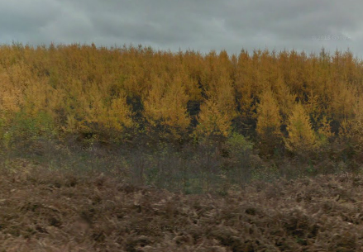
Figure 12: Tree rows visible on Cannock Chase

Source: Adapted from Google Maps (2013)
In order to search for C. europaeus nests in these types of environments surveyors would walk between the trees whereby if any nesting C. europaeus were present they would be flushed from the nest. At this point the search of the area would cease so that Jim Stewart could assess the nest for either eggs or young chicks. Once the nest had been found and recorded the location would be marked so that at a later date the nest could be located and returned to in order to see if any further developments had occurred. A simple mark such as taking leaves off the top of a tree or putting marks into the ground were used so that to a member of the public they would not appear out of the ordinary.
Once the location had been recorded a new area could then be searched as due to the nature of C. europaeus being territorial there would be no other nests or pairs of C. europaeus at that location (Stewart, 2012a).
As show in Figure 13 the areas could be quite dense and therefore this made the searches much harder in comparison to areas where the vegetation was at a lower height.
Figure 13: C. europaeus physical ground survey through pine woodland at site 12
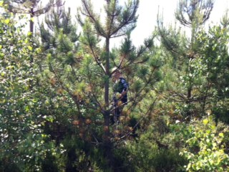
Areas where the vegetation cover was less dense such as those shown in Figure 14 were generally easier to survey as surveyors could access the areas much more easily. This generally applied to areas where heathland was being surveyed or where young conifer plantations were growing as the trees were low. There is a contrast between Figure 13 and Figure 14 where the vegetation cover is denser where the trees are taller in Figure 13. In order to search the areas where vegetation cover was low surveyors remained at a distance of 2m apart from one another so that no areas of the ground were missed. Due to the species being well camouflaged they can be easily missed if they are not disturbed as they will stay low upon the nest, therefore it is important that the area is covered thoroughly in order to not miss a nesting bird (Stewart, 2012a).

Figure 14: Low vegetation cover at site 9
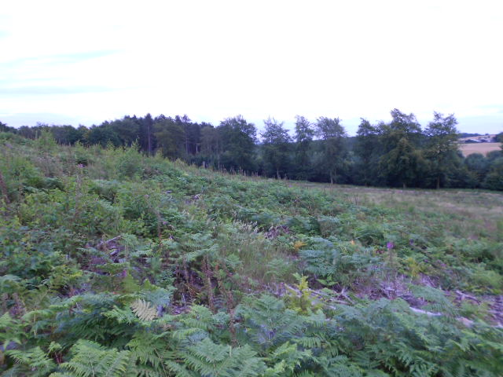
The whole site would be searched for C. europaeus nests with surveyors each having a row of trees designated to them. If no nests had been discovered then the search would continue to the end of the row, of which the next row would be then taken and the search would continue in the opposite direction until the site had been covered.
3.2 Nightjar Nest Monitoring
Monitoring of each nest took place in order to record developments. This was carried out so that a record could be built of the success of individual nests. If a nest had failed then a second search of the area would begin, as C. europaeus would normally have a second brood on the same location within the breeding season. However, if the eggs had hatched the chicks would be ringed and recorded by Jim Stewart once they were old enough; this was carried out at roughly one week old. The information from the ringing process would then be passed on to the BTO so that a national record of the individual birds could be held.
3.3 Netting
A second method used throughout the C. europaeus breeding season is netting, by which nets were used to catch adult C. europaeus during the evening as this is when they are most active. The adults were caught so that they could be ringed and recorded as many returning birds to the UK may not have been ringed whilst they were juveniles. Netting offers the opportunity for a detailed history of an individual bird to be made as more data can be added about an individual.
An area was cleared of vegetation so that a large net could be staked into the ground using metal poles, this was surrounded by dense vegetation, see Figure 15.
Figure 15: Net in place for catching C. europaeus
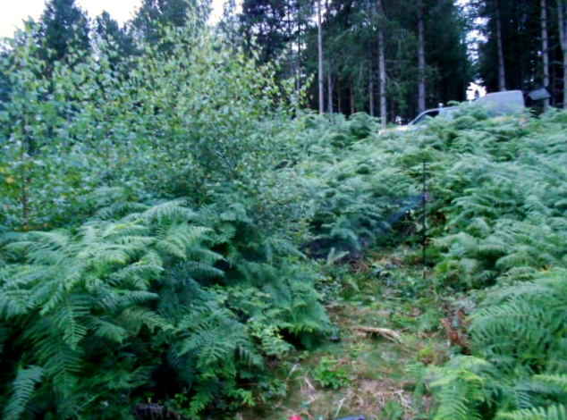
Once the net was in place a recording was played of the call of C. europaeus, with the aim to attract any birds towards the net and therefore into it. After setting up the recording next to the net the area would then be vacated, any surveyors present would have to stand away from the location of the net so that C. europaeus would not be deterred away. The playback of song and flight calls was used to provoke responses from any C. europaeus within the area.
After leaving the call playing for an hour the attempt to catch any birds would be stopped. During that time the net would be checked for any activity on regular intervals, with this being every ten minutes. If a C. europaeus was present within the net it would be carefully removed and then taken away to be checked over.
It is worth noting that this method can result in other bird species becoming caught within the net therefore it should be checked for other species as well as the individual species that the method is aimed at.
Whilst any birds caught in the net were checked by Jim Stewart the features of the bird such as wingspan and weight were recorded, along with any ringing information that was present upon the bird; if not ringed then it would be ringed and recorded for the BTO. This is indicated in Figure 16 where a Tree Pipit was caught in the net, it has then proceeded to be checked over by Jim Stewart.
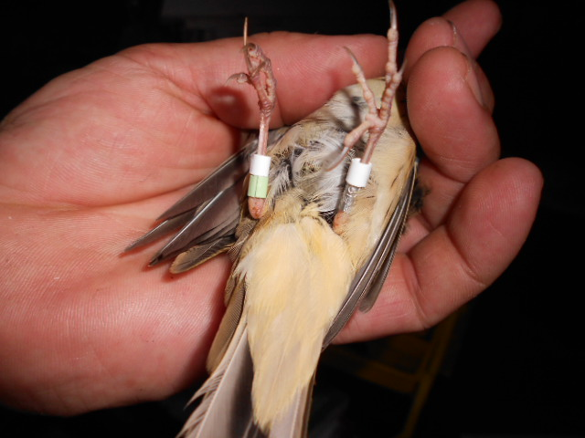
Figure 16: Tree Pipit having been ringed after being taken out of the net

Chapter 4: Results
The following results are from the period between June and August 2012, where C. europaeus nests were found, monitored and recorded. In addition to the data gathering carried out during 2012, additional data from 2010 and 2011 has been provided by Jim Stewart.
4.1 Physical Ground Survey Results
A total number of twelve sites were searched, eight of these yielded results of having C. europaeus nests upon them with eleven nests being found; these are shown in Table 2.
Table 2: Sites visited and dates of Nightjar nests found in 2012
Nest Number | Site Number | Date Found
1 | 1 | 18/06/2012
2 | 1 | 27/07/2012
3 | 2 | 26/06/2012
4 | 3 | 28/06/2012
5 | 3 | 22/07/2012
6 | 4 | 25/06/2012
7 | 5 | 25/06/2012
8 | 5 | 23/07/2012
9 | 6 | 26/06/2012
10 | 7 | 09/07/2012
11 | 8 | 05/07/2012
n/a | 9 | No nest found
n/a | 10 | No nest found
n/a | 11 | No nest found
n/a | 12 | No nest found

In regards to site 11 there was no nest found however a juvenile C.europaeus was witnessed in flight therefore this does imply that there had been a successful nest in this area. Despite searches on sites 9, 10, 11 and 12 there were no nests to be found with weather on occasion having an impact on the site searches, which did result in site 11 not being completely searched.
On a number of sites there was more than one nest found, for example on site 1 there were two broods found from the same pair of C. europaeus.
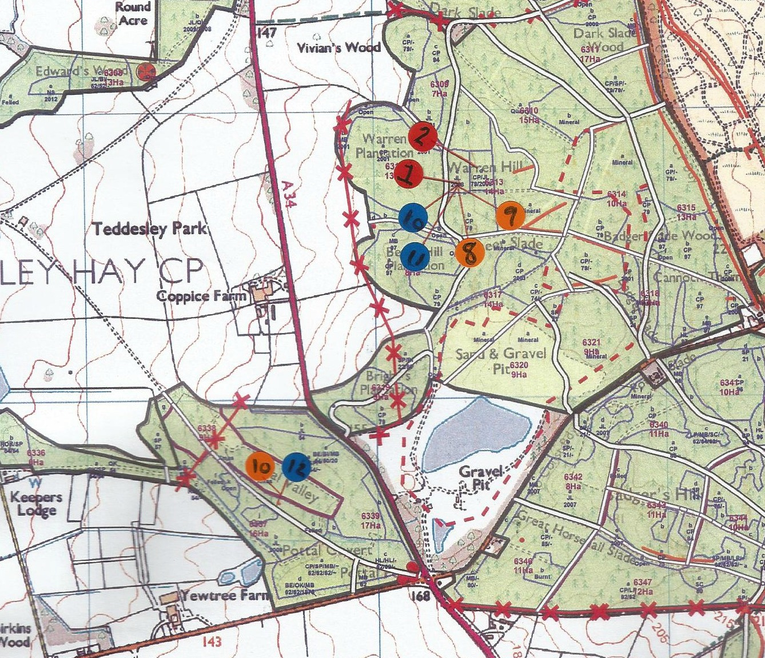
Figure 17: Location of Site 1 where two nests were found in 2012
Source: Stewart (2012c)
As can be shown from Figure 17 a pair of C.europaeus had two broods on site 1 which are indicated as the red dots. C.europaeus nests have been found in the same area during 2011 and 2010, with nests from 2011 indicated as blue dots and nests from 2010 indicated as orange dots.
The remaining site locations for nests found during 2012, 2011 and 2010 upon Cannock Chase can be found within the appendices.
4.2 Nightjar Nest Monitoring Results
Each nest was returned to in order to record further developments where as shown in Figure 18 there was a high rate of nest failure in 2012, 14 out of 22 eggs or chicks failed. The juvenile witnessed in flight has been recorded as it is regarded as a positive result for C. europaeus numbers on CC, even though the nest was not found there would have been a nest present in the area.
Figure 18: Monitoring results from C. europaeus research carried out on Cannock Chase in 2012

It is presumed that the second egg from the nest of which the juvenile in flight was seen had failed as they would have been present together.
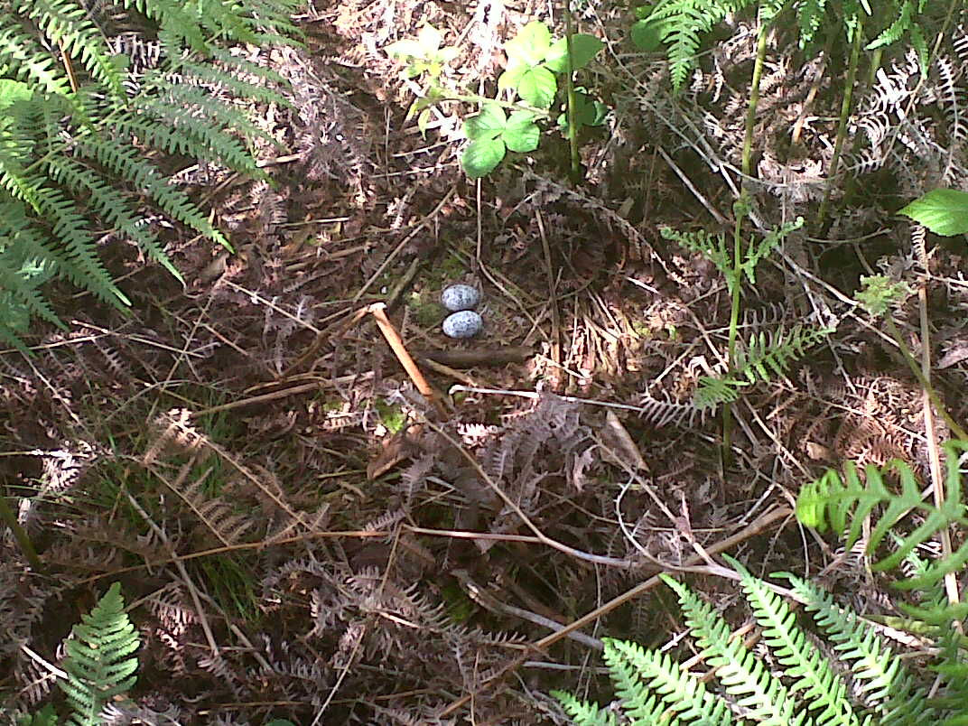
Figure 19: Nest 1 of C. europaeus at site 1

Two eggs are upon that of nest 1, as can be seen there is no physical structure to the nest.
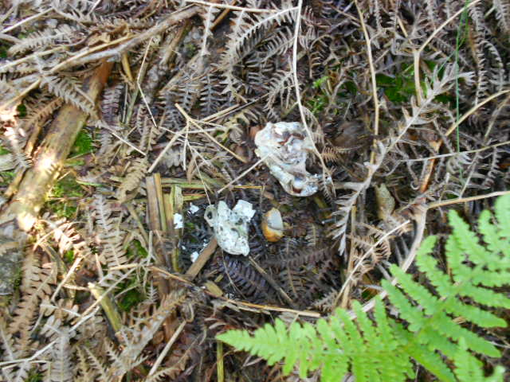
Figure 20: The predated C. europaeus eggs of nest 1 at Site 1

The first occurrence of nest predation was found at site 1
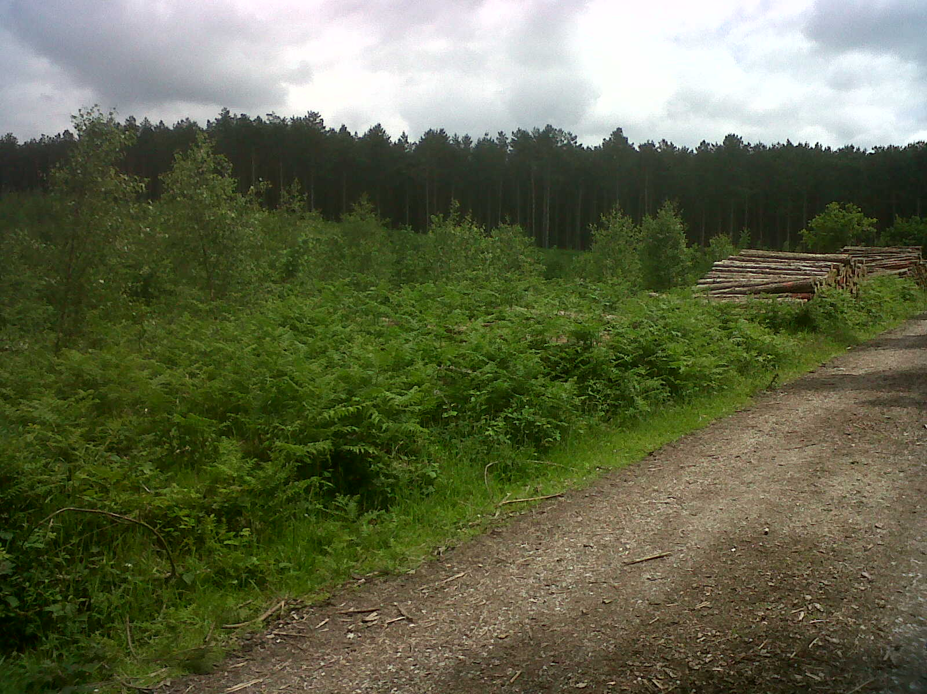
Figure 21: An image of Site 2 where the area is next to a public footpath

Site 2 was relatively close to a public path however the site itself was very dense therefore humans and dogs going off the path was unlikely.
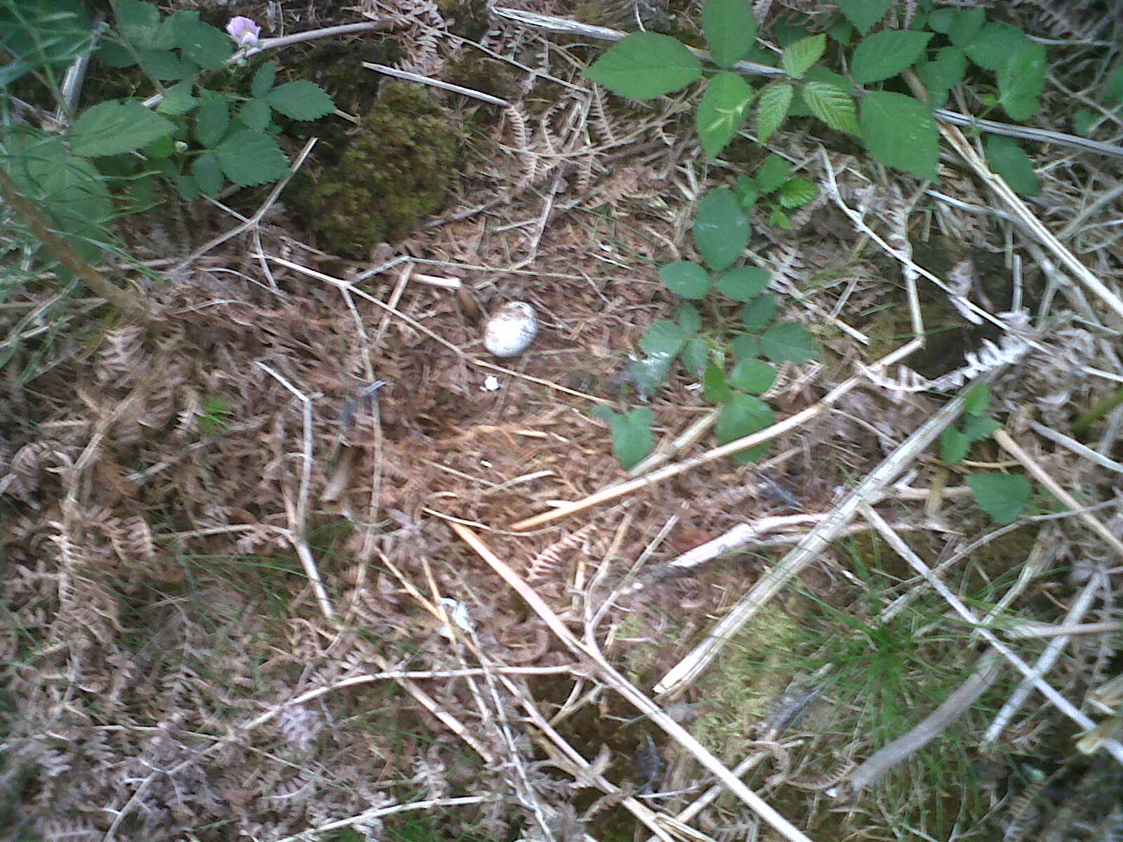
Figure 22: Site 2 where nest 3 had been abandoned

It is unclear as to why the nest in Figure 22 had failed; with the reason being put down to abandonment as there was no sign of distress from the female C. europaeus or any sign of predated eggs. As shown in Figure 22 there was one un-hatched egg at the nest, along with the skeleton of the second chick which is indicated in Figure 23 below.
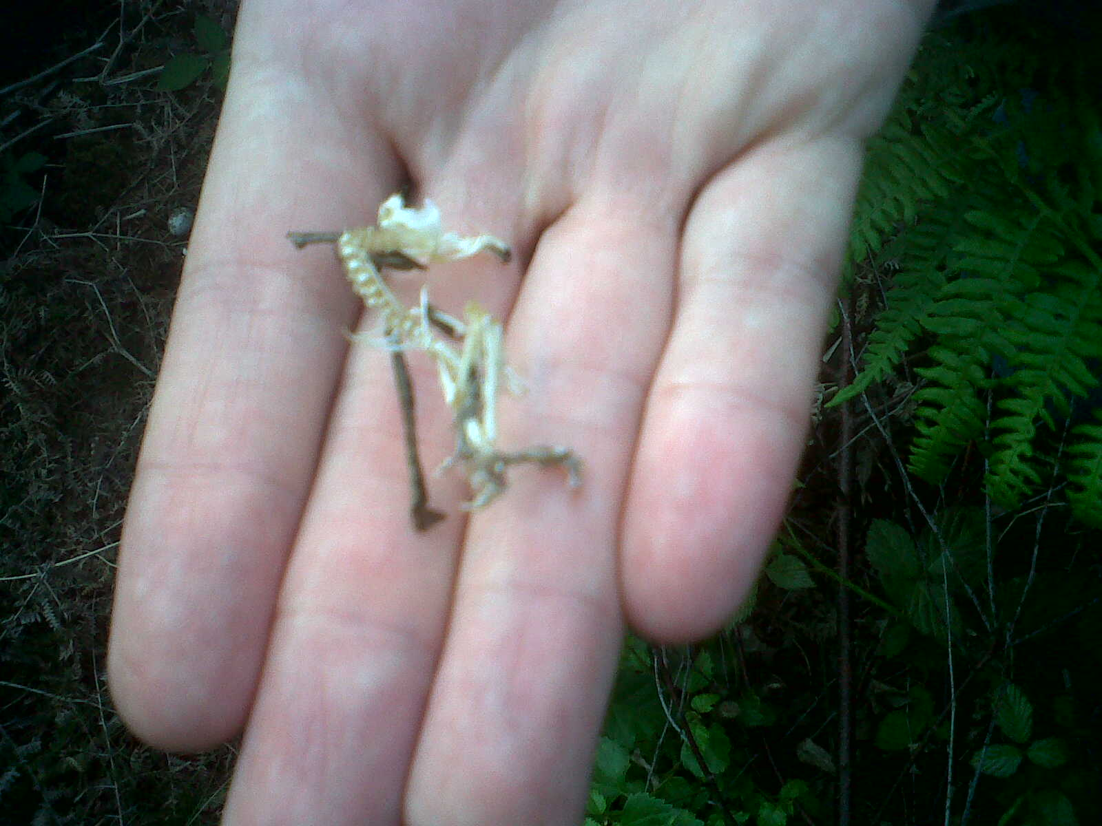
Figure 23: The Skeleton of a chick from the nest at Site 2

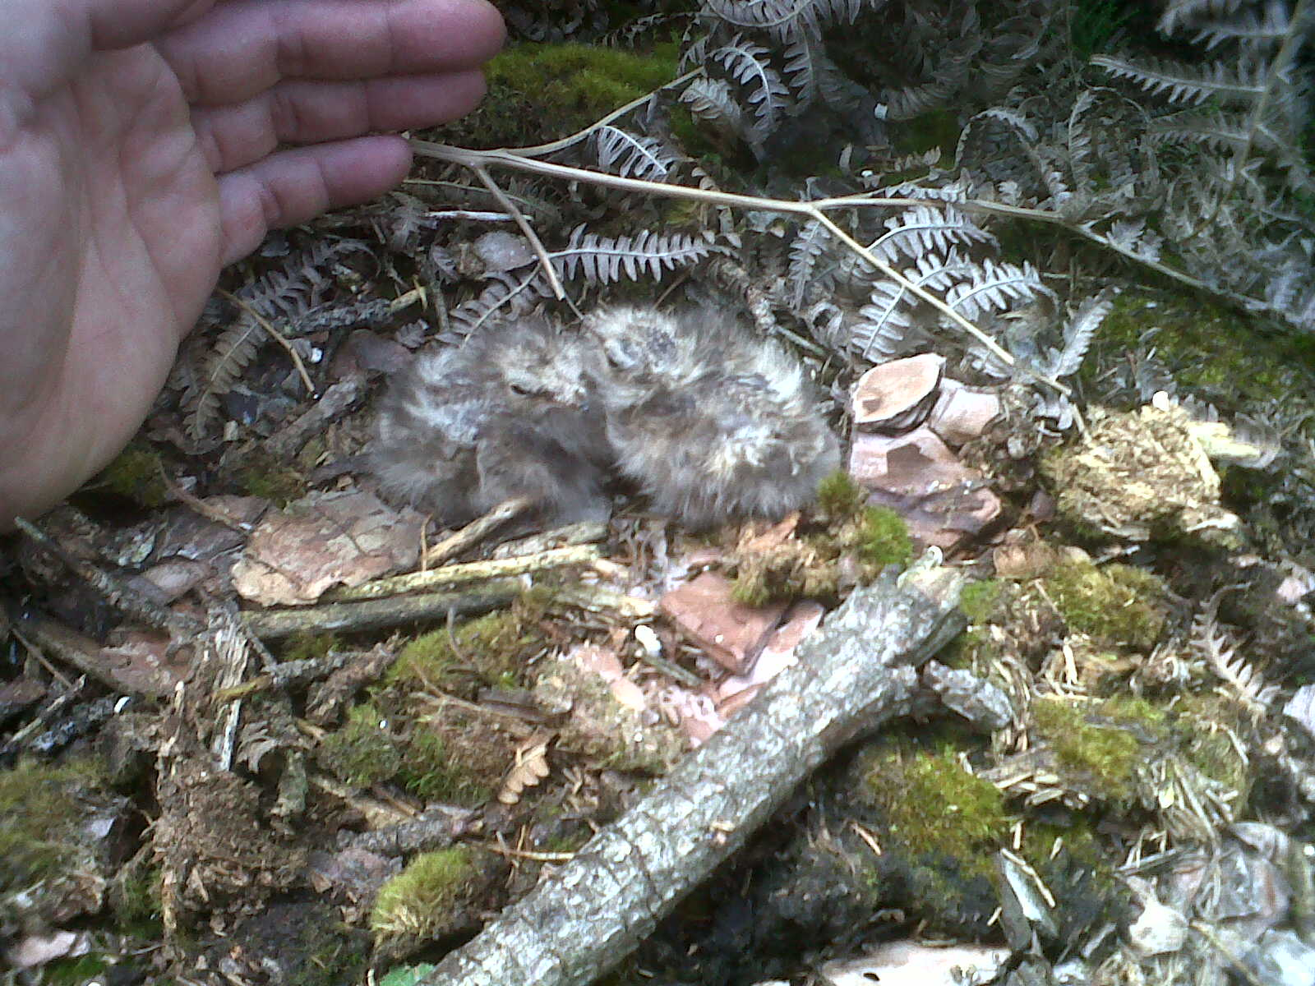
Figure 24: Nest 7 had hatched at site 5 with the young chicks on the nest

The young chicks shown at Site 5 in Figure 24 were thought to be just two days old; therefore they were too young to be ringed at that time. Site 5 was re-visited three days later where the chicks had grown in size; they were more suitable for ringing. As shown in Figure 25 a young chick displays defensive behaviour by opening its mouth wide.
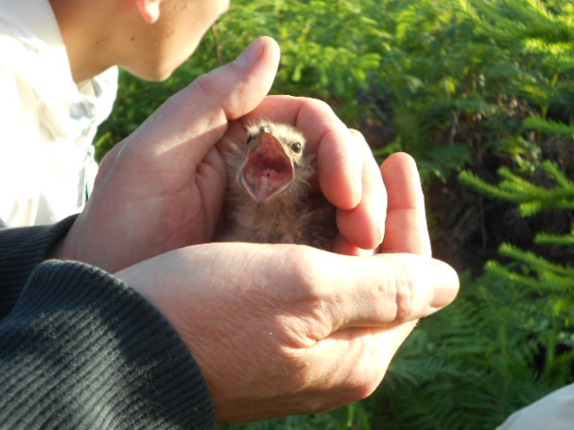
Figure 25: Young chick at site 5

Figure 26 shows the female C. europaeus on this occasion remaining upon the nest until she was disturbed as surveyors were able to get very close to the female on the nest before she was flushed.

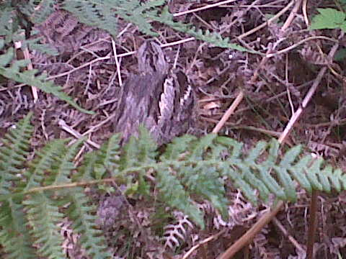
Figure 26: An adult female C. europaeus upon the nest 4 at Site 6

At site 9 there was a nest that held two chicks, see Figure 27 and Figure 28. These were older than the chicks at Site 5 upon first finding them therefore these were ringed on the day.
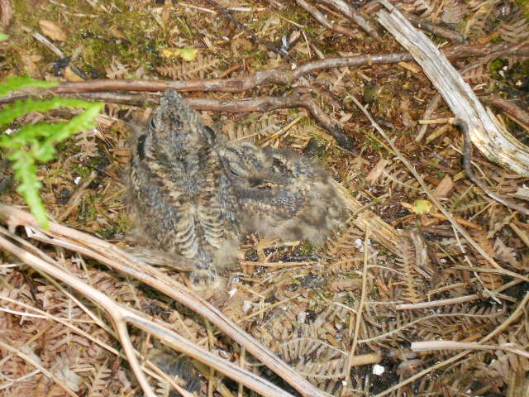
Figure 27: Chicks upon nest 9 at Site 9

Figure 28: Chicks from Site 9
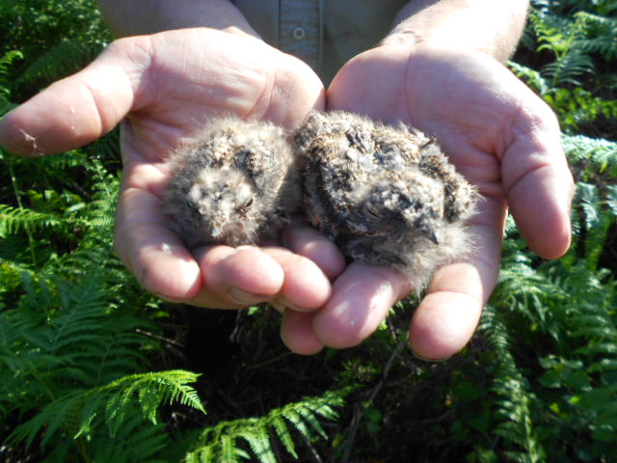

As shown in Figure 29 there was a high percentage of nest failure between June and August 2012 on Cannock Chase, with 64% of nests failing.
Figure 29: The percentage of C. europaeus nest failure and success on Cannock Chase in 2012
The juvenile witnessed in flight has been included within the percentage of chicks that reached ringing stage, as it was a successful individual, despite it not being ringed whilst on the nest.
4.2.1 Secondary data on C. europaeus monitoring carried out on Cannock Chase
Past results have been incorporated into a graph which compares C. europaeus nest numbers on CC between the years of 2010-2012; this is indicated below in Figure 30.
Figure 30: Number of C. europaeus found on Cannock Chase during 2010-2012
Source: Stewart and Keeling (2012)
As can be seen from Figure 30, the total number of nests found between 2010 and 2012 was relatively consistent, whereas the number of chicks ringed was low in 2010 with a peak in numbers during 2011 and a drop off in 2012. The number of nests that failed had increased each year since 2010, with the breeding season of 2012 being the worst of the three years being compared.
The number of juveniles witnessed in flight applies to the 2012 research as there was no data provided for 2010 and 2011.
As indicated in Table 3 there were a total of ten eggs across the eleven nests found that were predated upon. Whereas only two eggs failed to hatch with a third figure being included as this is presumed to be the fate of one egg which was not located
Table 3: Observations found at each nest in 2012

Nest Number | Number of chicks predated | Un-hatched eggs | Number of dead chicks found | Number of chicks ringed
1 | 2 |  | - | -
2 | - | - | -- | 2
3 | - | 1 | 1 | -
4 | 2 | - | - | -
5 | 2 | - | - | -
6 | - | 1 | - | 1
7 | - | - | - | 2
8 | 2 | - | - | -
9 | - | - | - | 2
10 | 2 | - | - | -
11 | - | 1* | - | -

* Nest 11 was not found however only one juvenile was witnessed in flight; it is presumed that the second egg did not hatch. It is unlikely it was predated on as both eggs would have been predated.

4.3 Netting Results
The method of netting yielded one result of a male C. europaeus being caught on the 20/08/2012 at the very end of the breeding season; indicated in Figure 31. During the same evening before the C. europaeus was caught an individual Tree Pipit was also caught in the net, this was a positive result in terms of this species as it is also a red list species (RSPB, 2012c).
The adult male C. europaeus was thought to be just passing through the area as he was not with a female. This adult was already ringed and had been a bird that had been to CC the previous year.
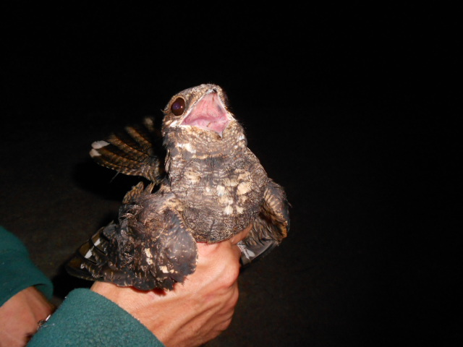
Figure 31: An adult male C. europaeus ready for release

At no stage during the research period were any members of the public encountered upon sites other than the volunteers that took part.

Chapter 5: Discussion
Over three months in the summer of 2012 C. europaeus nests were found and monitored across CC. This section will aim to relate those findings to the original aims set in place. Improvements and failings of the study will be discussed, as well as future recommendations for C. europaeus conservation in the UK and on CC.
5.1 Physical Ground Survey Analysis
The Physical Ground Survey was carried out at each of the twelve sites upon CC. By carrying out this method it allowed surveyors to work towards the aims set out in section 1.2, whereby the current numbers of breeding C. europaeus upon CC were investigated.
Across the twelve locations surveyed there were a total of eleven nests that were found, with a number of these nests being found in the same location. As shown in Table 2 nests found that occurred at the same site such as those at site 1, 3 and 5 indicated that a second brood had been laid by the female from the same pair of C. europaeus on that site of which the first nest belonged to. This is known to be the case because as discussed in section 2.2.2 Stewart (2012a) states how C. europaeus are territorial.
As shown in Table 2 there were only three sites in which a second brood was found, with the dates of these findings being roughly one month apart for each discovery. This time period would allow the first brood to be reared by the adults, allowing them to then proceed to locate another suitable location for the second nest which would be a small distance away from the location of the first nest on the same site (Stewart, 2012a).
In previous research C. europaeus nests have been found through observing the activity of the adults during late evening (Cross et al, 2007), this is discussed in section 2.7.2 however, in this instance this was not carried out as a main method in locating the nests. This is due to the fact that knowledge of the area and of the birds nesting locations was provided by Jim Stewart, as having worked with the birds over a number of years a pattern of their nesting locations was already known. Originally however, this method would have taken place in order to be able to gain the initial knowledge of where C. europaeus nested. For possible new locations for searching for C. europaeus nests in the future the method of observing adult activity would be carried out to save time time as there would be clear indications that C. europaeus was present.
Due to the nature of the fieldwork the time taken on each site varied considerably, this was due to locations of C. europaeus within a site being unpredictable. Timing ranged from ten minutes to three hours for finding individual nests across the surveyed locations. Even though there is past evidence stating that C. europaeus had been present in a number of the locations in previous years this did not mean that this would be repeated in 2012, therefore there are locations that were surveyed of which no C. europaeus nests were found.
The size area of the locations had an impact on how much time was required to carry out the physical ground survey, as the larger the area the greater the distance needing to be covered in order to survey the location properly.
Not all breeding C. europaeus on CC would have been found throughout the research period due to time and numbers of surveyors being limited; therefore it has to be acknowledged that there may have been more present on CC. However, in regards to the number of breeding C. europaeus that were found in 2012 this was a total of eight pairs.
5.2 Nightjar Nest Monitoring Analysis
Once C. europaeus nests had been located they were monitored by surveyors returning back to them on separate occasions. Whilst the monitoring was carried out it became apparent that there were factors that were negatively impacting upon breeding C. europaeus on CC. Investigating the negative impacts upon C. europaeus was an aim originally put forward in section 1.2, of which this aim was achieved as throughout the study both predation and changes in weather were impacting upon the C. europaeus nests found.
5.2.1 Weather
During the research carried out high amounts of rainfall were experienced, with this on two occasions preventing ground surveys being carried out as if C. europaeus were flushed from nests potential eggs or chicks would get wet and cold. This also posed as a hazard to surveyors as wet grass underfoot did become very slippery, particularly on areas which were on slopes.
High and frequent amounts of rainfall do pose as a risk to ground nesting birds for two main reasons. Firstly, as can be seen in Figure 24, the nest of C. europaeus is little more than twigs and moss of which this offers little protection, particularly when the adult is absent. Whilst the chicks are on the nest they are vulnerable as rainfall could cool them, as well as this frequent and intense rainfall could indeed cause flooding within a nest or around it.
Nest 7 located at site 5 was of particular concern to surveyors as the area was generally very boggy, therefore any further rainfall could have really been devastating to the nest; this nest however was successful as the young chicks were ringed.
Secondly, as discussed in section 2.4.3 high rainfall impacted on moth numbers across the UK in 2012, which with moths being the main food source of C. europaeus this would have had an impact on the amount of food available. Although rainfall did not appear to have caused an impact on C. europaeus through flooding it is unclear as to how much of an impact the reduction of moths had upon them.
5.2.2 Predation
Predation was a considerable factor in determining the success of C.europaeus on CC. It can be certain that ten eggs failed across five nests during the research period due to predation, with these being nests 1, 3, 4, 7 and 10.
As shown in Figure 17, nest 1 was located in an area which over the last three years had C. europaeus return to it. Nest 1 is thought to have been predated upon by a deer, see Figure 20, as there is no evidence of a fox predation event due to there being no feathers or signs of distress. It is thought that a deer may have flushed the adult away and either crushed the eggs through passing through them or having eaten parts of the shells, as discussed by Dolman (2010) in section 2.2.2 deer can predate upon ground nesting birds.
At site 5 nest 8 failed due to predation by a fox, this is known to surveyors as the dead female was present at the location of the nest. The fact that the female was dead resulted in the eggs chilling which ultimately led to the failure of the nest. As discussed by Langston et al (2007a) in section 2.2.5 predation events upon a relatively small population of C. europaeus found would have a large impact as this influenced the ultimate success of the species in the area.
Overall nest failure in 2012 was at an all time high with 64% of nests failing and only 36% of nests going on to have the chicks that were reared ringed, see Figure 29.
5.2.3 Secondary Data Analysis
The results from the C. europaeus nest monitoring carried out in 2012 were compared with that of 2011 and 2010. It is evident to see that in terms of C. europaeus ringing success 2012 was the least successful, see Figure 30. As previously discussed rainfall in 2012 was at an all time high therefore in relation to the last three years rainfall in 2012 was higher than in 2011 and 2010 with this possibly having an influence on the increase seen in nest failure as there were fewer moths for the adults to eat, however predation was the main factor of nest failure.
5.2.4 Human impacts
Despite previous research carried out on the Dorset Heathlands where human activity appeared to be impacting upon C. europaeus this cannot be said for CC. This is due to the locations of the sites in which the nests were found all being remote. The majority of nests were quite deep within forest plantations where people would not be present as dog walkers, runners and cyclists would stick to the paths that were in place.
Initial impressions from previous research were that humans would be a factor upon C. europaeus however as the research progressed it was very clear that this was of no issue. The area of CC is very different to the Dorset Heathlands as those areas are lower in terms of vegetation cover and therefore do offer less protection and shelter from outside elements.
5.3 Nightjar Netting Analysis
As discussed in section 2.6.7 netting is a practice widely used in order to catch birds. Whilst netting was carried out during the research period only one male was caught, see Figure 31. This finding in August was towards the end of the breeding season when the species is very close to returning back to areas of Africa where it resides throughout the remainder of the year.
Netting attempts did take place on other occasions during the research period however windy conditions did hinder these attempts as the mist nets were easily blown in the wind which made them visible to C. europaeus and indeed other species.
5.4 Limitations
Throughout the study period it did become apparent that there were a number of factors which hindered the research that was carried out.
5.4.1 Time
Due to C. europaeus only being present within the UK between late May and late August this resulted in all data collection having to be done during this timeframe. Therefore, before the research began there was a time restriction in place.
The surveyors taking part to help with the ground survey and nest monitoring all had other commitments outside of the research taking place, therefore this had to be taken into account as time to carry out the research had to fit around schedules of others.
Large amounts of time were spent out in the field carrying out the physical ground survey where on a number of occasions there were no C. europaeus found, sites such as 9, 10, 11 and 12 are prime examples of this where site 9 had three hours spent upon it with no nests being found.
It is also worth considering that if more surveyors had taken part then the physical ground survey would have taken less time to carry out as more ground could be covered upon a site in less time.
5.4.2 Transport
The area of CC in parts requires a vehicle in order to access remote areas. Jim Stewart, Tim Jobling and Katy Bridge all provided extremely vital and helpful transport which without this the research would have been difficult to carry out. Along with this many areas were cut off to the public with vehicles as Forestry Commission barriers were in place; access to these areas was provided by the Forestry Commission. During periods of independent study it was often difficult to organise how to get to areas as they were generally remote and isolated from the public.
5.4.3 Weather
The factor of weather had an impact upon the research carried out; this is discussed in section 5.2.1 where rainfall was high during the months of research. Rainfall is not a factor which can be controlled; it was however a limitation as it did prevent ground surveys being carried because of slippery conditions underfoot as well as threats to potential nests.
5.5 Recommendations
Having carried out the study upon CC there are a number of recommendations that could be followed for future research in regards to the success of C.europaeus nests.
5.6.1 Recommendations for the study
For surveyors wishing to replicate the study undertaken it is advised that transport is readily available, surveyors should also ensure that appropriate clothing is worn as terrain can become difficult in changing weather conditions.
In terms of how the study was carried out and the methods used it is considered useful that for future research the use of digital cameras should be considered. Digital cameras as examined in section 2.7.1 have been used in order to record events at nesting sites. This method would be extremely useful as it would allow surveyors to witness any potential predation events occurring at nest, as well as any other important events involving bird behaviour or even illegal human interaction from potential egg collectors.
The use of digital cameras however would require money in order for the equipment to be used which in some circumstances may not always be available.

5.6.2 Recommendations for Cannock Chase
As previously discussed in sections 2.7.1 and 2.7.2 digital cameras and radio tracking have been widely used for research in regards to C. europaeus.
For future tracking of C. europaeus and the locations of their nests it is recommended that these methods should be considered as they may help to indicate which predators are predating on the species, digital cameras in particular could help to tackle any wildlife crime occurring in the area. Resources may be an issue, however funding may be provided by authorities who would take an interest in the conservation of the species.
The removal of predators as an action taken in order to protect ground nesting birds was successful in other areas of the country. Therefore this could be considered as a future action for CC as predation from the research carried out in 2012 was the main reason as to why so many nests failed.
5.6.3 Recommendations for C. europaeus Populations Globally
Whilst it is important that the species are protected within the UK it is equally important that they are protected in other areas of the world as without conservation efforts in place this will ultimately affect the numbers returning to the UK during the spring. Therefore conservation efforts and legislation should be enforced to help protect the species from predators and indeed human activities as even though this was not a factor on CC it may be a factor in other countries.

Chapter 6: Conclusion
6.1 Summary
Over three months C. europaeus nests were found and monitored across CC. The initial aims set in place were achieved where it was established that the number of breeding C. europaeus pairs found in 2012 reached a total of eight, with eleven nests being found upon eight different locations. In terms of considering the factors which may have impacted negatively upon breeding C.europaeus it was deemed that predation was the main reason as ten out of fourteen failings had been caused by predation events.
The general consensus from past research on C. europaeus is that humans, predation and the loss of habitat are reasons as to why the species had declined over time. However as discussed habitat restoration and predator removal have increased the numbers of C.europaeus in areas of the UK. Where humans have indeed been a factor in other areas of the country this was not a factor on CC. There is comfort in this as despite the area in general being popular for recreational activities there is no evidence to suggest that humans are impacting upon breeding C. europaeus.
In conclusion to this research the success rates of C. europaeus nests on CC during 2012 was relatively poor as only 36% of nests produced chicks that were old enough to be ringed.

References
Baillie, S,R., Marchant, J,H., Crick, H,Q,P., Noble, D,G., Balmer, D,E., Beaven, L,P., Coombes, R,H., Downie, I,S., Freeman, S,N., Joys, A,C., Leech, D,I., Raven, M,J., Robinson, R,A., Thewlis, R,M (2005) Breeding birds in the wider countryside: their conservation status 2004. BTO Research Report No.385. BTO, Thetford.

BBC (2013) Nature Wildlife: Nightjar [online] Available at: http://www.bbc.co.uk/nature/life/European_Nightjar
Accessed 01/03/2013

Bibby, C, J., Burgees, N, D., Hill, D, A (1993) Bird Census Techniques. Academic Press: London pp 42-130

Bird Life International (2013) Eurasian Nightjar Caprimulgus europaeus [online] Available at:
http://www.birdlife.org/datazone/speciesfactsheet.php?id=2401
Accessed 01/03/2013

Bright, J, A., Langston, R, H, W., Bierman, S (2007) Habitat associations of nightjar
Caprimulgus europaeus breeding on heathland in England. RSPB Research Report No 25 [online] Available at:
http://www.rspb.org.uk/Images/bright_langston_bierman_tcm9-192440.pdf
Accessed 31/03/2013

British Trust for Ornithology (n.d) The Nest Record Scheme [online] Available at:
http://www.bto.org/volunteer-surveys/nrs
Accessed 20/03/2013

British Trust for Ornithology (2008) Table of productivity changes for Nightjar. [online] Available at:
http://www.bto.org/birdtrends2008/wcrnijar.shtml#productivity
Accessed 04/04/2013

British Trust for Ornithology (2009) National Nightjar Survey 2004 [online] Available at:
http://www.bto.org/survey/complete/nat_nightjar2004/nightjar_intro.htm
Accessed 27/010/2012

British Trust for Ornithology (2012a) Nightjar Tracking Project. [online] Available at:
http://www.bto.org/science/migration/tracking-studies/nightjars
Accessed 18/03/2012

British Trust for Ornithology (2012b) 2012 preliminary NRS results [online] Available at:
http://www.bto.org/volunteer-surveys/nrs/results/2012-preliminary-nrs-results
Accessed 11/02/2013

British Trust for Ornithology (2013) Nightjar Caprimulgus europaeus [online] Available at:
http://blx1.bto.org/birdfacts/results/bob7780.htm
Accessed 13/02/2013

Burgess, N, D., Evans, C, E., Sorensen, J (1989) The Management of Lowland Heath for Nightjars at Minsmere, Suffolk, Great Britain. Journal of Environmental Management, 31: 351-359
Butt, K (2012) Personal Communication. Group discussion regarding the Manx Shearwater on the Isle of Rum, Scotland. 22/05/2012
Cannock Chase Area of Outstanding Natural Beauty (n.d) Welcome to Cannock Chase. [online] Available at:
http://www.cannock-chase.co.uk/
Accessed 18/03/2012

Cannock Chase AONB (2007) Tranquillity Mapping in Cannock Chase AONB [online] Available at:
http://www.cannock-hase.co.uk/assets/downloads/TranquillityMappinginCannockChaseAONBfinal.pdf
Accessed 18/03/2013

Chamberlain, D, E., Fuller, R,J., Bunce, R,G,H., Duckworth, J,C., Shrubb, M (2000) Changes in the abundance of farmland birds in relation to the timing of agricultural intensification in England and Wales. Journal of Applied Ecology 37: 771–788.

Chapman, J, L., Reiss, M, J (2009) Ecology principles and applications. 2nd ed. Cambridge University Press: United Kingdom. p 25, 268

Conway, G., Wotton, S., Henderson, I., Langston, R., Drewitt, A. & Currie, F. (2007) Status and distribution of European Nightjars Caprimulgus europaeus in the UK in 2004. Bird Study, 54:98-111.

Cottam, C (1956) Uses of marking animals in ecological studies: marking birds for scientific purposes. Ecology, 37: 675–681

Crick, H. Q. P. (2004) The impact of climate change on birds. Ibis, 146: 48–56.
Cross, T., Lewis. J., Lloyd, J., Morgan, C., Rees, D (2007) Science for Conservation Management: European Nightjar Caprimulgus europaeus Breeding Success and Foraging Behaviour in Upland Coniferous Forests in Mid –Wales [online] Available at:
http://www.ecologymatters.co.uk/news/wp-content/uploads/2007/10/CCWNightjarreport.pdf
Accessed 02/04/2013

Department for Environment, Food and Rural Affairs (2011) Sites of Special Scientific Interest. [online] Available at:
http://www.defra.gov.uk/rural/protected/nationally/sssi/
Accessed 12/01/2013

Dolan, B (2012) Personal Communication e-mail to Author. Images taken whilst out ringing C. europaeus on Cannock Chase. July 2012.
Dolman, P. (2010) Woodlark and Nightjar Recreational Disturbance and Nest Predator Study 2008 and 2009. Final Report. UEA
Farrell, L (1993) Lowland Heathland: the extent of habitat change. English Nature Science No 12. Peterborough
Forestry Commission (2012) Nightjar. [online] Available at:
http://www.forestry.gov.uk/forestry/nightjar
Accessed 18/03/2012

Gibbons, D, W., Reid, J, B., Chapman, R, A (1993) New Atlas of Breeding Birds in Britain and Ireland: 1988-1991. T & A D Poyser, London. pp 256-257

Google Maps (2013) Cannock Chase [online] Available at:

https://maps.google.co.uk/

Accessed 18/03/2013

Hannah, L., Lohse, D., Hutchinson, C., Carr, J, L., Lankerani, A (1994) A preliminary inventory of human disturbance of world ecosystems. Science, 275: 397-400
Hunter, P (2007) The human impact on biological diversity. How species adapt to urban challenges sheds light on evolution and provides clues about conservation. EMBO 4:316-318

International Union for Conservation of Nature and Natural Resources (2012) Caprimulgus europaeus [online] Available at:
http://www.iucnredlist.org/details/summary/106002401/0
Accessed 18/01/2013

Lake, S (2004) Dorset Nightjar Survey 2004. RSPB Report, Wareham, Dorset.

Landscapes for Life (2013) Cannock Chase AONB [online] Available at:
http://www.landscapesforlife.org.uk/cannock-chase-aonb.html
Accessed 19/03/2013

Langston, R,H,W., Liley, D., Murison, G., Woodfield, E., Clarke, R, T (2007a) What effects do walkers and dogs have on the distribution and productivity of breeding European Nightjar Caprimulgus europaeus? Ibis 149: 27–36

Langston, R, H, W., Wotton, S, R., Conway, G,J., Wright, L, J., Mallord, J,W., Currie, F, A., Drewitt, A,L., Grice,P, V., Hoccom, D,G., Symes, N (2007b) Nightjar Caprimulgus europaeus and Woodlark Lullula arborea- recovering species in Britain? Ibis 149:250-260

Leseberg, A., Hockey, P.A.R., Loewenthal, D ( 2000) Human disturbance and the chick-rearing ability of African black oystercatchers (Haematopus moquini)—A geographical perspective: Biological Conservation, 96: 379–385.

Liley, D., Clarke, R, T (2003) The impact of urban development and human disturbance on the numbers of nightjar Caprimulgus europaeus on heathland in Dorset, England. Biological Conservation, 114: 219-230
Mares, M, A (1999) Encyclopaedia of Deserts. University of Oklahoma Press: Norman , p 391

Mawdsley, J. R., O’Malley, R., Ojima, D. S (2009), A Review of Climate-Change Adaptation Strategies for Wildlife Management and Biodiversity Conservation. Conservation Biology, 23: 1080–1089

Moore, N, W (1962) The heaths of Dorset and their conservation. Journal of Ecology. 50: 369-391

Natural England (n.d) Cannock Chase. [online] Available at:
http://www.naturalengland.org.uk/ourwork/conservation/designatedareas/aonb/cannock.aspx
Accessed 18/03/2012

Natural England (2011) Natural England Technical Information Note TIN006 A guide to those taking part in mist-netting birds in buildings. [online] Available at:
http://publications.naturalengland.org.uk/publication/22005
Accessed 03/04/2013

Newton, I (1998) Population Limitation in Birds. Academic Press, London.

Nisbet, I.C.T., 2000, Disturbance, habituation and management of water bird colonies: Water birds, 23: 313–322.

Owen, M (1971) The selection of feeding sites by White fronted Geese in winter. Journal of Applied Ecology. 8:905-917

Parmesan, C. & Yohe, G. (2003) A globally coherent fingerprint of climate change impacts across natural systems. Nature, 421: 37–42.
Ravenscroft, N,O,M (1989) The status and habitat of the Nightjar Caprimulgus europaeus in coastal Suffolk. Bird Study 36:161-169
Red Kite Environment (2010) State of the AONB Report Cannock Chase AONB. [online] Available at:
http://www.cannock-chase.co.uk/assets/downloads/CannockChaseStateoftheAONBReport.pdf
Accessed 24/03/2013
Root, T. L., Price, J, T., Hall, K, R., Schneider, S, H., Rosenzweig, C., Pounds, J, A (2003) Fingerprints of global warming on wild animals and plants. Nature 421:57–60.
Royal Society for the Protection of Birds (2007) The predation of wild birds in the UK: A review of its conservation impact and management. [online] Available at:
http://www.rspb.org.uk/Images/Predator%20Report_tcm9-177905.pdf
Accessed 08/02/2013

Royal Society for the Protection of Birds (2009) Birds of Conservation Concern 3[online] Available at:
http://www.rspb.org.uk/Images/BoCC_tcm9-217852.pdf
Accessed 11/02/2013

Royal Society for the Protection of Birds (2012a) The Wildlife and Countryside Act 1981 [online] Available at:
http://www.rspb.org.uk/ourwork/policy/wildbirdslaw/birdsandlaw/wca/index.aspx
Accessed 04/02/2013

Royal Society for the Protection of Birds (2012b) Nightjar [online] Available at:
http://www.rspb.org.uk/wildlife/birdguide/name/n/nightjar/index.aspx
Accessed 12/01/2013

Royal Society for the Protection of Birds (2012c) Tree Pipit [online] Available at:
http://www.rspb.org.uk/wildlife/birdguide/name/t/treepipit/index.aspx
Accessed 19/03/2013

Stewart, J and Keeling, A (2012) Research of C.europaeus nests carried out by author on Cannock Chase during 2012, additional data from Stewart 2010-2011.

Stewart, J (2012a) Personal Communication. Conversation regarding Nightjars territorial behaviour 18/06/2012

Stewart, J (2012b) Personal Communication. Conversation regarding the use of netting for bird capture. 16/08/2012

Stewart, J (2012c) Personal Communication. Maps provided with locations of 2012, 2011 and 2010 nest locations; not published work.

Thompson, P,S., Baines, D., Coulson, J,C., Longrigg, G (1994) Age at first breeding, philopatry and breeding site-fidelity in the Lapwing Vanellus vanellus. Ibis 136: 474–484.

United States Geological Survey (2013) Point Counts of Birds: What Are We Estimating? [online] Available at:
http://www.npwrc.usgs.gov/resource/birds/ptcounts/
Accessed 23/03/2013

Walther, G, R., Post, E., Convey, P., Menzel, A., Parmesan, C., Beebee, T.J.C., Fremont, J, M., Hoegh-Guldberg, O., Bairlein, F. (2002.) Ecological responses to recent climate change. Nature, 416: 389–395.

Wildlife Trust (n.d) Nightjar Caprimulgus europaeus [online] Available at: http://www.wildlifetrusts.org/species/nightjar

Accessed 11/02/2013

Appendix A

NRS Code of Conduct

For both ethical and scientific reasons, it is essential to minimise disturbance at nests while recording. The basic principle of the Code of Conduct, therefore, is that locating and observing a nest should not jeopardise its safety. Each observer must exercise a sense of responsibility, always putting the bird’s interests first. This section explains how observations can be conducted without putting nests at risk, and indicates things that should not be done.
There are three potential risks to the nest that must be eliminated during nest recording:

Accidental damage

Desertion

Attracting predators
Before addressing these potential risks, it is important to note that nests are naturally subject to both desertion and predation and recorders who employ cold-searching techniques in areas of suitable habitat often find nests that have already failed before monitoring has begun. Desertion may arise through adverse weather, food shortage or the death of a parent, or when eggs fail to hatch because they are infertile. Avian and mammalian predators are also responsible for the failure of a high proportion of nests each year, as documented by an increasing number of projects using nest cameras and sensors.
Participants often fear that visiting nests will increase the probability of the attempt failing. While this is a widely-held belief, extensive reviews of scientific studies (Götmark 1992, Mayer-Gross et al 1997) indicate that visits to solitary nesting birds, particularly passerines, have little or no significant effect on the outcome of the breeding attempt as long as the guidelines provided here are followed. The degree of consistency of failure rates reported by nest recorders and in scientific studies, all employing different methods and visiting regimes, lends further weight to these results. Searches of completely undisturbed areas late in the season can reveal far more nests showing obvious signs of failure than those showing signs of successful rearing.
1. Plan your visits
The first step to avoiding the potential risks associated with nest recording is to keep the amount of time spent at the nest to a minimum. On finding a nest:
- Note the location accurately so it can be found quickly on subsequent visits.
- Have all the equipment you need to hand before you approach.
- Only visit when necessary to collect data. For example, once the completed clutch size has been established, the eggs do not need to be counted again before hatching.
2. Take care whilst searching
A surprising number of species nest on the ground (e.g. those of Lapwing, Skylark, Willow Warbler) or low down in rank vegetation (e.g. Blackcap, Whitethroat), and can occur at reasonably high densities. Check carefully where you position your feet and always search ahead before pushing through foliage.
3. Don’t leave any evidence
While predators are unlikely to deliberately follow tracks made in the vegetation (persecuted mammals such as foxes are likely to avoid, rather than follow, human scent) in the hope of finding prey, they will use them as passageways, potentially bringing them into closer contact with nests than would otherwise be the case. Damaging vegetation can also expose the nest to rain and wind.
- Avoid making tracks as far as possible, but if you do, be sure to push the vegetation back into place afterwards (a stick is helpful for this).
- On approaching a known nest, pick a route that disturbs as little vegetation as possible, taking big strides and stepping over or gently parting clumps of undergrowth.
- Use a different return route so that any vestige of a trail does not end at the nest. Begin the approach to roadside nests some yards away along the verge to avoid taking a direct track.
- Always replace any vegetation moved to see into the nest exactly as you found it.
- Do not visit a nest while a predator is in the vicinity.
- If faecal sacs are produced by chicks during your visit to the nest, dispose of them yourself at a distance.
4. Approach a nest carefully, but casually
In case parent birds are watching, it is good practice to approach nests casually, as if by chance, rather than directly and deliberately. Birds are then likely to regard you as harmless (much as they would a passing herbivore), and not as a predator intent on robbing the nest.
5. Check for sitting birds
Ideally, nests should be approached while unattended. This is a relatively simple task during the chick stage, when parents spend the majority of time away collecting food, but during incubation, the female will spend the majority of her time sitting on the eggs, at which time she must never be startled.
- Birds are most sensitive to disturbance at the star of the breeding attempt, during egg laying and very early incubation, when they have invested less in the current attempt and have more time to lay a replacement clutch.
- As you approach an open nest, try to see if a parent is sitting; a bird crouching low on a nest above eye level can very easily be missed. If this is not possible, gently tapping the vegetation on the approach will alert the bird to your presence at it will slip off quietly.
- An equivalent approach can be taken for nest box species by making a reasonably noisy approach and tapping the box before opening it, giving the bird the opportunity to leave. On opening the box, positioning your body across the aperture will reduce the risk of a remaining bird flying out, and the lid can then be lowered again gently.
- Do not approach nests of diurnal species late in the day, when temperatures are low, or when it is raining.
- Special care must be taken when visiting the nests of tree- and crag-nesting raptors and Raven soon after hatching, as small young can be inadvertently carried to the edge of the nest, or even out of it, by brooding birds as they leave.
Certain species are more prone to disturbance than others – there is a lot of regional and individual variation, but we would ask any observers thinking of monitoring the following species during incubation to contact the Nest Records Unit beforehand so that we can put them in touch with an experienced recorder:
Species | Advice
Manx Shearwater | Take special care not to damage burrows when inspecting.
Storm Petrel | Sensitive to disturbance when laying and incubating.
Shelduck | Sensitive to disturbance when laying and incubating.
Black Grouse | Do not disturb leks in the mornings; search for nests later in day.
Grey Partridge | Sensitive to disturbance when laying and incubating.
Pheasant | Sensitive to disturbance when laying and incubating.
Sandwich Tern | Particularly sensitive to disturbance early in season; whole colony may desert for a new site. More tolerant at incubation onwards.
Puffin | Take special care not to damage burrows when inspecting.
Turtle Dove | Risk of desertion when laying.
Tawny Owl | Risk of desertion when laying. Also, eggs can also chill when female off, so visits best in late afternoon.
Long-eared Owl | Sensitive to disturbance during site selection and early incubation.
Grasshopper Warbler | Risk of trampling when searching nest site.
Wood Warbler | Risk of trampling when searching nest site.
Chiffchaff | Risk of trampling when searching nest site.
Willow Warbler | Risk of trampling when searching nest site.
Jay | Sensitive to disturbance when laying and incubating.
House Sparrow | Risk of desertion when laying.
Tree Sparrow | Risk of desertion when lying.
Bullfinch | Sensitive to disturbance when building.
Hawfinch | Sensitive to disturbance when laying and incubating.
Yellowhammer | Risk of desertion when lying.

6. be careful when monitoring large chicks
Parents become progressively less sensitive of disturbance as the nesting attempt continues, but the chicks’ awareness increases. As with sitting adults, large chicks must never be startled. When partially feathered, the young of some species may instinctively scatter from the nest on the close approach of a predator, a process known as ‘exploding’. This gives a chance of survival for at least part of the brood, but once out of the nest the survivors are vulnerable to chill and to ground predators.
- Sylvia warblers, wagtails, Dunnock, Linnet, Song Thrush and Blackbird are the species most prone to explosion, which can occur any time after the chicks reach about 8-9 days of age (usually c. 6 mm of primary feathers extending from the sheath).
- Be particularly careful when approaching nests of these species at this time, avoiding any sudden movements toward the nest and keeping as far away as possible while counting the contents.
- Chicks may only legally be handled by licensed bird ringers possessing the appropriate endorsement.

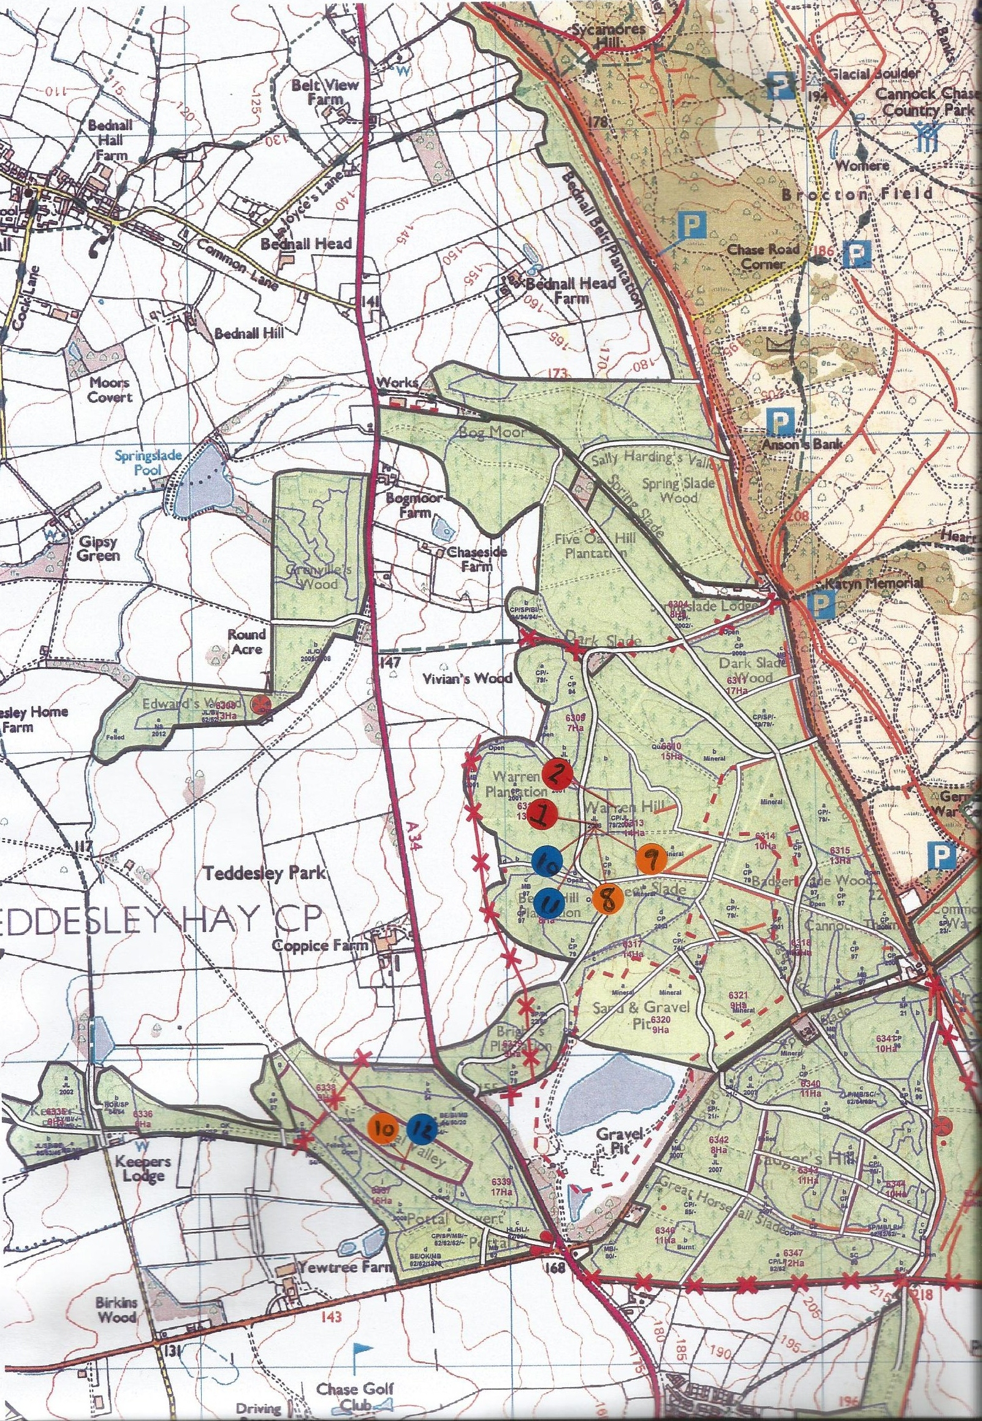
Appendix B
Site 1 and 2
Site 3
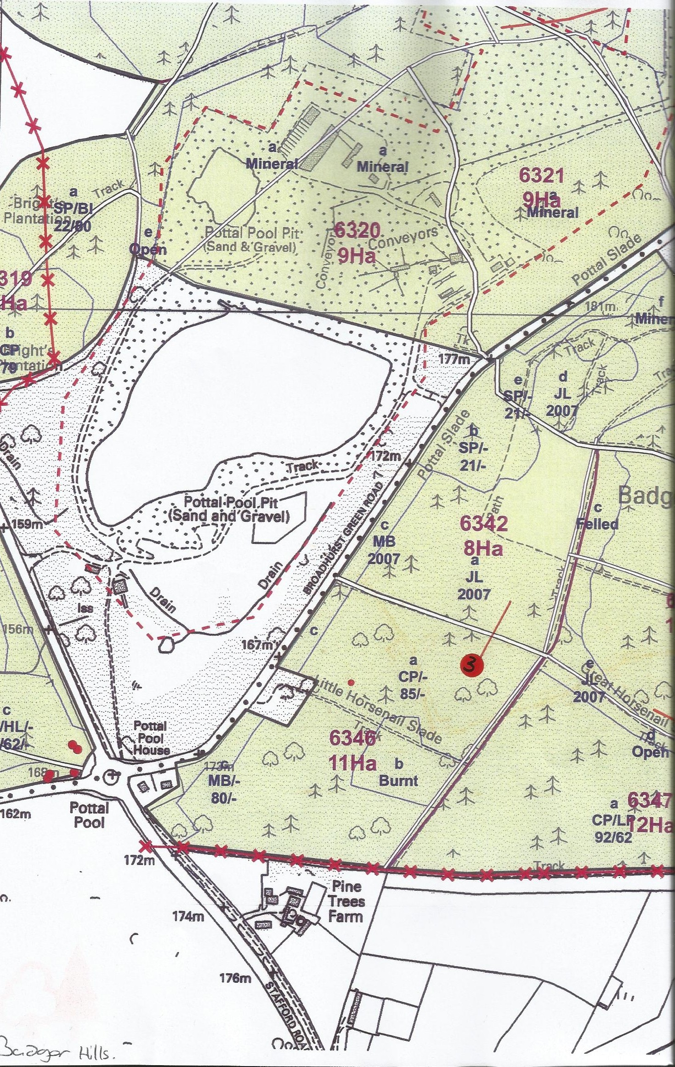

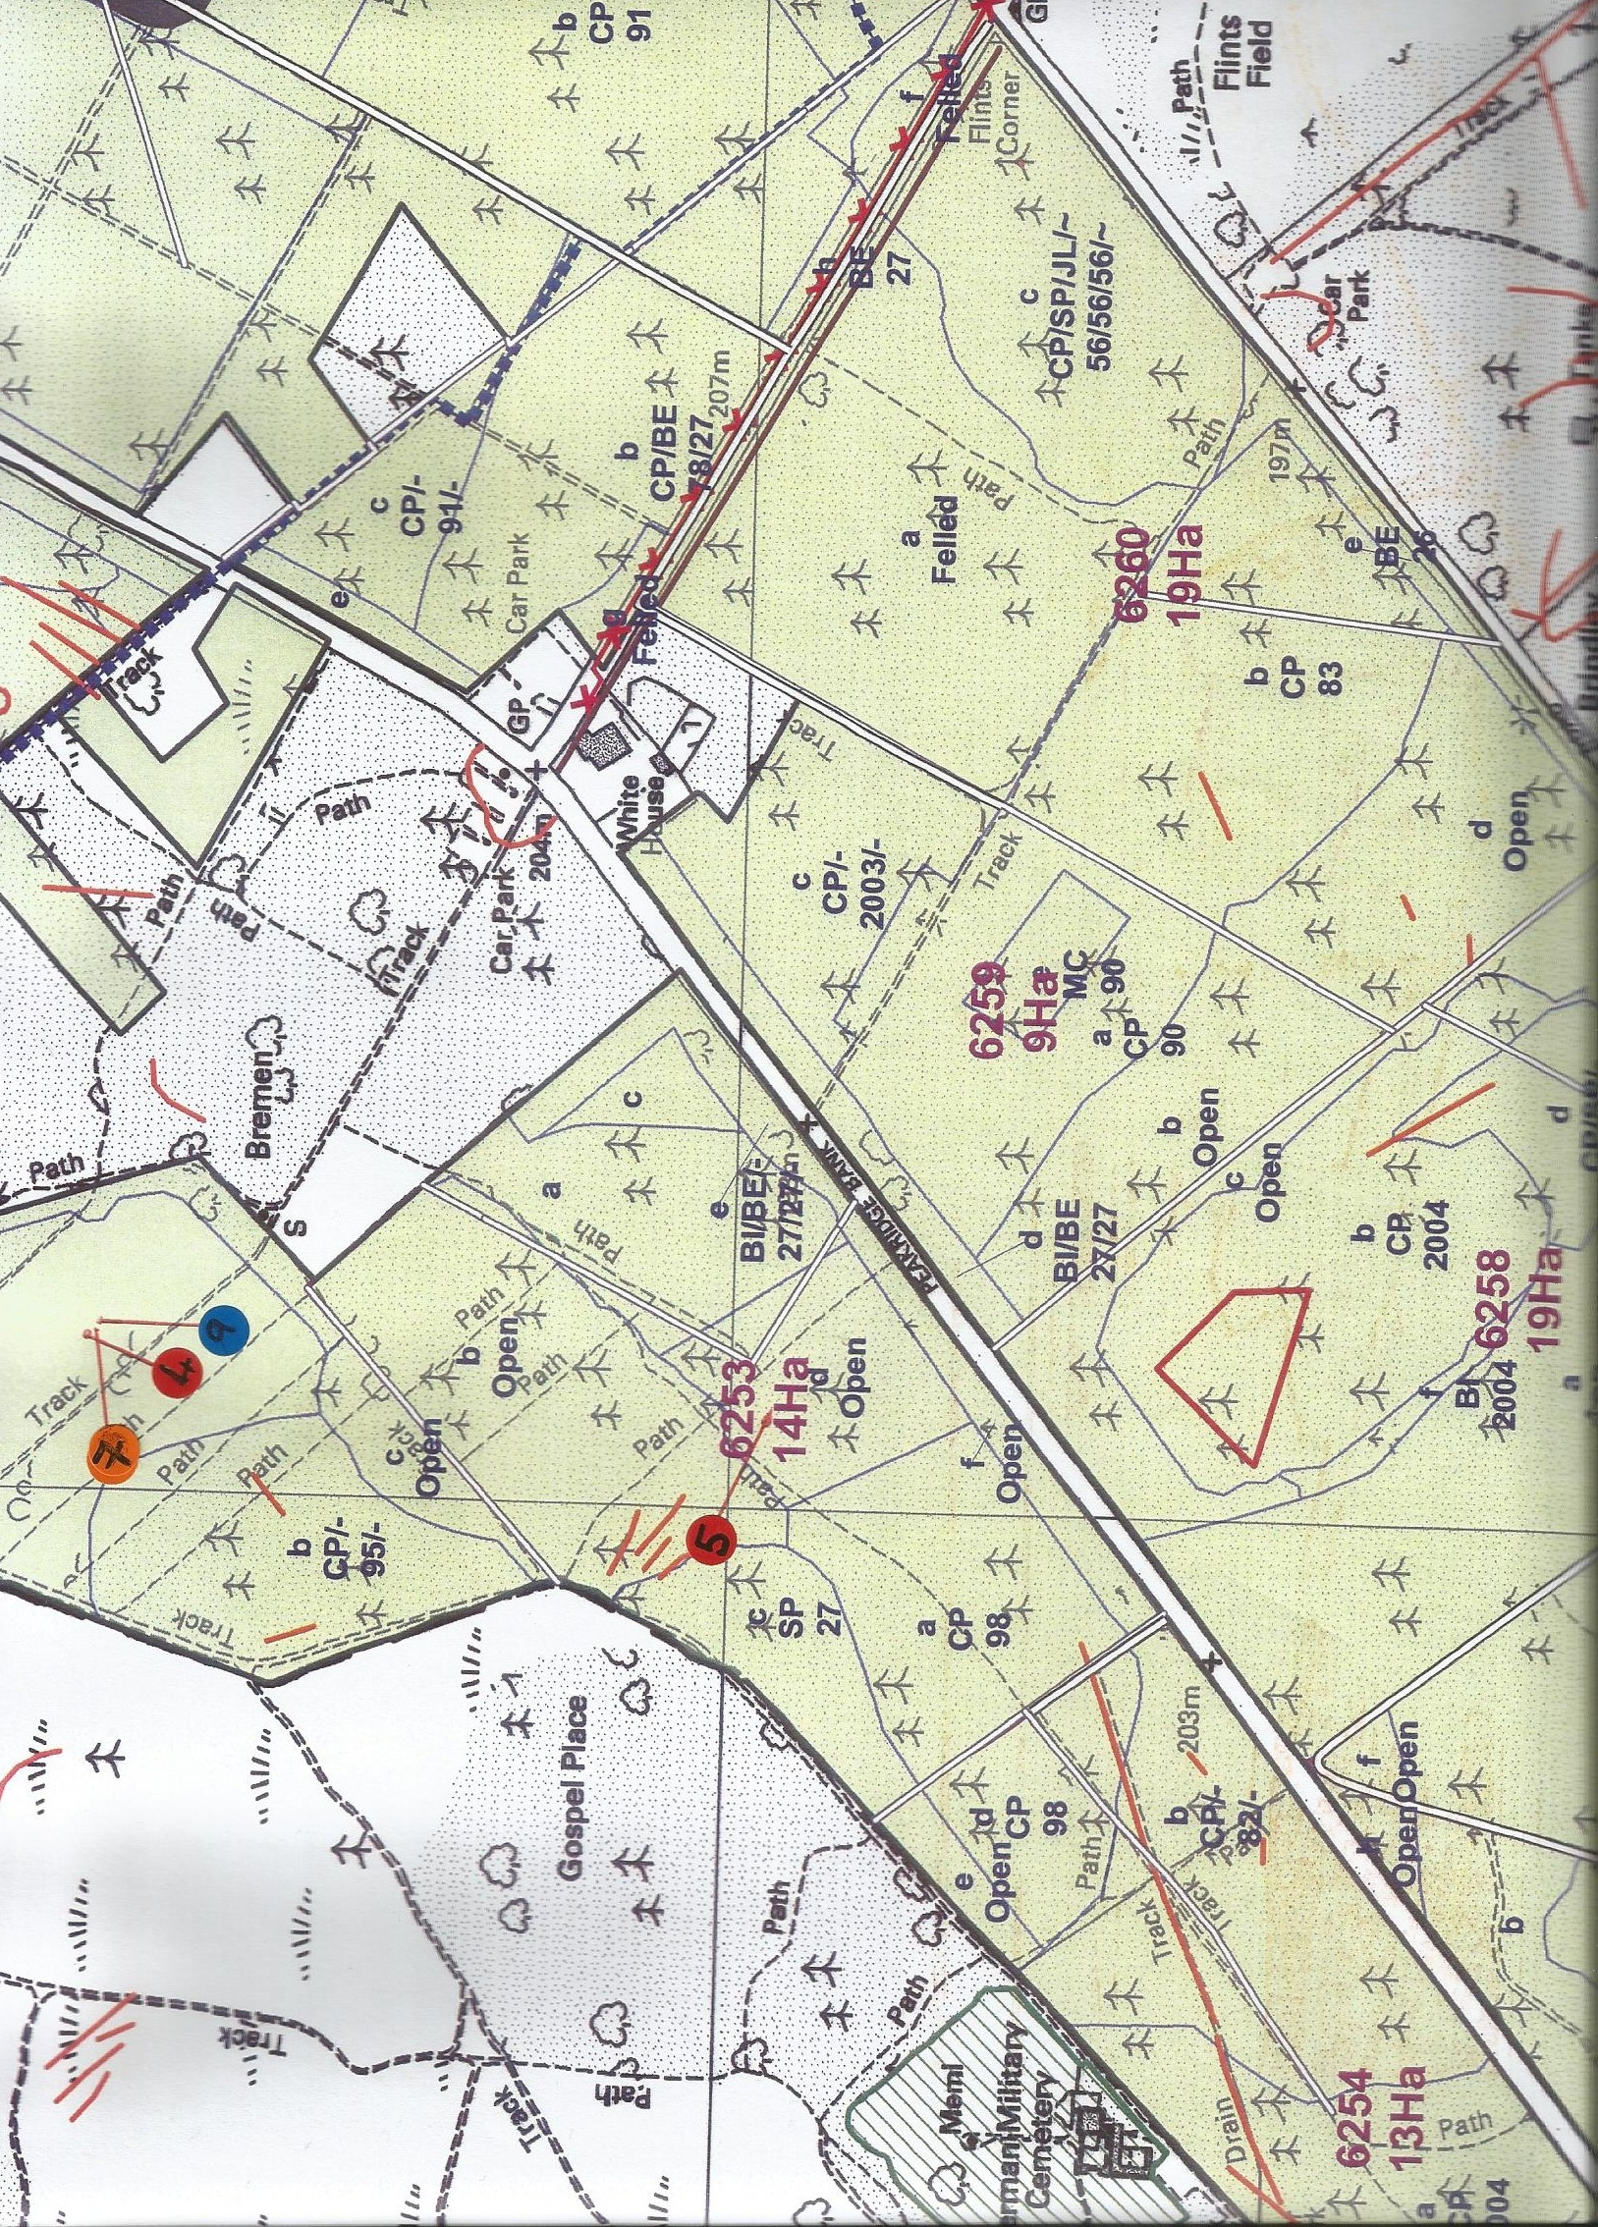
Site 4 and 5
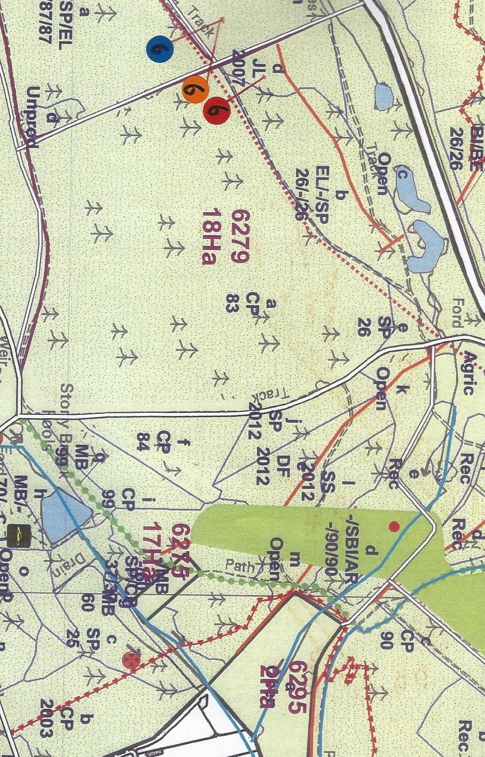
Site 6

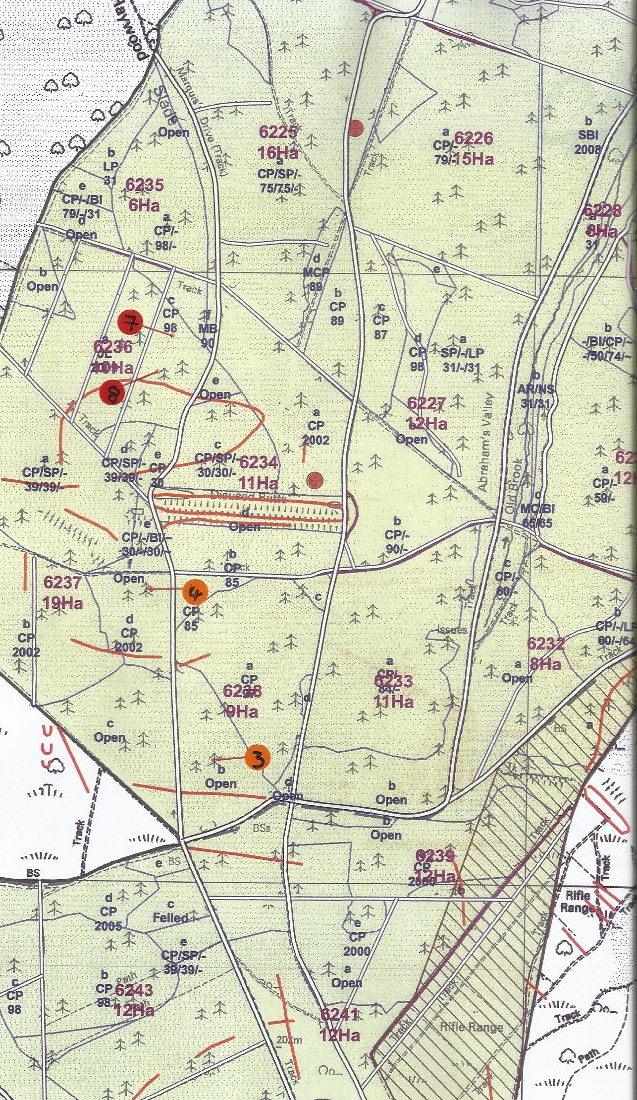
Site 7 and 8

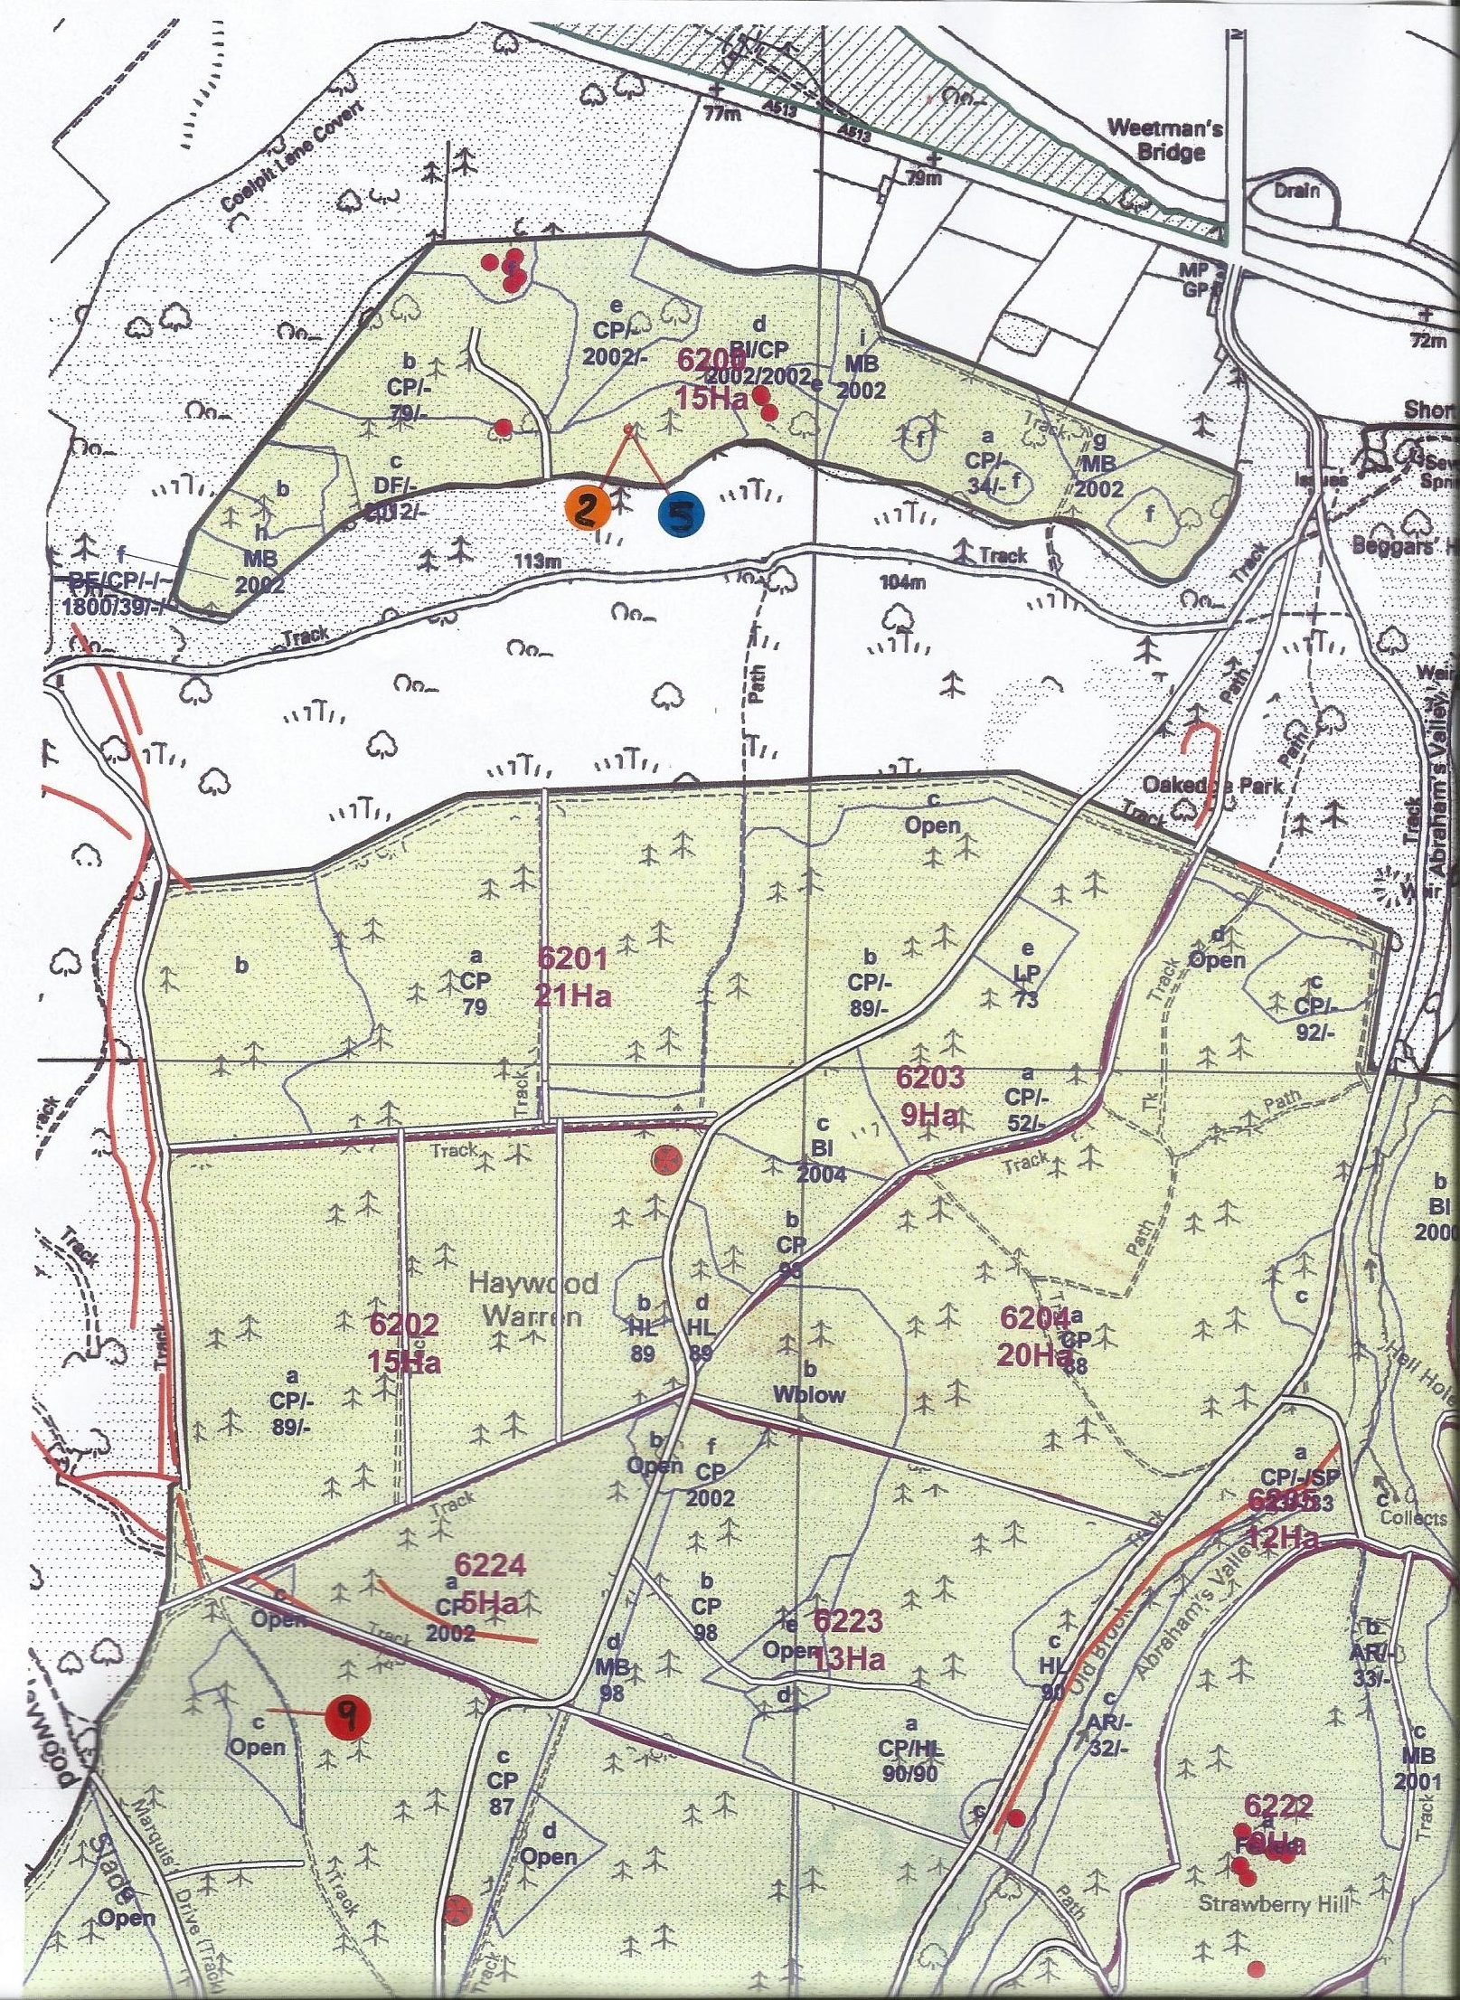
Site 9

Site 10 and 11
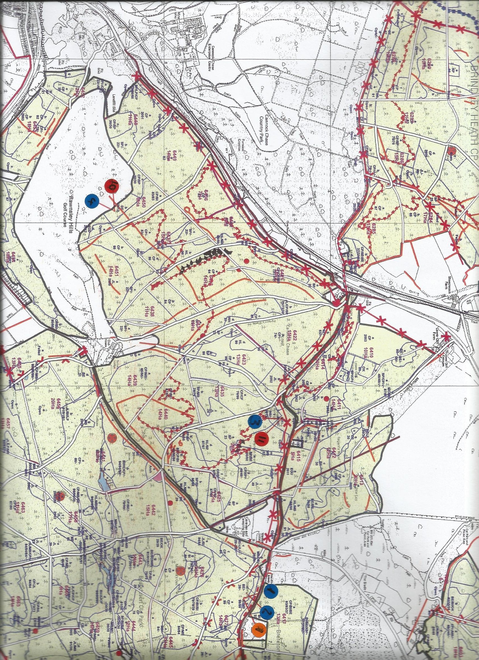
Appendix C

Application for safety and ethical approval for all projects

School of Built and Natural Environment
All undergraduate, postgraduate, commercial and research projects need ethical approval. No field work, experimentation or work with participants can start until approval is granted. The questions below should be completed by the Principal Investigator or supervisor of the proposed project. Where projects involve students, the Principal Investigator is always the supervisor and never the student.
For undergraduate and postgraduate taught projects: use the questions to identify whether the project should be referred to the relevant Ethics Committee.
- If you answer “No” to questions, then do not apply for approval.
- If you answer “Yes” to any of the questions, please discuss them with your supervisor. If your supervisor is confident that you can follow standard forms, protocols or approaches, then your supervisor can approve your application. If your supervisor is not, then the application should be sent for approval.
For research, commercial and other projects: use the questions to help compile suitable evidence to support your application.
- If you answer “No” to questions, then your application is likely to be approved quickly.
- If you answer “Yes” to any of the questions, please provide evidence relating to the management of the activity. If your approach seems appropriate, then your application is likely to be approved quickly.
Submit the application form and any supporting evidence to an appropriate Ethics Committee. Different committees might have different approval processes.
Principal Investigators, or project supervisors, are responsible for ensuring that all activities fall within the principles set down in the University Code of Conduct for Research and the University Ethical Principles for Teaching, Research, Knowledge Transfer, Consultancy and Related Activities. They are also responsible for exercising appropriate professional judgment in undertaking this review and evaluating the activity according to the criteria laid down in this application. If you are uncertain about any sections of this document, or need further information and guidance, please consult a member of the relevant School Ethics Committee.
The School Ethics and Safety Committees are to ensure that you comply with the University’s ethical principles in the conduct of the activity. Committees can ask for clarification or set conditions for you to meet before approval is granted.
Expiry and review: The principal investigator is responsible for ensuring activities are reviewed. Normally:
- each year: review risk assessments: check for changes to hazards and training refreshers
- after 5 years: review ethics: check for new laws, practices
- closure: dispose of materials and sensitive data properly
Refer to the relevant documents from the following links:
- Ethical Principles for Research, Consultancy, Practical Work and Related Activities
- Research Governance (Multiple documents)
- Health, Safety & Environment (Multiple documents)

1 Project synopsis |  |  |  | Approver: |  |  |  | Cmte number:
1.1 Title | The success rate of C. europaeus nests upon Cannock Chase in Staffordshire
1.2 Project type | Original research |  | Research degree |  | PG taught |  | UG taught |  | x | Commercial
1.3 Short description  in layman's terms [no acronyms or jargon] | This research will look at the success rates of Nightjar nests on Cannock Chase, in order to do this nests will be located and observed to record any changes taking place, for example disturbance or predation.
1.4 Dates | Start June 2012 |  |  | End April 2013
1.5 School of ….. | Built and Natural Environment
2 Participants
2.1 Project supervisor /principal investigator:  name, position  and original signature | Project supervisor: Kevin Butt  Principal investigator: Amy Keeling
2.2 Co-workers:  names and positions  [e.g. student] | Forestry Commission: Jim Stewart (Wildlife Ranger)

3 External collaborators
3.1 List external collaborating bodies
3.2 Provide evidence of any ethical approvals obtained [or needed] by external collaborators
3.3 Indicate whether confidentiality agreements have been or will be completed

Read any associated procedures and guidance or follow any associated checklist, and delete, Yes or No, for each characteristic in A) to F) below.
If you respond No, then in your judgment you believe that the characteristic is irrelevant to the activity.
If you respond Yes, then you should provide relevant documentation [including risk assessments] with the application, and cross-reference to it, e.g. A2 or B9. Use reference numbers of standard forms, protocols and approaches and risk assessments where they exist.
- Does the activity involve field work or travel to unfamiliar places? If Yes:  - Does the activity involve field work or leaving the campus [e.g. overseas]?  - Does the field work involve a ‘party’ of participants or lone working?  - Does the activity involve children visiting from schools? | A) Yes  - Yes  - Yes  - No
B) Does the activity involve humans other than the investigators? If Yes:  - Will the activity involve any external organisation for which separate and specific ethics clearance is required (e.g. NHS; school; any criminal justice agencies including the Police, CPS, and Prison Service)? – start this now [CRB clearance process at Loughborough; UCLan contact Carole Knight]  - Does the activity involve participants who are unable to give their informed consent (e.g. children, people with severe learning disabilities, unconscious patients etc.) or who may not be able to give valid consent (e.g. people experiencing mental health difficulties)?  - Does the activity require participants to give informed consent? [consent guidance at City U]  - Does the activity raise issues involving the potential abuse or misuse of power and authority which might compromise the validity of participants’ consent (e.g. relationships of line management or training)?  - Is there a potential risk arising from the project of physical, social, emotional or psychological harm to the researchers or participants?  - Does the activity involve the researchers and/or participants in the potential disclosure of any information relating to illegal activities; the observation of illegal activities; or the possession, viewing or storage (whether in hard copy of electronic format) which may be illegal?  - Will deception of the participant be necessary during the activity?  - Does the activity (e.g. art) aim to shock or offend?  - Will the activity involve invasion of privacy or access to confidential information about people without their permission?  - Does the activity involve medical research with humans, clinical trials or use human tissue samples or body fluids?  - Does the activity involve excavation and study of human remains? | B) Yes  - No  - No  - No  - No  - Yes  - No  - No  - No  - No  - No  - No
C) Does the activity involve animals and other forms of life? If Yes:  - Does the activity involve scientific procedures being applied to a vertebrate animal (other than humans) or an octopus?  - Does the activity involve work with micro-organisms?  - Does the activity involve genetic modification?  - Does the activity involve collection of rare plants? | C) Yes  - No  - No  - No  - No
D) Does the activity involve data about human subjects? If Yes:  - After using the data protection compliance checklist, have you any data protection requirements?  - After answering the data protection security processing questions, have you any security requirements? [Data storage] [keep raw data for 5 years] | D) No  - No  - No
E) Does the activity involve hazardous substances? If Yes:  - Does the activity involve substances injurious to human or animal health or to the environment? Substances must be disposed properly.  - Does the activity involve igniting, exploding, heating or freezing substances? | E) No  - No  - No
F) Other activities:  - Does the activity relate to military equipment, weapons or the Defence Industry?  - Are you aware of any ethical concerns about the company/ organisation, e.g. its product has a harmful effect on humans, animals or the environment; it has a record of supporting repressive regimes; does it have ethical practices for its workers and for the safe disposal of products? | F)  - No  - No
Note: in all cases funding should not be accepted from tobacco-related industries

If you respond Yes, then you should provide relevant documentation [including risk assessments] with the application, and cross-reference to it, e.g. A2 or B9. Use reference numbers of standard forms, protocols and approaches and risk assessments where they exist.
These standard forms are being followed [cross reference to the characteristic, e.g. A2]:
A1- See Risk Assessment
A2 – See Risk Assessment
B5 – See Risk Assessment
C- Nest observations on Nightjar nests will be carried out during the day, the birds will be on the nests at the time. If birds are encountered they will not be handled in any way, unless chicks are present when they will be ringed by a Wildlife Ranger working for the Forestry Commission. Other wildlife may be encountered during nest location, the same rules do apply. Also see risk assessment.


Appendix C


