

An investigation into the public’s perception of Haulbowline Island and the clean-up effort: A comparison of local Cork City and Cobh residents.

Rachel Murphy
BSc (Honours) Geography
2013
Student Number: G20505876

I declare that the main text of this dissertation is no more than 10,000 words and is all my own work

……………………………………………………

Rachel Murphy

Abstract

Cork Harbour is situated on the south coast of Ireland and it is considered to be one of the finest and largest natural harbours in the world. Haulbowline Island, a.k.a ‘The Toxic Island’ is just one of the many islands that can be found in this harbour.

This dissertation is an investigation into how the public populations of Cork city and the coastal town of Cobh perceive Haulbowline Island and the East-Tip; the current situation regarding hazardous waste that was inappropriately handled and the remediation. This thesis also aims to understand whether distance from the problem site affects how aware people are of the situation and furthermore; does distance from the island have an effect on how the public perceive it?

The research process generated data collected solely via 120 structured questionnaires. Sixty were handed out in a central location in Cork city and 60 more were distributed in the centre of Cobh town.

The findings from this dissertation provide evidence to suggest that region and knowledge of Haulbowline Island and the East-Tip are independent of each other but people in Cobh, closer to the hazardous waste site are more aware of the situation. Although this is the case, from the research it can also be seen that the study participants in both locations have relatively the same concerns regarding the East-Tip and the clean-up effort taking place.

Acknowledgements

I would like to acknowledge Alison Robinson first and foremost for her support and guidance whilst serving as my supervisor. Your advice has helped to keep me positive and confident in my abilities to complete such a large project.
I would also like to thank my family for their support. It has been a long road and everything you have done for me has been truly appreciated.
Finally I would like to say thank you to all of my friends and TEAM! who pretended to show an interest in my work and keep me motivated.

Cheers, people.

CONTENTS

Pages

Declaration i
Abstract ii
Acknowledgements iii
Contents Page iv
List of Figures vii
List of Tables viii

Chapter One 1
Introduction 1
  - Objectives 3
  - Rationale 4
  - Form of Dissertation 4

Chapter Two 5
Literature Review 5
  - Hazardous Waste 5
  - Waste Legislation 6
  - Waste Disposal and Management in Ireland 7
2.3.1Remediation of Haulbowline 11
  - Public Perception 12
    - Public Perception and Risk 12
  - Media 12
  - Summary 13

Chapter Three 14
Methodology 14
  - Establishing the Focus of Study 14
  - Site Selection 15
  - Selecting the Research Method 17
    - Development of Research Instrument 17
  - Primary Research Data Collection 19
  - Risk Assessment and Ethical Consideration 19

Chapter Four 21
Results and Discussion 21
4.1 Awareness of Haulbowline Island and the East-Tip 21
4.2 Public Perception of Haulbowline Island and the East-Tip 31
4.3 Demographics 37
4.4 Limitations 38
4.5 Further Work 38

Chapter Five 39
Conclusions 39

Chapter Six 41
References 41

Appendices 45

List of Figures
Figure 1: A map of Ireland 1
Figure 2: A satellite image of South Cork displaying all 3 sites. 2
Figure 3: A photograph of Haulbowline Island with different areas labelled 3
Figure 4: A diagram of exports of hazardous waste to Germany in 2009 8
Figure 5: A diagram of European hazardous waste flows in 2009 9
Figure 6: A satellite image of Cobh 16
Figure 7: A satellite image of central Cork city 16
Figure 8: A graph displaying Question 1 results 22
Figure 9: A graph displaying Question 2 results 23
Figure 10: A graph displaying Question 4 results 25
Figure 11: A diagram of the expansion of the East-Tip 26
Figure 12: A graph displaying Question 9 results 28
Figure 13: A graph displaying Question 11 results 29
Figure 14: A graph displaying Question 12 results 30
Figure 15: A graph displaying Question 6 results 31
Figure 16: A graph displaying Question 7 results 33
Figure 17: A photograph of East-Tip before clean-up 34
Figure 18: A photograph of East-Tip before remediation 34
Figure 19: Proposed design post-remediation 35
Figure 20: Proposed design post-remediation 35
Figure 21: A graph displaying Question 10 results 35
Figure 22: A graph displaying Question 13 results 36

List of Tables
Table 1: A table presenting Question 3 results 24
Table 2: A table presenting participant genders 38

List of Appendices

Appendix 1 – Table Displaying the Total Arising of Irelands Hazardous Waste
Appendix 2 – Pilot Questionnaire
Appendix 3 – Questionnaire Brief
Appendix 4 – Final Questionnaire
Appendix 5 - Completed Risk Assessment
Appendix 6 – Completed Ethics Form
Appendix 7 – Raw Questionnaire Data
Appendix 8 – Code Table

Chapter One
Introduction

The Oxford Dictionary (2012) defines perception as “the way in which something is regarded, understood, or interpreted” and because everyone has a mind of their own, how a group of people perceive the same situation can vary greatly. Harris (n.d) suggests that a person’s perception of something can be significantly influenced by their knowledge of it or in some cases, lack thereof.

Figure 1 below displays a map of Ireland and circled is the region of the country that will be discussed throughout this dissertation. Haulbowline Island is situated in Cork harbour in the south of Ireland and it is located approximately 1 kilometre from Cobh and 24 kilometres from Cork city. All 3 sites can be seen in Figure 2. Site 1 is Cork city, site 2 is Cobh and site 3 is Haulbowline Island.

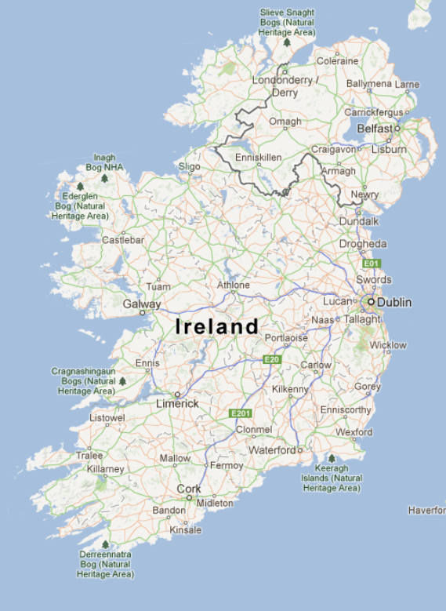
Figure 1: A map of Ireland
(Source: Google Maps, 2013)
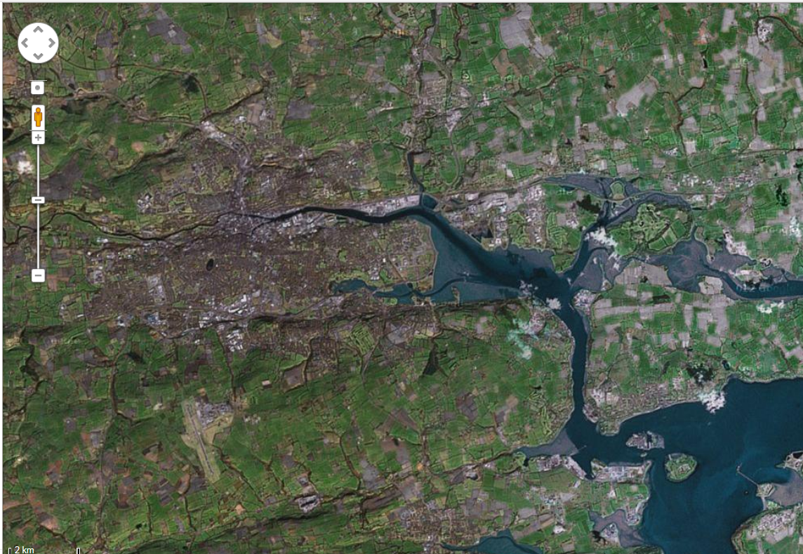

1
3
2
Figure 2: A satellite image of South Cork displaying all 3 sites.
(Source: Google Maps, 2013)
Haulbowline island currently amounts to about 84 hectares in total size (Passage West Monkstown, 2011) but 22 hectares of it is classified as an illegal waste disposal site that is managing to cause many problems for the Cork County Council and Irish government (Kelly, 2012; Reilly, 2012; Curtin, 2012). The island is home to the main Irish naval base and a former ISPAT steel plant that was decommissioned in 2001 and is currently in-situ (Reilly, 2012; RTE News, 2012; Kelly, 2012). For a number of years the hazardous waste contamination on the island has been dealt with inappropriately and so the condition of the land has deteriorated, especially on the east side of the island. Kelly (2012) notes in a Cork County Council report that 9 hectares on the island, known as the East-Tip (Figure 3), is an unauthorised waste site that is made up of slag deposits, heavy metals, hydrocarbons and other by-products of the steel making process. It is those 9 hectares that are the main issue on the island (RTE News, 2012; FOIE, 2009; CorkCoCo Presentation, 2013).
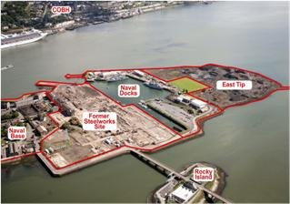
Figure 3: A photograph of Haulbowline Island with different areas labelled
(Source: Verde, 2012)

The first movements in the current attempt to clean-up the hazardous waste on the island were made in August 2011 by the Cork County Council after the European Commission threatened to fine the Irish government if it did not take action on the island (RTE News, 2011; RTE News, 2012; Reilly, 2012). €40 million of Irish government funding has been put towards the clean-up of the East-Tip with the hope that the project will be completed by 2014 (RTE News, 2012; Curtin, 2012) The Cork County Council have submitted an application to the Environmental Protection Agency (EPA) for a waste licence for the East-Tip (Cork County Council PO, 2012) to clear up and manage the estimated 500,000 tonnes of hazardous waste on the island (RTE News, 2008; RTE News, 2012).

1.1 Aims and Objectives
The main aim of this piece of research is to discover whether distance from Haulbowline Island and the hazardous waste site affect the public’s perception of it. Using the questionnaires designed for this investigation, the results will help to determine whether distance from Haulbowline Island and the problem site affects how much people know about the hazardous waste site and furthermore; how the public populations of both Cork city and Cobh perceive Haulbowline Island and the clean-up effort being conducted by the Cork County Council.

1.2 Rationale
The results from this investigation should shed light on the depth of understanding that the public of Cork city and Cobh have about Haulbowline Island and furthermore their feelings towards it. The hazardous waste present on the island could potentially be having negative effects on the health of the surrounding populations (Riegel, 2011; Anderson, 2008) and so it is important to know how they perceive the situation and the clean-up effort being conducted. The findings yielded from this research may prove useful to groups such as the Cork County Council in how they handle relating information to the communities.

1.3 Form of Dissertation
This dissertation is split into seven chapters. Following this introduction, the literature review will provide a summary of secondary material relevant to this dissertation. A concise description of the techniques used in the research process follows in the 3rd chapter titled Methodology and the 4th chapter contains the results and discussion. It consists of the tabulation and statistical analysis of the data collected, all supported further with text. The discussion of the all the research carried out throughout this project is also found in chapter four. The conclusions can be found in the 5th chapter. The conclusion will involve a summary of the main findings from the research that has taken place. The final chapter is the References chapter which contains all the details of the references that have been cited throughout the text in this document.

Chapter Two
Literature Review
The previous chapter introduced this study and the rationale behind it but this chapter, the literature review will explore works that have already been published relating to the topic of this dissertation. It will help to establish a theoretical foundation upon which this research is based.
2.1 Hazardous Waste
Hazardous waste was once thought of as waste that would result in danger to any person or structure which it came into contact with, but this then developed the more it was studied. The most recent description of a ‘hazardous waste’ is that it is hazardous to microorganisms present and to soil and water environments that are exposed to it (Hazardous Wastes, 2007). As cited by Williams (2006), hazardous waste can contain any number of organic or inorganic compounds that can pose a risk to a person’s health. When hazardous wastes are released into the air, water, or even land, they can spread and contaminate the environment further. Through inhalation, touch or indigestion, a person or animal can be exposed to hazardous substances and in this can cause a number of ill health effects. If exposed for a short time, this is known as acute exposure and health symptoms can often be seen immediately. Whereas, if they were exposed for a longer period of time, known as chronic exposure, health effects like cancer take longer to develop. Chronic exposure can also lead to bioaccumulation, which means that the substances are absorbed the body and stay for a long time (EPA, 2011).
In Ireland, hazardous waste is generated by a significant number of different industries and working sectors. According to (EU Hazardous Waste Table, 2010) in 2004 Ireland generated 724,345 tonnes of hazardous waste and in 2010 it generated a total of 1,972,204 tonnes (see Appendix 1). In the space of 6 years, that is a 272% increase.
The waste present on Haulbowline Island was disposed of incorrectly by a steel manufacturing factory from the early 1960’s until when the ISPAT plant was decommissioned (CorkCoCo Presentation, 2013).
2.2 Waste Legislation
Waste is defined by EU Law as being “any substance or object which the holder discards or intends or is required to discard” (Horspool and Humphreys, 2010) The Republic of Ireland is a member of the European Union and so follows the legislation set out by the different members of state. Union policy on the environment is stated in Article 191 TFEU and it has four main objectives:
- Preserving, protecting and improving the quality of the environment
- Protecting human health
- Prudent and rational utilisation of natural resources
- Promoting measures at international level to deal with regional or worldwide environmental problems, and in particular combating climate change. (Foster, 2010)
In 1993 a precautionary principle was added to the European Union law after it was noted in the Rio de Janerio 1992 UN conference. The principle is understood to mean that if there is a possibility of environmental degradation in a particular area; preventative measures should take place immediately. The precautionary principle also notes that lack of scientific evidence should not delay action taking place. (Horspool and Humphreys, 2010)
Horspool and Humphreys (2010) write that the directives put in place by the Court of Justice are there to be complied with and inspections are carried out on all hazardous waste disposals, recovery, collection and transport operations to ensure that all the requirements are existent. This is what has occurred in Ireland in recent years; the European Commission has followed up a complaint they received about Haulbowline Island and the East-Tip and have implemented their policies directly through the government.
It is the European parliament and the council that decide what action is to be taken by the union in order to achieve the targets referred to in article 191. (Foster, 2010) Foster (2010) also notes that Ireland, the EU member of state that has the environmental issues must finance and implement the environmental policies that are needed.
Across the world, in an attempt to avoid licence applications and paying out money to different organisations, many people and companies illegally dump their hazardous waste and it is then forgotten about and ignored. These abandoned hazardous waste sites in the USA are now being looked after by the environmental program, Superfund (EPA, 2011). This program allows the EPA to clean-up the sites and then makes the people responsible reimburse the agency or government.
2.3 Waste Disposal and Management in Ireland
Hazardous waste is often difficult to keep, treat and dispose of and within Europe; most of the hazardous waste that is produced comes from the manufacturing industry, like it did on Haulbowline Island (Williams, 2006).
Depending on what type of waste is being dealt with, and how dangerous it is, there are a large number of options for dealing with hazardous waste. The correct disposal of hazardous waste is not just to dump it. If possible, most of the hazardous waste produced in Ireland is exported for treatment (EPA IE, 2013).
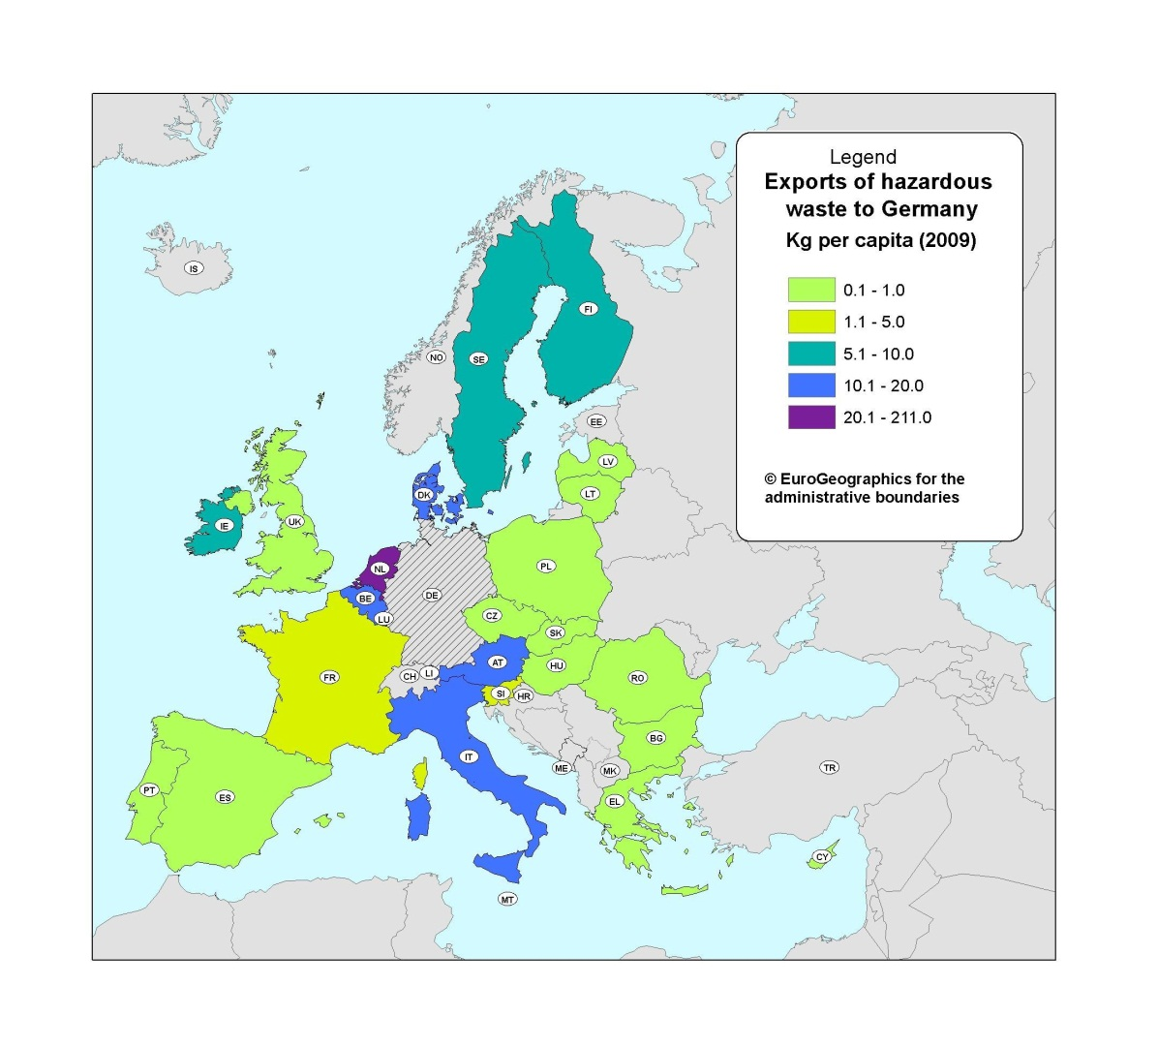
Figure 4 taken from the official website of the European Union displays the amount of hazardous waste that was exported to Germany in 2009. According to figure 4, Ireland exported between 5.1kg and 10 kg of hazardous waste per capita during 2009.

Figure 4: A diagram of exports of hazardous waste to Germany in 2009
(Source: EU Website; 2009)

Figure 5 also displays the largest flows of hazardous waste within Europe. Ireland exports a large amount of hazardous waste to the UK for treatment on a yearly basis. Figure 5 below shows that Ireland transported about 16.1kg – 20kg per capita of hazardous waste in 2009.
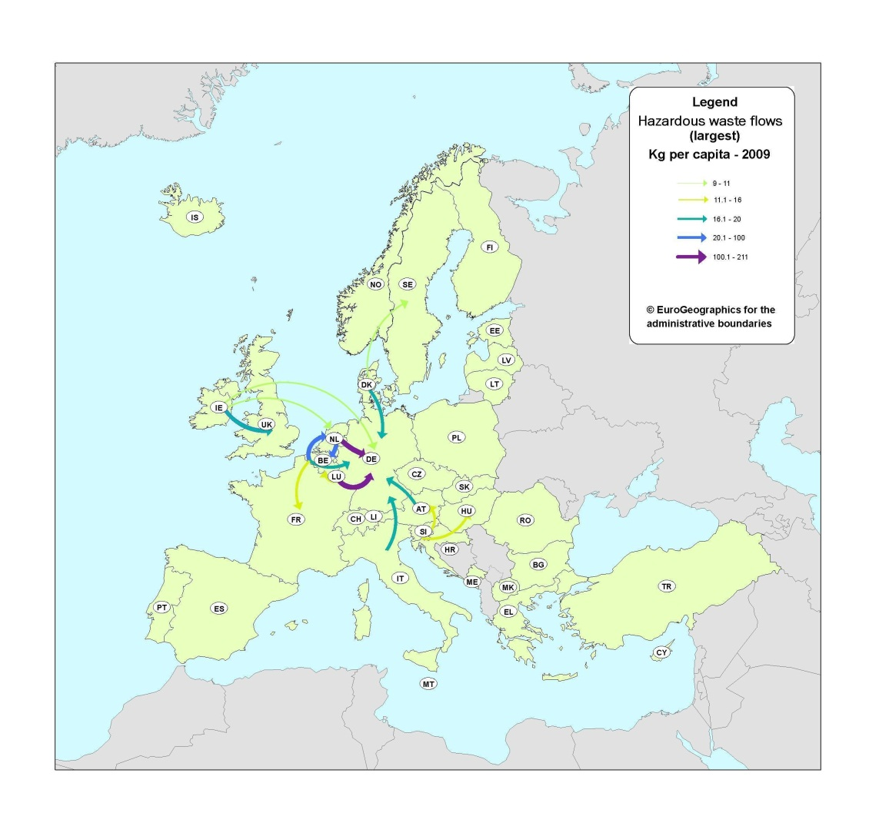

Figure 5: A diagram of European hazardous waste flows in 2009
(Source: EU Website; 2009)

It is due to incidents like Haulbowline, where inappropriate hazardous waste disposal has taken place and been left unreported that the Environmental Protection Agency has felt the need to create and implement a plan. Between the years of 2008 and 2012 the Environmental Protection Agency of Ireland has been attempting to put into action a National Hazardous Waste Plan. The plan makes particular recommendations to ensure that all hazardous waste produced by the country is collected and managed appropriately in a fashion that does not cause environmental pollution. (EPA IE, 2013). The purpose of plans such at the one set out by Irelands Environmental Protection Agency is to reduce and/or try and eliminate threats to the public (Alberini et al, 2007)
For countries that are part of the European Commission, they believe that disposing in waste landfills should be a last resort but it is also dependent upon that individual countries nation policy on waste treatment and disposal (Williams, 2006). If looking for a more sustainable method of waste disposal, the best option would be the incineration of hazardous waste with energy recovery. Although it is a very expensive option, it is also an organic one and for some countries, the only option. The burning of some types of hazardous waste in a kiln is considered a thermal method as well. When mixed with other fuels it produces organic wastes that have high calorific values and a lot of energy. Biological methods are another form of treatment and it involves the use of microorganisms. The microorganisms help to make the waste less hazardous. This treatment can be either aerobic or anaerobic, depending on the type of hazardous waste being treated. Solidification and stabilisation are 2 methods of physico-chemical treatments for hazardous waste. It is used to make handling the waste easier, by mixing solids with liquid waste. It can involve either physical absorption or chemical interaction depending on the situation (Williams, 2006)
The best option most of the time, if available, is to recycle or reuse the waste. (EPA, 2011). Many industrial hazardous wastes can be recycled without any negative consequences. According to the United States Environmental Protection Agency, if a hazardous waste is used, reused or reclaimed, it is considered to be recycled. Many hazardous materials will be recycled into lead-acid batteries or electric circuit boards (Hazardous Waste Recycling, 2012).
There is also the potential for hazardous waste to be incinerated. Ringaskiddy is another costal town located about 2km from Haulbowline Island. It is also connected to the island via a bridge. For many years now there has been a plan for 2 large incinerators to be built in the vicinity. This proposal has been turned down on many occasions mostly due to public opposition to the idea and the Cork Harbour Alliance believe that there are other, safer options to deal with waste. (RTE News 2, 2011; Independent, 2012)

2.3.1 Remediation of Haulbowline
The Cork Harbour website brings light to the fact that the issue of hazardous waste contamination on Haulbowline Island was first raised by local company Louis J O Regan Ltd. (Cork Harbour, 2008) They were carrying out initial remedial works on the site and were contracted to remove the 15,000 tonnes of left over waste from the surface of the East-Tip but by doing so, they uncovered the large amounts of hazardous waste below the surface. This also included the chemical Chromium 6; a well known carcinogen (FOIE, 2009)
The cost of cleaning up hazardous waste sites is often very costly. An example of this is the contaminated land that was cleaned up to make way for the Olympic Stadium in East London. According to the article in the Guardian newspaper written by Barley (2010), the site was left seriously contaminated by the chemical storage facility that was demolished so that building work could begin on the main stadium. The clean-up operation is said to have cost around £12.7 million. With that money, the best they could still do is just containing 95% of the chemical spill. The Irish government estimate that the 36 month clean-up effort is going to cost about forty million Euros.
At a public information evening held by the Cork County Council in January 2013, they discussed the remediation of the East-Tip. After identifying and quantifying the risks that the site posed to human health and the environment they then came upon a suitable plan for dealing with the area. The recommendations that were made and are in the process of being carried out were to cap the land and then landscape it. Low permeability capping is to be used to prevent further leaching of toxic substances and then additionally erosion protection around the shoreline perimeter of the island is to be included to stop future sediment loading (CorkCoCo Presentation, 2013)
Although €40 million has been be put toward the remediation of Haulbowline by the government, some experts believe that it could cost upwards of €350 million (Anderson, 2008)
2.4 Public Perception
A person’s perception of something is derived from the use of their senses and is basically the way in which they extract information from the environment. (Barber and Legge, 1976) Barber and Legge (1976) note that perceptions of certain situations can be difficult to decipher for certain because of the number of variables that are more than likely present. As referred to previously, knowledge is often a key factor in a person’s perception of something.
2.4.1 Public Perception and Risk
Alberini et al (2007) state that sites contaminated with hazardous waste often means that people are at risk of entailing exposure to carcinogens and other toxic chemicals that can cause long-term negative health effect.
Risk is an important factor in person’s perception as it can affect how safe a person feels. The main risk associated with Haulbowline Island is the suggestion that the toxic chemicals that have been discovered at the site may have an effect on the health of the public populations that are a relatively near distance to the island. Reports and investigations conducted by the council and secondary companies have shown that there is no immediate risk to human health from the island, but then again studies do show that Cobh has a 37% higher cancer rate than other locations across Ireland (Tobin, 2011; O’Sullivan, 2013). Although that is the case, O’Sullivan (2008) writes that people only believe this to be true because they already perceive Haulbowline Island as a hazard.
2.5 Media
We live in a society that depends on the media to deliver up to date information on a day to day basis. For a number of people in the present, it is a necessity to have access to some form of media at all times. In the last few decades the media industry has grown a huge amount and very quickly. (Dawn Newspaper, 2010). Media is one of the best ways to deliver information that will quickly raise awareness of topics like the East-Tip in a relatively easy fashion.
Perception can be influenced very easily by a number of different things but the media has huge potential to alter a person’s perspective (Rayuso, 2008). A number of newspaper and internet articles have been published about Haulbowline Island and the East-Tip in the last decade but the majority of them have focused on the negatives of the island, without providing much information regarding the clean-up, which is a more positive aspect of what is occurring.
  - Summary
This chapter focused on previous literature that has been published relating to the different topics that will be discussed in this dissertation. It helps to provide context and background information regarding various parts. Although much has been published on hazardous waste in general and how to manage it, very little has been published on perception in relation to hazardous waste. The most common angle this subject is approached from is the risk perception of waste. There is also no accessible literature referring to distance and perception that could be discussed within this review. This chapter also includes information in relevance to how the media has the ability to alter a person’s perception.

Chapter Three
Methodology

Having assessed and reviewed the relevant literature to this study in the previous chapter, the following writing will describe and explain the methods that were employed during this study. Many aspects of the research process will be covered in this section of the project; from choosing a topic of investigation to collecting the primary data for analysis. This dissertation consists of data that was collected via a structured questionnaire that was then distributed in a form of convenience sampling in two different locations.
3.1 Establishing a Focus of Study
Chapter One brought attention to the subject and purpose of this investigation i.e. to ascertain how the public of Cork city and Cobh perceive Haulbowline Island and then to discover if there is a link between peoples knowledge and perception of Haulbowline and how far away they are from the problem site

McNeill and Chapman (2005) noted that choice of research topic can be influenced by things such as the researchers own values and interests, current issues or by funding. The focus of this study has stemmed from the fact that the hazardous waste site on Haulbowline is an on-going environmental issue for Cork County and now also has the involvement of the Irish government and European Commission.

Although this is the case, information regarding the island, its hazardous waste site and the remediation project has not obviously been made available to the public. Mary O’Leary, chairperson for the Cork Harbour Alliance for a Safe Environment (CHASE), also notes that local people are deeply frustrated by the authorities’ failure to provide them with relevant information sooner. (Anderson, 2008) As mentioned previously in the introduction, a person’s perception of something can be significantly influenced by their knowledge of it or the lack thereof.

3.2 Site Selection
Marshall and Rossman (2010) note that site selection is one of the most crucial parts of the research process. This dissertation project is investigating and comparing the perceptions of the public populations of two areas in the county of Cork; Cork city and Cobh.

Cork city centre is a relatively dynamic area with people about at all times of day. This survey was carried out on the main shopping street in the centre of town, St Patrick’s Street. This location is drastically more urbanised than the second site. According to the census conducted by the Central Statistics Office, in 2011 the population of Cork city stood at 119,230 (CSO, 2011). The fact that the area had a relatively large population means that it may be easier to get a varied age range for the study being conducted.
Cobh is a much smaller coastal settlement but it is located at a much closer proximity to Haulbowline Island and the illegal hazardous waste site. In an attempt to make the results more representative, the questionnaires in this area were handed out on the main shopping area of town too. The difference in the closeness of each site to Haulbowline Island allows for the idea of distance being an influence in the public perception, to be tested.
As mentioned previously, Figure 2 shows all 3 sites relevant to this dissertation; the two survey locations and Haulbowline Island itself. Figure 6 and figure 7 are satellite images more specific to each study site.

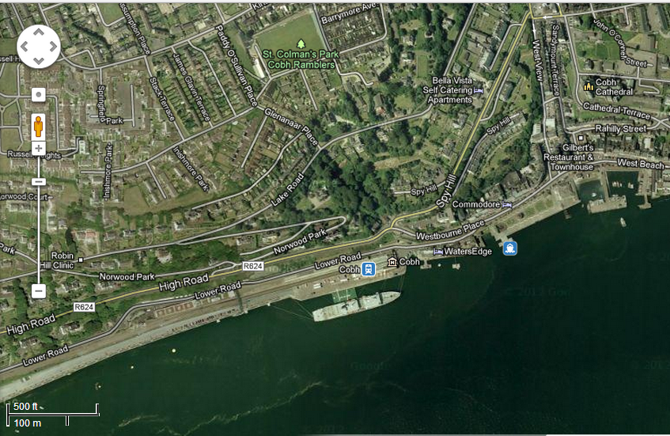
Figure 6: A satellite image of Cobh
(Source: Google Maps; 2013)

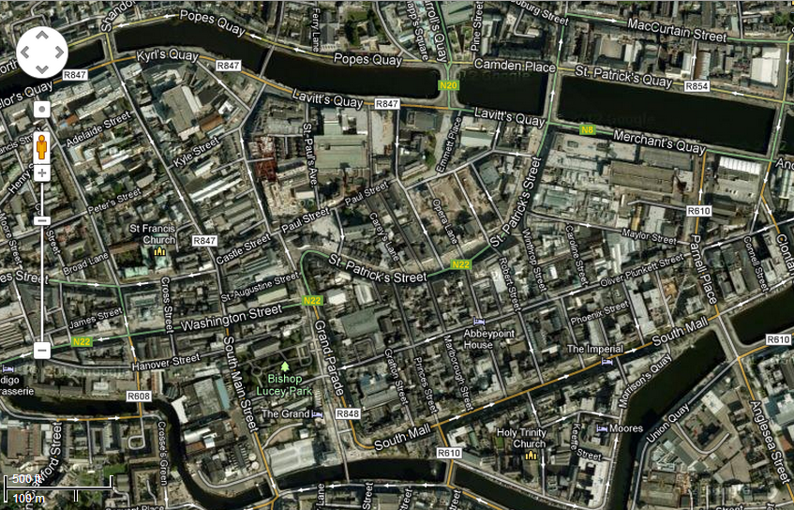
Figure 7: A satellite image of central Cork city
(Source: Google Maps, 2013)

3.3 Selecting the Research Method
An investigation into the public perception of an issue means that the information needed to achieve the aims needs to be personal to each participant in the study. Therefore, the best way to do this is to carry out a form of research interview. According to Stacey (1969), the aim of any type of research interview, including questionnaires, is to receive honest information on a topic of which they are under no obligation to tell if they’d prefer. Questionnaires are an ideal way to get information, opinions or ideas from people but in a written format (Winstanley, 2009) and they allow anonymity for the study participant (Munn and Drever, 2004). McNeill and Chapman (2005) state “the questionnaire also allows the researcher the possibility of using larger numbers of respondents than any other method available, therefore increasing the representativeness of the sample and the ability to generalize from the results”. This is useful as this investigation is trying to determine how the general publics in two different locations perceive the same issue

The choice to use structured questionnaires to collect the primary data has some obvious advantages such as the fact that all respondents will have the same questions, meaning that they are standardized (McNeill and Chapman, 2005) Questionnaires allow the use of a range of different types of questions such as open-ended ones or ones that are closed (Stacey, 1969). As Munn and Drever (2004) mention, another useful element of using questionnaires is that the responses provided can easily be quantified using statistical techniques during analysis.

3.3.1 Development of Research Instrument
As discussed above, questionnaires were chosen as the research instrument during this investigation and the one used was designed with both an open-ended question and the rest, closed questions. The decision to use both types of questions was made in the early stages of the design process because it means that the responses from the study participants will provide both quantitative and qualitative data. The purpose of this is to improve the validity of the questionnaire and it allows for more in depth data to be collected (Winstanley, 2009).
As well as choosing the questions, how language is used is of importance too. Clear communication was essential in order to successfully complete the questionnaires. This saves time for the participant, and it also means that there is a higher chance of people completing them. The questionnaire used during this investigation consists of a total of sixteen questions.

Some of the questions in the questionnaire were included for a specific purpose and not to just gather general information. Question 20 for example; “Where in Cork are you resident?” This was included in the questionnaire so that during the analysis of the results it would be possible to detect if there is any correlation between the persons distance from Haulbowline Island and how much the study participant knows about the hazardous waste dump situation. Many of the other questions present on this questionnaire are asking the respondent for specific facts relating to the island that the East Tip.

A pilot study was undertaken on the completion of a draft of the study questionnaire (see Appendix 2) in order to help refine it for use in the actual investigation. The purpose of this part of the research process is to try and identify any problems with the layout or wording of the questions and to make sure that the answers from respondents will provide the information needed to meet the project aims. The pilot survey was conducted on a similar selection people to those that will be investigated during the actual survey (McNeill and Chapman, 2005) Once this stage has been completed and all the problems on the questionnaire have been corrected, it is ready to be administered to the public. The actual questionnaire distributed can be found in Appendix 4.

3.4 Collection of Primary Research Data
Primary data collection occurred on the 9th and 10th of January 2013 in Cork city and then the same process took place in Cobh on the 12th and 13th of January 2013. When deciding how to administer the questionnaires for this study, there were two main options to be considered; through the post or face to face. Because the data needed for this investigation is site specific the best option seemed to be conducting face to face surveying and McNeill and Chapman (2005) suggests that there will be a better response rate with this method.
The surveying was conducted between the hours of 10am and 3pm on all four days. The weather on these particular dates remained similar; overcast with sunny spells and the odd rain shower. The questionnaires were handed out in a non-random fashion using a form of convenience sampling. The respondents used in this study were chosen due to the fact that there was easy access to them.

When considering the size of the sample needed for this investigation, it’s important so that the data collected is as reliable as possible (Winstanley, 2009). Sixty questionnaires were completed at each site by random people and altogether 120 surveys were completed. On average each questionnaire took the study participant 10 minutes to complete.

3.5 Risk Assessment and Ethical Consideration
Before carrying out field work, a risk assessment should always be carried out to figure out what hazards may be encountered during the work. It is beneficial to the researcher carrying out the study because it allows time for them to put in place precautions to prevent them coming to any harm whilst conducting the study (HSE, 2011) For this investigation a number of risks were identified but were all declared as low level hazards and therefore the appropriate controls and safety procedures were implemented before and during the handing out of the questionnaires. A copy of the university approved risk assessment can be found in Appendix 5.

For this dissertation to be conducted, the ethics of the investigation needs to be considered first. Research can impact certain people in different ways and so how the researcher behaves and carries out the investigation is important (McNeill and Chapman, 2005) Ethical approval is granted by the University if no ethical issues are identified and if any have arisen they need to be dealt with satisfactorily before conducting any research. Not telling survey participants could be considered an ethical issue (Swetnam, 2000) and so it is for this reason that the questionnaires were distributed with an attached cover sheet (see Appendix 3). The cover sheet is a brief that contains a basic background of the research project and explains that the person has is not obligated to participate. The completed and approved ethics form can be found in Appendix 6.

Chapter Four
Results and Discussion

The following chapter will focus on the results of the primary data collected through the use of the questionnaires mentioned in the previous chapters. The data will be displayed and described using either graphs or tables. Statistical analysis in the form of chi-squared testing will be used to test the association between different variables within my results.
This chapter will also include discussion of the research using previously published literature as a framework and that will help to provide the link between the investigation results and the conclusions that will follow.
All the raw data discussed in the following chapter can be found in Appendix 7, and the table of codes for that data is located in Appendix 8.

4.1 Awareness of Haulbowline Island and the East-Tip
Haulbowline Island has been used in Cork harbour as a naval base for many years and over the best part of the last 60 years, a section of the island has developed into a toxic waste land; the East-Tip. Currently, much is being done as quickly as possible to rectify the situation but it has become evident through this research that how much people know about the island varies significantly between the 2 tested locations, both situated in Cork County. As previously mentioned, 120 questionnaires were answered; half in Cork city and half in Cobh. Cobh is located at a much closer proximity to the island compared to the county's main city.

Questions 1 and 2 both aimed to gather basic information about the public’s knowledge of Haulbowline Island and the East-Tip. As can be seen in figures 8 and 9, there is a noticeable difference in the participant’s knowledge of both Haulbowline Island and the East-Tip.

Figure 8: A graph displaying Question 1 results
Figure 8 above, shows that only 26 out of the 60 survey respondents in Cork city had heard of Haulbowline, meaning that over ½ of them had no knowledge of the island. This graph also displays the results from survey site 2. Out of the 60 participants, 52 were aware of Haulbowline Island and only 8 of the respondents in Cobh were not aware of it.

Figure 9 below presents the results from question 2 of the questionnaire and it indicates that more people from Cobh, rather than those from Cork city are aware of the East-Tip, the hazardous waste site on Haulbowline. In Cobh, out of the 60 questionnaire respondents, over two thirds of the answers were ‘Yes’ meaning that they were aware of the hazardous waste dump, however only 13 out of the 60 respondents in Cork city answered ‘Yes’, meaning that the majority, 47 out of the 60 respondents at survey site 1, were not aware of it.

Figure 9: A graph displaying Question 2 results
The results of questions 1 and 2 were crucial in helping to achieve the first aim of this dissertation; to discover whether distance from Haulbowline affects how aware people are of it and the situation regarding the East-Tip. Dretske (n.d) notes that to be aware of something, is to have knowledge of it and then that allows the possibility of perception. Dretske (n.d) asks in his paper “Perception without Awareness”, “Isn't perception defined as a kind of awareness?” The most common way of people achieving awareness of Haulbowline Island and the East-Tip has been through different forms of media such as radio, newspapers and news programs on television. Question 3 of the questionnaire asked how the participant became aware of the East-Tip.

Table 1 below shows the results from both survey sites for question 3. For this question the respondents had 8 answers to choose from and were allowed to choose as many as they needed that applied to them. The question was only answered if the participant had previously answered 'Yes' to question 2. In Cork 13 participants answered this question and in Cobh 44 people answered it.

Question 3: If yes, how did you become aware of the East-Tip?

 | Newspaper | Television | Radio | Internet | School | Public  Information  Evening | Local Knowledge | Other
Cork | 9 | 3 | 8 | 3 | 0 | 0 | 5 | 0
Cobh | 13 | 1 | 7 | 2 | 0 | 16 | 44 | 0
Table 1: A table presenting Question 3 results
Out of the 44 responses from the Cobh survey, 100% answered that they had local knowledge of Haulbowline and the East-Tip whereas only 5 of the 13 responses from Cork city had what they deemed local knowledge. The most popular responses in Cork city were newspaper and radio, both forms of media. As previously discussed in the Literature Review, media can affect perception and plays a large role in creating awareness (Ressel, n.d)

In Cobh, apart from local knowledge, the most popular answers were newspaper and the non-statutory public information evening that the Cork County council held. 16 out the 44 respondents had learnt of the East-Tip by attending one of the 3 information session held over the course of September 2012 – January 2013. These public information evenings were only advertised in the local Cobh area and on the Cork County Council website, which makes it more understandable as to why none of the Cork city respondents had attended one. None of the participants from either site had become aware of the East Tip through school.

The hazardous waste site on Haulbowline Island has never been front-page news, but at the same time it has become a much larger issue in recent years, and it is only since then that media sources have been reporting on it. RTE news has reported about Haulbowline in various online article since 2008, when the East-Tip became a serious environmental issue.

Figure 10: A graph displaying Question 4 results
When asked what definition they believe best describes toxic waste, the study participants in both locations had relatively similar answers. Figure 10 above displays the results for this question. The majority of people at both sites chose definition (b) as their answer. Definition (b) was “Waste, often chemical, that can cause physical damage or fatality to living things in the environment and those who are exposed it”. Out of the 60 respondents in Cork city, only 1 chose answer (a) and 2 out of 60 in Cobh chose (a). None of the Cobh participants chose definition (c), while only 1 in Cork city chose this option.

Question 5 asked the study participants what they believe caused the toxic waste to become present on Haulbowline Island. The results of this question varied. Many of those who were aware of the East-Tip wrote down answers such as ‘Smelter’, ’Dangerous chemical disposal’ and ‘Steel factory’. These were all educated and were in theory, correct answers. The hazardous waste on the East-Tip was generated by a former ISPAT steel manufacturing plant. Whilst still in operation, in breach of a number of environmental laws (FOIE, 2009) they illegally dumped their waste on the East side of Haulbowline Island.
Four responses out of the 120 answers were ‘Bad government’. In some sense this answer could be seen as correct. Although the waste was not caused by the government directly, the situation on the island was made much worse by the government not taking the necessary actions to prevent the illegal dumping and build-up of toxic waste on the island. The East-Tip is technically reclaimed land on top of what was a concrete extension off the East side of the island (FOIE, 2009; CorkCoCo Presentation, 2012). As included in the presentation in one of the presentations given at the County Council information evenings, figure 11 displays how the East-Tip has expanded between 1969 and 2008.

Figure 11: A diagram of the expansion of the East-Tip
( Source: CorkCoCo Presentation, 2012)

The ISPAT steel plant that used to be present on the island was reported on numerous occasions in response to complaints about excessive pollution (FOIE, 2009).
Many of the respondents who were not aware of the East-Tip left this question blank but in some cases where the question was answered, people responded with relatively uneducated guesses such as ’People dumping rubbish’, ’Public waste’. These answers are ones that do relate to general waste and pollution but are not related to this specific situation.

It has previously been suggested in the published literature that distance from a situation can have an effect on an individual’s knowledge of it. A chi-squared test was used to test this idea using the data collected for this research project. The following chi-squared analysis should provide sufficient evidence, enough to determine whether there is any association between the location of the participant and their knowledge of Haulbowline Island and the East-Tip. It used the results from both sites and the different possible combinations of answers to questions 1 and 2 in the questionnaire. Cork city is location 1 and Cobh location 2.

The hypothesis' being tested are:

Null Hypothesis: Region and a person’s knowledge of Haulbowline Island are independent
Alternative Hypothesis: Region and person’s knowledge of Haulbowline Island are not independent

Yes,Yes No, No Yes, No Total
1 32 15 13 60
38.00 11.50 10.50
0.947 1.065 0.595

2 44 8 8 60
38.00 11.50 10.50
0.947 1.065 0.595

Total 76 23 21 120

Chi-Sq = 5.216, DF = 2, P-Value = 0.074
The p-value is greater than 0.05 and so from this it can be said that the null hypothesis should be accepted.
The results from this test proved that the region a person is from and knowledge of Haulbowline Island and the East-Tip are independent of each other. This means that that there is no statistical evidence to prove that distance from the island has any effect on how a much the person knows about it or the illegal hazardous waste dump.

Figure 12: A graph displaying Question 9 results
Figure 12 shows the results for question 9 regarding the amount of money being spent on the remediation of Haulbowline Island. As can be seen in the graph, once again answers varied. Out of the responses from Cobh, the majority chose the 6th option, the correct estimation; €40,000,001 to €50,000,000, whereas the most common answer from the respondents in Cork city was €1,000,001 to €10,000,000 with a frequency of 14.

In Chapter Two, the cost of hazardous waste site remediation was discussed. Estimating the cost of a remediation can be complex as it the projects are often fraught with many uncertainties (Remediation, 2008). The EU has a strict polluter pays policy as previously mentioned and so clean-up of the East-Tip is being funded by the Irish government as they now hold responsibility for what has been left by the former steel manufacturing plant.

Figure 13: A graph displaying Question 11 results
When asked how much waste the participant believes is present on the East-Tip of Haulbowline Island there was a mixture of responses. In Cork city the most popular answers were 100 tonnes and 500 tonnes, with 17 people each choosing these answers. The second most common answer was 500,000 tonnes which was the correct answers. 500,000 tonnes was the most popular answer from the respondents in Cobh with 22 people choosing this answer and that was closely followed by 500 tonnes which 21 participants in Cobh chose. In Cobh the answer that had the lowest frequency was 1 ton, with only 2 respondents. In the Cork city survey 1,000,000 tonnes was the answer with the lowest frequency of 3.

The amount of waste present on the East-Tip of Haulbowline Island was not initially known until the first efforts were being made to clean it up. (FOIE, 2009; Cork Harbour, 2008). After initial belief that there was only 15,000 tonnes of slag deposits present in the area, removal of the surface waste revealed the below there was a great deal more present and it contained a number of harmful substances. After investigation it was determined that the East-Tip contains an estimated 500,000 tonnes of hazardous waste. (Kelly, 2012; FOIE, 2009)

Figure 14: A graph displaying Question 12 results

Figure 14 displays the results of question 12 comparing respondent’s answers of how long they believe the clean-up is going to take. The most chosen answer by the participants in Cobh was 2 years with 28 out of 60 choosing it. In Cork city, 15 out of the 60 respondent chose 5 years and that was the most popular answer from that location.

The length of time the clean-up process is going to take has been reported by various media sources in previous years because it is a crucial piece of the remediation of the East-Tip. The length of time it takes to clean up a hazardous waste site can vary depending on the risk it poses to human health, the environment and location of the contamination and the chosen method of management. A site such as Haulbowline Island where the long term action is necessary, a clean-up project can take many years. (EPA Superfund, 2011) The Irish government has given Cork County Council approximately 2 years from August 2011 to complete the project (RTE News, 2012). This is in part due to the pressure and threat of fines put on them by the European Commission (Reilly, 2012; RTE News, 2012).

All of the above questions and responses are useful in trying to gauge how much people actually know about Haulbowline Island, the East-Tip and the remediation project being carried out. It is possible to see from all the results that awareness of different aspects of the situation does vary in the 2 locations.

4.2 Public perception of Haulbowline Island and the clean-up effort
The following questionnaire results are all useful in gathering data relevant to understanding how the respondents perceive Haulbowline Island and the clean-up effort being conducted by the Cork County Council.

Figure 15: A graph displaying Question 6 results

Figure 15 displays the results from both sites for question 6 of the questionnaire. There was a significant difference in the responses of both areas. In Cork city 32 people, over ½ of the participants in that survey believe that the situation on Haulbowline poses no risk at all to their health whereas only 4 out of 60 people in Cobh believe there is no risk to their health. 22 people out of 60, over one third of the participants in Cobh believe that they are at great risk from the hazardous waste on Haulbowline compared to only 2 of the respondents in Cork city believing that their health is at great risk.
As mentioned in Chapter Two of this paper, risk can play a major part in how people perceive something. The public population from Cobh appear to believe that there is a large risk of their health being affected by the waste on the East-Tip. Although this is the case, a number of Environmental Impact Assessments have been carried out in recent years in association with these current remedial works in order to quantify the risk to human health that the site posed. According to the Cork County Council, the results of investigations carried out on the island between 2005 and 2012 has shown that the East-Tip poses no risk to the surrounding communities now, during the remediation or in the long term (CorkCoCo Presentation, 2013) According to the people of Cork city, many believe that there is no great risk to their health from the situation on the island and this may be due to fact that they are situated approximately 24 kilometres from issues. A recent study conducted by a fourth year medical student found that the peoples belief in Cobh that they have a higher cancer rate than other places is greatly affected by the fact that they believe they are living by a hazardous area (O’Sullivan, 2013)

Figure 16: A graph displaying Question 7 results
Figure 16 shows the results from both sites for question 7 of the questionnaire. The graph indicates a varied response from Cobh participants but the results from Cork city show the majority of the people, 25 out of 60, chose ‘3’ on the scale for their happiness with the method of management. In Cobh the answer with the highest frequency was ‘4’ with 19 out of 60 choosing it.

In Chapter Two, various methods of hazardous waste management are covered as they are discussed in previous literature. Question 8 of the questionnaire asked the study participant what their reason was for their answer to question 7. The most popular answers from both locations were between ‘3’ and ‘5’ on the scale. These answers lean towards being unhappy with the County Councils chosen method of management. As mentioned prior, the Cork County Council plans on retro-fitting the East-Tip as a landfill. The most common response from participants was that they were unhappy with this method because it doesn’t get rid of the toxic substances present at the site. One participant from Cobh responded with “Although the aesthetics will be improved, the land will remain contaminated”. This answer is relatively correct. The County Council will be capping the East-Tip on Haulbowline Island to prevent further contamination and isolate the waste (Cork CoCo Presentation, 2013; EPA, 2012) The majority of those who answered ‘3’ were from Cork city. Many of those participants did not answer question 7 although those who did responded with answers such as “Don’t know enough about it” or “Doesn’t affect me”
Figures 17 to 20 were taken from the presentation given by the County Council in January 2013 and show the existing East-Tip and what they propose it will look like once the clean-up has concluded. (CorkCoCo Presentation, 2013)

Figure 17: A photograph of East-Tip before clean-up
(Source: CorkCoCo Presentation, 2013)

Figure 18: A photograph of East-Tip before remediation
(Source: CorkCoCo Presentation, 2013)

Figure 19: Proposed design post-remediation
(Source: CorkCoCo Presentation, 2013)

Figure 20: Proposed design post-remediation
(Source: CorkCoCo Presentation, 2013)

Many of the participants who answered either ‘1’ or ‘2’ for question 7, indicating that they are happy with the remediation plans, responded with answers such as “The County Council know what they are doing” and “The plans have been approved by authorities so it must be the best plan of action”

Figure 21: A graph displaying Question 10 results
Figure 21 shows the results of question 10 from both Cork city and Cobh. The graph indicates a significant difference in the answers of both sites. More people in Cobh believed that the clean-up of Haulbowline Island is a good way for the government to be spending their money with 58 of the 60 participants answering whereas only 41 of the 60 Cork city study participants answered ‘Yes’.

Figure 22: A graph displaying Question 13 results

Figure 22 shows the responses of question 13 from both sites. The graph indicates similar results from both locations. In Cork city 58 out of 60 respondents said ‘Yes’ to feeling as though they should be more aware of the situation earlier and 59 out of 60 in Cobh said the same.

In total, 117 out of the 120 survey respondents in both areas feel that they should have been made aware of this situation at an earlier date. As previously stated board member of the Cork Harbour Association for a Safe Environment spoke out about peoples’ frustration in relation to not knowing very much about the situation and the lack of readily available information (Anderson, 2008) Although in the past year the County Council has further attempted to inform the public about the clean-up, the advertising for the information evenings was limited.

4.3 Demographics
In this investigation the demographics of both areas varied. In an attempt to make the results fairer, the number of male and female participants was kept similar in both areas. In Cobh an even 50% of the participants were male and 50% were female. In Cork city that changed slightly with 48% of the respondents being male and 52% were female (See Table 2)

 | Male | Female
Cork | 29 | 31
Cobh | 30 | 30
Table 2: A table presenting participant genders

Figures 23 and 24 below, display the results for the ages of the participants at both survey sites.
Figure 24: A graph displaying Cork city participant ages
Figure 23: A graph displaying Cobh participant ages
The graphs show that Cobh had a wider age-range of participants than Cork city. In Cork city none of the respondents were aged 66 or above. This could partly be due to the limitations that age can put on the older generation. Mobility is often limited in a number of elderly people. However, in Cobh, the smaller coastal settlements 13% of the participants were aged 66 and over.

4.4 Study Limitations
Although the research has reached its aims, there are many ways in which this study could have been improved. This investigation gathered data from 120 respondents, and although this is a good size sample, in an attempt to get a more accurate representation of the 2 different populations’ interviews could be conducted with members of the public.
-
Although using questionnaires solely as the research instrument in this investigation works best, there are also limitations to this method. The primary data that can be collected with questionnaires is often very descriptive rather than explanatory (Munn and Drever, 2004). There is also a chance that the respondent may answer the questions superficially if they were to become uninterested whilst completing it. As to the questionnaire used during this investigation being standardized, the researcher will be unable to explain points in the questions and so there is a possibility of misinterpretation (Milne, 1999).

4.5 Further Work
The situation on Haulbowline Island has been a negative issue for many years although the remediation of the East-Tip, which has been discussed throughout this dissertation, is almost finished. A suggestion for further investigation would be to carry out another survey after the remediation is complete to see whether the public’s perception has altered due to the hazardous waste site being cleared and improved. As mentioned previously, the County Council hope that the remediation of the East-Tip will create a green legacy for the area.
Chapter Five
Conclusion

The research carried out in conjunction with this dissertation has provided a number of conclusions which all help to support the aims set out in Chapter One. Three aims were set out and conclusions for each will be provided in this chapter.

Aim 1 – To discover whether distance from Haulbowline affects how aware people are of it and the situation regarding the East-Tip

One of the main findings from this research is that the results suggest that the further away the person is resident from Haulbowline Island and the East-Tip does have an effect on how aware they are of the site and the remediation. It can be seen from the results of the questionnaires that people in Cobh, the location closer to Haulbowline Island, are far more aware of it and the East Tip than those who reside in Cork city. Although that appears to be the case, the results from both locations of questions relating to factual information regarding the island do vary. Even though the people at both survey sites have had access to the same sources of information, the amount they know does differ.

Aim 2- To discover how the public of both areas perceive the island and the clean-up effort being conducted.

As mentioned previously in Chapter One, perception can be influenced by many things and that includes knowledge. This investigation has discovered that the public populations of both areas have somewhat negative perceptions of Haulbowline Island and the East-Tip. However the majority of people at both sites agree that the remediation of the island is worth the €40 million being spent by the government. There were mixed responses regarding how happy the participants were of the County Council’s method of managing the hazardous waste on the island and that appears to be linked with their thoughts of how much of a risk the waste on the island poses to their health. Overall, the publics of Cork city and Cobh perceive Haulbowline Island and the East-Tip as an environmental hazard.

Aim 3 - To discover whether distance from the island affects the public perception of it.

The main aim of this dissertation was to discover whether distance from the island has had an effect on how the public populations of Cork city and Cobh perceive Haulbowline Island and the East-Tip remediation. From the results it can be said that the distance a person is from the island and situation doesn’t seem to change their perception. In conclusion, the respondents in both locations have the same concerns about the island.

References

Alberini A, Tonin S, Turvani M, Chiabai A (2007) Paying for Permanence: Public preferences for contaminated site cleanup Published 16th March 2007, Journal of Risk and Uncertainty http://ehis.ebscohost.com/eds/pdfviewer/pdfviewer?sid=8f04f0ed-6341-4b66-88bb-61d701ce9976%40sessionmgr13&vid=4&hid=5, Accessed 17/2/13

Anderson (2008), Our Poisioned Paradise, http://www.independent.ie/lifestyle/our-poisoned-paradise-26461162.html, Accessed 14/11/12

Barber, P.J and Legge, D (1976), Perception and Information, Essential Psycology Edited by Peter Herriot, Richard Clay (The Chaucer Press) Ltd Bungay, Suffolk

Barley, S. (2010), Toxic waste clean-up on Olympic site cost taxpayers £12.7m, http://www.guardian.co.uk/environment/2010/nov/12/toxic-waste-clean-up-olympic, Accessed 19/3/12

CorkCoCo Presentation (2012), Remediation of the East-Tip, Haulbowline Island, http://www.corkcoco.ie/co/pdf/489024003.pdf, Accessed 5/11/12

CorkCoCo Presentation (2013), Remediation of the East-Tip, Haulbowline Island, http://www.corkcoco.ie/co/pdf/786992707.pdf, Accessed 2/2/13

Cork Harbour (2008), Contamination on Haulbowline Island, http://www.corkharbour.ie/pages/news/news_june08_Chromium6_Haulbowline.htm, Accessed 12/12/12

County Council PO (2012), Haulbowline Project Overview, http://www.corkcoco.ie/co/web/Cork%20County%20Council/Departments/Environment%20%26%20Waste/Haulbowline, Accessed 4/10/12

CSO (2011), http://www.cso.ie/en/statistics/population/populationofeachprovincecountyandcity2011/, Accessed 24/3/13

Curtin, B.H (2012) Clean up all of Haulbowline, says group
http://corkindependent.com/stories/item/6996/2012-3/News, Accessed 19/3/12

Dawn Newspaper (2010), Media’s role vital for creating awareness, http://dawn.com/2010/12/09/media-s-role-vital-for-creating-awareness/, Accessed 13/1/13

Dretske, F. (n.d), Perception without Awareness, in Tamar S. Gendler & John Hawthorne (eds.), Perceptual Experience. Oxford University Press (2006), http://www.nyu.edu/gsas/dept/philo/courses/representation/papers/Dretske.pdf, Accessed 9/4/13

EPA (2011), Hazardous Substances and Hazardous Waste http://www.epa.gov/superfund/students/clas_act/haz-ed/ff_01.htm#, Accessed 12/12/12

EPA (2012), A Citizen’s Guide to Capping http://www.clu-in.org/download/citizens/a_citizens_guide_to_capping.pdf, Accessed 19/3/13

EPA IE (2013), Hazardous Waste Management, http://www.epa.ie/waste/hazardous/, Accessed 19/3/13

EPA Superfund (2011), http://superfund.supportportal.com/link/portal/23002/23020/Article/17520/How-long-does-it-take-to-clean-up-a-hazardous-waste-site, Accessed 1/4/13

EU Europa Hazardous Waste Table (2010), http://appsso.eurostat.ec.europa.eu/nui/submitViewTableAction.do, Accessed 9/1/13

EU Website Figure 4 (2009), http://epp.eurostat.ec.europa.eu/statistics_explained/index.php?title=File:Hazardous_waste_shipments_from_EU_Member_States_to_Germany,_kg_per_capita,_2009.jpg&filetimestamp=20120210061255, Accessed 9/1/13

EU Website Figure 5 (2009), http://epp.eurostat.ec.europa.eu/statistics_explained/index.php?title=File:Hazardous_waste_shipments_between_EU_Member_States_above_10_kg_per_capita,_2009.jpg&filetimestamp=20120210061449, Accessed 9/1/13

FOIE (2009), Friends of the Irish Environment, Toxic Island: Industrial Contamination at the Former Site of the Irish Steel Plant at Haulbowline Island, County Cork,
http://www.friendsoftheirishenvironment.net/cmsfiles/files/library/toxic_island.pdf, Accessed 19/3/12

Foster, N. G (2010) Blackstone's EU treaties & legislation 2010-2011, Oxford : Oxford University Press 2010

Google Maps (2013), www.google.ie/maps, Accessed 16/4/13

Harris, S (n.d) Perception and Paradigm, http://www.google.co.uk/url?sa=t&rct=j&q=&esrc=s&frm=1&source=web&cd=2&ved=0CD4QFjAB&url=http%3A%2F%2Fwww.business.auburn.edu%2F~harris4%2FParadigms%2520and%2520Perception.ppt&ei=rl4VUcPPBYqd0QXZ4oGICQ&usg=AFQjCNHMKTLXjQ6DEgSYVG0hn_g79uIogA, Accessed 23/2/13

Hazardous Waste Recycling (2012), http://www.epa.gov/epawaste/hazard/recycling/index.htm, Accessed 19/3/12

Hazardous Wastes (2007), http://www.sciencedirect.com/science?_ob=PdfExcerptURL&_imagekey=3-s2.0-B9780123724939500466-main.pdf&_piikey=B9780123724939500466&_cdi=276381&_user=11283330&_acct=C000010098&_version=1&_userid=11283330&md5=4a65b717dd72594ef7873b91984ecca5&ie=/excerpt.pdf, Accessed 12/3/12

Horspool, M. and Humphreys, M. (2010) European Union Law, Oxford University Press, 2010

HSE (2011), 5 Steps to Risk Assessment, http://www.hse.gov.uk/pubns/indg163.pdf, Accessed 2/2/13

Independent (2012), Toxic waste incinerator for Ringaskiddy is blocked, http://www.independent.ie/irish-news/toxic-waste-incinerator-for-ringaskiddy-is-blocked-26741151.html, Accessed 3/1/13

Kelly, C (2012), East Tip, Haulbowline Factual Report, http://www.corkcoco.ie/co/pdf/182547428.pdf, Accessed 3/1/13

Marshall, C and Rossman, G (2010) Designing Qualitative Research 5th Edition, Sage Publications, Inc;

McNiell, P. and Chapman, S. (2005), Research Methods 3rd Edition, Routledge, 2 Park Square, Milton Park, Abingdon, Oxon OX14 4RN

Milne, J. (1999), Questionnaires: Advantages and Disadvantages, http://www.icbl.hw.ac.uk/ltdi/cookbook/info_questionnaires/index.html, Accessed 1/2/13

Munn, P and Drever, E (2004), Using Questionnaires in Small Scale Research A beginners guide, The SCRE Centre, Faculty of Education, University of Glasgow, 11 Eldon Street, Glasgow, G36NH

O’Sullivan, C (2013), ‘Town wrongly thinks it has higher cancer rate’, http://www.irishexaminer.com/ireland/town-wrongly-thinks-it-has-higher-cancer-risk-218327.html, Accessed 17/4/13

Oxford Dictionary (2012), http://oxforddictionaries.com/definition/english/perception, Accessed 24/1/13

Passage West Monkstown (2011), http://www.passagewestmonkstown.ie/haulbowline-island.asp, Accessed 2/4/13

Rayuso (2008), Mass Media Influence on Society, http://rayuso.hubpages.com/hub/Mass-Media-Influence-on-Society, Accessed 17/4/13

Reilly (2012), Threats of EU fine prompts clean-up of toxic Cork dump, http://www.thejournal.ie/threats-of-eu-fine-prompts-clean-up-of-toxic-cork-dump-319168-Jan2012/, Accessed 23/1/13

Reigel, R (2011). Town in shadow of toxic dump has 40pc higher cancer rate. http://www.independent.ie/national-news/town-in-shadow-of-toxic-dump-has-40pc-higher-cancer-rate-2967294.html
, Accessed 19/3/12

Ressel, A (n.d), The Power of Media, http://www.monkeybiz.co.za/PDFs/NationalMuseumOfEthnologyExhibitionLeiden.pdf, Accessed 28/3/13

RTE News (2008), Gormley denies Haulbowline poses health risk, http://www.rte.ie/news/2008/0626/105004-haulbowline/, Accessed 4/12/12

RTE News (2011), Residents seek action on Haulbowline clean-up, http://www.rte.ie/news/2011/0413/299849-haulbowline/, Accessed 4/12/12

RTE News 2 (2011), Permission refused for Cork incinerator, http://www.rte.ie/news/2011/0610/302219-ringaskiddy/, Accessed 3/1/13

RTE News (2012), 2014 deadline for Haulbowline clean-up, http://www.rte.ie/news/2012/0103/310474-haulbowline/, Accessed 4/11/12

Stacey, M (1969), Methods of Social Research, Pergamon Press Ltd., Headington Hill Hall, Oxford OX3 0BW, England pp72

Swetnam, D. (2000), Writing your dissertation, How To Books Ltd, 3 Newtec Place, Magdalen Road, Oxford OX41RE, United Kingdom,

Tobin, P (2011), Health minister orders investigation into Cobh cancer rates, http://archive.corkindependent.com/local-news/local-news/health-minister-orders-investigation-into-cobh-cancer-rates-2011%1105%1105/, Accessed 11/12/12

Verde (2012), http://www.verde.ie/news/verde-environmental-group-appointed-consultancy-framework-deal-east-tip-haulbowline-island-co-c, Accessed 9/1/13

Williams, P.T (2006), Waste Treatment and Disposal. 2nd ed. West Sussex: John Wiley & Sons Ltd. p93-103.

Winstanley (2009), Writing a Dissertation For Dummies, John Wiley and Sons Ltd, The Atrium, Southern Gate, Chichester, West Sussex, PO198SQ, England

Regenerate (2008), Contamination and Dereliction Remediation Costs, http://www.regenerate.co.uk/EP_Contamination%20&%20Remediation%20costs.pdf, Accessed 11/4/13

Appendix 1

UNIT | Tonnes
HAZARD | Hazardous waste
NACE_R2 | All NACE activities plus households
GEO | Ireland
WASTE/TIME | 2004 | 2006 | 2008 | 2010
Total Waste | 724,345 | 708,791 | 743,418 | 1,972,204
Chemical and medical wastes | 228,834 | 190,682 | 176,278 | 1,540,033
Spent solvents | 138,578 | 140,090 | 130,170 | 606,104
Acid, alkaline or saline wastes | 26,826 | 6,593 | 5,517 | 28,618
Used oils | 28,371 | 9,795 | 2,983 | 57,880
Spent chemical catalysts | 1,066 | 398 | 572 | :
Chemical preparation wastes | 9,657 | 9,228 | 11,320 | :
Chemical deposits and residues | 23,718 | 22,183 | 20,328 | :
Industrial effluent sludges | 424 | 2,304 | 5,322 | 53,495
Health care and biological wastes | 194 | 91 | 65 | 18,758
W06-W07_X_W077 | : | : | : | :
Metallic wastes | 30 | 31 | 15 | :
Glass wastes | 0 | 0 | 0 | 2,269
Paper and cardboard wastes | : | : | : | :
Rubber wastes | : | : | : | :
Plastic wastes | : | : | : | :
Wood wastes | 25 | 8 | 0 | 3,584
Textile wastes | : | : | : | :
W077_W08 | : | : | : | :
Waste containing PCB | 82 | 10 | 19 | 94
Discarded equipment (except discarded vehicles and batteries and accumulators waste) | : | : | : | :
Discarded vehicles | 14 | 0 | 6 | 44,082
Batteries and accumulators wastes | 504 | 113 | 170 | 10,857
Animal and vegetal wastes | : | : | : | :
Animal and vegetal wastes (except animal waste of food preparation and products; and animal faeces, urine and manure) | : | : | : | :
Animal waste of food preparation and products | : | : | : | :
Animal faeces, urine and manure | : | : | : | :
Mixed ordinary wastes | 613 | 139 | 2,099 | 6,693
Household and similar wastes | : | : | : | :
Mixed and undifferentiated materials | 613 | 63 | 2,073 | 1,693
Sorting residues | 0 | 76 | 26 | 5,000
Common sludges | : | : | : | :
Common sludges (excluding dredging spoils) | : | : | : | :
Dredging spoils | : | : | : | :
Mineral and solidified wastes | 309,219 | 500,312 | 537,956 | 343,857
Mineral wastes (except combustion wastes, contaminated soils and polluted dredging spoils) | : | : | : | :
Combustion wastes | 599 | 309 | 1,914 | 35,682
Soils | : | : | : | 204,457
Solidified, stabilised or vitrified wastes | 0 | 0 | 0 | :

Appendix 2

Pilot Questionnaire

Please respond with the appropriate answers for the following questions.

1. Have you ever heard of Haulbowline Island?

Yes No

2. Are you aware of the toxic waste disposal site on the East Tip of Haulbowline Island?

Yes No

3. If yes, how did you hear about it? Please circle all relevant.

Newspaper Television Radio Internet

School Local Knowledge
If other, please state: ___________________________________________________

4. Which of these definitions do you think best describes toxic waste?

(a) Imperishable substances that causes significant pollution to an area

(b) Waste, often chemical, that can cause physical damage or fatality to living things in the environment and those who are exposed it

(c) Materials that, only when ingested are dangerous

5. What do you think caused this amount of toxic waste to become present on Haulbowline Island?

6. What do you think your chances of your health being affected by the situation on Haulbowline are?

Small Moderate Great No Risk At All

7. A clean – up operation on the Island is underway at the moment. The county council currently plan to retro-fit the East Tip as a landfill and then cap it. On a scale of 1 to 5 how happy are you with this method of management of the area?

Happy Very Unhappy
1 2 3 4 5

8. If you disagree with the method the Council are using, please explain why:

9. How much do you think the estimated cost is for the clean-up?

Less than €1,000,000 €1,000,001 to €10,000,000

€10,000,001 to €20,000,000 €20,000,001 to €30,000,000

€30,000,001 to €40,000,000 €40,000,001 to €50,000,000

More than €50,000,001

10. Do you think that it is a good way for the government to be spending this amount, especially in the current economic climate?

Yes No

11. If you answered yes, why? If you answered No, where do you think the money could be better spent?

12. There is a long running campaign for two incinerators to be built in Ringaskiddy which would help to locally manage hazardous waste. On a scale from 1 to 5 how happy would you be if permission was given for them to be built?

Happy Very Unhappy
1 2 3 4 5

13. How much toxic waste is present on the East Tip of Haulbowline Island?

1 ton 100 tonnes 350,000 tonnes 450 tonnes

500,000 tonnes 1,000,000 tonnes

14. The waste has been collecting on the island for more than 40 years. How long has Cork County Council been given to clean-up the dump?

6 months 1 year 2 years 3years 5 years

7 years 10 years

15. Do you feel that you should have been made aware of the situation at an earlier date?

Yes No

16. How old are you?

Under 25 25 – 35 36 – 45 46 – 55 56 – 65 66 – 75
Over 75

17. What is your gender?

Male Female

18. What is your highest level of education?

None Primary Secondary Post-Secondary

19. What is your occupation?

20. Where are you resident in Cork?

Cork city (including surrounding townlands) Cobh

Appendix 3



Dear Participant:

My name is Rachel Murphy and I am an undergraduate Geography student at the University of Central Lancashire. For my final research project I am conducting an investigation into the public’s perception of Haulbowline Island and the clean-up effort.

Attached to this letter is a brief questionnaire and it will require about 10 minutes of your time to complete. In order to ensure that all the information will be kept confidential, please DO NOT include your name.

I hope you will help me with my research but your contribution is strictly voluntary and there will be no penalty if you do no participate.

If you would like any additional information or have any questions please don’t hesitate to contact my supervisor or I at one of the e-mail addresses listed below.

Sincerely,

Student
Rachel Murphy
rmurphy1@uclan.ac.uk

Supervisor
Alison Robinson
AJRobinson@uclan.ac.uk

Appendix 4

Questionnaire

Please respond with the appropriate answers for the following questions.

1. Have you ever heard of Haulbowline Island?

Yes No

2. Are you aware of the hazardous waste disposal site, the East Tip on Haulbowline Island?

Yes No

3. If yes, how did you hear about it? Please circle all relevant.

Newspaper Television Radio Internet

School Public Information Evening Local Knowledge

If other, please state: ___________________________________________________

4. Which of these definitions do you think best describes toxic waste?

(a) Imperishable substances that causes significant pollution to an area

(b) Waste, often chemical, that can cause physical damage or fatality to living things in the environment and those who are exposed it

(d) Materials that, only when ingested are dangerous

5. What do you think caused this amount of toxic waste to become present on Haulbowline Island?

6. What do you think your chances of your health being affected by the situation on Haulbowline are?

Small Moderate Great No Risk At All

7. A clean – up operation on the Island is underway at the moment. The county council currently plan to retro-fit the East Tip as a landfill and then cap it. On a scale of 1 to 5 how happy are you with this method of management of the area?

Happy Very Unhappy
1 2 3 4 5

8. Please explain your answer to Question 7:

9. How much do you think the estimated cost is for the clean-up?

Less than €1,000,000 €1,000,001 to €10,000,000

€10,000,001 to €20,000,000 €20,000,001 to €30,000,000

€30,000,001 to €40,000,000 €40,000,001 to €50,000,000

More than €50,000,001

10. Do you think that it is a good way for the government to be spending this amount, especially in the current economic climate?

Yes No

11. How much toxic waste is present on the East Tip of Haulbowline Island?

1 ton 100 tonnes 350,000 tonnes 450 tonnes

500,000 tonnes 1,000,000 tonnes

12. The waste has been collecting on the island for more than 40 years. How long has Cork County Council been given to clean-up the dump?

6 months 1 year 2 years 3years 5 years

7 years 10 years

13. Do you feel that you should have been made aware of the situation at an earlier date?

Yes No

14. How old are you?

Under 25 25 – 35 36 – 45 46 – 55 56 – 65 66 – 75
Over 75

15. What is your gender?

Male Female

16. Where are you resident in Cork?

Cork City (including surrounding townlands) ]

Appendix 5

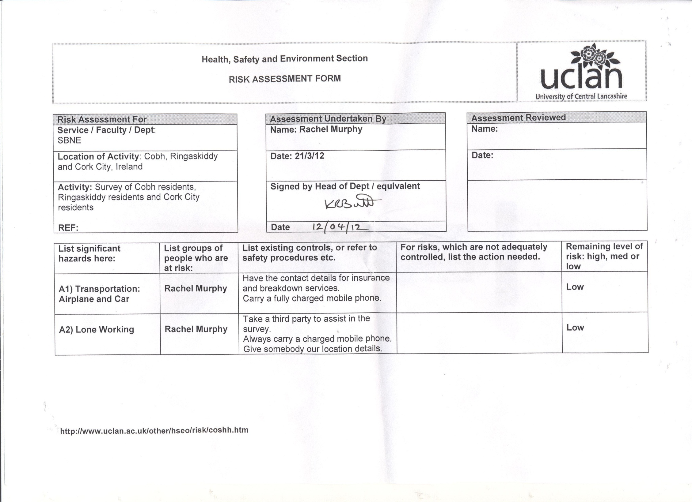
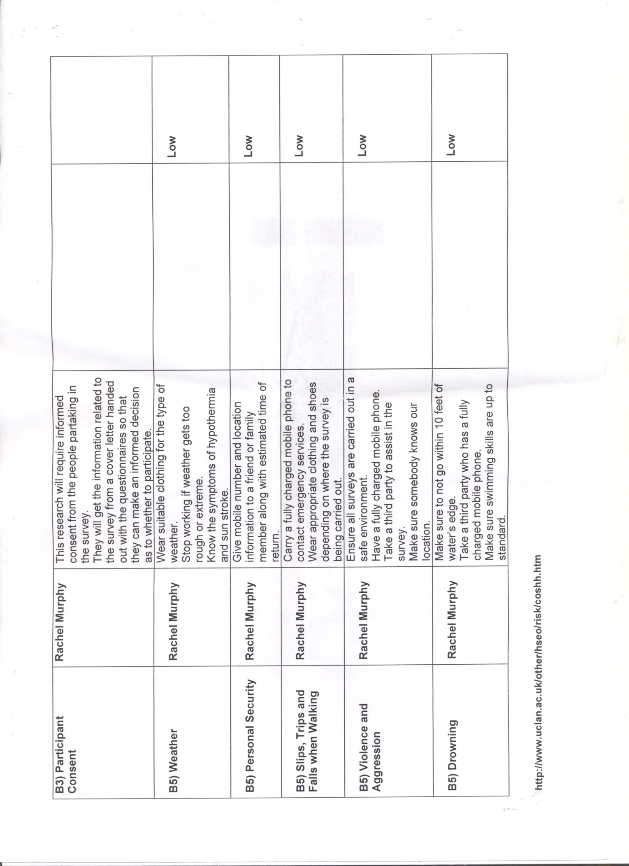

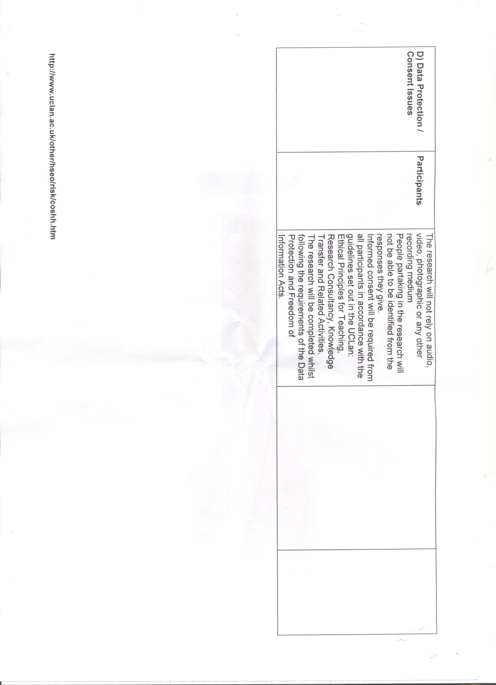

Appendix 6

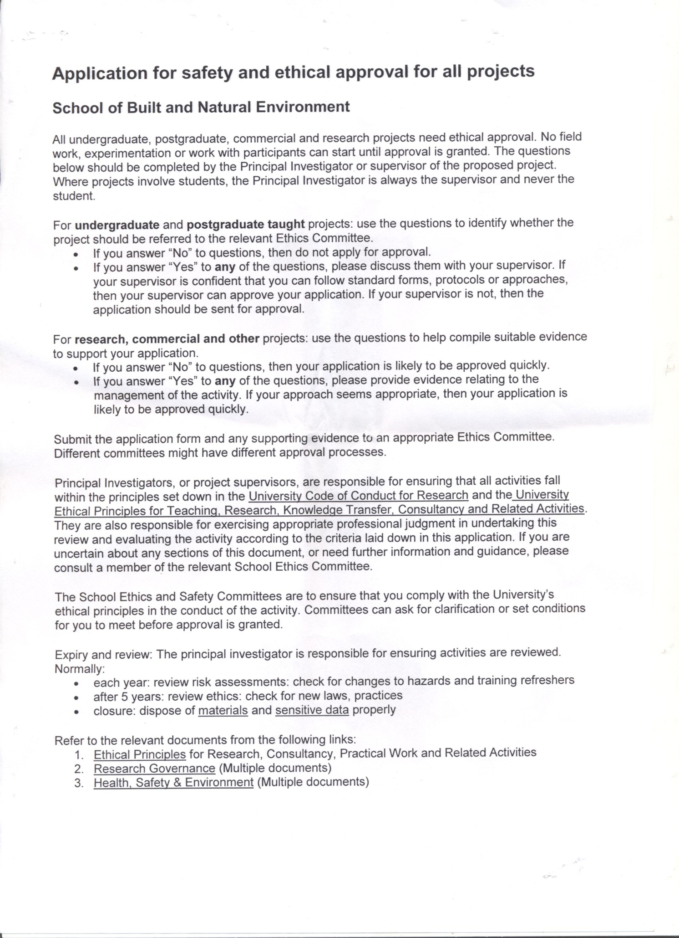
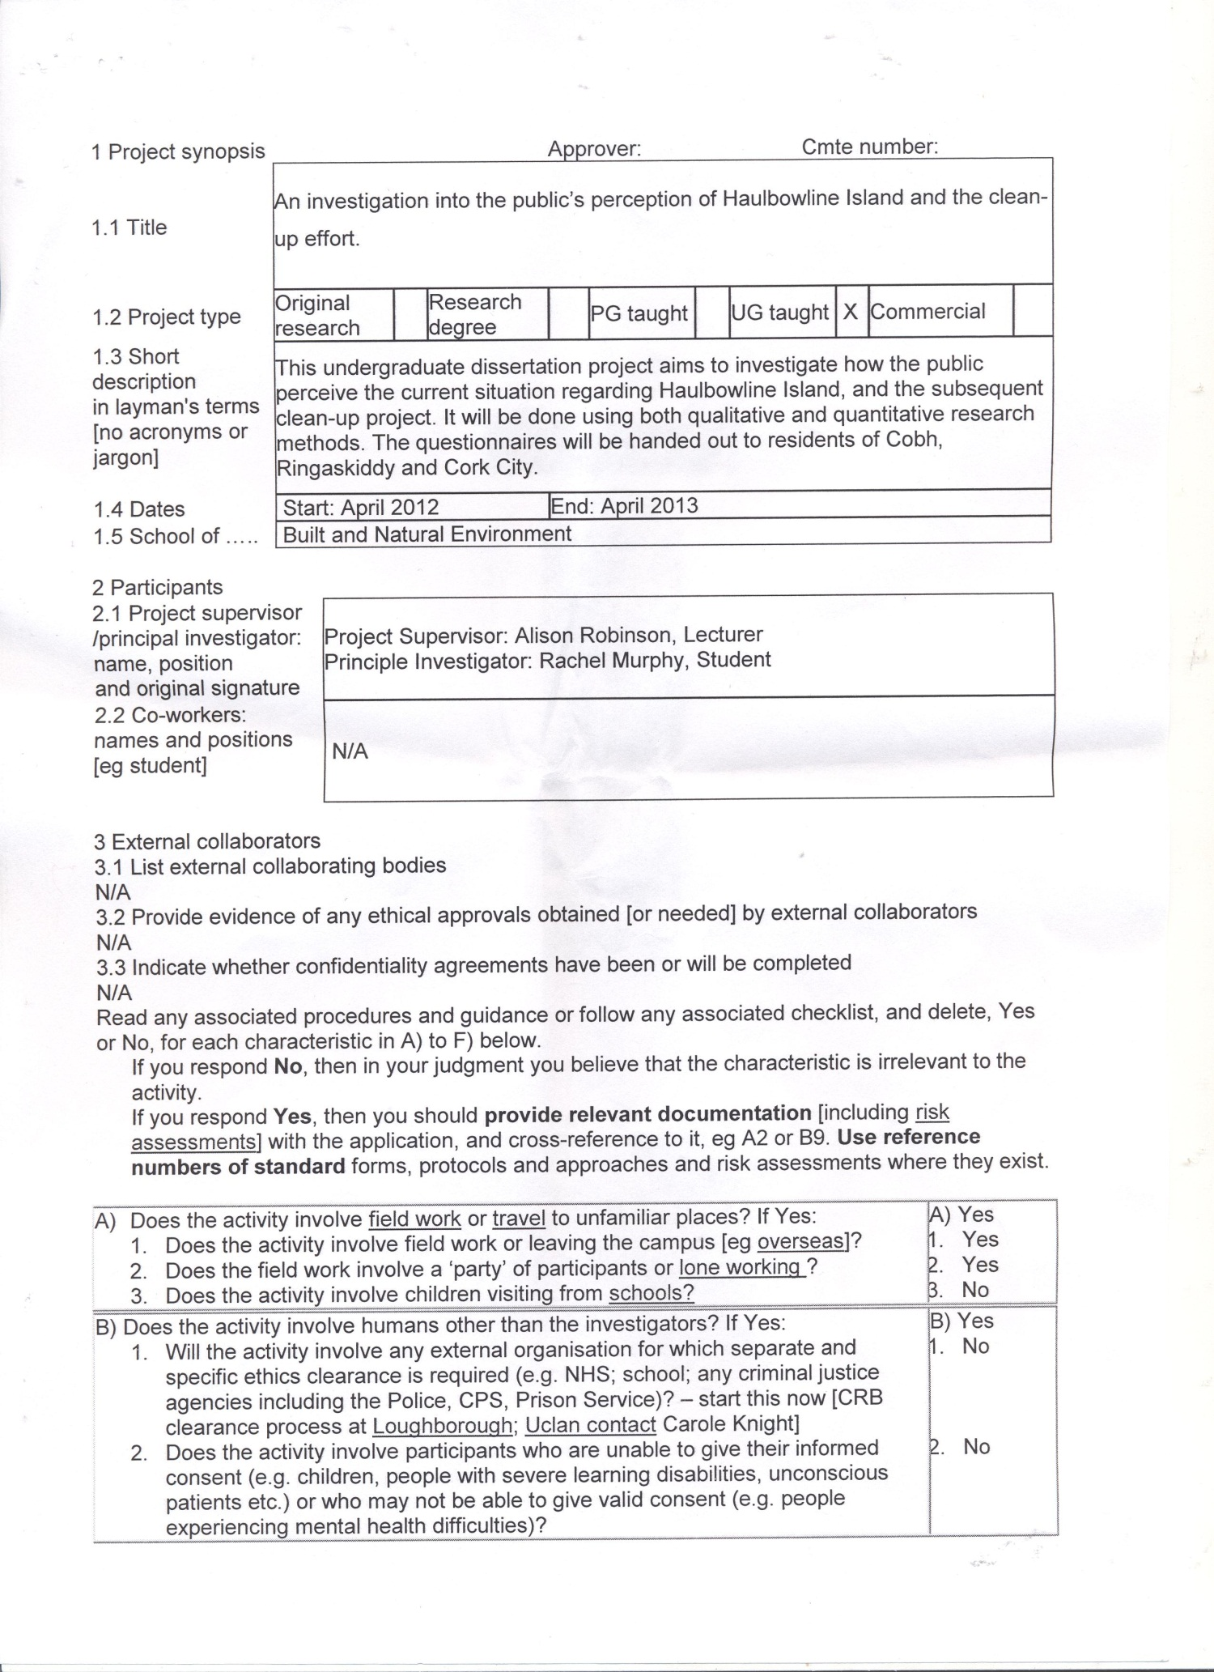
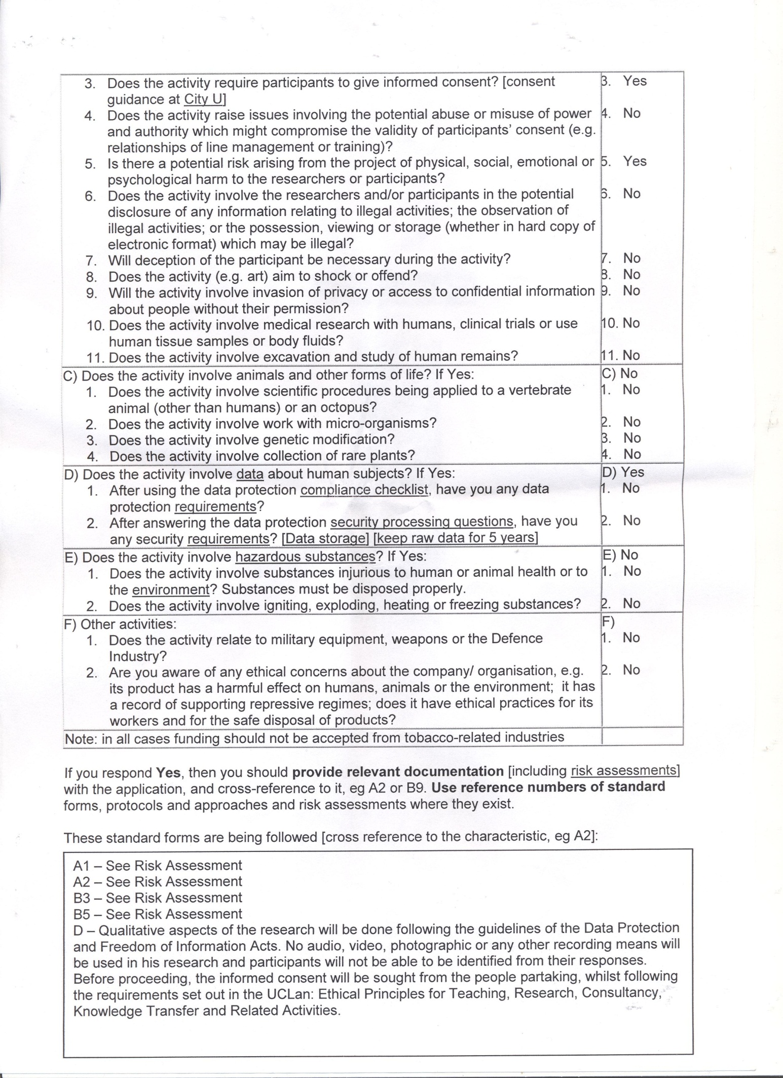
Appendix 7

Cobh Results Respondent | Q1 | Q2 | Q3 | Q4 | Q5 | Q6 | Q7 | Q8 | Q9 | Q10 | Q11 | Q12 | Q13 | Q14 | Q15 | Q16
1 | 1 | 1 | 6 | 2 |  | 3 | 4 |  | 1 | 1 | 3 | 4 | 1 | 2 | 1 | 2
2 | 1 | 1 | 6 | 2 |  | 2 | 2 |  | 5 | 1 | 5 | 5 | 1 | 2 | 2 | 2
3 | 1 | 1 | 6,7 | 2 |  | 2 | 2 |  | 2 | 1 | 6 | 3 | 1 | 1 | 2 | 2
4 | 1 | 2 | / | 2 |  | 1 | 2 |  | 6 | 1 | 5 | 2 | 1 | 2 | 1 | 2
5 | 1 | 1 | 3,6 | 2 |  | 4 | 2 |  | 3 | 1 | 2 | 5 | 1 | 3 | 2 | 2
6 | 2 | 2 | / | 2 |  | 4 | 4 |  | 6 | 2 | 5 | 3 | 1 | 5 | 2 | 2
7 | 1 | 1 | 6 | 2 |  | 3 | 4 |  | 6 | 1 | 4 | 4 | 1 | 5 | 2 | 2
8 | 1 | 1 | 6 | 2 |  | 3 | 2 |  | 2 | 1 | 5 | 3 | 1 | 4 | 2 | 2
9 | 1 | 2 | / | 2 |  | 4 | 1 |  | 5 | 1 | 2 | 3 | 1 | 1 | 1 | 2
10 | 1 | 1 | 6,7 | 2 |  | 4 | 5 |  | 2 | 1 | 3 | 5 | 1 | 4 | 1 | 2
11 | 1 | 1 | 1,4,6 | 2 |  | 4 | 1 |  | 1 | 2 | 5 | 5 | 1 | 5 | 1 | 2
12 | 1 | 1 | 6 | 2 |  | 3 | 2 |  | 6 | 1 | 3 | 3 | 1 | 3 | 1 | 2
13 | 1 | 2 | / | 2 |  | 3 | 4 |  | 6 | 1 | 3 | 3 | 1 | 3 | 1 | 2
14 | 1 | 1 | 6 | 2 |  | 3 | 3 |  | 2 | 1 | 5 | 3 | 1 | 3 | 1 | 2
15 | 1 | 1 | 6 | 2 |  | 4 | 4 |  | 2 | 1 | 3 | 4 | 1 | 4 | 2 | 2
16 | 1 | 1 | 6,7 | 2 |  | 1 | 4 |  | 6 | 1 | 3 | 4 | 1 | 1 | 1 | 2
17 | 1 | 1 | 1,6,7 | 2 |  | 4 | 1 |  | 6 | 1 | 5 | 3 | 1 | 5 | 1 | 2
18 | 1 | 1 | 1,6 | 2 |  | 4 | 5 |  | 2 | 2 | 5 | 3 | 1 | 6 | 2 | 2
19 | 1 | 1 | 6 | 2 |  | 4 | 4 |  | 5 | 2 | 2 | 3 | 1 | 4 | 1 | 2
20 | 1 | 1 | 6,7 | 2 |  | 1 | 2 |  | 3 | 2 | 5 | 2 | 1 | 7 | 2 | 2
21 | 1 | 1 | 1,3,6 | 2 |  | 1 | 2 |  | 3 | 1 | 5 | 2 | 1 | 5 | 2 | 2
22 | 1 | 1 | 6,7 | 2 |  | 3 | 5 |  | 7 | 1 | 4 | 3 | 1 | 1 | 2 | 2
23 | 1 | 1 | 6 | 2 |  | 4 | 1 |  | 6 | 1 | 3 | 3 | 1 | 4 | 1 | 2
24 | 1 | 1 | 6 | 2 |  | 3 | 5 |  | 6 | 1 | 5 | 5 | 1 | 5 | 2 | 2
25 | 2 | 2 | / | 3 |  | 4 | 5 |  | 1 | 1 | 5 | 5 | 1 | 5 | 1 | 2
26 | 1 | 1 | 1,4,6,7 | 2 |  | 4 | 1 |  | 5 | 1 | 5 | 3 | 1 | 4 | 2 | 2
27 | 1 | 1 | 6 | 2 |  | 4 | 1 |  | 5 | 1 | 3 | 4 | 1 | 6 | 2 | 2
28 | 2 | 2 | / | 2 |  | 3 | 5 |  | 5 | 1 | 5 | 3 | 1 | 1 | 2 | 2
29 | 1 | 1 | 1,3,6 | 2 |  | 3 | 4 |  | 2 | 1 | 3 | 5 | 1 | 5 | 1 | 2
30 | 2 | 2 | / | 2 |  | 3 | 4 |  | 2 | 2 | 1 | 3 | 1 | 4 | 1 | 2
31 | 1 | 2 | / | 2 |  | 4 | 4 |  | 6 | 1 | 2 | 4 | 1 | 2 | 1 | 2
32 | 1 | 2 | / | 2 |  | 4 | 5 |  | 3 | 1 | 3 | 5 | 1 | 5 | 2 | 2
33 | 1 | 1 | 6,7 | 2 |  | 3 | 3 |  | 6 | 1 | 2 | 6 | 1 | 1 | 2 | 2
34 | 1 | 1 | 1,6,7 | 2 |  | 3 | 5 |  | 6 | 1 | 6 | 3 | 1 | 5 | 2 | 2
35 | 1 | 1 | 6 | 2 |  | 3 | 4 |  | 2 | 1 | 3 | 5 | 1 | 2 | 2 | 2
36 | 1 | 2 | / | 1 |  | 3 | 5 |  | 6 | 1 | 3 | 3 | 1 | 7 | 1 | 2
37 | 1 | 1 | 6,7 | 2 |  | 3 | 3 |  | 6 | 1 | 5 | 7 | 1 | 5 | 2 | 2
38 | 1 | 1 | 6 | 2 |  | 4 | 4 |  | 2 | 1 | 5 | 5 | 1 | 1 | 1 | 2
39 | 1 | 1 | 1,3,4,6 | 2 |  | 4 | 4 |  | 2 | 2 | 4 | 5 | 2 | 4 | 2 | 2
40 | 1 | 1 | 6 | 1 |  | 4 | 4 |  | 6 | 1 | 5 | 5 | 1 | 2 | 1 | 2
41 | 1 | 1 | 6 | 2 |  | 4 | 4 |  | 6 | 1 | 3 | 3 | 1 | 5 | 2 | 2
42 | 1 | 2 | / | 2 |  | 3 | 5 |  | 2 | 1 | 3 | 3 | 1 | 4 | 2 | 2
43 | 1 | 1 | 6 | 2 |  | 4 | 3 |  | 5 | 1 | 2 | 3 | 1 | 6 | 1 | 2
44 | 2 | 2 | / | 2 |  | 4 | 3 |  | 5 | 1 | 3 | 2 | 1 | 4 | 1 | 2
45 | 2 | 2 | / | 2 |  | 4 | 5 |  | 2 | 1 | 5 | 2 | 1 | 4 | 1 | 2
46 | 2 | 2 | 1,6,7 | 2 |  | 3 | 3 |  | 6 | 1 | 5 | 3 | 1 | 6 | 1 | 2
47 | 1 | 1 | 6 | 2 |  | 4 | 5 |  | 3 | 1 | 1 | 3 | 1 | 5 | 2 | 2
48 | 1 | 1 | 6,7 | 2 |  | 4 | 5 |  | 4 | 1 | 3 | 4 | 1 | 4 | 2 | 2
49 | 1 | 1 | 6,7 | 2 |  | 4 | 4 |  | 6 | 1 | 3 | 5 | 1 | 6 | 1 | 2
50 | 1 | 1 | 6 | 2 |  | 4 | 4 |  | 2 | 1 | 3 | 4 | 1 | 6 | 1 | 2
51 | 1 | 1 | 1,6 | 2 |  | 4 | 5 |  | 1 | 1 | 6 | 3 | 1 | 5 | 2 | 2
52 | 1 | 1 | 6 | 2 |  | 3 | 5 |  | 4 | 1 | 5 | 4 | 1 | 3 | 2 | 2
53 | 1 | 1 | 1,6 | 2 |  | 4 | 5 |  | 5 | 1 | 3 | 3 | 1 | 2 | 2 | 2
54 | 1 | 1 | 1,6 | 2 |  | 4 | 4 |  | 4 | 1 | 5 | 3 | 1 | 2 | 1 | 2
55 | 2 | 2 | / | 2 |  | 4 | 5 |  | 2 | 1 | 6 | 7 | 1 | 2 | 2 | 2
56 | 1 | 1 | 6,7 | 2 |  | 3 | 3 |  | 5 | 1 | 3 | 5 | 1 | 5 | 2 | 2
57 | 1 | 1 | 6,7 | 2 |  | 3 | 2 |  | 4 | 1 | 3 | 3 | 1 | 4 | 2 | 2
58 | 1 | 1 | 6 | 2 |  | 4 | 2 |  | 2 | 1 | 2 | 3 | 1 | 4 | 1 | 2
59 | 1 | 2 | / | 2 |  | 4 | 4 |  | 6 | 1 | 6 | 4 | 1 | 4 | 1 | 2
60 | 1 | 1 | 1,2,6,7 | 2 |  | 3 | 2 |  | 5 | 1 | 5 | 5 | 1 | 3 | 1 | 2
Cork city Results Respondent | Q1 | Q2 | Q3 | Q4 | Q5 | Q6 | Q7 | Q8 | Q9 | Q10 | Q11 | Q12 | Q13 | Q14 | Q15 | Q16
1 | 1 | 2 | / | 2 |  | 1 | 3 |  | 3 | 2 | 2 | 3 | 2 | 2 | 1 | 1
2 | 2 | 2 | / | 2 |  | 2 | 1 |  | 1 | 1 | 4 | 2 | 1 | 3 | 1 | 1
3 | 2 | 2 | / | 1 |  | 4 | 5 |  | 1 | 2 | 5 | 7 | 1 | 3 | 1 | 1
4 | 2 | 2 | / | 2 |  | 3 | 4 |  | 2 | 1 | 6 | 6 | 1 | 1 | 2 | 1
5 | 1 | 2 | / | 2 |  | 3 | 3 |  | 2 | 1 | 2 | 7 | 1 | 4 | 1 | 1
6 | 1 | 1 | 1,2,3,6 | 2 |  | 2 | 3 |  | 3 | 1 | 3 | 5 | 1 | 2 | 2 | 1
7 | 2 | 2 | / | 2 |  | 2 | 2 |  | 4 | 1 | 2 | 2 | 1 | 3 | 1 | 1
8 | 2 | 2 | / | 2 |  | 2 | 3 |  | 2 | 2 | 4 | 3 | 1 | 1 | 1 | 1
9 | 2 | 2 | / | 2 |  | 3 | 1 |  | 5 | 1 | 3 | 7 | 1 | 2 | 1 | 1
10 | 1 | 1 | 4,6 | 2 |  | 3 | 3 |  | 6 | 1 | 2 | 7 | 2 | 3 | 1 | 1
11 | 2 | 2 | / | 2 |  | 2 | 2 |  | 4 | 1 | 2 | 5 | 1 | 1 | 2 | 1
12 | 2 | 2 | / | 2 |  | 1 | 2 |  | 3 | 1 | 2 | 3 | 1 | 1 | 2 | 1
13 | 2 | 2 | / | 2 |  | 1 | 2 |  | 2 | 2 | 3 | 1 | 1 | 5 | 1 | 1
14 | 2 | 2 | / | 2 |  | 2 | 3 |  | 7 | 1 | 5 | 6 | 1 | 1 | 2 | 1
15 | 1 | 1 | 1 | 2 |  | 4 | 4 |  | 2 | 1 | 5 | 7 | 1 | 1 | 2 | 1
16 | 2 | 2 | / | 2 |  | 2 | 3 |  | 1 | 2 | 2 | 2 | 1 | 3 | 1 | 1
17 | 1 | 2 | / | 2 |  | 1 | 2 |  | 6 | 1 | 3 | 2 | 1 | 4 | 1 | 1
18 | 2 | 2 | / | 2 |  | 1 | 1 |  | 6 | 1 | 1 | 6 | 1 | 4 | 2 | 1
19 | 2 | 2 | / | 2 |  | 1 | 3 |  | 2 | 1 | 2 | 5 | 1 | 3 | 1 | 1
20 | 1 | 2 | / | 2 |  | 1 | 5 |  | 5 | 1 | 4 | 5 | 1 | 2 | 1 | 1
21 | 2 | 2 | / | 2 |  | 2 | 3 |  | 4 | 2 | 4 | 5 | 1 | 5 | 1 | 1
22 | 2 | 2 | / | 2 |  | 1 | 3 |  | 6 | 2 | 3 | 6 | 1 | 1 | 2 | 1
23 | 1 | 1 | 1,3 | 2 |  | 2 | 3 |  | 1 | 1 | 3 | 3 | 1 | 2 | 2 | 1
24 | 1 | 2 | / | 2 |  | 1 | 4 |  | 5 | 1 | 2 | 3 | 1 | 1 | 2 | 1
25 | 2 | 2 | / | 2 |  | 2 | 3 |  | 5 | 1 | 4 | 4 | 1 | 1 | 1 | 1
26 | 2 | 2 | / | 2 |  | 1 | 3 |  | 2 | 1 | 1 | 3 | 1 | 1 | 1 | 1
27 | 2 | 2 | / | 1 |  | 1 | 3 |  | 2 | 2 | 1 | 7 | 1 | 1 | 2 | 1
28 | 2 | 2 | / | 2 |  | 2 | 1 |  | 3 | 2 | 2 | 5 | 1 | 3 | 1 | 1
29 | 2 | 2 | / | 2 |  | 2 | 3 |  | 6 | 1 | 3 | 5 | 1 | 4 | 1 | 1
30 | 1 | 1 | 1,3,6 | 2 |  | 1 | 5 |  | 2 | 1 | 3 | 5 | 1 | 1 | 2 | 1
31 | 2 | 2 | / | 2 |  | 1 | 3 |  | 6 | 1 | 2 | 7 | 1 | 4 | 2 | 1
32 | 2 | 2 | / | 2 |  | 2 | 3 |  | 6 | 2 | 1 | 2 | 1 | 1 | 2 | 1
33 | 1 | 2 | / | 2 |  | 1 | 4 |  | 3 | 1 | 3 | 4 | 1 | 1 | 1 | 1
34 | 1 | 1 | 1 | 2 |  | 1 | 1 |  | 3 | 1 | 2 | 5 | 1 | 4 | 2 | 1
35 | 1 | 1 | 1,3 | 2 |  | 2 | 5 |  | 1 | 2 | 3 | 4 | 1 | 3 | 2 | 1
36 | 1 | 1 | 1 | 2 |  | 1 | 5 |  | 5 | 1 | 2 | 2 | 1 | 1 | 1 | 1
37 | 2 | 2 | / | 1 |  | 1 | 1 |  | 1 | 1 | 2 | 5 | 1 | 1 | 1 | 1
38 | 1 | 1 | 6,4 | 2 |  | 1 | 2 |  | 4 | 1 | 4 | 5 | 1 | 2 | 1 | 1
39 | 2 | 2 | / | 2 |  | 2 | 4 |  | 4 | 1 | 3 | 7 | 1 | 3 | 1 | 1
40 | 1 | 1 | 3,6 | 2 |  | 1 | 3 |  | 6 | 1 | 3 | 7 | 1 | 1 | 2 | 1
41 | 1 | 2 | / | 2 |  | 1 | 5 |  | 7 | 1 | 5 | 7 | 1 | 2 | 1 | 1
42 | 1 | 2 | / | 2 |  | 1 | 3 |  | 6 | 1 | 3 | 5 | 1 | 1 | 2 | 1
43 | 2 | 2 | / | 2 |  | 3 | 4 |  | 6 | 2 | 3 | 5 | 1 | 1 | 2 | 1
44 | 2 | 2 | / | 2 |  | 3 | 3 |  | 2 | 1 | 5 | 3 | 1 | 1 | 2 | 1
45 | 1 | 2 | / | 2 |  | 1 | 5 |  | 2 | 1 | 2 | 2 | 1 | 2 | 2 | 1
46 | 1 | 1 | 2,3 | 2 |  | 1 | 1 |  | 2 | 1 | 1 | 4 | 1 | 1 | 2 | 1
47 | 2 | 2 | / | 2 |  | 2 | 2 |  | 4 | 2 | 3 | 7 | 1 | 4 | 1 | 1
48 | 1 | 2 | / | 2 |  | 1 | 4 |  | 3 | 1 | 5 | 5 | 1 | 4 | 1 | 1
49 | 2 | 2 | / | 2 |  | 2 | 2 |  | 5 | 1 | 5 | 5 | 1 | 4 | 1 | 1
50 | 1 | 2 | / | 2 |  | 1 | 1 |  | 1 | 2 | 5 | 2 | 1 | 1 | 1 | 1
51 | 1 | 1 | 1,2,3,4 | 2 |  | 1 | 3 |  | 6 | 2 | 2 | 7 | 1 | 5 | 2 | 1
52 | 1 | 1 | 1 | 2 |  | 1 | 5 |  | 3 | 1 | 2 | 4 | 1 | 1 | 2 | 1
53 | 2 | 2 | / | 3 |  | 2 | 3 |  | 6 | 2 | 6 | 3 | 1 | 1 | 1 | 1
54 | 2 | 2 | / | 2 |  | 1 | 4 |  | 3 | 1 | 5 | 6 | 1 | 4 | 1 | 1
55 | 1 | 1 | 3,4 | 2 |  | 1 | 3 |  | 2 | 1 | 5 | 1 | 1 | 5 | 1 | 1
56 | 1 | 2 | / | 2 |  | 1 | 4 |  | 4 | 2 | 1 | 7 | 1 | 1 | 2 | 1
57 | 2 | 2 | / | 2 |  | 2 | 4 |  | 5 | 1 | 3 | 4 | 1 | 4 | 1 | 1
58 | 2 | 2 | / | 1 |  | 3 | 2 |  | 1 | 2 | 3 | 4 | 1 | 1 | 1 | 1
59 | 1 | 1 | 1 | 2 |  | 1 | 5 |  | 4 | 1 | 5 | 6 | 1 | 4 | 1 | 1
60 | 1 | 2 | / | 2 |  | 1 | 5 |  | 2 | 2 | 6 | 3 | 1 | 3 | 2 | 1

Appendix 8

 | Question | Variables | Code
Q1 | Have you ever heard of Haulbowline Island? | Yes  No | 1  2
Q2 | Are you aware of the hazardous waste disposal site on the East-Tip of Haulbowline Island? | Yes  No | 1  2
Q3 | If yes, how did you hear about it? | Newspaper  Television  Radio  Internet  School  County Council Information Evening  Local Knowledge  Other | 1  2  3  4  5  6  7  8
Q4 | Which of these definitions do you think best describes toxic waste? | (a)  (b)  (c) | 1  2  3
Q5 | What caused this amount of toxic waste to become present on Haulbowline Island?
Q6 | What do you think your chances of your health being affected by the situation on Haulbowline are? | No Risk At All  Small  Moderate  Great | 1  2  3  4
Q7 | A clean-up effort on the island is underway at the moment. The County Council currently plan to retro-fit the East-Tip as a landfill and then cap it. On a scale of 1 to 5 how happy are you with this method of management of the area? | 1  2  3  4  5 | 1  2  3  4  5
Q8 | If you disagree with the method the council are using, please explain why:
Q9 | How much do you think the estimated cost is for the clean-up? | Less than 1,000,000  1,000,001 to 10,000,00  10,000,001 to 20,000,000  20,000,001 to 30,000,000  30,000,001 to 40,000,000  40,000,001 to 50,000,000  More than 50,000,001 | 1  2  3  4  5  6  7
Q10 | Do you think that it is a good way for the government to be spending this amount, especially in the current economic climate? | Yes  No | 1  2
Q11 | How much toxic waste is present on the East-Tip of Haulbowline Island? | 1 ton  100 tonnes  500 tonnes  350,000 tonnes  500,000 tonnes  1,000,000 tonnes | 1  2  3  4  5  6
Q12 | The waste has been collecting on the island for more than 40 years. How long has the Cork County Council been given to clean-up the dump? | 6 Months  1 year  2 Years  3 Years  5 Years  7 Years  10 Years | 1  2  3  4  5  6  7
Q13 | Do you feel that you should have been made aware of the situation at an earlier date? | Yes  No | 1  2
Q14 | How old are you? | Under 25  25-35  36-45  46-55  56-65  66-75  Over 75 | 1  2  3  4  5  6  7
Q15 | What is your gender? | Male  Female | 1  2
Q16 | What is your highest level of education? | None  Primary  Secondary  Post-Secondary | 1  2  3  4
Q17 | Where are you resident in Cork? | Cork city (including surrounding town lands)  Cobh | 1  2

Cobh

