The effects of limestone quarrying on the River Ribble in the Yorkshire Dales National Park


Gemma Warren
April 2013

School of Built and Natural Environment
Geography BSc

‘I declare that the main text of this dissertation is no more than 10,000 words, and is all my own work’

…………….........GWarren………………….......
Gemma Warren

Abstract
Over the past century, quarrying has become more prominent in the British Isles; however, there has been little focus on the effects of water quality from potential added quarry discharge, especially in the Yorkshire Dales. This research will aim to provide detailed water quality analysis whilst exploring reasons behind the effects of the Horton Quarry in the Yorkshire Dales.
The methods used within this study look at both physical and chemical parameters of the River Ribble. The physical parameters such as width, depth, wetted perimeter, flow and slope angle were measured by entering the River Ribble and using a metre rule, tape measure and flow meter. After which cross-sectional area, velocity and discharge were calculated. The chemical factors such as TDS, TSS, pH, temperature and conductivity, were measured using a combination of both field and laboratory methods. In the field TDS, pH, temperature and conductivity were collected by inserting a probe into collected water samples and obtaining an average value. For TSS, the water samples were filtered and then the residue was weighed once the filter papers were dry.
The study found that quarrying does have effects on water quality along the River Ribble especially concerning chemical parameters. However, it was also found that farming has an effect along the river too. After compiling results, it was found that agriculture has a greater effect on the River Ribble than quarrying possibly due to regulations and laws the Horton Quarry must adhere to in order to extract limestone within the National Park.

Acknowledgements
Dr Jo Dawson of the University of Central Lancashire for her advice, knowledge and support throughout this project
Mr Ian Fleming for his permission to undertake my research and for providing information to further my knowledge and understanding of the River Ribble and its ecology
Margaret and Karen Holmes for letting me stay with them for the duration of my initial research and data collection
Luke Clark for assisting me with the research and data collection

Table of Contents

Table of Figures 1
1.0 Introduction 2
2.0 Literature Review 4
2.1 Quarrying and its processes 4
2.2 Potential pollution 5
2.3 Agriculture and quarrying 6
2.4 Quarrying along the River Ribble 7
2.5 Quarrying effects on river water quality 8
2.6 Abandoning quarries 9
3.0 Methodology 11
3.1 Determining the study areas 11
3.2 Initial observations 13
3.3 Collecting the data 14
3.4 Testing the data 14
3.5 Method evaluation 15
4.0 Results 16
4.1.Site observations 16
4.2 River Corridor Surveys 17
4.3 Physical Parameters 17
4.3.1 Width, Wetted Perimeter and Depth 17
4.3.2 Cross-Sectional Area 18
4.3.3 Velocity and Discharge 18
4.4 Chemical Parameters 19
4.4.1 pH 19
4.4.2 Temperature 20
4.4.3 Conductivity 21
4.4.4 TDS and TSS 21
4.5 Conclusions 22
5.0 Discussion 23
5.1 General observations 23
5.2 Site by site analysis 24
5.3 Similarities 28
5.4 Summary 29
6.0 Conclusion 31
6.1 Main Findings 31
6.2 Research Limitations 31
6.3 Further Study 32
References 33
Appendices i
Appendix I – Risk Assessments and Ethics Form ii
Appendix II – Results table viii
Appendix III – River Corridor Survey ix
Appendix IV – River cross sections at each site x

Table of Figures
Figure 1 - Limestone quarrying process. Source: British Geological Survey, 2013 5
Figure 2 – Map of the selected site locations within the Yorkshire Dales 11
Figure 3 – Map of the selected sites (1) within the Yorkshire Dales 12
Figure 4 – Map of the selected sites (2-6) within the Yorkshire Dales 13
Figure 5 – Sheep along the riparian buffer strip at Horton (site 2). Source - Author 16
Figure 6 – Width, wetted perimeter & depth of the River Ribble across six sites 18
Figure 7 – Cross sectional areas of the sites along the River Ribble 18
Figure 8 – Velocity and Discharge of the River Ribble at all sites 19
Figure 9 – pH levels of the River Ribble of all study sites 20

Figure 10 – Temperature of the River Ribble from all study sites 20

Figure 11 – Conductivity values of the River Ribble at all sites 21
Figure 12 – TDS and TSS of all sites along the River Ribble 22
Figure 13 – Confluence of the Cam Beck and Gayle Beck. Source - Author 25
Figure 14 – Bank erosion near Horton Quarry. Source - Author 26
Figure 15 – Fallen tree due to bank erosion at Horton Quarry. Source - Author 26

Figure 16 – Livestock crossing area along the farm beck. Source - Author 28

Figure 17 – Vegetation at the quarry beck. Source - Author 29

1.0 Introduction
Quarries are mainly used for the extraction of raw materials for construction. Limestone is amongst a list of rock that can be excavated, with many of the quarried stones removed as larger slabs before being cut into smaller tiles, polished and being used in either industrial or residential properties. However, quarrying has its problems. The main concern is that quarries tend to be located in areas that have shallow groundwater systems and therefore have problems with drainage and discharge. This creates problems with drainage, which can be rectified by some quarries using discharge becks, like the Horton Quarry being analysed in this study.
As quarrying has become more prominent in the British Isles within the past century, there has been little focus on the affects of water quality from potential added quarry discharge and materials to river systems. The main factors associated with water quality affected by quarrying are usually suspended solids and dissolved solids, however it is unclear if these solids are transported along the entire length of the river or whether due to other environmental factors the solids are absorbed by soil along the riverbanks.
As the title suggests, this dissertation aims to outline the key effects limestone quarrying has on water quality within rivers, with a particular focus on the River Ribble in the Yorkshire Dales. The Yorkshire Dales is a limestone rich area, which is mainly exploited for construction purposes, and the exploitation is likely to increase in the future with the increase in demand. This project focuses on the topic of quarrying for a number of purposes. The first being that quarrying has not been fully studied in terms of influencing water quality, especially in the Yorkshire Dales; secondly, the project will be taking agricultural discharge into account by sampling parameters from a farmland beck for comparison to the quarry beck, and finally, the research will also hopefully provide a possible theory into how far quarrying affects water quality. This could then help to determine the extent of effects quarrying has on nearby river systems as well as provide a simple comparison to agriculture affecting water quality along the same river.
The River Ribble has its source at the confluence of the Gayle Beck and the Cam Beck, near Ribblehead at approximately 422 metres above sea level and covers nearly 75 miles before reaching the Irish Sea near Lytham, Lancashire. The majority of the river is surrounded by agricultural land, which is intensively farmed amongst other diffuse pollution sources such as quarrying. The upper catchment of the Ribble, where this study focuses, is almost untouched with many parts of the river being designated for trout fisheries and ecological importance.
This dissertation comprises of data collected through quantitative measurements. In order to produce sufficient evidence the morphological and hydrological aspects of the river shall be measured. Most of the information will have been collected whilst in the field on site visits, apart from one area of laboratory work needed to analyse the total suspended solids within each of the water samples. The research will aim to provide detailed water quality analysis whilst exploring reasons behind the affects of quarrying in the British Isles, specifically in the Yorkshire Dales. As well as this, the research will also aim to produce the following outcomes in terms of water quality in relation to the quarrying activities that are currently occurring and have previously occurred:
- Identify and study areas along the River Ribble from the Yorkshire Dales and provide water samples for field testing. Tests will include: pH, conductivity, dissolved oxygen, temperature, cross sectional area, velocity and discharge, bed load and any noticeable fauna in the area;
- Using laboratory methods, carry out a total suspended solids test on the collected water samples in order to obtain analytical data;
- Analyse the results obtained from objectives 1 and 2 to develop better knowledge and understanding of the potential effects of quarrying on water quality along the River Ribble.
In the following chapters, this study will discuss existing literature on the subject of this dissertation, with a focus on quarrying and diffuse sources of pollution. The selected methods to collect the data for this study will then be outlined and explained. After which, results will refer to this information and will then be discussed. The conclusions will look into the methods used in this study, the outcomes of the survey and will consider any changes for future analysis.

2.0 Literature Review
Over the previous few thousand years humans have altered river channel morphology, river flows and rates of sedimentation (Holden, 2008), through human activities such as urbanisation, land drainage, construction, mining and quarrying, which is the focus of this research. Each year the world generates around 400 billion tonnes of industrial waste, limestone quarrying is incorporated within this. Consequently, rivers can become contaminated with heavy metals amongst other pollutants and therefore has an effect on the water quality (Dunn et al, 2009). This chapter will cover past research into quarrying and discharge pollution affecting water quality, including case studies and parameters potentially affected.
2.1 Quarrying and its processes
Quarrying is one of the primary industries which also includes fishing and agriculture. These are all considered primary industries as they involve either the collection or exploitation of resources which have been produced by Earth’s physical processes. Whilst being a primary industry, quarrying is also a non-renewable energy source which can be highly polluting to the surrounding area (Hitchcock and Blair, 2000). What is important to remember is that quarrying is only one part of the overall industrial process which provides the raw materials for construction at a later stage of production. Not only does the process require substantial amounts of energy by using large machines but also the natural drainage, vegetation, soil and ecology suffer extensive disruptions and permanent changes. Although quarrying has a much more localised impact on the landscape, it is far more dramatic due to processes such as blasting (Hitchcock and Blair, 2000).
Quarrying provides raw materials for building, paving, construction, and other industrial purposes. Quarry sites are usually selected according to accessibility, quantity and quality of the raw materials, suitability for production and overall cost (Enis and Shechter, 1974). Most quarrying is for building purposes and raw materials are found throughout the country, many small quarries were opened in hilly areas, such as the Yorkshire Dales. Quarrying and its processes are a source of coarse and fine particle matter otherwise known as dust, which can be transported by wind to surrounding areas and may have an environmental impact (Bluvshtein et al, 2011). Quarrying includes a range of processes, such as blasting, grinding and transportation (Figure 1). Due to these processes, it has the potential to release particulate matter into the atmosphere.

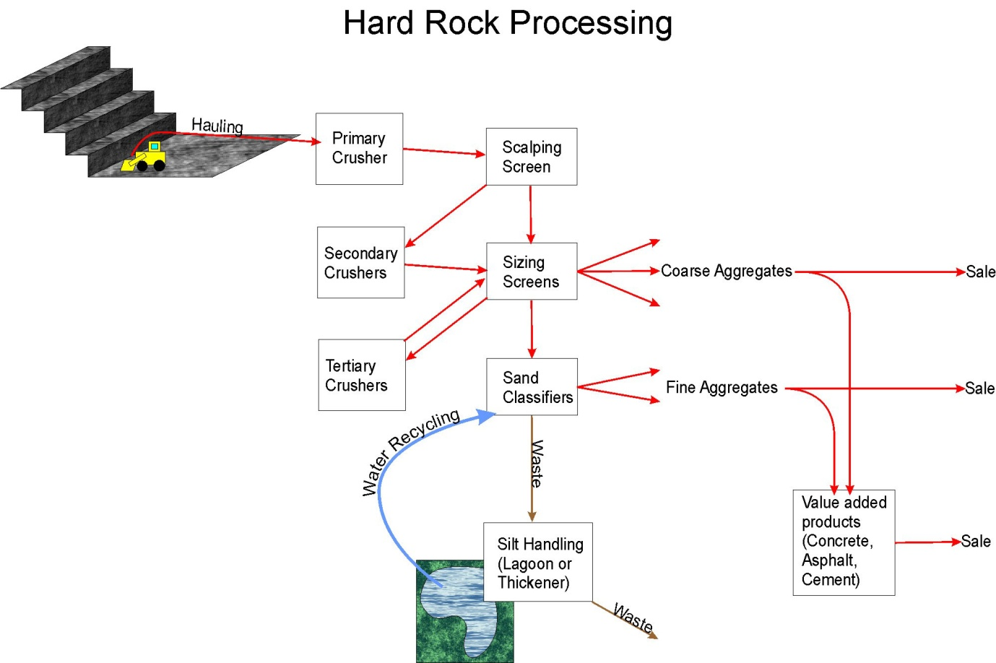
Figure 1 - Limestone quarrying process. Source: British Geological Survey, 2013
2.2 Potential pollution
Quarrying is seen as a non-point source for pollution as discharge and pollutants can enter the river system through surface or ground water and it is well known that sedimentation can increase through site runoff (Cech, 2003). Non-point sources are also known as diffuse sources, these sources are usually great in size and are too spread out to pinpoint the exact origin of pollutants (Davie, 2002), because of this suspended solids become an important factor in determining water quality as there are a number of causes and factors influencing them. Suspended sediment is a main factor when considering effects of quarrying on water quality as the solids could influence bed load, flow and the geomorphological aspects of the channel. Although this needs to be taken into account when considering potential quarry discharge, the suspended sediments are generally formed from natural processes (Davie, 2002).
Quarry discharge can arise from different aspects of rock extraction, making it possible to provide an effect on river systems both physically, (with changes in suspended sediment) and chemically, (changes in river pH) (Newson, 2009). The extraction process of quarrying is not particularly complicated, however, it can be seen to be environmentally damaging. The rock is extracted by controlled blasting, each blast uses between six and nine tonnes of explosives in order to produce approximately 20,000 tonnes of rock (LaFarge, 2010). As the blasting process is carried out around ten times a year - noise pollution, sediment discharge and dust pollution will almost be continuous. After the blasting process the limestone is picked up by a mechanical loading shovel and placed in dumper trucks. These trucks will then carry the rock to the crushing plant where it is reduced in size in a three-stage crushing process. By using these dumper trucks more noise pollution as well as carbon and sulphur pollution is emitted into the surrounding environment. Once the stone has been tested for durability, it is delivered in larger trucks or lorries which transport the limestone to construction projects all over the UK. This again creates noise and traffic pollution (LaFarge, 2010). Just from quarrying methods it is clearly noted that pollution occurs throughout the process, however, discharge becks are not usually associated as having an immediate effect on water quality when the becks become confluent with natural rivers.

2.3 Agriculture and quarrying

Farmers have traditionally quarried stone and gravel for roads, buildings, drain backfill and other purposes. This still continues, with the risk of associated discharges of turbid water. Some extraction of gravel from stream beds occurs, both casually by riparian land users and commercially. The risk of immediate release of fine sediment is obvious. In the long term, removal of only a few centimetres of gravel can destabilize the bed and banks for up to a kilometre upstream, causing bed degradation, accelerated bank erosion and meandering, and increased sediment yield downstream (Rundquist, 1980).
In this instance, gravel mining is a key problem; although similar to quarrying it takes gravel directly from the river bed. Martín-Vide et al (2010) found that the direct mining of gravel from alluvial sources is causing severe degradation to the River Tordera in Spain, although the gravel is better quality than that which has been mined, as a result the equilibrium of the river is disturbed; this includes bank instability and changes of the channel planform. At the industrial scale, quarrying and open-cast working for a range of minerals includes aggregate/gravel, sand, peat, coal, china, ball and brick clays, along with other materials. In many circumstances, these workings have the potential to generate turbid water. In some cases, use of water is integral to the process and the undertakings are controlled over discharges to watercourses.
2.4 Quarrying along the River Ribble

Limestone has been quarried for over three hundred years along the River Ribble. It was originally used to build walls, buildings and occasionally burnt into lime for agricultural use. Since its launch in the 1900s Horton Quarry has provided lime for agriculture and steel industries, before the oil kilns were demolished in 1986 (BBC, 2011). Limestone is still produced for agricultural purposes, however it is now crushed instead of burnt, but the extraction of the limestone is mainly for infrastructure such as roads. As well as the Horton Quarry in Horton-in-Ribblesdale, there is another quarry along the Ribble, which has had extended permission to excavate gritstone until 2021. Dry Rigg Quarry is located approximately four miles south of Horton Quarry and also has a discharge beck onto the River Ribble. As both quarries produce environmental pollution within the Yorkshire Dales National Park, planning policies have been produced so neither quarry operates unless no alternative sources of limestone or gritstone are available (Thornton, 2011).
Most quarrying along the River Ribble began in 1780 and by the mid-19th century fifteen quarries were in operation, including the Horton Quarry and Dry Rigg Quarry. During the latter 1800s quarries expanded as they begun to provide raw materials for towns, factories and railways. A number of quarries, including Horton and Dry Rigg, supplied hand-made paving flags for the streets and pavements for towns around the North East of England (LaFarge, 2010).
Some quarries, like Dry Rigg, have attempted to improve pollution produced form quarrying by following an environmental policy. Dry Rigg adheres to the following processes to reduce their environmental impact:
- the plant is totally enclosed to reduce dust emissions and noise outputs;
- any unused areas of the site has been restored to blend in with the landscape; and
- no stone wagons leave the site at weekends and lorry movements are restricted to certain hours mid week.
(LaFarge, 2010)
From these policies, it is clear that a few British quarries are attempting to become more environmentally friendly, yet, most policies do not take into account water quality of nearby rivers
However, there can be extreme examples of conflicts, as for instance in the Doon Valley in Uttar Pradesh, India where limestone quarrying is physically destroying the aquifer (Shaman, 1996). For those who are extracting the limestone it is seen as a good investment for industrial purposes. On the other hand many of the residents believe that the limestone is key to the water and soil resources, which many people rely on as most of the industry within the Doon Valley is of the primary sector (Bandyopadhyay and Shiva, 1985).

2.5 Quarrying effects on river water quality

Some forms of human involvement in the natural environment are potentially going to damage the physical and biological processes that occur within the river system. The natural drainage system may be damaged by the removal of surface vegetation, which reduces natural interception and increases surface runoff (Enis and Shechter, 1974). It is also well known that quarrying can cause damage by exposing soft material to erosion, which could affect water quality.
Landform changes such as urban development and quarrying activities can have a contribution to sediment supply from areas disturbed by excavation or the accumulation of earth materials (Rivas et al, 2006). Sedimentation rates increased and finer grain materials were deposited within rivers of North Yorkshire after the late forties and early fifties, which could have been due to the increase in mining, industrial and constructional activities (Green et al, 2005 ). Mineral extraction then began to affect the quality of river systems, where fish life had been plentiful. However, these species need special conditions; and between quarrying and other activities such as agriculture, they are disappearing at an alarming rate (Blades et al, 2007).
Having said this no natural water is pure H₂O, there are always dissolved solids or gases within the flow. Dissolved oxygen is affected by the aquatic organisms, which are subsequently affected by the pH of the water. Limestone quarrying could potentially have an impact on river pH and therefore aquatic organisms and dissolved oxygen levels, amongst other factors (British Geological Survey, 2012). Water quality can depend upon a number of factors such as surrounding geology and soil type. As well as this, quality also depends on the amount of water available for diluting and dispersing pollutants (Davie, 2002). The more water available, the quicker the pollutants will be dispersed. Water pollution can occur either naturally, but is generally caused by human intervention. Water is considered to be polluted if it is unusable for a particular purpose (Cech, 2003).
Temperature is also a main factor for chemical reaction rates. Previous research has shown power stations have an impact on the temperature of the river (Davie, 2002) however; limestone quarrying could also have an effect on temperature by companies using ponds with controlled temperatures in order to dissolve any unwanted sediment. If this percolates into the groundwater system the controlled water could reach the nearby river system and affect the natural temperature (Missouri Department of Natural Resources, 2006). If river water is warmer sediments can be dissolved quicker than if the water was cooler. This would then affect the total suspended solids; however, it could also be affected by additional sediments and particles into the river system.
The amount of sediments in a river system will affect the aquatic fauna able to survive (Davie, 2002). The varying amounts of suspended solids potentially make it difficult for fish and aquatic invertebrates to breed. If quarrying adds to the sediment load, species diversity shall decrease. As well as total suspended and dissolved solids affecting organisms within rivers the pH can also become an important aspect. As the Yorkshire Dales quarries are extracting limestone there is a possibility that the river could increase in alkalinity and could have an effect on potential ecology.

2.6 Abandoning quarries

Horton Quarry has activity permission until 2042, at this time the contract can either be extended or the quarry is filled and abandoned. Old quarries are of particular interest to industrial archaeologists and geologists (Turner, 1998), which has been the case for some quarries in the Lake District and each have now become part of a charming landscape which planning authorities now wish to retain. As an example the Lake District National Park Plan has “indicated a strong concern for most derelict sites to be left alone, as they form part of the landscape character giving interest and variety” (Lake District Special Planning Board, 1978). The Planning Board is also “against further large scale aggregate working in the National Park and any new quarry or extension to an existing quarry will be severely restricted” (Lake District Special Planning Board, 1978).
From the literature it is clear that quarrying has the potential to affect water quality however, it does not describe to what extent the effects are neither does it focus its case studies within Britain. This research will therefore provide detailed analysis of quarrying affecting water quality within the British Isles. The following chapter will cover the various methods used within this study along with reasons why these were chosen.

3.0 Methodology
This chapter will cover how the study sites were selected and the methods used to obtain each sample. When looking at measuring the water quality there are a variety of parameters that can be tested. Not all the parameters need to be measured in order to obtain a suitable analytical study; however the relevant features need to be measured for a particular study (Davie, 2002). For this research it will mainly be the physical parameters that are tested along with two simpler chemical parameters. This is due to the main effects of limestone quarrying affecting more physical characteristics of rivers rather than complex chemical factors.
3.1 Determining the study areas
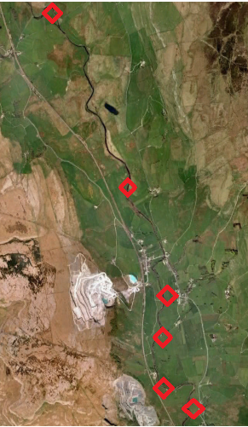
Figure 2 – Map of the selected site locations within the Yorkshire Dales
In total there are six study sites which cover approximately twelve miles from the source to Helwith Bridge (Figure 2). This gives the study a basis for exploring quarrying effects as it allows a statistically relevant amount of data, with at two water samples being taken, and reduces potential anomalies. Each site was chosen for different reasons, the first site (Figure 3) being the source of the River Ribble which should give an indication of numbers and amounts of each factor already in place, such as suspended and dissolved sediment and pH. The source will provide control samples which can be used for comparison with other sites further downstream. The second study area within the village of Horton-in-Ribblesdale provided samples of the river before the quarry discharge beck became confluent with the River Ribble. Although by this point the river would have flown approximately seven miles from its source, there are no additional becks or streams that could cause any significant change in the river parameters that are being measured by this study.
The third site is the meeting point of the quarry discharge beck and the River Ribble. The discharge beck will be measured separately from the river to compare the parameters; after which the river will be measured just after the confluence which will attempt to gather data determining any effects from the quarry after they have mixed with the River Ribble. The fourth site is approximately two miles from the confluence of the quarry discharge beck and the River Ribble. This site is being measured to determine if any material from the quarry has been added to the River Ribble and if there is still evidence of effects further downstream.
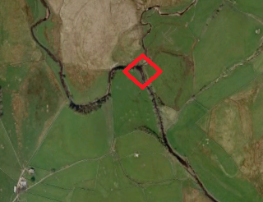
Figure 3 – Map of the selected sites (1) within the Yorkshire Dales
The fifth site (Figure 4) is another confluence of a beck and the River Ribble. The beck is formed mainly from agricultural waste such as run-off water including pesticides and fertilisers, amongst animal waste. This will be studied in order to determine if either limestone quarrying or agriculture has a stronger effect on physical and chemical river parameters. This will be done by examining pH, total dissolved and suspended solids, temperature, conductivity, flow, velocity, discharge, bed load, and comparing the results. Finally the sixth site is alongside a small reservoir near Helwith Bridge. Similarly to the fourth site, it is being measured to determine if effects of the agricultural discharge is still evident, and if it is potentially a more serious effect on a river than limestone quarrying. As Helwith Bridge is surrounded by farmland for livestock and crops and is not located near a quarry, if any effects are still being found – or if any parameters increase, there is a fair chance it could be due to the surrounding agriculture and not the limestone quarry, mainly due to the decline in pH as limestone is an alkaline substance and the increase in total dissolved solids from livestock waste and percolated fertilisers.
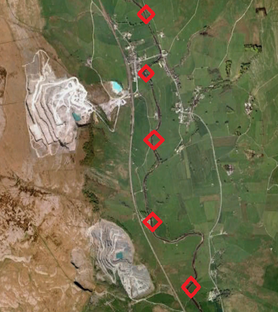

Figure 4 – Map of the selected sites (2-6) within the Yorkshire Dales
After the six sites were chosen it was decided that the study was best conducted in summer in order to utilise better weather conditions associated with the season, such as reduced rainfall. By collecting the samples from each site during this period, there is a likelihood of the results being influenced by precipitation and will therefore show the quarrying effects more clearly.
3.2 Initial observations
At each of the sites mentioned above a river morphology survey is carried out. This morphology survey will include parameters of width, depth, wetted perimeter, velocity, flow, cross-sectional area, pH, temperature, total dissolved solids, total suspended solids, conductivity and discharge of the River Ribble at these specific points. By measuring these factors it could help to identify any spikes or anomalies within the data suggesting alterations made by human activity, such as quarrying.
On arrival at each site, initial observations and photographs were taken which will allow comparisons of surrounding environments and could further knowledge of any factors that could otherwise influence the quality of the river water. After which, the safest access point into the river was chosen in order to comply with the completed ethics and risk assessment forms (Appendix I).
3.3 Collecting the data
Using a tape measure the river width and wetted perimeter at each site will be noted, this will then be followed by dividing the river width into one metre intervals in order to measure the depth of the river from its left bank to its right bank. By dividing the width into smaller intervals the information and data collected will be more accurate which could enable an increased accuracy with calculations, results, graphs and diagrams.
After the depth has been measured, the flow is calculated along the same one metre intervals to create a more accurate result for average velocity and discharge of the River Ribble at each site. This will be done by using a flow meter which is a small rotating blade attached to a device which counts the rotations the blade makes within a sixty second time period. This will be carried out three times at each metre interval across the River Ribble at each individual site in order to obtain average river velocities.
Once this is complete, the angle of the river surface is taken using a clinometer. This is done at both banks and the centre of the River Ribble in order to attempt if the river slope is similar across its width or if the bed is sloping differently. Once these angles have been taken the result will be noted and two water samples will be collected using 750ml bottles at either side of the river, to look at variations between the banks of the River Ribble and if one is affected more by any parameters than the other. When the two discharge becks are studied there will only be one water sample in 750ml bottles collected from both sites as the becks are not wide enough to collect samples from either bank. The samples will be stored in the 750ml bottles until laboratory access is given to perform a test concerning total suspended solids.
3.4 Testing the data
After the water samples have been collected at each of the six sites, there will be various tests undertaken to determine other parameters. By using two separate handheld devices the samples are tested for pH, temperature, total dissolved solids and conductivity. The first device measures pH and temperature. By submerging the small probe into the collected samples the equipment will give a reading for each parameter. This will be done three times for each sample in order to obtain an average, for an accurate measurement. The second implement that can be used in the field will measure the conductivity and total dissolved solids within the samples. This probe will also be submerged to obtain a reading, and will be done three times for an equally accurate result as the first instrument.
After all the testing in the field is complete, the samples will be kept in a fridge to an average temperature from results data, in order to keep the samples in a natural state as possible. After which each sample will be tested in the laboratory for total suspended solids. In order to weigh the suspended solids accurately, the first step will be to weigh the individual filter papers separately. The papers which will be used are grade III, approximately 47mm in diameter and have a holding capacity of 6µm; these will be labelled to correspond with the sample that will be filtered onto the paper. By inserting the filter paper into the filtering device and using the magnetic measuring flask to seal it, a beaker is place underneath and is attached to a vacuum, which will pump the water through the filtering device. As the samples will be in large volumes each sample will need to fill three beakers before removing the filter paper and the leftover sediment.
Once this has been completed for each sample, the filter papers will be placed on a tray in order for any remaining water to dry, therefore leaving only the filter paper and what was suspended sediment. After the samples have dried, each one will be weighed and the final result will be calculated from taking the initial weight of the filter paper away from the combined weight of the paper and the sediment, after being converted into milligrams per litre (mg/l) this will then give the amount of total suspended solids within each sample.
3.5 Method evaluation
The methods chosen to collect these samples are the most common when it comes to river channel morphology surveys. By measuring the variety of factors through this survey, it enables an increased understanding of the river and any potential causes of its changing channel behaviour. Measuring most of the parameters whilst in the field will give an increased accuracy to the results rather than keeping the samples to be tested in a laboratory, as the river is a natural environment rather than a controlled area. The total suspended solid parameter is the only exception to this due to the need for filtering devices to remove the water and retain suspended sediments.
Using the suggested methods above and therefore collecting a variety of results from a number of considerations the hypothesis of this study will be easier to conclude and the theory should be more accurate than if the study was only considering one parameter.
The water samples were collected in summer, throughout this season the River Ribble had a higher flow than expected due to heavy rainfall being received the preceding week before the data was collected. Fortunately, the River Ribble was still safe to enter and collect data from the channel centre at each individual site. A notebook was used to record all data taken in the field and in the laboratory, as a table for each sample area. Complete data tables were then produced to compare parameter variations downstream (Appendix II).
Although most of the River Ribble sites were along public footpaths there was not a significant amount of hikers or dog walkers, which in turn made the data collection easier. The footpaths made gaining access to the sites easier and safer, especially as some were close to nearby steep, rocky hills.

4.0 Results
In this chapter, most of the results will be presented in graph format with a detailed description of significant values and/or any anomalies; with referral to previous studies and literature. When looking at the results it is important to refer back to previous studies to understand any similarities or differences these results could have. As well as this, the sites and surroundings from where the data was initially collected must be considered to attempt to describe possible causes.
4.1 Site observations
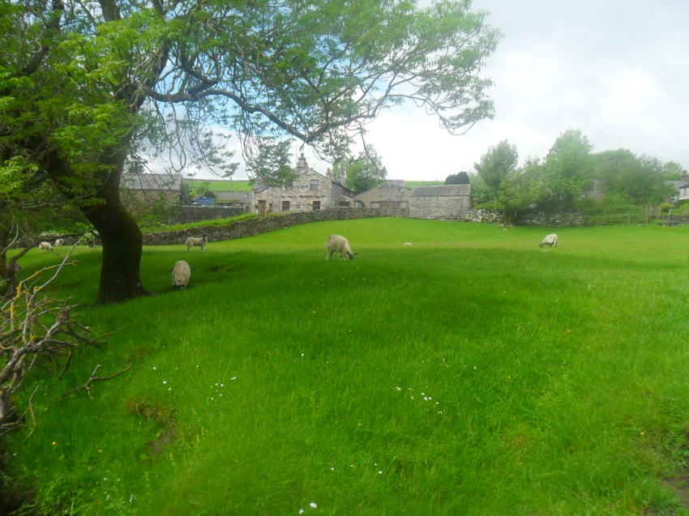
Farmland was the major surrounding for every site, except for when the quarry beck (site 3) becomes confluent with the River Ribble at site four. At this point, although farmland was evident, the quarry was more significant due to the pH being more alkaline than acidic. At the third site in Horton-in-Ribblesdale, there were sheep along the riparian strip of the River Ribble and some had been standing along the shallow banks (Figure 5). It was also noted that defecation was located close to each bank (site 2 and 5).There were no significant differences at any individual site other that of the quarry, each site had evidence of slight bank erosion and vegetation was very similar, with grass and trees making up most of each riparian buffer.

Figure 5 – Sheep along the riparian buffer strip at Horton (site 2). Source - Author

4.2 River Corridor Surveys
The corridor survey (Appendix III) shows the changing physical aspects of the River Ribble along with the changing vegetation patterns. Most of the surrounding vegetation is grassland or deciduous trees, such as elm and birch. The survey also denotes locations of farms and both active and disused quarries, as well as areas where livestock had been grazing.
4.3 Physical Parameters
4.3.1 Width, Wetted Perimeter and Depth
The source (site 1) has the largest width and wetted perimeter amongst all sites tested on the River Ribble (Figure 6), 15m and 16m respectively. The quarry discharge beck (site 3) has the lowest value of both width and wetted perimeter with 1m and 1.5m respectively. There seems to be a trend of the River Ribble gradually reducing in width as it flows further downstream, as does the wetted perimeter. When considering depth of each study site the trend is also decreasing as the river flows further downstream with the exception of the farm beck (site 5) with an average depth of 0.705m. The quarry beck (site 3) once again has the lowest value for depth with a shallow 0.09m.
Figure 6 – Width, wetted perimeter & depth of the River Ribble across six sites
4.3.2 Cross-Sectional Area
Similarly to the previous physical aspects, cross-sectional area also has a downward trend as the river flows downstream (Figure 7). The farm beck (site 5) is the anomaly with this trend as the cross section spikes to 7.1m². Although the cross sectional areas vary between the sites, each cross section (Appendix IV) takes a regular channel form, increasing towards the centre and decreasing towards each bank.
Figure 7 – Cross sectional areas of the sites along the River Ribble
4.3.3 Velocity and discharge
Unlike conductivity there is a direct contrast between the two discharge becks when looking at velocity and discharge (Figure 8). The agricultural beck has the highest velocity and discharge, 4.2m²/s and 2.98m³/s respectively. However the quarry discharge beck has the minimal velocity and discharge values with 0.9m²/s and 0.000081m³/s respectively. The source of the River Ribble has the second highest values for flow, velocity and discharge. The discharge seems to slightly decrease across all of the sites before increasing at the agricultural beck. This however, is not consistent with the velocity values, which seem to spike at both confluences of the becks and the River Ribble.
Figure 8 – Velocity and Discharge of the River Ribble at all sites
4.4 Chemical Parameters
4.4.1 pH
The pH of most of the sites were alkaline with the limestone quarry discharge beck having the highest pH at 11. When the discharge beck became confluent with the River Ribble it did affect the pH by rising from 8.9 to 9.7 (Figure 9). When the agricultural beck reached the river there was a greater change in the pH, as there was a decrease from 8.9 to 6.4. This effect is much more significant as the quarry discharge, with a change of 2.5 units. Altogether the change in pH from the source of the River Ribble to the final site is between 0.1 – 0.5 units, showing a downward trend in pH as the River Ribble flows further downstream

Figure 9 – pH levels of the River Ribble of all study sites
4.4.2 Temperature
Temperature is another parameter that appears to be almost consistent throughout the study (Figure 10). There is little variation from 10°C to 12°C at each site. The quarry discharge beck is the coolest temperature taken from the field data, which seemed to reduce the River Ribble temperature by 0.4 – 1.1°C. The beck from farm lands did not seem to have a great effect on the river temperature, as there was only a difference of 0.1-0.2°C. Having said this, the final site is, on average, 0.7°C higher than the temperatures taken from the source of the River Ribble.

Figure 10 – Temperature of the River Ribble from all study sites
4.4.3 Conductivity
Both discharge becks had the highest conductivity rates (Figure 11). The agricultural beck had the highest conductivity level at 915µS/cm (micro Siemens per centimetre of water) (Canadian Government, n.d) with the quarry discharge beck averaging 598µS/cm. When the quarry discharge beck meets the River Ribble, there is a significant increase in the conductivity, from 184 – 591µS/cm. The agricultural beck also has a similar effect on the River Ribble conductivity with a rise of 40µS/cm but this is not as significant. Although the agricultural discharge beck has the highest conductivity measures, the quarry discharge seems to have a greater effect on the River Ribble.

Figure 11 – Conductivity values of the River Ribble at all sites
4.4.5 TDS and TSS
The values for the total suspended solids along the six study sites rise exponentially at the two discharge becks (Figure 12), the agricultural beck having the highest level similarly to its flow, velocity, discharge and conductivity rates. The source (site 1) has the second lowest level of suspended solids with 2.2mg/l whilst the lowest value of 1.27mg/l is found at site four. Similarly to the total suspended solids, the highest two values of total dissolved solids are also from the two discharge becks with 406mg/l (site five) and 290mg/l (site 3), followed immediately by site four, the confluence of the quarry discharge beck and the River Ribble, with 286mg/l. Site one, the source of the River Ribble, has the lowest form of dissolved solids with 89mg/l. The dissolved solids do not follow a specific pattern unless only considering the becks and the River Ribble confluences of each. Aside from one anomaly at the second site, where the values of the total suspended solids are inconsistent with the total dissolved solids, the values seem to follow a positive growth pattern where if the value of total dissolved solids has increased, so has the rate of total suspended solids.

Figure 12 – TDS and TSS of all sites along the River Ribble
4.5 Conclusions
There is a consistency for the two discharge becks (site 3 and site 5) to have the highest amounts of each parameter, with the exception of velocity and discharge of the quarry beck (site 3). Site one, the source of the River Ribble, tends have the lowest value for all the chemical parameters and some of the highest physical factors. Some of the parameters also seem to have anomalies within the results, whereas others have a constant trend. These results shall be discussed further in the next chapter.
5.0 Discussion
In this chapter the results of the study will be discussed in more detail, with explanations of each parameter and how the results are consistent or inconsistent with previous literature, as well as combining the results of this research with other case studies for comparisons. It will take into account any anomalies that have been found and offer explanations as to why these exist within this study.
5.1 General observations
Although the Ribble Valley received heavy rainfall and flooding in some areas between June and July, the River Ribble was not greatly affected (Lancashire Country Council, 2012). However, this precipitation would have had an impact on the geomorphological aspects of the River Ribble, including depth and wetted perimeter. As the River Ribble was still shallow enough for livestock to enter at sites two, five and six which could have had an impact on the suspended and dissolved solids found within the water samples. When the livestock, particularly sheep in the case of this study, wade into the River Ribble, direct defecation noted from site observations becomes a factor that could potentially affect parameters such as pH, total suspended solids and total dissolved solids.
The pH levels were not strongly alkaline at each site of River Ribble even though it has been flowing through a limestone rich area. Limestone is an alkaline substance, which would increase the pH over 7.0, and at the limestone quarry discharge beck the pH again becomes increasingly alkaline rising from 8.75 to 11 (Figure 9). The River Ribble flows within a catchment rich in Millstone Grit and Carboniferous Limestone which enters the river through natural spring water running through the groundwater table (National River Authority, 1995).
Total suspended solids tended to increase as the sites became further downstream, with the exception of Crag Hill (site 4) where the results decreased by 5mg/l (Figure 12). The data increased at both discharge becks, with the agricultural beck being the highest, which could be due to the heavy rainfall which was received in the weeks prior to the study. However, rain particles absorb gases and particulates as it falls through the atmosphere. As the precipitation contacts the ground it dissolves fertilisers, pesticides and other possible chemical pollutants from industrial waste, in this case quarry discharge (Pagenkopf, 1978). This subsequently could have affected soil erosion from increased run-off which would have increased the level of suspended sediment (Murphy, 2007).
Carboniferous limestone will be easy to dissolve if the river water is slightly acidic as the sedimentary rock contains calcium and carbonate (Cossey and Adams, 2004). This could become dissolved into the River Ribble which not only increases the total dissolved solids but also the pH. Similarly to this, the total dissolved solids steadily increased the further downstream the data was collected. Again, with the exception of Crag Hill (site 4) which showed a decrease in dissolved sediment by 24mg/l. The decrease in dissolved sediment could be due to the water being softer as the dissolved ions are more resistant to pH changes (Bryant et al, 2002).
Conductivity is the number of ions present in the water sample and can be related to temperature (Golterman, 1969). Although there is no specific indication of ions present within the water samples; the higher the concentration of these ions will cause a rise in conductivity. The degree of conductivity can also be influenced by temperature, as ionisation processes are usually greater with higher temperatures. Therefore it can be assumed that the differences in conductivity are determined by the different in ion concentrations within the River Ribble. When looking at the sites in this study, there is a positive correlation between all sites with conductivity tending to increase downstream. This could be due to the increase in man-made surroundings such as the quarry, as well as the natural environment increasing in dissolved calcium carbonate.
Slope angle tended to increase downstream as the surrounding landscape became increasingly lower. The angle of slopes will affect the run-off of water and potentially higher or lower the average velocity and discharge. The angle of the River Ribble at the quarry beck (site 3) was 2° lower than the farm beck (site 5), and subsequently the velocity was lower by 0.33m²/s (Figure 8). This would have then affected the two confluence sites (site four and site six) as a higher velocity could have increased the River Ribble’s velocity. Another consideration in angle and velocity is bed load. The increased roughness of the bed of the River Ribble could have reduced the flow of the river and therefore the velocity and discharge of the study sites. The presence of bed load and suspended particles potentially induced by bank erosion could cause an increase in flow resistance and therefore a decrease in total velocity and discharge (Omid et al, 2010).
5.2 Site by site analysis
The source of the River Ribble did not have the lowest results of all measured parameters as was expected. Most of the results were not as high as some further downstream, and the site had the least value of total dissolved solids at 91mg/l from the right bank and 87mg/l on the left bank. As the source had an angle of 5° it has the second largest velocity and discharge levels. As the source is a confluence of two smaller becks (Figure 13), the alkalinity was evident as a water way flowing through a carboniferous limestone area. Calcium carbonate, or limestone, tends to have a pH of between 7.0 and 8.4 (Trudgill, 1985), as the source (site 1) has an average pH of 8 (Figure 6) it can be assumed that the River Ribble is consistent with a typical limestone waterway.
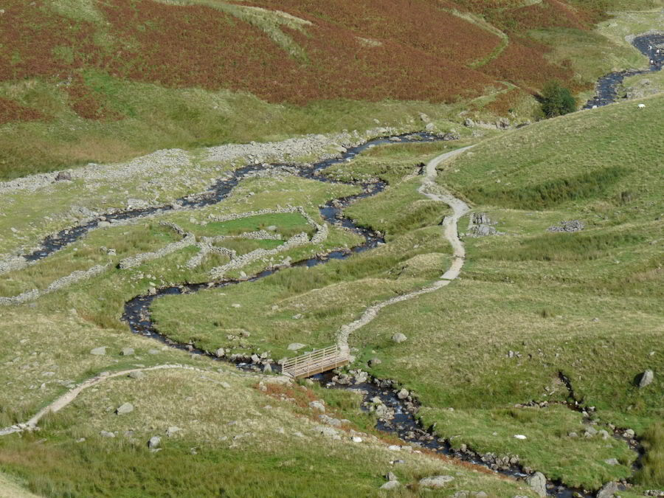

Figure 13 – Confluence of the Cam Beck and Gayle Beck. Source - Author
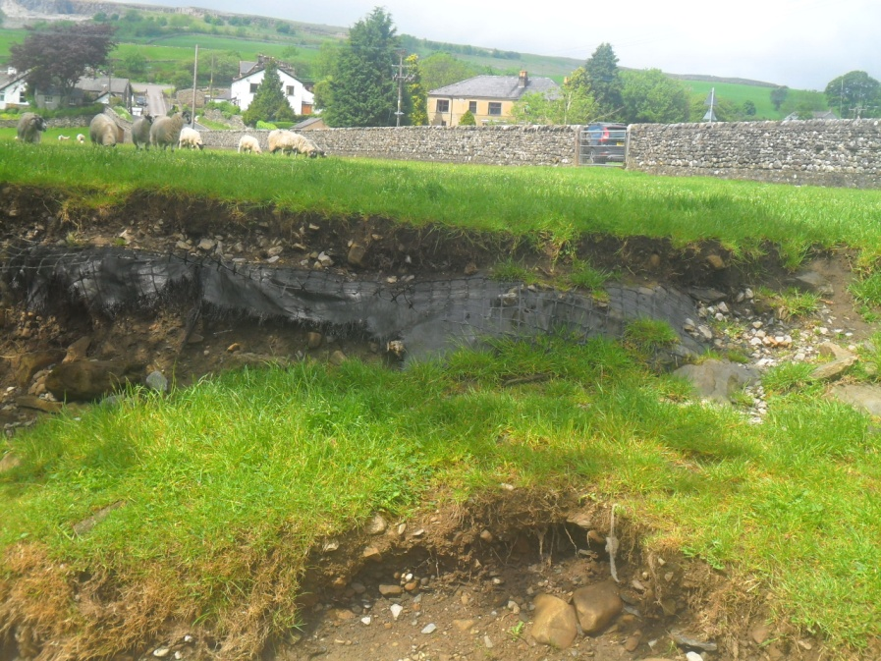
Horton-in-Ribblesdale is approximately 7 miles downstream from the source of the River Ribble (site 1). It has a relatively low flow, velocity and discharge in comparison to other sites which could also be due to the slope angle being 3° lower than other areas. The total dissolved solids were not high like other sites; however the total suspended sediment is the largest level which appears to have occurred naturally, before the two discharge becks (site 3 and 5) have become confluent with the River Ribble. The increase in total dissolved solids could have been due to the livestock entering the River Ribble and grazing along the riparian buffer (Figure 5). As well as the livestock potentially affecting results, the site could also have an influence from the source in terms of pH, total suspended and dissolved solids and velocity. Sediment could be transported from the source or from bank erosion upstream to this second site at Horton which could have affected velocity.
The quarry discharge beck has the highest alkalinity level with a pH of 11.0 which affects the River Ribble at the confluence of both waterways. This high pH could be due to the underlying carboniferous limestone which is being quarried, as well as the quick lime areas in close proximity to the discharge beck. There is some evidence of bank erosion (Figure 14) which can increase sedimentation within the River Ribble (USGS, 2001), and therefore increase the total suspended and dissolved solids. This is proven by both results increasing at a large rate and being the second highest values taken of each parameter, 15.87mg/l for suspended sediment and between 87mg/l and 198mg/l for dissolved solids, when compared with all the sites. Conductivity is once again the second highest value when compared to all sites, which when meeting the River Ribble increases the conductivity by 297µS/cm. The increase in conductivity can be due to many factors including dissolved and suspended sediments, temperature and the geology of the area (APHA, 1992). As the discharge beck is directly from the quarry, it can be assumed that the main influence in the high conductivity is due to dissolved and suspended solids.

Figure 14 – Bank erosion near Horton Quarry. Source - Author

The confluence of the River Ribble and the quarry discharge (site 4) shows not only an increase in conductivity but also an increase in flow, velocity and discharge. The pH is also increased by approximately 0.7 units from 8.75 to 9.45. There is also an increase in total dissolved and suspended particles which is due to the discharge beck. It can also be assumed that the slight decrease in temperature by roughly 1° is also due to the quarry discharge beck, as this has the coolest temperature from all sites. The velocity and discharge could have slightly increased due to the increase in flow when the discharge beck met the River Ribble. There is also a significant amount of vegetation surrounding the site which potentially controls the nearby livestock (USGS, 2001); it could also affect the turbidity of the River Ribble as some trees along the riparian buffer have fallen into the water due to bank instability (Figure 15).
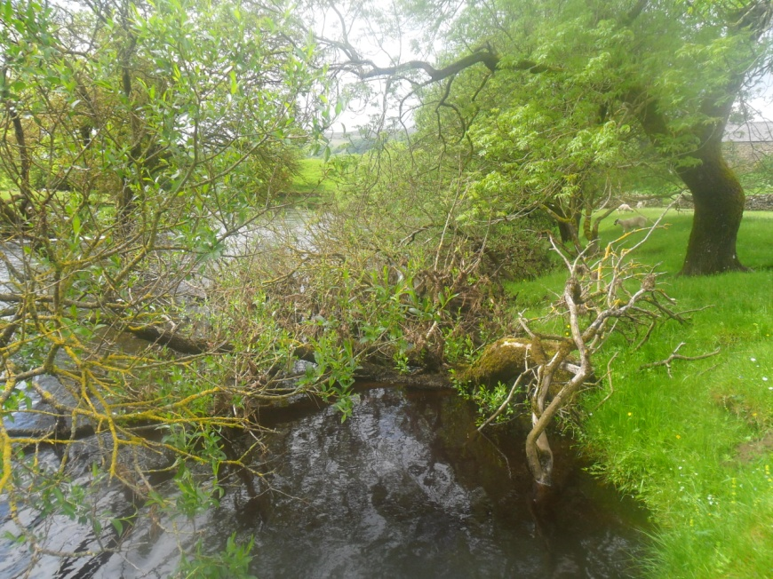

Figure 15 – Fallen tree due to bank erosion at Horton Quarry. Source - Author
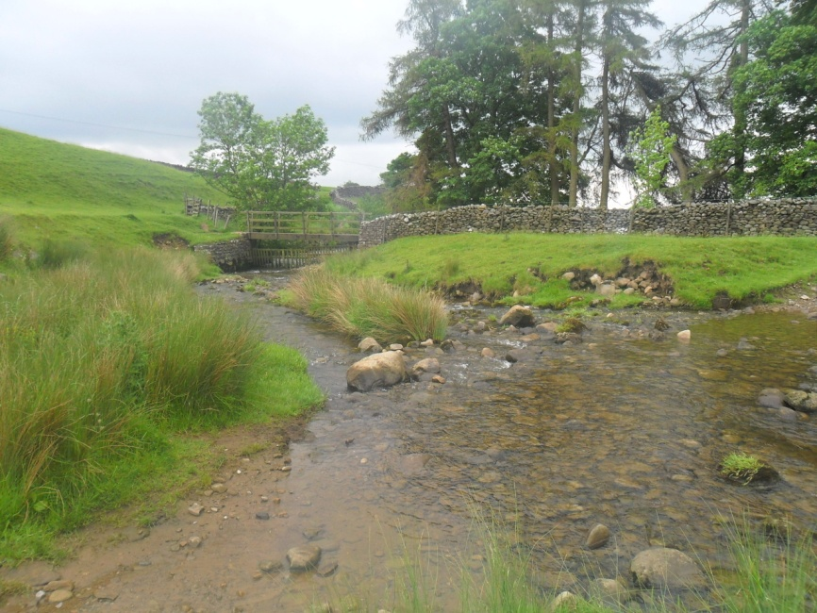
Crag Hill (site 4) provided low results for most parameters tested in the field and laboratory. This could be due to the effects from the quarry beck (site 3) still being evident within the river system. For example, the total dissolved solids increases to 286 mg/l from 145mg/l at Horton (site 2). As the fourth site is directly after the confluence it can be assumed that the 290mg/l of dissolved solids from the quarry beck (site 3) is the main influence. The bed load was particularly high with the average size being 25.3cm which could have affected the velocity and discharge of the River Ribble, offering an explanation as to why these are the lowest at this site, 0.242m²/s and 1.09m³/s respectively (excluding the quarry beck). As the temperature is high, this could explain the conductivity levels still being high in comparison to other sites. Temperature is a main factor when considering values of conductivity as it determines the amount of ions dissolved within the river system (Gardner and Moon, 1983). Although in this study the conductivity does not appear to be affected by temperature in comparison to it possibly being affected by the two discharge becks (site 3 and 5).
The total suspended and dissolved sediments drop significantly between the source (site 1) and Horton (site 2), this could be due to human error as there is more evidence of bank erosion around the site, and as the bed load is larger here the suspended sediment will take longer to pass through the bed rock (USGS, 2001). Having said this, the increased bed load could have reduced the flow of the river, which is evident in this study as the average velocity decreases from 0.034m/s to 0.217m/s (Figure 8). From this decreased flow the sediment will not have been mixed and would more than likely not become suspended.
The farm beck (site five) gave the highest results for most of the parameters that were tested at each site. As it had the fastest flow rate, it provided the fastest speed of velocity and discharge. This could have been caused by the steepness of the hillslope as it was almost 5° steeper than the quarry discharge beck. The conductivity was also the highest out of all the sites which could have been caused by the high rate of dissolved and suspended solids within the water. The total suspended and dissolved sediment was the largest value, 25.7mg/l and 406mg/l respectively, out of all the compared sites, which have been caused by the evident bank erosion, potential run-off of fertilisers or pesticides that had become dissolved by precipitation, as well possible defecation from livestock crossing the beck or standing in it (Figure 16).
The only parameter which was measured as the lowest was the pH value. This pH level of 6.65 was more acidic than alkaline, which again could have been caused by livestock, dissolved or suspended sediment, or excess agricultural waste, such as sheep dip. Sheep dip is a form of insecticide that protects sheep from lice or tick infestations. Plunge dipping is commonly used in the Yorkshire Dales, with a permanent structure built into the ground. This structure is constantly filled with a mixture of water and the dip which could permeate the soil and eventually reach the River Ribble (Environment Agency, 2011). Alternatively, sheep walking through water ways after being recently dipped can cause an increase in dissolved solids and a decrease in pH (DEFRA, 2005). As this site has an area for livestock crossing (Figure 16) this must be considered.

Figure 16 – Livestock crossing area along the farm beck. Source - Author
Helwith Bridge (site 6) is the final study site within this project. It had a relatively low flow and therefore a lower velocity and discharge rate than other sites. It has a high level of conductivity which could be caused by the temperature being the warmest out of all the water samples within the study, and also from the effects of the joining agricultural beck. The pH is rising after the acidity of the preceding beck which is likely to be because of the limestone geology of the area which will balance out the acid by slowly dissolving ions into the River Ribble. The total suspended solids have decreased dramatically from the beck beforehand, which could be due to the smaller bed load at Helwith Bridge, allowing a greater free flow of sediments.
5.3 Similarities
Horton-in-Ribblesdale (site 2), the quarry beck (site 3) and the farm beck (site 5) all have livestock access into the River Ribble; this is due to the surrounding land being used for grazing. The steadily rising slopes of the surrounding hills from 2° to 9° between the source (site 1) and Helwith Bridge (site 6) means run off will become slightly faster so any sediment both suspended and dissolved will have become increased in the River Ribble. All sites have an alkaline pH which is consistent with the surrounding geology of the landscape. The carboniferous limestone, locally known as Great Scar Limestone or Horton limestone at the study sites, which formed approximately 330 million years ago, dissolves in water containing carbon dioxide (Wilson, 1992) which in turn heightens the pH.
The bank erosion that is evident at nearly all sites could have been caused by various factors; the areas in close proximity to livestock the banks could have given way from trampling, grazing and ground saturation from rainfall and river erosion. However, the abundant vegetation at the quarry discharge beck (Figure 16) provided a buffer for the small stream, decreasing the likelihood of any outside factors like livestock affecting the levels of the different parameters. The discharge beck was not close to a footpath until the confluence of the River Ribble, which could have affected the values of results but, the footpath was 1.5 metres away from the bank of the River Ribble. There is only one direct access point into the river at this site which does not show severe signs of erosion, therefore it can be assumed that the River Ribble is not usually entered by people at this point.
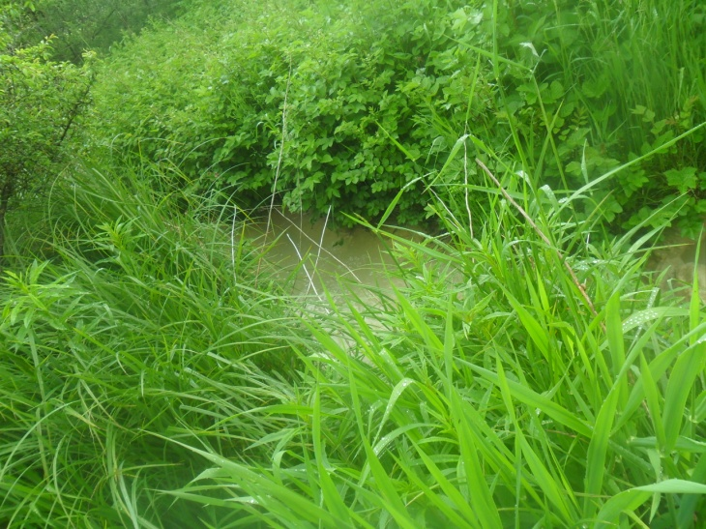

Figure 17 – Vegetation at the quarry beck. Source - Author
5.4 Summary
The results of this study show that limestone quarrying has an effect on water quality, both chemically and physically. Most of the effects are shown in chemical parameters such as pH, conductivity and total dissolved solids, with a rise from Horton (site 2) and Crag Hill (site 4) after the quarry discharge enters the river system. In this case, the farm beck (site five) decreased flow, pH, velocity and discharge of the River Ribble whilst increasing conductivity, temperature as well as total dissolved and suspended solids. Having looked into these effects in more detail by examining a farm beck (site 5) it is substantially clear that agriculture has a higher impact on rivers. Although both becks affect the River Ribble the waste from agriculture is significantly altering the River Ribble more than the quarry,
This is perhaps due to the regulations that the Horton Quarry must adhere to in order to extract limestone. In conjunction with the Yorkshire Dales National Park Authority, Horton Quarry must “provide a scheme of groundwater monitoring and reporting to avoid adverse impacts on groundwater” (Yorkshire Dales National Park Authority, 2011). Whereas, although farmers must adhere to some regulations, it is not regularly enforced by any environmental authority in the Yorkshire Dales, except for areas within an Environmentally Sensitive Area Scheme (ESAs). If farmland is within these areas, farmers are not allowed to use some pesticides or fertilisers on the fields which have a negative effect on water or overstock their land with sheep or cows. The study area falls into one of these ESAs and therefore results are not likely to have been affected by fertilisers at any of the six sites. By understanding this, it can be considered that livestock could be the main influence on water quality on farmland with river systems in close proximity, due to waste and crossing/entering the River Ribble.
In the final chapter this study will reflect on the main findings of this project and explore the limitations and aims for future research. As well as this the aims and hypothesis that were initially set up for this dissertation will attempt answer these original theories in relation to previous research.

6.0 Conclusion

This study has provided a snapshot depiction of limestone quarrying affecting the water quality of a 20 mile stretch of the River Ribble. The data collected was tested both in the field and in the laboratory to determine if any parameters such as total suspended solids, total dissolved solids and pH were affected by limestone quarrying and results were then analysed with reference to previous studies and literature. This chapter will conclude this project by summarising the main findings of the research; suggest changes to methods for future analysis and discussing any limitations of the dissertation.
6.1 Main Findings
- The river is generally alkaline, with the quarry beck having the highest pH;
- Conductivity levels exceeded 900µS/cm;
- TSS and TDS levels spiked at both the quarry and farm becks;
- Livestock influenced parameters such as TSS, TDS and conductivity;
- Bed load tended to have an effect on flow, velocity and discharge at each site;
- The quarry discharge beck did not affect the river channel as much as the
farm beck
6.2 Research Limitations
As this research only provides a snapshot study of the River Ribble, the results obtained were minimal making them less accurate for future comparisons. Certain parameters were not tested for such as nutrient levels or dissolved oxygen content, this was due to a set timescale, if these results had been collected it would have provided a more accurate record of the River Ribble’s water quality. The use of rainwater data may have also given a more complete data set as heavy rainfall was received in the area prior to the study, unfortunately as the River Ribble is mainly surrounded by farmland or public footpaths there was no suitable areas rainwater gauges could have been placed without being damaged or disturbed.
The quarry discharge beck was chosen as it had direct access to the River Ribble; however, the water within the beck would have been diluted before being discharged from the quarry to comply with regulations put in place by the Environment Agency and the Yorkshire Dales National Park Authority which states “There shall be no discharge of foul or contaminated drainage from the site into either groundwater or any surface waters, either directly or via soakways”(Yorkshire Dales National Park Authority, 2011 courtesy of David Parrish). The discharge would not have affected the River Ribble as strongly as perhaps it would have if not diluted beforehand. Another factor which was not in control of the author was dust being released from quarry blasting. Dust particles will be distributed into the air, and then will fall onto surrounding land. When precipitation occurs the dust particles will infiltrate the soil and geology with water particles and can potentially feed into the ground water supply, affecting the River Ribble as the ground water flows into the channel.
Similarly to the dust particles, another factor which was out of the author’s control was the amount of rainfall the river catchment received before the study took place. The rainfall could have affected farming methods and livestock influence on the River Ribble. As the banks at some sites were saturated livestock were not able to access the River Ribble for drinking as previous, and therefore these influences would have been affected.
6.3 Further Study
This project could be extended by analysing the sites over a weekly or monthly period, thus giving more data and ability for statistical testing. More parameters could be tested in conjunction with those in this study, to give a more accurate result and analysis of the limestone quarry affecting the River Ribble. Finally, a larger stretch of the River Ribble could have been tested in order to study sites with a longer distance between each, or choosing additional sites for data collection.

References
APHA (1992). Standard methods for the examination of water and wastewater. 18th ed. American Public Health Association, Washington, DC.

Bandyopadhyay, J and Shiva, V (1985) ‘The Conflict Over Limestone Quarrying in Doon Valley, Dehradun, India’ Journal of Environmental Conservation, 12, pp 131-139
BBC (2011) Domesday Reloaded: Horton Quarry. Available at: http://www.bbc.co.uk/history/domesday/dblock/GB-380000-471000/page/5 Accessed on 17th May 2012

Blades, N and Marchant, G and Greening, P (2007) Impacts of crushed rock quarries on historic villages and cultural landscapes. In: Proceedings of the 7th European Conference "SAUVEUR", Safeguarded Cultural Heritage - Understanding & Viability for the Enlarged Europe, pp. 61 - 70. Prague, Czech Republic.
Bluvshtein N, Mahrer Y, Sandler A, Rytwo G (2011) Evaluating the impact of a limestone quarry on suspended and accumulated dust. Journal of Atmospheric Environment, 45, pp 1732-1739
British Geological Survey (2012) ‘Resources: Crushed Rock Aggregate: Limestone’ Available at: http://www.bgs.ac.uk/planning4minerals/Resources_7.htm Accessed on 7th September 2012
British Geological Survey (2013) ‘Quarrying and the Environment: Water and Caves’ Available at: http://www.bgs.ac.uk/mendips/aggregates/environment/water.html Accessed on 7th January 2013
Bryant G, McPhilliamy S and Childers H (2002) A survey of the water quality of streams in the primary region of mountaintop/valley ﬁll coal mining. US Environmental Protection Agency, Philadelphia, Pennsylvania.
Cech, T.V (2003) Principles of Water Resources. John Wiley & Sons, New Jersey, USA
Cossey P.J. and Adams A.E (2004) ‘Introduction to British Lower Carboniferous Stratigraphy’ In: Cossey P.J, Adams, A.E., Purnell, M.A., Whiteley, M.J., Whyte, M.A. and Wright, V.P., (2004), British Lower Carboniferous Stratigraphy, Geological Conservation Review Series, Joint Nature Conservation Committee, 29, pp 3-12. Peterborough, U.K.
Davie, T (2002) Fundamentals Of Hydrology. Routledge, U.K.
DEFRA (2005) ‘Draft Sheep Dip Pollution Reduction Programme’ Available at: http://www.vmd.defra.gov.uk/pdf/sheepdip_draftPRP.pdf Accessed on 10th February 2013
Dunn, C, Adams, K, Holmes, D, Hordern B, Knifton D, Oakes S, Palmer A, Warn S, Witherick M and Yates N (2009) Geography. Philip Allan Updates, Oxfordshire, U.K
Enis R and Shechter M (1974) Environmental analysis of quarrying: An Israeli experience. Journal of Landscape Planning, 1, pp 289-302
Environment Agency (2011) ‘Mobile dipping contractors - Handling and disposing of waste sheep dip’ Available at: http://www.environment-agency.gov.uk/static/documents/Business/Handling_disposal_of_sheep_dip.pdf Accessed on 10th February 2013
Gardner, L and Moon F.G (1983) ‘The relationship between electrical conductivity and temperature of aviation turbine fuels containing static dissipater additives’ Division of Mechanical Engineering, National Research Council, Canada.
Green, J.A. Pavlish J.A, Merritt R.G, and Leete J.L (2005) Hydraulic Impacts of Quarries and Gravel Pits. Report prepared for the Legislative Commission on Minnesota Resources. Minnesota, USA.
Golterman H.L (1969) Methods for chemical analysis of fresh waters. Blackwell Scientific Publications, Oxford, U.K
Haygarth, P and Jarvis, S (2002). ‘Agriculture, Hydrology and Water Quality.’ Cambridge, Massachusetts , USA. CABI Publishing, p 161.
Hitchcock, D and Blair, A (2000). ‘Environment and Business.’ Florence, Kentucky, USA.
Routledge, p 203.
Holden, J (2008) An Introduction to Physical Geography and the Environment. Pearson Education Ltd, Essex, England.
LaFarge (2010) ‘Dry Rigg Quarry: Visitor Guide’ Available at: http://www.lafarge.co.uk/pdf/Dry_Rigg_Leaflet-A5-8pp_Rev_6.pdf Accessed on 5th September 2012
Lake District Special Planning Board (1978) Lake District National Park Plan. Kendal, U.K
Lancashire County Council (2012) Environment Directorate Progress – Ribble Valley: Quarter 1 April-June 2012. Lancashire, U.K
Martín-Vide J.P, Ferrer-Boix, C and Ollero, A (2010) ‘Incision due to gravel mining: Modelling a case study from the Gállego River, Spain’. Journal of Geomorphology, 117, pp 261–271
Missouri Department of Natural Resources (2006) ‘Limestone: Missouri’s Billion Dollar Industry’ In: The Geologic Column of Missouri, 1, Issue 1. Available at: http://www.dnr.mo.gov/geology/docs/gcwinter6.pdf Accessed on 12th December 2012
Murphy, S (2007) ‘General Information on Solids’ Available at: http://bcn.boulder.co.us/basin/data/NEW/info/TSS.html Accessed on 10th October 2012
National River Authority (1995) River Ribble Catchment Management Plan: Action Plan. London, U.K
Newson, M.D (2009) Land, water and development: Sustainable and Adaptive Management of Rivers. Routledge, U.K
Omid M.H, Karbasi M and Farhoudi J (2010) Effects of bed-load movement on flow resistance over bed forms. Journal of Sadhana, 35, pp 681-691.
Pagenkopf, G.K (1978) Introduction to natural water chemistry. New York, USA
Rivas V, Cendrero A, Hurtado M, Cabral M, Giménez J, Forte L, del Rio L, Cantú M, Becker A (2006) Geomorphic consequences of urban development and mining activities; an analysis of study areas in Spain and Argentina. Journal of Geomorphology, 73, pp 185-206
Rundquist, L.A. 1980. Effects of gravel removal on river hydrology and hydraulics. In: Woodward-Clyde Consultants, Gravel removal studies in arctic and subarctic floodplain in Alaska - technical report; pp. 67-140. U.S. Fish Wildlife Service, Biological Services Program.
Shaman, D (1996) India’s Pollution Regulatory Structure and Background. NIPR Papers. World Bank, Washington D.C.
Thornton, H (2011) ‘Quarrying Issues’ Available at: http://www.yds.org.uk/?page_id=623 Accessed on 3rd September 2012
Trudgill S.T (1985) Limestone Geomorphology. Longman, London, U.K
Turner, T (1998). ‘Landscape Planning and Environmental Impact Design.’ Florence, Kentucky, USA. Routledge, p 205.

USGS (2001) ‘Potential Environmental Impacts of Quarrying Stone in Karst- A Literature Review’ Available at: http://pubs.usgs.gov/of/2001/ofr-01-0484/ofr-01-0484so.pdf Accessed on 3rd November 2012.
Wilson, A (1992) ‘Geology of the Yorkshire Dales National Park’. Yorkshire Dales National Park Committee, Skipton, U.K
Yorkshire Dales National Park Authority (2011) Notice of Decision of Planning on Application for Determination of New Conditions for a Mineral Site under the Provisions of Section 96 and Schedule 13 of the Environment Act 2005. Courtesy of David Parrish via email to author, March 2013.

Appendices

Appendix I – Ethics Form & Risk Assessment

Application for safety and ethical approval for all projects
School of Built and Natural Environment
All undergraduate, postgraduate, commercial and research projects need ethical approval. No field work, experimentation or work with participants can start until approval is granted. The questions below should be completed by the Principal Investigator or supervisor of the proposed project. Where projects involve students, the Principal Investigator is always the supervisor and never the student.
For undergraduate and postgraduate taught projects: use the questions to identify whether the project should be referred to the relevant Ethics Committee.
- If you answer “No” to questions, then do not apply for approval.
- If you answer “Yes” to any of the questions, please discuss them with your supervisor. If your supervisor is confident that you can follow standard forms, protocols or approaches, then your supervisor can approve your application. If your supervisor is not, then the application should be sent for approval.
For research, commercial and other projects: use the questions to help compile suitable evidence to support your application.
- If you answer “No” to questions, then your application is likely to be approved quickly.
- If you answer “Yes” to any of the questions, please provide evidence relating to the management of the activity. If your approach seems appropriate, then your application is likely to be approved quickly.
Submit the application form and any supporting evidence to an appropriate Ethics Committee. Different committees might have different approval processes.
Principal Investigators, or project supervisors, are responsible for ensuring that all activities fall within the principles set down in the University Code of Conduct for Research and the University Ethical Principles for Teaching, Research, Knowledge Transfer, Consultancy and Related Activities. They are also responsible for exercising appropriate professional judgment in undertaking this review and evaluating the activity according to the criteria laid down in this application. If you are uncertain about any sections of this document, or need further information and guidance, please consult a member of the relevant School Ethics Committee.
The School Ethics and Safety Committees are to ensure that you comply with the University’s ethical principles in the conduct of the activity. Committees can ask for clarification or set conditions for you to meet before approval is granted.
Expiry and review: The principal investigator is responsible for ensuring activities are reviewed. Normally:
- each year: review risk assessments: check for changes to hazards and training refreshers
- after 5 years: review ethics: check for new laws, practices
- closure: dispose of materials and sensitive data properly
Refer to the relevant documents from the following links:
- Ethical Principles for Research, Consultancy, Practical Work and Related Activities
- Research Governance (Multiple documents)
- Health, Safety & Environment (Multiple documents)

1 Project synopsis |  |  |  | Approver: |  |  |  | Cmte number:
1.1 Title | The effects of limestone quarrying on the River Ribble in the Yorkshire Dales
1.2 Project type | Original research |  | Research degree |  | PG taught |  | UG taught |  | X | Commercial
1.3 Short description  in layman's terms [no acronyms or jargon] | This undergraduate dissertation project aims to provide detailed water quality analysis whilst exploring reasons behind the affects of quarrying in the British Isles, specifically in the Yorkshire Dales. As well as this, the research will also aim to produce analytical results of pH, temperature, dissolved oxygen, bed load, total suspended solids, cross sectional area, velocity, discharge, conductivity and abundance of microorganisms in terms of water quality in relation to the quarrying activities that are currently occurring and have previously occurred.
1.4 Dates | Start: May 2012 |  |  | End: April 2013
1.5 School of ….. | Built and Natural Environment
2. Participants
2.1 Project supervisor /principal investigator:  name, position  and original signature | Project Supervisor: Dr Jo Dawson  Project Investigator: Gemma Warren
2.2 Co-workers:
names and positions
[eg student]

3 External collaborators
3.1 List external collaborating bodies
Manchester Anglers
3.2 Provide evidence of any ethical approvals obtained [or needed] by external collaborators
To be determined
3.3 Indicate whether confidentiality agreements have been or will be completed
N/A
Read any associated procedures and guidance or follow any associated checklist, and delete, Yes or No, for each characteristic in A) to F) below.
If you respond No, then in your judgment you believe that the characteristic is irrelevant to the activity.
If you respond Yes, then you should provide relevant documentation [including risk assessments] with the application, and cross-reference to it, eg A2 or B9. Use reference numbers of standard forms, protocols and approaches and risk assessments where they exist.

- Does the activity involve field work or travel to unfamiliar places? If Yes:  - Does the activity involve field work or leaving the campus [eg overseas]?  - Does the field work involve a ‘party’ of participants or lone working ?  - Does the activity involve children visiting from schools? | A) Yes  - Yes  - No  - No
B) Does the activity involve humans other than the investigators? If Yes:  - Will the activity involve any external organisation for which separate and specific ethics clearance is required (e.g. NHS; school; any criminal justice agencies including the Police, CPS, Prison Service)? – start this now [CRB clearance process at Loughborough; UCLan contact Carole Knight]  - Does the activity involve participants who are unable to give their informed consent (e.g. children, people with severe learning disabilities, unconscious patients etc.) or who may not be able to give valid consent (e.g. people experiencing mental health difficulties)?  - Does the activity require participants to give informed consent? [consent guidance at City U]  - Does the activity raise issues involving the potential abuse or misuse of power and authority which might compromise the validity of participants’ consent (e.g. relationships of line management or training)?  - Is there a potential risk arising from the project of physical, social, emotional or psychological harm to the researchers or participants?  - Does the activity involve the researchers and/or participants in the potential disclosure of any information relating to illegal activities; the observation of illegal activities; or the possession, viewing or storage (whether in hard copy of electronic format) which may be illegal?  - Will deception of the participant be necessary during the activity?  - Does the activity (e.g. art) aim to shock or offend?  - Will the activity involve invasion of privacy or access to confidential information about people without their permission?  - Does the activity involve medical research with humans, clinical trials or use human tissue samples or body fluids?  - Does the activity involve excavation and study of human remains? | B) No  - No  - No  - No  - No  - No  - No  - No  - No  - No  - No  - No
C) Does the activity involve animals and other forms of life? If Yes:  - Does the activity involve scientific procedures being applied to a vertebrate animal (other than humans) or an octopus?  - Does the activity involve work with micro-organisms?  - Does the activity involve genetic modification?  - Does the activity involve collection of rare plants? | C) No  - No  - No  - No  - No
D) Does the activity involve data about human subjects? If Yes:  - After using the data protection compliance checklist, have you any data protection requirements?  - After answering the data protection security processing questions, have you any security requirements? [Data storage] [keep raw data for 5 years] | D) No  - No  - No
E) Does the activity involve hazardous substances? If Yes:  - Does the activity involve substances injurious to human or animal health or to the environment? Substances must be disposed properly.  - Does the activity involve igniting, exploding, heating or freezing substances? | E) No  - No  - No
F) Other activities:  - Does the activity relate to military equipment, weapons or the Defence Industry?  - Are you aware of any ethical concerns about the company/ organisation, e.g. its product has a harmful effect on humans, animals or the environment; it has a record of supporting repressive regimes; does it have ethical practices for its workers and for the safe disposal of products? | F)  - No  - No
Note: in all cases funding should not be accepted from tobacco-related industries

If you respond Yes, then you should provide relevant documentation [including risk assessments] with the application, and cross-reference to it, eg A2 or B9. Use reference numbers of standard forms, protocols and approaches and risk assessments where they exist.

These standard forms are being followed [cross reference to the characteristic, eg A2]:
A1 – See Risk Assessment

Appendix II – Results Table

 | Width (m) | Depth (m) | Wetted Perimeter (m) | Flow (rpm) | pH | Conductivity (µS/cm) | Temp (°C) | TSS (mg/l) | TDS (mg/l) | Bed load (cm) | Velocity (m²/s) | Discharge (m³/s) | Cross Sectional Area (m²)
Site 1 | 15 | 0.587 | 16 | 296.86 | 8 | 178.5 | 11.9 | 2.2 | 89 | 15.1 | 0.304 | 2.68 | 8.81
Site 2 | 10 | 0.53 | 12 | 195.3 | 8.75 | 241 | 11.8 | 3.3 | 142.5 | 10.9 | 0.217 | 1.16 | 5.34
Site 3 | 1 | 0.09 | 1.5 | 51 | 11 | 598 | 10.6 | 15.9 | 290 | n/a | 0.09 | 0.000081 | 0.09
Site 4 | 9 | 0.502 | 10 | 224.6 | 9.45 | 589 | 11 | 1.27 | 286 | 12.7 | 0.242 | 1.09 | 4.52
Site 5 | 11.4 | 0.705 | 13.2 | 436.27 | 6.65 | 914 | 12 | 25.7 | 406 | 14.1 | 0.42 | 2.982 | 7.1
Site 6 | 8 | 0.489 | 10.1 | 190.63 | 7.8 | 795 | 12.6 | 6.3 | 245.5 | 12.4 | 0.212 | 0.737 | 3.475

Appendix III – River Corridor Survey 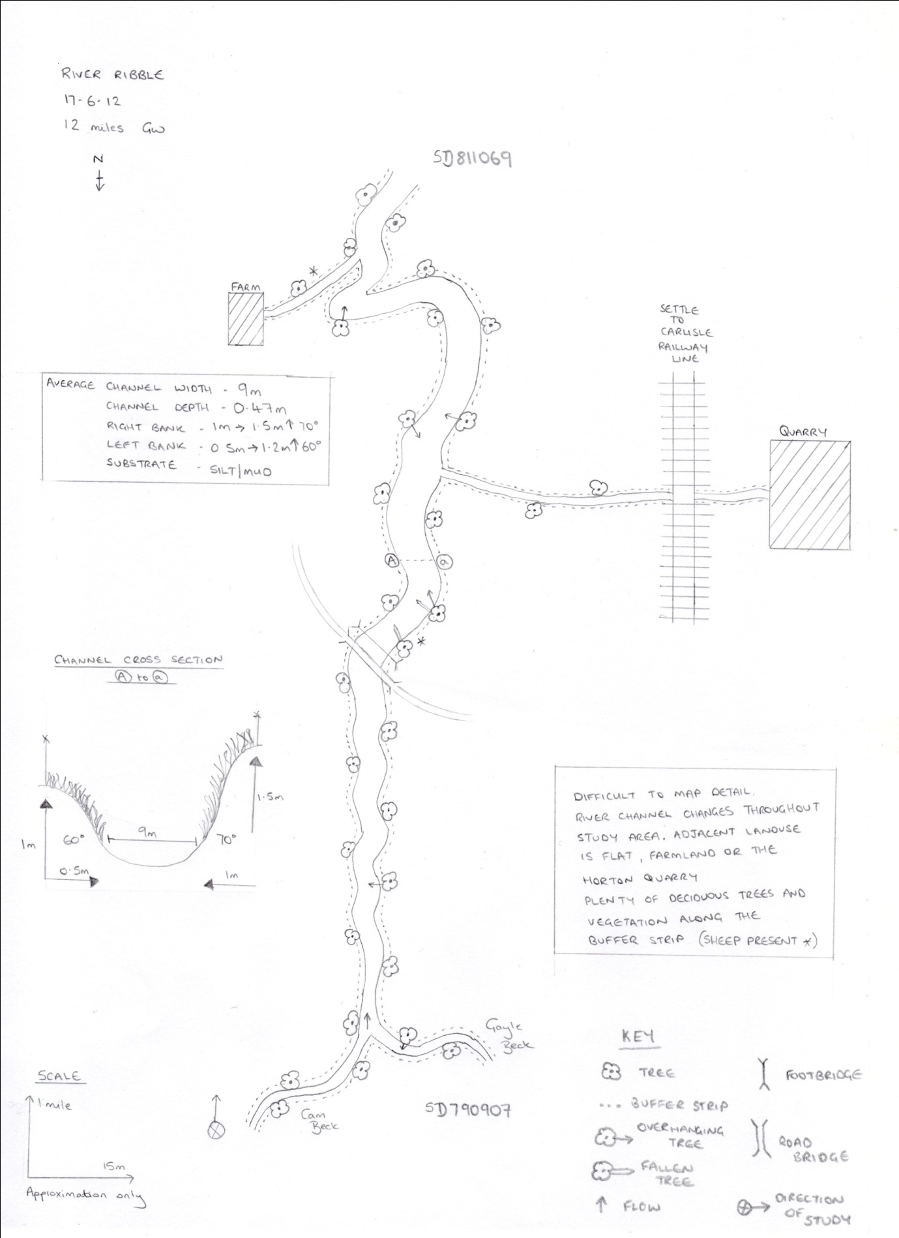
Appendix IV – River cross sections
Site 1

Site 2

Site 3

Site 4

Site 5

Site 6

