

Domestic Energy Efficiency in North West England, an Assessment of Trends and Effects of Income

Richard Wolfenden
Environmental Management BSc
April 2013
I declare that the main text of this dissertation is all my own work

Richard Wolfenden
16.04.2013

Abstract

The study conducted had numerous aim and objectives, with the main aim being to assess the domestic energy efficiency situation in North West England. Britain’s energy industry is in a transitional stage, as acts and bills are sluggishly being passed through parliament, and dependence on fossil fuel being reduced with nuclear power becoming a low carbon alternative. An 80% reduction in UK carbon by 2050, is the target set in the Climate Change Act 2008, and 27% of Britain’s carbon emissions come from homes. Government run schemes, such as the Warm Front Scheme, allow citizens to improve their home’s energy efficiency for a small fee or possibly at zero cost. The only way of gathering data used in the dissertation was by interviewing random strangers, and filling in a questionnaire. 300 responses were recorded, 150 from 6 towns (25 each) and 150 from cities (50 each). The questionnaire consisted of personal questions such as ‘What bracket does your annual household income fall under?’, until eventually moving on to questions about energy efficiency, ‘Have you taken any measures to make your home more energy efficient?’. Each question was in place to achieve one of the aims of dissertation. The data answered many questions, identifying numerous patterns and trends throughout the North West. The data revealed that the most popular measure taken to improve energy efficiency was installing loft insulation, possibly due to it being cost effective and available for a low cost through the Warm Front Scheme. The data also shows that as you move away from the city centre, mean expenditure on energy efficient measures increases. These are just a couple of examples of what the data shows.

Thanks
Thank you for the inspiration, assistance and guidance from Dr Michael Clark, University of Central Lancashire.
Many thanks to the supermarkets that allowed the interviews to take place outside of their premises:
- ASDA, Colne Superstore
- Sainsbury’s, Garstang Store
- Sainsbury’s, Longridge Store
- Sainsbury’s, Nantwich Store
- Tesco, Burscough Store
Thank you to Dr Chris Lowe, for leading the module and providing priceless advice.
Thank you to Mr Simon Horlock at EvoEnergy, for providing me with detailed information about the solar energy industry in the UK.

Contents
- Introduction
  - Introduction to the dissertation
  - Background information related to the study
  - Problem Statement
  - Relevance of the study
  - Brief of Methodology
  - Delimitations

- Review of Relevant Literature
  - Introduction to the Literature Review
  - Climate Change
  - Carbon Management and Low Carbon Technologies
  - Finance and Energy in the UK
  - How to Improve Home Energy Efficiency / Reduce Household Carbon Emissions
  - Bills, Acts and Energy Related Governmental Schemes
  - Energy Efficiency and the North West England Home

- Methodology
  - Briefing of Data Collection
  - Data Collection Perspective
  - Research and Data Collection Methods
  - Participants
  - Procedures
  - Data Analysis

- Results and Discussion
  - Introduction to Results
  - Is there a geographical pattern, in terms of money spent on measures taken to improve energy efficiency?
  - What is the most popular way of improving home energy efficiency in the North West?
  - Does a certain age group spend more on energy saving devices?
  - Does the amount of household income affect the amount spent on improving homes’ energy efficiency?
  - Are the public aware of how they can do to improve their home’s energy efficiency and are they aware of local businesses that can provide the service?
  - Delimitations
5. References
6. Appendices
Appendix 1. Questionnaire
Appendix 2. Blank Data Collection Sheet
Appendix 3. Burscough Answers
Appendix 4. Colne Answers
Appendix 5. Garstang Answers
Appendix 6. Longridge Answers
Appendix 7. Nantwich Answers
Appendix 8. West Kirby Answers
Appendix 9. Manchester Answers
Appendix 10. Preston Answers
Appendix 11. Liverpool Answers
Appendix 12. Image of Research Areas
Appendix 13. Ethics Form
Appendix 14. Risk Assessment

Table of Tables
Table and Page No. | What the table shows | Chapter
Table 1 – Page 17 | Where research was conducted | Methods
Table 2 – Page 26 | Each counties mean expenditure on energy saving measures | Results + Discussion
Table 3 – Page 27 | Frequency of measures taken in the North West | Results + Discussion
Table 4 – Page 29 | Showing each age groups expenditure in each county | Results + Discussion
Table 5 – Page 29 | Showing mean expenditure for each age group around the UK, and amount of representatives from each age group | Results + Discussion
Table 6 – Page 34 | Showing the frequency of answers from Q12 and Q13 | Results + Discussion
Table 7 – Page 37 | Frequency of excuses for not improving energy efficiency | Results + Discussion

Table of Figures
Figure and Page No. | What figure shows | Chapter
Figure 1 – Page 6 | Keeling Curve | Lit Review
Figure 2 – Page 7 | 2008 CO2 Emissions | Lit Review
Figure 3 – Page 10 | Map of UK Salaries | Lit Review
Figure 4 – Page 17 | Map Showing Research Locations | Methodology
Figure 5 – Page 22 | Spread sheet and Map showing amount spent to improve energy efficiency in Lancashire | Results + Discussion
Figure 6 – Page 22 | Spread sheet and Map showing amount spent to improve energy efficiency in Merseyside | Results + Discussion
Figure 7 – Page 23 | Spread sheet and map showing amount spent to improve energy efficiency in Greater Manchester | Results + Discussion
Figure 8 – Page 23 | Spread sheet and map showing amount spent to improve energy efficiency in Cheshire | Results + Discussion
Figure 9 – Page 24 | Map showing the entire North West's boroughs expenditure on energy efficient measures | Results + Discussion
Figure 10 – Page 25 | Map showing mean county expenditure on energy efficient measures | Results + Discussion
Figure 11 – Page 30 | Map of North West with age group, mean expenditure and region expenditure | Results + Discussion
Figure 12 – Page 32 | Line graph showing mean expenditure for each income bracket in the North West | Results + Discussion
Figure 13 – Page 33 | Line graph showing median expenditure on energy saving measures for each income bracket | Results + Discussion
Figure 14 – Page 35 | Pie chart showing percentage of people who are aware of how they can improve their homes energy efficiency | Results + Discussion
Figure 15 – Page 35 | Pie chart showing people who are aware of local businesses that can improve their homes energy efficiency | Results + Discussion
Figure 16 – Page 36 | Bar chart showing the frequency of potential combinations to questions Q5 and Q12 | Results + Discussion
Abbreviations in Dissertation
LCT – Low Carbon Technologies
NOAA – National Oceanic and Atmospheric Association
ESRL – Earth System Research Laboratory
GHG – Green House Gas
PV – Photovoltaic
CCC – Committee on Climate Change
DECC – Department of Energy and Climate Change
- Introduction

1.1 Introduction
This dissertation aims to give a thorough report on domestic energy efficiency in the North West of England. Energy is one of the largest industries in the world, and is forever changing. This dissertation looks at one of the important factors that, in the last decade, has impacted most of the British public, energy efficiency. With governmental carbon reduction targets being set and Britain entering a new phase of its energy history, this paper will give detailed coverage of the topic and identify patterns and trends in the North West of England. This chapter will give an overview and basic analysis of the subject at hand, as well as a run through of the legislation and other relative academic publications. The significance of the survey and an examination into the methodology involved in the study will also be mentioned in this chapter.
1.2 Background information related to the study.
Home Truths: A low Carbon strategy to reduce UK housing emissions by 80% by 2050 (Boardman, 2007) reports that UK households are responsible for 27% of Britain’s Carbon footprint. This remarkable fact was one of the leading reasons for this study to transpire. Though a single fact rarely merits an entire study based around it, other developments and studies gave added incentive to partake in an academic survey, related to home energy efficiency. For example, the Feed-in-Tariff introduced in the UK on April 1st 2010, meant that the British public now had the opportunity to reduce their energy bill, make money and make their homes more energy efficient (whilst decreasing the carbon footprint). This was an incentive to alter Britain’s attitudes towards energy and renewables, hoping that this change would aid their attempts to reduce the countries carbon footprint to below 80% by 2050 (Carbon Emissions Reduction Target) (Department of Energy and Climate Change, 2010). The Feed-in-Tariff grants Britons the opportunity to generate energy for their own home. The unused energy is fed into the national grid, the amount of energy passed into the national grid is relative to the amount of money the individual will receive. The Feed-in-Tariff (FIT) wasn’t the solitary piece of legislation that inspired the dissertation. The Warm Front Scheme allows certain people who live in certain homes the opportunity of getting £6,000 worth of free energy saving devices (depending on what bracket you fall under) (Robert, 2012). Insulating the loft in many houses is the cheapest and most popular way of improving home energy efficiency, according to the research undertaken for this dissertation. The global recession has been around for several years and its affects are still obvious. The renewable energy market was not a cheap option in 2008 when the recession began, and continues to be an expensive market to delve into. The conventional solar panels are a preferred choice in the UK, when it comes down to home renewables (Renewable Solutions, 2013). Although they are an expensive commodity to acquire, deciding to buy solar panels, then self-installing them, is a sufficiently cheaper course of action to take, albeit a bit risky. The more costly but safer route is to have them installed through the medium of a professional company. The cost will be greater although they will be installed correctly and securely. The average price for a solar panel system in the UK is around £4,200 (BBC, 2008), this is simply too much to pay for a regular household, even with the FIT.
1
1.3 Problem Statement.
Global warming is a one of the most abundant environmental topics covered by the world media, as they loosely relate every environmental issue to global warming. The earth’s temperature is rising and it is widely accepted that there are anthropologic reasons behind this change (National Research Council, 2010). Sea level rises, glaciers melting and changes in annual temperatures have occurred throughout history, leaving a small group to believe that humans are not having an effect. Though there have been so many tests and experiments leaving the chances of it being an entirely natural process very small indeed. With many industrialised countries (particularly European) realising this, they have taken it upon themselves to reduce their carbon emissions. Large wind farms such as that off Burbo Bank in Merseyside have been erected to power homes with green energy (Dong Energy, 2013). After revealing the statistic that 27% of Britain’s carbon footprint came from the British household, the government had to encourage and motivate citizens into installing energy saving equipment. Numerous grants were given and accepted in a relatively smooth process, though these reduced home energy efficiency, they are not as effective as other devices, which, unfortunately are expensive. The cost of the major devices implies they are not for the financially weak, though to have a dramatic influence on the countries carbon footprint, renewable energy devices and energy efficient appliances must be affordable for all. The North West is one of the more densely populated areas in England (Easton, 2008), suggesting that it is a key battleground for the war on carbon. Wealth in the region is diverse, meaning that the people with less money will have less of a chance to reduce their carbon footprint.
2
This study has numerous aims and objectives to achieve;
- To find patterns throughout the North West on particular topics, such as expenditure on energy saving measures
- To discover if age is a factor when investing in energy efficient devices
- To find which measures are the most popular in the North West
- To see if annual household income affects the amount spent on energy efficient devices
- To discover how aware the general public are when it comes down to available grants and businesses near to them
The questionnaire was designed for every person, no matter what their knowledge on the subject, to be able to answer the questions. The data gathered from the questionnaire provides enough data to achieve each aim set out.
1.4 Relevance of the study.
By December 10th 2012, all major power companies in the UK announced a rise in the cost of gas and electricity. Each company raised the price by 6% - 11%, adding a potential £100 to the average energy bill (Bachelor & Osborne, 2012). With this change in mind, logic dictates that investing in energy saving devices or energy efficient appliances makes utter sense. However, as previously stated in the aforementioned section, devices are not affordable for every class of household. The section of society that aren’t as well off as others, would benefit from energy saving devices more than any other class. Money is tighter in these households, and each pound needs to be saved. The study is not only professionally significant, it is relevant to retail as the interviews could be viewed as market research. Finding out the reason why the public aren’t purchasing energy saving appliances is information that would be valuable to all energy companies, as well as companies who build energy efficient devices. To see whether there is a pattern between different areas of society; age, income and location are taken into aspect. This will hopefully reveal if there are any correlations regarding each specific subject, for example seeing if a certain age group have made an effort to improve their homes efficiency, whereas another group may not have. This may change in different areas of the North West and may be influenced by wealth.
3

1.5 Brief of Methodology
The backbone of the research conducted for this study was the questionnaire consisting of 13 questions. Each individual didn’t answer all the questions, early answers open and shut other questions depending on the individual’s responses. To get a wide variety of results and properly represent the North West (strengthening the validity of the study), research was undertaken in 9 separate locations around the North West. So that every walk of life could be represented, 6 locations where smaller towns (e.g. Nantwich, Colne) and the other 3 where cities (e.g. Liverpool). 25 interviews would take place on the streets of the towns in midweek, resulting in 150 responses. 50 results would be taken from each city resulting in a total collection of 300 responses. Each answer was written down in brief on the day then transferred to a computer so that statistical analysis could take place. This study contains both qualitative research and quantitative research. The initial answers are all separate to the individual before being grouped together into frequencies, making the statistical analysis more straightforward. The information supplied by the public will only be held for the purpose of this study, although names, phone numbers and addresses were not recorded this was still vocally expressed to each interviewee. A further and more meticulous explanation will be provided further on in the dissertation.

4
1.6 Delimitations
As this was a North West based study, the researcher had to visit areas across the region. The Northern area of North West of England is particularly difficult region to access unless the use of a personal vehicle is available. Cumbria is an expensive area to reach when using public transport, as limited funds were available, this led to Cumbria being a restricted zone, so the research took place in the easily accessible areas of the North West.
300 is a strong number to have for the study, although a greater number would have been preferred. 1000 would have been an ideal amount of responses, though time, money and man power was an issue. If there was a group of researchers conducting the interviews, the research would have been gathered at a greater rate and results would equal greater accuracy. Most of the results were gathered in summer time, although some were gathered in September when students will have returned to education potentially reducing the amount of students interviewed.
5
2. Literature Review
2.1 Introduction to the Literature Review
This literature review will be structured by first giving an overview of the subject at hand, delivering information on a wider scale, before focusing in on the specific subject. Firstly, the wide topic of Climate Change will be covered, before discussing Carbon Management in the UK and Low Carbon Technologies (LCT). As the chapter continues, the subject matter will become narrower, making the latter section of the literature review more relevant to the dissertation title. Eventually finishing with legislation passed through parliament, that is relevant to the paper. The literature review covers a variety of literate forms, from sources more open to the public (Newspaper Articles), or references which are more hidden away (Statistics from reports). A large amount of the literature reviewed is academic publications found in journals, though some sources are taken from the internet. The internet is not always a reliable choice for research, though the sources used from the web in this dissertation, come from reliable, recognisable websites, reducing the chance of false information being passed on.
2.2 Climate Change
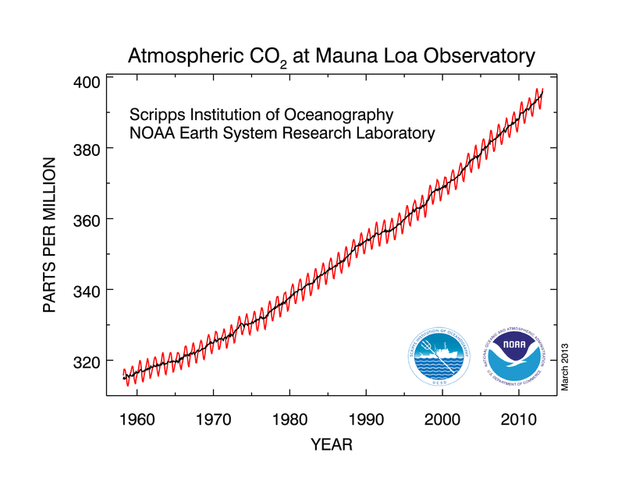
Climate change is in every British newspaper, every week, without doubt. The internet is full of stories related to the climate change. Academic journals are full of climate change studies and findings. Almost every kind of source for information will have a large section dedicated to climate change and the greenhouse effect. The first recorded data of global climate change due to carbon was researched by Guy Stewart Callendar (Black, 2009). His data had shown an increase in global temperatures by 0.5˚c between 1890 and 1935, ‘reviving an old theory that human emissions of carbon dioxide gas from burning fossil fuel could cause a “greenhouse effect”… It all sounded dubious to most meteorologists’ (Malik, 2008). This was the first study showing global warming in 1938, the fact that Callendar believed it was influenced by man led to much scepticism. Meteorologists didn’t believe that man could have such a dramatic influence on the planet. The work undertaken by Callendar is relevant to this study in the way that, Watson and Crick’s DNA structure work is relative to genetics. It opened the door to a subject that had previously not been recognised, but has an influential impact on science. The first study that provided unequivocal proof that carbon dioxide levels were rising was conducted by Charles David Keeling, an American scientist. Using atmospheric carbon dioxide measuring devices atop of Mauna Loa, Hawaii, his work drew up the famous ‘Keeling Curve’ that shows the steady increase of carbon dioxide concentrations by 20% over the last half century, which increases by an average 2ppm each year with seasonal fluctuations caused by photosynthesis rates increasing in the spring time, causing lower ppm. In the winter rates are higher due to furnaces burning more fuel to heat for longer periods (Perlmutter, 2010).
6
Climate change literature is very specific to certain aspects of it, such as rising temperatures, carbon dioxide concentration or weather patterns. To get a general overview of climate change the best sources of literature to use would be newspaper articles. For they put information in easily manageable segments which make the reading experience easier by putting all the information in the article, but written in a casual, non-academic way. The most relevant subject to this dissertation is carbon and its management.
Figure 1. The Keeling Curve (Source - (NOAA/ESRL, 2013))
2.3 Carbon Management and Low Carbon Technologies
Britain’s Carbon emissions in 2008 were around 6000 million tonnes (see figure 2), and were the second highest emitters of the greenhouse gas in Europe, only second to Germany. Since then there have been changes in European and British policy regarding carbon. In 2008, the Climate
7
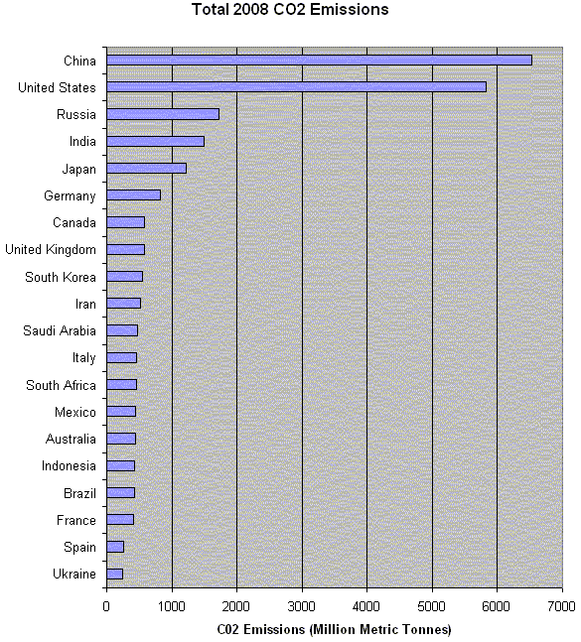
Figure 2. 2008 Carbon Dioxide Emissions (Source - (Union of Concerned Scientists, 2012))
Change Act was passed through parliament. As well as introducing an independent committee on climate change, it will also allow the UK to become a low-carbon economy (Anon., 2008). The bill also means that the UK will have to reduce its carbon emissions by 80% by 2050. To do this, numerous changes will need to occur. The reason for the UK’s high rate of carbon emissions is it reliance on fossil fuels (Oil, Gas and Coal), a dirty, pollutant energy source. Though in decline, combustibles are still the most used source of energy around the globe, counting for 63% of global electricity generation (International Energy Agency (IEA), 2013). The UK in 2011 had a high reliance on fossil fuels, with around 70% of its electricity generation also coming from combustibles. To reduce the reliance on fossil fuels, other technologies need to be exploited. Being an island, the British Isles have a resource that is yet to be fully exploited. Wind energy (Eccleston, 2007). Wind farms are a hot topic in the UK, though they provide energy with no carbon emissions, there is opposition. A whirring buzz is often an irritant to neighbours residing close to the wind farms, leading to offshore wind farms, which still have opposition, as they ‘reduce landscape value, kill birds and compromise wildlife habitats’ (National Opposition to Windfarms, 2012). Another major form of renewable energy generation comes from the sun. Solar panels positioned on rooftops throughout the UK could generate enough power to cut £120 off household energy bills, although the initial cost is astronomical (Thompson, 2010). Solar power industry in the UK recently hit a snag. The Feed-in-Tariff (FIT), allows people to generate their own electricity and feed it into the national grid, depending on how much energy is transferred into the grid, the home owner receives a sum of money from the buildings energy supplier (gov.uk, 2013). Though in October 2011 the government reduced the rate of pay from 43.3p per kWh to a meagre 21p kWh, causing massive financial losses in the solar industry that lead to certain companies cutting away one third of their work force (Harvey, 2013). The industry with the best prospects for Britain is the nuclear sector. The UK has a relatively small nuclear sector compared to other countries around the world, France produces the most nuclear energy in Europe, although, by a distance, the USA produces the most energy (World Nuclear Association, 2012). With a low-carbon output (EDF Energy, 2013), nuclear power seems like the future of UK energy as we await the passing of the new energy bill, when passed this will see the start of retiring a group of coal fired power stations and see the transition to nuclear power plants. On March 20th 2013 details of the first of many new nuclear power stations was announced, Hinkley’s current power station will be decommissioned in 2023 and the new plant will be located in the same place and will be operational in 8-10 years (Jowit, 2013). Though this will help reduce Britain’s carbon emissions, other polluting concerns arise. Nuclear waste is produced from all nuclear power stations. This waste is radioactive, which can have negative effects on man and the environment. Radioactivity causes cells to mutate, which can lead to cancer in humans and bizarre growth in plant life as well as causing death (Contemporary Physics Education Project, 2003).
8

9
2.4 Finance and Energy in the UK
The global recession that occurred in the late 00’s had dramatic effects on the UK energy industry. With money becoming scarcer and the value of sterling plummeting, the consumer’s financial situation has become tighter. In 2012, Britain saw a rise in the price of domestic gas and electricity (Kirkup & Hough, 2012). All major suppliers (i.e. British Gas) had an increase in their tariffs of around 6%-11%, ‘E.On blamed rising wholesale prices that it paid, the cost of transporting energy to homes, and the increasing cost of government social schemes for the price rise. It also suggested that the cost of creating more renewable sources of energy was a key factor in the costs it faced’ (BBC, 2012). Government social schemes such as the Warm Front Scheme, contribute to raising prices. The Warm Front Scheme ran from 2000 to 2013 and was designed to give people on a low income the opportunity to reduce their energy bills by making their home more energy efficient. Energy efficient boilers, cavity wall insulation and loft insulation where all available for a cut price or free for people on low incomes or a pension credit (Which?, 2013). The start of 2013 saw the end of the Warm Front Scheme and the beginning of the Green Deal (which will be covered later in the chapter) (gov.uk, 2013). Wealth is not evenly distributed around the UK, there tends to be higher salaries in the South than in the North. Studies taken up by the Office for National Statistics show the average salary in each UK constituency (Office for National Statistics, 2011). The data is best displayed in map form, to make patterns more obvious (see figure 3). This North-South divide in wealth is also obvious in the amount of business which companies receive. EvoEnergy are a solar panel install company, who ‘install solar photovoltaics (PV) and solar thermal systems for homes and businesses across the UK’ (EvoEnergy, 2013). Mr Horlock who works for EvoEnergy, believes that the South is a more abundant area for solar panel installation, and specifies Suffolk and Bristol as two hotspots in the UK (Horlock, 2013). People who reside in the North have used the Warm Front Scheme in 2009/2010 more than people from the South (Department of Energy and Climate Change, 2010). It is the same story the year after too (Department of Energy and Climate Change, 2011). The data published by the ONS assists in uncovering patterns, but also helps to explain them by backing up hypotheses about financial limitations.
10
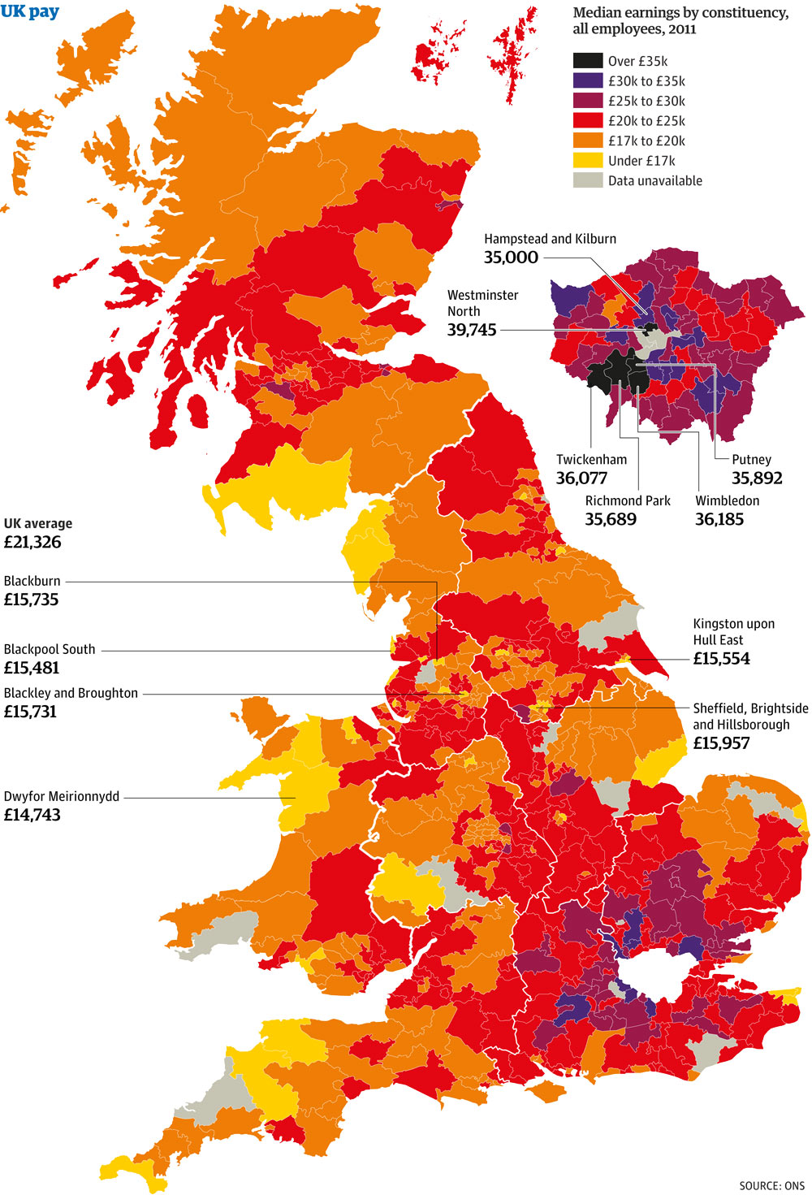
Figure 3. Map Showing Median Salaries in the UK by Constituency (Source - (Office for National Statistics, 2011) Retrieved from (Ball, 2011)
11
2.5 How to Improve Home Energy Efficiency / Reduce Household Carbon Emissions
In this section, most of the citations are from government ran websites. The most simplistic, yet, effective technique of improving home energy efficiency is to insulate the loft. As one of the cheapest ways of improving energy efficiency (£50-£350 DIY costs (USwitch, 2013)), installing just 270mm of rolled, insulative material can save you £180 (Energy Saving Trust, 2013), it is essentially putting a woolly hat on the building, reducing the heat escaping upwards through the roof. Not only does this insulation reduce the price of energy bills, it also dramatically reduces the carbon footprint of the building. ‘If everyone in the UK installed 270mm loft insulation, we could save nearly £500 million – and 2.7 million tonnes of carbon dioxide every year, the equivalent of taking nearly 100,000 cars off the road’ (Energy Saving Trust, 2013). Loft insulation was free for certain people under the Warm Front Scheme, as was cavity wall insulation.
Cavity wall insulation is similar to loft insulation in the sense that it is putting another layer on the building, though is more of a woolly jumper than a hat, to stop heat escaping through the walls. Cavity walls are filled with a loose material similar to that found in lofts. Costing around £500, it can be a messy and expensive job, though the savings of £140 a year means that it pays of in a short 4 years (Energy Saving Trust, 2013).
One of the more common practises in improving energy efficiency is the installation of double glazed windows. Double glazing is defined as ‘two panes of glass in a window, fitted to reduce heat loss’ (McLeod & Hanks, 1988). Changing all single pane windows in a home to B-rated double glazing can result in saving £170 on the energy bill, as well as a reduction in household carbon emissions, around 680kg a year to be exact (Energy Saving Trust, 2013).
Boilers are a typical way of heating a British home. Boil water, transport it around the house through insulated pipes and eventually emit the heat through radiators in each room (British Gas, 2013). Energy efficient boilers are an expensive commodity to acquire, though when accounting for 55% of the yearly household energy bills it is sensible to make them as efficient as possible (Energy Saving Trust, 2013). Remarkably, when replacing the old boiler with a new, energy efficient boiler, the savings can be around £300 (if replacing a largely inefficient boiler).
12
2.6 Bills, Acts and Energy Related Governmental Schemes
The Kyoto protocol (1997) was the first globally adopted agreement that set obligations for countries to reduce its greenhouse gas emissions (United Nations, 2013). This was the first real piece of political involvement in reduction of greenhouse gases (GHG) in the UK, this meant that the UK had to reduce its GHG emissions by 5% by the period 2008-2012, eventually becoming international law in 2005 for the countries remaining in the agreement (Black, 2009).
The Climate Change and Sustainable Energy Act 2006 was introduced to decrease carbon emissions and increase the amount of micro-generation systems in Britain (gov.uk, 2006). When it was passed, it made changes to the Carbon Emissions Reduction Target (CERT) (designed to make energy suppliers reduce their carbon emissions). It gradually increased the numbers which companies had to meet, so that there was a worthwhile carbon reduction, CERT also helps ‘reduce energy demand; enhance the UK’s security of supply; reduce energy bills for those receiving measures; reduce fuel poverty; and, secure jobs in energy efficiency industries’ (National Archives, 2012).
Britain, in 2008, introduced the Climate Change Act. This was introduced to meet Kyoto protocol agreements that the UK would reduce its GHG emissions by at least 80% by 2050 (gov.uk, 2008), including the aviation and shipping sectors (Butfield, 2013). The act would also create a Committee on Climate Change (CCC) which advises the government run Department of Energy and Climate Change (DECC) (The CCC , 2013). This committee is also in charge of Community Energy Saving Programme (CESP), the programme goes hand in hand with CERT. It requires gas and electric suppliers to deliver energy saving measures to domestic consumers in specific low income areas in the UK (Ofgem, 2007).
One way in which government have provided the opportunity for the public to make their home more energy efficient was through the Warm Front Scheme. It was initially launched in 2000, though after receiving criticism for not focusing on people who needed it most, it was re-launched with considerably less money available in 2010, funds were cut (dropped from £345m in 2010/2011 to 110 million in 2011/2012), and the amount of people who matched the criteria was less (Hough, et al., 2012). The Warm Front Scheme was introduced so that people falling under a certain criteria can get reduced or even free energy saving devices (Which?, 2013). Loft and cavity wall insulation, energy efficient heating system and an energy efficient boiler were all available for less through a government grant. The Warm Front ran until the end of 2012, this is when the Green Deal became available.
13
The Green Deal was introduced in January 2013, ‘it lets people pay for energy-efficiency improvements through savings on their energy bills’ (Energy Saving Trust, 2013). An assessor decides what will have the most worthwhile effect on saving energy in the home, then, once the devices are installed, the person who dwells in the property begins to pay off the costs through energy bills (Citizens Advice Bureau, 2013). If a different person moves into the building and the changes aren’t paid off, the new tenants continue to pay for the changes (gov.uk, 2013). The Green Deal’s launch also saw the start of the ECO.
ECO, or, Energy Company Obligation replaced the existing CERT and CESP programmes. Working with the Green Deal, it is in place to provide the option of heating and insulation packages to low income households. ‘ECO creates a legal obligation on energy suppliers to improve the energy efficiency of households’ (Ofgem, 2013). Companies also have to meet carbon saving targets set by Ofgem, the board which administer the targets:
- The Carbon Emissions Reduction Obligation (CERO), the target is to save 20.9 million lifetime tonnes of carbon dioxide through insulative measures in homes. (Ofgem, 2013)
- The Carbon Saving Community Obligation (CSCO), the target is to save 6.8 million lifetime tonnes of carbon dioxide from district heating systems, particularly in low income areas. (Ofgem, 2013)
- Home Heating Cost Reduction Obligation (HHCRO), targeting a saving of £4.2 billion of lifetime savings by requiring energy suppliers to provide measures so that low income areas can heat their homes for less. (Ofgem, 2013)

Generating renewable energy in your own home now has more of an incentive after the creation of the Feed-in-Tariff. By generating renewable electricity (e.g. using solar panels or wind turbines), you can save money on your energy bills by putting the electricity you don’t use into the national grid (gov.uk, 2013). The current export rate (as of 25/3/2013) is 4.5p per unit of electricity (using solar panels) (gov.uk, 2013). Though, at the start of 2013 the government altered the export rate to a much lower figure, causing a massive decline in solar panel sales (Harvey, 2013).
14
Currently passing through parliament is the Energy Bill 2012/2013. This bill will alter Britain’s energy outlook until at least 2020. The changes formed ‘the biggest transformation of Britain's electricity market since privatisation’ (Davey, 2012). The main aim of the bill is to reduce Britain’s dependence on hydrocarbon fuelled electricity generation. It will see the decommissioning of coal-fired power stations and see the growth and development of Britain’s nuclear sector, along with the erecting of nuclear power plants (Bakewell, 2012).
2.7 Energy Efficiency and the British Home
Britain’s domestic carbon emissions account for 27% of the nation’s overall amount (Boardman, 2007). This frightening figure has the UK government scrambling to reduce this figure, through new energy saving schemes and building energy efficient zero-carbon housing by 2016 (Banfill & Peacock, 2007). As well as the grants available in the Green Deal and through the Warm Front Scheme, there are simple things that can have an effect on reducing household carbon emissions. The Energy Saving Trust and similar boards have television advertising campaigns to highlight the money, and carbon that can be saved by simply switching off electric appliances (Meet Dave - The new star of the Energy Saving Trust TV ad, 2009). The government has the difficult job of, giving customers affordable energy, reducing GHG emissions and keeping the energy sector profitable, a challenging a sensitive issue. One way in which the ECO’s target ‘CSCO’ could be reached is through district heating systems in terraced housing areas, which account for 2.5 million of the countries housing stock (Frost, et al., 2012). Frost et al, suggests that this technique could increase the amount of carbon saved and would save the low income areas money, with greater benefits if walls are properly insulated. In terms of finding out patterns or trends in the North West, there isn’t any accessible material available. This study aims to fill the gap, and make aware what areas of the region are spending, or not.
15

3. Methodology
3.1 Briefing on Data Collection
The only way data was gathered for this study was by filling in questionnaires, with answers provided by complete strangers. The interviewee would provide answers to at least 9 questions (at most 11), all questions allowed the interviewer to receive enough data about household income, place of residence and money spent, without getting information that is too personal i.e. name, address. Once these questions were answered, the matter turned to the energy efficiency of their home, where, the interviewee answered questions such as ‘Have you taken any measures to make your home more energy efficient?’ (full questionnaire is available in appendices as ‘Appendice 1’). Once all data was collected from 300 interviewees, the data was transferred to a computer and arranged into boroughs.
Due to lack of data gathered from residences in Cumbria, the results do not provide enough of a representation to precisely assess the county, meaning that it will be treated as an anomaly and conclusions about the North West will exclude this county.
The structure of this chapter is following the advice of Glatthorn, 1998.
3.2 Data Collection Perspective
The data collected contained both qualitative and quantitative data. For example, when asking about the interviewee’s age, they chose the bracket into which they fell, whereas, when giving their opinion on why Britain’s homes aren’t energy efficient, it was rarely the one word answer which it was arranged into. All qualitative data was rearranged so that it was quantitative. When asking questions such as Q11, a lot of responses were longwinded and for convenience it was reduced to a one word answer. For some questions, it was taken into account that some interviewees would give a large variety of answers, such as Q2, so there were multiple answers to choose from, dividing ages into age groups, making the answers quantitative rather than qualitative.

16
3.3 Research and Data Collection Methods
Before going into the field, the questionnaire had to be designed, and the towns and cities where the fieldwork would take place had to be decided on. The questionnaire is designed so that, for example, if the answer to Q5 is ‘No’, then the interviewee doesn’t have to answer Q6 or Q7 as they didn’t take any measures to make their home more energy efficient, rendering the question moot. Alternatively, if the answer to Q5 is ‘Yes’, then the interviewee has to answer Q6 and Q7, though they do not have to provide answers for the questions; Q8, Q9 and Q10 as they did not answer ‘No’ to Q5. The questionnaire consists of 13 questions (interviewee’s don’t answer them all), it takes around one minute to complete the questionnaire if the interviewee doesn’t dawdle. The responses where written down on a spread sheet (Appendix 2) rather than individual questionnaires, to reduce the amount of paper used in the study (for environmental and financial reasons) and for convenience. The questionnaire had to be brief, as midweek in town centres isn’t full of people on a day out, it’s usually people going to work, people on lunch breaks or people popping out to the shops. The question’s chosen were designed to fulfil the aims and objectives of the dissertation. By finding out expenditure on measures taken to improve energy efficiency and household income, this made it easy to work out if there was a relationship between the amount of money people have and how much they spend. When the initial questionnaire was devised, the study had different aims and objectives meaning that some of the data for this paper is now excess data. For example, Q4 asks what property the interviewee lives in, yet the data is not utilised in chapter 4.
Choosing the destinations was an important part of the study. The objective was to get 300 responses, 150 from cities (Appendices 9-11) and 150 from small towns (Appendices 3-8). The spread had to be wide across the North West, unfortunately, due to financing, Cumbria was inaccessible, data was collected from Merseyside, Greater Manchester, Lancashire and Cheshire. The cities selected to complete research in were Liverpool, Preston and Manchester. Whereas the small towns reached out to every county (bar Cumbria), the towns were; Nantwich, Burscough, West Kirby, Longridge, Garstang and Colne. Figure 4 shows the dispersion of the study areas throughout the North West (Images of locations are found in Appendix 12).
17
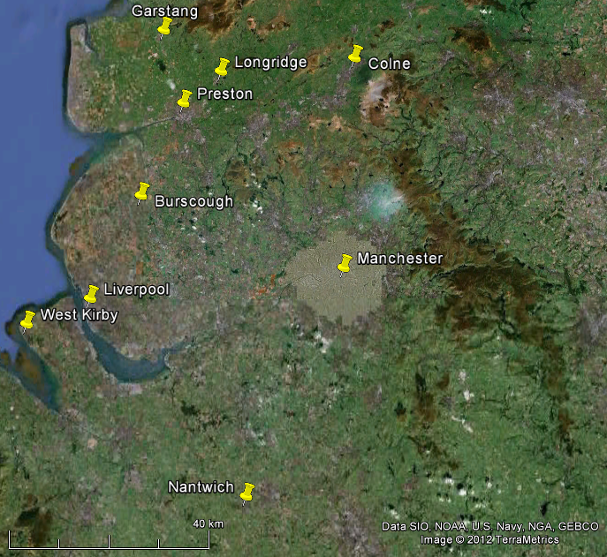

Figure 4. Map showing destinations where research took place (Google Earth, 2013)

The cities are all found in different counties, increasing the likelihood of getting a diverse range of answers from different sections of the North West. The locations selected in the cities are all commercial areas, where a high density of people will be, these densely populated areas would reduce the time taken to collect the results. Whereas for the towns, the target was to find towns that were not suburbs of cities, but had their own high street or a large super market, that would attract people from the surrounding towns and villages. After doing some research using Google Earth, the locations where the research took place were decided:
TOWN/CITY | LOCATION | OS GRID REFERENCE
Liverpool | 1st Location.  Bold Street, Outside Liverpool Central Train Station  2nd Location. South John Street, Outside Debenhams next to Liverpool One  18 | SJ 34894 90165  SJ 34406 90281
Manchester | Market Street, Outside the Arndale Centre | SJ 83982 98485
Preston | Friargate, Outside St Georges Shopping Centre | SD 53861 29496
Garstang | Park Hill Road, Sainsbury’s Superstore Entrance/Exit | SD 49168 44932
Longridge | Inglewhite Road, Sainsbury’s Superstore Entrance/Exit | SD 60202 37881
Colne | Corporation Street, Asda Superstore Entrance/Exit | SD 87161 39220
Burscough | Liverpool Road North, Tesco Superstore Entrance/Exit | SD 44271 12362
West Kirby | Dee Lane, Alongside Shops | SJ 21253 86861
Nantwich | Middlewich Road, Sainsbury’s Superstore Entrance/Exit | SJ 65654 53594
Table 1. Showing where research took place (Appendice
In West Kirby, the Morrison’s Superstore was the ideal location, but upon arrival, permission was not granted to conduct research in front of the store. Meaning that walking along the main roads, interviewing people was the next best option available. In Liverpool it was a similar story, permission had to be prearranged, to enter the premises of Liverpool One, the shopping centre, this lead to relocating to Bold Street.
The timing of the interviews was crucial to getting a wide spread of answers. Research took place in the summer months of July and August, but some research had to take place in the first half of September. The summer is the ideal time period to conduct the research, people have holidays in the summer, allowing more time to themselves, and are generally more chipper. This could lead to them being more relaxed and friendly, increasing the chance of them completing the questionnaire. The research took longer than expected, taking around 10 weeks to complete. Unfortunately, the summer of 2012 was the wettest in 100 years (Met Office, 2012) leading to the research being broken up. Pen and paper would simply not be able to withstand the barrage of rain, halting any field work during bad weather. The data collected in Liverpool was collected over two days as the weather took a turn for the worse, forcing a second visit to the city. Face to face interviews was the only technique used in gathering the data. This option was preferable as it took data from members of the public who didn’t have strong opinions or knowledge on the subject, giving a realistic data set. Group interviews were not conducted but considered. Gathering people who were interested in the topic, would more likely have given a more ‘energy friendly’ view and would all have been at one end of the scale, whereas with the face to face impromptu interviews, this gives a wide variety of views. Online interviews were also considered, but it was more expensive than just taking public transport to populated areas.
19
3.4 Participants
Selecting participants was initially random, but once in the field, exceptions were made. For example, most of the interviews taking place in the towns were outside a supermarket, here, people carrying several bags of shopping would not be an ideal participant as it would not be convenient to them, and they couldn’t possibly spare a minute. Otherwise the selection of participants was completely random and everyone was a potential target.
3.5 Procedures
When conducting the field work, there were a few simple procedures that were followed. Once in the location, the initial question before the participant began the questionnaire was; ‘excuse me, do you live in the North West?’. If the stranger answered, ‘yes’, then the next question would be; ‘do you have a couple of minutes to answer some questions?’. If their response was positive, the questions would be rolled out to them. The answers would be written down on a spread sheet (Appendice 2) attached to a clipboard, this way, less paper would be used when compared to printing off sheets for every participant to fill in. When asking questions were the answer was multi-choice, the clipboard was shown to the interviewee so they could read the options, for example, Q1 asks for the participant’s household income. Most people would not feel comfortable telling a stranger their income, so giving them the option of brackets would be the best technique. When answering Q12; ‘are you aware of what is available to improve your home more energy efficient?’, the protocol would be to then say ‘such as government run schemes or devices you can install’. Saying the extra line, cleared up any confusion that might have occurred, as early on in the research, interviewees where answering with ‘turn the lights off when not in the room’ or ‘turn devices off he power instead of leaving them on standby’.
20
3.6 Data Analysis
Each chapter in the results and discussion had its data analysed differently. Although each question did start by extracting the data required from the raw questionnaire data. It then involved organising it in a fashion that would make the analysis easier. For example, when trying to work out which age group spends most on improving household energy efficiency in 4.4, all interviewees were arranged into their counties, age group and eventually in order of expenditure. This allowed a simpler analysis, working out the mean and median for each age group, seeing which age group spent the most on improving energy efficiency in each county and region wide. Putting data into tables is a simple method used throughout the dissertation, as it shows frequencies and other data of numerical value. Using different visual methods of displaying data is also applied, such as line graphs, pie charts and maps of the North West. Using graphs (such as in sub-chapter 4.5) shows patterns in a much more aesthetically pleasing way than tables of data. Graphs can help disprove a hypothesis or prove it, there are graphs used in the results section of this paper. Another visual method used in data analysis is the use of maps. This dissertation has aims that are related to finding patterns throughout the North West, the best technique of showing patterns in terms of geographically differing data is by using a colour coded map. In sub-chapter 4.4, a map is devised showing the mean expenditure on improving energy efficiency in each borough/district. Each value of expenditure falls under a certain bracket and is assigned a colour. This makes it easier to identify a pattern other than looking at raw data.
21
4 Results and Discussion
4.1 Introduction to Results
This section of the study will display the results of the research, with an obligatory explanation of what the results show. Chapter 4 will be arranged so that each section will be dedicated to one of the aims that the introduction outlines. Beginning with the questions related to income and expenditure, before finishing with the question about awareness. Instead of having 2 chapters, one for results and one for discussion, this chapter will cover results relative to certain questions and have a discussion after it describing what the results mean. In certain sub-chapters, data from Cumbria is ignored. This will be due to the lack of data available for the county, which could lead to inaccurate perception of certain aspects in the county. The key issue related to all of these questions is domestic energy efficiency, and how it is financially important as well as environmentally required. Rising costs in fuel are leading to higher energy bills. Improving home energy efficiency is the most effective way of saving money on domestic energy and is therefore financially and environmentally vital.
4.2 Is there a geographical pattern, in terms of money spent on measures taken to improve energy efficiency?
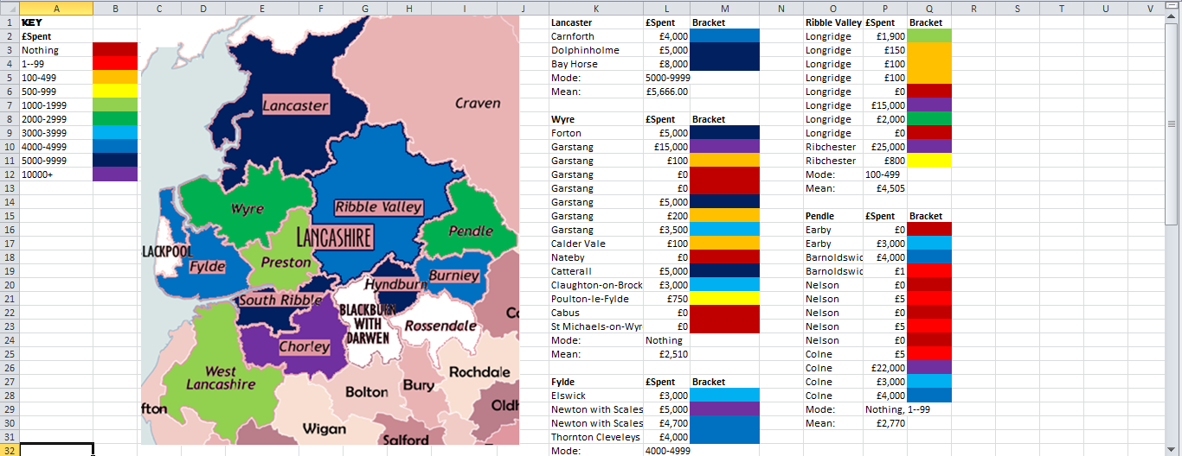
The results required to answer this question, come from answers to Q3, Q5 and Q7. The question aims to find which areas spent what on improving energy efficiency, as well as identifying a pattern around the UK. The first step taken was to organise the raw data. The data was arranged so that the interviewees’ responses were organised into the county that they reside. Using Microsoft Excel, the counties were organised onto a spread sheet and put in alphabetical order. Once this was done, the answers were then separated into their individual boroughs or districts. This was done so that the interviewees who had taken measures to improve energy efficiency, could be organised so that the mean and mode expenditure could be worked out for each borough. The mode was worked out, by giving the most commonly occurring bracket. Whereas, the mean, was all the money spent, divided by the amount of answers in each borough or district. Then the overall mean and mode for the county were worked out. The layout used is shown in Figure 5, with the key on the far left, giving each bracket a representative colour on the map. On the right of Figure 5, is the data taken from answers with the corresponding colour next to it. On the next 2 pages are the spread sheets and maps showing money spent on measures to improve domestic energy efficiency.
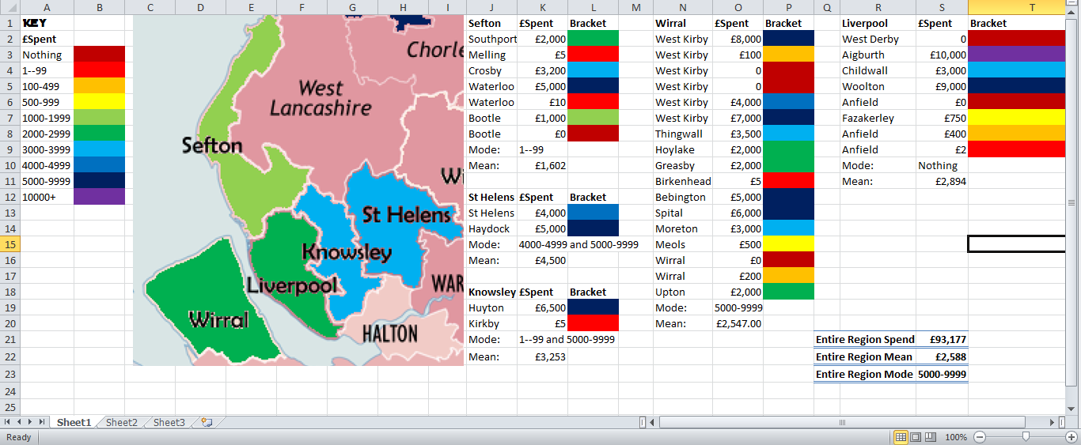
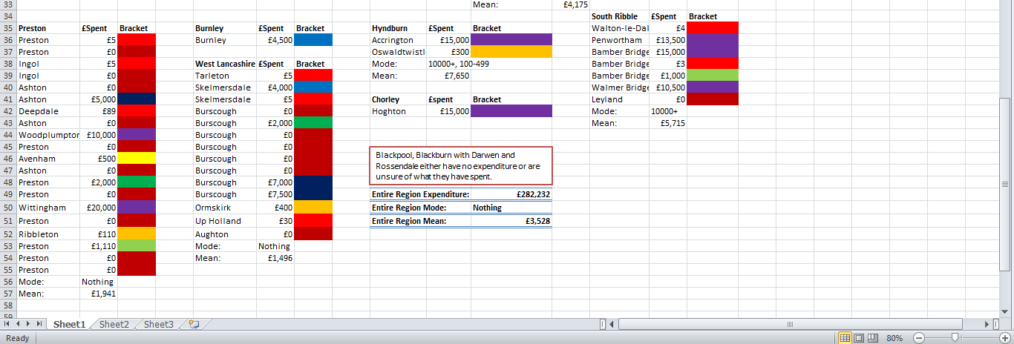
Figure 6. Spread sheet on Excel showing money spent on measures to improve homes in Merseyside. Also displaying map that shows what an average household spends in each borough.
Figure 5 . Spread sheet on Excel showing money spent on measures to improve homes in Lancashire. Also displaying map that shows what an average household spends in each borough. (Areas with white have not spent or are unsure of how much they spent on changes)
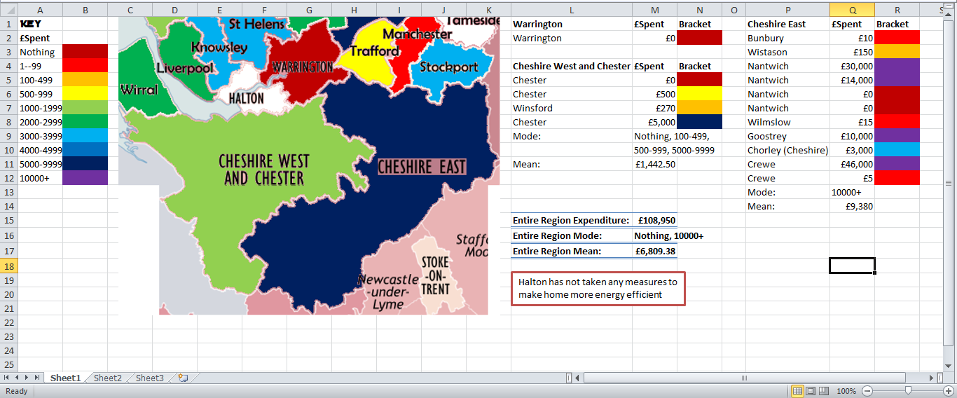
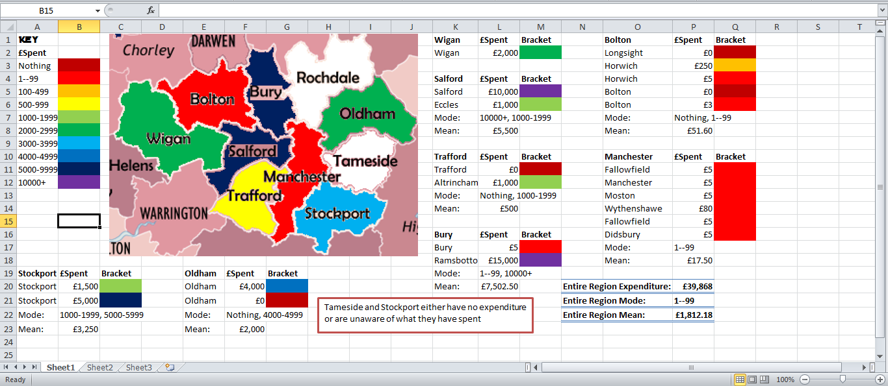
By working out the average for each borough, there isn’t a noticeable pattern in any county. To see if there is an obvious region-wide pattern, all maps were put together to give Figure 9 (see next page). One noticeable pattern from Figure 9 is that the North of the region (excluding Cumbria) and the South both have spent £5000-£9999 on measures, a high amount. In the middle of the region (South Lancashire, Greater Manchester, Merseyside, North Cheshire) there is a mixture of expenditures with no discernible pattern. In order to see if there is a pattern with the counties, a new map had to be made colour coding the mean of each county, creating Figure 10.
Figure 8. Spread sheet on Excel showing money spent on measures to improve homes in Cheshire. Also displaying map that shows what an average household spends in each borough. (Areas with white have not spent or are unsure of how much they spent on changes)
Figure 7. Spread sheet on Excel showing money spent on measures to improve homes in Greater Manchester. . Also displaying map that shows what an average household spends in each borough. (Areas with white have not spent or are unsure of how much they spent on changes)
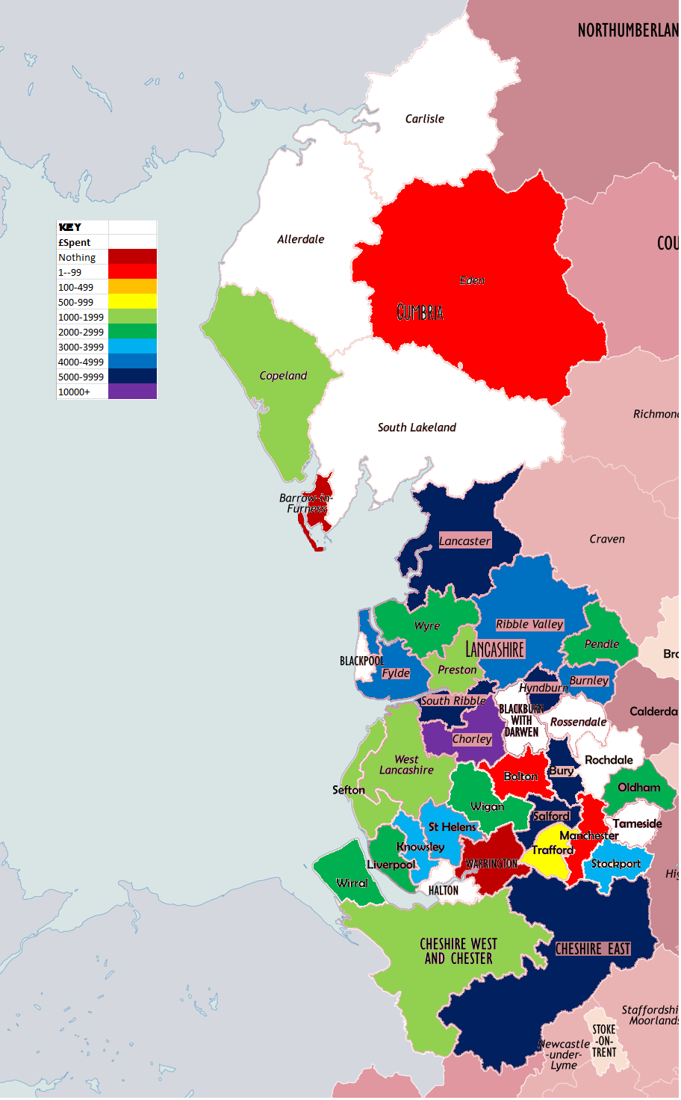
Figure 9. A map showing each borough or district in the North West, with a colour representative of the mean expenditure on energy saving measures.
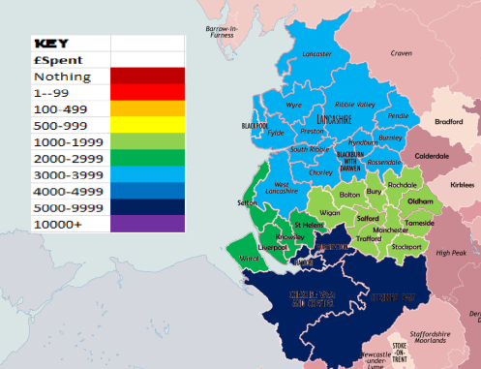

Figure 10. Map showing mean county expenditure on energy efficient devices in the North West

Cheshire has the highest expenditure out of all the counties with an average of £5000-£9999 being spent on energy saving devices. The next highest expenditure is in Lancashire, at £3000-£3999, then Merseyside at £2000-£2999 and the lowest expenditure on energy saving devices is from Greater Manchester at £1000-£1999. The potential idea of the North and the South spending the most is nullified by Figure 10. As Lancashire is a large county with such alternating expenditure patterns in different boroughs, it brings the average down to £3528, from the high expenditure of £5666 in Lancaster, but bring up from the lows like £1496 in West Lancashire. With no discernible pattern obvious, there isn’t a trend through the region, although the data reveals the highest and lowest spending areas when it comes to investing in energy saving devices. One pattern that is obvious from Figure 9, is that in Manchester, Chester and Preston, as you move away from the city centre, the amount spent on improving energy efficiency increases, although the pattern in Liverpool doesn’t match Preston, Chester and Manchester, as Sefton has a lower rate compared to Liverpool.

County | Mean Expenditure on Measures
Cheshire | £6,809
Cumbria | £668
Greater Manchester | £1,812
Lancashire | £3,528
Merseyside | £2,588
Table 2. The mean expenditures on energy saving devices in each county.

It’s understandable to see the Cheshire at the higher end of the scale in terms of income, as it is considered a very affluent area. In the Telegraphs’ ‘Britain’s Richest Towns’, the county has 4 of the 50 towns (with most towns being in Southern England) (McGhie, 2008). The area known as ‘Footballer’s Alley’ is located in Cheshire and is home to numerous football stars, where the average house price is £1.6 million pounds (Cheshire Life, 2012). Cheshire doesn’t have a city on the same scale as Greater Manchester or Merseyside. Liverpool and Manchester are the North West’s biggest cities, and in the inner city areas such as Toxteth or Moss Side many household incomes are low, which reduce the mean expenditure rate for the city boroughs, having an effect on the whole county. This low income has affected the expenditure in inner city areas. The Metropolitan Borough of Manchester has a mean expenditure of £1-£99, the second lowest bracket, in all the surrounding areas (except the boroughs with no data) such as Stockport and Trafford, there is a higher mean expenditure. There is a similar pattern in Preston. The City of Preston has a mean expenditure of £1000-£1999, and similarly to Manchester, the surrounding areas like Fylde and South Ribble have a higher mean expenditure. Again, in Cheshire West and Chester, there is a higher expenditure in the surround boroughs. The only exception to this pattern is in Liverpool, where the Wirral and Sefton have the same and lower mean expenditures, respectively, although Knowsley does have higher mean expenditure to the East. This pattern could be related to the low income areas associated with inner cities in the UK. Looking at mean salaries from city constituencies, it reads like this; Manchester £20726, Preston £16895, Chester £20890 and Liverpool £19722 (Ball, 2011). As surrounding constituencies have higher salaries, this could lead to them having larger expendable income compared to inner city constituencies. In Greater Manchester constituencies, for example, Cheadle and Bury North Constituencies in the suburbs of Manchester have mean salaries of £22298 and £23971 respectively, both higher than in the city centre (other outer city areas have higher mean salaries’). In Lancashire, Lancaster and Fleetwood, and South Ribble constituencies have higher average salaries than Preston, at £18911 and £20876 correspondingly. Using this data, the only obvious pattern in the North West, is that inner cities spend less on improving home energy efficiency, and the amount spent increases as you move away from the city centres.
4.3 What is the most popular way of improving home energy efficiency in the North West?
In this sub-chapter, gathered data from Q6 will be used to answer this question. The first step to finding the answer is to tally the answers provided, and put them in a simple table. Table 3 is all the measures that interviewees have conducted on their homes, as well as the frequency of how often the answer occurred.

Measure | Frequency
Loft Insulation | 145
Cavity Wall Insulation | 59
Draught Excluders | 9
2x Glazing | 83
3x Glazing | 2
Energy Efficient Bulbs | 40
Energy Efficient Boiler | 19
Solar Panels | 10
Thermal Panels | 1
Insulative Tiles | 2
Solar Tiles | 1
Thermalite Walls (Solid Wall Insulation) | 1
Boiler Jacket | 2
Wood Burners | 1
Wood Burning Stove | 1
Energy/Electricity Usage Meter | 2

Table 3. Table showing measures taken in the North West, and the frequency of the occurring measure

The standout data from Table 3 is the frequency of Loft Insulation (145). Out of 300 interviews, almost half of them said that they have had loft insulation installed in their home. The next, popular is double glazing with 83/300 interviewees having it installed in their home, and then cavity wall insulation is the 3rd most popular with 59 people installing it. 223 interviewees had made changes to their homes that would improve its energy efficiency.
But why is loft insulation so popular when compared to other measures? The Warm Front Scheme offered loft and cavity wall insulation for a reduced price (or free in certain circumstances) to people falling under a certain criteria (low income, pensioner). It was also in place for 10 years, so was utilised for a long time, in 2010 when it was re-launched, more people fell under the criteria to get the grant available from the Warm Front Scheme. Most homes in the UK have a loft or attic. A simple idea of putting an insulative layer in the loft to reduce the rate of escaping heat up through the attic, can save around £180 a year and 730kg of carbon (Energy Saving Trust, 2013). It also pays for itself after 2 years, a much better return for the money paid than solar panels that can take 12 years to pay off (Jackson, 2010). Cavity wall insulation is similar to loft insulation. Instead of reducing the amount of heat lost through the roof, its reducing heat lost through the walls. Most houses built after 1920 have a wall cavity, cavity wall insulation fills that gap with an insulative material that can save £140 on energy bills (Energy Saving Trust, 2013). With both of these measures available for less under government schemes, and in the current economic climate, cheaper energy saving measures are always likely to be the most popular.
4.4 Does a certain age group spend more on energy saving devices?
This question aims to find out if a certain age group spends more money on energy saving devices, and if the age group differs throughout the region (excluding Cumbria). The UK government’s energy scheme, the Warm Front, favours the elderly and those on a low income (Which?, 2013). This should add extra incentive for those on a pension credit to invest in energy saving measures, assisting Britain in reaching its carbon reduction targets. To find out what age groups spend on energy saving devices, the data is organised so that interviewees who spent money on measures are arranged into their age group in each county. The mean spend of each age group is worked out in each region before discovering which age group spends the most on average. Table 4 shows the mean expenditure from each age group in each county (where that age group is represented). Though Table 4 doesn’t provide enough information to work out which age group, on average, spends the most on energy efficient devices. To do this, a new table must be constructed. Table 4 shows age groups in each county, Table 5 shows age groups mean expenditure from throughout the region.

County | Age Group | Mean Spend | County Mean Spend
Cheshire | 20-29 | £173 | £6,809
 | 40-49 | £15,005
 | 50-59 | £3,054
 | 60+ | £10,525
G.Manchester | 20-29 | £670 | £1,812
 | 30-39 | £377
 | 40-49 | £693
 | 50-59 | £125
 | 60+ | £7,500
Lancashire | Less 20 | £1,333 | £3,189
 | 20-29 | £22
 | 30-39 | £126
 | 40-49 | £4,628
 | 50-59 | £5,094
 | 60+ | £2,615
Merseyside | Less 20 | £2,003 | £2,560
 | 20-29 | £193
 | 30-39 | £1,751
 | 40-49 | £1,721
 | 50-59 | £3,571
 | 60+ | £3,430

Table 4. Table showing each age groups mean expenditure in each county, as well as the overall county mean

Age Group | Mean Expenditure | Frequency
Less 20 | £1,601 | 5
20-29 | £286 | 27
30-39 | £713 | 13
40-49 | £4,453 | 32
50-59 | £4,157 | 35
60+ | £4,176 | 51
 |  | 163 | Total

Table 5. Showing mean expenditure for each age group around the North West, as well as the amount of interviewees from that age group (frequency)

Table 5 clearly shows that the older age groups have spent considerably more on improving their homes, except for the anomaly of the age group, less than 20. The 40-49 age group had spent the most on measures (£4453), whereas the 20-29 year olds spent the least (£286). The general pattern has an increasing trend as the older the ages get, the mean expenditure increases. Although in Cheshire, two age groups are not represented (Less 20, 30-39) and Less than 20’s are not represented in
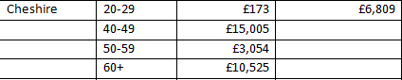
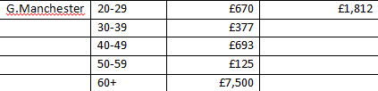
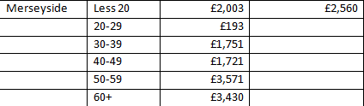
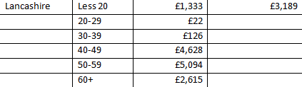
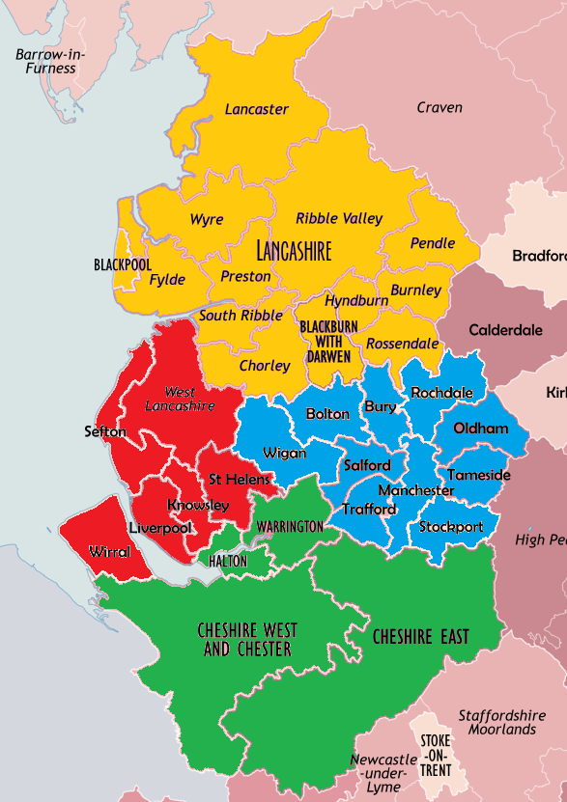
Figure 11. Map of the North West (Cheshire-Green, Merseyside-Red, Greater Manchester-Blue, Lancashire-Yellow) with age groups, mean expenditure and region expenditure next to the corresponding county.

Greater Manchester, which could have an impact on the results, as Less than 20 and 30-39 are underrepresented. There is a variety of top spenders throughout the region. In the four different counties, there are 3 different top spenders, all in the oldest 3 categories (Lancashire and Merseyside, 50-59; Cheshire, 40-49; Greater Manchester, 60+).
As expected the older generations have spent more on their home to improve energy efficiency. The Warm Front Scheme has now finished and been replaced by the Green Deal, but the data gathered was collected in the summer of 2012 when the Warm Front Scheme was active, meaning that it would have had an impact on the age group’s investment. Compared to younger generations, the older generations will have a larger amount of disposable income to spend on making their home more energy efficient. Having been in work for a longer time, most likely being married by the age of 40 (national average is 30, (Wallop, 2011)) and are more likely to own property than the younger generations, it is understandable for the data to show the older generations spending more. The Less than 20 age group, is poorly represented, and is only found in Merseyside and Lancashire. Surprisingly, under 20’s have a relatively high mean expenditure, although there isn’t enough data to support that age group, children under the age of 20 tend to still live with their parents (average age of leaving home is 26 (The Telegraph, 2011)). It’s more believable that when asking ‘how much did this cost all together, including installation?’ that they have answered with the sum that their parents paid, consequently, that expenditure is represented in the younger than 20 age group. The 20-29 age group has the lowest mean expenditure throughout the region, and the lowest in 3 of the 4 counties. At this age, a large amount of interviewees would be students and will be living without support of their parents, limiting them to the amount spent on energy saving measures. When asking interviewees why they couldn’t improve their homes’ energy efficiency, a common answer was ‘due to landlord’. Many people of this age will not own their own property and are most likely to be renting accommodation, landlords will decide what changes occur to the property, and the only changes that could be made are minor ones (draft excluders, energy saving light bulbs).

4.5 Does the amount of household income affect the amount spent on improving homes’ energy efficiency?
As previously discovered in sub-chapter 4.4, the older generations spend more on improving energy efficiency. But does having a larger income mean that more money will be spent on improving household energy efficiency, compared to those on a lower income? To answer this question, data will be required from Q1, Q5 and Q7. Firstly, the hypothesis for this question is; ‘the greater the household income, the higher the amount of money spent on improving energy efficiency in the home’. To accept or reject this hypothesis, the mean and median for each household income bracket will be worked out using Microsoft Excel. Once the data has been arranged so that the mean and median of each bracket are known, a line graph can be constructed (Figure 12).
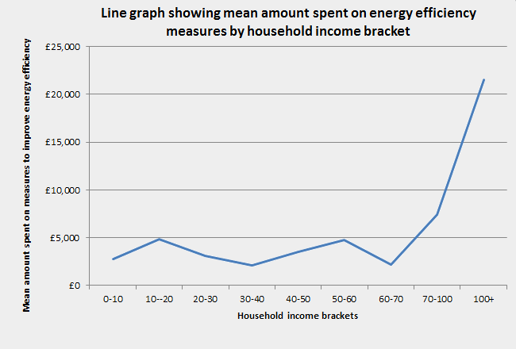
Figure 12 clearly shows a rise at the tail end of the graph. From 0-10 to 60-70 there is no general pattern with alternating amounts spent. From the 60-70 income bracket, there is then a rise. Figure 12 does not provide enough evidence to support the hypothesis that ‘the greater the household income, the higher the amount of money spent on improving energy efficiency in the home’. Using another average method, finding the median, should give more evidence in support of the hypothesis. Figure 13 is a line graph showing the median spends on improving energy efficiency for each household income bracket. 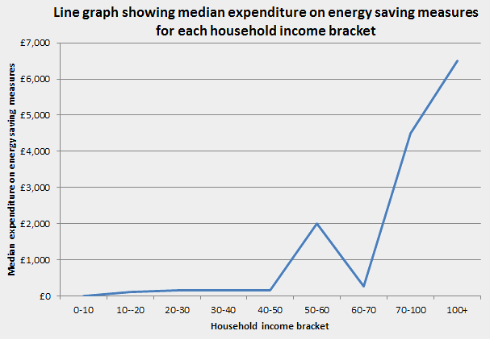
Figure 12. A line graph showing the mean amount spent on energy efficiency measures for each household income bracket in the North West
Figure 13. Line graph showing median expenditure on energy saving measures for each household income bracket
Figure 13 shows gradually increasing median expenditure, before a large rise and decline, before a final rise, similar to that in Figure 12. If it wasn’t for the anomaly of such a large median for the bracket, 50-60, then the graph would have shown an increase throughout the entire graph. However, the data shown does not provide enough evidence to accept the hypothesis, so we accept an alternative hypothesis; ‘When the average household income is above £60,000, expenditure on measures to improve domestic energy efficiency increases’.
The UK’s current economic climate is in a state of recovery from the financial collapse of the late 00’s (Oxlade, 2013). While this climate persists, purchasing energy efficient devices will cost more, making the public more reluctant to spend their money without government grants or support. The general trend is that the higher the household income, the higher the expenditure on energy saving measures. Though with the data provided, there isn’t a steady growth throughout the income bracket to confirm this, instead, there is an anomaly in the median average and a fluctuating average mean. What the data shows is that, improving energy efficiency is currently for those whose household earns over £60,000 per annum. Although people with lower incomes can still make changes to improve the energy efficiency of their home, it will have a much greater impact on their finances than it would in a higher earning home. Cheaper measures can make a difference, loft insulation, energy saving bulbs and water boiler jackets don’t cost as much as solar panels or double glazing, although the cheaper measures are often more cost effective than the expensive measures.
4.6 Are the public aware of how they can do to improve their home’s energy efficiency and are they aware of local businesses that can provide the service?
With government schemes and grants available to improve energy efficiency, just how well informed are the North West public when it comes down to their knowledge of energy efficiency? This question intends to discover, how well informed the general public are about energy efficiency and if there is a correlation between awareness and investing in energy saving measures. When asking Q12: ‘Are you aware of what’s available to make your home more energy efficient?’ the protocol would be to follow it up with the line ‘such as government run schemes, or devices you can install’. Saying the extra line cleared up any confusion that may have arisen from the question. The final two questions on the questionnaire are relative to the knowledge of the interviewees. Q12 and Q13 required a simple yes or no answer, although some interviewees preferred to give examples, those answers were quantified into ‘yes’ responses. Firstly the answers were taken from all questionnaire responses and tallied.
Q12 |  |  | Q13
Yes | No |  | Yes | No
261 | 39 |  | 145 | 155

Table 6. Table showing the frequency of answers to Q12 and Q13 from the North West

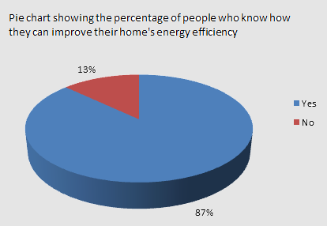

Figure 14. Pie chart showing percentage of people who are aware of how they can improve their home’s energy efficiency
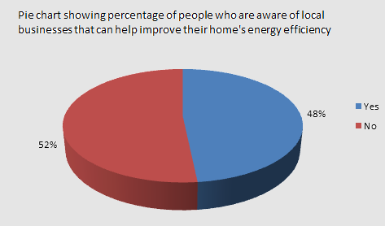

Figure 15. Pie chart showing percentage of people who are aware of local businesses that can help improve their home’s energy efficiency

Pie charts are a better representation than a table when showing the difference in frequency of answers. In Figure 12 the pie chart shows an overwhelming majority of interviewees responded with ‘yes’ (87%) when asked, ‘are you aware of what’s available to make your home more energy efficient?’. For Q13, when asked, ‘do you know of any local businesses which can improve your homes energy efficiency?’, it was almost 50/50 with answers, but 48% (145) only knew of local businesses that could improve domestic energy efficiency compared to the 52% (155) that didn’t. The second aim of the sub-chapter is to see if there is a correlation between awareness and investing in energy saving measures. The hypothesis is; ‘if people are aware of what is available to make their home more energy efficient, they are more likely to take strides in improving efficiency’. The data was then organised into sections; improved home energy efficiency and are aware of what is available, improved home energy efficiency and not aware of what is available, not improved home energy efficiency but aware of what is available, finally, not improved energy efficiency and not aware of what is available. Once all data was arranged into the relevant section, a graph could be made showing the frequency of combined responses to Q5 and Q12 (Figure 14).
Figure 14 shows that the majority of interviewees have made changes to their home, and they are aware of what is available to improve its energy efficiency. For the energy saving trust, this will be positive news, however there is still a large percentage of the database that haven’t made changes, and some people still aren’t aware of what is available. 197/300 responses said that they are aware of what is available to make their
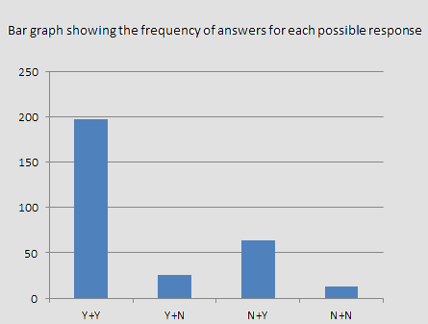
Figure 16. Graph showing the frequency of each possible response partnerships to Q5 and Q12.

home more energy efficient, and they have taken action and improved their home’s energy efficiency. The data on the graph reinforces the hypothesis; ‘if people are aware of what is available to make their home more energy efficient, they are more likely to take strides in improving efficiency’. The graphs also shows that the second highest bar is for interviewees who have not taken any measures to improve energy efficiency, but are aware of what they can do to improve it. Similarly to the Y+Y bar, this is good news, as the energy efficiency information is being advertised at a reasonably successful level. People who are yet to invest but are aware gave numerous excuses during the interviews (Table 7).

Excuses | Frequency
Cost | 17
Landlord's Decision | 8
Happy as it is | 2
Fully Efficient | 5
Time Consuming | 1
Moving Home | 3
Eco House | 1
Lazy | 2
Pointless | 1
Incapable | 2
Home is a vehicle | 1
Too old to be fussed | 1
Wear more layers (improve personal energy efficiency) | 1
New Building | 1

Table 7. Showing the frequency of excuses for not improving home energy efficiency, from interviewees who are aware of what is available to make their home more energy efficient

For this group of interviewees to improve their energy efficiency, they must overcome the obstacles in Table 7. The most frequently occurring reason is due to cost. To reach the target of an 80% reduction in carbon, this group of people who can’t afford to improve their energy efficiency need extra assistance from the government. The current schemes clearly do not reach all of the target audience, granted, it reaches a large amount, although this will still leave a large section of North West (potentially across Britain) homes which cannot be improved due to financial restraints. The Green Deal is yet to have a dramatic effect and will be judged in due course, as their will undoubtedly be a group of cynics who do not believe that the current scheme does enough to affect the UK’s carbon emissions. There have already been criticisms in the press regarding the green deal (Gammell, 2013).Remarkably, there are 5 people who believe that their homes are already fully efficient, though this is a minute number, in this age of information, you would expect people to understand that there isn’t such a thing as fully efficient.

4.7 Delimitations
The biggest delimitation of the study is the lack of data from Cumbria. In a study aimed to represent the North West, the most northern county has not been represented in the data well enough to make conclusions about the area, or the whole North West. The cost of travelling to areas that would have been promising to conduct research was too inaccessible. Whitehaven on the coast was a preferred study site, but was too remote.
The target of getting all data in the summer was unachievable mainly due to the weather. The wettest summer in one hundred years proved to be a large obstacle in gathering data. Given dryer weather, the data would have been gathered in a much shorter time, and all would have been gathered in July and August. Though 300 results were gathered, it could have been done in a much shorter time period.
The amount of interviewees was 300. Given more time and more money, this number could have been larger, increasing the validity of the research.

5. References

Bachelor, L. & Osborne, H., 2012. Guardian. [Online]
Available at: http://www.guardian.co.uk/money/2012/dec/10/eon-price-rise-completes-big-six-increases
[Accessed 10 December 2012].
Bakewell, S., 2012. U.K. Nuclear Push Gains With Bill to Revamp Power Market. [Online]
Available at: http://www.bloomberg.com/news/2012-11-29/u-k-nuclear-push-advances-with-bill-to-revamp-power-market.html
[Accessed 25 March 2013].
Ball, J., 2011. Wages throughout the country: how does your area compare?. [Online]
Available at: http://www.guardian.co.uk/news/datablog/2011/nov/24/wages-britain-ashe-mapped#
[Accessed 21 March 2013].
Banfill, P. F. G. & Peacock, A. D., 2007. Energy Efficient new housing - the UK reaches for sustainability. Building Research and Information, 4(35), pp. 426-436.
BBC, 2008. Watchdog. [Online]
Available at: http://www.bbc.co.uk/watchdog/consumer_advice/latest_solar_panels_pic.shtml
[Accessed 29 November 2012].
BBC, 2012. E.On to incease energy prices by 8.7%. [Online]
Available at: http://www.bbc.co.uk/news/business-20640304
[Accessed 10 December 2012].
Black, R., 2009. A Brief History of Climate Change. [Online]
Available at: http://news.bbc.co.uk/1/hi/sci/tech/8285247.stm
[Accessed 18 March 2013].
Black, R., 2011. BBC News Lancashire. [Online]
Available at: http://www.bbc.co.uk/news/uk-england-lancashire-14990573
[Accessed 27 March 2012].
Blaxall, R., 2011. Tesco's Burscough Business boost. [Online]
Available at: http://www.ormskirk.gb.com/ormskirk/news_list/Tesco's_Burscough_business_boost-50809552.htm
[Accessed 14 April 2013].
Boardman, B., 2007. Home Truths: A low-carbon strategy to reduce UK housing emissions by 80% by 2050, Oxford, England: University of Oxford.
Bonta, D. & Snyder, S., 2008. New Green Home Solutions: Renewable Household Living and Sustainable Living. 1st ed. Layton: Gibbs Smith.
British Gas, 2013. Conventional Boilers. [Online]
Available at: http://www.britishgas.co.uk/products-and-services/boilers-and-central-heating/new-boilers/central-heating-and-boilers-explained/how-it-works/conventional-boilers.html
[Accessed 23 March 2013].
Broome, J., 2007. The Green Self-Build Book:How to Design and Build Your Own Eco-Home. 1st ed. Totnes: Green.
Buchanan, P., 2005. Ten Shades of Green: Architecture and the Natural World. 1st ed. New York: Architectural League of New York.
Butfield, C., 2013. WWF Campaigns that Changed The World. [Online]
Available at: http://www.wwf.org.uk/what_we_do/campaigning/campaigns_that_changed_the_world.cfm
[Accessed 24 March 2013].
Cheshire Life, 2012. Cheshire Life. [Online]
Available at: http://cheshire.greatbritishlife.co.uk/article/millionaires-rows--cheshires-des-res-homes-38865/
[Accessed 5 April 2013].
Citizens Advice Bureau, 2013. Green Deal How it Works. [Online]
Available at: http://www.adviceguide.org.uk/wales/consumer_w/consumer_energy_and_water_supply_e/consumer_energy_supply_e/consumer_saving_money_on_energy_bills_e/consumer_green_deal_e/green_deal_how_it_works.htm
[Accessed 26 March 2013].
Contemporary Physics Education Project, 2003. Radiation in the Environment. [Online]
Available at: http://www.lbl.gov/abc/wallchart/teachersguide/pdf/Chap15.pdf
[Accessed 21 March 2013].
Davey, E., 2012. Energy Bill 2012/2013. London, The Guardian.
Department of Energy and Climate Change, 2010. Carbon Emissions Reduction Target (CERT). [Online]
Available at: http://www.decc.gov.uk/en/content/cms/funding/funding_ops/cert/cert.aspx
[Accessed 27 November 2012].
Department of Energy and Climate Change, 2010. The Warm Front Scheme Annual Report, Newcastle upon Tyne: Department of Energy and Climate Change.
Department of Energy and Climate Change, 2011. Warm Front Scheme Annual Report, Newcastle upon Tyne: Department of Energy and Climate Change.
Department of Energy; Hutton, Sandra, 1985. Energy Efficiency in Low Income Households: an Evaluation of Local Insulation Projects. London: HMSO.
Direct Gov, 2011. Direct Gov: Warm Front scheme. [Online]
Available at: http://www.direct.gov.uk/en/Environmentandgreenerliving/Energyandwatersaving/Energygrants/DG_10018661
[Accessed 21 April 2012].
Dong Energy, 2013. The Burbo Bank Project. [Online]
Available at: http://www.dongenergy.com/Burbo/Project/The_burbo_bank_project/Pages/The_Burbo_bank_project.aspx
[Accessed 14 April 2013].
Easton, M., 2008. BBC. [Online]
Available at: http://www.bbc.co.uk/blogs/thereporters/markeaston/2008/09/map_of_the_week_crowded_britai.html
[Accessed 1 December 2012].
Eccleston, P., 2007. Britain's Massive Offshore Wind Farm Potential. [Online]
Available at: http://www.telegraph.co.uk/earth/energy/windpower/3309258/Britains-massive-offshore-wind-power-potential.html
[Accessed 19 March 2013].
EDF Energy, 2013. Carbon Emissions from nuclear power. [Online]
Available at: http://www.edfenergy.com/energyfuture/energy-gap-climate-change/nuclear-and-the-energy-gap-climate-change
[Accessed 21 March 2013].
Energy Saving Trust, 2013. Cavity Wall Insulation. [Online]
Available at: http://www.energysavingtrust.org.uk/Insulation/Cavity-wall-insulation
[Accessed 7 April 2013].
Energy Saving Trust, 2013. Green Deal and ECO. [Online]
Available at: http://www.energysavingtrust.org.uk/Take-action/Find-a-grant/Green-Deal-and-ECO
[Accessed 25 March 2013].
Energy Saving Trust, 2013. Improve Your Home. [Online]
Available at: http://www.energysavingtrust.org.uk/Take-action/Improve-your-home
[Accessed 23 March 2013].
Energy Saving Trust, 2013. Replacing Your Boiler. [Online]
Available at: http://www.energysavingtrust.org.uk/Heating-and-hot-water/Replacing-your-boiler
[Accessed 23 March 2013].
Energy Saving Trust, 2013. Roof and Loft Insulation. [Online]
Available at: http://www.energysavingtrust.org.uk/Insulation/Roof-and-loft-insulation
[Accessed 7 April 2013].
Energy Saving Trust, 2013. Windows. [Online]
Available at: http://www.energysavingtrust.org.uk/Insulation/Windows
[Accessed 23 March 2013].
European Environment Agency; ECOTEC Research Consulting Ltd; Mourelatou, Aphrodite , 2001. Renewable Energies: Success Stories. Luxembourg: Office for Official Publication of the European Communities.
EvoEnergy, 2013. EvoEnergy. [Online]
Available at: http://www.evoenergy.co.uk/
[Accessed 21 March 2013].
Frost, C., Wang, F., Woods, P. & MacGregor, R., 2012. The “District Heating Wall”: A Synergistic Approach to Achieve Affordable Carbon Emission Reductions in Old Terraced Houses. Low Carbon Economy, Issue 3, pp. 115-129.
Gammell, K., 2013. The Telegraph. [Online]
Available at: http://www.telegraph.co.uk/finance/personalfinance/consumertips/household-bills/9839987/green-deal-99-for-a-flawed-assessment.html
[Accessed 11 April 2013].
Gipe, P., 1993. Wind Power for Home and Business: Renewable Energy for the 1990's and Beyond. Chelsea: Green.
Glatthorn, A. A., 1998. Writing the Winning Dissertation. 1st ed. California: Corwin Press.
Google, 2010. Google Earth. s.l.:Google.
gov.uk, 2006. Climate Change and Sustainable Energy Act 2006. [Online]
Available at: http://www.legislation.gov.uk/ukpga/2006/19/introduction
[Accessed 24 March 2013].
gov.uk, 2008. Climate Change Act 2008. [Online]
Available at: http://www.legislation.gov.uk/ukpga/2008/27/section/1
[Accessed 24 March 2013].
gov.uk, 2008. Climate Change Act 2008. [Online]
Available at: http://www.legislation.gov.uk/ukpga/2008/27/pdfs/ukpga_20080027_en.pdf
[Accessed 19 March 2013].
Gov.uk, 2012. Warm Front Scheme. [Online]
Available at: https://www.gov.uk/warm-front-scheme/overview
[Accessed 27 November 2012].
gov.uk, 2013. Feed In Tariffs. [Online]
Available at: https://www.gov.uk/feed-in-tariffs/overview
[Accessed 25 March 2013].
gov.uk, 2013. Feed-in-Tariff. [Online]
Available at: https://www.gov.uk/feed-in-tariffs/how-to-apply
[Accessed 19 March 2013].
gov.uk, 2013. Repayments. [Online]
Available at: https://www.gov.uk/green-deal-energy-saving-measures/repayments
[Accessed 25 March 2013].
gov.uk, 2013. Warm Front Scheme. [Online]
Available at: https://www.gov.uk/warm-front-scheme/overview
[Accessed 21 March 2013].
Gritt, A., 2007. Wikiemedia Commons. [Online]
Available at: http://commons.wikimedia.org/wiki/File:Friargate_Preston_on_a_busy_weekday_afternoon_-_geograph.org.uk_-_1710831.jpg
[Accessed 14 April 2013].
Guy, P., 2012. Bold Street Festival 2012. [Online]
Available at: http://www.liverpoolecho.co.uk/liverpool-news/in-the-mix/2012/09/10/no-headline-100252-31804333/
[Accessed 14 April 2013].
Harvey, F., 2013. Solar companies to sue UK government for £140m over feed-in tariff cuts. [Online]
Available at: http://www.guardian.co.uk/environment/2013/jan/23/solar-companies-feed-in-tariff-cuts
[Accessed 19 March 2013].
Hedges, A., 1991. Attitudes to Energy Conservation in the Home. 1st ed. s.l.:HMSO.
Hewitt, M. & Telfer, K., 2007. Earthships: Building a Zero Carbon Future for Homes. Bracknell: IHS BRE.
Horlock, S., 2013. Solar Panel Industry [Interview] (22 March 2013).
Hough, D., Bolton, P. & Richards, P., 2012. Warm Front Scheme - Commons Library Standard Note. [Online]
Available at: http://www.parliament.uk/briefing-papers/SN06231
[Accessed 25 March 2013].
Hymers, P., 2006. Converting to an Eco Friendly Home: the Complete Handbook. 1st ed. London: New Holland.
International Energy Agency (IEA), 2013. Monthly Electricity Statistics: December 2012. [Online]
Available at: http://www.iea.org/stats/surveys/mes.pdf
[Accessed 19 March 2013].
Jackson, R., 2010. Money Week. [Online]
Available at: http://www.moneyweek.com/personal-finance/will-solar-panels-pay-for-themselves-47322
[Accessed 7 April 2013].
Jowit, J., 2013. New Nuclear Power Station Gets Planning Consent. [Online]
Available at: http://www.bbc.co.uk/news/uk-21839684
[Accessed 21 March 2013].
Kirkup, J. & Hough, A., 2012. Energy bill rises will outpace inflation next year, forecasters warn. [Online]
Available at: http://www.telegraph.co.uk/finance/personalfinance/consumertips/household-bills/9738793/Energy-bill-rises-will-outpace-inflation-next-year-forecasters-warn.html
[Accessed 21 March 2013].
Kutz, M., 2007. Environmentally Conscious Alternative Energy Production. Hoboken: Wiley.
Malik, A., 2008. Causes of Climate Change. 1st ed. Delhi: Global Media.
McGhie, C., 2008. Britains 50 Richest Towns. [Online]
Available at: http://www.telegraph.co.uk/property/3360997/Britains-50-richest-towns.html
[Accessed 5 April 2013].
McLeod, W. T. & Hanks, P., 1988. The New Collins Concise English Dictionary. 3rd ed. London: Guild Publishing London.
Meet Dave - The new star of the Energy Saving Trust TV ad. 2009. [Film] Directed by Energy Saving Trust. UK: Energy Saving Trust.
National Archives, 2012. Carbon Emissions Reduction Target. [Online]
Available at: http://webarchive.nationalarchives.gov.uk/20121217150421/http://decc.gov.uk/en/content/cms/funding/funding_ops/cert/cert.aspx
[Accessed 24 March 2013].
National Opposition to Windfarms, 2012. The NOW Charter. [Online]
Available at: http://www.nowind.org.uk/
[Accessed 2013 March 2013].
National Research Council, 2010. Advancing the Science of Climate Change, Washington: National Academies Press.
NOAA/ESRL, 2013. Atmospheric CO2 at Mauna Loa Observatory. s.l.:NOAA/ESRL.
Office for National Statistics, 2011. 2011 Annual Survey of Hours and Earnings, Newport: Office for National Statistics.
Office for National Statistics, 2011. Heat map showing average salaries by contituencies in the UK. Newport: Office for National Statistics.
Ofgem, 2007. Community Energy Saving Programme. [Online]
Available at: http://www.ofgem.gov.uk/Sustainability/Environment/EnergyEff/cesp/Pages/cesp.aspx
[Accessed 24 March 2013].
Ofgem, 2013. Energy Companies Obligation. [Online]
Available at: http://www.ofgem.gov.uk/Sustainability/Environment/ECO/Pages/index.aspx
[Accessed 25 March 2013].
Oxlade, A., 2013. The Telegraph. [Online]
Available at: http://www.telegraph.co.uk/finance/personalfinance/9849449/how-this-recovery-from-recession-compares-with-those-of-the-past.html
[Accessed 11 April 2013].
Perlmutter, D. D. R. R. L., 2010. Challenges of Climate Change: Which Way Now?. 1st ed. Hoboken: Wiley-Blackwell.
Renewable Solutions, 2013. Solar Heating. [Online]
Available at: http://www.renewablesolutionsuk.com/home/solar-thermal-hot-water
[Accessed 4 April 2013].
Robert, M., 2012. Warm Front Scheme Makes Millions Available For UK Homes. [Online]
Available at: http://www.uswitch.com/gas-electricity/news/2012/09/06/warm-front-scheme-makes-millions-available-to-uk-homes/
[Accessed 27 November 2012].
Ryker, L., 2007. Off the Grid Homes. 1st ed. Salt Lake City: Gibbs Smith.
The CCC , 2013. About Us. [Online]
Available at: http://www.theccc.org.uk/about/
[Accessed 24 March 2013].
The Telegraph, 2011. The Telegraph. [Online]
Available at: http://www.telegraph.co.uk/finance/personalfinance/8684283/boomerang-children-make-a-3500dent-in-parents-savings.html
[Accessed 11 April 2013].
Thompson, L., 2010. The misleading claims that prompt the question: Can solar panel savings ever eclipse their costs?. [Online]
Available at: http://www.dailymail.co.uk/news/article-1316082/Can-solar-panel-savings-eclipse-costs.html
[Accessed 19 March 2013].
Traynor, I. & Gow, D., 2007. EU promises 20% reduction in carbon emissions by 2020. [Online]
Available at: http://www.guardian.co.uk/environment/2007/feb/21/climatechange.climatechangeenvironment
[Accessed 21 March 2013].
Union of Concerned Scientists, 2012. CO2 Emissions. [Online]
Available at: http://www.ucsusa.org/global_warming/science_and_impacts/science/graph-showing-each-countrys.html
[Accessed 19 March 2013].
United Nations, 2013. Kyoto Protocol. [Online]
Available at: http://unfccc.int/kyoto_protocol/items/2830.php
[Accessed 24 March 2013].
USwitch, 2013. How to Insulate a Loft or Roof. [Online]
Available at: http://www.uswitch.com/insulation/guides/how-to-insulate-a-loft/
[Accessed 23 March 2013].
Wallop, H., 2011. The Telegraph. [Online]
Available at: http://www.telegraph.co.uk/news/8415852/average-age-for-women-to-marry-hits-30-for-first-time.html
[Accessed 11 April 2013].
Waterfield, P., 2006. The Energy Efficient Home: a Complete Guide. Ramsbury: Crowood.
Which?, 2013. Energy Grants. [Online]
Available at: http://www.which.co.uk/energy/creating-an-energy-saving-home/guides/energy-grants/warm-front-and-other-government-grants/
[Accessed 21 March 2013].
World Nuclear Association, 2012. Nuclear Share Figures, 2001-2011. [Online]
Available at: http://world-nuclear.org/info/Facts-and-Figures/Nuclear-generation-by-country/#.UUrxKBy-2So
[Accessed 21 March 2013].
XyrsD, 2010. Map of UK Boroughs. [Online]
Available at: http://commons.wikimedia.org/wiki/File:England_Adminstrative_2010.png
[Accessed 14 April 2013].
Zarem, A. M. & Erway, D. D., 1963. Introduction to the Utilization of Solar Energy. New York: McGraw Hill.

Appendix 1
Questionnaire
1. What bracket does your annual household income fall under?... less than £10,000, £10,000- £20,000, £20,000 - £30,000, £30,000 - £40,000, £40,000 - £50,000, £50,000 - £60,000, £60,000 - £70,000, £70,000 - £100,000, more than £100,000
2. What age group do you belong to?... younger than 20, 20 – 29, 30 – 39, 40 – 49, 50 – 59, 60+
3. Where do you live?
4. What kind of property do you live in? e.g. semi-detached
5. Have you taken any measures to make your home more energy efficient? If yes go to 6, no go to 8
6. If yes: What measures have you taken?
7. How much did this cost all together, including installation?
8. If no: are you planning any changes to make your home more energy efficient?
9. If no: Is this mainly due to financial reasons?
10. If no: what is the main reason?
11. What do you think the main reason is for UK citizens not making their homes more energy efficient?
12. Are you aware of what is available to make your home more energy efficient?
13. Do you know of any local businesses which can improve your homes energy efficiency?
Locations to complete questionnaire
Urban Areas -Liverpool – Bold Street, Preston – Mill Lane, Manchester – Market Street
Rural Areas - Burscough, West Kirby, Colne, Nantiwch, Garstang, Longridge
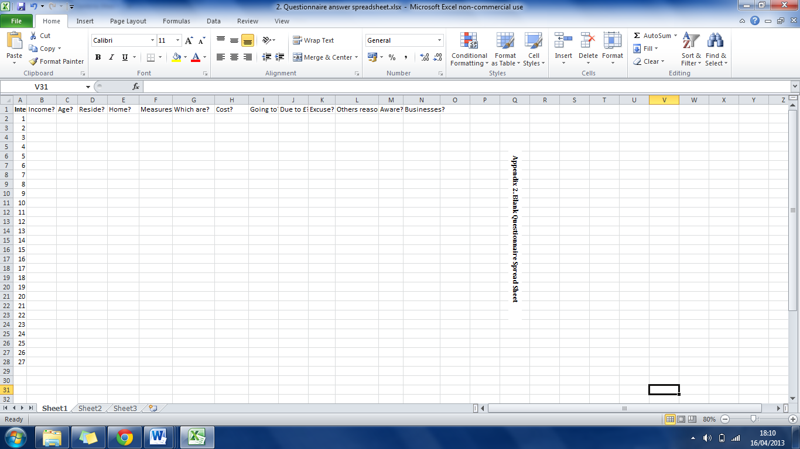

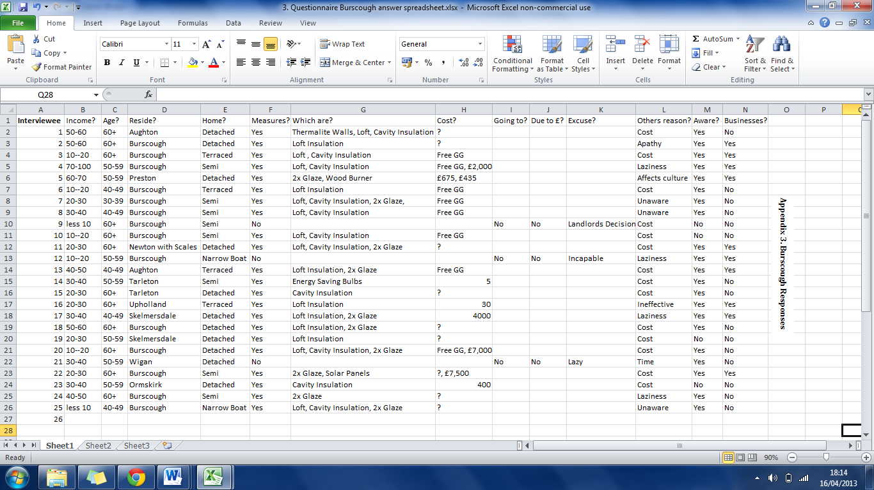
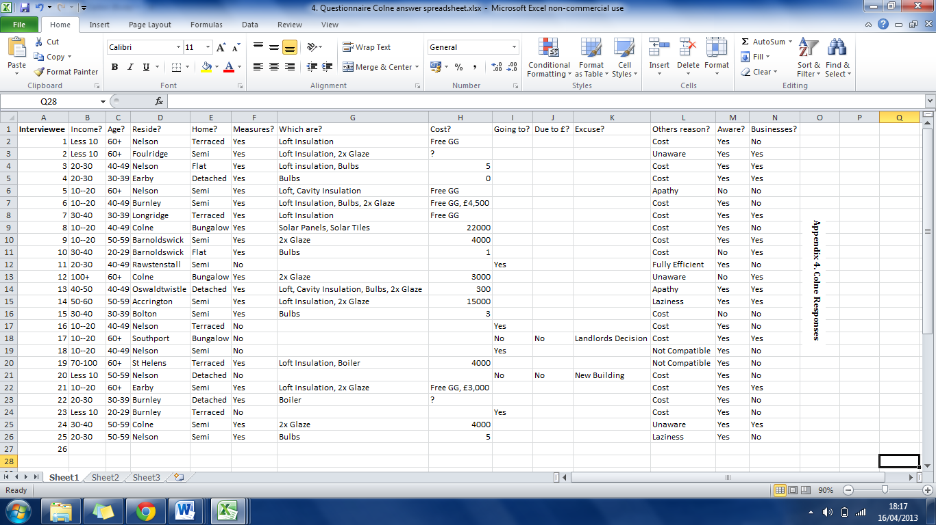
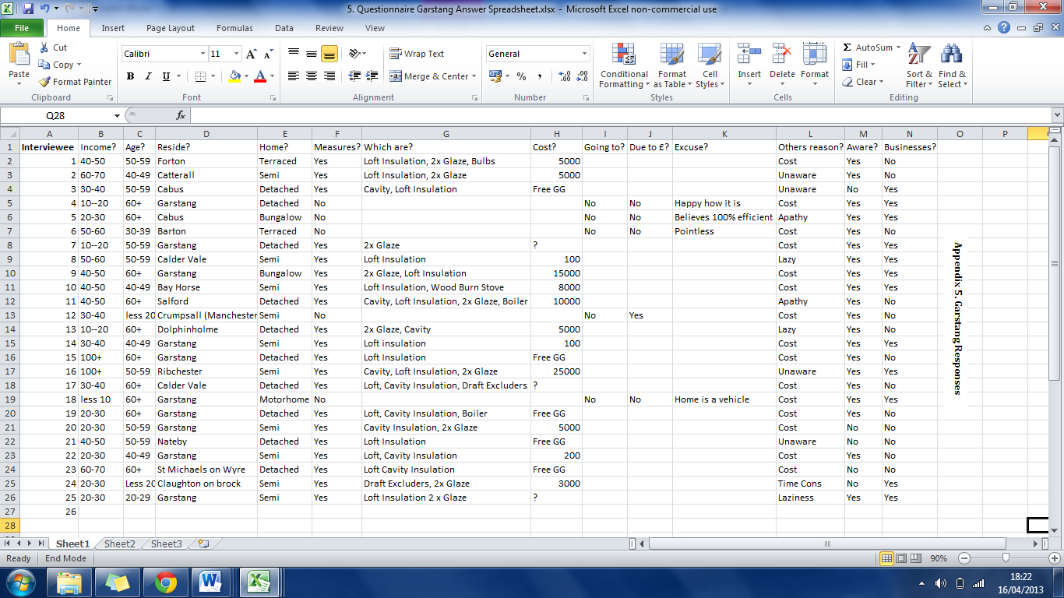
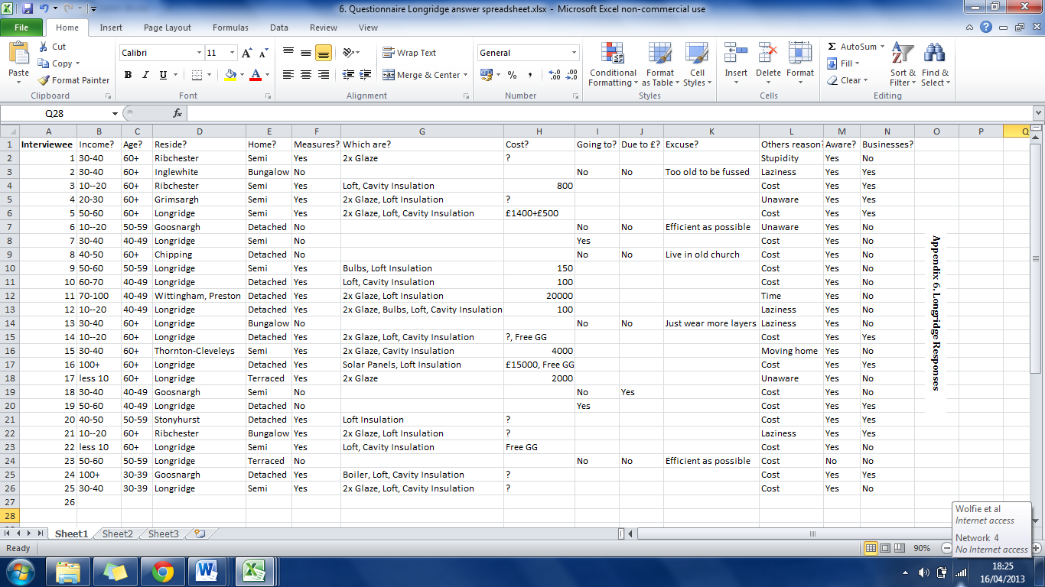
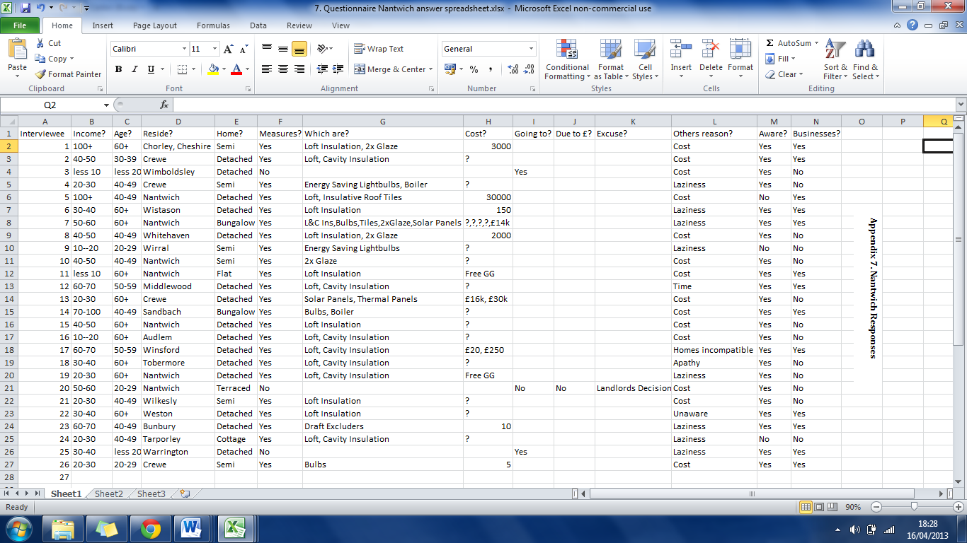
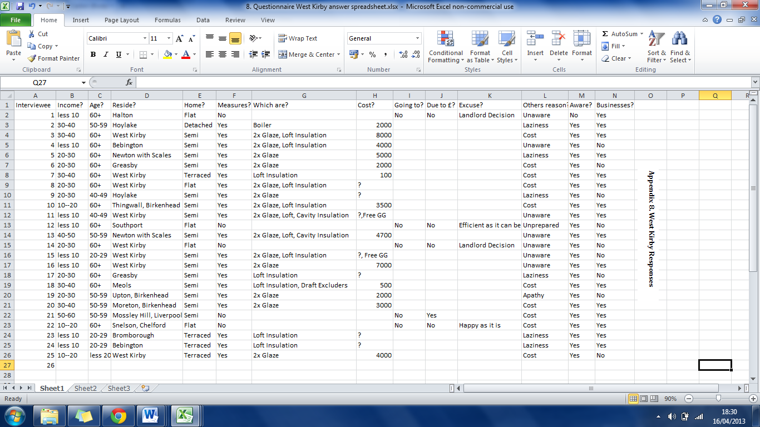
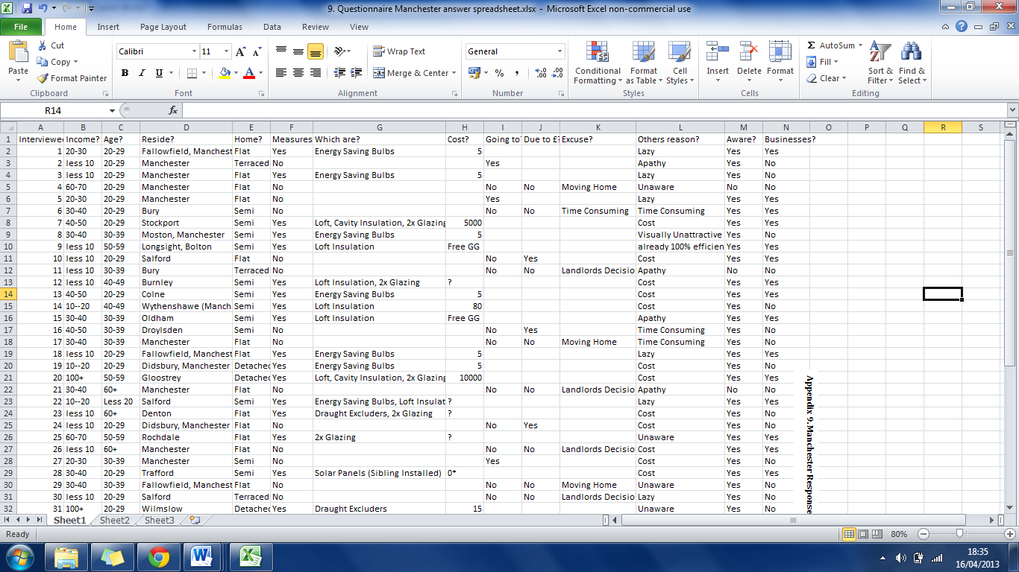
Appendix 9. Manchester Responses

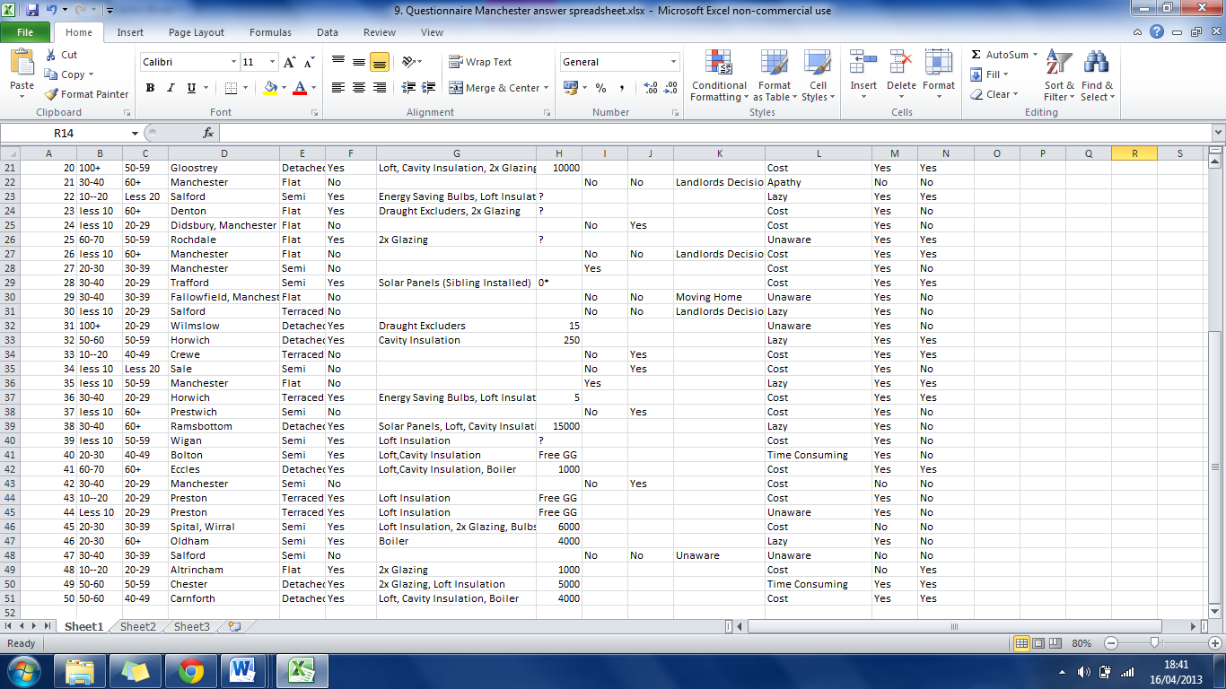
Appendix 9. Manchester Responses Continued
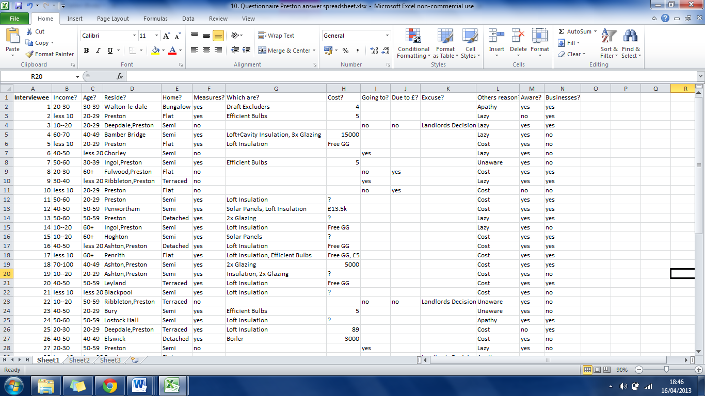
Appendix 10. Preston Responses
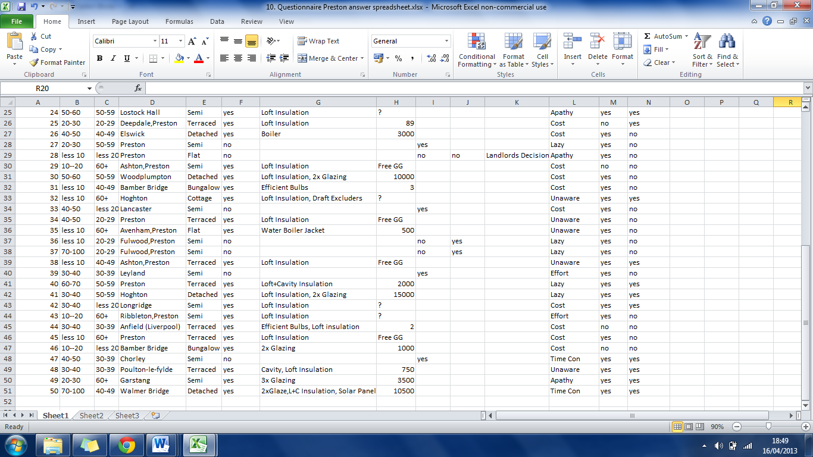
Appendix 10. Preston Responses Continued
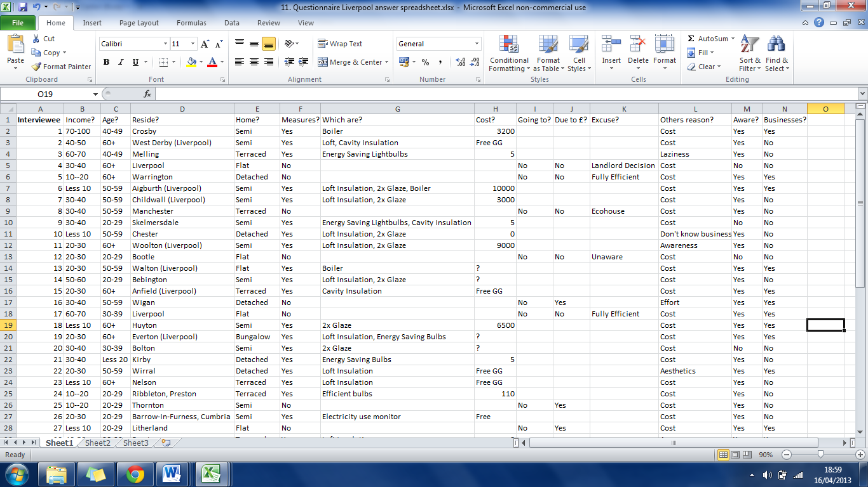
Appendix 11. Liverpool Responses
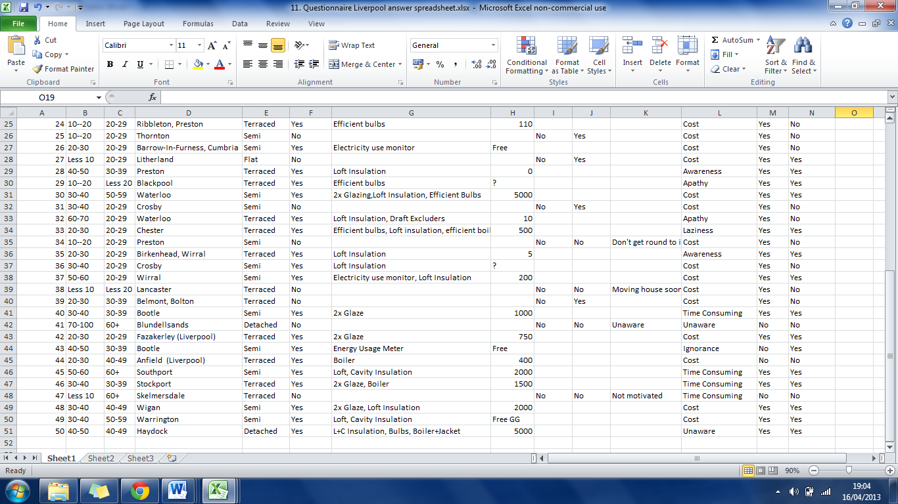
Appendix 11. Liverpool Responses Continued
Appendix 12. Images of research areas. All images are authors own unless stated
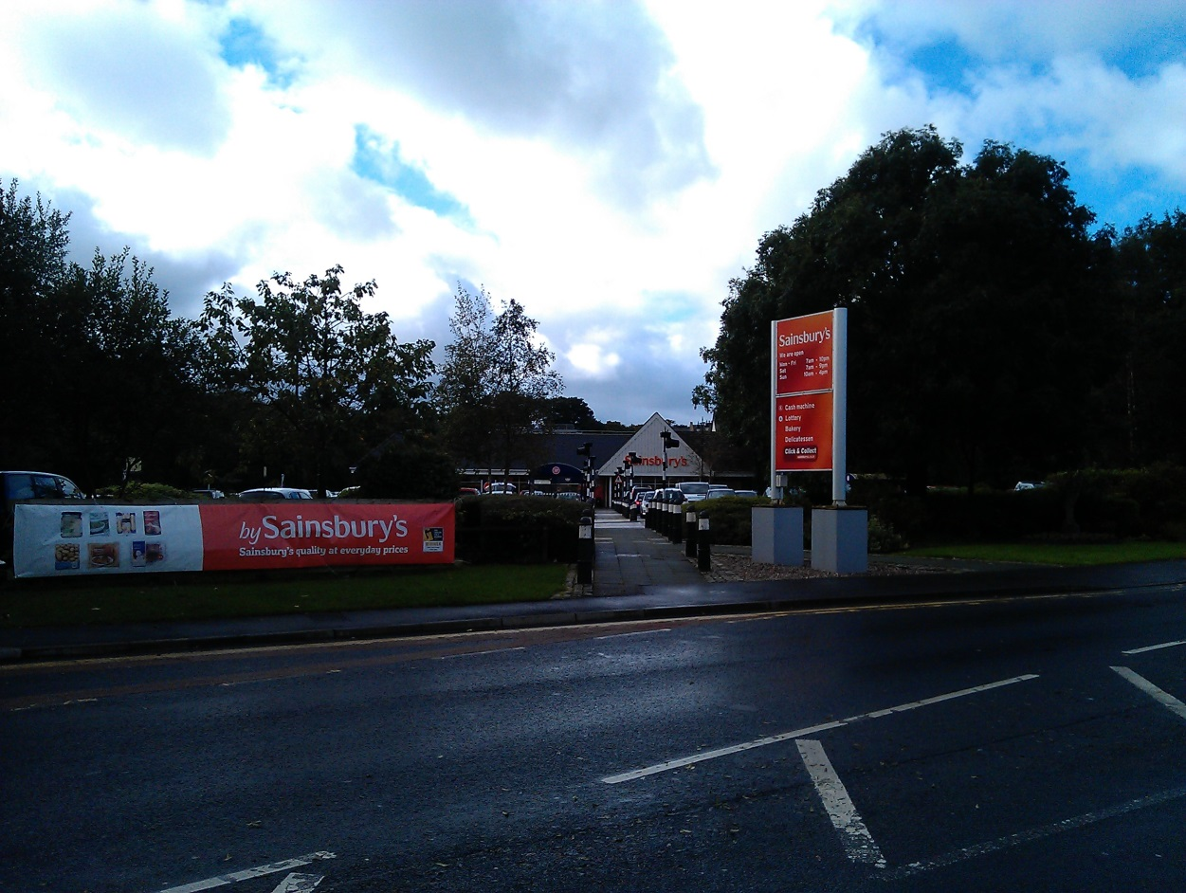
Colne Research Area
Garstang Research Location
Longridge Research Location
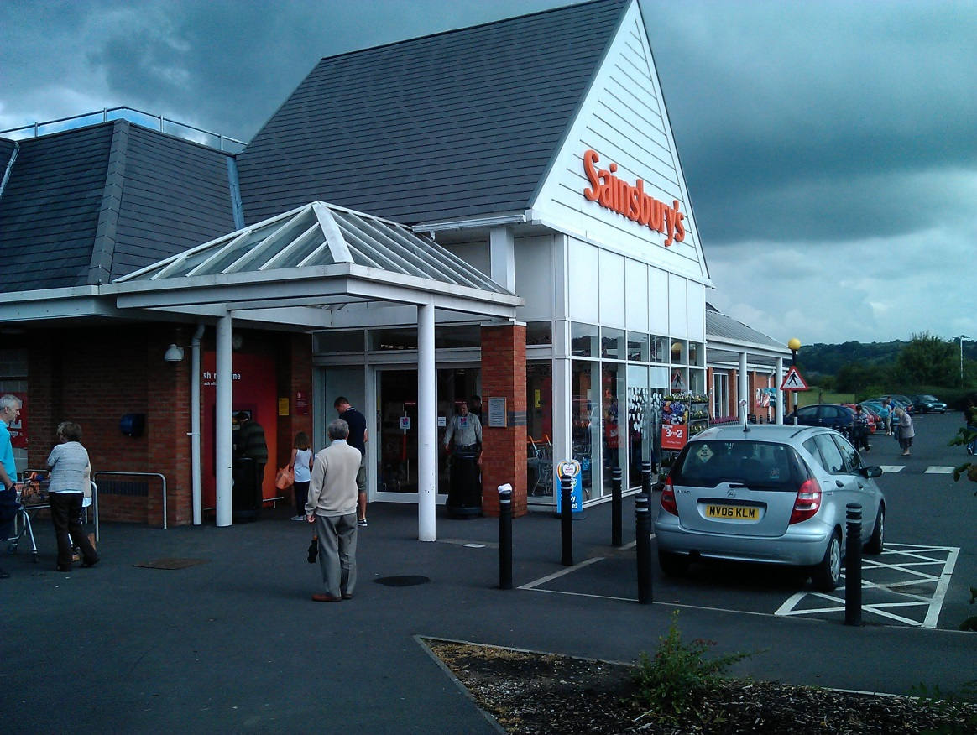

Nantwich Research Location

West Kirby Research Location
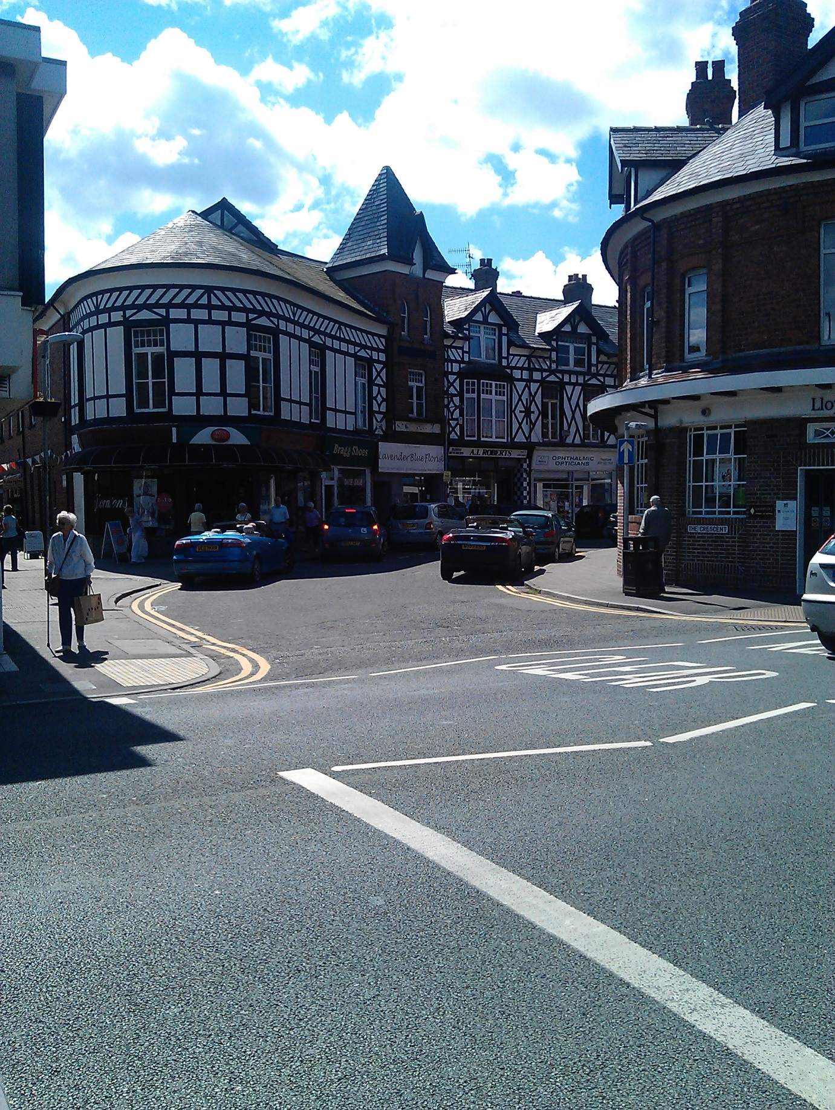

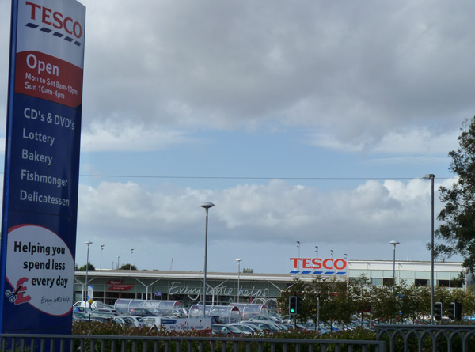
Burscough Research Area (Blaxall, 2011)
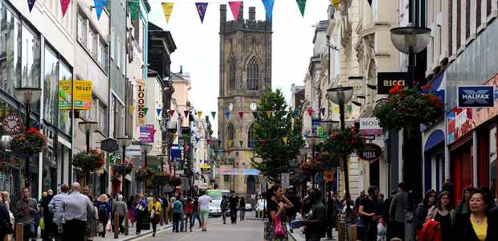
Liverpool Research Area (Guy, 2012)

Manchester Research Location


Preston Research Area (Gritt, 2007)
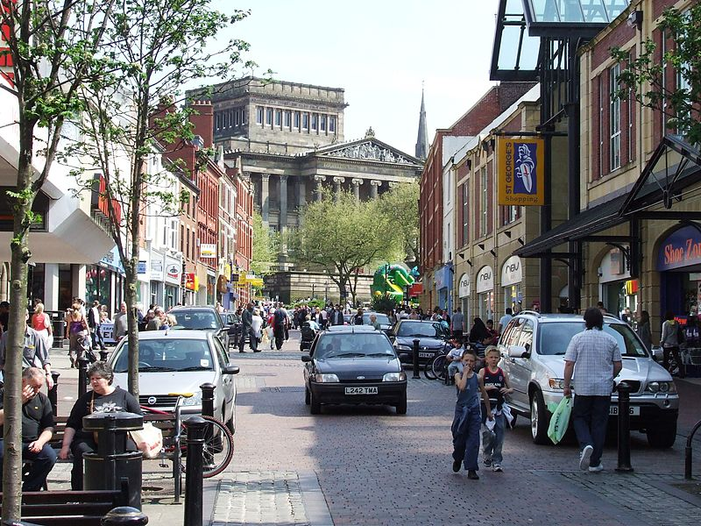

Application for safety and ethical approval for all projects
Appendix 13. Ethics Form

School of Built and Natural Environment
All undergraduate, postgraduate, commercial and research projects need ethical approval. No field work, experimentation or work with participants can start until approval is granted. The questions below should be completed by the Principal Investigator or supervisor of the proposed project. Where projects involve students, the Principal Investigator is always the supervisor and never the student.
For undergraduate and postgraduate taught projects: use the questions to identify whether the project should be referred to the relevant Ethics Committee.
- If you answer “No” to questions, then do not apply for approval.
- If you answer “Yes” to any of the questions, please discuss them with your supervisor. If your supervisor is confident that you can follow standard forms, protocols or approaches, then your supervisor can approve your application. If your supervisor is not, then the application should be sent for approval.
For research, commercial and other projects: use the questions to help compile suitable evidence to support your application.
- If you answer “No” to questions, then your application is likely to be approved quickly.
- If you answer “Yes” to any of the questions, please provide evidence relating to the management of the activity. If your approach seems appropriate, then your application is likely to be approved quickly.
Submit the application form and any supporting evidence to an appropriate Ethics Committee. Different committees might have different approval processes.
Principal Investigators, or project supervisors, are responsible for ensuring that all activities fall within the principles set down in the University Code of Conduct for Research and the University Ethical Principles for Teaching, Research, Knowledge Transfer, Consultancy and Related Activities. They are also responsible for exercising appropriate professional judgment in undertaking this review and evaluating the activity according to the criteria laid down in this application. If you are uncertain about any sections of this document, or need further information and guidance, please consult a member of the relevant School Ethics Committee.
TheSchool Ethics and Safety Committees are to ensure that you comply with the University’s ethical principles in the conduct of the activity. Committees can ask for clarification or set conditions for you to meet before approval is granted.
Expiry and review: The principal investigator is responsible for ensuring activities are reviewed. Normally:
- each year: review risk assessments: check for changes to hazards and training refreshers
- after 5 years: review ethics: check for new laws, practices
- closure: dispose of materials and sensitive data properly
Refer to the relevant documents from the following links:
- Ethical Principles for Research, Consultancy, Practical Work and Related Activities
- Research Governance (Multiple documents)
- Health, Safety & Environment (Multiple documents)
1 Project synopsis |  |  |  | Approver: Dr Mike Clark |  |  |  | Cmte number:
1.1 Title | Cost: Why British homes are not energy efficient?
1.2 Project type | Original research | Yes | Research degree |  | PG taught |  | UG taught |  |  | Commercial
1.3 Short description  in layman's terms [no acronyms or jargon] | The study will tell us if the key reason behind Britain's homes not being energy efficient is due cost. It will also show us if there is regional pattern and if it is related to either age, lack of knowledge or another factor.
1.4 Dates | Start 1/6/2012 |  |  | End 1/4/2013
1.5 School of ….. | Built and Natural Envrionment

2 Participants
2.1 Project supervisor /principal investigator:
name, position
and original signature
2.2 Co-workers:  names and positions  [eg student] | Richard Wolfenden

3 External collaborators
3.1 List external collaborating bodies
3.2 Provide evidence of any ethical approvals obtained [or needed] by external collaborators
3.3 Indicate whether confidentiality agreements have been or will be completed

Read any associated procedures and guidance or follow any associated checklist, and delete, Yes or No, for each characteristic in A) to F) below.
If you respond No, then in your judgment you believe that the characteristic is irrelevant to the activity.
If you respond Yes, then you should provide relevant documentation [including risk assessments] with the application, and cross-reference to it, eg A2 or B9. Use reference numbers of standard forms, protocols and approaches and risk assessments where they exist.

- Does the activity involve field work or travel to unfamiliar places? If Yes:  - Does the activity involve field work or leaving the campus [eg overseas]?  - Does the field work involve a ‘party’ of participants or lone working ?  - Does the activity involve children visiting from schools? | A) Yes/No  - Yes/No  - Yes/No  - Yes/No
B) Does the activity involve humans other than the investigators? If Yes:  - Will the activity involve any external organisation for which separate and specific ethics clearance is required (e.g. NHS; school; any criminal justice agencies including the Police, CPS, Prison Service)? – start this now [CRB clearance process at Loughborough; Uclan contact Carole Knight]  - Does the activity involve participants who are unable to give their informed consent (e.g. children, people with severe learning disabilities, unconscious patients etc.) or who may not be able to give valid consent (e.g. people experiencing mental health difficulties)?  - Does the activity require participants to give informed consent? [consent guidance at City U]  - Does the activity raise issues involving the potential abuse or misuse of power and authority which might compromise the validity of participants’ consent (e.g. relationships of line management or training)?  - Is there a potential risk arising from the project of physical, social, emotional or psychological harm to the researchers or participants?  - Does the activity involve the researchers and/or participants in the potential disclosure of any information relating to illegal activities; the observation of illegal activities; or the possession, viewing or storage (whether in hard copy of electronic format) which may be illegal?  - Will deception of the participant be necessary during the activity?  - Does the activity (e.g. art) aim to shock or offend?  - Will the activity involve invasion of privacy or access to confidential information about people without their permission?  - Does the activity involve medical research with humans, clinical trials or use human tissue samples or body fluids?  - Does the activity involve excavation and study of human remains? | B) Yes/No  - Yes/No  - Yes/No  - Yes/No  - Yes/No  - Yes/No  - Yes/No  - Yes/No  - Yes/No  - Yes/No  - Yes/No  - Yes/No
C) Does the activity involve animals and other forms of life? If Yes:  - Does the activity involve scientific procedures being applied to a vertebrate animal (other than humans) or an octopus?  - Does the activity involve work with micro-organisms?  - Does the activity involve genetic modification?  - Does the activity involve collection of rare plants? | C) Yes/No  - Yes/No  - Yes/No  - Yes/No  - Yes/No
D) Does the activity involve data about human subjects? If Yes:  - After using the data protection compliance checklist, have you any data protection requirements?  - After answering the data protection security processing questions, have you any security requirements? [Data storage] [keep raw data for 5 years] | D) Yes/No  - Yes/No  - Yes/No
E) Does the activity involve hazardous substances? If Yes:  - Does the activity involve substances injurious to human or animal health or to the environment? Substances must be disposed properly.  - Does the activity involve igniting, exploding, heating or freezing substances? | E) Yes/No  - Yes/No  - Yes/No
F) Other activities:  - Does the activity relate to military equipment, weapons or the Defence Industry?  - Are you aware of any ethical concerns about the company/ organisation, e.g. its product has a harmful effect on humans, animals or the environment; it has a record of supporting repressive regimes; does it have ethical practices for its workers and for the safe disposal of products? | F)  - Yes/No  - Yes/No
Note: in all cases funding should not be accepted from tobacco-related industries

If you respond Yes, then you should provide relevant documentation [including risk assessments] with the application, and cross-reference to it, eg A2 or B9. Use reference numbers of standard forms, protocols and approaches and risk assessments where they exist.

These standard forms are being followed [cross reference to the characteristic, eg A2]:
A1: Will be leaving the campus and visiting postal services E.G. Royal Mail, as well as visiting some rural areas to post questionnaires.
A2: Lone working when distributing the questionnaire. Online and posting to rural areas.

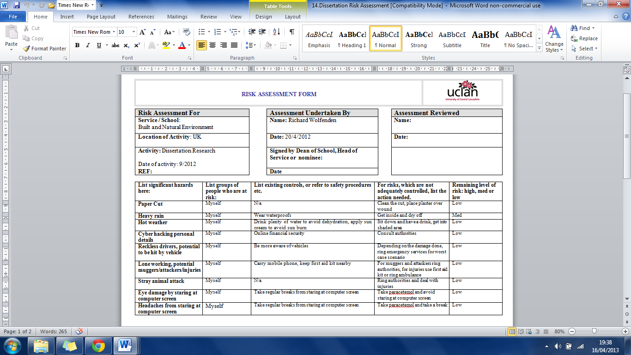
Appendix 14. Risk Assessment

